 

**PM2.5 Emissions in Yakutat City and Borough, Alaska County, 2000**  
Made with CAT VISUALIZER by Gao Labs @ Cornell University.

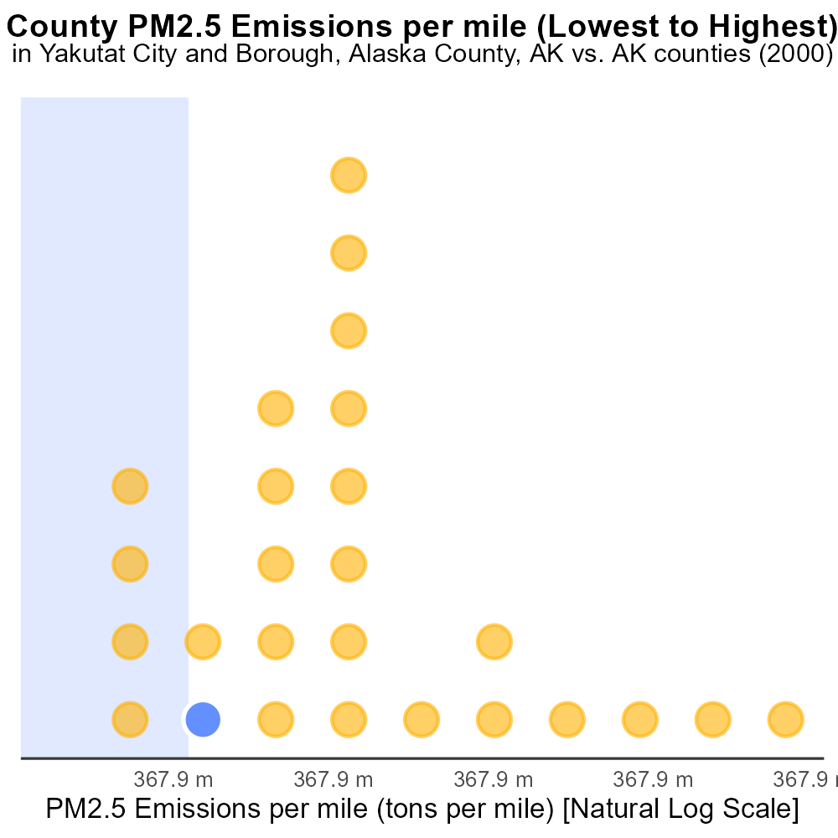

## Keywords

Primary Exhaust; PM2.5; Total emissions; on-road transportation; Yakutat City and Borough; Alaska County

## Highlights

* Study examines PM2.5 emissions from on-road vehicles in Yakutat City and Borough, AK in 2000.
* Data on primary exhaust emissions crucial for assessing air quality impacts in the region.
* Transportation sector plays a significant role in local air pollution levels.
* Results will provide insight into the environmental effects of on-road transportation in the area.
* Understanding emissions trends can inform policy decisions for improving air quality.

# Introduction

The following report presents an analysis of Primary Exhaust PM2.5 total emissions from on-road transportation in Yakutat City and Borough, Alaska County, AK in the year 2000. This study aims to assess the environmental impact of vehicular emissions on air quality in the region.

Transportation is a key source of air pollution, with on-road vehicles being a major contributor to PM2.5 emissions. Understanding the extent of these emissions is essential for developing effective mitigation strategies and improving public health outcomes in Yakutat City and Borough. By examining the data on primary exhaust emissions, this report seeks to provide valuable insights into the environmental effects of on-road transportation, helping policymakers make informed decisions to enhance air quality standards.

# Emissions by Fuel Type

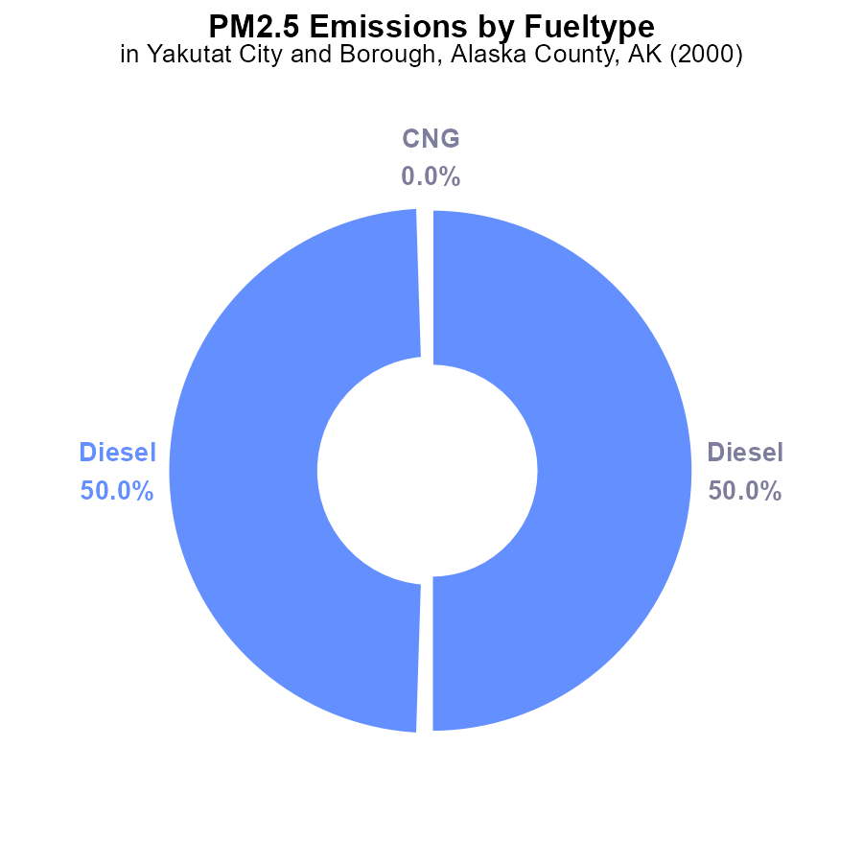

## Findings

* Diesel emissions in 2000 totaled 400 tons, making up 100% of PM2.5 emissions.
* No emissions were reported from CNG or gas sources in 2000.
* Diesel emissions dominated PM2.5 pollution in Yakutat City and Borough, Alaska County in 2000.

## Recommendations

To lower PM2.5 emissions in Yakutat City and Borough: 1. Encourage transitioning to cleaner fuel sources. 2. Implement stricter regulations on diesel emissions. 3. Invest in public transportation to reduce individual vehicle use.

# Time Driven by Regulatory Class

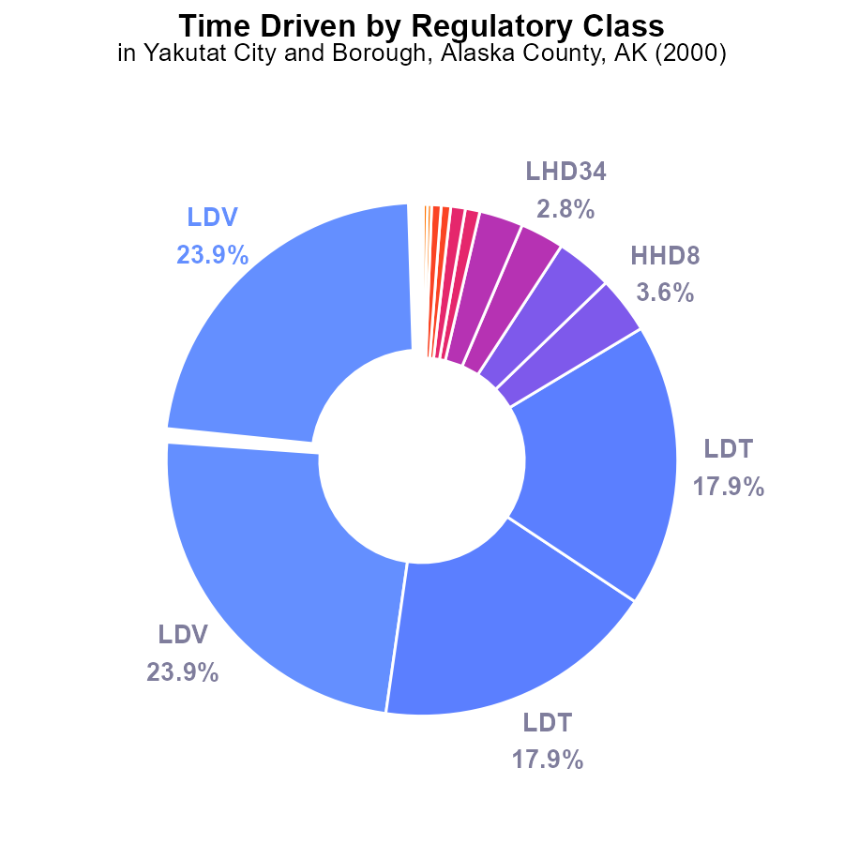

## Findings

* Private vehicles (LDV) contribute to 47.8% of PM2.5 emissions in Yakutat City and Borough in 2000.
* Light-duty trucks (LDT) account for 35.8% of the emissions, showing a significant impact.
* Recommendations: Encourage carpooling, promote public transportation, and incentivize the use of electric vehicles to reduce PM2.5 emissions from vehicles in Yakutat City and Borough.

# Emissions over Time for Passenger Vehicles

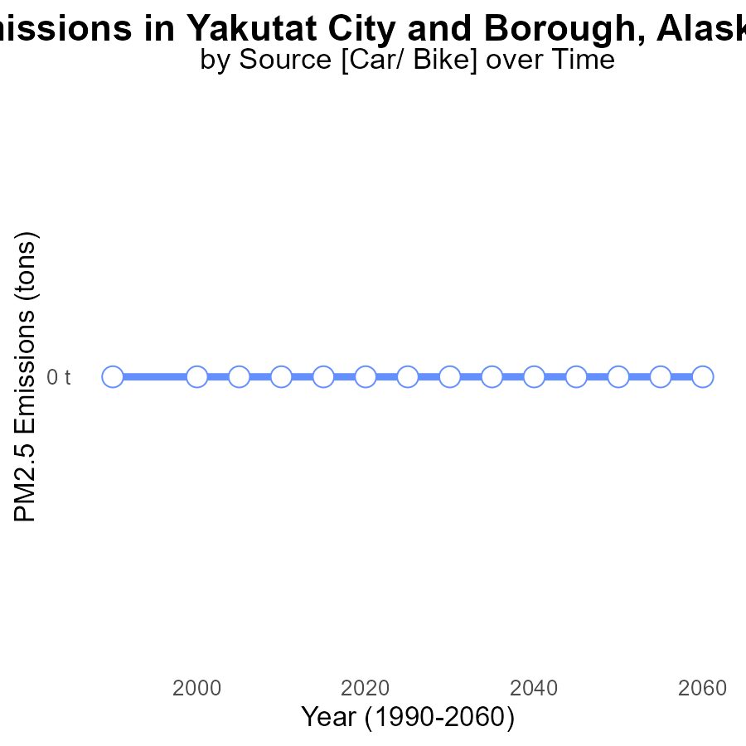

## Findings

* PM2.5 emissions in Yakutat City and Borough, AK have consistently remained at 0 tons from 1990 to 2020.
* There has been no observed change in PM2.5 emissions over the past three decades in the area.
* The emissions data for Yakutat City and Borough, AK indicate no measurable impact on PM2.5 levels in the air.

## Recommendations

Given the consistent zero emissions of PM2.5 in Yakutat City and Borough, AK, focus should shift towards maintaining existing pollution control measures to continue the trend of zero emissions. Regular monitoring and enforcement of emission standards is crucial to prevent any potential future increase in emissions.

# Emissions Rate (per capita) Overall over Time

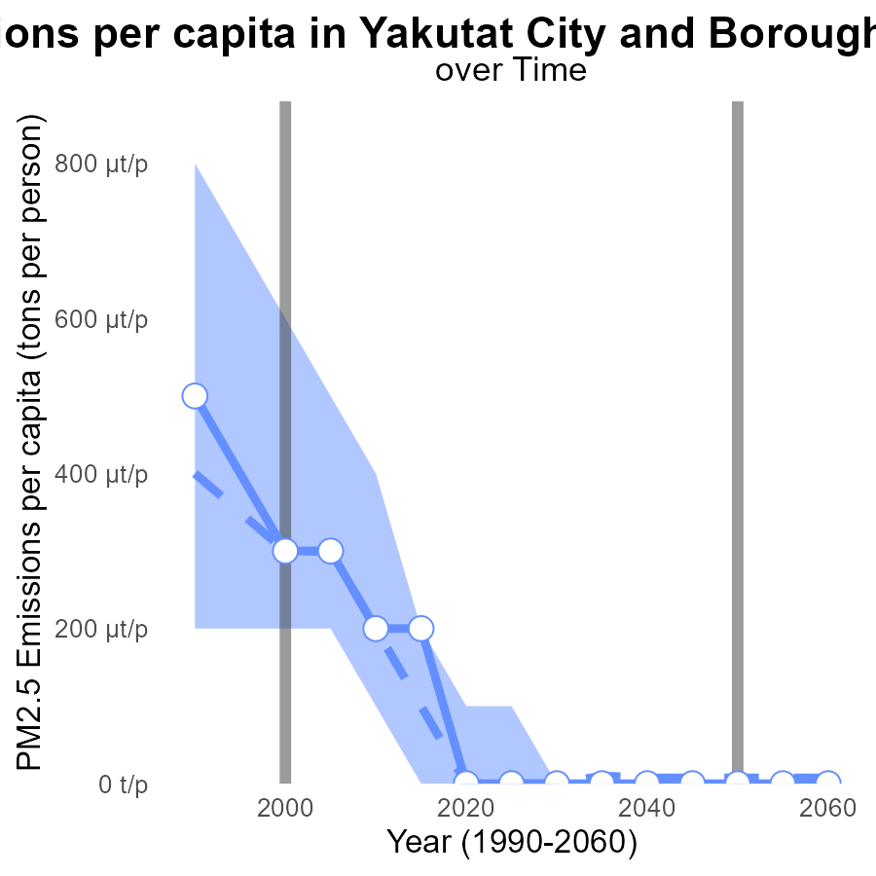

## Findings

* Emissions per capita of PM2.5 in Yakutat City and Borough, Alaska, were significantly above the median area in 1990, 2005, and 2015.
* A decreasing trend is observed in emissions per capita from 1990 to 2020, with a noticeable drop from 2010 to 2020.
* In 2020, there was a substantial reduction in emissions, reaching zero tons per person in Yakutat City and Borough.

## Recommendations

To maintain the decreasing trend and further reduce emissions, Yakutat should invest in cleaner energy sources, encourage the use of public transportation, and implement stricter emissions regulations for industries.

# Population Mapped by Area

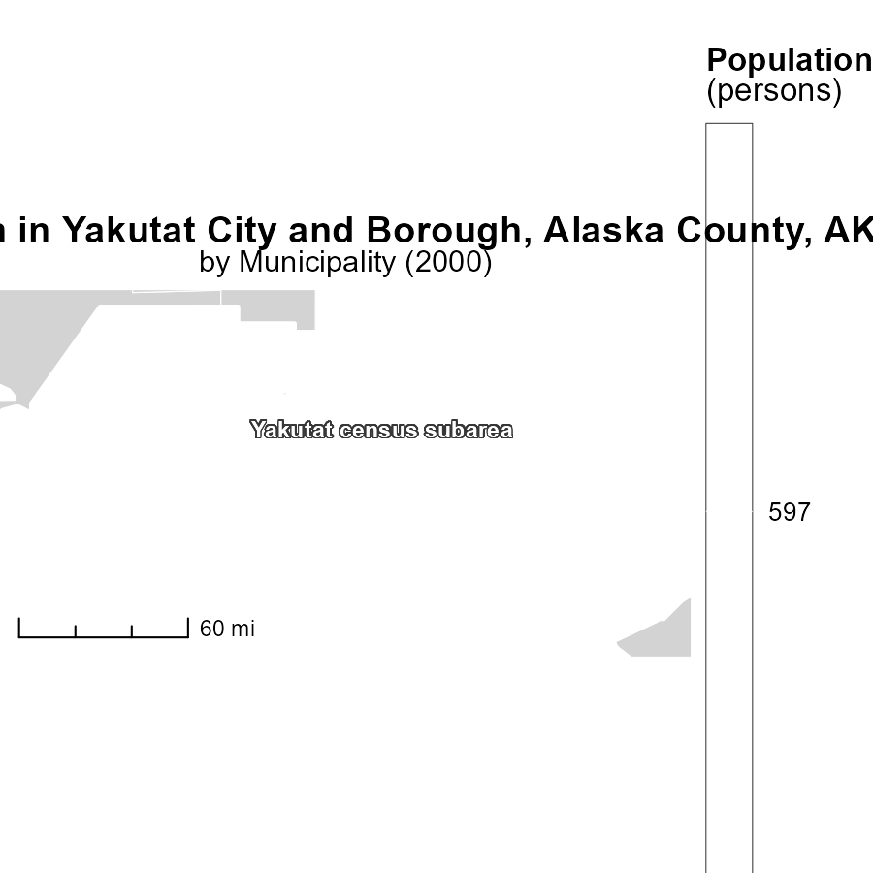

## Findings

* The population of Yakutat census subarea, AK is 597 persons.

## Recommendations

Encourage sustainable development to limit emissions per capita.

# Vehicle Starts in My Region

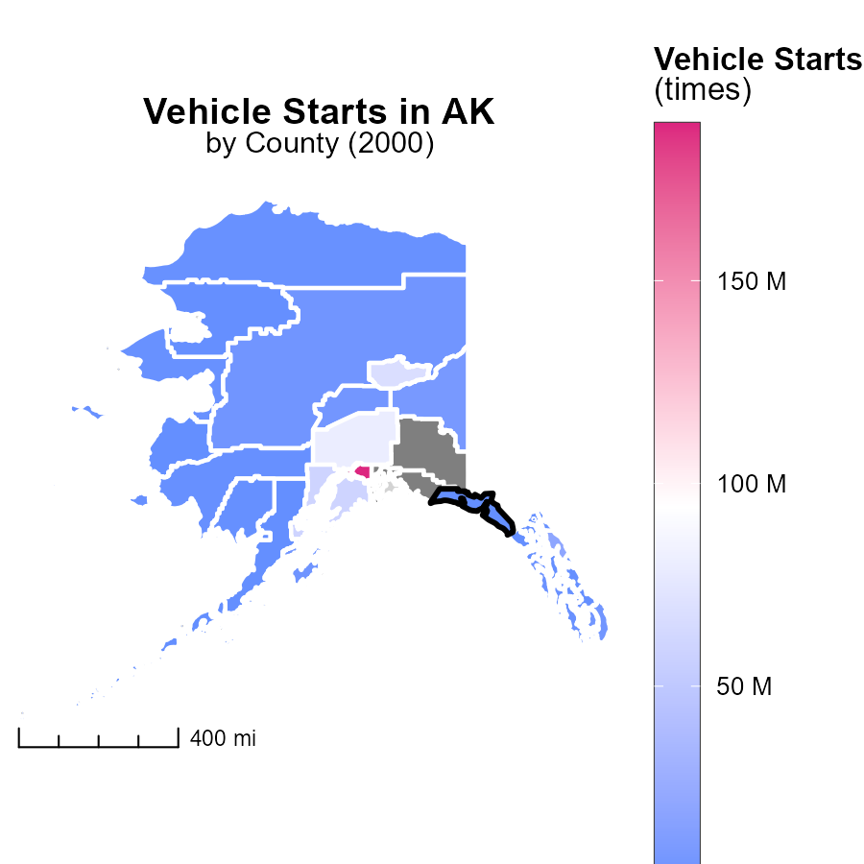

## Findings

* Anchorage Municipality, AK has the highest vehicle starts with 188.8 million times.
* North Slope Borough, AK has a median of 1.7 million vehicle starts.
* Lake and Peninsula Borough, AK has the lowest with zero vehicle starts.

## Recommendations

Encourage carpooling and public transportation in Anchorage Municipality to reduce emissions from the high number of vehicle starts. Implement car-sharing programs in North Slope Borough to decrease the median vehicle starts. Promote biking and walking initiatives in Lake and Peninsula Borough to further reduce emissions.

# Time Driven by Fuel Type over Time

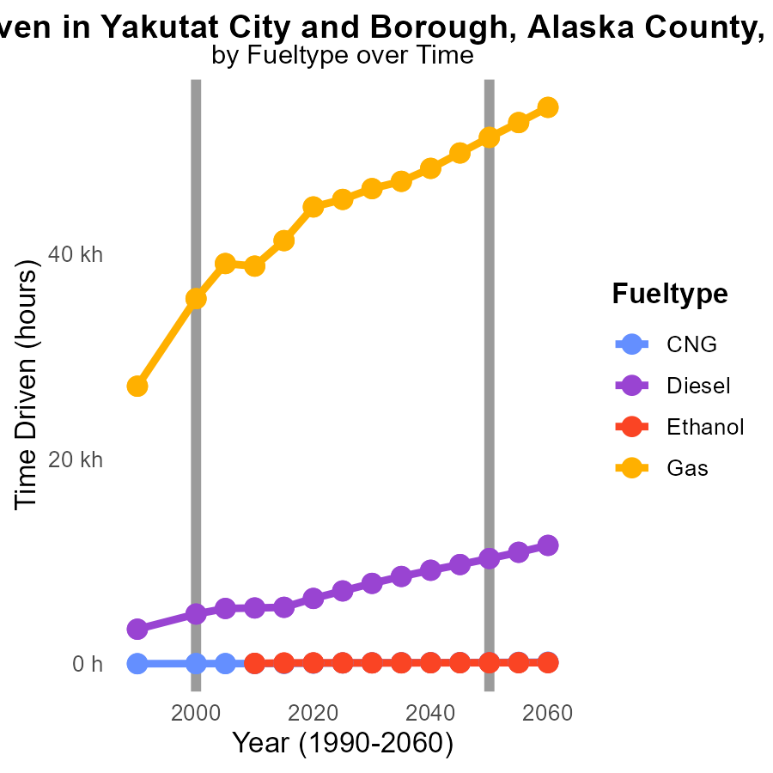

## Findings

* PM2.5 emissions for CNG decreased from 13.3 in 1990 to 8.2 in 2010.
* Diesel emissions increased from 3.4k in 1990 to 5.4k in 2010.
* Gas emissions showed a fluctuating trend, peaking at 39.1k in 2005 and slightly decreasing to 38.8k in 2010.

## Recommendations

To lower emissions: promote cleaner fuel sources like CNG and ethanol, incentivize the use of lower emission vehicles, enforce stricter emission standards for diesel vehicles.

# Hotelling (Engines Off) by Vehicle Type over Time

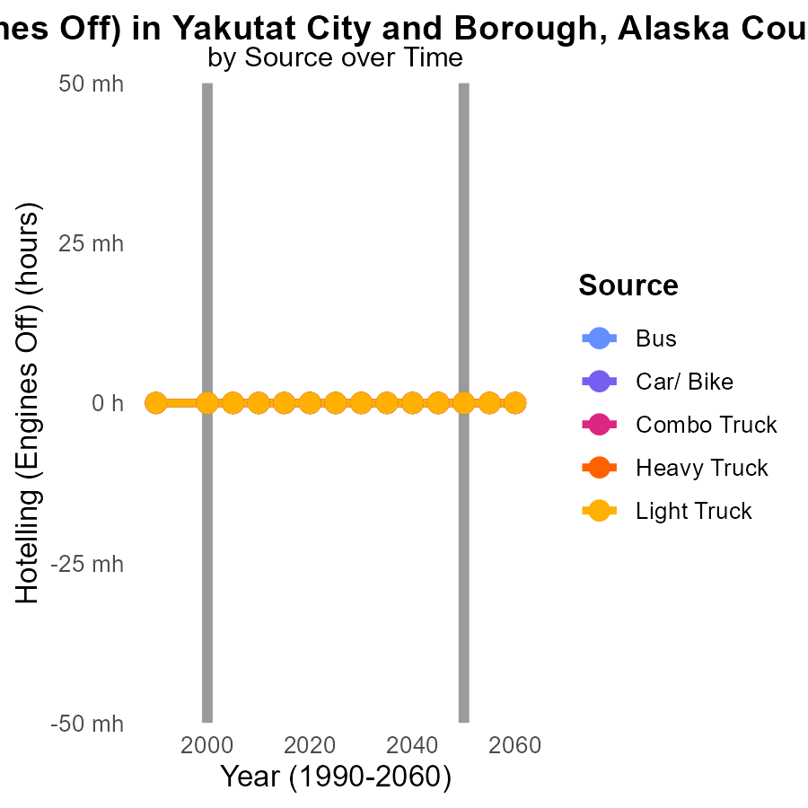

## Findings

* From 1990 to 2010, all vehicle types in Yakutat City and Borough, AK emitted zero PM2.5 due to Hotelling (Engines Off).
* There were no differences in emission levels with the projected 2050 values for all vehicle types.
* Overall, there were no PM2.5 emissions from vehicles in Yakutat City and Borough, AK between 1990 and 2010.

## Recommendations

Given the zero emissions from vehicles due to Hotelling (Engines Off) during 1990-2010 in Yakutat City and Borough, AK, there seems to be an effective use of this practice. To further lower emission levels, continue promoting and enforcing policies that encourage engine-off practices in various types of vehicles.

# Areas Ranked by Emissions Rate (per mile)

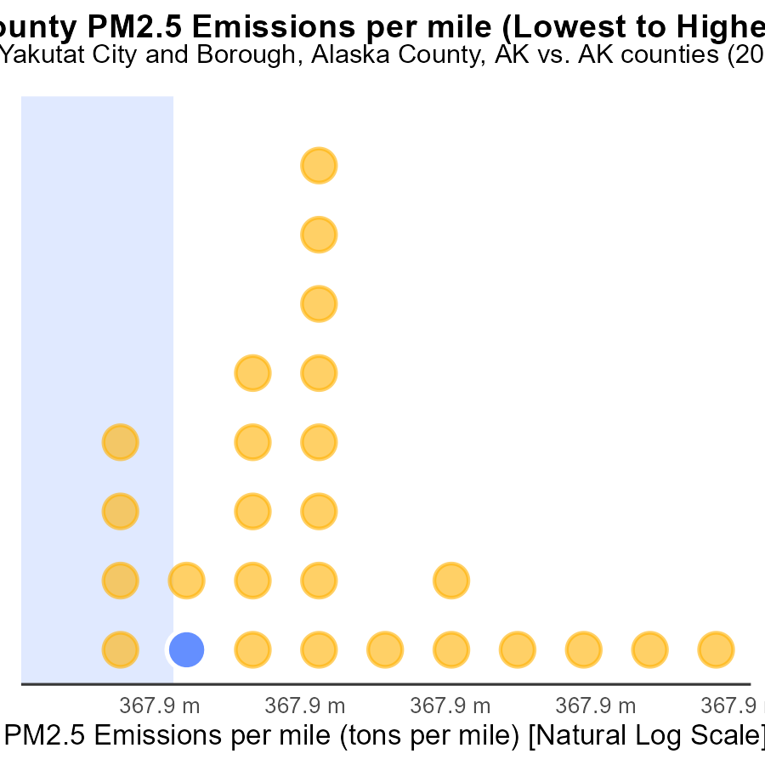

## Findings

* Yakutat City and Borough, Alaska emits 102.4 tons of PM2.5 per mile, ranking 5th at 19.2%.
* Kodiak Island Borough, Alaska emits 97.1 tons of PM2.5 per mile, ranking 4th at 15.4%.
* Fairbanks North Star Borough, Alaska emits 109.9 tons of PM2.5 per mile, ranking 6th at 23.1%.

## Recommendations

To reduce emissions, targeted strategies like promoting electric vehicle use, improving public transport, and enforcing stricter emissions standards for vehicles should be considered in Yakutat City, Kodiak Island, and Fairbanks North Star Borough.

# Areas Ranked by Emissions Rate (per vehicle)

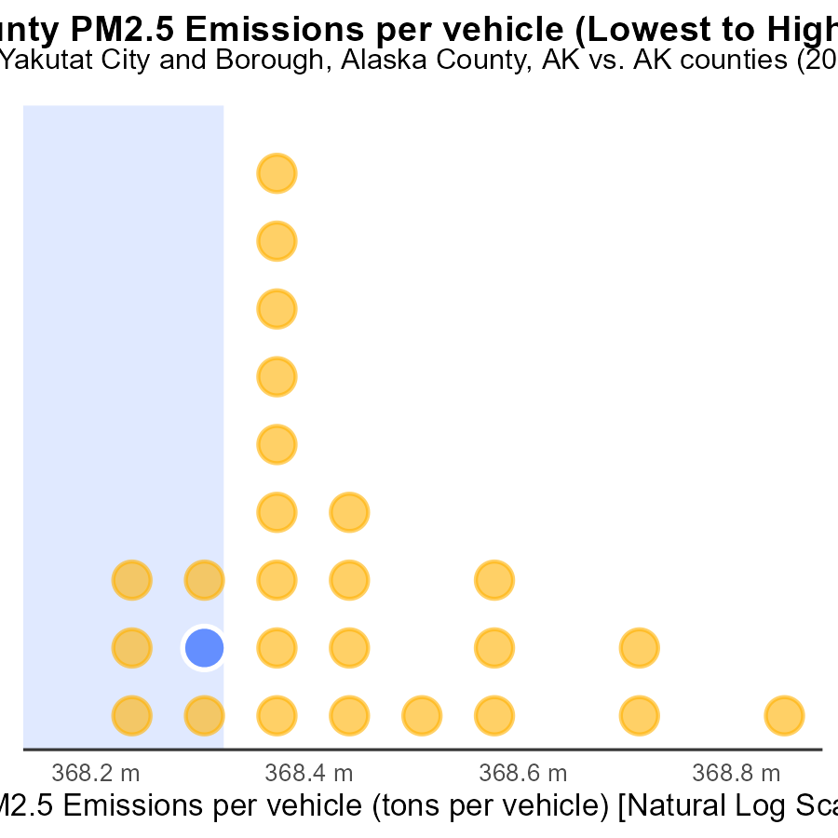

## Findings

* Yakutat City and Borough, Alaska has the highest emissions per vehicle at 1.3 tons.
* Fairbanks North Star Borough, Alaska ranks 6th in rate of vehicles but accounts for 23.1% of emissions.
* Kodiak Island Borough, Alaska ranks 4th in rate of vehicles with emissions of 1.2 tons per vehicle.

## Recommendations

To lower emissions, Yakutat City and Borough should focus on improving vehicle emission standards. Fairbanks North Star Borough needs targeted policies to reduce emissions despite a moderate rate of vehicles. Kodiak Island can benefit from promoting cleaner transportation options to decrease emissions per vehicle.

# Conclusion

In conclusion, the data from 2000 shows that diesel emissions were the primary source of PM2.5 pollution in Yakutat City and Borough, Alaska. Emissions from diesel totaled 400 tons, representing 100% of the PM2.5 emissions in the area. With no reported emissions from CNG or gas sources, addressing diesel emissions is crucial to reduce pollution levels.

To combat the high PM2.5 emissions from on-road transportation, recommendations include transitioning to cleaner fuel sources, implementing stricter regulations on diesel emissions, and investing in public transportation to reduce individual vehicle use. Private vehicles and light-duty trucks were significant contributors to the emissions in 2000, emphasizing the need for strategies like carpooling, promoting public transport, and incentivizing electric vehicle use.

Looking ahead, the consistent zero emissions of PM2.5 from 1990 to 2020 indicate a positive trend that should be maintained through rigorous monitoring and enforcement of emission standards. The decreasing trend in emissions per capita from 1990 to 2020 shows progress, with opportunities to further reduce emissions by investing in cleaner energy sources and encouraging sustainable development. By focusing on these strategies, Yakutat City and Borough can continue to improve air quality and reduce PM2.5 pollution.

# About This Report

Data based on MOVES estimates collected by the Climate Action in Transportation program at Cornell University. Demographic data sourced from the US Census's American Community Survey 5-year estimates. This report was generated with the help of AI.

# References

* U.S. Census Bureau. (2023). American Community Survey 5-year estimates: Detailed tables. Retrieved from https://data.census.gov
* U.S. Environmental Protection Agency. (2024). Motor Vehicle Emission Simulator (MOVES 4.0) [Software]. Retrieved from https://www.epa.gov/moves