 

**CO Emissions in Sacramento County, 2035**  
Made with CAT VISUALIZER by Gao Labs @ Cornell University.

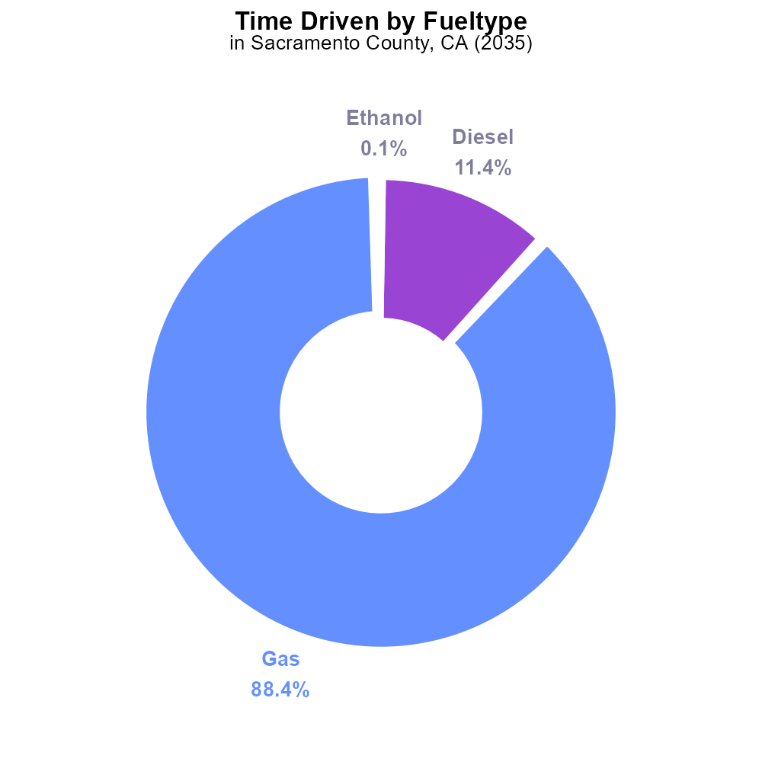

## Keywords

Carbon Monoxide (CO); emissions; on-road transportation; Sacramento County; 2035

## Highlights

* CO emissions impact air quality & public health.
* On-road transportation main source in Sacramento County.
* 2035 data crucial for understanding future trends.
* Addressing CO emissions essential for sustainability.
* Findings will guide future policies & interventions.

# Introduction

The presence of Carbon Monoxide (CO) emissions poses a significant threat to air quality and public health, with transportation being a major contributor. This report focuses on the analysis of CO emissions from on-road transportation in Sacramento County, CA, projected for 2035. Understanding the dynamics of CO emissions in this region is crucial for developing effective strategies to mitigate their impact.

Sacramento County, known for its bustling road networks and urban activities, faces unique challenges in managing vehicular emissions. By examining the CO emissions data for 2035, this report aims to provide insights into the potential trends and hotspots. Addressing these emissions is essential for ensuring sustainability and fostering a healthier environment. The findings of this report will serve as a foundation for shaping future policies and interventions to reduce CO emissions and enhance air quality in the region.

# Population by Fuel Type

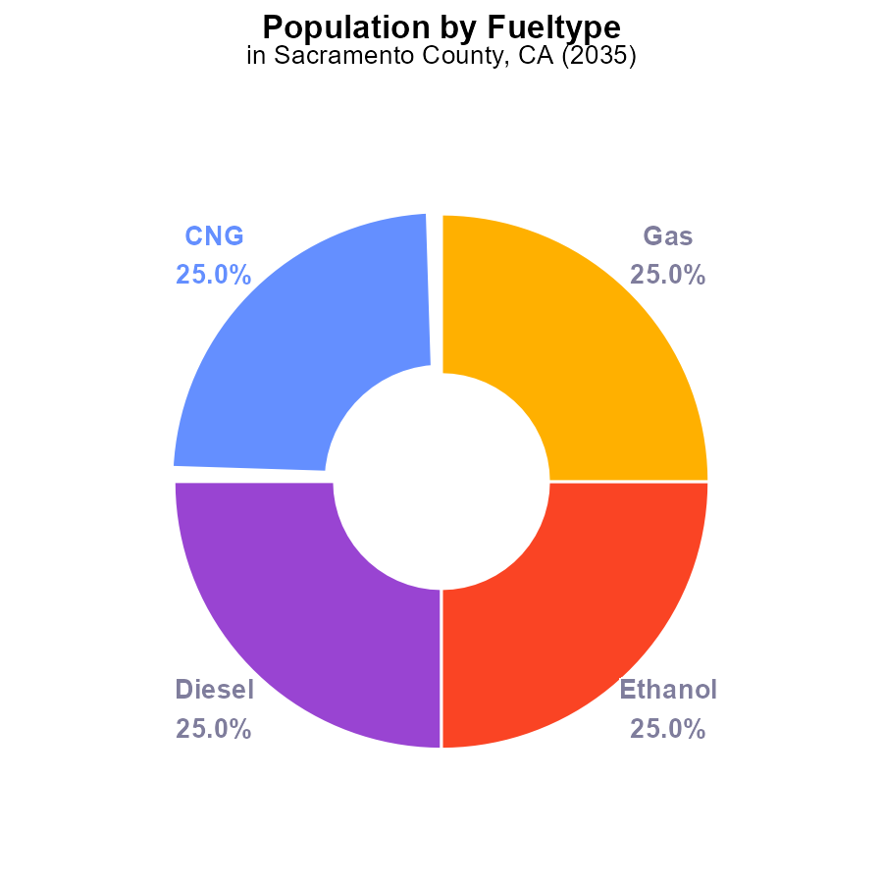

## Findings

* In 2035, total CO emissions from vehicles in Sacramento County will be 6 million persons.
* The distribution is equal, with each type contributing 25% (1.5 million persons) to the total emissions.
* This data indicates a balanced impact of different vehicle types on CO emissions.

## Recommendations

To lower CO emissions, policymakers could focus on promoting cleaner fuel alternatives and incentivizing the use of electric vehicles to reduce emissions from all vehicle types equally.

# Time Driven by Fuel Type

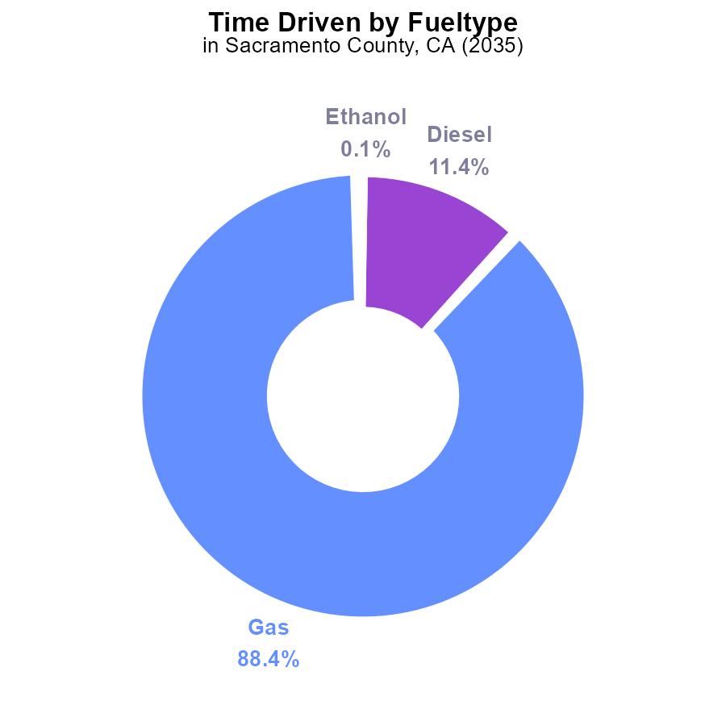

## Findings

* Gasoline contributes to 88.4% of CO emissions from time-driven sources in Sacramento County in 2035.
* Diesel contributes to 11.4% of CO emissions from time-driven sources in Sacramento County in 2035.
* Ethanol and CNG each contribute less than 0.1% to CO emissions from time-driven sources in Sacramento County in 2035.

## Recommendations

To lower CO emissions, policymakers should focus on reducing gasoline and diesel consumption through promoting electric vehicles, enhancing public transportation, and investing in alternative fuel infrastructure.

# Emissions Overall over Time

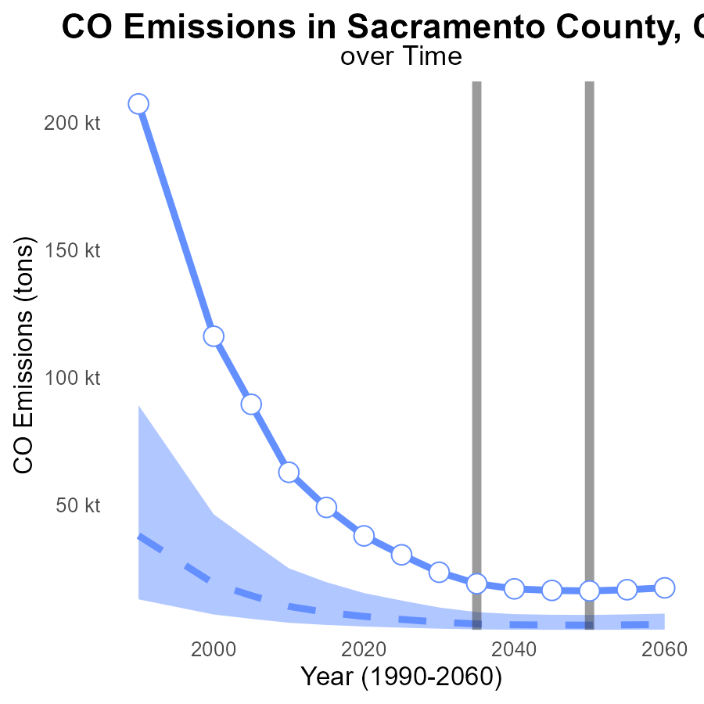

## Findings

* Emission levels have consistently decreased from 2015 to 2055.
* The emissions in 2055 were 16.7k tons, a decrease of 32.3k tons compared to 2015.
* Even though emissions are decreasing, they are still above the benchmark difference.

## Recommendations

To further lower emissions, focus on reducing diff_from_median_area values. Implement stricter regulations on industries and promote clean energy initiatives.

# Hotelling (Diesel Aux) over Time for Passenger Vehicles

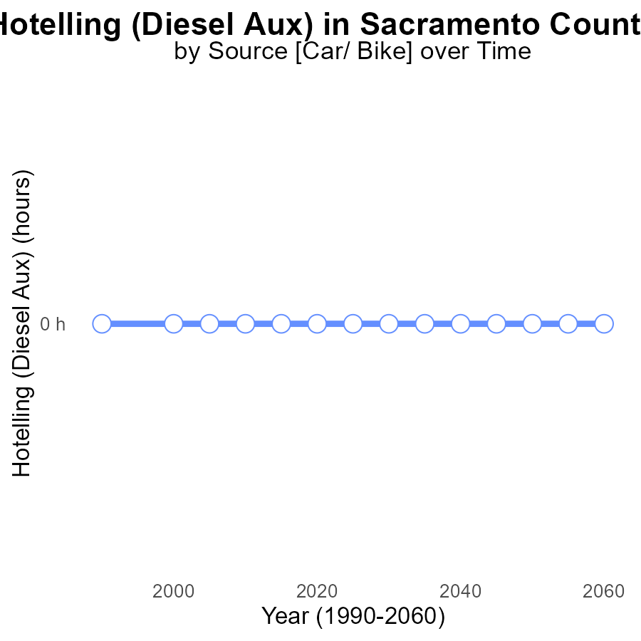

## Findings

* Emissions from Hotelling (Diesel Aux) in Sacramento County, CA are consistently at 0.0 over the years 2015 to 2055.
* There has been no change in emissions from Hotelling (Diesel Aux) between 2015 and 2055 in this area.
* The emissions data show no deviation from the benchmark emissions level over the years.

## Recommendations

Given the consistent emissions from Hotelling (Diesel Aux) in Sacramento County, CA from 2015 to 2055, it is recommended to conduct a comprehensive review of the equipment, maintenance processes, and fuel sources involved to ensure they meet current emission standards. Implementing regular emission testing and maintenance checks can help verify and sustain the zero-emission levels observed.

# Emissions Rate (per vehicle) in My Region

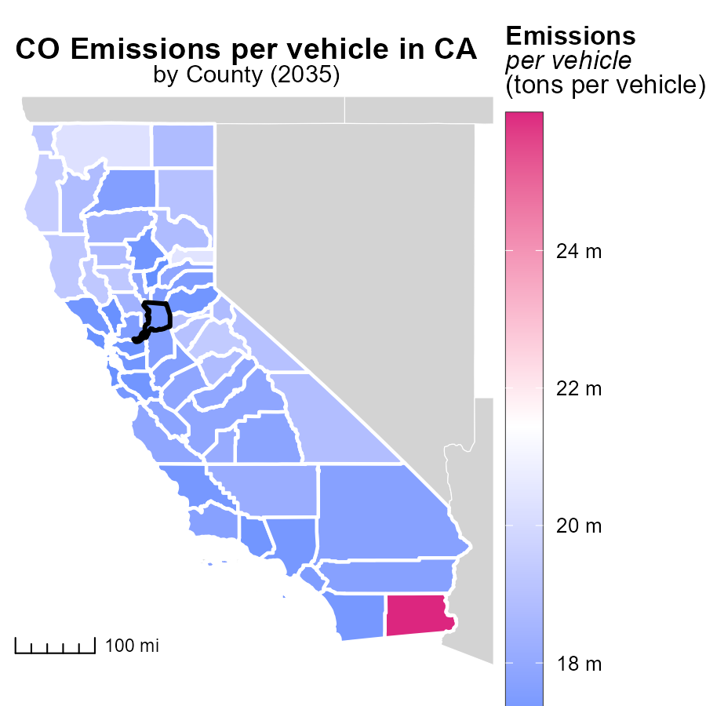

## Findings

* Imperial County, CA has the highest emissions per vehicle at 26.0 tons.
* Sutter County, CA has a median emissions rate per vehicle of 17.9 tons.
* Yuba County, CA has the lowest emissions per vehicle at 16.9 tons.

## Recommendations

Local policymakers should focus on implementing vehicle emission reduction programs tailored to each county, especially in Imperial County which has the highest emissions rate.

# Population Mapped by Area

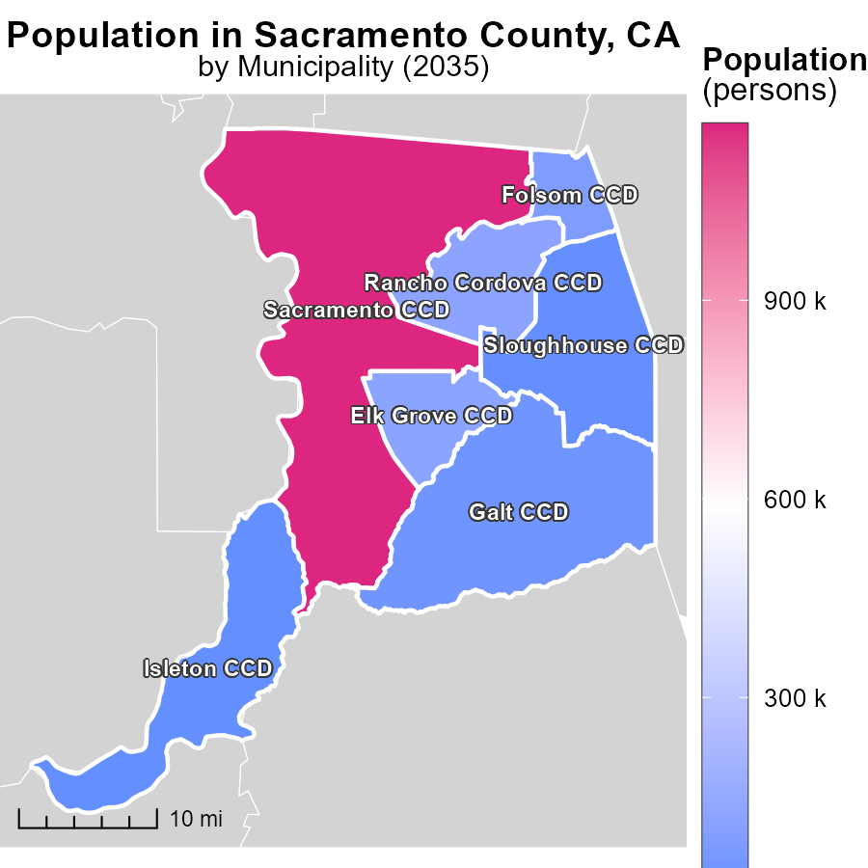

## Findings

* Sacramento CCD has the highest population of 1.2 million.
* Folsom CCD has a median population of 79.6 thousand.
* Isleton CCD has the lowest population of 4.4 thousand.

## Recommendations

To lower emissions, focus on high-population areas like Sacramento CCD by improving public transport, promoting carpooling, and investing in renewable energy sources. Implement city-wide emissions reduction policies.

# Time Driven by Vehicle Type over Time

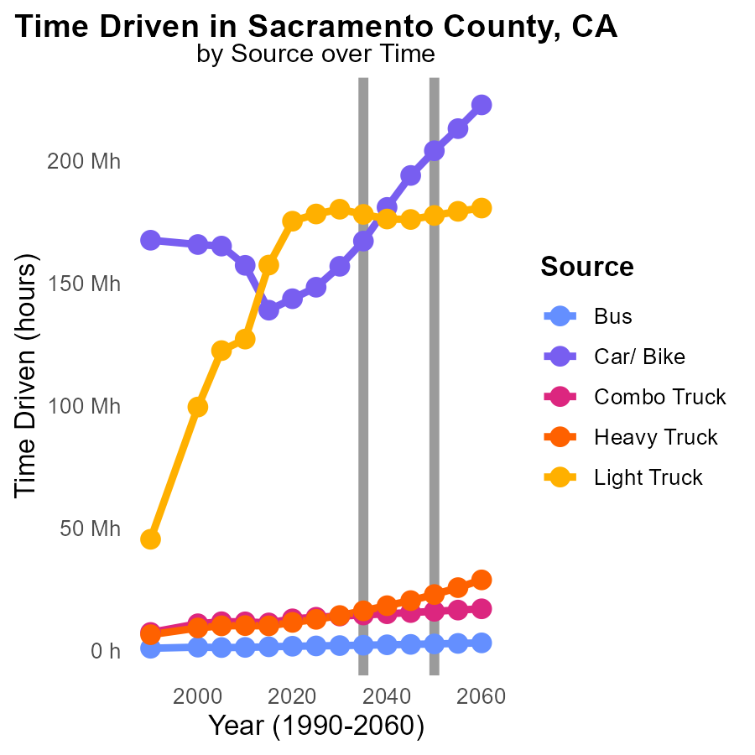

## Findings

* Bus emissions are decreasing gradually between 2025 and 2045.
* Car and Bike emissions show a slight increase until 2040, decreasing by 2045.
* Emissions from Combo Trucks, Heavy Trucks, and Light Trucks generally increase over the years.

## Recommendations

To lower emissions, increase bus ridership, promote electric cars and bikes, and implement strict emission standards for trucks.

# Vehicle Miles Traveled by Fuel Type over Time

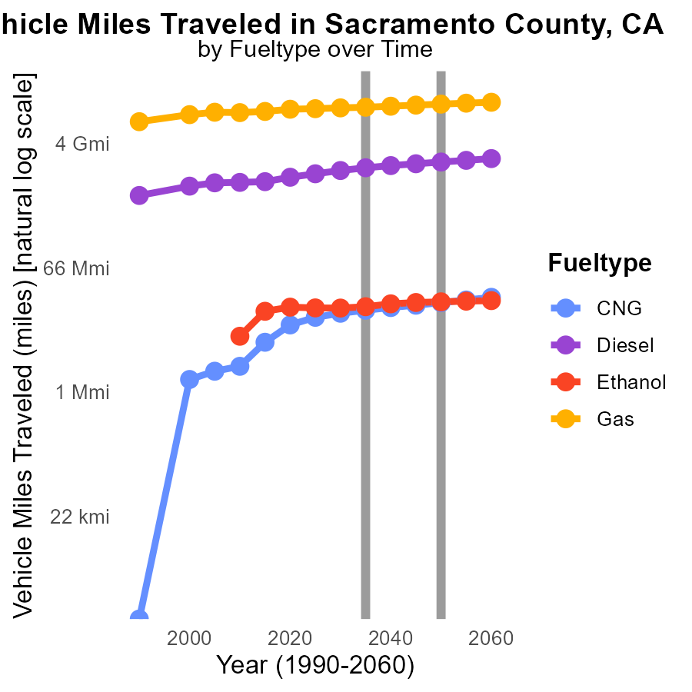

## Findings

* CNG vehicle miles traveled will increase by 47.1% from 2025 to 2045, impacting 1691796.1 fewer miles than in 2050.
* Diesel consumption will decrease by 79.7% from 2025 to 2045, reaching 108095272.3 gallons less usage than in 2050.
* Gas usage will slightly rise by 11.3% from 2025 to 2045, recording a decrease of 414100232.5 gallons compared to 2050.

## Recommendations

To reduce emissions, policies promoting a shift from diesel to CNG and ethanol should be encouraged. Incentivizing the expansion of alternative fueling infrastructure can support an increase in CNG and ethanol vehicles, contributing to lowered emissions in the transportation sector.

# Areas Ranked by Emissions

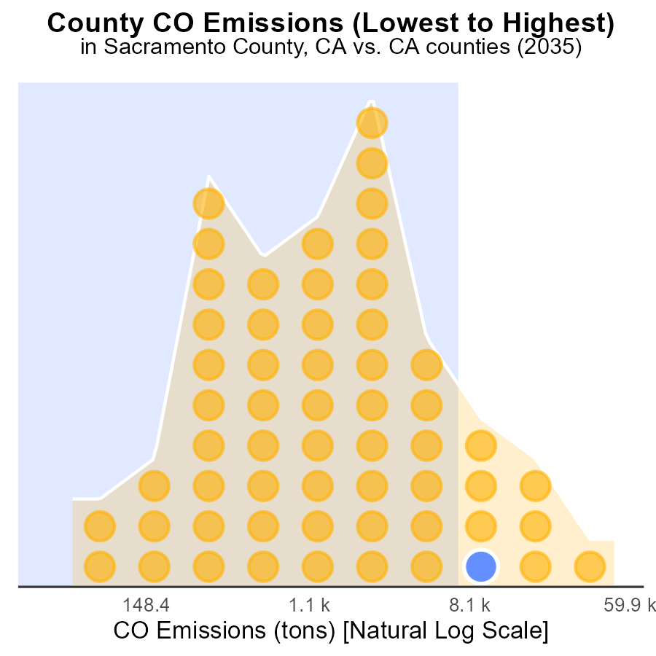

## Findings

* Los Angeles has the highest CO emissions with 138.4 k tons.
* Alpine has the lowest CO emissions with 154.9 tons, ranking 1st.
* Overall, Los Angeles emits the most CO, ranking 58th with 100.0% percentile.

## Recommendations

To lower emissions, focus on reducing transportation-related CO emissions in heavily emitting counties like Los Angeles and Sacramento. Implement stricter regulations on industries in counties like Kern and Alameda to decrease emissions.

# Areas Ranked by Hotelling (Engines Off)

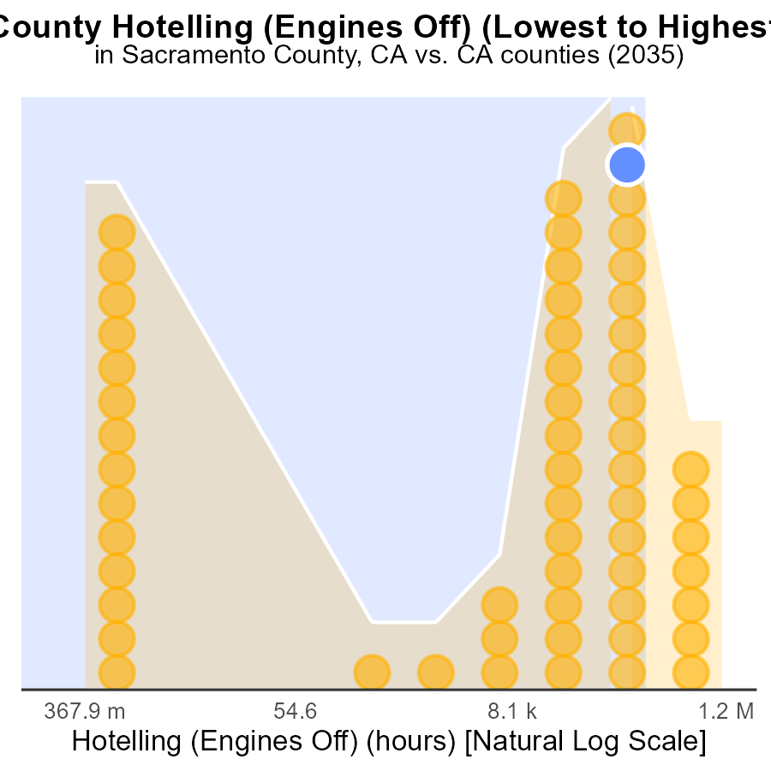

# Conclusion

In conclusion, the data from the analysis of Carbon Monoxide (CO) emissions from on-road transportation in Sacramento County, CA in 2035 reveals several key insights. The distribution of CO emissions among different vehicle types indicates a balanced impact, with gasoline being the primary contributor. While emissions have decreased over the years, they are still above the benchmark levels, suggesting the need for further reduction strategies. The consistent emissions from Hotelling (Diesel Aux) warrant a thorough review to ensure compliance with emission standards. County-specific emissions rates highlight the importance of tailored emission reduction programs, especially in high-emitting areas like Imperial County. Lastly, trends in vehicle miles traveled and fuel consumption underscore the significance of promoting alternative fuels like CNG and ethanol to lower emissions.

Moving forward, policymakers should prioritize promoting cleaner fuel alternatives, incentivizing electric vehicle adoption, and implementing stricter emission standards to achieve significant reductions in CO emissions from on-road transportation. By focusing on targeted strategies for different vehicle types and counties, in addition to encouraging a shift towards alternative fuels, Sacramento County can make significant strides towards a cleaner and more sustainable transportation sector.

# About This Report

Data based on MOVES estimates collected by the Climate Action in Transportation program at Cornell University. Demographic data sourced from the US Census's American Community Survey 5-year estimates. This report was generated with the help of AI.

# References

* U.S. Census Bureau. (2023). American Community Survey 5-year estimates: Detailed tables. Retrieved from https://data.census.gov
* U.S. Environmental Protection Agency. (2024). Motor Vehicle Emission Simulator (MOVES 4.0) [Software]. Retrieved from https://www.epa.gov/moves