 

**Carbon Emissions in Oxford County, 2035**  
Made with CAT VISUALIZER by Gao Labs @ Cornell University.

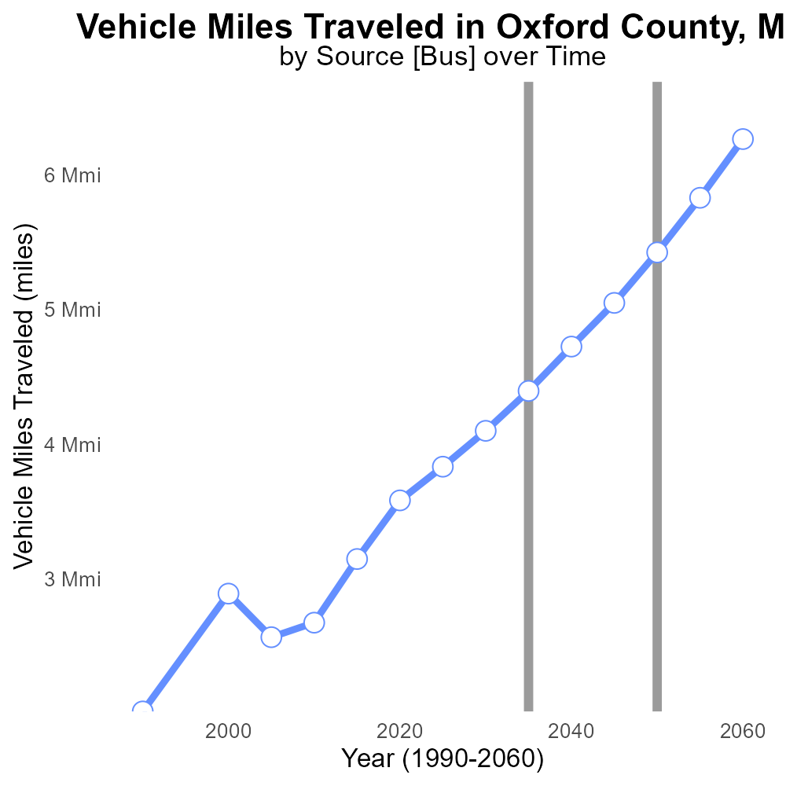

## Keywords

CO2 equivalent emissions; on-road transportation; Oxford County; Maine; 2035

## Highlights

* The report examines CO2 emissions from transportation in Oxford County, ME.
* It focuses on on-road transportation and its impact on the environment.
* Findings are based on data collected in 2035.
* The goal is to identify trends and assess the scale of the problem.
* Recommendations for mitigation strategies may be included.

# Introduction

The following report presents an analysis of CO2 equivalent emissions from on-road transportation in Oxford County, Maine, in the year 2035. With a growing concern for environmental sustainability, understanding the impact of transportation on greenhouse gas emissions is crucial for effective policy planning and decision-making. This report aims to provide insights into the trends and patterns of CO2 emissions specifically from on-road transportation within Oxford County.

By examining data collected in 2035, this report will assess the scale of the emissions, identify key contributing factors, and potentially propose mitigation strategies to reduce the carbon footprint of on-road transportation in the county. The findings are essential for stakeholders, policymakers, and the community to work towards a more sustainable and eco-friendly transportation system in Oxford County.

# Vehicle Starts by Road Type

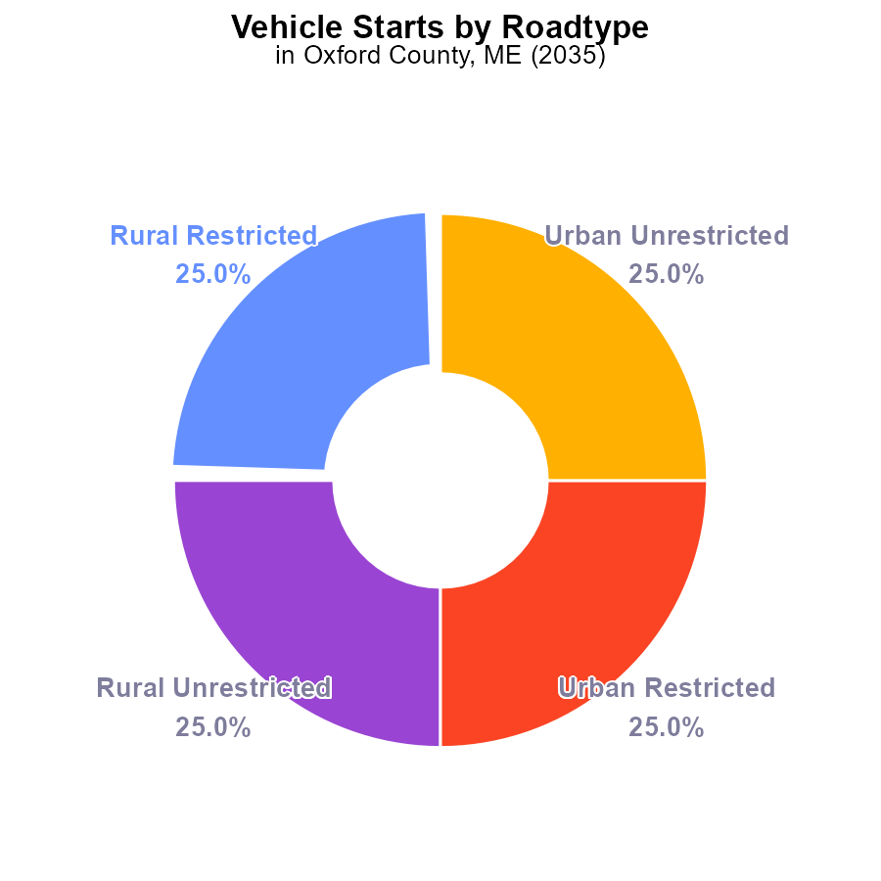

## Findings

* All types of vehicle starts in Oxford County, ME in 2035 emitted 239.2 million metric tons of CO2e.
* Rural and urban areas contributed equally to the total emissions, each accounting for 50%.
* Emission levels are consistent across different types of roads in the county.

## Recommendations

To lower emissions in Oxford County, ME, policies should focus on reducing vehicle starts through initiatives such as promoting carpooling, investing in public transportation, and incentivizing the use of electric vehicles.

# Vehicles Overall by Area

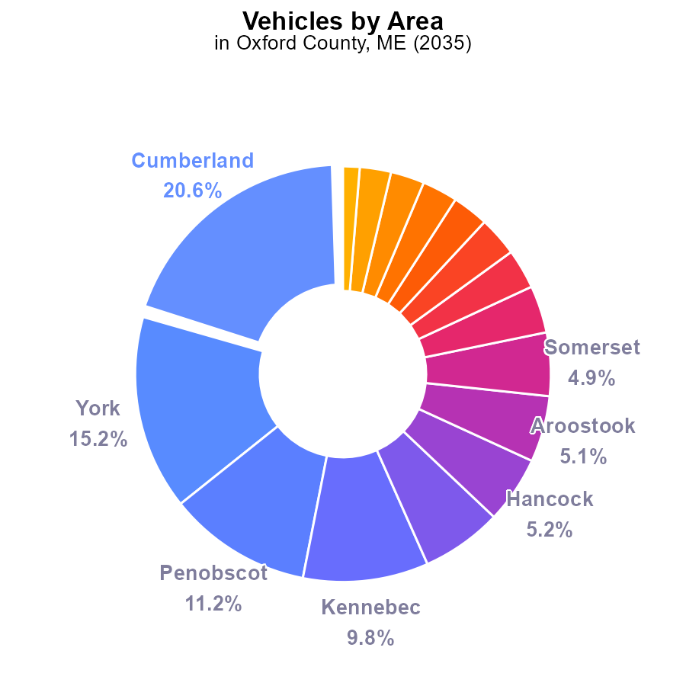

## Findings

* Cumberland emits 20.6% of CO2e from vehicles in Oxford County, ME in 2035.
* The top 4 counties (Cumberland, York, Penobscot, Kennebec) contribute to 56.8% of emissions.
* Piscataquis has the lowest contribution, at 1.3% of CO2e from vehicles.

## Recommendations

To lower emissions, focus on Cumberland, York, Penobscot, and Kennebec counties due to their significant contributions. Implement vehicle emission reduction programs, promote public transportation, and encourage the use of electric vehicles in these areas.

# Vehicle Miles Traveled over Time for Buses

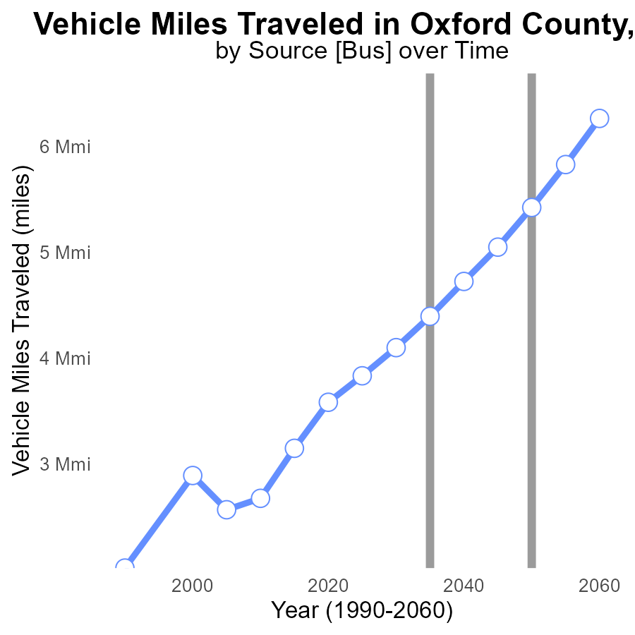

## Findings

* Vehicle miles traveled in Oxford County, ME have steadily increased from 3.1 M in 2015 to 5.8 M in 2055.
* The benchmark difference has shown a generally decreasing trend over the years, from 2274012.7 miles in 2015 to -405273.4 miles in 2055.
* There was a significant drop in benchmark difference between 2040 and 2050, with a reduction of 669985.5 miles.

## Recommendations

To lower emissions levels, policymakers should prioritize investments in public transportation systems, promote telecommuting, and incentivize the use of electric vehicles. Implementing stricter vehicle emission standards and expanding bike lanes can also help reduce miles traveled.

# Vehicles over Time for Passenger Vehicles

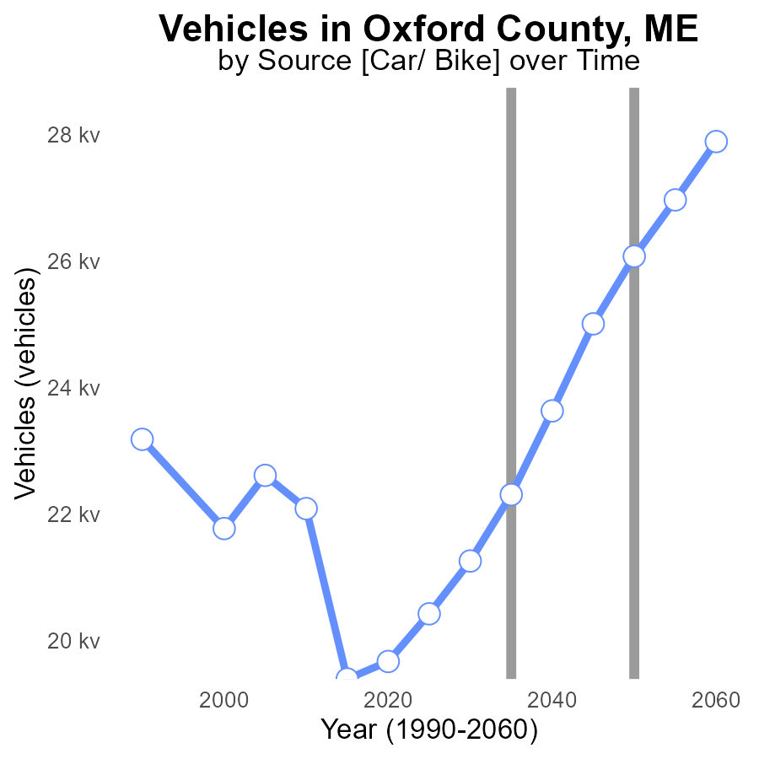

## Findings

* Emissions from vehicles in Oxford County, ME have increased steadily over the years.
* By 2050, emissions will be at 26.1k CO2e, a 1069.0 increase from 2045.
* From 2045 to 2055, there is a decrease in emissions, reaching 27.0k CO2e in 2055.

## Recommendations

To lower emissions, Oxford County should invest in public transportation, encourage carpooling, promote electric vehicles, and improve infrastructure for walking and cycling.

# Time Driven in My Region

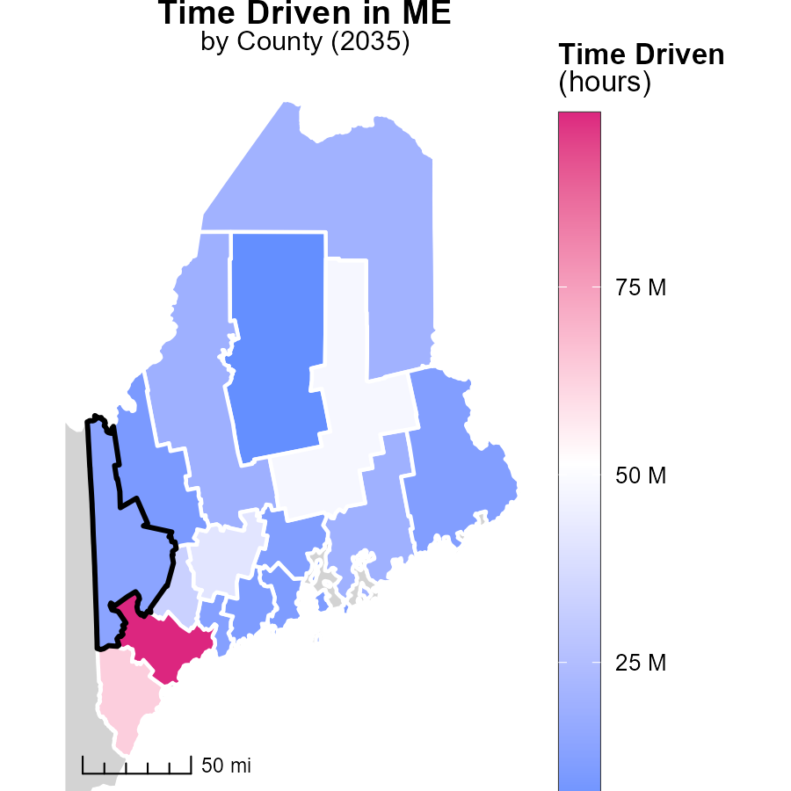

## Findings

* Cumberland County, ME has the highest emissions at 98.2 million hours.
* Somerset County, ME has median emissions with 19.2 million hours.
* Piscataquis County, ME displays the lowest emissions at 4.8 million hours.

## Recommendations

To reduce emissions in Cumberland County, focus on promoting telecommuting or flexible work hours. Somerset County could benefit from carpooling initiatives. Piscataquis County should invest in public transportation.

# Emissions Rate (per capita) Mapped by Area

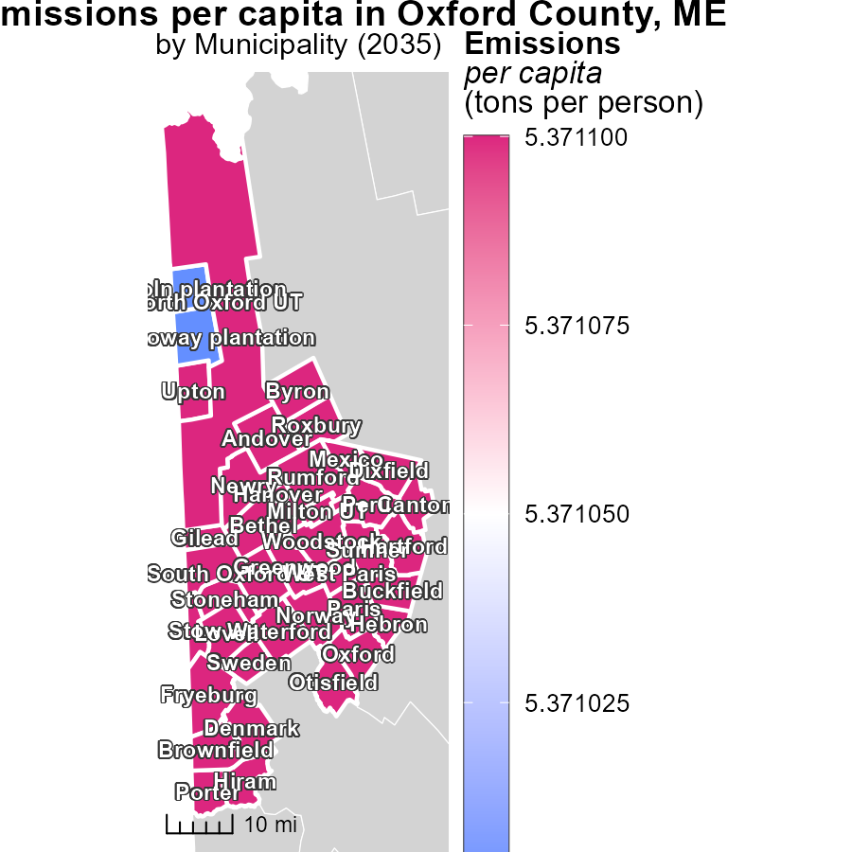

## Findings

* Emissions per capita in Andover, ME, North Oxford UT, ME, and Magalloway Plantation, ME, are 5.4 tons per person.
* This indicates that these areas have the same emissions level, with Andover, ME, being at the highest point.
* The data suggests a need for targeted emissions reduction strategies in these locations.

## Recommendations

To lower emissions in Andover, ME, North Oxford UT, ME, and Magalloway Plantation, ME, local policymakers should consider implementing initiatives aimed at reducing emissions from transportation, buildings, and waste management. Ensuring better public transportation, promoting energy-efficient buildings, and encouraging recycling and waste reduction practices can contribute to decreasing emissions in these areas.

# Vehicles by Area over Time

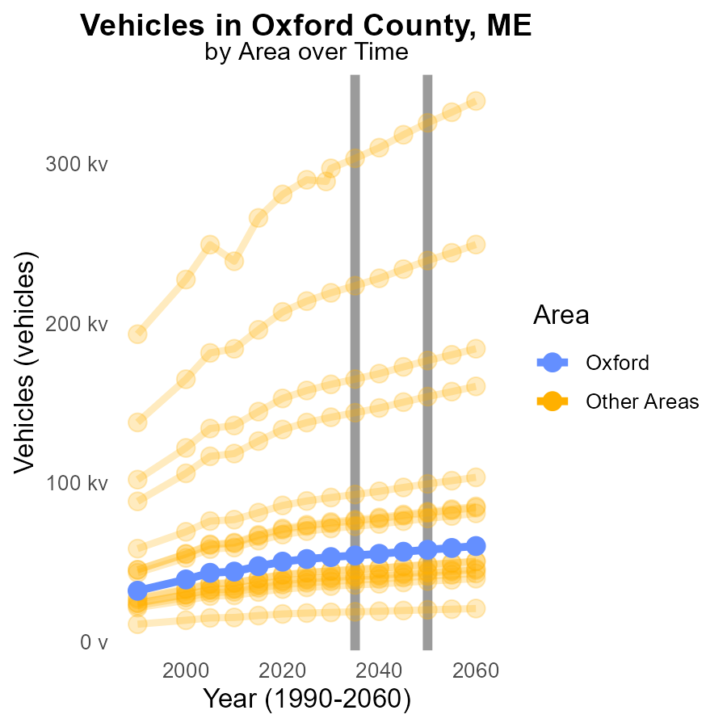

## Findings

* In 2035, maximum county emits 303.5 kilotons of CO2e from vehicles.
* Target county emits 54.3 kilotons of CO2e from vehicles in 2035.
* Minimum county emits 19.0 kilotons of CO2e from vehicles in 2035.

## Recommendations

To lower vehicle emissions, high emitting counties should implement strict emission control measures. Encouraging the adoption of electric vehicles can significantly reduce emissions in target and minimum emitting counties.

# Time Driven by Area over Time

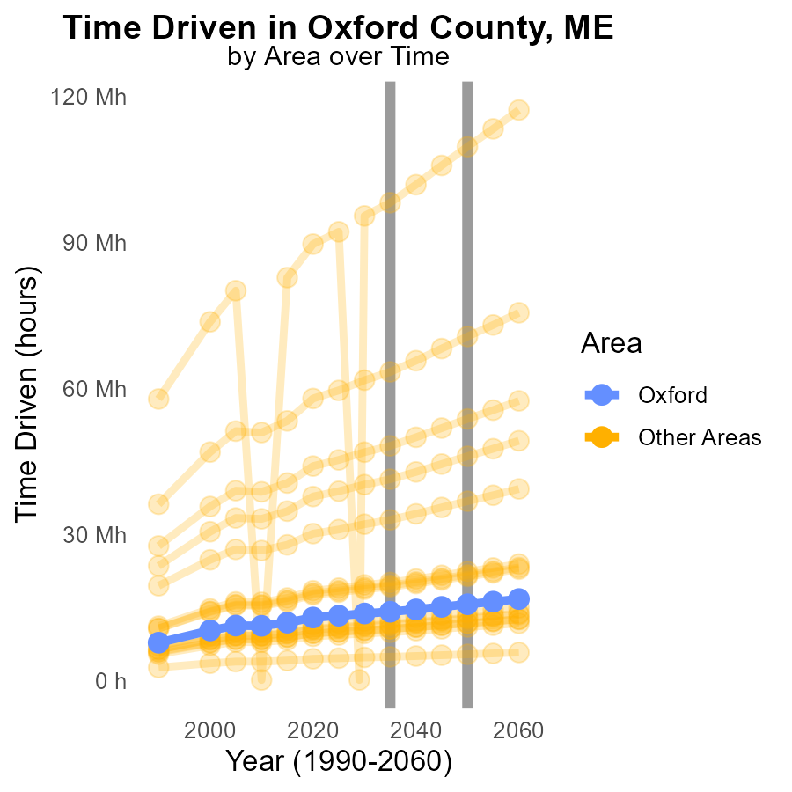

## Findings

* In 2035, the maximum emitting county had 98.2 million CO2e, 82.1% more than the target county (14.1 million) and 203.3% more than the minimum emitting county (4.8 million).

## Recommendations

Policymakers should focus on reducing emissions in the maximum emitting county to bring its levels closer to the target county and minimum emitting county, which would contribute significantly to overall emission reduction efforts.

# Areas Ranked by Vehicle Miles Traveled

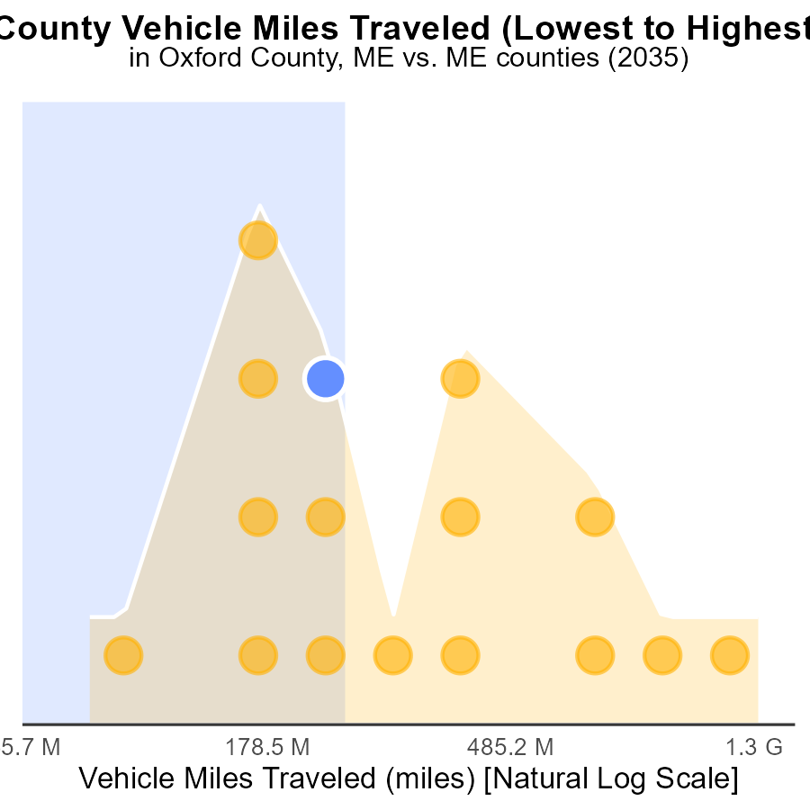

## Findings

* Cumberland county has the highest vehicle miles traveled (3.7 billion miles), ranking 16th nationally.
* Somerset county has the largest share of VMT emissions (56.2%) among the listed counties.
* Piscataquis county has the lowest VMT emissions with only 6.2% of the total.

## Recommendations

To reduce emissions, focus on initiatives in Cumberland, Somerset, and Oxford counties where the highest VMT and emissions are concentrated. Encourage the use of public transportation, carpooling, and invest in infrastructure to support cycling and walking to decrease the reliance on individual vehicles.

# Areas Ranked by Population

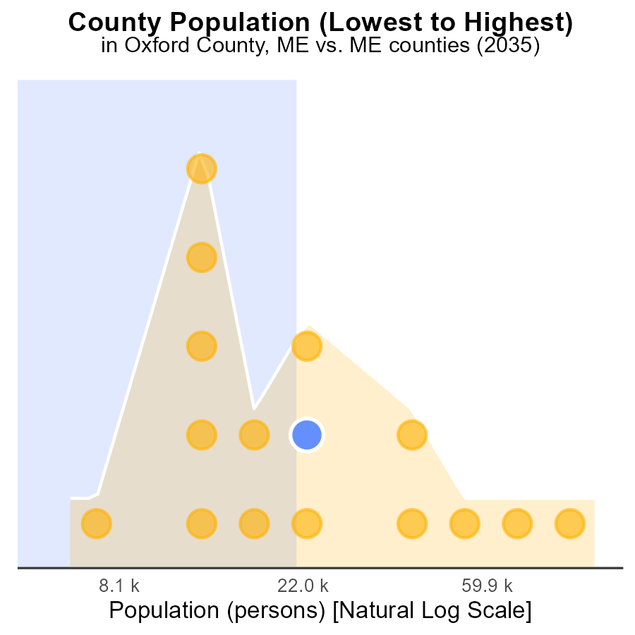

## Findings

* Cumberland county has the highest population with 294.5k people.
* Piscataquis county, although 2nd in population, contributes only 6.2% to the total emissions
* Oxford county, with a population of 57.7k, accounts for 62.5% of the total emissions.

## Recommendations

To lower emissions, focus on Oxford county due to its high emission per capita ratio. Implement green initiatives and raise awareness to reduce the impact.

# Conclusion

In conclusion, the data from the CO2 Equivalent emissions report on on-road transportation in Oxford County, ME in 2035 reveals several key insights that can guide emission reduction strategies. With a total of 239.2 million metric tons of CO2e emitted, it is evident that both rural and urban areas play an equal role in contributing to emissions. Policies should target initiatives such as promoting carpooling, investing in public transportation, and incentivizing the use of electric vehicles to effectively lower emissions levels.

Furthermore, focusing on high emitting counties like Cumberland, York, Penobscot, and Kennebec can significantly impact overall emissions reduction efforts, considering they contribute to over half of the total emissions. Implementing stricter vehicle emission standards, expanding public transportation systems, and encouraging telecommuting are essential steps towards curbing emissions. Additionally, addressing the steady increase in vehicle miles traveled over the years, along with tailoring targeted strategies for locations with high emissions per capita, will be crucial in achieving sustainable emission reduction goals.

# About This Report

Data based on MOVES estimates collected by the Climate Action in Transportation program at Cornell University. Demographic data sourced from the US Census's American Community Survey 5-year estimates. This report was generated with the help of AI.

# References

* U.S. Census Bureau. (2023). American Community Survey 5-year estimates: Detailed tables. Retrieved from https://data.census.gov
* U.S. Environmental Protection Agency. (2024). Motor Vehicle Emission Simulator (MOVES 4.0) [Software]. Retrieved from https://www.epa.gov/moves