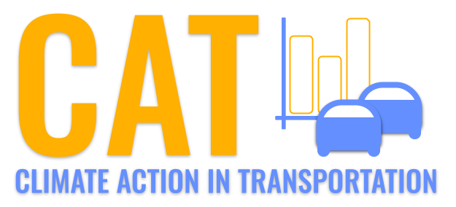 

**PM2.5 Emissions in Beaufort County, 2055**  
Made with CAT VISUALIZER by Gao Labs @ Cornell University.

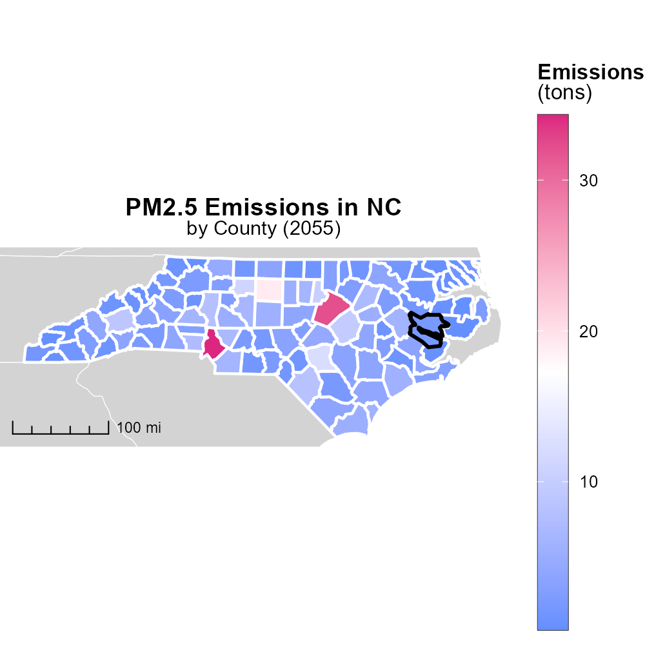

## Keywords

Primary Exhaust PM2.5; Total emissions; on-road transportation; Beaufort County; NC; 2055

## Highlights

* Study on PM2.5 from transportation emissions in Beaufort County, NC in 2055.
* Examining primary exhaust PM2.5 from on-road vehicles in the county.
* Analyzing total emissions to understand the impact on air quality.
* Potential strategies to reduce PM2.5 emissions for a cleaner environment.
* Importance of monitoring and addressing transportation-related pollution.

# Introduction

This report investigates the levels of Primary Exhaust PM2.5 emissions from on-road transportation in Beaufort County, North Carolina, specifically focusing on the year 2055. The study aims to provide a comprehensive analysis of the total emissions generated by various vehicles traversing the county's road networks.

By delving into the specifics of PM2.5 emissions, the report seeks to shed light on the environmental implications and health risks associated with transportation-related pollution. Additionally, the findings will offer insights into potential mitigation strategies and policy interventions to alleviate the impact of PM2.5 on air quality and public health in Beaufort County.

# Vehicle Starts by Regulatory Class

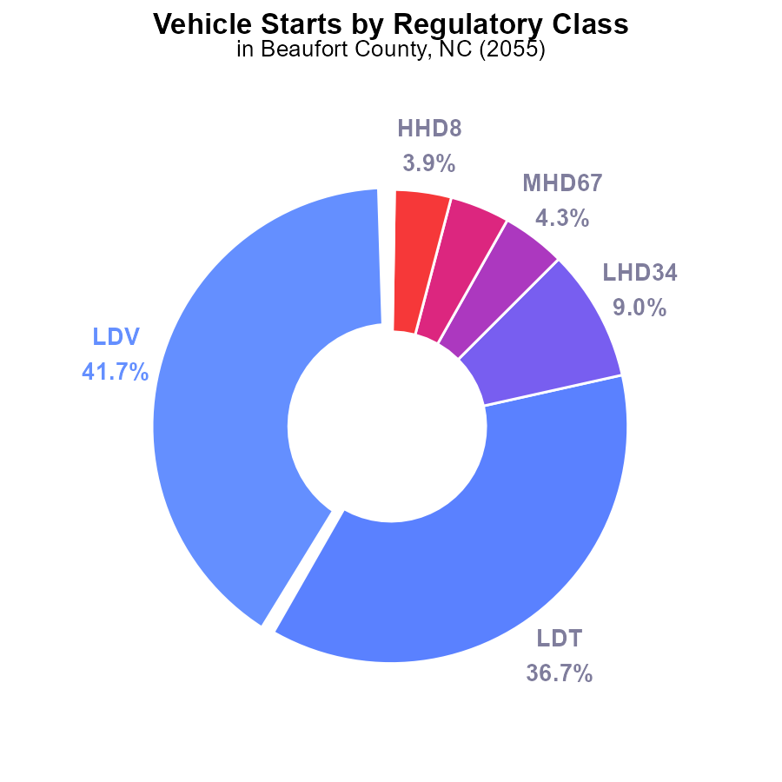

## Findings

* Light Duty Vehicles (LDV) and Light Duty Trucks (LDT) account for 78.4% of PM2.5 emissions from vehicle starts.
* Medium and Heavy Duty Trucks (LHD34, MHD67, LHD45) constitute 17.4% of emissions.
* Motorcycles (MC), Urban Buses, and Gliders collectively contribute to less than 1% of total emissions.

## Recommendations

To lower PM2.5 emissions, focus on reducing pollution from LDVs and LDTs. Implement stricter emission standards for these vehicles. Encourage the adoption of electric vehicles to decrease overall emissions.

# Hotelling (Diesel Aux) Overall by Area

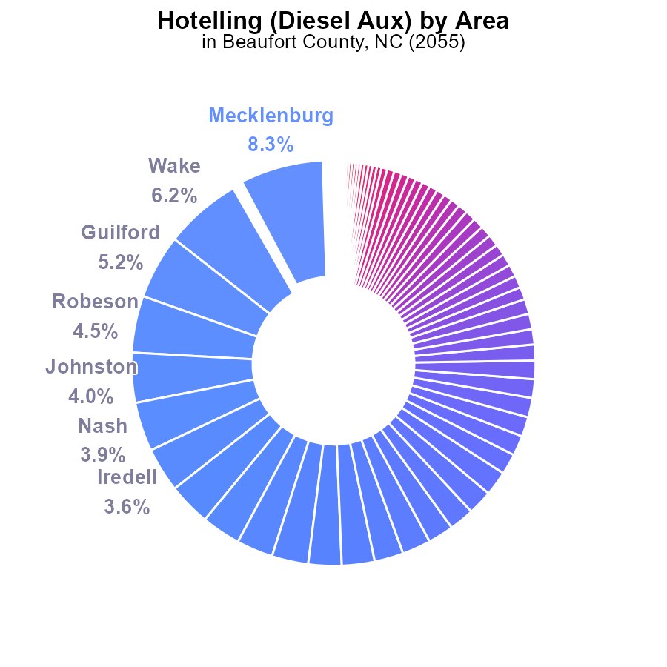

## Findings

* Top counties with highest PM2.5 emissions are Mecklenburg (8.3%), Wake (6.2%), and Guilford (5.2%).
* Combined emissions of counties with less than 1% contribution total 5.6%.
* Many counties, including Alexander, Bertie, and Martin, have negligible or no emissions.

## Recommendations

To reduce PM2.5 emissions, prioritize mitigation efforts in high-emitting counties like Mecklenburg and Wake. Implement stricter emissions regulations and promote cleaner technologies to lower overall emissions levels.

# Vehicles over Time for Buses

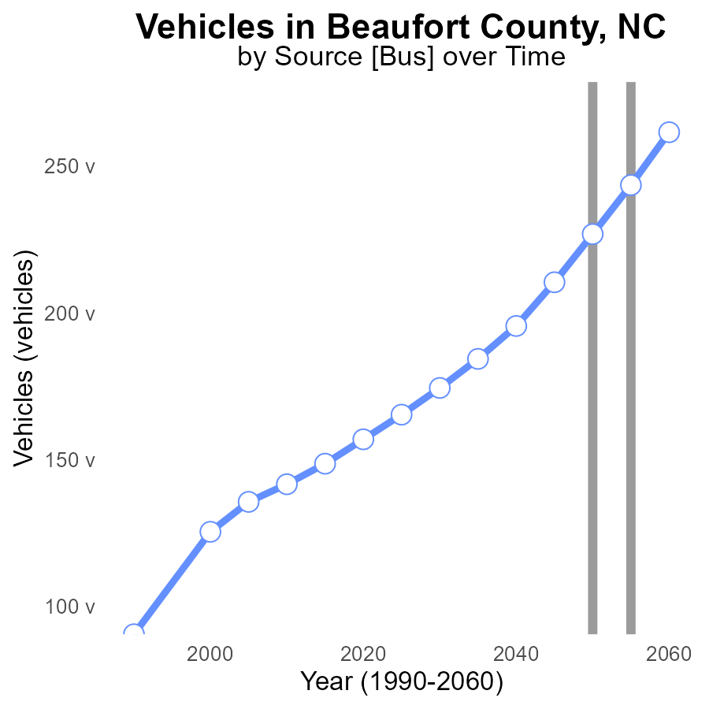

## Findings

* PM2.5 emissions from vehicles in Beaufort County are projected to decrease by 15.8% from 2035 to 2060.
* By 2050, the emissions are expected to meet the benchmark value, showing positive progress.
* The reduction in emissions after 2050 indicates successful implementation of emission reduction strategies.

## Recommendations

To further lower PM2.5 emissions, focus on sustainable transportation options like electric vehicles, promote public transportation, and invest in infrastructure to support non-motorized transportation.

# Hotelling (Engines Off) over Time for Buses

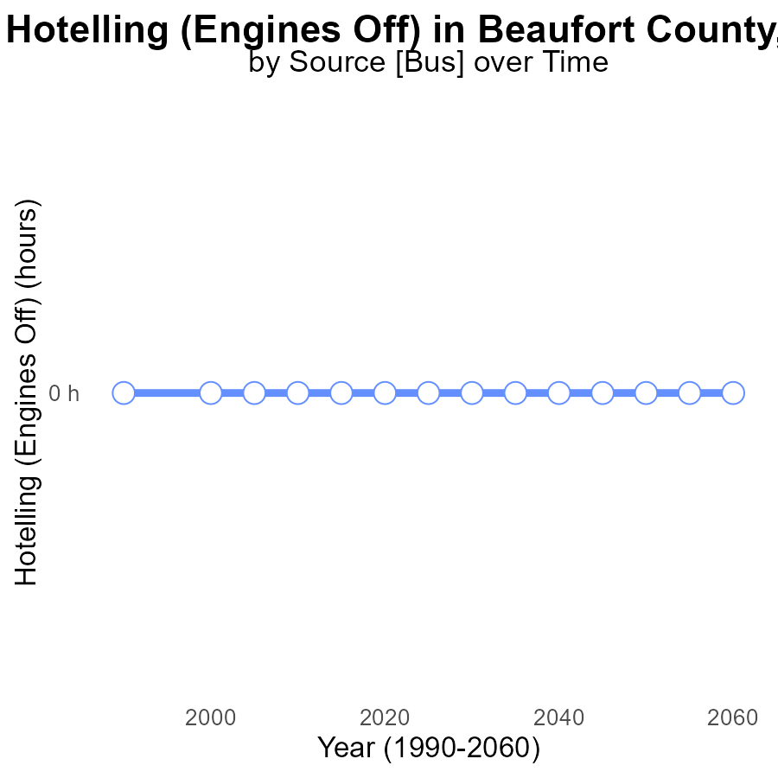

## Findings

* There has been no PM2.5 emissions from Hotelling (Engines off) in Beaufort County, NC from 2035 to 2060.

## Recommendations

Given the consistently low emissions, it is important to continue promoting and enforcing policies that encourage the use of alternative transportation methods, such as electric vehicles or public transportation, to maintain this emission-free trend.

# Emissions in My Region

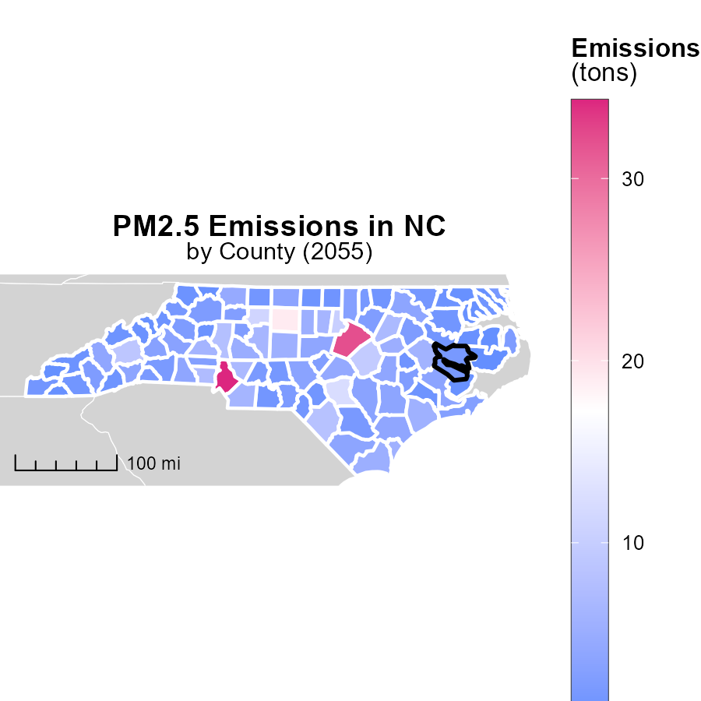

## Findings

* Mecklenburg County, NC has the highest emissions at 34.3 tons.
* Hyde County, NC has the lowest emissions at 200.0 tons.
* Lenoir County, NC's emissions stand at 2.5 tons, close to the lowest recorded.

## Recommendations

To lower emissions, focus on decreasing emissions in Mecklenburg County by implementing stricter regulations and promoting clean energy initiatives. Encourage energy-efficient practices in Hyde County to maintain low emission levels.

# Vehicles in My Region

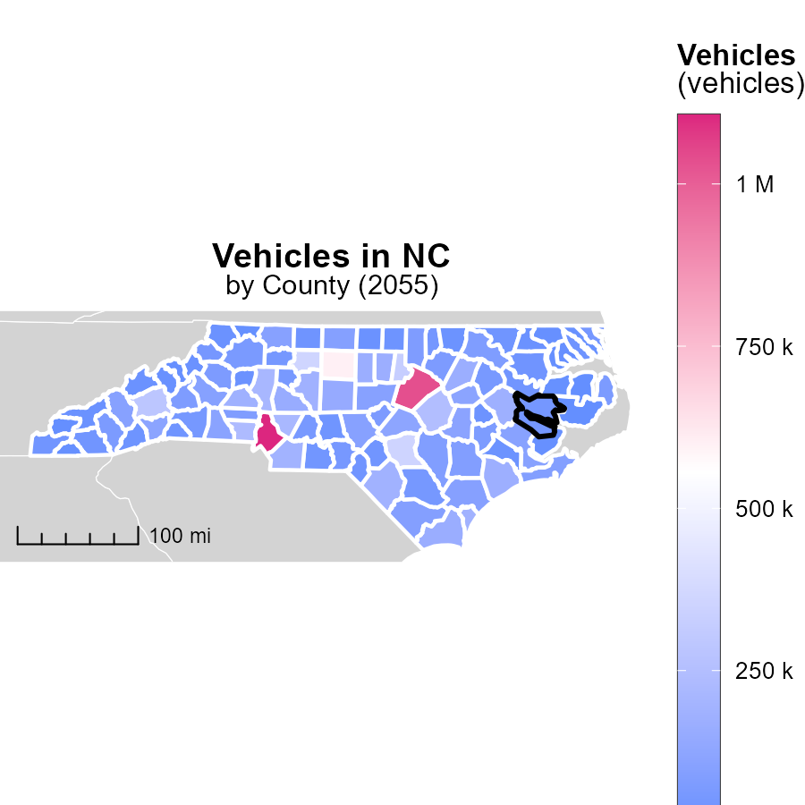

## Findings

* Mecklenburg County, NC has the highest number of vehicles emissions with 1.1 million.
* Dare County, NC has a median emission level with 70.7 thousand vehicles.
* Hyde County, NC has the lowest vehicle emissions with 7.0 thousand vehicles.

## Recommendations

To lower vehicle emissions, incentivize public transportation usage, promote carpooling, and invest in electric vehicle infrastructure in these counties based on the emission levels reported.

# Idling by Area over Time

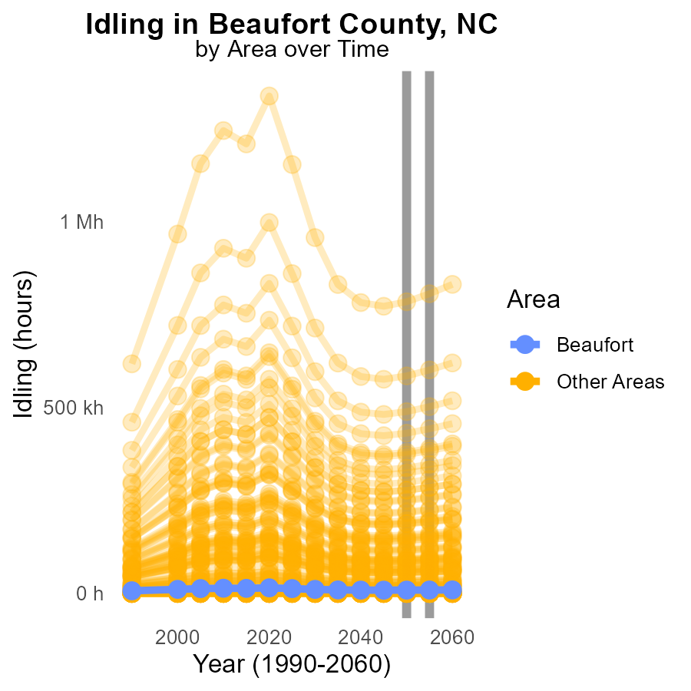

## Findings

* In 2055, target_county had 8.8 k PM2.5 emissions.
* Max_county experienced 21575.5 units decrease in PM2.5 compared to 2050.
* Min_county had consistent 0.0 PM2.5 emissions in 2055.

## Recommendations

To reduce PM2.5 emissions: implement stricter idling regulations in target_county to lower emissions by 236.6 units, continue efforts in max_county to maintain reductions, and further investigate why min_county is consistently at 0.0 emissions.

# Idling by Regulatory Class over Time

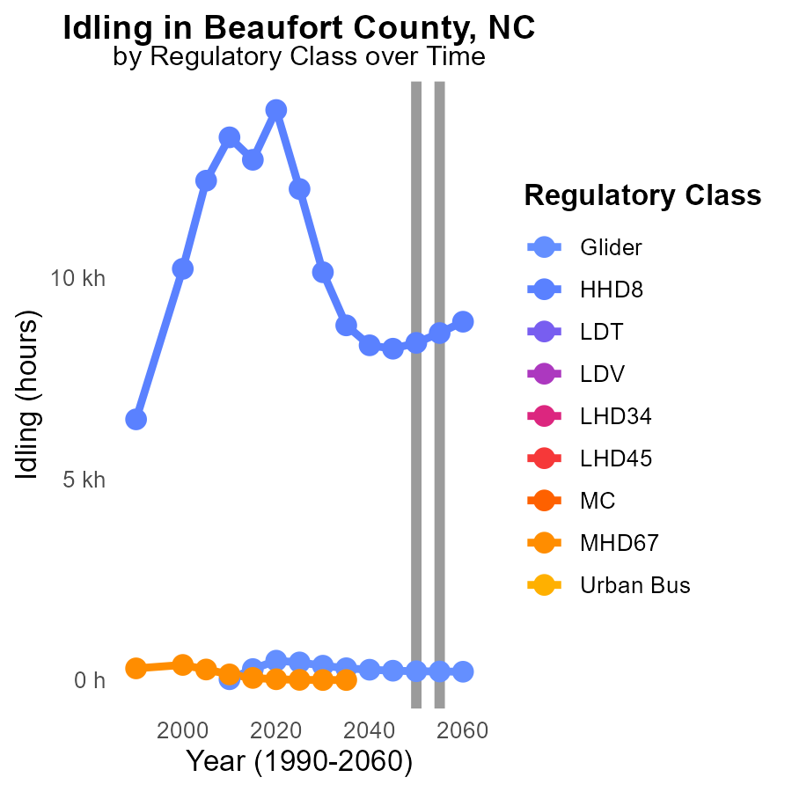

## Findings

* By 2060, Glider emissions are projected to decrease by 12.8% compared to 2050 levels.
* In contrast, HHD8 emissions are expected to increase by 525.4% by 2060 compared to 2050.
* All other vehicle types show no emission data available for the years 2045 to 2060.

## Recommendations

To mitigate the rising trend in HHD8 emissions, implementing stricter idling regulations and promoting technologies that reduce idling time could be beneficial. For Glider vehicles, continue monitoring and supporting the current emission reduction strategies to achieve further improvements.

# Areas Ranked by Population

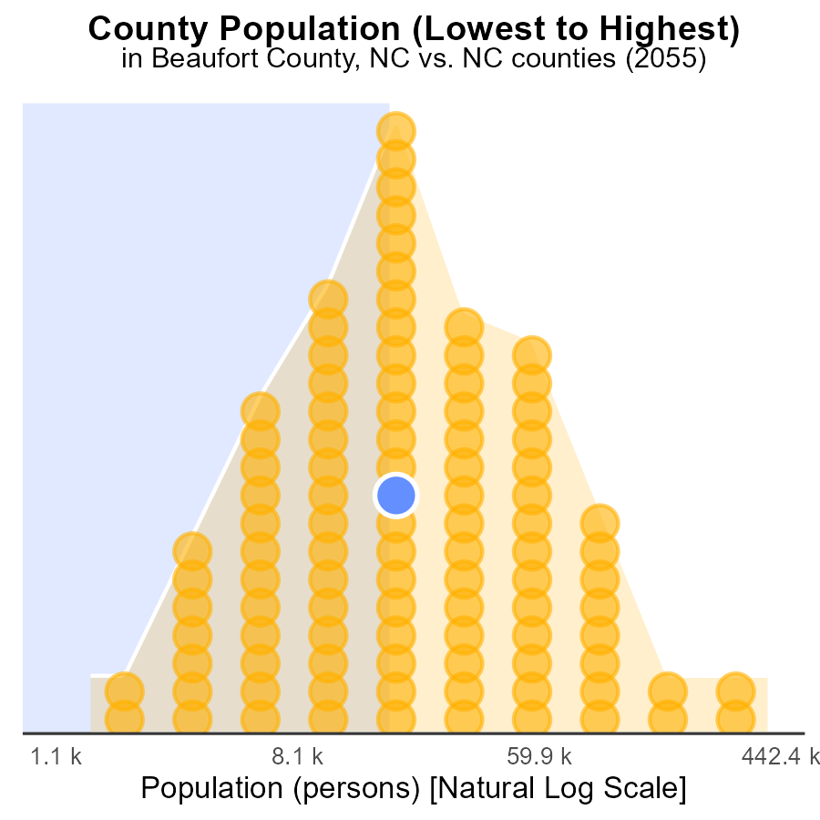

## Findings

* Beaufort County has a PM2.5 emission of 47.2 k persons, ranking 92nd nationally.
* Tyrrell County has a PM2.5 emission of 4.0 k persons, ranking 2nd nationally.
* Mecklenburg County has a PM2.5 emission of 1.1 M persons, ranking 200th nationally.

## Recommendations

To reduce PM2.5 emissions, local policymakers should focus on implementing stricter regulations on industries, promoting public transportation, and increasing the use of renewable energy sources. Specifically, measures such as promoting electric vehicles and enhancing green infrastructure can help lower emissions levels in these counties significantly.

# Areas Ranked by Emissions

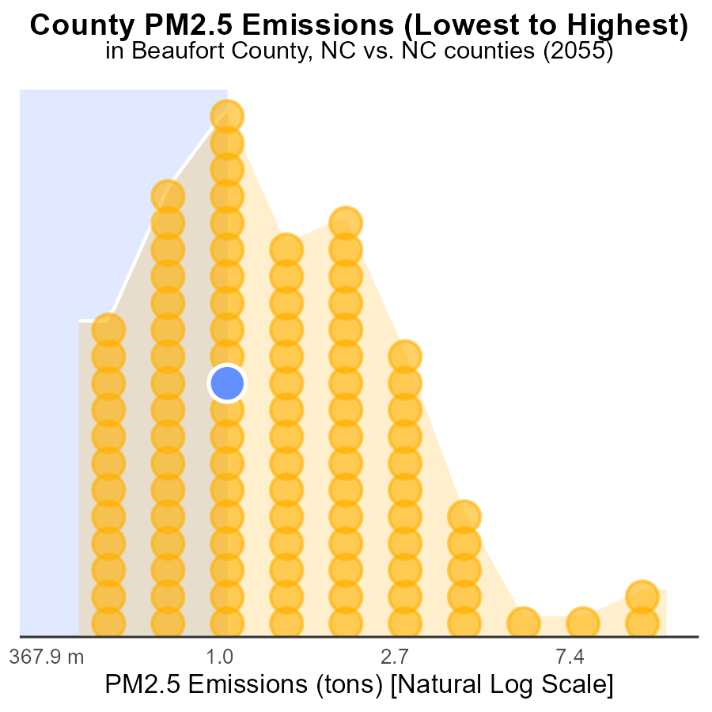

## Findings

* Highest emissions in Hyde county with 200.0 tons of PM2.5 in 2055
* Mecklenburg county ranked 100th with 34.3 tons, the highest emissions among all counties.
* Vance and Beaufort counties had the same emissions of 1.8 tons, ranking 40th and 39th, respectively.

## Recommendations

To reduce emissions, focus efforts in Hyde county to significantly lower emissions. Implement stricter regulations in Mecklenburg county to decrease high emissions. Encourage Beaufort and Vance counties to maintain their comparatively lower emission levels and potentially decrease them further.

# Conclusion

In conclusion, the data from the report on Primary Exhaust PM2.5 emissions from on-road transportation in Beaufort County, NC in 2055 highlights the importance of targeting specific vehicle types and high-emitting counties to effectively reduce pollution levels. The focus on Light Duty Vehicles (LDV) and Light Duty Trucks (LDT) as the primary contributors to PM2.5 emissions underscores the need for implementing stricter emission standards and promoting the adoption of electric vehicles to curb overall emissions. Counties with the highest emissions, such as Mecklenburg, Wake, and Guilford, require immediate attention through stringent regulations and cleaner technologies to mitigate pollution levels.

Furthermore, the projected decrease in PM2.5 emissions in Beaufort County by 15.8% from 2035 to 2060 indicates positive progress towards achieving emission reduction goals. To sustain this momentum, prioritizing sustainable transportation options like electric vehicles, public transportation, and non-motorized transport infrastructure is crucial. Additionally, the absence of PM2.5 emissions from Hotelling (Engines off) in Beaufort County signifies the success of current policies promoting alternative transportation methods. By aligning strategies to the specific needs of each county and vehicle type, significant reductions in PM2.5 emissions can be achieved across the region.

# About This Report

Data based on MOVES estimates collected by the Climate Action in Transportation program at Cornell University. Demographic data sourced from the US Census's American Community Survey 5-year estimates. This report was generated with the help of AI.

# References

* U.S. Census Bureau. (2023). American Community Survey 5-year estimates: Detailed tables. Retrieved from https://data.census.gov
* U.S. Environmental Protection Agency. (2024). Motor Vehicle Emission Simulator (MOVES 4.0) [Software]. Retrieved from https://www.epa.gov/moves