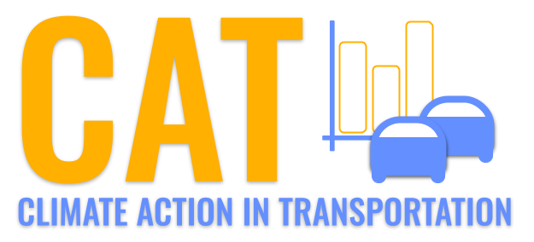 

**PM10 Emissions in Carroll County, 2005**  
Made with CAT VISUALIZER by Gao Labs @ Cornell University.

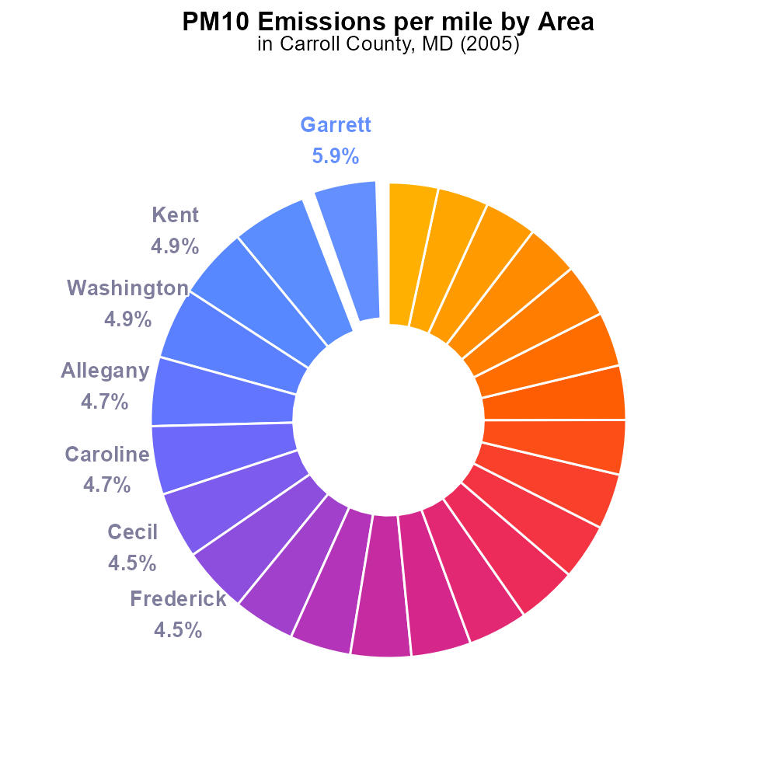

## Keywords

Primary Exhaust PM10; Total emissions; on-road transportation; Carroll County; MD; 2005

## Highlights

* Analysis of primary exhaust PM10 emissions in Carroll County, MD.
* Focus on total emissions from on-road transportation in 2005.
* Identifying key pollutants and their sources in the region.
* Assessing the environmental impact and health implications.
* Recommendations for reducing emissions and improving air quality.

# Introduction

In 2005, primary exhaust PM10 emissions from on-road transportation had a significant impact on air quality in Carroll County, MD. This report aims to analyze the total emissions of PM10 pollutants, their sources, and overall environmental implications.

The study will delve into the data collected in 2005 to provide a comprehensive understanding of the primary exhaust PM10 emissions from various vehicles and roadways in the county. Recommendations for mitigating these emissions and improving air quality will also be discussed, highlighting the importance of sustainable transportation practices.

# Emissions Rate (per mile) Overall by Area

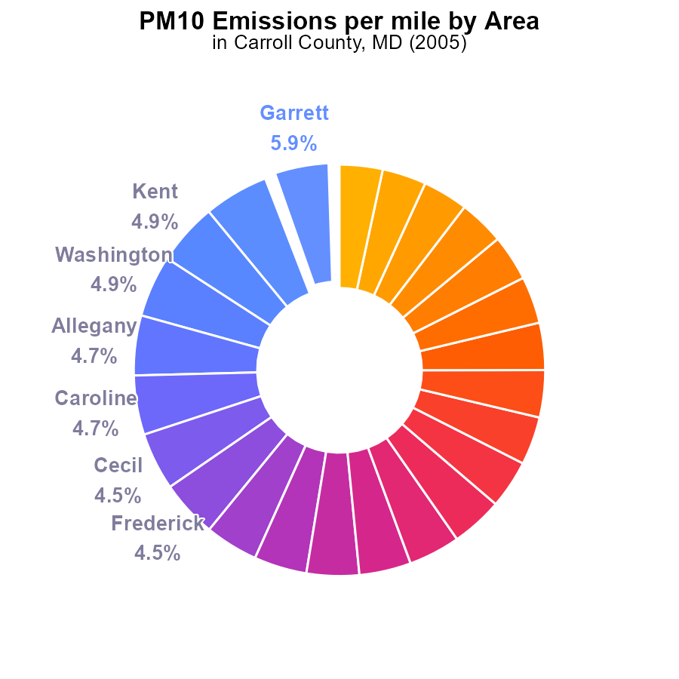

## Findings

* Garrett County has the highest PM10 emissions per mile at 138.8 tons, accounting for 5.9% of the total emissions.
* Calvert County has the lowest PM10 emissions per mile at 79.8 tons, making up 3.4% of the total emissions.
* Baltimore City, Maryland falls in the middle range, with PM10 emissions per mile at 81.6 tons, contributing 3.5% to the total emissions.

## Recommendations

To reduce PM10 emissions, focus on counties like Garrett by implementing stricter environmental regulations for industries and promoting cleaner transportation methods. Encourage local initiatives for green energy usage could also help mitigate emissions in Baltimore City.

# Emissions by Vehicle Type

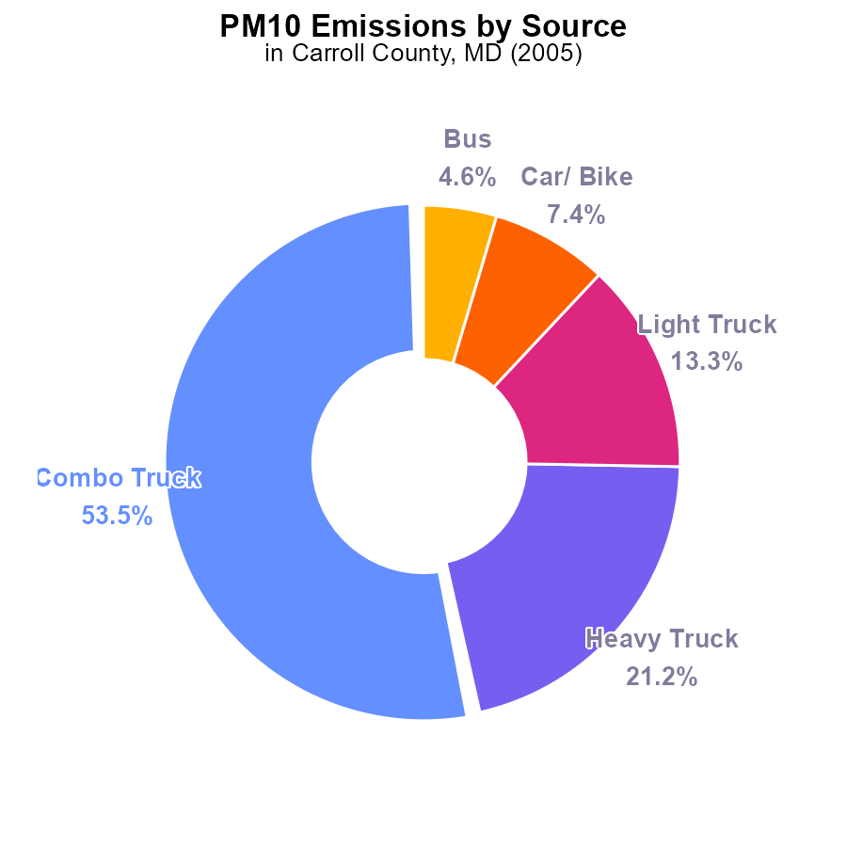

## Findings

* The majority of PM10 emissions in Carroll County, MD in 2005 came from Combo Trucks with 53.5%.
* Heavy Trucks contributed to 21.2% of the PM10 emissions.
* Light Trucks, Cars/Bikes, and Buses contributed to 13.3%, 7.4%, and 4.6% of the PM10 emissions respectively.

## Recommendations

Strategies to reduce PM10 emissions should focus on Combo Trucks as they are the largest contributors. Implementing stricter emission standards for trucks and promoting the use of cleaner fuel sources can help lower emissions significantly.

# Emissions over Time for Passenger Vehicles

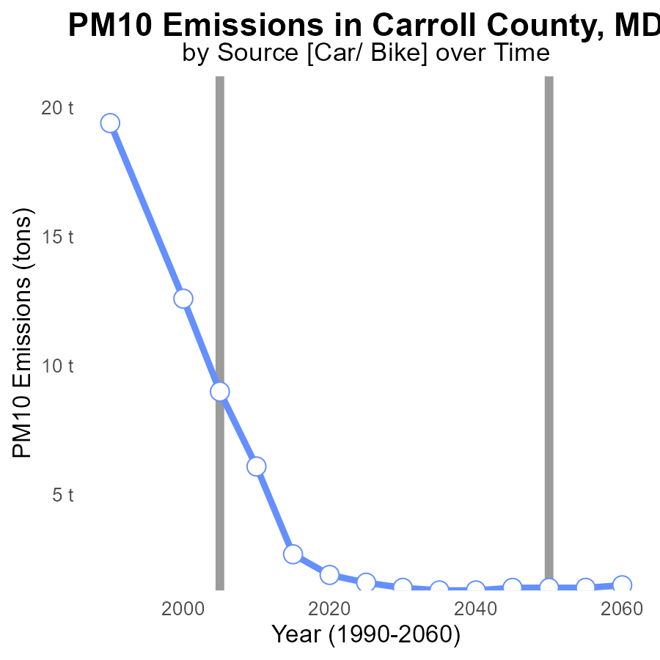

## Findings

* Emissions of PM10 in Carroll County have decreased consistently from 1990 to 2025.
* The benchmark difference shows a significant reduction, indicating progress in lowering emissions.
* The most substantial decrease occurred between 1990 and 2000, with a 35.6% reduction.

## Recommendations

Continued efforts should focus on adopting cleaner technologies and promoting sustainable practices to further reduce PM10 emissions. Implement stricter regulations and incentivize the use of clean energy sources.

# Vehicle Miles Traveled over Time for Passenger Vehicles

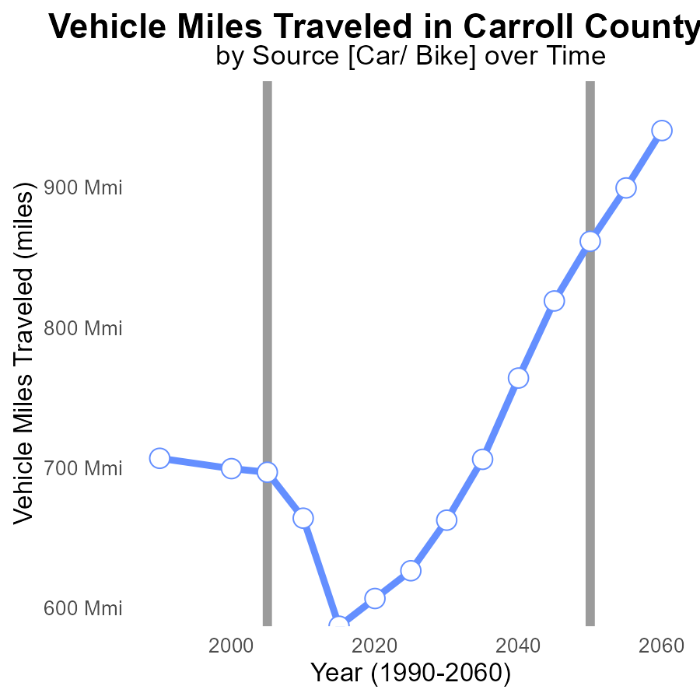

## Findings

* Between 1990 and 2025, vehicle miles traveled increased by 77.7 million miles in Carroll County, MD.
* The benchmark difference has been decreasing over the years, suggesting a more efficient use of vehicles.
* A notable decrease in vehicle miles traveled was observed between 2010 and 2015, amounting to a reduction of 77.1 million miles.

## Recommendations

To further reduce emissions, encourage the use of public transportation, carpooling, and telecommuting. Implement policies to promote electric vehicles and biking/walking to decrease reliance on personal vehicles.

# Hotelling (Diesel Aux) in My Region

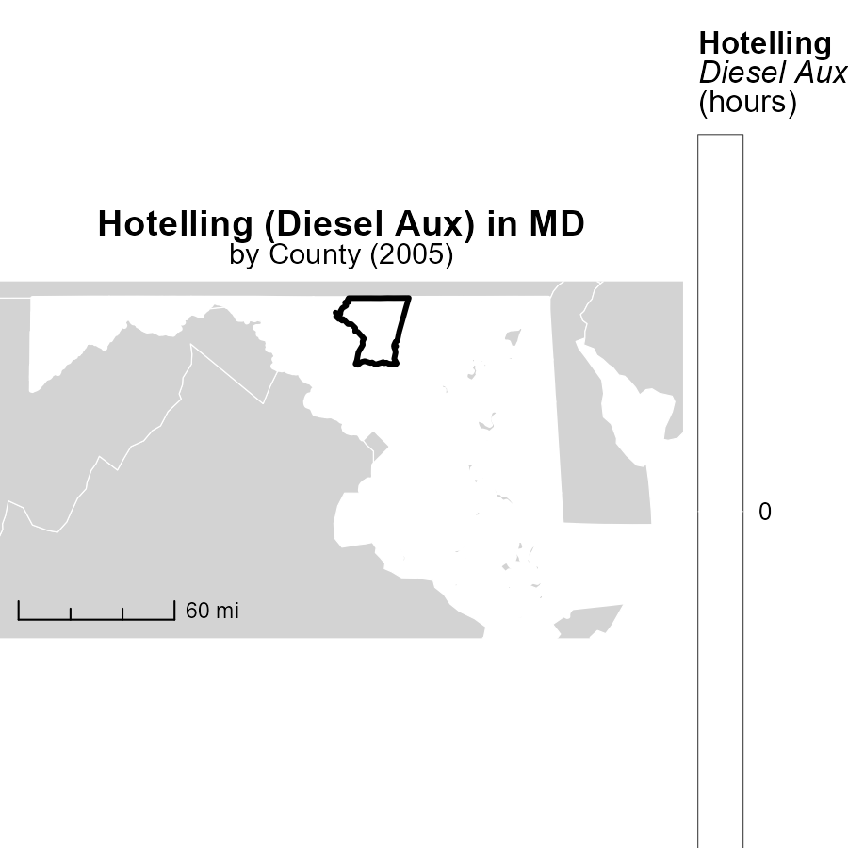

## Findings

* In 2005, Allegany County, MD had the highest raw emissions from Hotelling (Diesel Aux) at 0.0 hours.
* Harford County, MD recorded a median value of 0.0 hours for Hotelling (Diesel Aux) emissions in 2005.
* Baltimore City, Maryland County, MD showed the lowest emissions among the areas listed, with 0.0 hours in 2005.

## Recommendations

To lower emissions from Hotelling (Diesel Aux), policymakers should focus on implementing stricter regulations, promoting cleaner alternative technologies, and investing in public transportation infrastructure.

# Idling in My Region

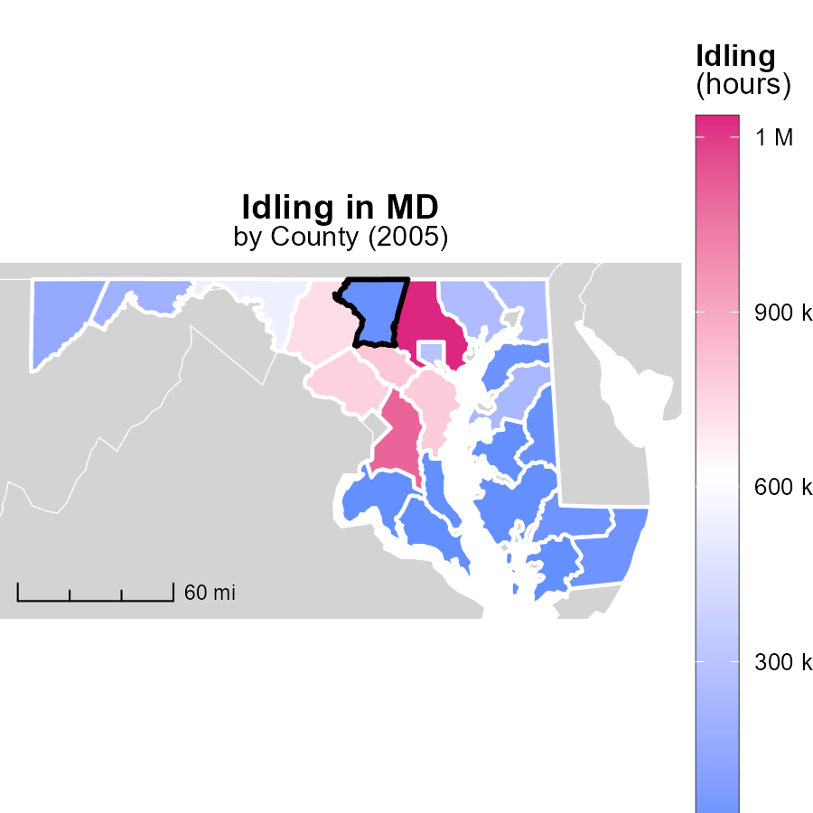

## Findings

* In 2005, Baltimore County, MD had the highest idling hours at 1.2 million.
* Allegany County, MD had a median of 198.6 thousand idling hours in 2005.
* Talbot County, MD had the lowest idling hours in 2005, with zero recorded.

## Recommendations

To lower emissions from idling vehicles, Baltimore County should implement idling reduction programs. Allegany County could explore incentives for reduced idling, and Talbot County should continue efforts to maintain zero idling hours.

# Idling by Fuel Type over Time

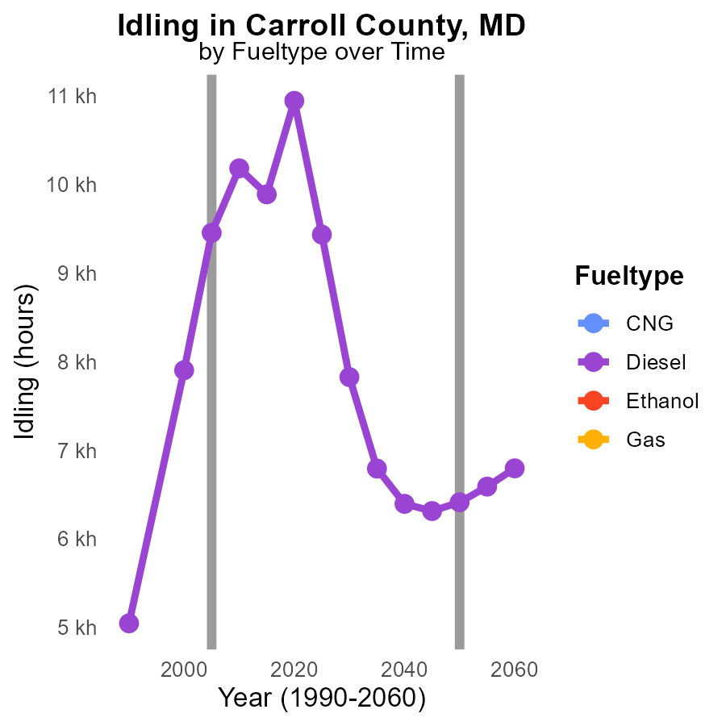

## Findings

* PM10 emissions from idling vehicles in Carroll County decreased by 37.5% from 2000 to 2015.
* Diesel vehicles contributed the most to PM10 emissions, with a decrease of 44.0% from 2000 to 2015.
* Despite the decrease in diesel emissions, there was a significant difference of 3471.8 tons from the target set for 2050.

## Recommendations

To further reduce emissions, policies should focus on transitioning diesel vehicles to cleaner fuel types like CNG or Ethanol. Implement stricter idling regulations and promote the usage of electric vehicles.

# Hotelling (Engines Off) by Area over Time

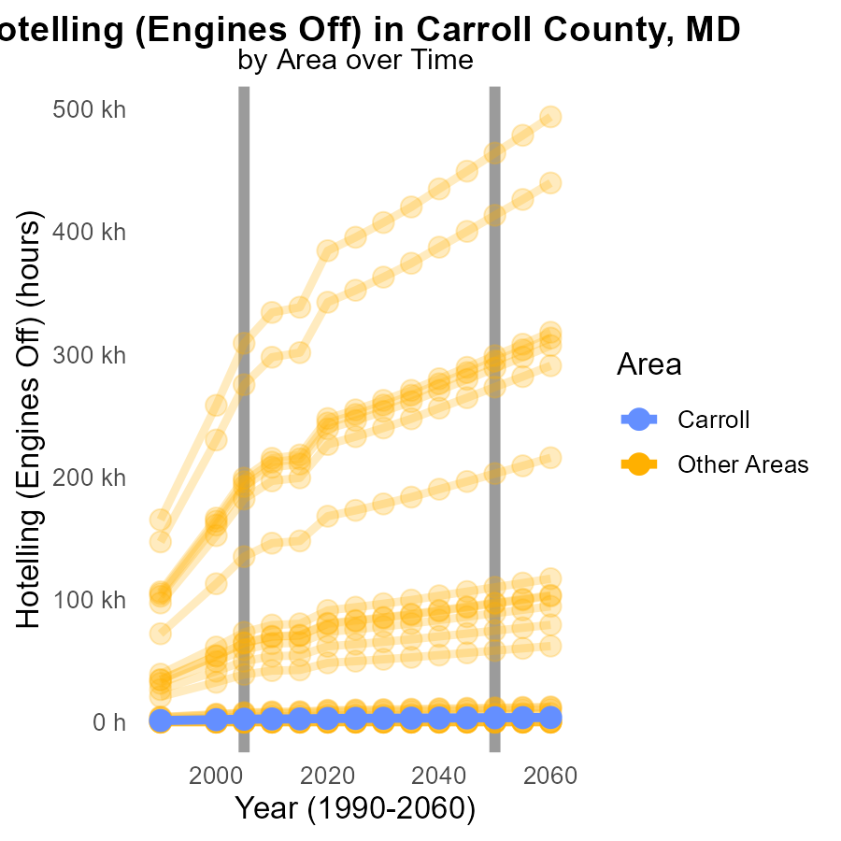

## Findings

* In 2005, max_county emitted 309.0 k units of PM10 emissions.
* In 2005, target_county emitted 2.4 k units of PM10 emissions.
* The difference in PM10 emissions between 2005 and the target year 2050 is 155121.1 for max_county.

## Recommendations

To lower PM10 emissions, max_county should implement stricter regulations on vehicle emissions and promote the use of cleaner transport options such as electric vehicles. For target_county, investing in renewable energy sources and enhancing air quality monitoring systems can help reduce emissions further.

# Areas Ranked by Emissions Rate (per capita)

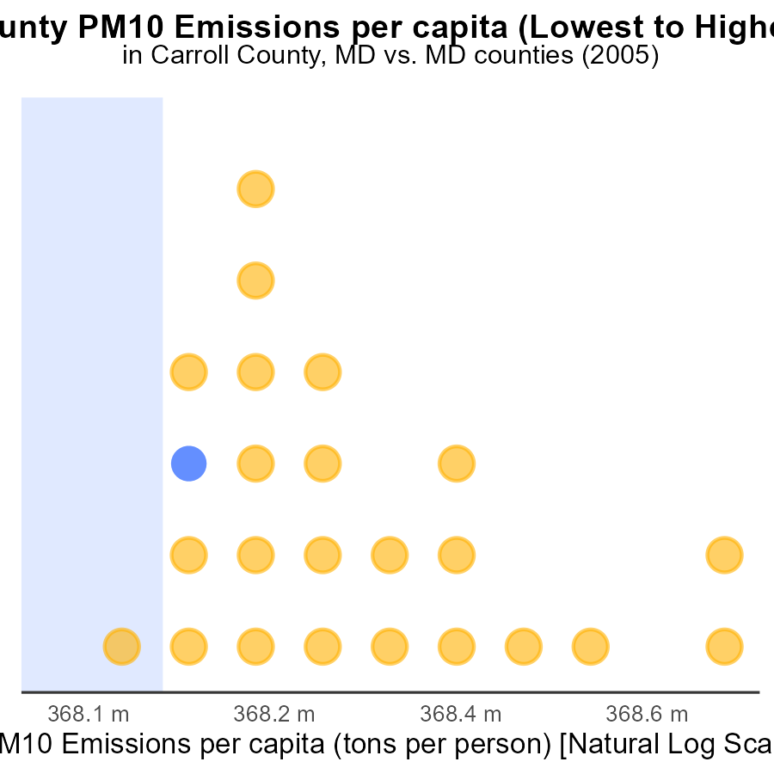

## Findings

* Queen Anne's county had the highest PM10 emissions per capita in 2005, at 2.3 tons per person.
* Baltimore city, Maryland ranked 1st with PM10 emissions per capita of 459.1 µ tons per person.
* Charles county had the highest percentile of PM10 emissions per capita at 20.8% in 2005.

## Recommendations

To reduce emissions, policies could include investing in cleaner transportation options, promoting energy-efficient practices, and enforcing stricter regulations on industrial emissions.

# Areas Ranked by Population

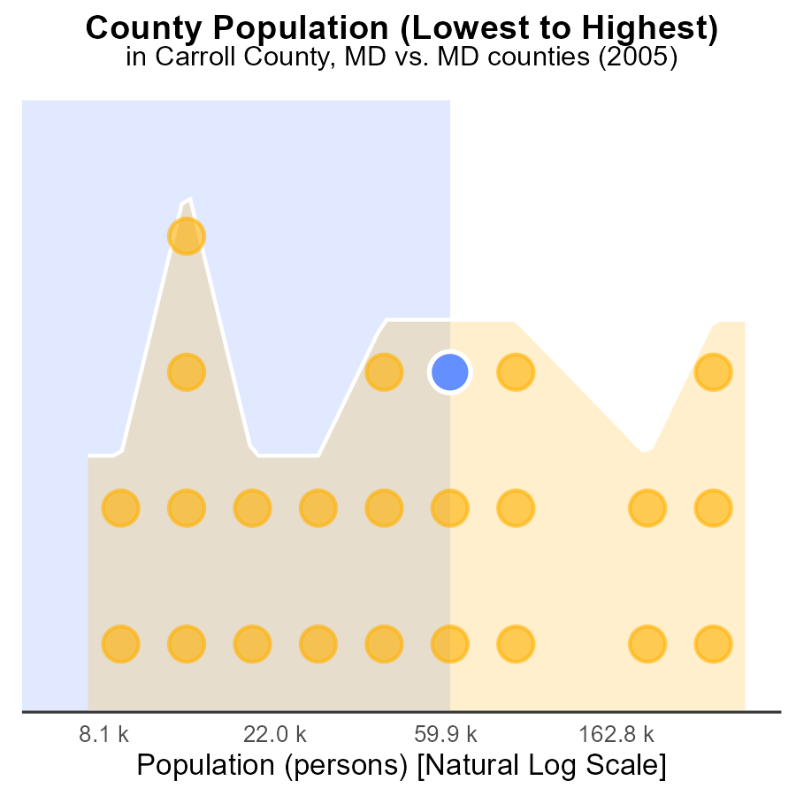

## Findings

* In 2005, Montgomery had the highest population with 947.2k individuals.
* Carroll had 167.2k population, ranking 32nd, and contributing 66.7% of PM10 emissions.
* Kent, with a population of 20.0k and ranking 2nd, contributed 4.2% of PM10 emissions.

## Recommendations

To reduce PM10 emissions, focus on Montgomery due to its large population contribution. Implement strict emission control measures in Carroll and Kent to lower their percentage contributions.

# Conclusion

In conclusion, the data on PM10 emissions from on-road transportation in Carroll County, MD in 2005 reveals valuable insights for emission reduction strategies. The analysis indicates that Combo Trucks are the primary contributors to PM10 emissions in the county, emphasizing the need for stringent regulations and cleaner fuel sources for these vehicles. Significant progress has been made in decreasing PM10 emissions from 1990 to 2025, showcasing the effectiveness of ongoing efforts.

To further mitigate PM10 emissions, the county should continue to promote sustainable transportation methods such as public transportation, carpooling, and telecommuting. Transitioning diesel vehicles to cleaner alternatives like CNG or Ethanol, implementing stricter idling regulations, and incentivizing the use of electric vehicles are crucial steps towards achieving emission reduction targets. Additionally, focusing efforts on counties with high emissions per mile like Garrett, and encouraging the adoption of greener practices in industrial sectors will play a vital role in enhancing air quality and reducing environmental impact in Carroll County, MD.

# About This Report

Data based on MOVES estimates collected by the Climate Action in Transportation program at Cornell University. Demographic data sourced from the US Census's American Community Survey 5-year estimates. This report was generated with the help of AI.

# References

* U.S. Census Bureau. (2023). American Community Survey 5-year estimates: Detailed tables. Retrieved from https://data.census.gov
* U.S. Environmental Protection Agency. (2024). Motor Vehicle Emission Simulator (MOVES 4.0) [Software]. Retrieved from https://www.epa.gov/moves