 

**SO2 Emissions in Crook County, 2010**  
Made with CAT VISUALIZER by Gao Labs @ Cornell University.

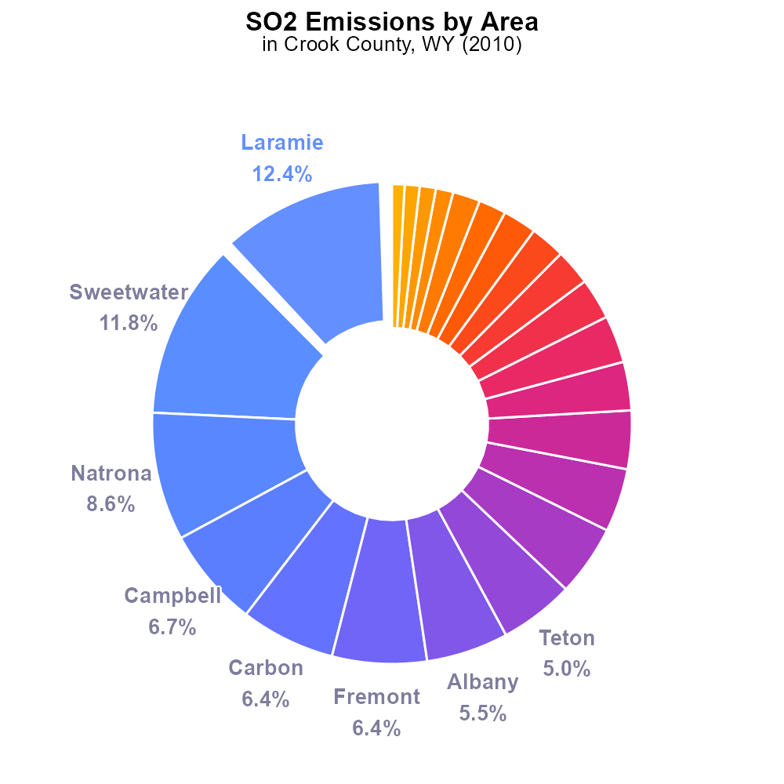

## Keywords

Sulfur Dioxides; on-road transportation; Crook County; Wyoming; emissions; 2010

## Highlights

* SO2 emissions from on-road in Crook County, WY in 2010.
* Examining the impact of transportation on air quality.
* Analysis of sulfur dioxide levels and sources in the region.
* Implications for public health and environmental policy.
* Understanding the need for emission reduction strategies.

# Introduction

The report investigates the sulfur dioxide (SO2) emissions stemming from on-road transportation in Crook County, Wyoming, during the year 2010. With a focus on air quality and environmental impact, this study delves into the specific sources and levels of SO2 in the region.

By analyzing the data collected, this report aims to provide insights into the implications of transportation-related sulfur dioxide emissions on public health and the environment. Additionally, the findings of this study can inform policymakers and stakeholders about the necessity of implementing effective strategies to reduce emissions and mitigate the associated risks.

# Emissions Overall by Area

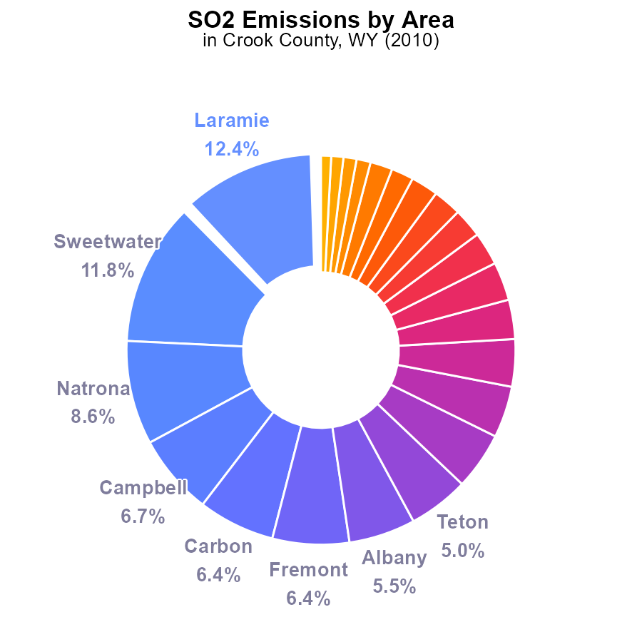

## Findings

* Laramie and Sweetwater counties are the largest contributors to SO2 emissions in Crook County, each accounting for over 11%.
* The top 5 counties collectively contribute approximately 35% of the total SO2 emissions in the region.
* Counties with lower emissions, such as Hot Springs and Washakie, still play a role, each contributing less than 1.0% of the total.

## Recommendations

To lower SO2 emissions, focus on decreasing output in top-emitting counties like Laramie and Sweetwater. Implement targeted emission reduction strategies in these areas. Additionally, encourage counties with relatively lower emissions, such as Hot Springs and Washakie, to maintain their current low levels.

# Emissions Rate (per mile) by Vehicle Type

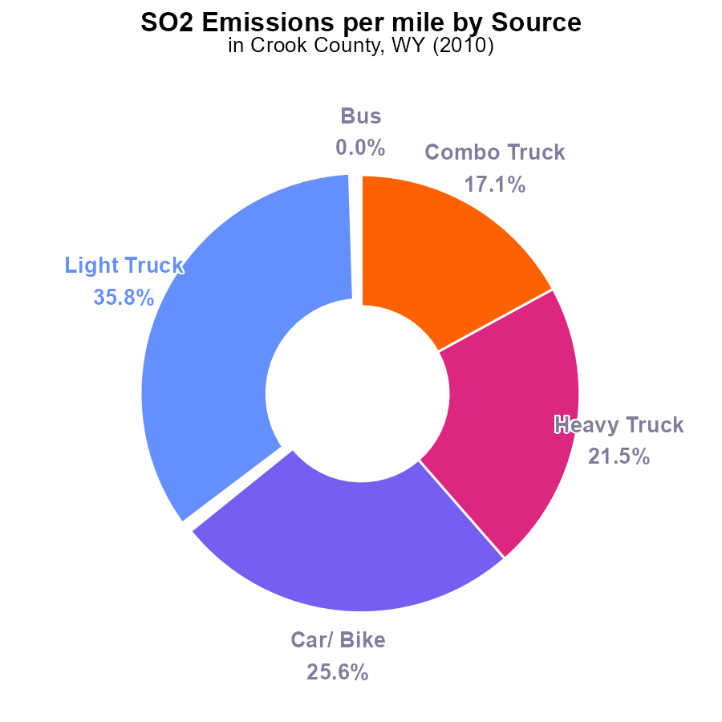

## Findings

* In 2010, Crook County, WY emitted a total of 43.9 tons of SO2 per mile.
* The majority of SO2 emissions per mile came from light trucks at 35.8%, followed by cars/bikes at 25.6%.
* Buses did not contribute to SO2 emissions in 2010 in Crook County, WY.

## Recommendations

To lower SO2 emissions in Crook County, WY, focus on reducing emissions from light trucks and cars/bikes by incentivizing the use of cleaner fuels or electric vehicles in these categories. Implement stricter emission standards for these vehicles to reduce overall emissions.

# Vehicle Starts over Time for Passenger Vehicle Starts

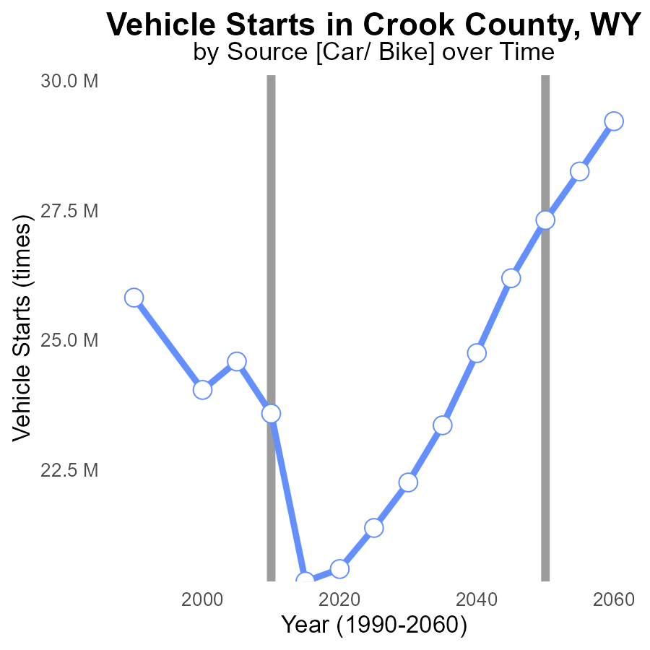

## Findings

* SO2 emissions in Crook County, WY have decreased by 21% from 1990 to 2030.
* Vehicle starts decreased by 20% in the same period.
* The difference from the benchmark has fluctuated but increased by 238% from 1990 to 2030.

## Recommendations

To further reduce SO2 emissions, policymakers could incentivize the use of electric vehicles, improve public transportation infrastructure, and enforce stricter emission standards for vehicles in Crook County, WY.

# Population over Time for Buses

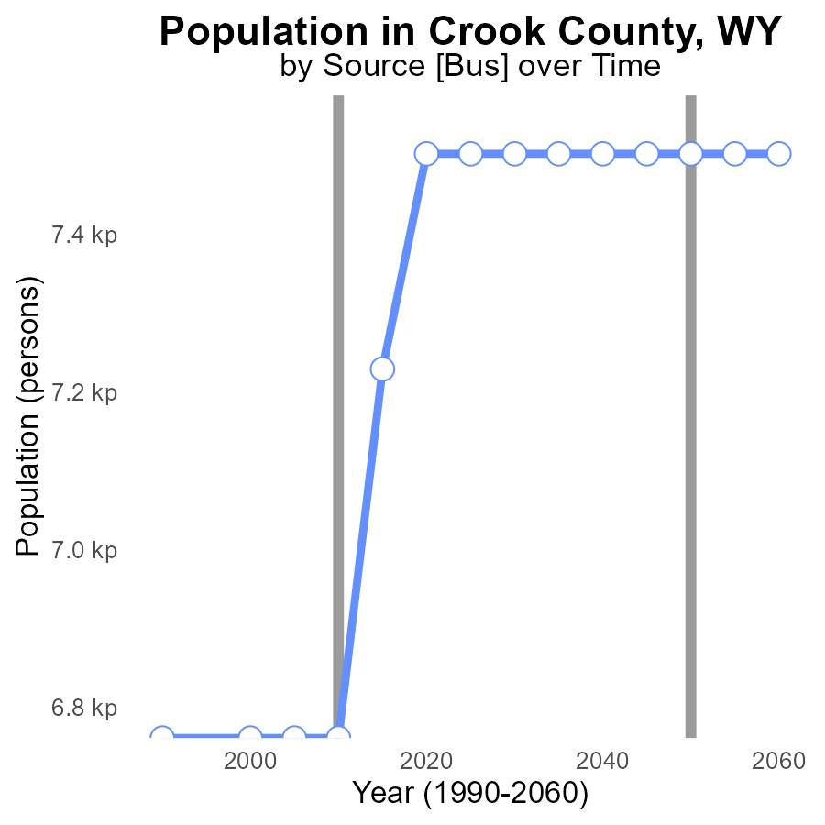

## Findings

* Between 2015 and 2020, the population in Crook County increased by 4.2%.
* Sulfur dioxide (SO2) emissions remained constant at 6.8 k persons from 1990 to 2010.
* By 2030, SO2 emissions are projected to stay constant at 7.5 k persons, indicating no reduction.

## Recommendations

To reduce SO2 emissions despite population growth, consider implementing stricter emission control measures on industrial sources. Encourage the adoption of cleaner technologies and renewable energy sources.

# Hotelling (Engines Off) Mapped by Area

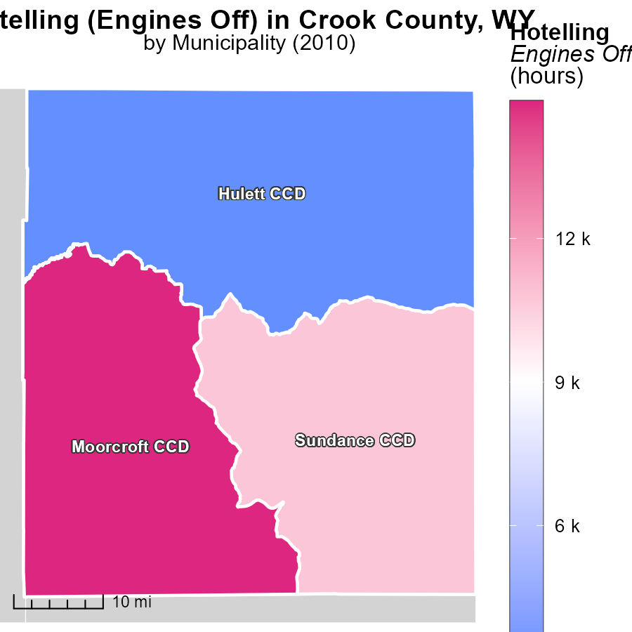

## Findings

* In 2010, Moorcroft CCD, WY had the highest emissions with 14.9k hours.
* Sundance CCD, WY emitted a median of 10.8k hours during the year.
* Hulett CCD, WY had the lowest emissions in 2010, with 3.2k hours.

## Recommendations

Efforts should focus on reducing engine idling time in high-emission areas like Moorcroft CCD. Implementing policies to promote engine shutdown can help lower emissions. Providing incentives for adopting cleaner technologies in Sundance and Hulett CCDs could further reduce overall emissions.

# Hotelling (Diesel Aux) Mapped by Area

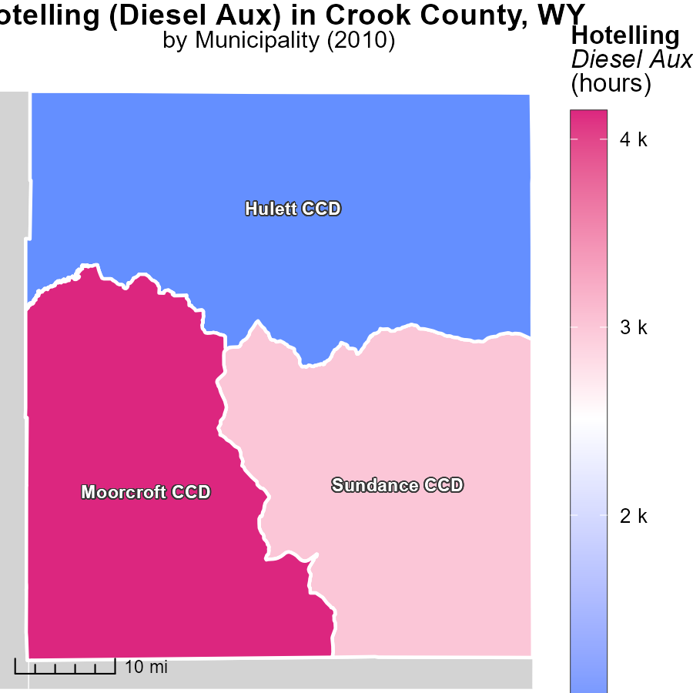

## Findings

* Moorcroft CCD, WY had the highest emissions with 4.2 k hours.
* Sundance CCD, WY had emissions of 3.0 k hours, which is the median value.
* Hulett CCD, WY had the lowest emissions with 884.0 hours.

## Recommendations

To lower emissions, consider reducing the usage hours in Moorcroft CCD, WY. Implement efficient technologies in Sundance CCD, WY as it represents the median value. Encourage sustainability practices in Hulett CCD, WY to maintain low emissions.

# Population by Road Type over Time

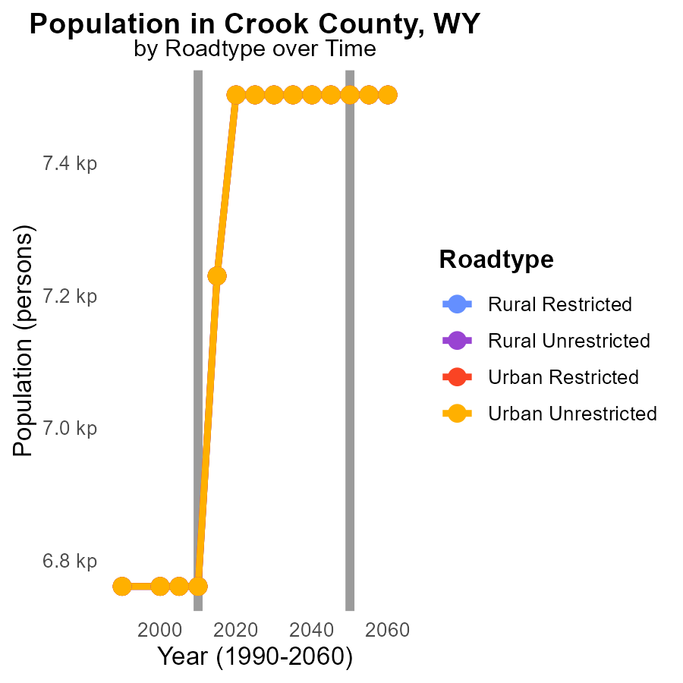

# Vehicles by Road Type over Time

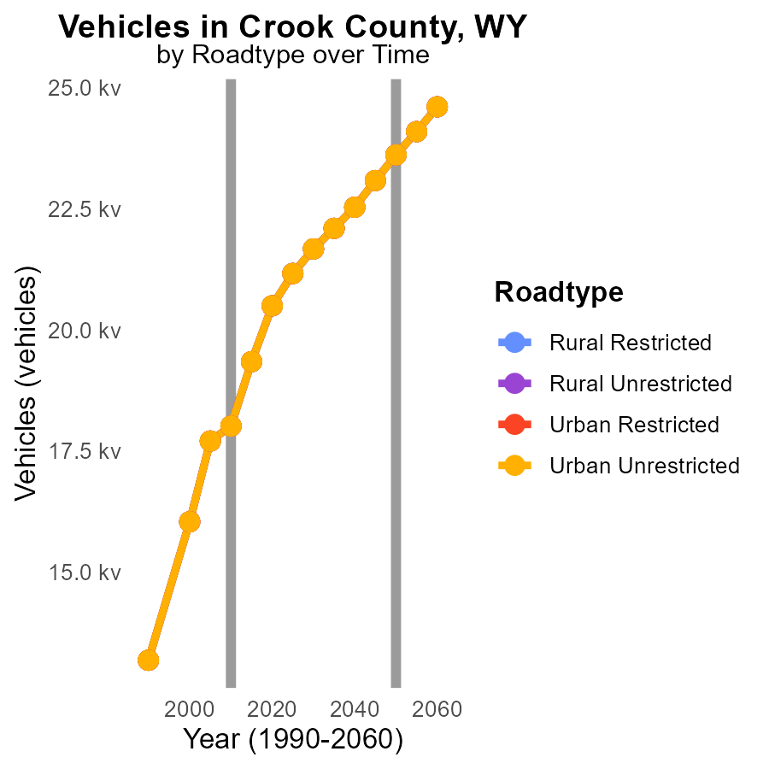

## Findings

* SO2 emissions from vehicles in Crook County, WY have consistently increased over the years from 2000 to 2020.
* The highest emissions were observed in Urban Unrestricted areas, with a total of 20.5 k reported in 2020.
* Overall, emissions decreased by approximately 59% from 7571.8 in 2000 to 3114.9 in 2020 across all road types and areas.

## Recommendations

To reduce SO2 emissions from vehicles in Crook County, it is advisable to implement stricter emission standards for vehicles, promote the use of electric vehicles, enhance public transportation systems, and invest in infrastructure to support walking and cycling.

# Areas Ranked by Hotelling (Diesel Aux)

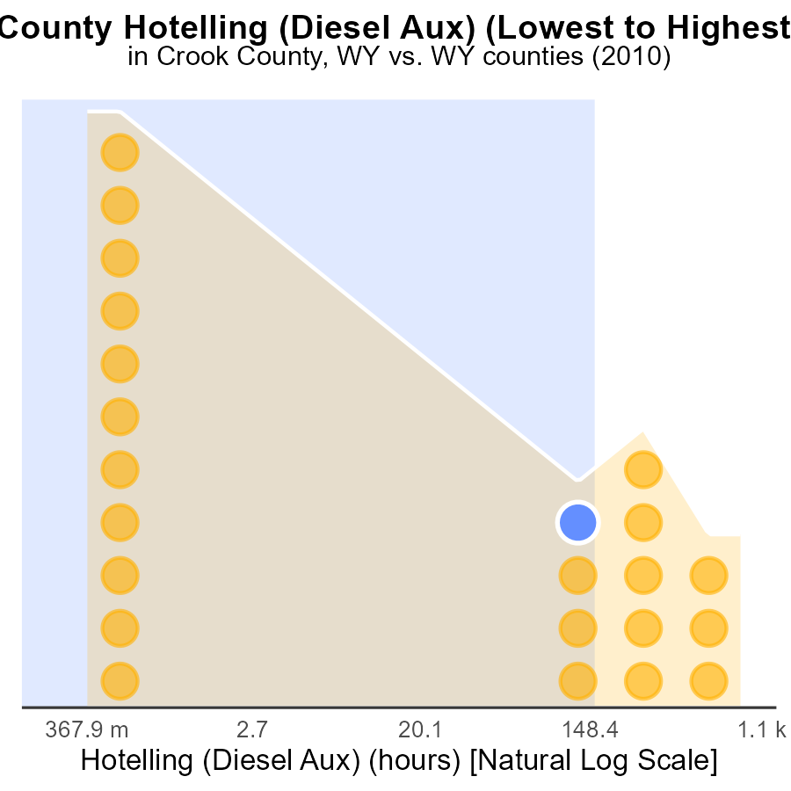

## Findings

* Highest SO2 emissions in Johnson county with 508.0 hours.
* Crook county contributed significantly to SO2 emissions with 410.8 hours.
* Sweetwater county had negligible emissions compared to others at only 2.4 hours.

## Recommendations

To lower SO2 emissions, focus on Johnson and Crook counties by regulating and reducing diesel auxiliary hours. Implement cleaner energy sources to decrease emissions further.

# Areas Ranked by Hotelling (Engines Off)

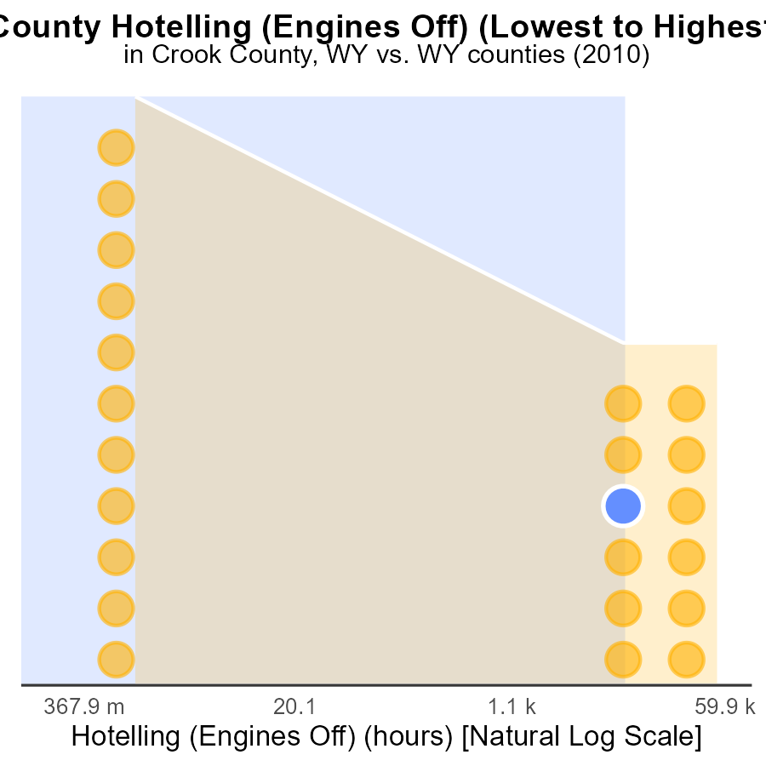

# Conclusion

In conclusion, the data from Crook County, WY in 2010 indicates that the region faces significant challenges with sulfur dioxide (SO2) emissions from on-road transportation. While emissions have decreased from 1990 to 2030, the county still emitted a total of 43.9 tons of SO2 per mile in 2010, with light trucks and cars/bikes being the primary contributors. To effectively address this issue, targeted strategies should be implemented in counties like Laramie and Sweetwater, which are the largest emitters, while also encouraging counties with lower emissions to maintain their current levels. Incentivizing the use of cleaner fuels, electric vehicles, and enforcing stricter emission standards are crucial steps to reducing SO2 emissions in Crook County, WY.

Moreover, the projection that SO2 emissions will remain constant at 7.5 k persons by 2030 despite population growth is concerning, indicating a need for more stringent emission control measures on industrial sources. Efforts to reduce engine idling time and adopt cleaner technologies in high-emission areas like Moorcroft CCD, while promoting sustainability practices in areas like Hulett CCD, will be vital in achieving a sustained reduction in SO2 emissions. Additionally, the focus on implementing stricter emission standards, promoting electric vehicles, enhancing public transportation systems, and investing in infrastructure for walking and cycling can further contribute to lowering SO2 emissions from vehicles in Crook County, WY.

# About This Report

Data based on MOVES estimates collected by the Climate Action in Transportation program at Cornell University. Demographic data sourced from the US Census's American Community Survey 5-year estimates. This report was generated with the help of AI.

# References

* U.S. Census Bureau. (2023). American Community Survey 5-year estimates: Detailed tables. Retrieved from https://data.census.gov
* U.S. Environmental Protection Agency. (2024). Motor Vehicle Emission Simulator (MOVES 4.0) [Software]. Retrieved from https://www.epa.gov/moves