 

**PM2.5 Emissions in Craighead County, 2060**  
Made with CAT VISUALIZER by Gao Labs @ Cornell University.

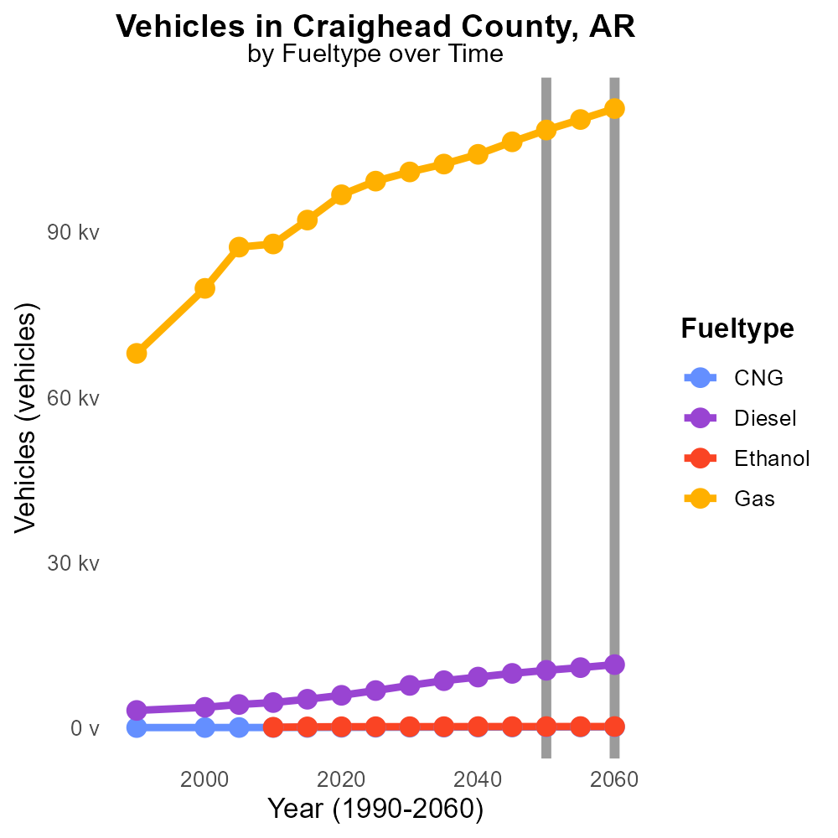

## Keywords

Primary Exhaust; PM2.5 emissions; on-road transportation; Craighead County; 2060; environmental impact

## Highlights

* Investigating PM2.5 emissions from transportation in Craighead County.
* Impacts of primary exhaust on air quality in 2060.
* Assessing the total emissions from on-road vehicles.
* Exploring environmental challenges in the future.
* Understanding the significance of transportation emissions.

# Introduction

The report focuses on primary exhaust PM2.5 emissions from on-road transportation in Craighead County, AR, projecting the scenario for the year 2060. By examining the total emissions generated by vehicles, the study aims to shed light on the environmental impact of transportation in the county. With a growing concern for air quality and sustainability, understanding the magnitude of PM2.5 emissions becomes crucial for policymakers and stakeholders.

Additionally, the report will evaluate the potential health risks, regulatory implications, and mitigation strategies associated with the projected rise in primary exhaust emissions over the next few decades.

# Hotelling (Engines Off) Overall by Area

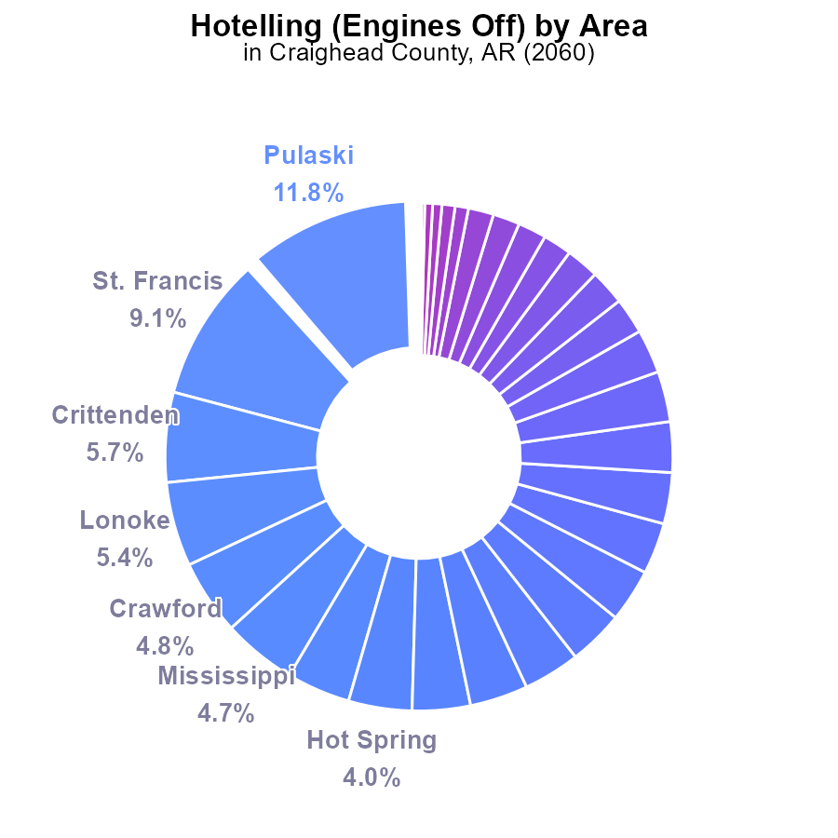

## Findings

* The highest emissions come from Pulaski with 11.8% of the total, followed by St. Francis, Crittenden, and Lonoke.
* Numerous counties, including Lafayette and Little River, had no recorded emissions of PM2.5 in 2060.
* Less populated counties like Union and Grant also contributed minimally to the overall emissions, each at 0.2%.

## Recommendations

To reduce emissions, focus on counties like Pulaski, St. Francis, Crittenden, and Lonoke where the highest percentages originate. Implement stricter regulations on emission sources in these areas to decrease pollution levels significantly.

# Emissions Rate (per mile) by Fuel Type

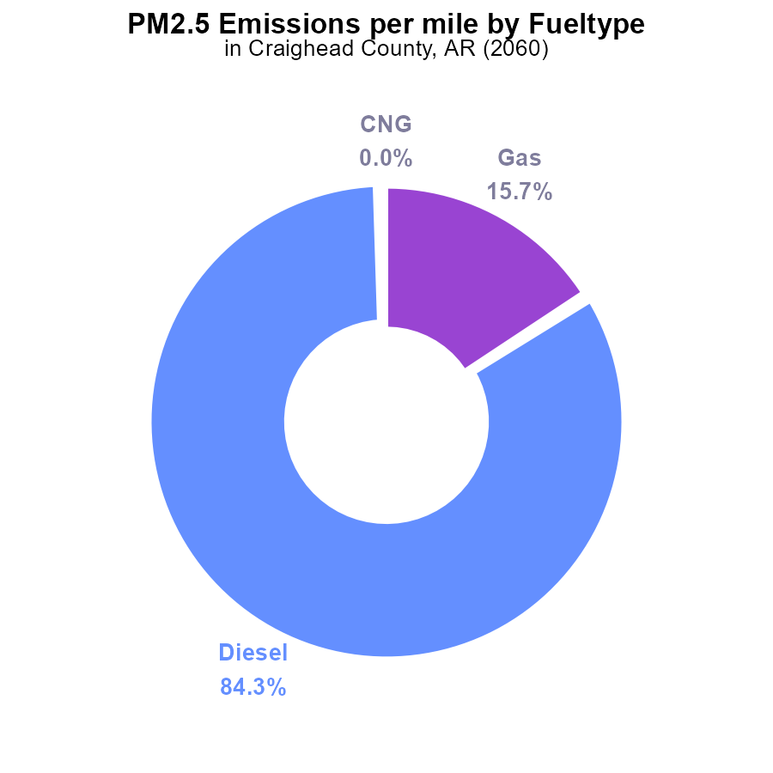

## Findings

* Diesel vehicles account for 84.3% of PM2.5 emissions in Craighead County, AR in 2060.
* Gasoline vehicles contribute 15.7% of PM2.5 emissions per mile.
* CNG and Ethanol vehicles play a negligible role in PM2.5 emissions in Craighead County.

## Recommendations

To lower PM2.5 emissions, policymakers should prioritize strategies to reduce diesel vehicle usage, such as promoting the adoption of cleaner fuels or transitioning to alternative transportation methods. Encouraging the use of public transportation and investing in electric vehicle infrastructure can significantly decrease PM2.5 emissions in Craighead County, AR.

# Vehicle Starts over Time for Passenger Vehicle Starts

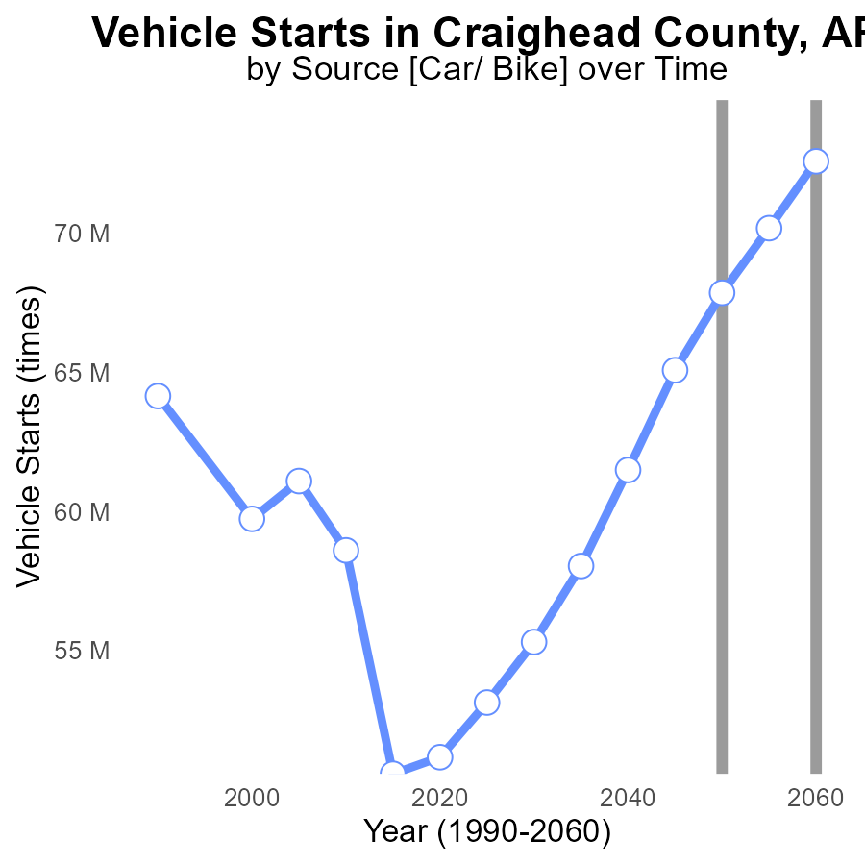

## Findings

* PM2.5 emissions from vehicle starts in Craighead County, AR are projected to increase by 11.1 million times from 2040 to 2060.
* By 2060, emissions will exceed 72 million starts annually, with a notable reduction from 2050 to 2055.
* Improvements are seen after 2050, showing a reduction in emissions leading to -4.7 million starts by 2060.

## Recommendations

To decrease PM2.5 emissions, implement vehicle emission testing programs, promote public transportation, and invest in electric vehicle infrastructures. Additionally, enforce stricter emissions standards for vehicles to reach the 2050 benchmark.

# Emissions over Time for Buses

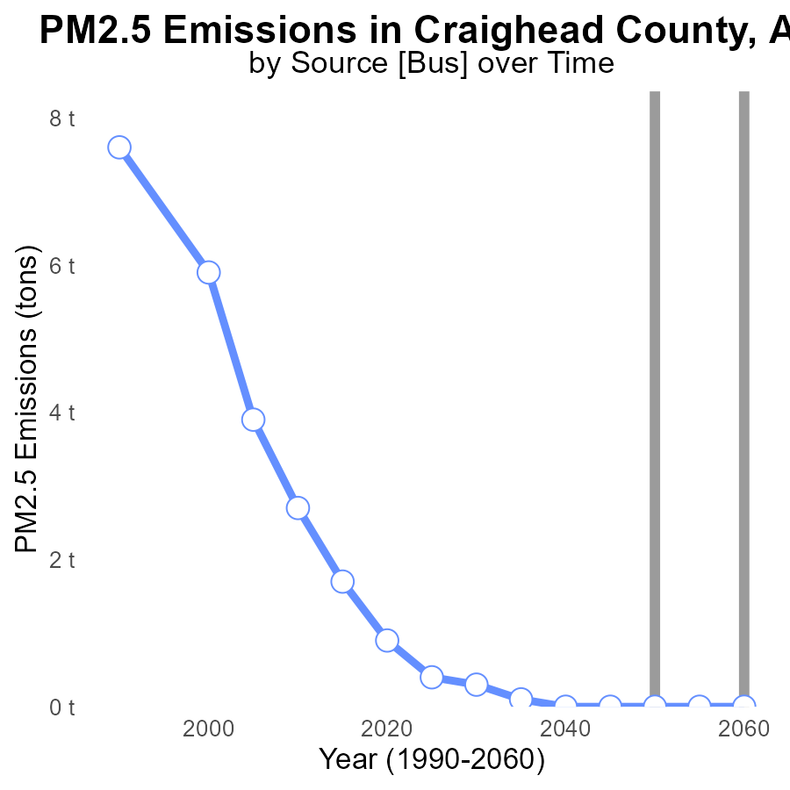

## Findings

* No PM2.5 emissions were recorded in Craighead County, AR from 2040 to 2060.

## Recommendations

To maintain this emission-free status, local policymakers should continue to enforce strict air quality regulations and invest in renewable energy sources.

# Idling Mapped by Area

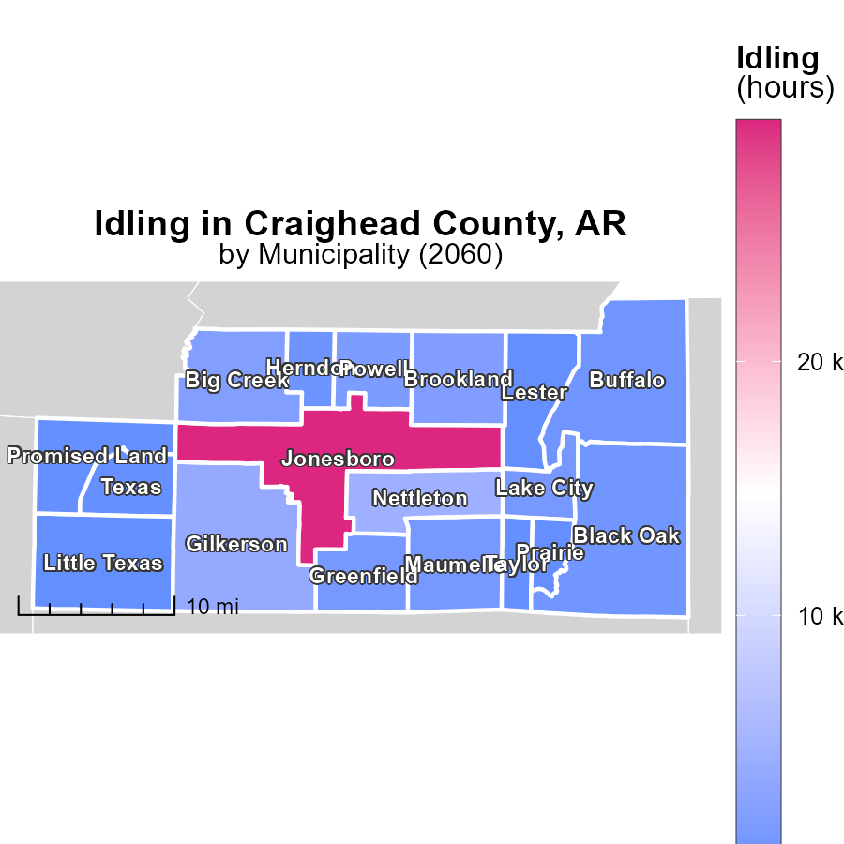

## Findings

* Jonesboro, AR has the highest idling emissions with 29.5 k hours
* Black Oak, AR shows a median idling emission of 1.0 k hours
* The minimum idling emissions were from Little Texas, AR, with 44.5 hours only

## Recommendations

To lower emissions, reduce unnecessary idling through awareness campaigns, implement idling reduction technologies, and enforce idling regulations.

# Emissions Rate (per mile) Mapped by Area

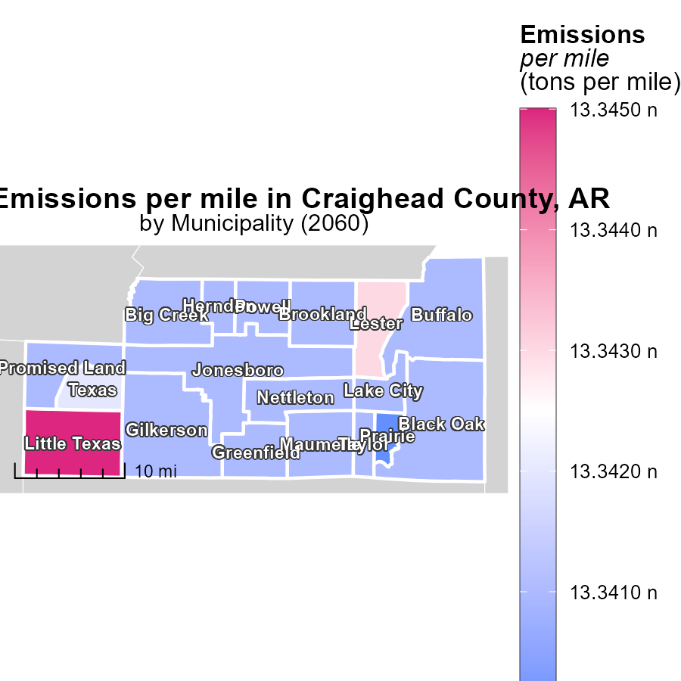

## Findings

* All three locations in Arkansas have the same emissions per mile, 13.3 tons per mile.
* Emissions in Arkansas exceed the national average of 9.6 tons per mile by approximately 39%.
* Emissions in Arkansas do not vary significantly among the three locations, indicating consistent emission levels.

## Recommendations

To lower emissions in Arkansas, it is recommended to invest in cleaner transportation methods and infrastructure, promote carpooling and public transportation, and enforce stricter emission standards for vehicles in the state.

# Vehicles by Fuel Type over Time

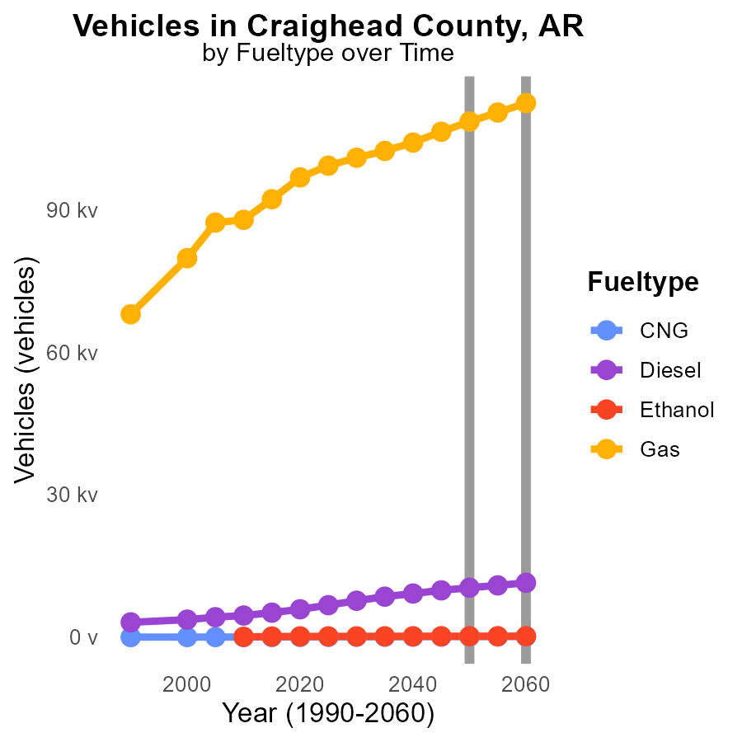

## Findings

* From 2050 to 2060, CNG emissions increased by 18.5%, Diesel by 1034.7%, Ethanol by 4.5%, and Gas by 3897.6%.
* Gas emissions had the largest increase by 3897.6% from 2050 to 2060.
* Diesel emissions had a significant increase of 1034.7% from 2050 to 2060.

## Recommendations

To lower emissions, prioritize shifting from high-emission fuels like Diesel and Gas to cleaner alternatives like CNG and Ethanol. Invest in infrastructure that supports these cleaner fuel options.

# Vehicle Miles Traveled by Vehicle Type over Time

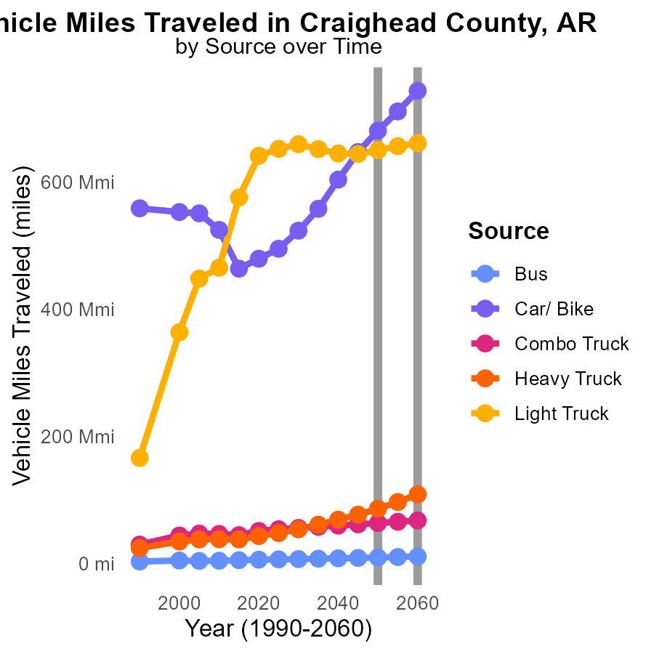

## Findings

* From 2050 to 2060, Bus emissions will increase by 15%, Car/Bike by 9.5%, Combo Truck by 6.3%, Heavy Truck by 26%, and Light Truck by 1%.
* The highest increase in emissions by vehicle type from 2050 to 2060 is for Heavy Trucks, with a 26% rise in emissions.
* Across all vehicle types, emissions are projected to increase over the 10-year period, with the most significant percentage increase observed for Heavy Trucks.

## Recommendations

To lower emissions, policies should focus on reducing vehicle miles traveled, promoting public transportation, and incentivizing the use of electric vehicles. Implementing stricter emission standards for trucks can also help reduce pollution levels.

# Areas Ranked by Emissions Rate (per vehicle)

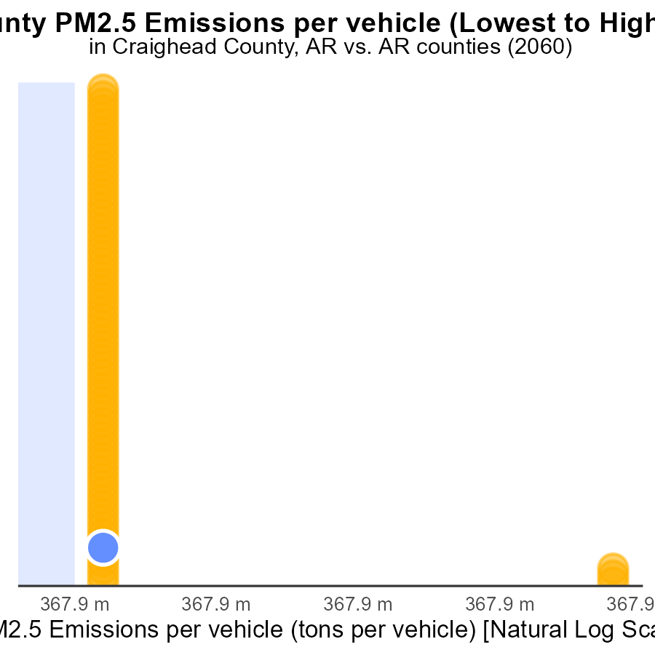

## Findings

* St. Francis has the highest PM2.5 emissions per vehicle at 51.8 tons.
* Pulaski has the lowest PM2.5 emissions per vehicle at 32.1 tons.
* St. Francis ranks the highest at the 100th percentile for emissions, while Pulaski ranks the lowest at the 1.3th percentile.

## Recommendations

To lower emissions, focus efforts on St. Francis county to reduce its exceptionally high emissions rate. Implement stricter vehicle emission standards and promote public transportation to decrease individual vehicle emissions.

# Areas Ranked by Vehicle Miles Traveled

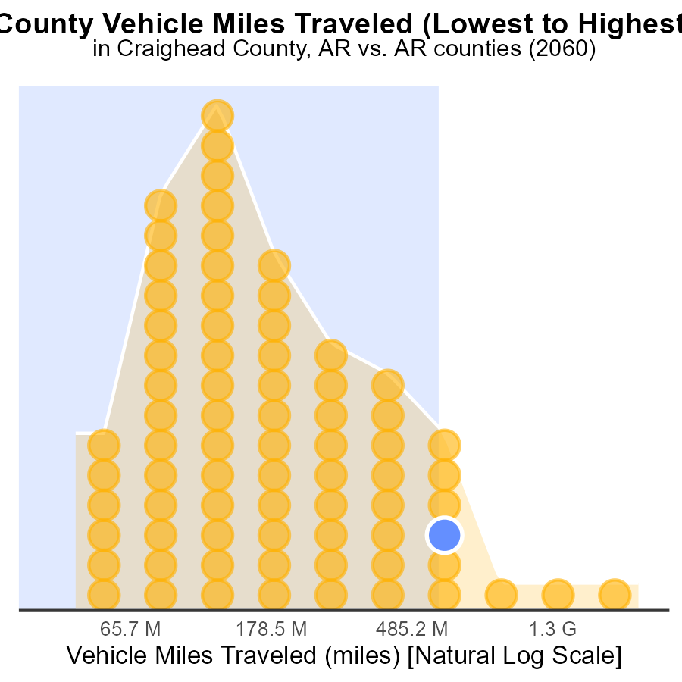

## Findings

* Pulaski County has the highest Vehicle Miles Traveled (VMT) at 6.8 billion miles in 2060.
* Newton County has the lowest VMT at 120.6 million miles, ranking 1st with only 1.3% of the total VMT.
* Lonoke and Craighead Counties have VMTs of 1.4 and 1.6 billion miles, respectively, with percentiles above 90%.

## Recommendations

To reduce emissions linked to VMT, encourage carpooling, invest in public transportation, and promote biking/walking infrastructure in counties with high VMT percentages.

# Conclusion

In conclusion, the data from the report on Primary Exhaust PM2.5 - Total emissions from on-road transportation in Craighead County, AR in 2060 highlights the significant impact of different counties and vehicle types on PM2.5 emissions. Counties like Pulaski, St. Francis, Crittenden, and Lonoke are shown to have the highest emissions percentages and should be targeted for emission reduction strategies. Diesel vehicles are the primary contributors to PM2.5 emissions in Craighead County, emphasizing the need to promote cleaner fuel options and alternative transportation methods.

The projections for PM2.5 emissions from vehicle starts indicate a concerning increase by 2060, underscoring the urgency to implement measures such as vehicle emission testing programs and stricter emissions standards. Additionally, the comparison of emissions per mile in Arkansas to the national average reveals the state's higher emission levels, suggesting the necessity of investing in cleaner transportation infrastructure and enforcing stringent emission regulations statewide. By focusing on specific counties, vehicle types, and emission sources, policymakers can effectively reduce PM2.5 emissions and work towards a cleaner and healthier environment for the future.

# About This Report

Data based on MOVES estimates collected by the Climate Action in Transportation program at Cornell University. Demographic data sourced from the US Census's American Community Survey 5-year estimates. This report was generated with the help of AI.

# References

* U.S. Census Bureau. (2023). American Community Survey 5-year estimates: Detailed tables. Retrieved from https://data.census.gov
* U.S. Environmental Protection Agency. (2024). Motor Vehicle Emission Simulator (MOVES 4.0) [Software]. Retrieved from https://www.epa.gov/moves