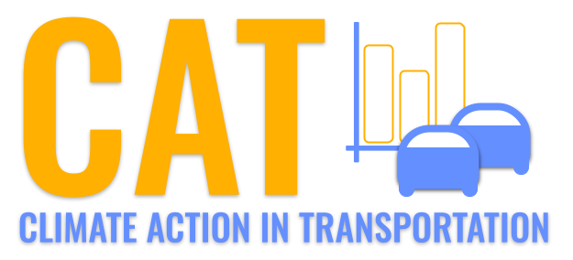 

**PM2.5 Emissions in Ellsworth County, 2020**  
Made with CAT VISUALIZER by Gao Labs @ Cornell University.

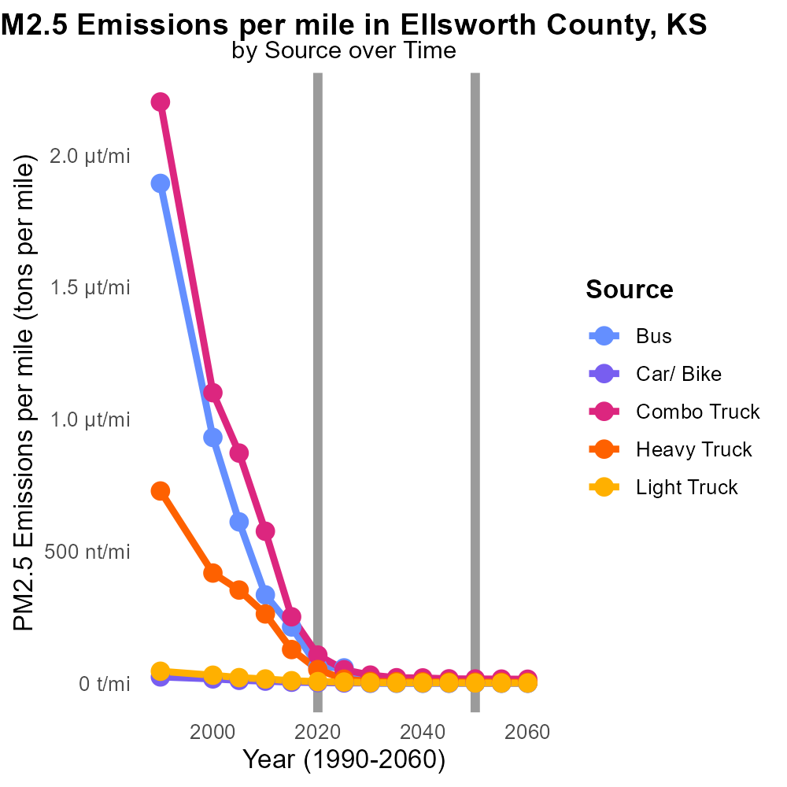

## Keywords

Primary Exhaust PM2.5; on-road transportation; Ellsworth County; 2020; total emissions

## Highlights

* Ellsworth County experienced significant on-road transportation emissions in 2020.
* Primary Exhaust PM2.5 levels from transportation sources pose health risks.
* Understanding and addressing these emissions is crucial for public health.
* This report examines the total PM2.5 emissions from on-road transportation.
* Data from 2020 sheds light on the environmental impact of transportation in the county.

# Introduction

In 2020, Ellsworth County, Kansas, faced a notable issue with primary exhaust PM2.5 emissions originating from on-road transportation activities. These emissions, particularly from vehicles, are a major source of fine particulate matter that poses significant health risks to residents in the area. As such, it is essential to assess and mitigate the impact of these emissions on both the environment and public health.

This report delves into the total emissions of primary exhaust PM2.5 from on-road transportation in Ellsworth County during the year 2020. By analyzing the data and trends related to these emissions, valuable insights can be gained regarding the environmental burden caused by transportation activities in the county. Additionally, understanding the scale of these emissions is crucial for devising effective strategies to reduce pollution levels and safeguard the well-being of the community.

# Time Driven by Vehicle Type

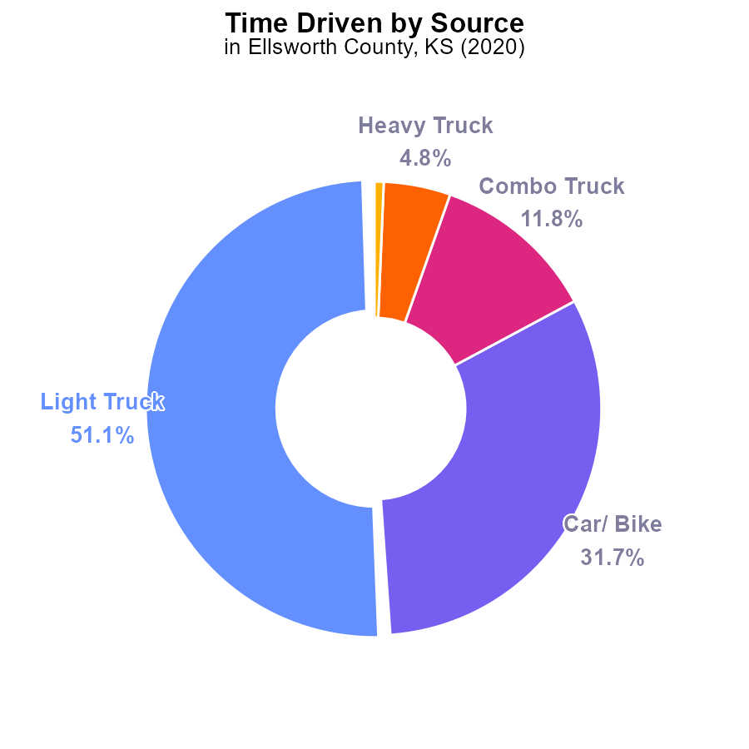

## Findings

* Light trucks emit the highest amount of PM2.5 with 2.2 million label_value, representing 51.1% of total emissions.
* Cars/Bikes follow with 1.4 million label_value, constituting 31.7% of the emissions.
* Heavy trucks have the lowest emissions at 209.0 thousand, making up only 4.8% of the total PM2.5 emissions.

## Recommendations

To lower PM2.5 emissions in Ellsworth County, focus on reducing emissions from light trucks by implementing stricter emission regulations. Promote public transportation and explore options to encourage alternative transportation methods to decrease car and bike emissions. Implement technologies to reduce PM2.5 emissions from heavy trucks.

# Idling by Fuel Type

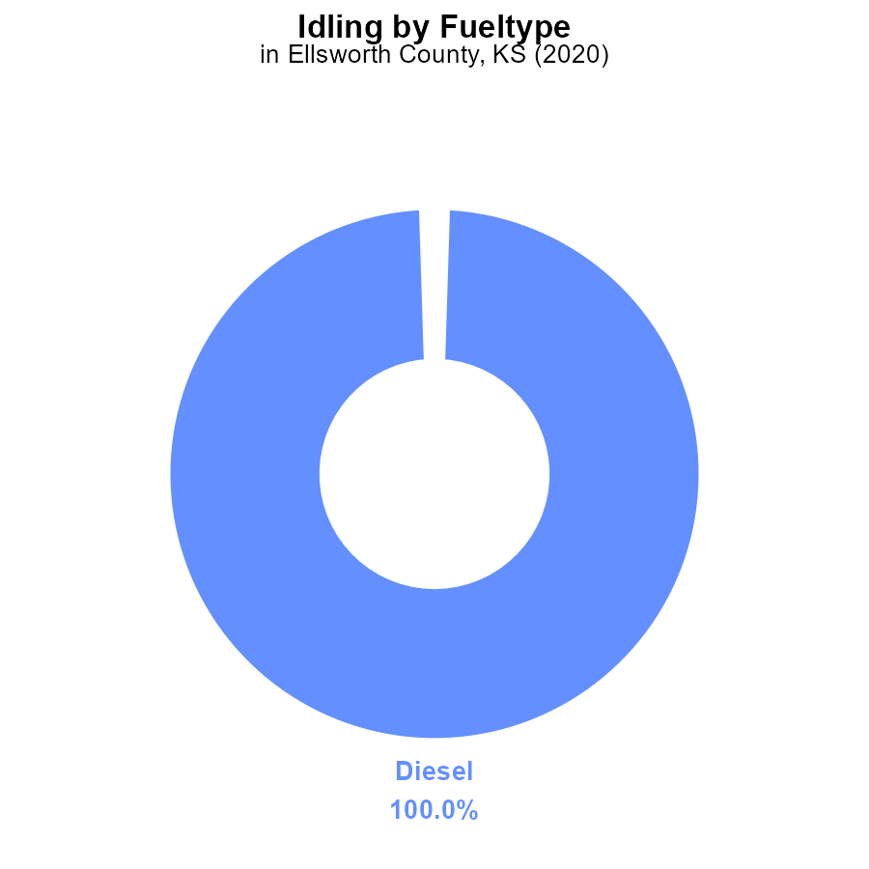

## Findings

* Diesel vehicles were responsible for 100% of PM2.5 emissions from idling in Ellsworth County, KS in 2020.
* No PM2.5 emissions were attributed to CNG, ethanol, or gas vehicles during idling in the same year.
* Diesel vehicles had an average idling time of 108.9 hours, contributing significantly to pollution levels.

## Recommendations

To reduce PM2.5 emissions in Ellsworth County, policies should target diesel vehicles, such as incentivizing the use of cleaner fuel alternatives and promoting technologies that reduce idling time.

# Vehicle Starts over Time for Buses

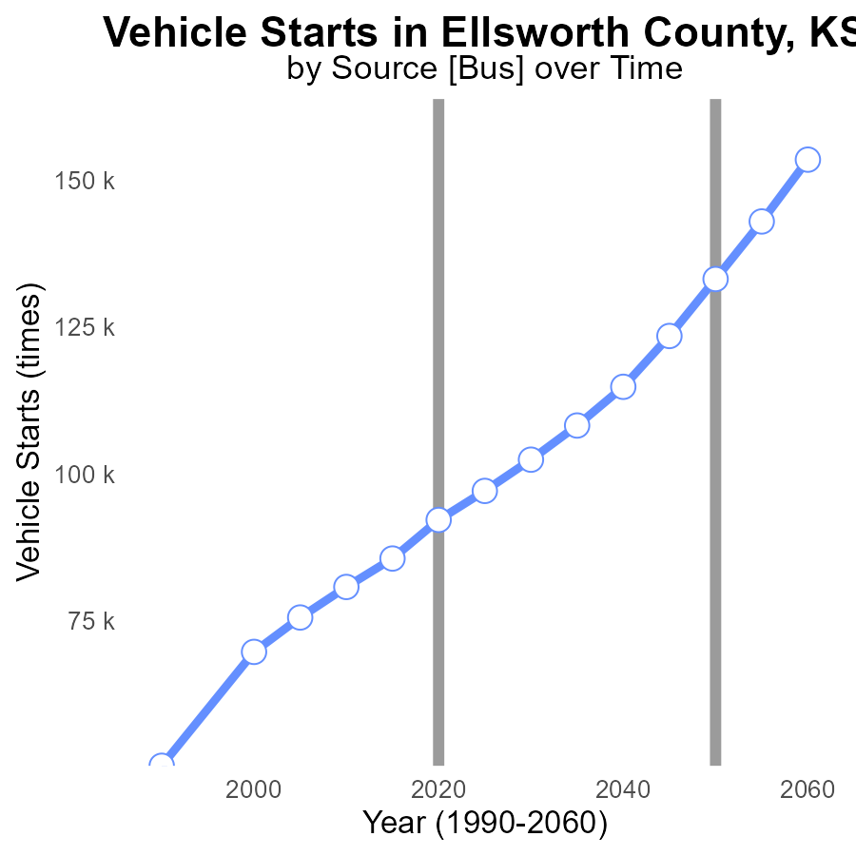

## Findings

* PM2.5 emissions in Ellsworth County have consistently increased from 69.6k times in 2000 to 114.8k times in 2040.
* The benchmark difference has decreased steadily, dropping from 63,533.8 in 2000 to 18,362.4 in 2040.
* By 2040, the PM2.5 emissions are projected to be 65.2% higher compared to the year 2000.

## Recommendations

To lower PM2.5 emissions, policymakers in Ellsworth County should focus on promoting the adoption of electric vehicles, improving public transportation systems, and implementing stricter vehicle emission standards. Additionally, investing in infrastructure for non-motorized transportation modes like biking and walking can help reduce the dependency on vehicles and decrease emissions in the long run.

# Emissions Rate (per capita) over Time for Passenger Vehicles

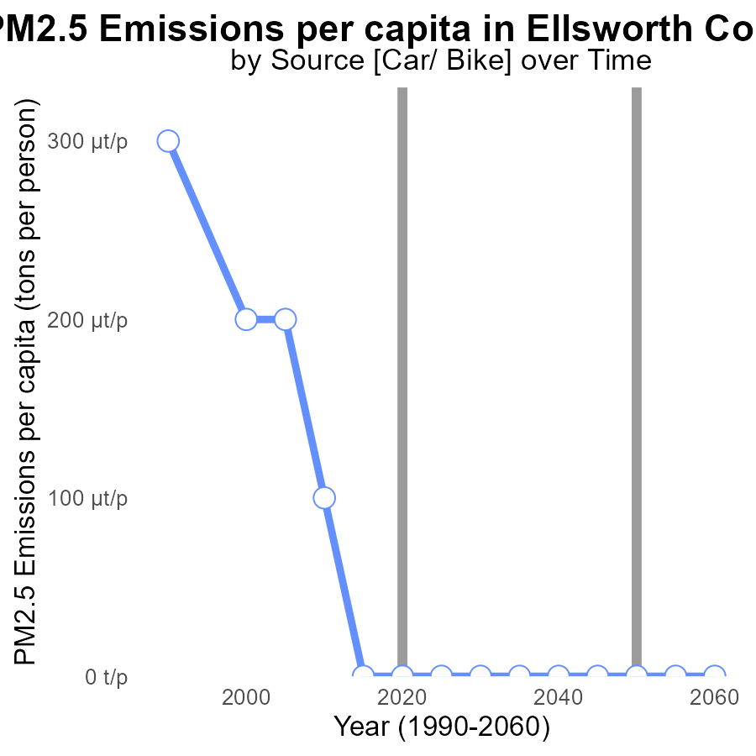

## Findings

* Emissions of PM2.5 in Ellsworth County, KS have been decreasing steadily over the years.
* Emissions per capita have consistently fallen from 231.6 tons per person in 2000 to 16.2 tons per person in 2040.
* The benchmark difference shows a continuous improvement trend, reaching zero in 2015 and remaining stable thereafter.

## Recommendations

Policymakers should continue investing in clean energy initiatives and strict emission regulations to further reduce PM2.5 emissions in Ellsworth County, KS.

# Vehicles Mapped by Area

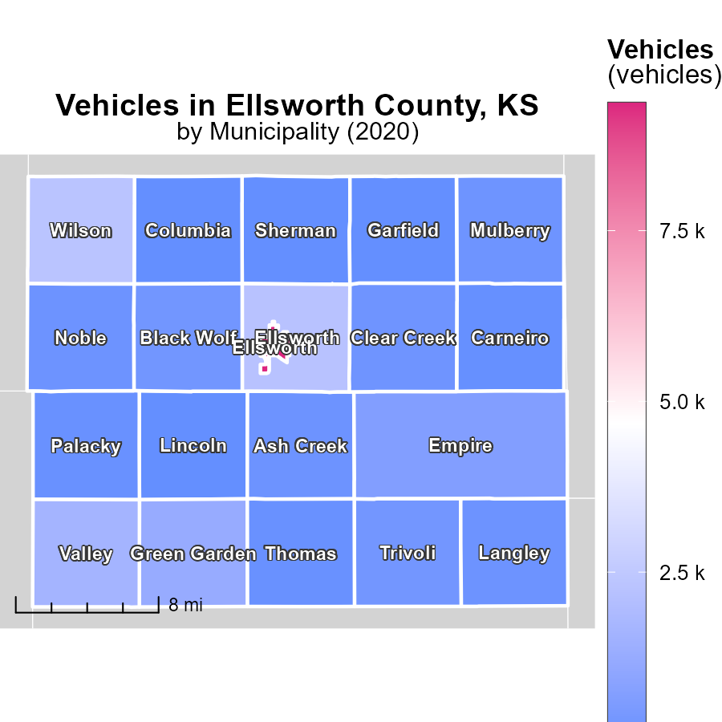

## Findings

* The highest emissions were in Ellsworth, KS with 9.4 k units
* Mulberry, KS had a median emission of 216.4 units
* Sherman, KS reported the lowest emissions at 0.0 units

## Recommendations

To decrease emissions, focus on low-emission vehicle incentives in Ellsworth, KS. Implement emission testing in Mulberry, KS. Encourage eco-friendly transportation options in Sherman, KS.

# Hotelling (Engines Off) Mapped by Area

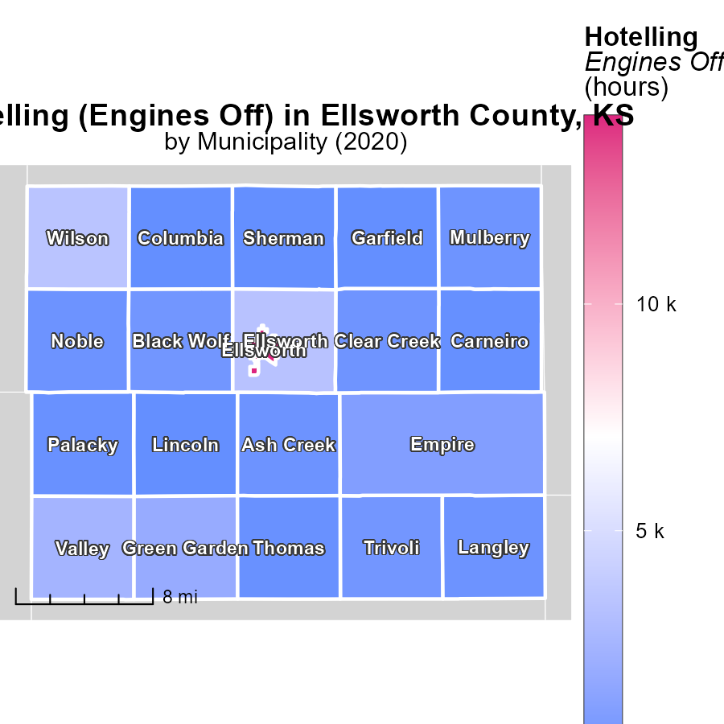

## Findings

* Ellsworth, KS had the highest emissions with 14.1 k hours of engines off.
* Mulberry, KS had a median emissions level of 326.8 hours of engines off.
* Sherman, KS showed the lowest emissions with 0.0 hours of engines off.

## Recommendations

Local authorities in Ellsworth, KS should investigate ways to reduce idle time, possibly by incentivizing drivers to turn off engines when not in use. Mulberry, KS can develop awareness campaigns to reduce idle time. Sherman, KS can maintain their no-idling momentum through continued enforcement and education.

# Emissions Rate (per mile) by Vehicle Type over Time

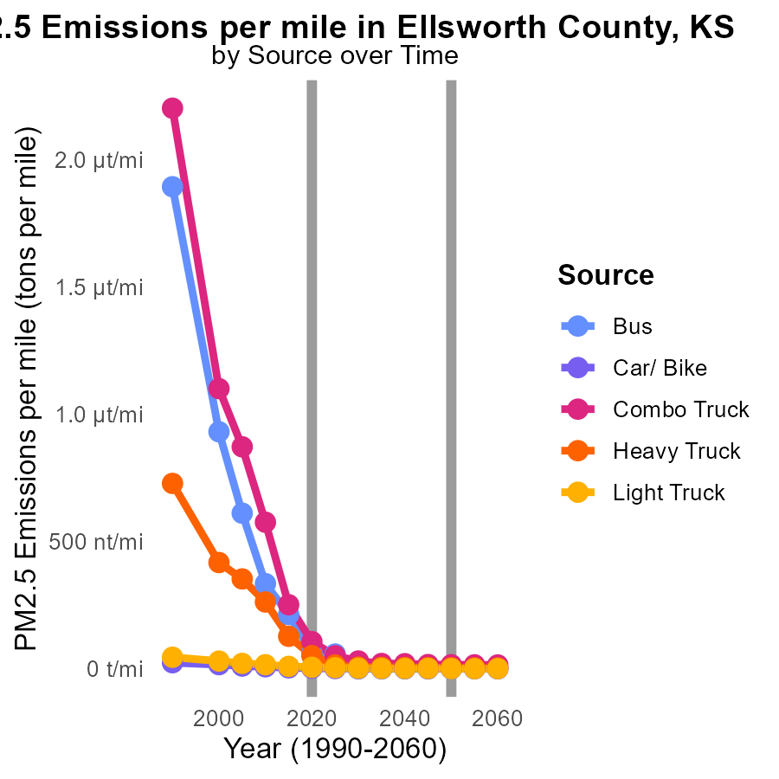

## Findings

* Bus emissions dropped from 334.6 to 0.0 tons per mile between 2010 and 2030.
* Emissions from Combo Trucks reduced from 575.6 to 30.9 tons per mile from 2010 to 2030.
* Heavy Truck emissions decreased significantly from 262.5 to 6.9 tons per mile during 2010-2030.

## Recommendations

To further decrease emissions in Ellsworth County, policies should focus on promoting the use of electric vehicles and public transport, increasing fuel efficiency, and implementing stricter emission standards for trucks.

# Emissions Rate (per vehicle) by Vehicle Type over Time

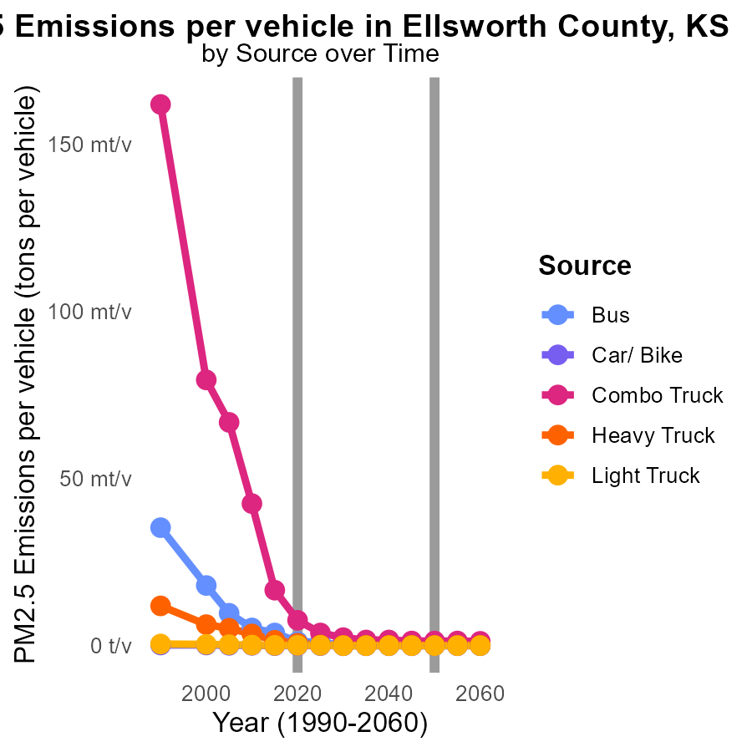

## Findings

* Emissions from buses in Ellsworth County decreased by 100% from 2010 to 2030.
* Emissions from combo trucks decreased by 94.4% from 2010 to 2030.
* Emissions from light trucks decreased by 86.4% from 2010 to 2030.

## Recommendations

To further reduce emissions, policymakers should incentivize the transition to cleaner fuel technologies in buses, combo trucks, and light trucks. Encouraging the adoption of electric vehicles and implementing stricter emission standards will help sustain the decreasing trend.

# Areas Ranked by Hotelling (Diesel Aux)

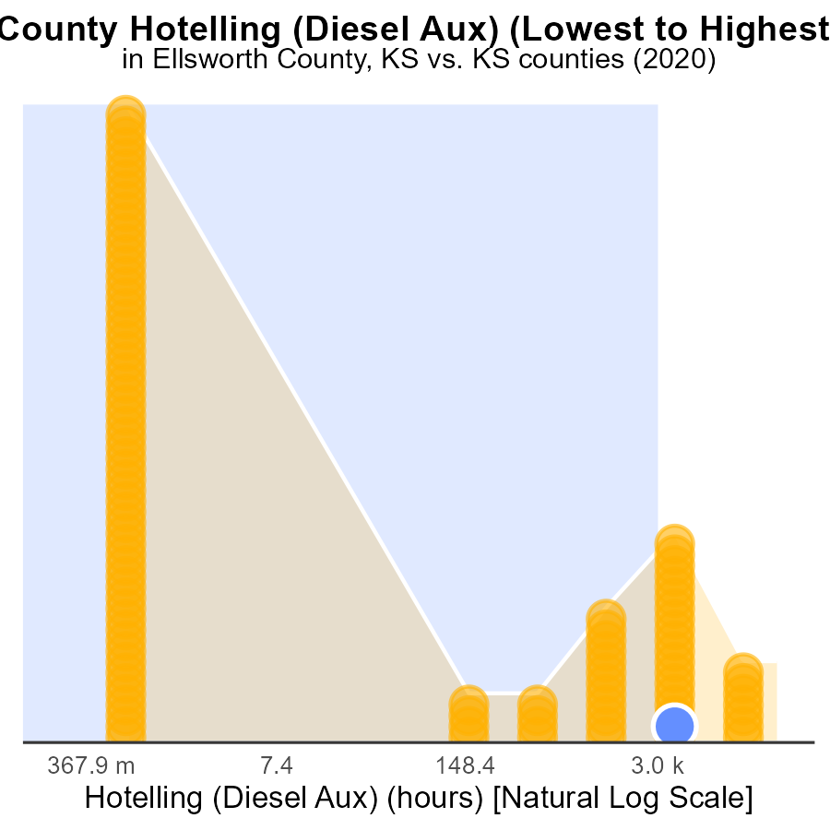

## Findings

* The highest PM2.5 emissions in 2020 were found in Johnson county with 54.8 k hours.
* Ellsworth and Chase counties had similar PM2.5 emissions with around 8.2 k hours in 2020.
* Allen county had the lowest PM2.5 emissions in 2020 with 0.0 hours recorded.

## Recommendations

To lower PM2.5 emissions, focus on reducing diesel auxiliary usage in counties with high emissions such as Johnson, Ellsworth, and Chase. Implement stricter regulations and promote cleaner energy sources.

# Areas Ranked by Emissions Rate (per mile)

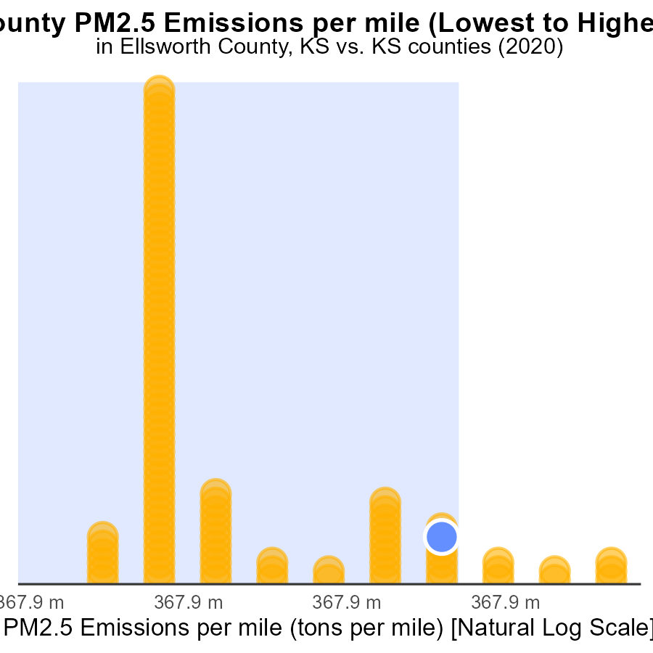

## Findings

* Gove county has the highest PM2.5 emissions per mile with 23.5 tons per mile.
* Wyandotte county has the lowest PM2.5 emissions per mile with 12.8 tons per mile.
* On average, the counties surveyed show high emissions levels, with most above 19.9 tons per mile.

## Recommendations

To lower emissions, counties should incentivize carpooling, promote public transportation, and invest in electric vehicles to reduce emissions per mile.

# Conclusion

In conclusion, the data from the report on Primary Exhaust PM2.5 - Total emissions from on-road transportation in Ellsworth County, KS in 2020 paints a clear picture of the current situation. Light trucks are the major contributors to PM2.5 emissions, followed by cars/bikes and heavy trucks. Diesel vehicles play a significant role in idling emissions, necessitating a focus on cleaner fuel alternatives and technologies to reduce idle time. Over the years, there has been a gradual decrease in PM2.5 emissions per capita, showcasing the positive impact of clean energy initiatives and emission regulations.

To further reduce PM2.5 emissions in Ellsworth County, policymakers should concentrate on promoting electric vehicles, enhancing public transportation systems, and enforcing stricter vehicle emission standards. Additionally, incentivizing low-emission vehicle adoption, implementing emission testing, and encouraging eco-friendly transportation options in different areas can aid in lowering emissions and improving air quality throughout the county. By prioritizing sustainable transportation methods and cleaner fuel technologies, Ellsworth County can work towards a greener and healthier environment for its residents.

# About This Report

Data based on MOVES estimates collected by the Climate Action in Transportation program at Cornell University. Demographic data sourced from the US Census's American Community Survey 5-year estimates. This report was generated with the help of AI.

# References

* U.S. Census Bureau. (2023). American Community Survey 5-year estimates: Detailed tables. Retrieved from https://data.census.gov
* U.S. Environmental Protection Agency. (2024). Motor Vehicle Emission Simulator (MOVES 4.0) [Software]. Retrieved from https://www.epa.gov/moves