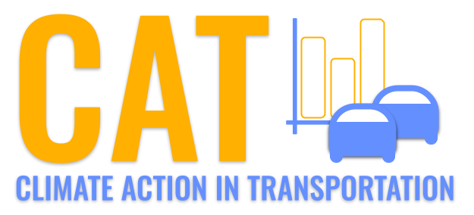 

**PM10 Emissions in Kay County, 2015**  
Made with CAT VISUALIZER by Gao Labs @ Cornell University.

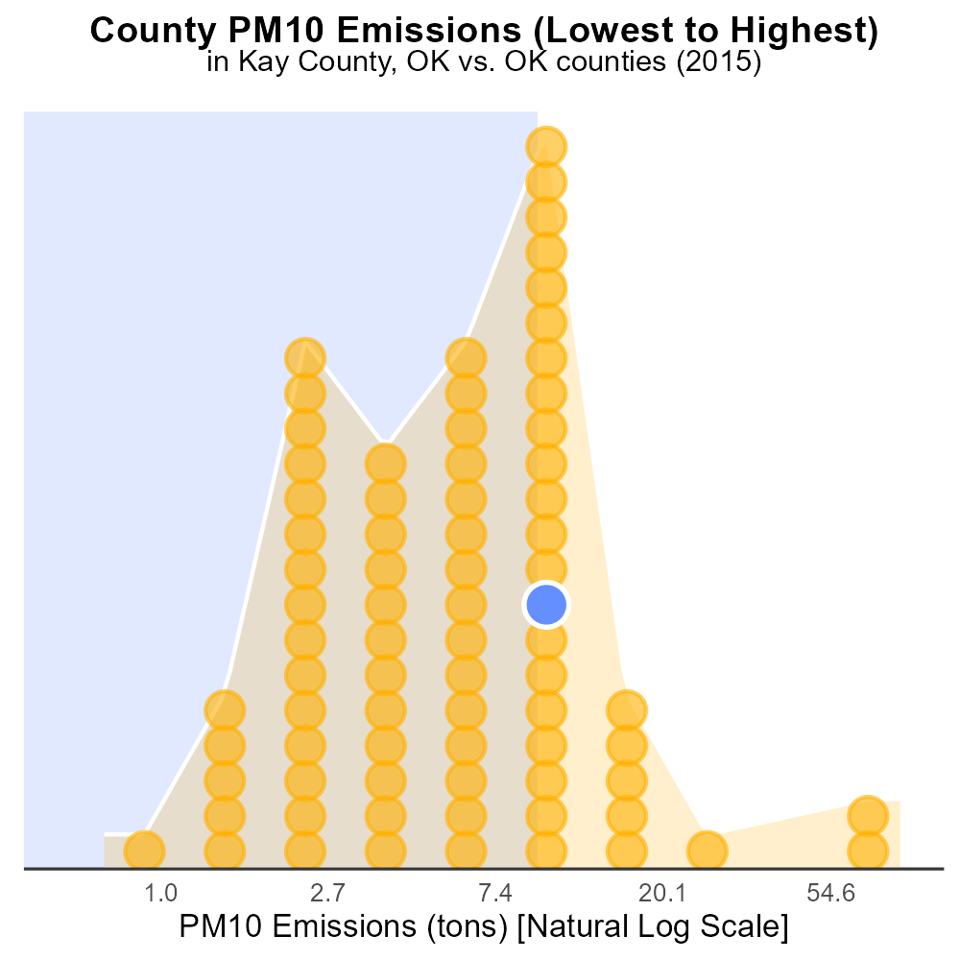

## Keywords

Primary Exhaust PM10; Total emissions; On-road transportation; Kay County; OK; 2015

## Highlights

* Study on PM10 emissions from on-road vehicles in Kay County, OK.
* Focus on primary exhaust emissions from transportation sector.
* Analysis of total PM10 emissions in the county for 2015.
* Importance of understanding air quality impact of transportation.
* Recommendations for reducing emissions and improving air quality.

# Introduction

The following report presents a detailed analysis of Primary Exhaust PM10 emissions from on-road transportation in Kay County, Oklahoma for the year 2015. PM10 refers to particulate matter with a diameter of 10 micrometers or less, which can have significant impacts on air quality and public health.

The study aims to specifically examine the total emissions of PM10 originating from exhaust sources within the transportation sector, including cars, trucks, and other vehicles. Understanding the levels of primary exhaust PM10 emissions in Kay County is crucial for assessing the environmental and health risks associated with on-road transportation activities and for formulating effective mitigation strategies.

# Emissions Rate (per vehicle) by Road Type

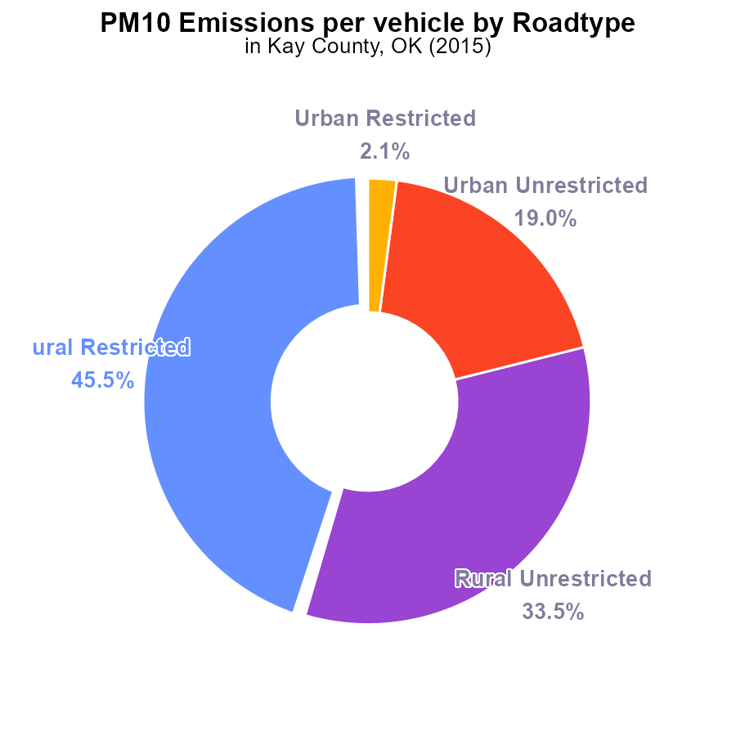

## Findings

* The highest PM10 emissions per vehicle were from Rural Restricted areas with 213.9 tons per vehicle and accounting for 45.5% of the total emissions.
* Rural Unrestricted areas had 157.5 tons per vehicle, representing 33.5% of the total emissions.
* Urban areas, both Restricted and Unrestricted, had significantly lower emissions per vehicle at 9.7 tons (2.1%) and 89.4 tons (19.0%) respectively.

## Recommendations

To reduce emissions in Kay County, OK, initiatives must target rural areas, especially the Rural Restricted zones, where the highest emissions per vehicle are observed. Implementing stricter emission standards for vehicles in these areas and promoting public transportation could help lower overall emissions levels.

# Idling by Vehicle Type

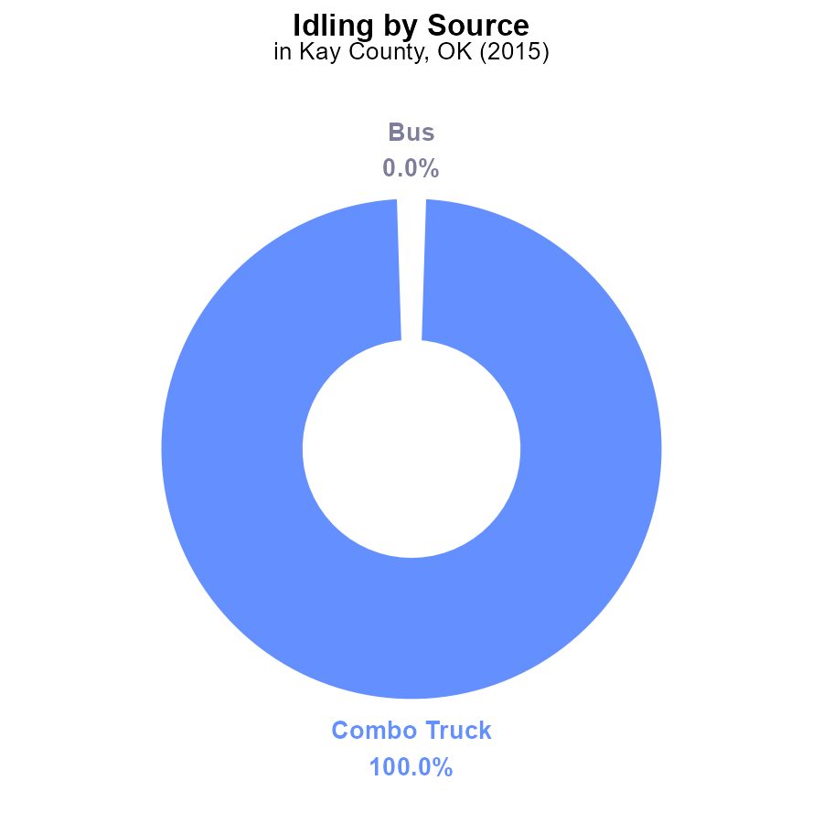

## Findings

* In 2015, Combo Trucks in Kay County, OK emitted 158.7 kg of PM10 while idling, representing 100% of the total emissions for that year.
* No PM10 emissions were reported for Buses, Cars/Bikes, Heavy Trucks, or Light Trucks in Kay County, OK in 2015.

## Recommendations

To lower PM10 emissions in Kay County, OK, focus on reducing idling time for Combo Trucks through implementing anti-idling policies or investing in technologies that can automatically shut off engines after a certain idling period. Additionally, consider promoting the use of cleaner fuel alternatives.

# Emissions Rate (per vehicle) over Time for Buses

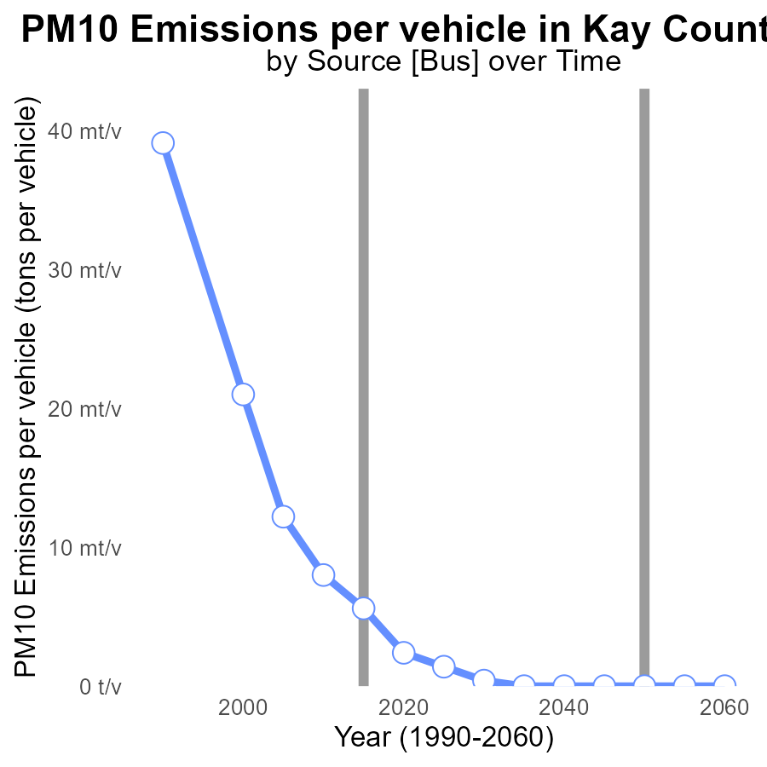

## Findings

* Emissions per vehicle in Kay County for PM10 decreased steadily over the years.
* The largest reduction occurred between 2000 and 2010 with a decrease of 13 tons per vehicle.
* By 2035, emissions per vehicle are projected to be at 0 tons per vehicle for PM10 in Kay County.

## Recommendations

To further decrease emissions, policymakers should continue to invest in cleaner technologies for vehicles in the area, incentivize the use of electric vehicles, and implement stricter emission regulations for all vehicles.

# Emissions Rate (per vehicle) Overall over Time

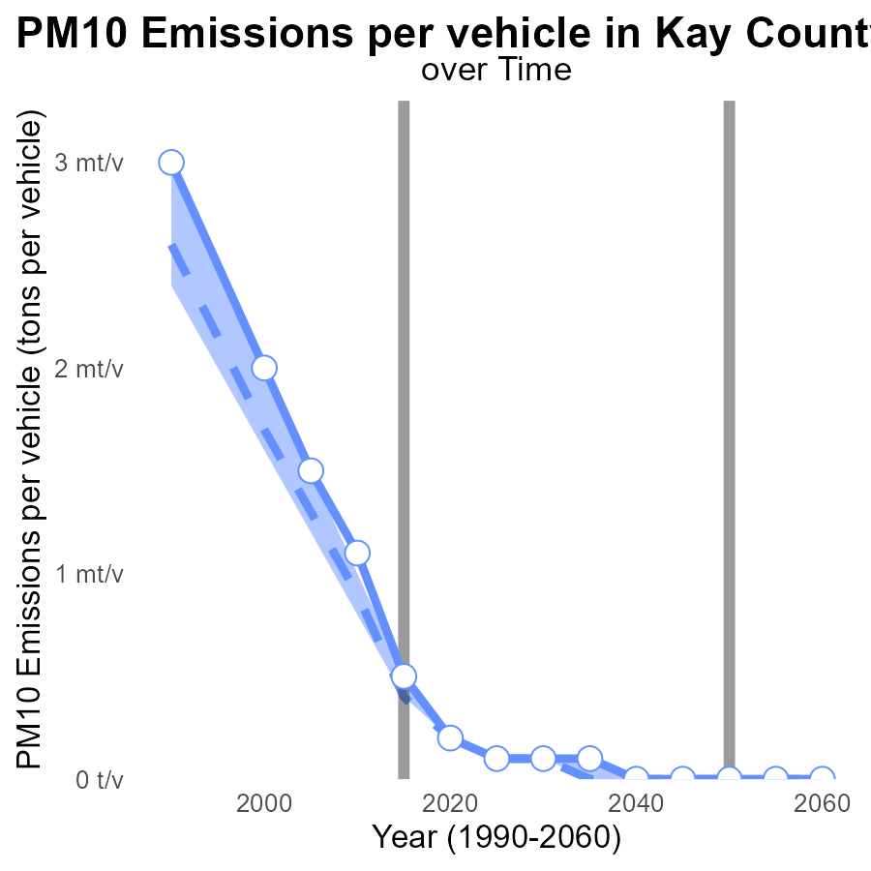

## Findings

* PM10 emissions per vehicle in Kay County have consistently decreased over the years.
* The emissions in this area have been significantly higher than the median and upper 75th percentile of areas.
* There is a decreasing trend in emissions, but they still remain above benchmark levels.

## Recommendations

To lower emissions in Kay County, action needs to be taken to further reduce PM10 emissions from vehicles. Implementing stricter vehicle emissions standards and promoting the use of electric vehicles could help bring the emissions levels closer to the median and below benchmark levels.

# Emissions Rate (per vehicle) in My Region

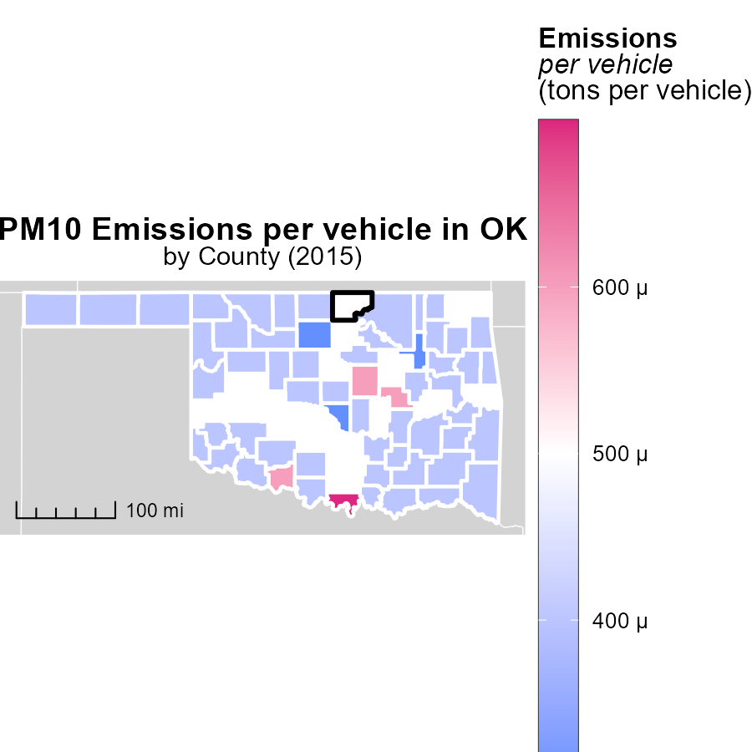

## Findings

* Love County, OK had the highest emissions per vehicle at 659.2 tons.
* Greer County, OK had a median emission level of 392.7 tons per vehicle.
* Tulsa County, OK had the lowest emissions per vehicle at 328.0 tons.

## Recommendations

Policymakers should focus on implementing stricter emission standards in Love County, while promoting sustainable transportation methods to reduce emissions. In Greer County, efforts should be made to maintain the median level and invest in eco-friendly infrastructure. Tulsa County should continue its trend of low emissions by incentivizing electric vehicles and public transportation.

# Hotelling (Diesel Aux) Mapped by Area

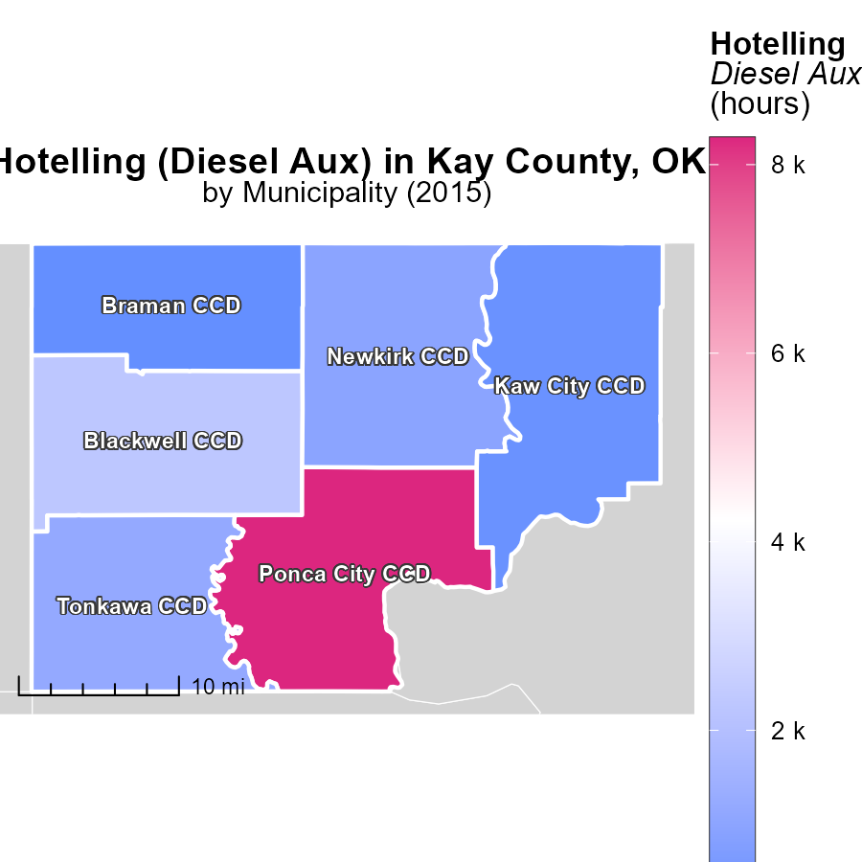

## Findings

* The maximum diesel auxiliary emissions in Ponca City CCD, OK in 2015 were 8.3 k hours.
* The median diesel auxiliary emissions in Newkirk CCD, OK in 2015 were 985.0 hours.
* The minimum diesel auxiliary emissions in Braman CCD, OK in 2015 were 181.5 hours.

## Recommendations

To lower the diesel auxiliary emissions, focus on reducing usage during peak hours in Ponca City CCD. Implement efficient energy management systems in Newkirk CCD to bring down emissions. Encourage technological updates in Braman CCD to decrease emissions further.

# Emissions Rate (per mile) by Vehicle Type over Time

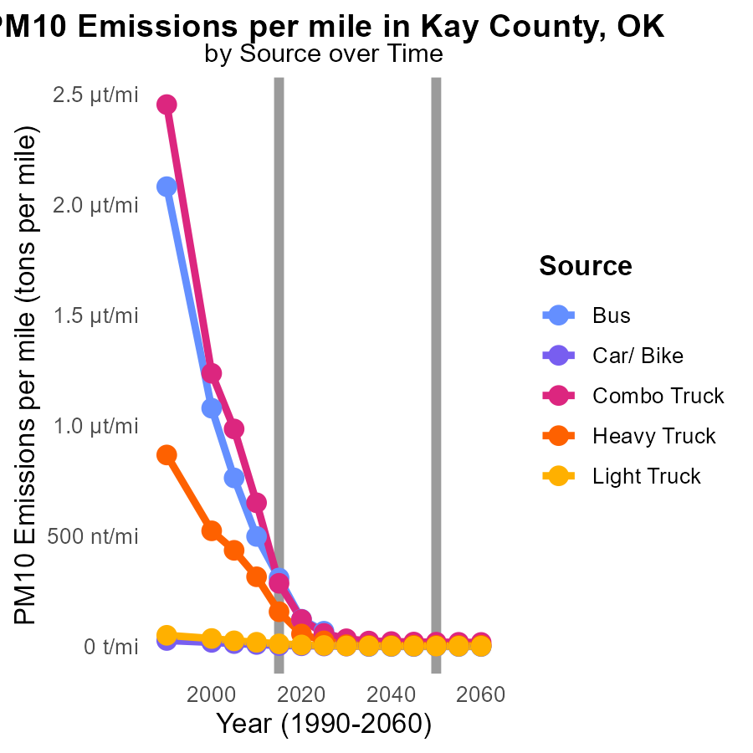

## Findings

* Bus emissions decreased by 91.95% from 2005 to 2025.
* Combo Truck emissions decreased by 99.39% from 2005 to 2025.
* Heavy Truck emissions decreased by 94.11% from 2005 to 2025.

## Recommendations

To further reduce emissions in Kay County, OK, focus on transitioning public transportation and freight vehicles to cleaner energy sources. Encourage the adoption of electric or hybrid buses and trucks, and provide incentives for the replacement of older, more polluting vehicles.

# Emissions Rate (per vehicle) by Area over Time

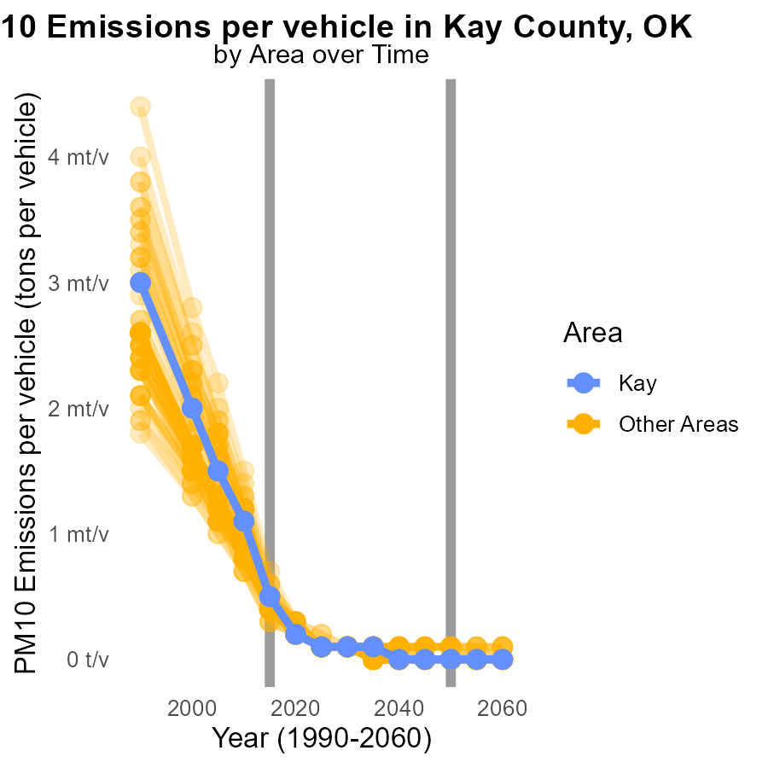

## Findings

* Average PM10 emissions per vehicle in 2015 ranged from 328.0 to 659.2 tons per year.
* Target county had the highest emissions at 470.5 tons per year in 2015.
* Emissions reduced slightly from 2005 levels, with differences around -0.0003 to -0.0006 tons per year.

## Recommendations

To decrease PM10 emissions, prioritize target county for stricter vehicle emission controls. Implement air quality monitoring systems in counties with high emissions to track progress over time.

# Areas Ranked by Emissions

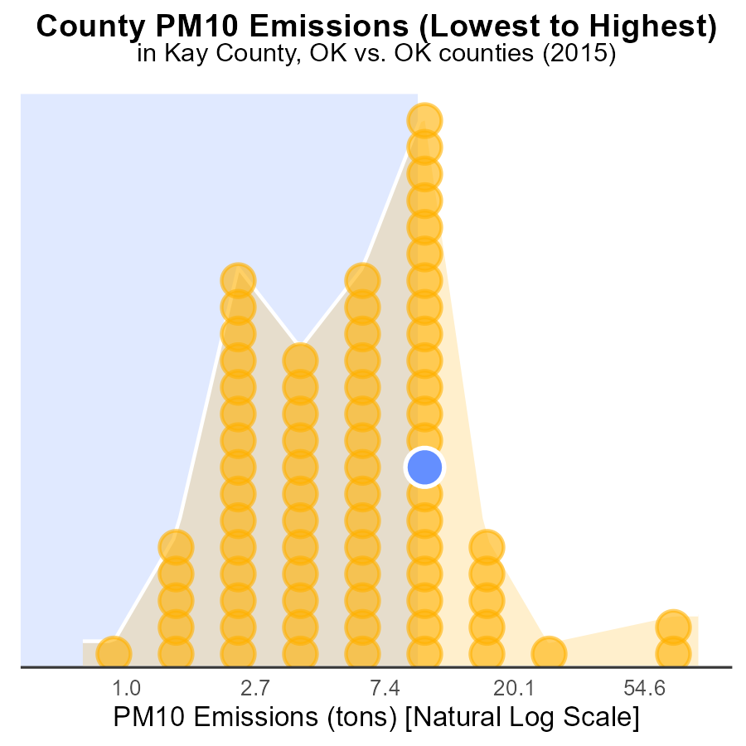

## Findings

* Oklahoma had the highest PM10 emissions with 229.4 tons in 2015.
* Harmon County ranked 1st with 900.0 tons of PM10 emissions, but its percentile was low at 1.3%.
* Counties Kay, Love, and Sequoyah had similar PM10 emissions ranging from 23.5 to 24.7 tons.

## Recommendations

To decrease emissions, focus on curbing industrial activities in high-emission counties like Harmon and Oklahoma. Implement stricter regulations for polluting industries and incentivize cleaner production methods. Collaborate with local authorities for effective monitoring.

# Areas Ranked by Vehicles

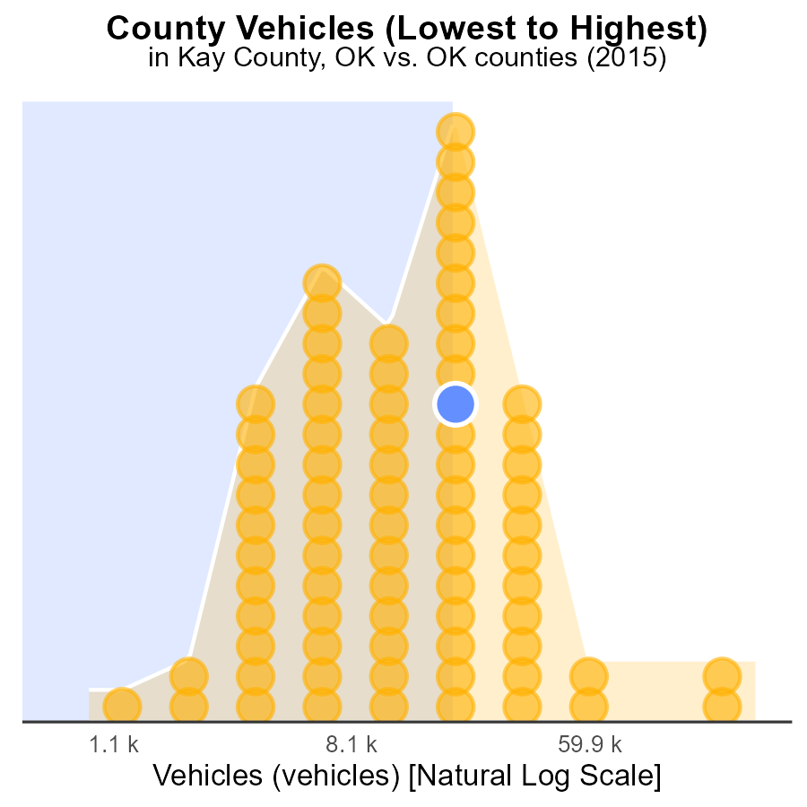

## Findings

* Oklahoma county has the highest number of vehicles emitting PM10 in 2015.
* Harmon county has the lowest number of vehicles emitting PM10 in 2015.
* Sequoyah county emits PM10 from vehicles at the highest percentage compared to other counties in 2015.

## Recommendations

To lower PM10 emissions, focus on reducing vehicle emissions in counties with higher vehicle counts and percentages, such as Oklahoma and Sequoyah, by implementing stricter vehicle emission standards and promoting the use of cleaner transportation alternatives.

# Conclusion

Overall, the report on Primary Exhaust PM10 - Total emissions from on-road transportation in Kay County, OK in 2015 reveals key insights for emission reduction strategies. Rural Restricted areas were identified as the highest contributors to PM10 emissions per vehicle, suggesting a need for targeted initiatives in these regions. While Urban areas exhibited lower emissions, the focus should remain on implementing stricter emission standards for vehicles to further decrease pollution levels. Furthermore, the data highlights a steady decrease in emissions per vehicle over the years, with projections indicating a promising trend towards zero emissions per vehicle by 2035. To achieve this goal, continuous investment in cleaner vehicle technologies, promotion of electric vehicles, and enforcement of stringent emission regulations are imperative. Collaborative efforts with local authorities and the adoption of sustainable transportation methods will play a pivotal role in achieving significant reductions in PM10 emissions in Kay County, OK.

Efforts should also extend to neighboring counties with higher emissions levels, such as Love and Sequoyah, where tailored policies can address specific emission sources effectively. By targeting industries in high-emission counties and incentivizing cleaner production methods, a comprehensive approach towards reducing PM10 emissions can be established. The significant decrease in emissions observed in various vehicle categories over the past two decades underscores the importance of transitioning public transportation and freight vehicles to cleaner energy sources. Encouraging the adoption of electric or hybrid vehicles, alongside the replacement of older, more polluting vehicles, will be instrumental in achieving sustainable emission levels. As counties aim to align with median and lower benchmark emission levels, continuous monitoring of air quality and implementation of efficient energy management systems will be crucial steps towards a greener, healthier environment for residents and communities.

# About This Report

Data based on MOVES estimates collected by the Climate Action in Transportation program at Cornell University. Demographic data sourced from the US Census's American Community Survey 5-year estimates. This report was generated with the help of AI.

# References

* U.S. Census Bureau. (2023). American Community Survey 5-year estimates: Detailed tables. Retrieved from https://data.census.gov
* U.S. Environmental Protection Agency. (2024). Motor Vehicle Emission Simulator (MOVES 4.0) [Software]. Retrieved from https://www.epa.gov/moves