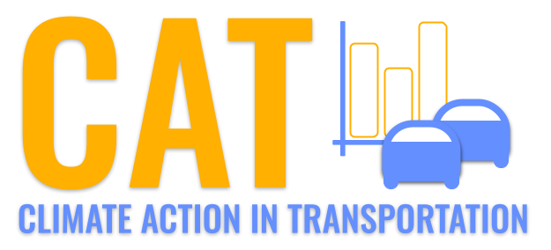 

**PM10 Emissions in Washakie County, 2060**  
Made with CAT VISUALIZER by Gao Labs @ Cornell University.

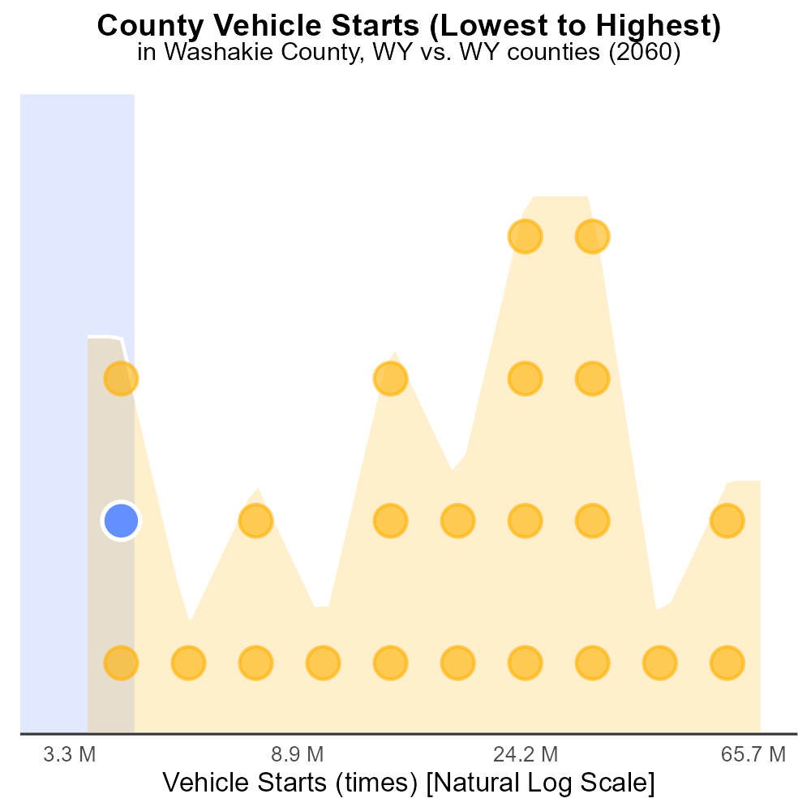

## Keywords

Primary Exhaust PM10; on-road transportation; Washakie County; emissions; 2060

## Highlights

* Analysis of PM10 emissions from on-road transportation in 2060.
* Key focus on primary exhaust emissions in Washakie County, WY.
* Impact assessment of transport-related air pollutants.
* Identification of trends, challenges, and potential mitigation measures.
* Insights for policy-makers and environmental advocates.

# Introduction

This report presents a comprehensive analysis of Primary Exhaust PM10 emissions from on-road transportation in Washakie County, Wyoming, projected for the year 2060. With a particular focus on the total emissions arising from primary exhaust sources, this study aims to provide a detailed assessment of the environmental impact and challenges posed by transport-related air pollutants in the region.

By examining the trends in PM10 emissions, identifying key sources, and evaluating the potential health and environmental implications, this report offers valuable insights for policymakers, environmental advocates, and other stakeholders. Additionally, the report explores possible mitigation measures and strategies to address the growing concerns surrounding air quality and public health in Washakie County, with the ultimate goal of fostering sustainable transportation practices and minimizing the adverse effects of on-road emissions.

# Population by Road Type

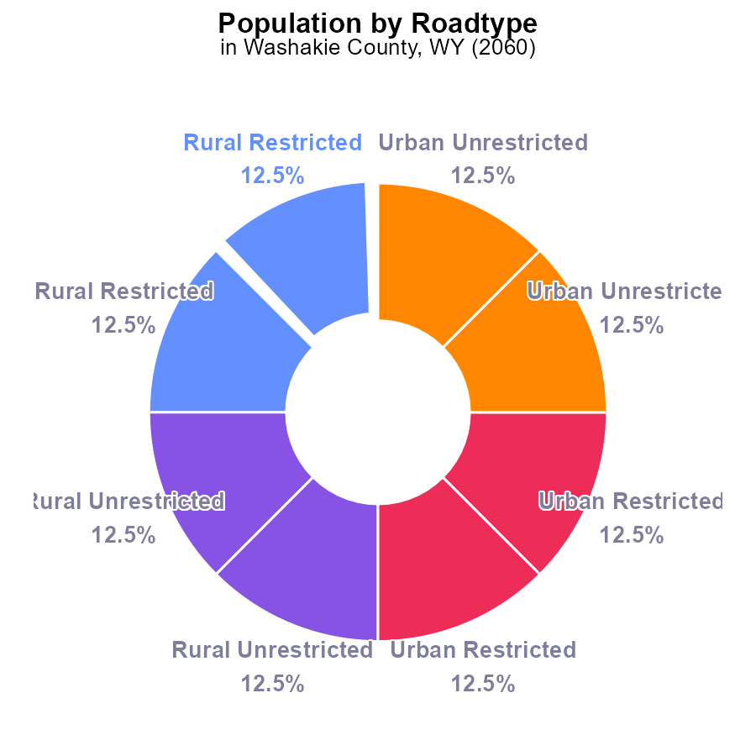

## Findings

* Rural Restricted areas contribute 25% of PM10 emissions.
* Urban areas, both Restricted and Unrestricted, each contribute 25% of PM10 emissions.
* Washakie County's total PM10 emissions in 2060 are 63.2 k.

## Recommendations

To lower PM10 emissions in Washakie County, focus on reducing emissions from Rural Restricted areas by implementing stricter regulations. Additionally, invest in clean energy initiatives in both Urban areas to decrease overall pollution levels.

# Emissions Rate (per capita) by Regulatory Class

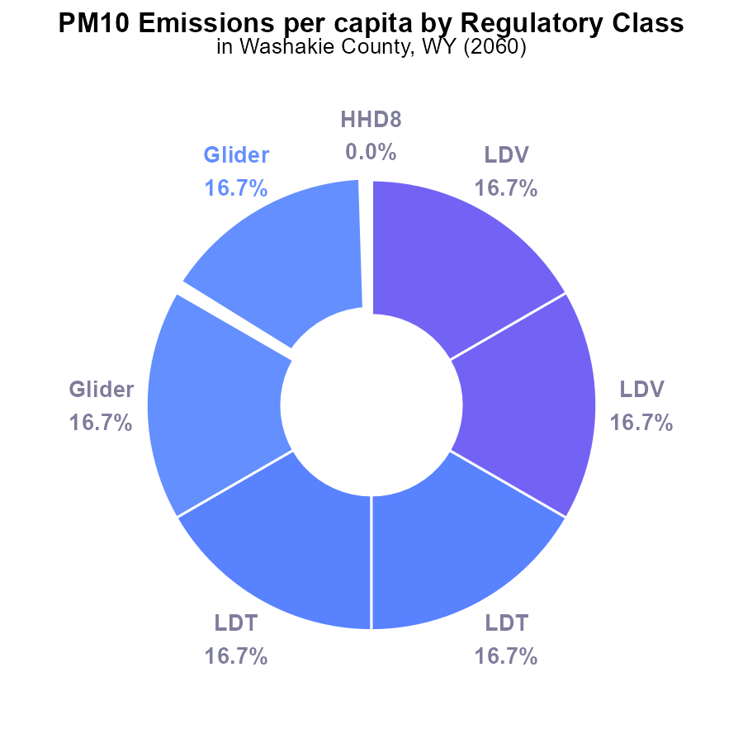

## Findings

* Glider, LDT, and LDV vehicles contribute to 100% of PM10 emissions in Washakie County.
* Heavy-duty vehicles (HHD8, HHD34, HHD45) and other vehicle types contribute 0% to PM10 emissions per capita.
* There is a significant need to focus on reducing emissions from Glider, LDT, and LDV vehicles.

## Recommendations

To lower PM10 emissions in Washakie County, policymakers should prioritize implementing stricter emission standards specifically targeting Glider, LDT, and LDV vehicles. Additionally, investing in public transportation and promoting carpooling can help reduce individual car usage, leading to lower emissions.

# Population over Time for Buses

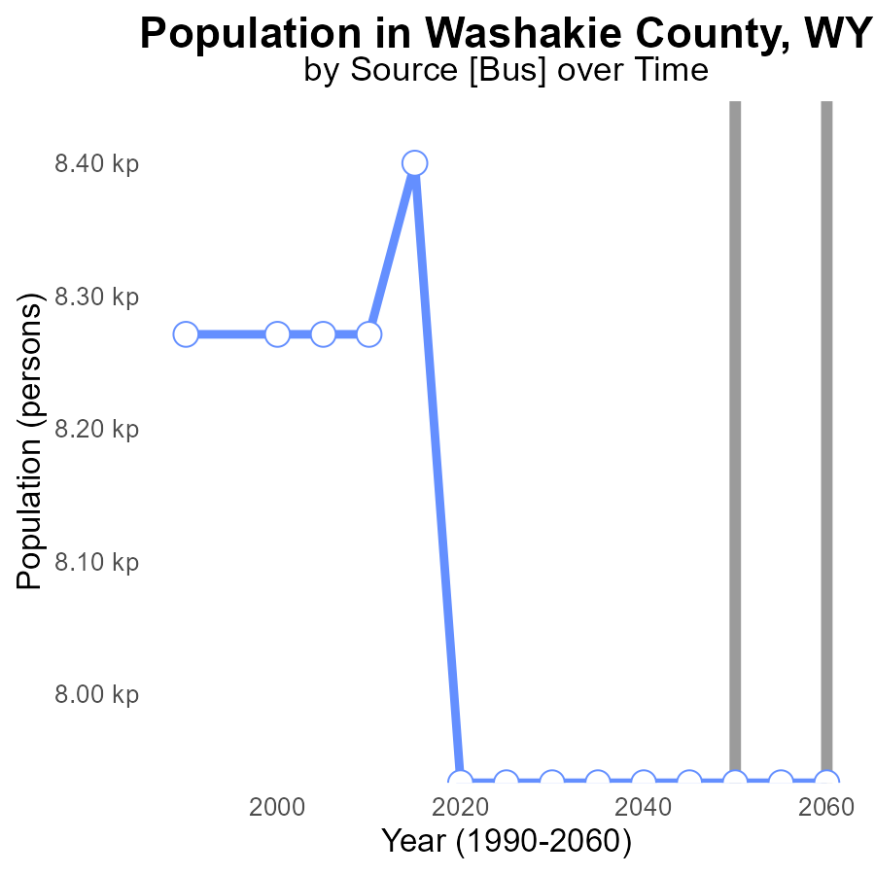

## Findings

* In Washakie County, WY, PM10 emissions are projected to stay constant at 7.9 kilotons from 2040 to 2060.
* The emissions are consistently meeting the benchmark, showing no improvement or deterioration over the years.
* Stagnant emissions levels call for a review of current policies and implementation of more effective air quality measures.

## Recommendations

To lower PM10 emissions in Washakie County, consider evaluating existing pollution control strategies and introducing new initiatives. Regular monitoring and collaboration with industries can ensure adherence to emission standards.

# Emissions Rate (per mile) Overall over Time

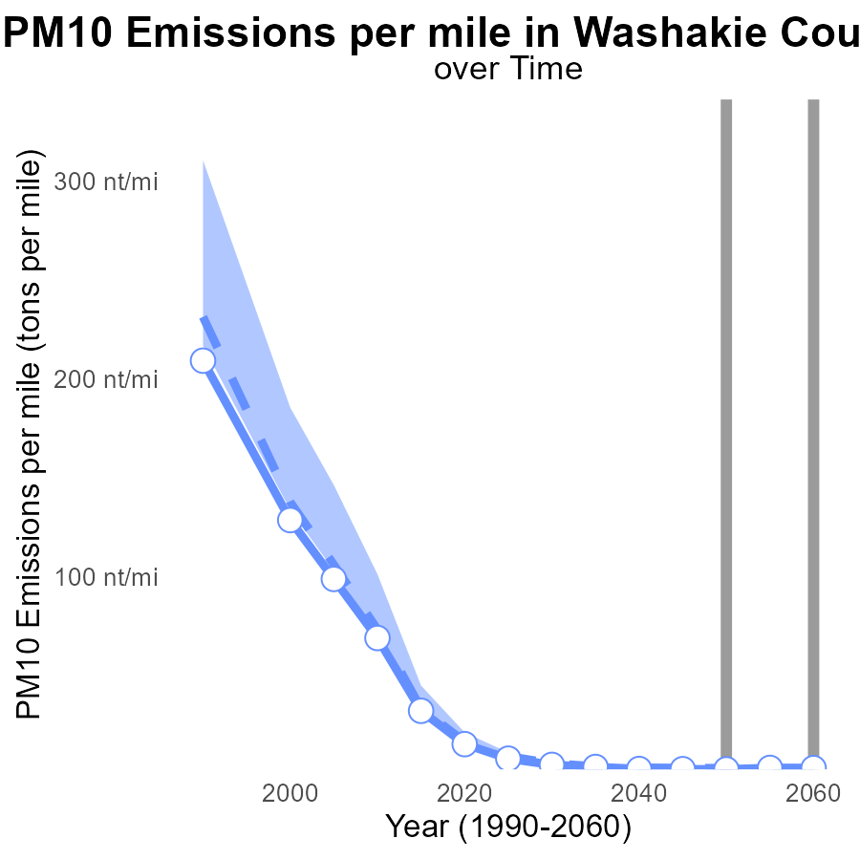

## Findings

* Washakie County's PM10 emissions per mile are projected to decrease by 0.2 tons from 2040 to 2060.
* In 2055, PM10 emissions are expected to increase by 0.8 tons per mile compared to 2040.
* Despite fluctuations, emissions levels in Washakie County remain consistently below the median area benchmark.

## Recommendations

To further decrease PM10 emissions, consider investing in sustainable transportation methods and enforcing stricter emission regulations in the county.

# Hotelling (Engines Off) in My Region

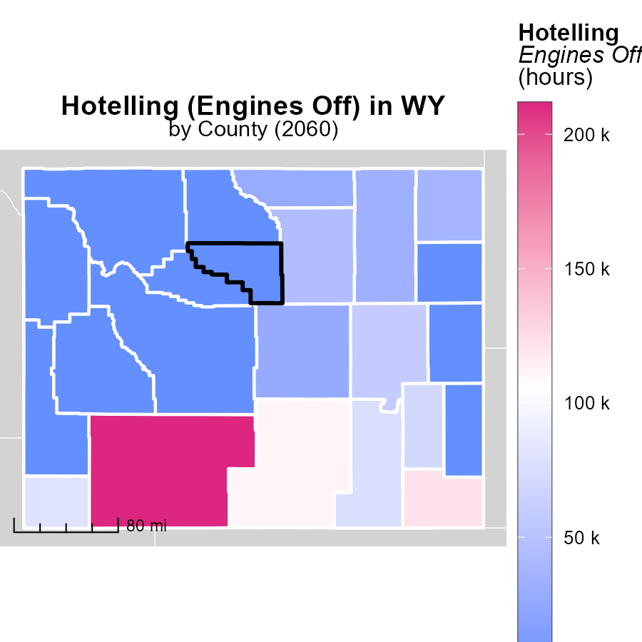

## Findings

* Sweetwater County, WY has the highest emissions with 211.7k hours.
* Natrona County, WY has median emissions at 27.3k hours.
* Weston County, WY shows the lowest emissions with 0.0 hours.

## Recommendations

To lower emissions, focus on reducing engine idling in Sweetwater County. Implement programs to promote engine-off policies. Encourage the use of alternative transportation methods to decrease idle time.

# Idling Mapped by Area

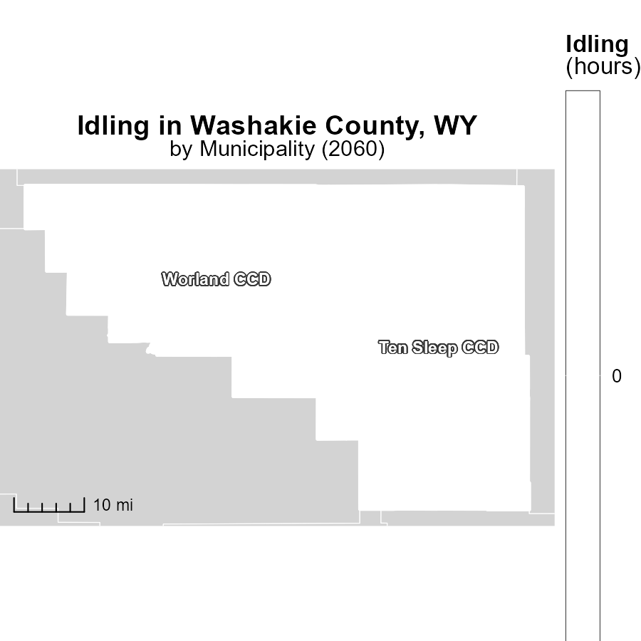

## Findings

* Idling emissions in 2060 were highest in Ten Sleep CCD, WY, at 0.0 hours.
* The median idling emissions in 2060 in both Ten Sleep CCD and Worland CCD, WY, were 0.0 hours.
* The lowest idling emissions in 2060 were recorded in Worland CCD, WY, at 0.0 hours.

## Recommendations

To reduce idling emissions in these areas, policies promoting the use of alternative fuels, implementing idling reduction technologies, and promoting carpooling or the use of public transportation can be effective.

# Emissions Rate (per capita) by Regulatory Class over Time

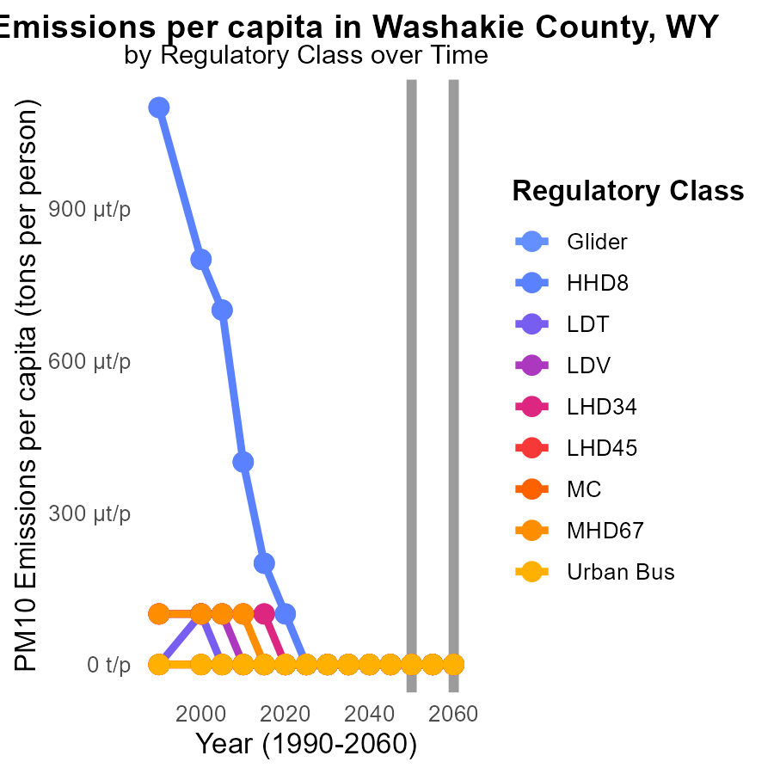

## Findings

* In 2050, Glider, LDT, LDV, and MC had emissions of 12.6 µ per person.
* All vehicle types showed no change in emissions by 2060.
* In 2050, HHD8, LHD34, LHD45, MHD67, and Urban Bus had no emissions.

## Recommendations

To lower emissions, focus on improving Glider, LDT, LDV, and MC efficiencies as they have consistent emissions per capita. Develop sustainable alternatives for vehicle types with no emissions.

# Population by Regulatory Class over Time

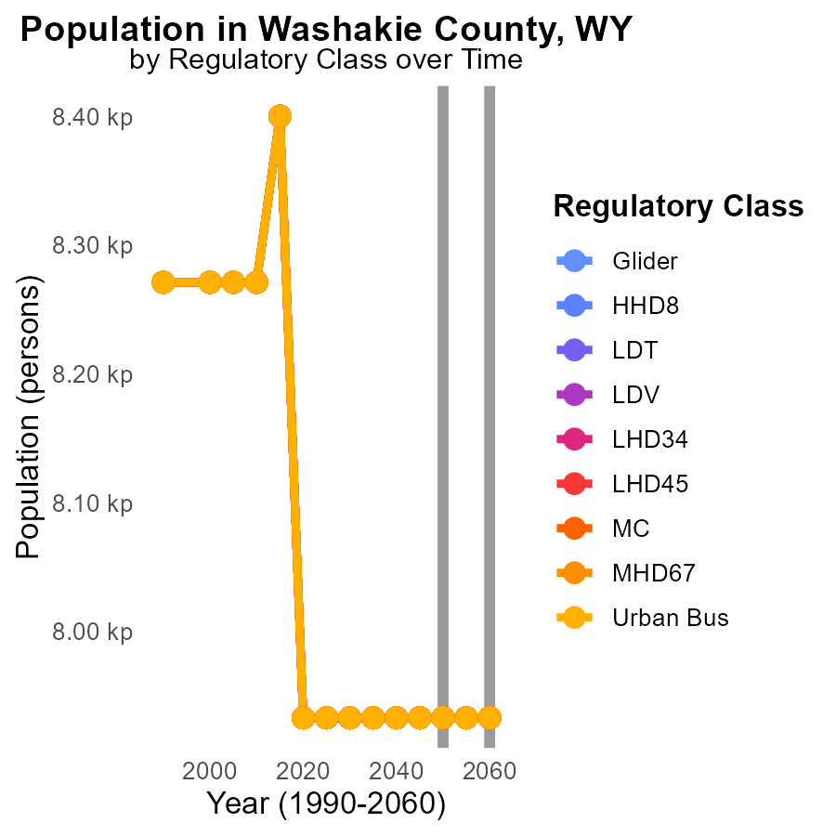

## Findings

* Stable PM10 emissions of 7.9k tons from 2050 to 2060 across all vehicle types in Washakie County.
* No change in emissions despite different vehicle classes including Glider, HHD8, LDV, and others.
* Consistent emissions indicate a need for targeted emission reduction strategies to improve air quality.

## Recommendations

Given the stable emissions over time, policymakers should focus on implementing stricter emission regulations, promoting the use of cleaner fuels, and incentivizing the adoption of electric vehicles to reduce PM10 levels in Washakie County.

# Areas Ranked by Vehicle Starts

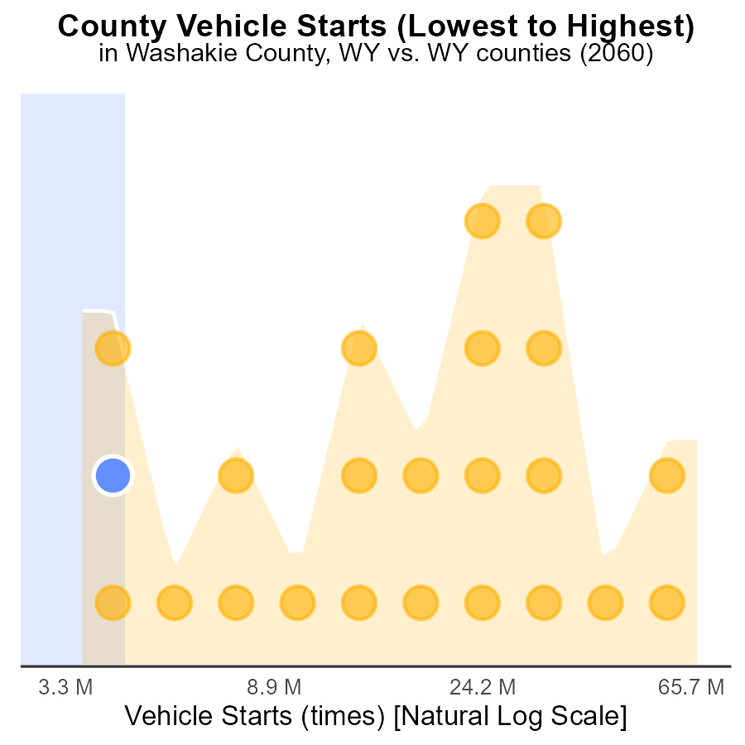

## Findings

* Laramie county has the highest number of vehicle starts with 183.9 million.
* Weston county has the highest percentile of vehicle starts at 13.0%.
* Hot Springs county ranks first with 9.6 million vehicle starts.

## Recommendations

To decrease emissions, implement vehicle start-stop technologies, promote carpooling, and incentivize the use of public transportation to reduce the number of vehicle starts.

# Areas Ranked by Time Driven

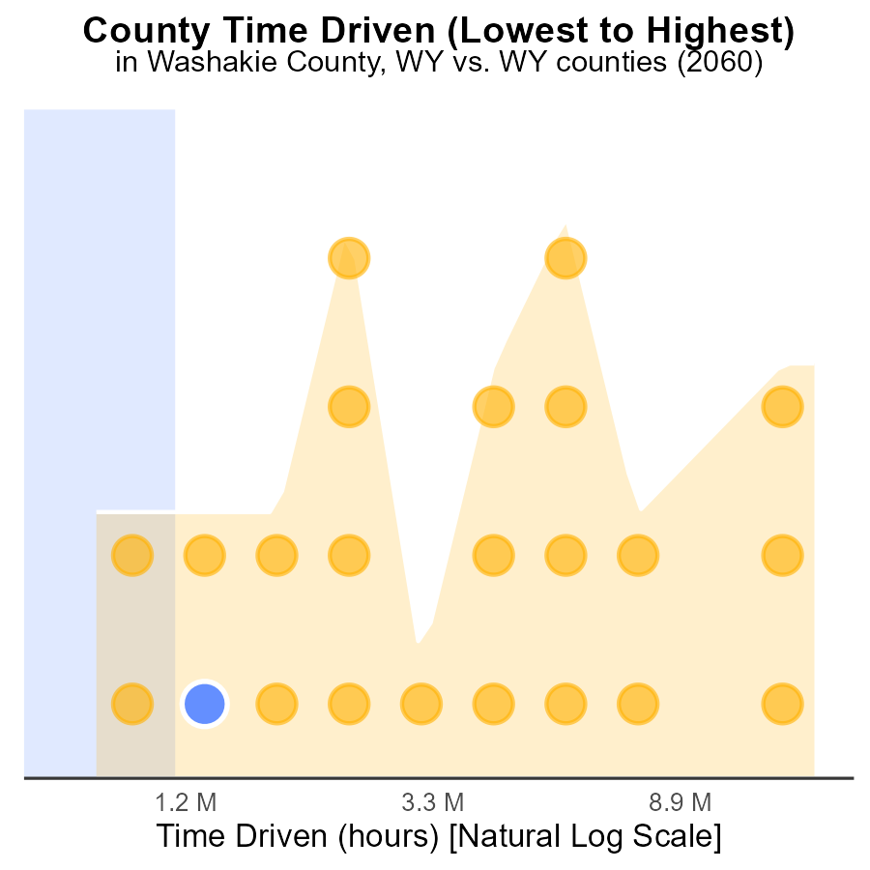

## Findings

* Laramie county contributes to 100.0% of PM10 emissions in the region.
* Niobrara county ranks 4th but contributes a significant 17.4% to PM10 emissions.
* Hot Springs county ranks 1st with 4.3% of PM10 emissions, indicating lower pollution levels.

## Recommendations

Efforts to reduce PM10 emissions should focus on Laramie and Niobrara counties due to their substantial contributions. Implement stricter emissions controls for major sources in these counties to lower pollution levels effectively.

# Conclusion

In conclusion, the data on Primary Exhaust PM10 - Total emissions from on-road transportation in Washakie County, WY in 2060 highlights several key findings. Firstly, the distribution of PM10 emissions across different areas within Washakie County indicates that Rural Restricted areas are significant contributors. This emphasizes the importance of implementing stricter regulations in these regions to lower emissions. Additionally, a focus on clean energy initiatives in Urban areas can help decrease overall pollution levels. Secondly, the concentration of PM10 emissions from Glider, LDT, and LDV vehicles underscores the need for targeted strategies to reduce emissions from these vehicle types. Thirdly, despite stagnant overall PM10 emissions levels from 2040 to 2060, there is a pressing need to review current policies and consider more effective air quality measures to ensure continued improvement. Finally, the projection of decreasing PM10 emissions per mile suggests progress, but fluctuations in emissions over the years call for sustained efforts in investing in sustainable transportation methods and enforcing stricter emission regulations in Washakie County.

To address the challenges posed by PM10 emissions in Washakie County, policymakers should prioritize the implementation of stricter emission standards for Glider, LDT, and LDV vehicles, invest in public transportation, and promote carpooling to reduce individual car usage. Furthermore, evaluating existing pollution control strategies, introducing new initiatives, and collaborating with industries for adherence to emission standards can lead to improved air quality in the region. By focusing on these strategies and sustaining efforts to lower emissions, Washakie County can achieve a cleaner and healthier environment for its residents and future generations.

# About This Report

Data based on MOVES estimates collected by the Climate Action in Transportation program at Cornell University. Demographic data sourced from the US Census's American Community Survey 5-year estimates. This report was generated with the help of AI.

# References

* U.S. Census Bureau. (2023). American Community Survey 5-year estimates: Detailed tables. Retrieved from https://data.census.gov
* U.S. Environmental Protection Agency. (2024). Motor Vehicle Emission Simulator (MOVES 4.0) [Software]. Retrieved from https://www.epa.gov/moves