 

**SO2 Emissions in Archer County, 2030**  
Made with CAT VISUALIZER by Gao Labs @ Cornell University.

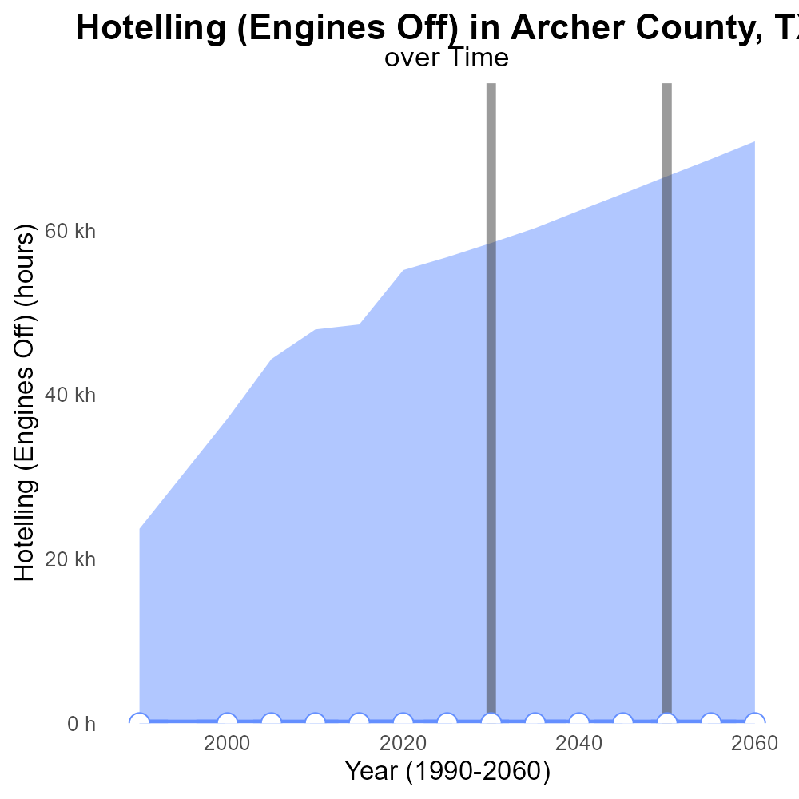

## Keywords

Sulfur Dioxides emissions; on-road transportation; Archer County; TX; 2030

## Highlights

* In 2030, Archer County, TX faces concerning SO2 emissions from on-road transportation.
* Monitoring these emissions is crucial for environmental and public health assessments.
* Understanding the sources and impacts of SO2 is vital for effective mitigation strategies.
* Projections indicate a potential increase in SO2 emissions without intervention.
* This report aims to analyze and propose solutions for managing SO2 emissions in the county.

# Introduction

In 2030, the issue of Sulfur Dioxide (SO2) emissions from on-road transportation in Archer County, Texas has gained significant attention due to its environmental and public health implications. SO2 is a harmful air pollutant that can cause respiratory issues and contribute to acid rain formation when released into the atmosphere. Monitoring and reducing these emissions have become a critical priority for local authorities and environmental agencies. It is imperative to understand the sources, trends, and potential consequences of SO2 emissions in order to develop effective mitigation strategies and safeguard the well-being of the community.

Projections for 2030 suggest a concerning increase in SO2 emissions from on-road transportation in Archer County if current trends persist. This report aims to provide a comprehensive analysis of the situation, examining the contributing factors, potential impacts, and proposing sustainable solutions to manage and reduce SO2 emissions effectively.

# Emissions Rate (per capita) Overall by Area

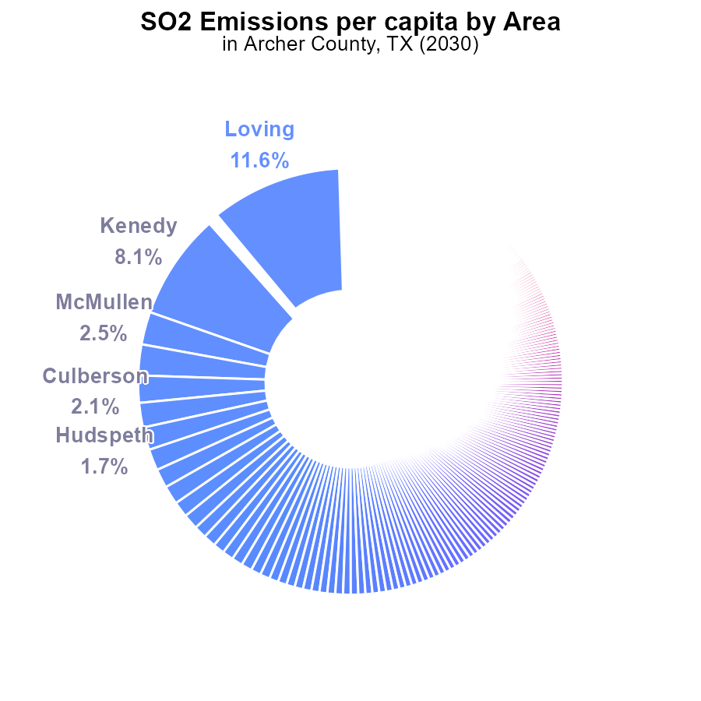

## Findings

* The highest SO2 emissions per capita in Archer County, TX, in 2030 were from Loving at 2.6 tons per person.
* The top five contributors to SO2 emissions per capita accounted for 20.6% of the total emissions.
* Fort Bend had the lowest SO2 emissions per capita at 16.2 µ tons per person.

## Recommendations

Policy interventions focusing on the top contributors can significantly reduce overall SO2 emissions in Archer County, TX by implementing cleaner technologies and stricter emissions standards.

# Idling by Road Type

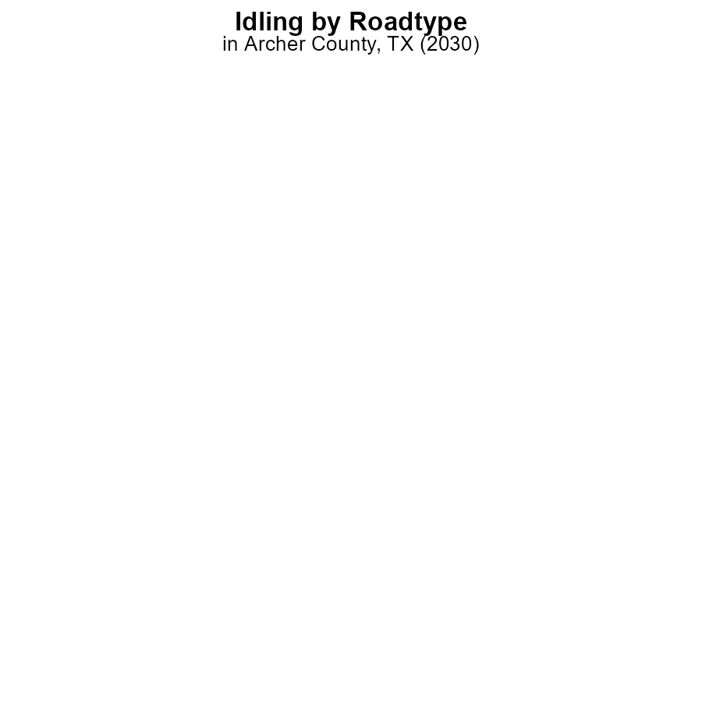

## Findings

* In 2030, Archer County, TX recorded 0.0 hours of idling emissions for SO2 across all categories.
* No specific category in terms of area type (rural or urban) showed any idling emissions for SO2 in 2030.
* This indicates a complete absence of SO2 emissions from idling activities in Archer County, TX in 2030.

## Recommendations

To maintain this excellent standard and continue to reduce emissions, policymakers should focus on promoting and enforcing idling reduction measures, such as anti-idling campaigns and regulations in the county.

# Hotelling (Engines Off) Overall over Time

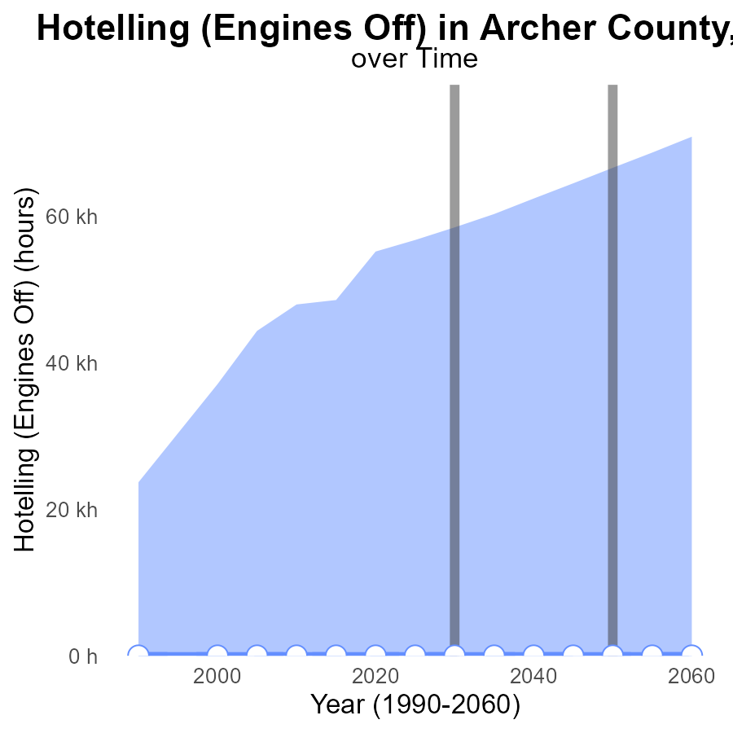

## Findings

* From 2010 to 2050, there was no observed SO2 emissions in Archer County, TX related to Hotelling (Engines Off) activities.
* The median area emission level consistently stayed at 0, with no difference compared to upper or lower percentiles.
* Benchmark differences were consistently at 0, indicating no deviations from expected emission levels.

## Recommendations

Given the consistent lack of SO2 emissions in Archer County, TX, it is recommended to continue monitoring to ensure early detection of any potential pollution sources and maintain stringent emission control measures.

# Emissions Rate (per mile) over Time for Passenger Vehicles

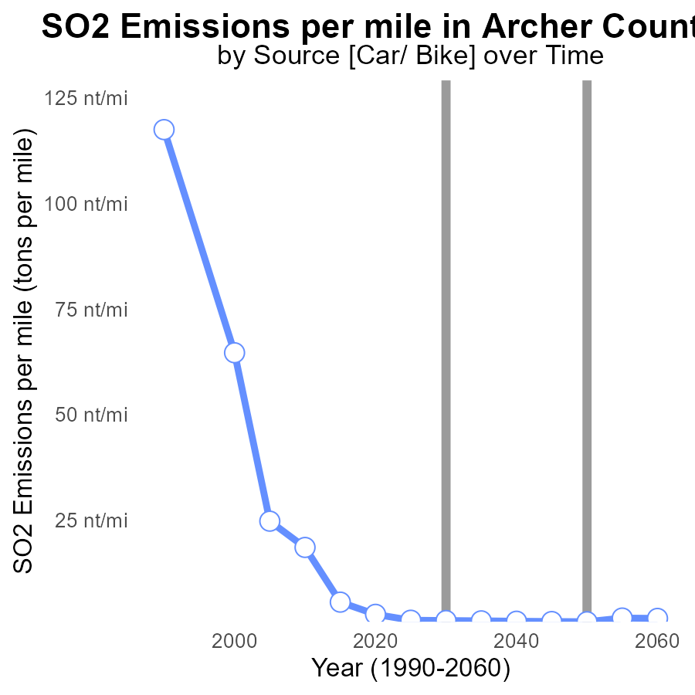

## Findings

* SO2 emissions in Archer County, TX have decreased consistently from 2010 to 2050.
* There was a significant drop in SO2 emissions from 2010 (18.5 tons per mile) to 2020 (2.7 tons per mile).
* By 2050, SO2 emissions had drastically declined to 953.0 pounds per mile, marking a substantial reduction.

## Recommendations

To continue the decreasing trend in SO2 emissions, policymakers should focus on promoting renewable energy sources, implementing stricter emission regulations for industries and vehicles, and investing in technology to reduce pollution.

# Idling Mapped by Area

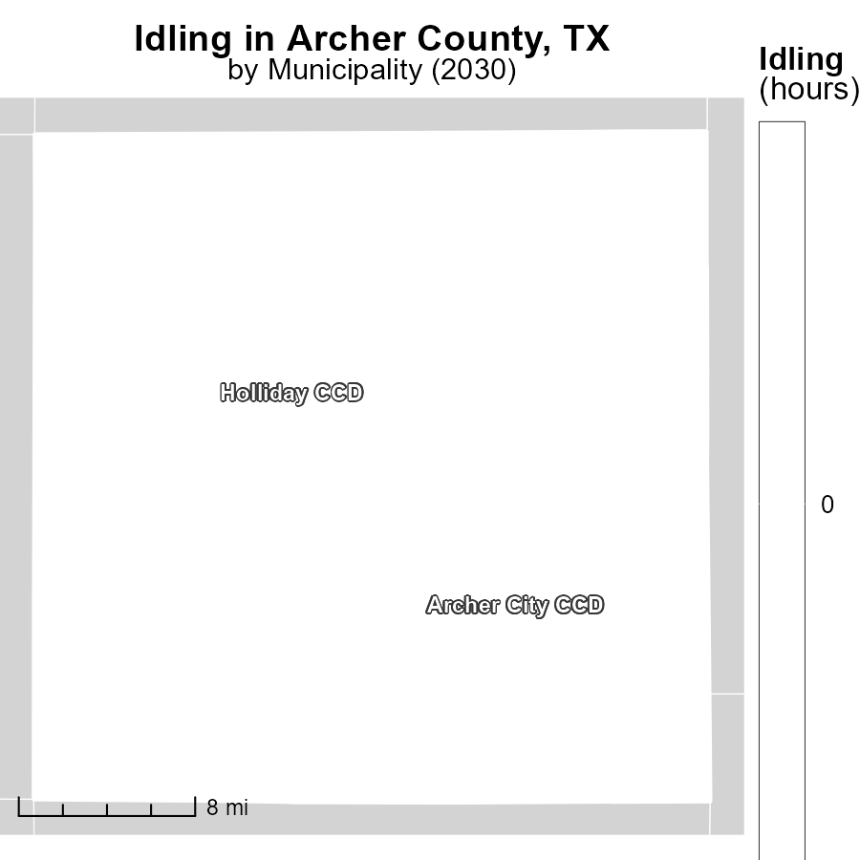

## Findings

* Archer City CCD, TX has the highest idling hours in 2030 with 0.0 hours.
* Holliday CCD, TX has a median idling time of 0.0 hours in 2030.

## Recommendations

To lower emissions, policies can be implemented to reduce idling in both Archer City CCD and Holliday CCD, potentially through increased awareness campaigns or incentives for using idling reduction technologies.

# Hotelling (Engines Off) in My Region

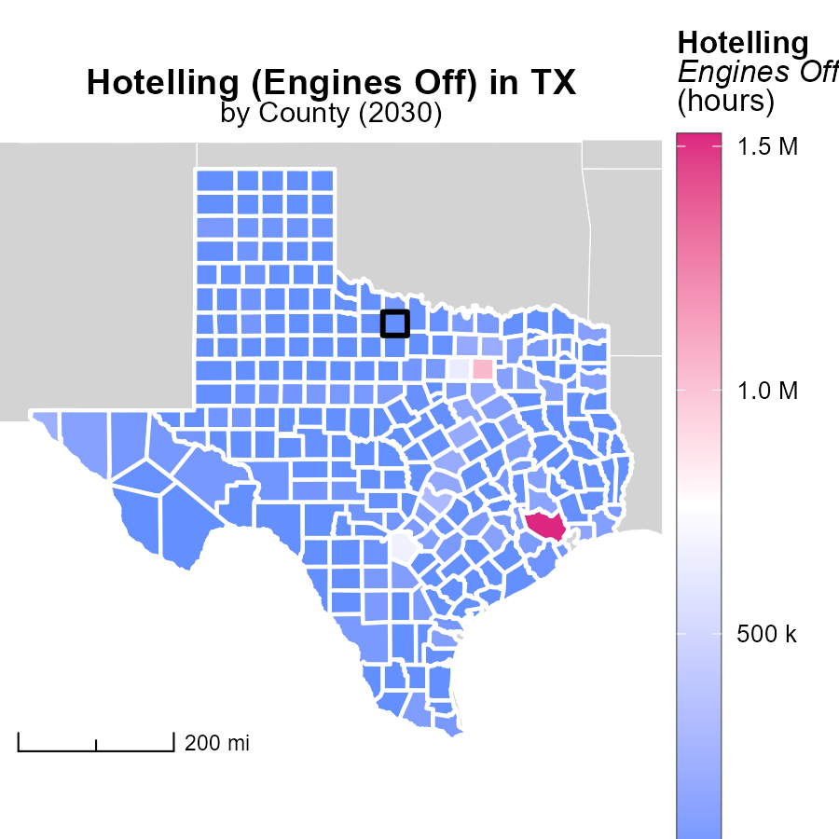

## Findings

* Harris County, TX has the highest emissions with 1.5 million hours.
* Briscoe County, TX has no emissions during the specified period.
* Zavala County, TX also shows no emissions for this category.

## Recommendations

To reduce emissions, strategies could include promoting the use of electric vehicles in Harris County, implementing idle reduction measures in Briscoe County, and exploring alternative transportation options in Zavala County.

# Emissions Rate (per vehicle) by Road Type over Time

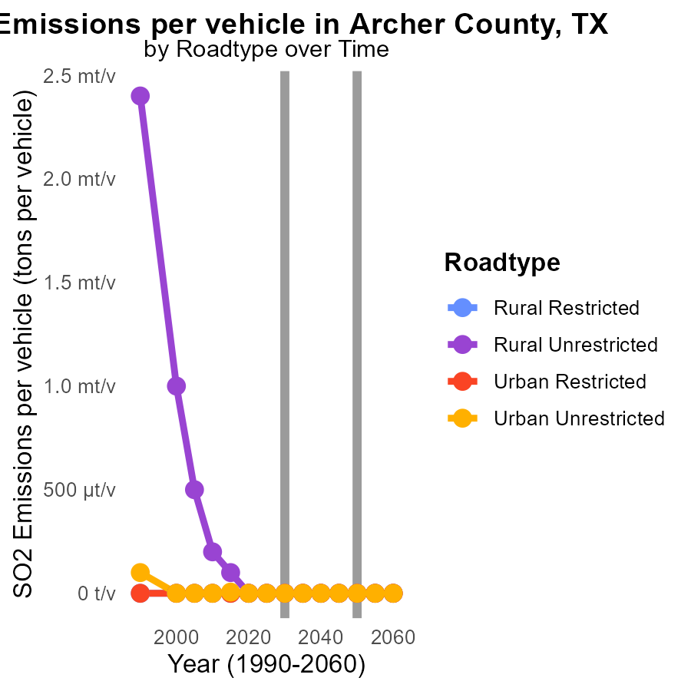

## Findings

* By 2040, SO2 emissions per vehicle in Archer County, TX, will decrease to almost zero across all road types.
* Rural Unrestricted areas have the highest initial SO2 emissions per vehicle, dropping from 32.7 µ in 2020 to 24.9 µ in 2040.
* Urban areas show no SO2 emissions per vehicle across all road types from 2020 to 2040.

## Recommendations

To further reduce emissions, the county should focus on incentivizing cleaner vehicle technologies and promoting public transport to maintain the decreasing trend. Additionally, implementing stricter emission standards for vehicles in rural unrestricted areas can help lower emissions more effectively.

# Emissions Rate (per vehicle) by Regulatory Class over Time

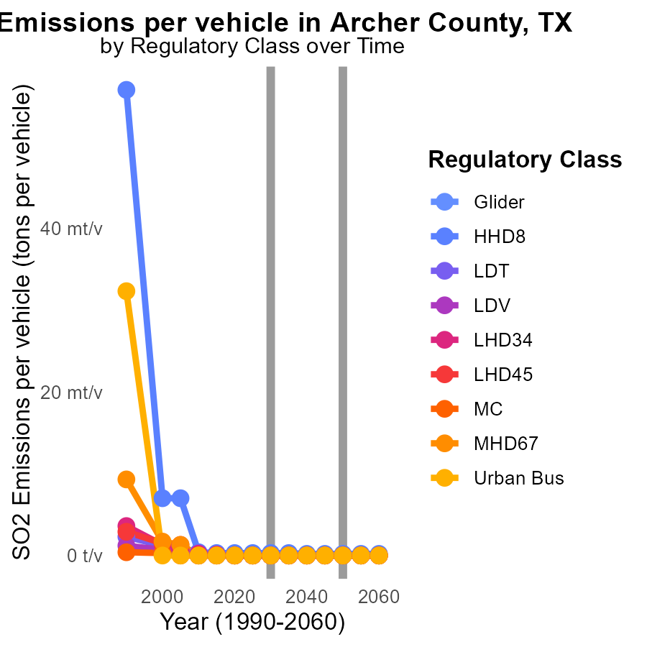

## Findings

* In 2020, the highest SO2 emissions per vehicle were from HHD8 at 302.1 µ tons per vehicle, followed by LDT at 31.6 µ and LDV at 30.8 µ.
* By 2040, emissions decreased significantly across all vehicle types, with HHD8 reducing to 238.2 µ, LDT to 20.9 µ, and LDV to 12.8 µ.
* Urban Bus, MC, MHD67, LHD45, LHD34, and Glider had no SO2 emissions per vehicle from 2020 to 2040.

## Recommendations

To further reduce SO2 emissions in Archer County, focus on implementing stricter regulations for heavy-duty vehicles (HHD8), light-duty trucks (LDT), and light-duty vehicles (LDV). Encourage the adoption of cleaner fuel technologies in these categories.

# Areas Ranked by Time Driven

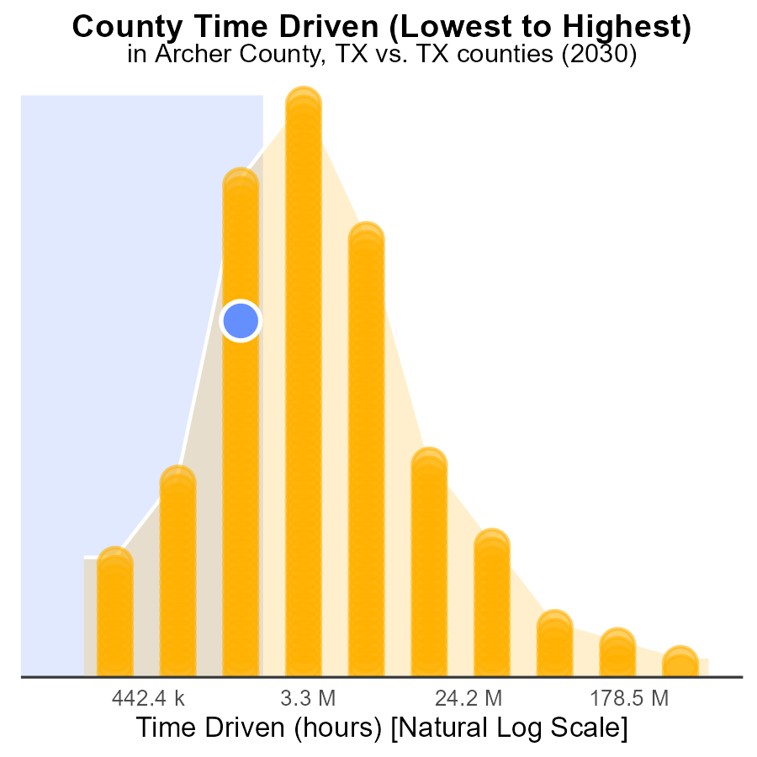

## Findings

* Harris county is the highest SO2 emitter, accounting for 100.0% of emissions.
* Briscoe county emits the least SO2, contributing only 0.4% of the total.
* Archer, Childress, and Franklin counties have similar SO2 emissions, ranging from 29.1% to 29.9%.

## Recommendations

To reduce emissions, targeted strategies should focus on Harris county due to its significant contribution. Implement stricter emissions controls and transition to cleaner energy sources in this county.

# Areas Ranked by Hotelling (Diesel Aux)

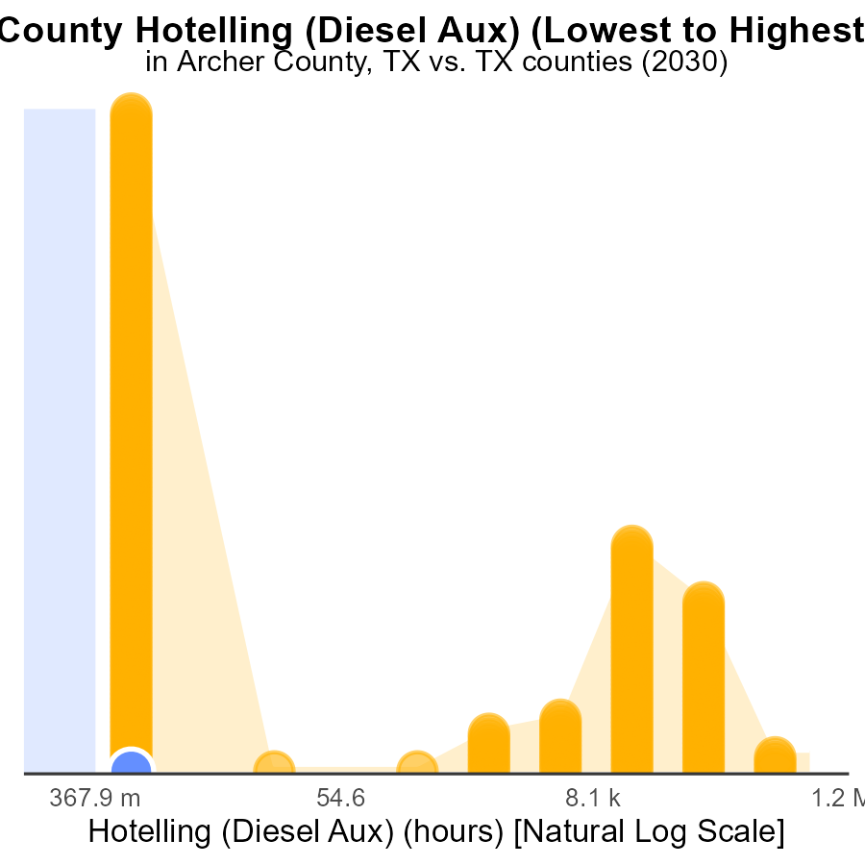

## Findings

* Archer county has the lowest SO2 emissions with 0.0 hours.
* Harris county ranks 254th out of all counties with 1.7 M hours, representing 100.0% of emissions.
* Archer county is consistent in its low emissions, ranking 1st and occupying 55.5% of emissions.

## Recommendations

To lower SO2 emissions, focus on counties with higher rankings like Harris by implementing stricter emission control measures. Additionally, continue monitoring and supporting low emitting counties like Archer to maintain their low emissions levels.

# Conclusion

In conclusion, the data from Archer County, TX in 2030 regarding Sulfur Dioxides (SO2) emissions from on-road transportation paints a promising picture. The county has shown a consistent decrease in SO2 emissions per vehicle, indicating a positive trend towards lower overall pollution levels. Policy interventions focusing on top contributors have the potential to significantly reduce emissions, especially with cleaner technologies and stricter emissions standards in place.

Furthermore, the absence of idling emissions and the notable reduction in SO2 emissions over the years demonstrate that targeted strategies and continuous monitoring are effective in maintaining low emission levels. Moving forward, promoting renewable energy sources, enforcing stricter emission regulations, and investing in pollution-reducing technologies remain crucial steps towards further lowering SO2 emissions in Archer County, TX.

# About This Report

Data based on MOVES estimates collected by the Climate Action in Transportation program at Cornell University. Demographic data sourced from the US Census's American Community Survey 5-year estimates. This report was generated with the help of AI.

# References

* U.S. Census Bureau. (2023). American Community Survey 5-year estimates: Detailed tables. Retrieved from https://data.census.gov
* U.S. Environmental Protection Agency. (2024). Motor Vehicle Emission Simulator (MOVES 4.0) [Software]. Retrieved from https://www.epa.gov/moves