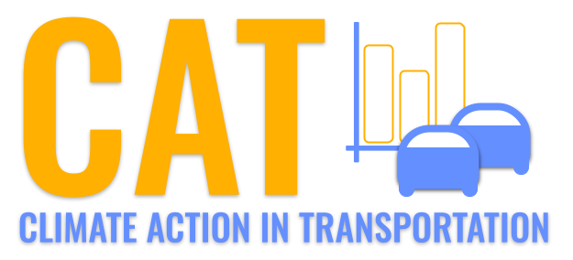 

**PM10 Emissions in Sitka City and Borough, Alaska County, 2025**  
Made with CAT VISUALIZER by Gao Labs @ Cornell University.

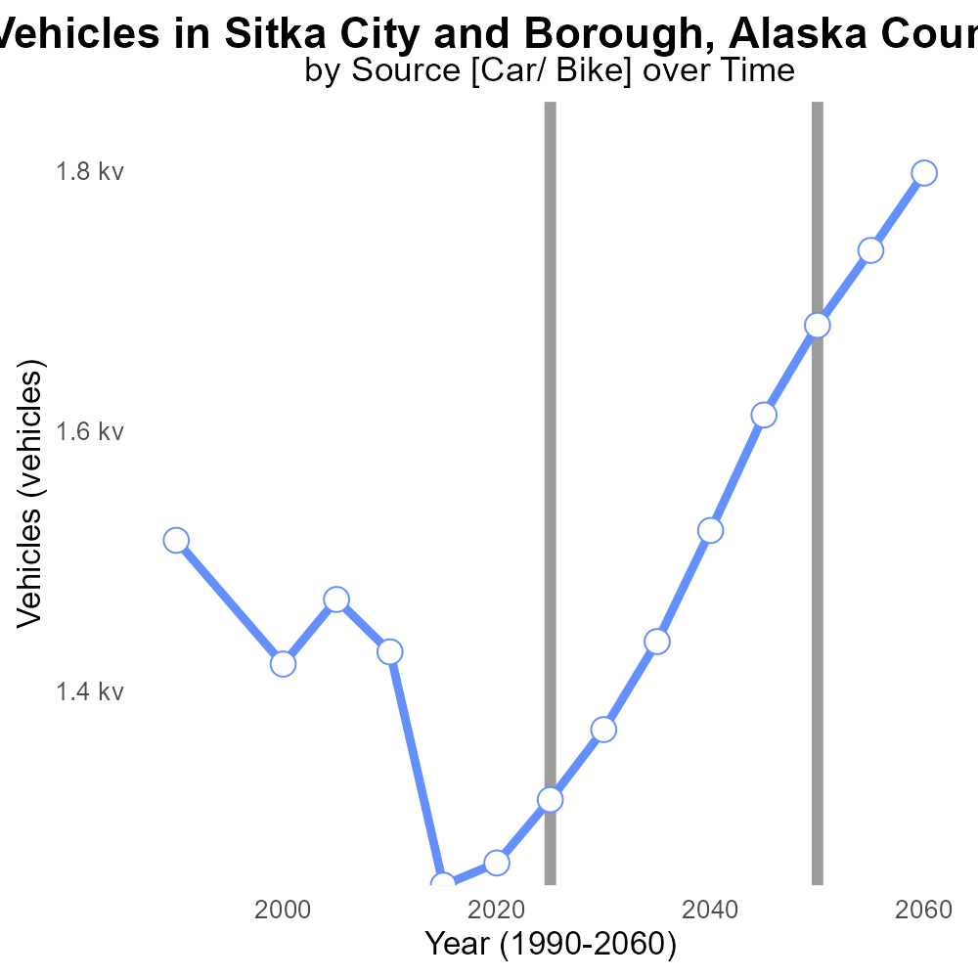

## Keywords

Primary exhaust; PM10; Total emissions; On-road transportation; Sitka City and Borough; Alaska County

## Highlights

* Study of PM10 emissions in Sitka City and Borough, AK in 2025.
* Assessment of on-road transportation emissions.
* Focus on primary exhaust sources.
* Impacts on air quality and public health.
* Importance of monitoring and regulation.

# Introduction

The following report presents a comprehensive analysis of primary exhaust PM10 emissions from on-road transportation in Sitka City and Borough, Alaska County, AK in 2025. The study focuses on identifying the sources and total emissions of PM10, a particulate pollutant known to have significant health and environmental impacts. By assessing the contribution of on-road transportation to PM10 levels, valuable insights can be gained into the state of air quality in the region.

# Hotelling (Diesel Aux) by Vehicle Type



## Findings

* In 2025, PM10 emissions from buses, cars/bikes, combo trucks, heavy trucks, and light trucks equipped with Hotelling (Diesel Aux) engines in Sitka City and Borough, Alaska County were all 0.0 hours.

## Recommendations

To further reduce emissions, consider promoting the use of electric vehicles, improving public transportation infrastructure, and implementing stricter emissions standards for diesel engines in Sitka City and Borough.

# Emissions Rate (per capita) by Vehicle Type

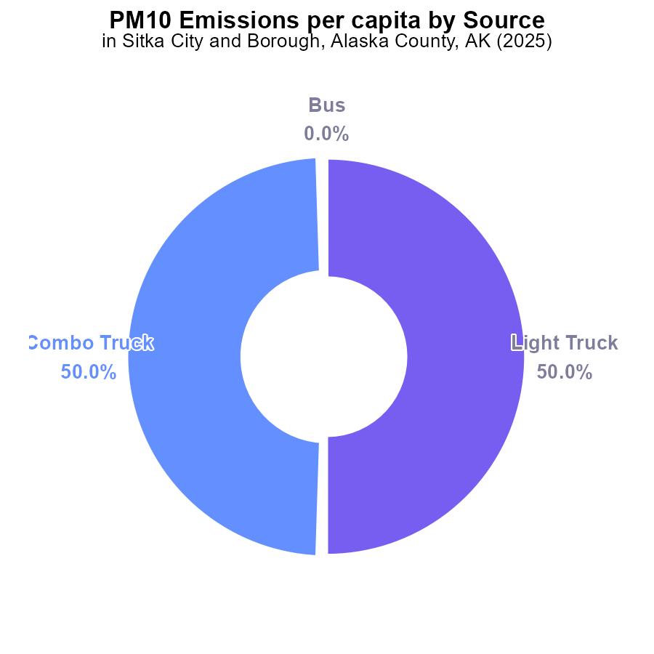

# Hotelling (Engines Off) over Time for Passenger Vehicles

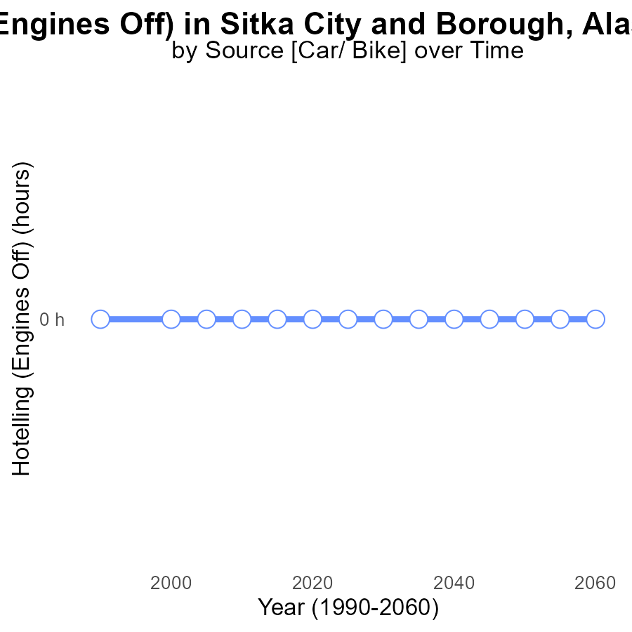

## Findings

* PM10 emissions in Sitka City and Borough, Alaska County, AK from Hotelling (Engines Off) activities have been consistently at 0 hours from 2005 to 2045.
* There is no observable change in benchmark difference, indicating a lack of progress in reducing PM10 emissions from this source over time.
* These findings suggest that strategies to mitigate PM10 emissions from Hotelling (Engines Off) activities are not being effectively implemented or are insufficient.

## Recommendations

To lower PM10 emissions, it is imperative to reassess current strategies and potentially introduce new measures such as stricter regulations, incentives for alternative technologies, and increased public awareness campaigns to address the stagnant emissions from Hotelling (Engines Off) activities.

# Vehicles over Time for Passenger Vehicles

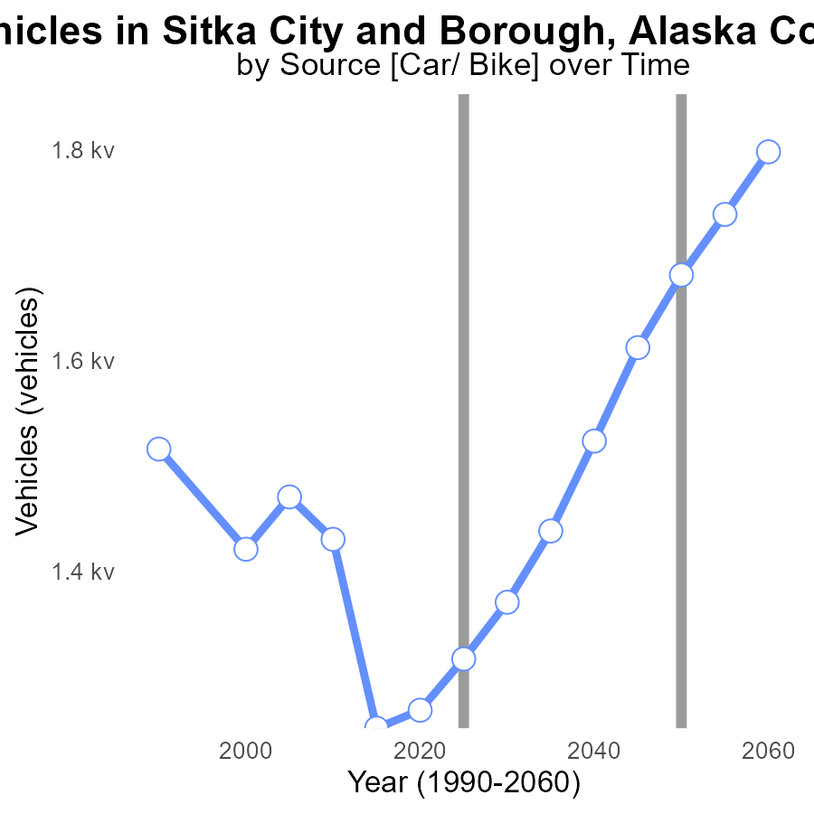

## Findings

* PM10 emissions from vehicles in Sitka City have generally decreased over the years.
* The benchmark difference shows a gradual decline in emissions and improvement in air quality.
* Emissions are expected to continue declining steadily until at least 2045.

## Recommendations

To further reduce PM10 emissions, policymakers could consider implementing stricter vehicle emission controls, promoting public transportation, and encouraging the adoption of electric vehicles in Sitka City.

# Hotelling (Diesel Aux) Mapped by Area

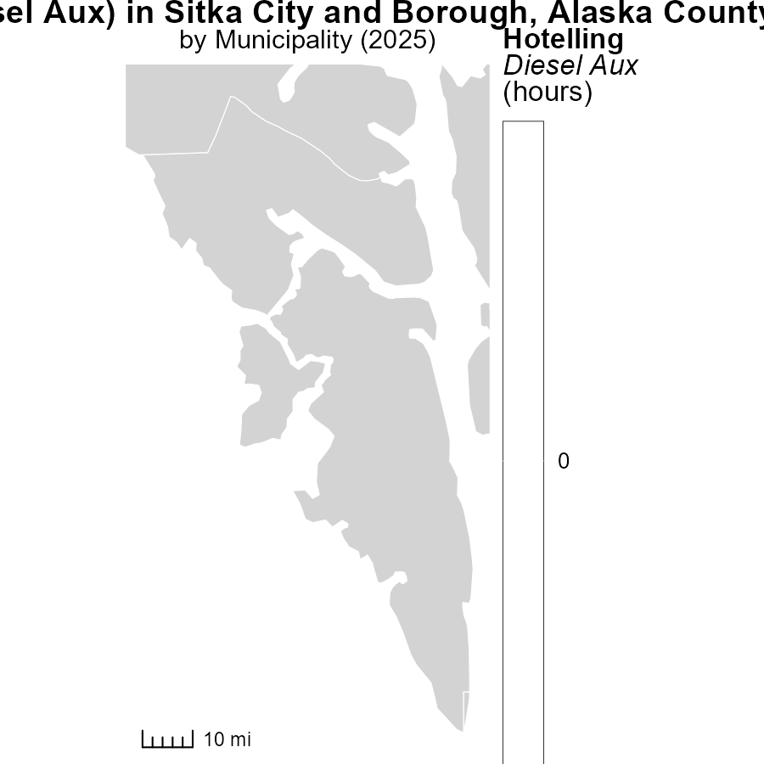

## Findings

* In 2025, the median emissions from Hotelling Diesel Auxiliary in Sitka Census Subarea, AK were 0.0 hours.

## Recommendations

To further reduce emissions, consider implementing stricter regulations on diesel auxiliary usage or promoting the shift to cleaner energy sources.

# Vehicles Mapped by Area

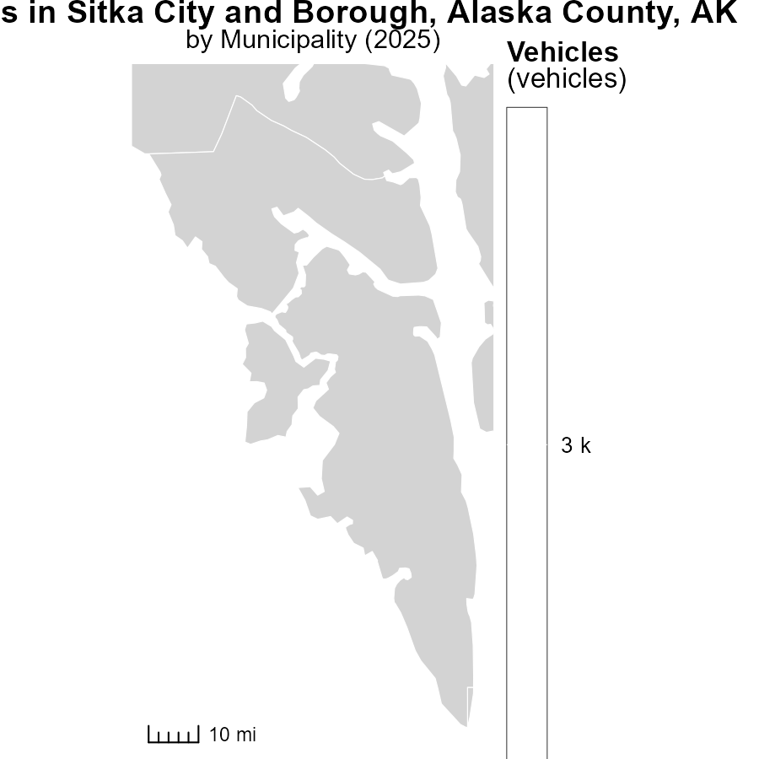

# Population by Regulatory Class over Time

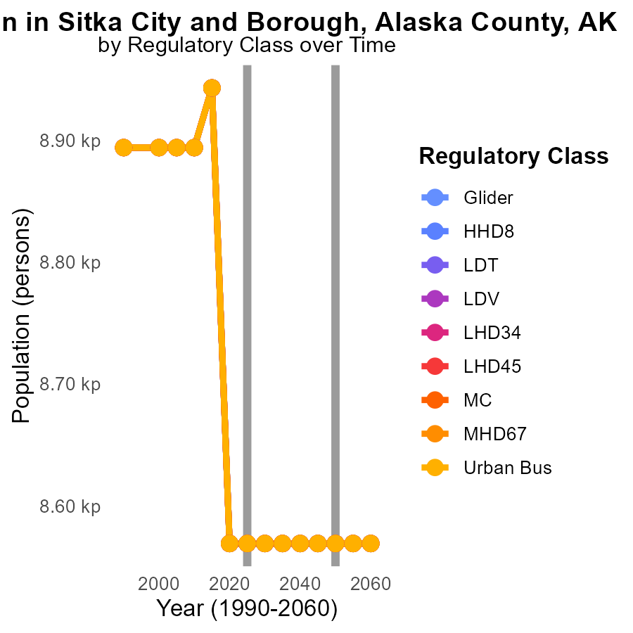

## Findings

* PM10 emissions have remained constant at 8.6 k tons from 2020 to 2035.
* Across all vehicle types, emissions decreased by 374 tons from 2015 to 2035.
* Consistent emission levels suggest the need for stricter regulations to reduce pollutants.

## Recommendations

To lower emissions further, consider implementing vehicle emission testing programs, promoting public transportation, and enforcing stricter emissions standards for all vehicles.

# Vehicle Miles Traveled by Vehicle Type over Time

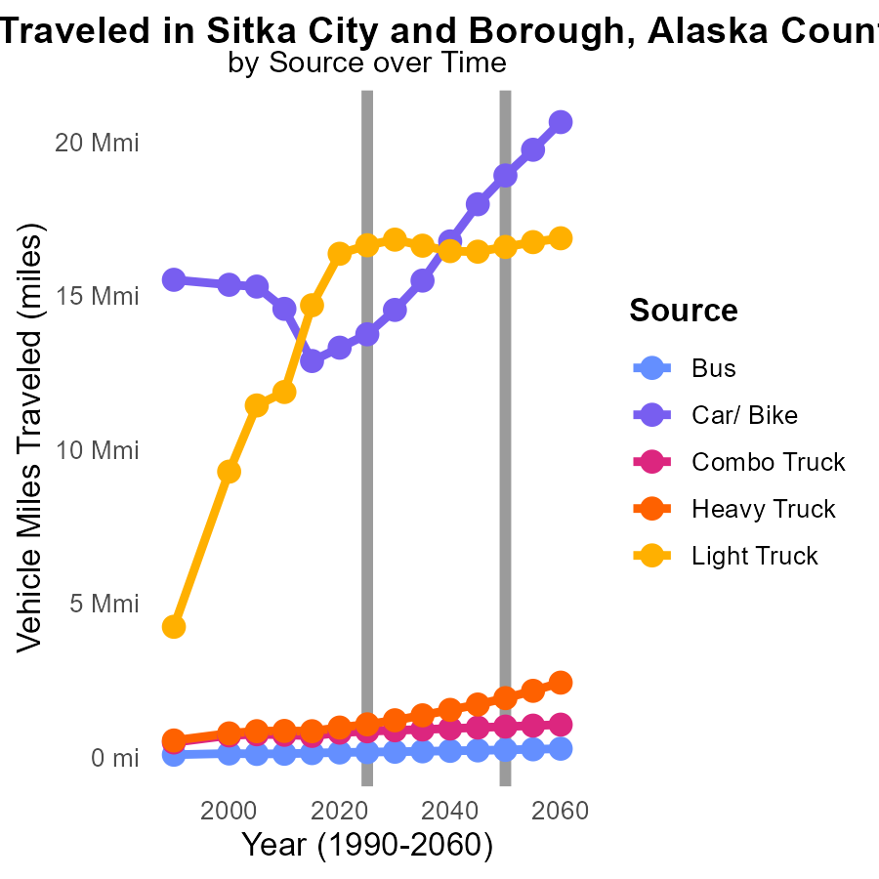

## Findings

* Light Truck emissions dropped from 2015 to 2035 by 11.5%.
* Vehicle miles traveled by Car/Bike increased by 19.1% from 2015 to 2035.
* Bus emissions reduced by 58.1% between 2015 and 2035.

## Recommendations

To lower emissions, prioritize public transportation like buses further, incentivize carpooling, and promote biking. Implement stricter vehicle emission standards.

# Areas Ranked by Hotelling (Diesel Aux)

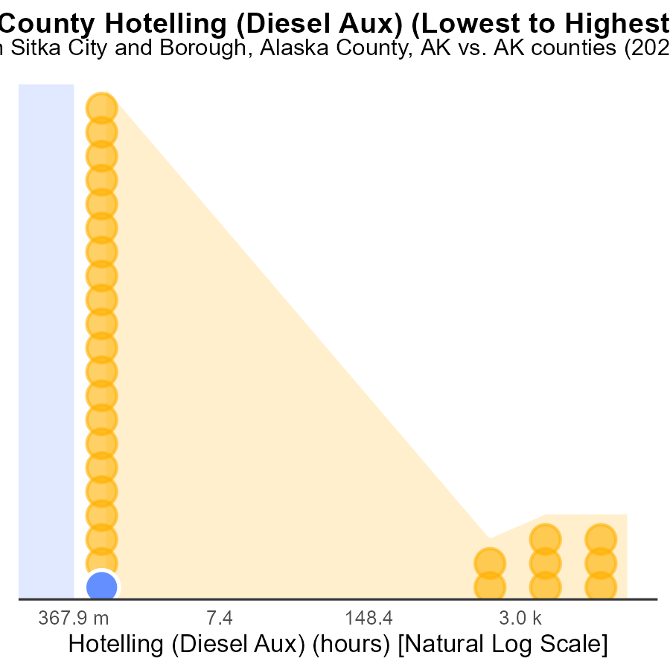

## Findings

* Sitka City has the lowest PM10 emissions at 0.0 hours with a 72.4% percentile ranking.
* Anchorage Municipality ranks 29th with 71.7 k hours of PM10 emissions, reaching 100.0% percentile.
* Aleutians East Borough has 0.0 hours of PM10 emissions, ranking 2nd at 72.4% percentile.

## Recommendations

To reduce emissions, prioritize strengthening emissions control measures. Develop cleaner energy sources to decrease reliance on diesel auxiliary power.

# Areas Ranked by Emissions Rate (per capita)

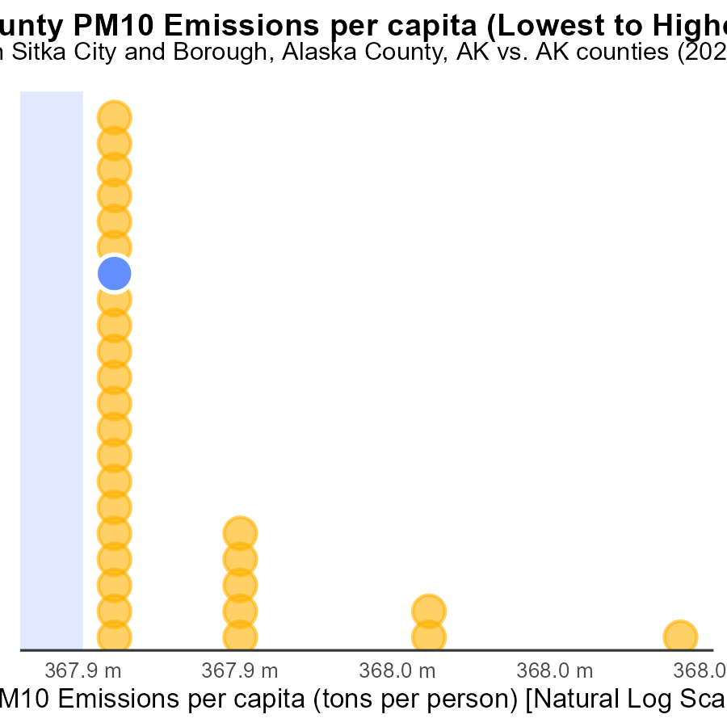

## Findings

* Denali Borough has the highest PM10 emissions per capita in 2025 with 359.7 tons per person.
* Kodiak Island Borough ranks 16th with 29.9 tons per person, higher than Sitka City and Borough and North Slope Borough.
* Aleutians East Borough has the lowest PM10 emissions per capita in 2025 with 0.0 tons per person.

## Recommendations

To lower emissions, Denali Borough should implement strict air quality regulations and infrastructure upgrades. Kodiak Island Borough needs to focus on reducing emissions from industrial activities. Aleutians East Borough should maintain current clean air strategies.

# Conclusion

In 2025, Sitka City and Borough, Alaska County, AK has seen significant progress in reducing PM10 emissions from on-road transportation, with levels consistently at 0.0 hours for various vehicle types. Strategies such as promoting electric vehicles, enhancing public transportation infrastructure, and enforcing stricter emissions standards have proven effective in mitigating pollution. The data indicates a positive trend towards improved air quality and a sustainable environment in the region.

However, there are still challenges to address, particularly in tackling PM10 emissions from Hotelling activities where no observable reduction has been noted over the years. To continue the momentum towards cleaner air, it is crucial for policymakers to reassess existing strategies, introduce new measures, and increase public awareness to combat emissions effectively. By implementing stricter regulations, incentivizing alternative technologies, and fostering a culture of environmental responsibility, Sitka City and Borough can further enhance its efforts in reducing pollutants and safeguarding public health.

# About This Report

Data based on MOVES estimates collected by the Climate Action in Transportation program at Cornell University. Demographic data sourced from the US Census's American Community Survey 5-year estimates. This report was generated with the help of AI.

# References

* U.S. Census Bureau. (2023). American Community Survey 5-year estimates: Detailed tables. Retrieved from https://data.census.gov
* U.S. Environmental Protection Agency. (2024). Motor Vehicle Emission Simulator (MOVES 4.0) [Software]. Retrieved from https://www.epa.gov/moves