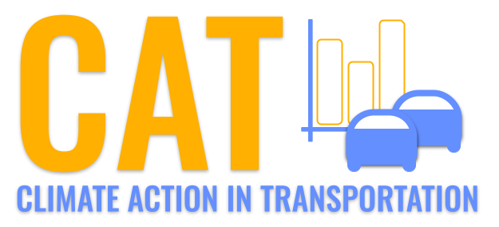 

**CO Emissions in Caribou County, 2050**  
Made with CAT VISUALIZER by Gao Labs @ Cornell University.

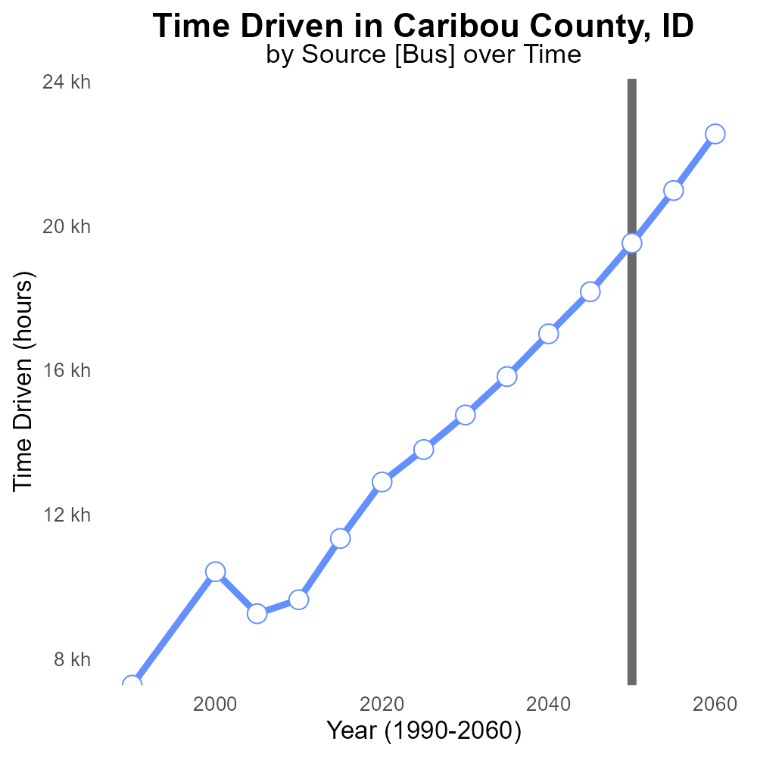

## Keywords

Carbon Monoxide emissions; on-road transportation; Caribou County; 2050; environmental impact; public health

## Highlights

* A study on CO emissions from on-road vehicles in Caribou County, ID in 2050.
* Focus on the environmental and public health implications.
* Analysis of the trends and projections for CO levels in the county.
* Recommendations for mitigation strategies to reduce CO emissions.
* Impacts of CO emissions on air quality and human health in Caribou County.

# Introduction

In 2050, the levels of Carbon Monoxide (CO) emissions from on-road transportation in Caribou County, ID have become a pressing concern due to their significant impact on the environment and public health. This report delves into the current state of CO emissions in the county, projecting future trends and focusing on how they affect air quality and human well-being.

The study aims to provide a comprehensive analysis of the sources and effects of CO emissions from on-road vehicles, offering insights into the potential risks posed by high levels of this harmful gas. By exploring mitigation strategies and proposing recommendations, this report seeks to address the challenges posed by CO emissions and safeguard the environmental and public health of Caribou County residents.

# Emissions Rate (per capita) by Road Type

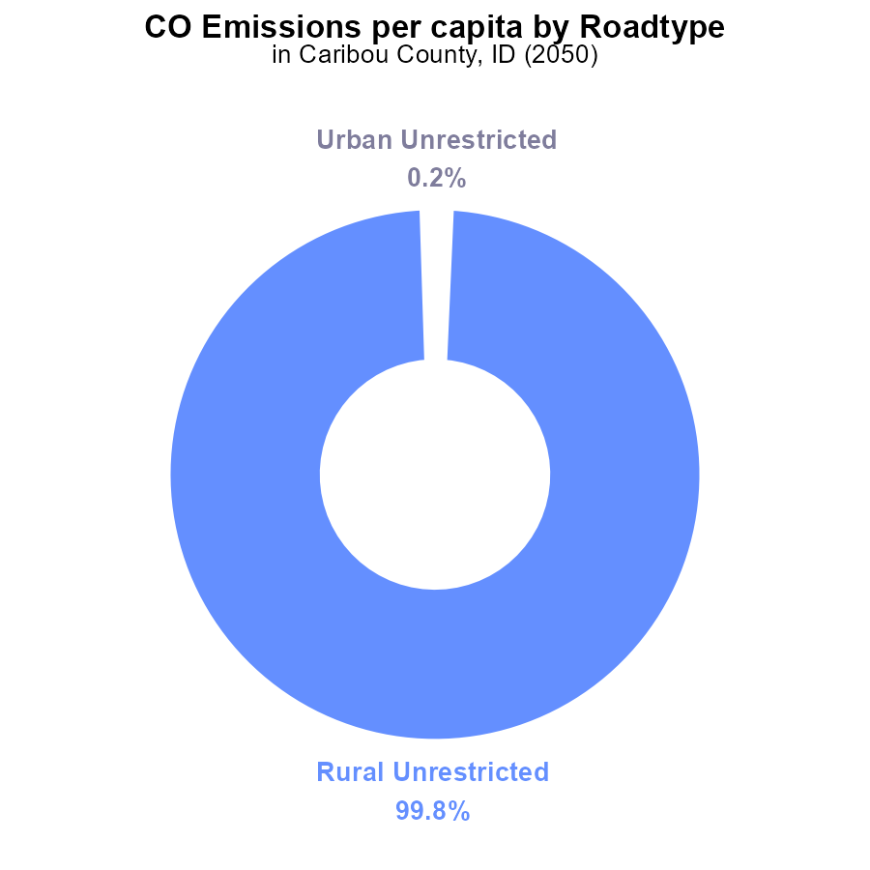

# Hotelling (Diesel Aux) Overall by Area

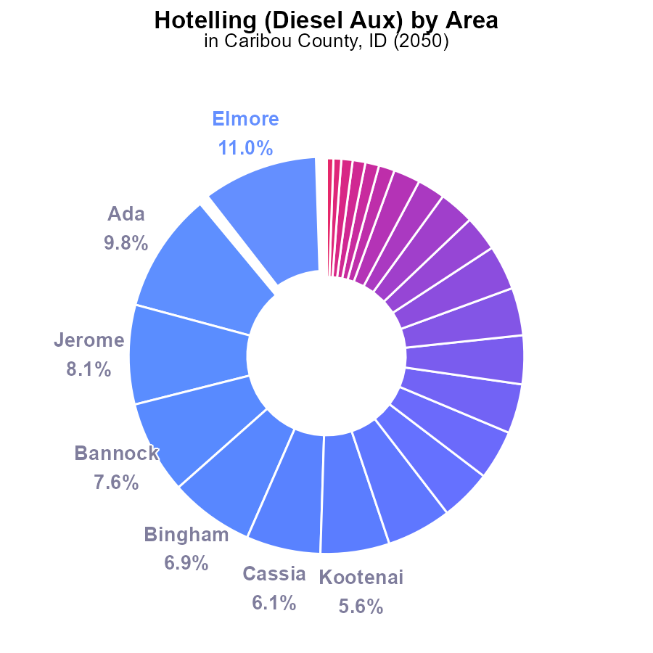

## Findings

* Top 5 emitters (Elmore, Ada, Jerome, Bannock, Bingham) contribute 42.4% of CO emissions.
* Non-emitting counties make up 19.5% of total emissions.
* Remaining counties contribute less than 5% individually to CO emissions.

## Recommendations

To reduce emissions, targeted efforts should focus on the top 5 emitting counties. Implementing stricter emission regulations for diesel auxiliary sources can significantly decrease overall CO emissions.

# Time Driven over Time for Buses

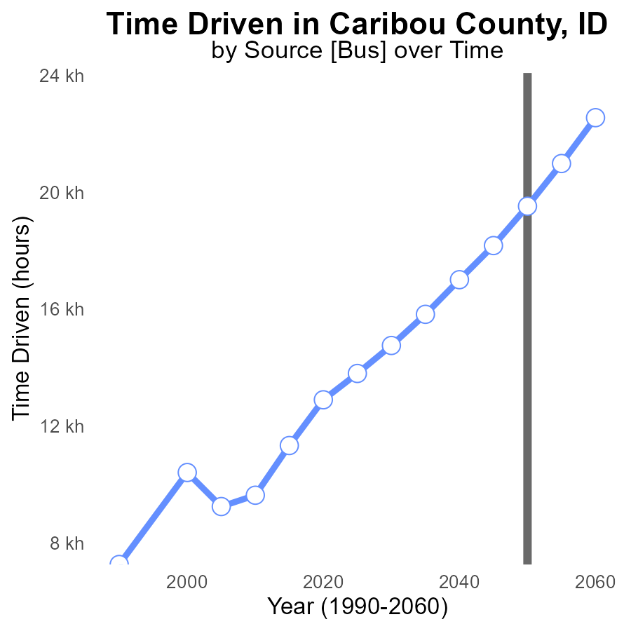

## Findings

* Emissions in Caribou County, ID, are projected to decrease consistently over the next three decades.
* By 2050, emissions are expected to reduce by 24.8% compared to 2030 levels.
* A significant decline of 35.6% in emissions is projected from 2030 to 2060.

## Recommendations

To maintain this downward trend in emissions, policymakers should prioritize investing in sustainable transportation initiatives, such as promoting electric vehicles and improving public transportation infrastructure. Additionally, implementing measures to reduce overall reliance on personal vehicles, such as carpooling incentives and bike-friendly infrastructure, can further contribute to lowering emissions in Caribou County, ID.

# Vehicles over Time for Buses

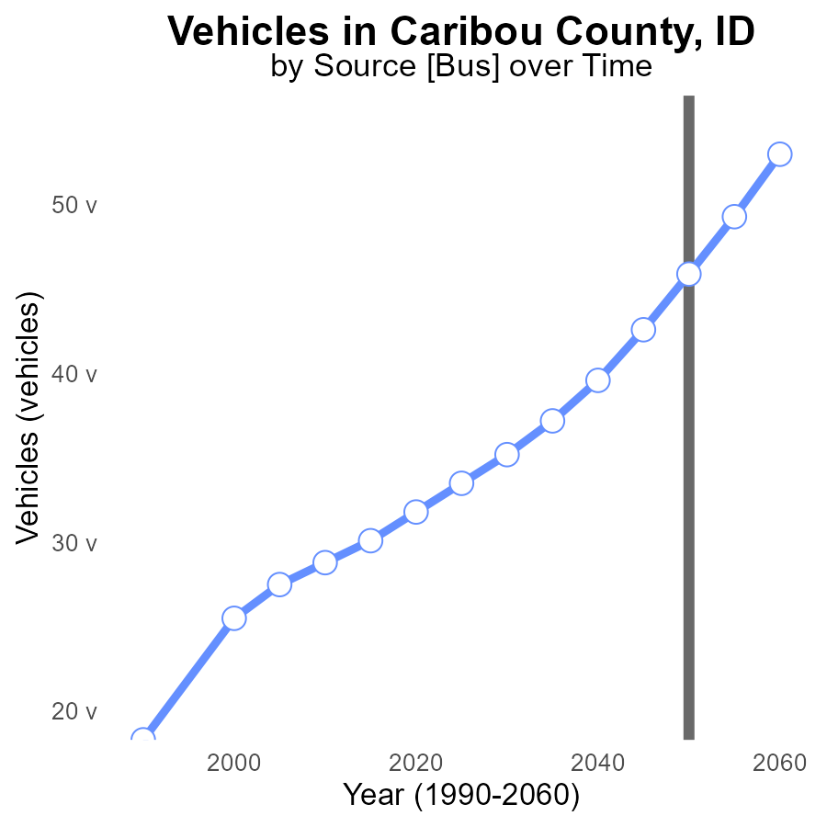

## Findings

* Emissions from vehicles in Caribou County, ID have consistently increased from 35.2 in 2030 to 53.0 in 2060.
* The benchmark difference shows a steady decline over the years, indicating improved emission control measures.
* By 2050, the emissions are expected to be reduced to 45.9, meeting the benchmark goal of 0.0.

## Recommendations

To further reduce emissions from vehicles in Caribou County, ID, policymakers can consider implementing stricter vehicle emission standards, promoting the use of electric vehicles, and investing in public transportation infrastructure.

# Vehicles in My Region

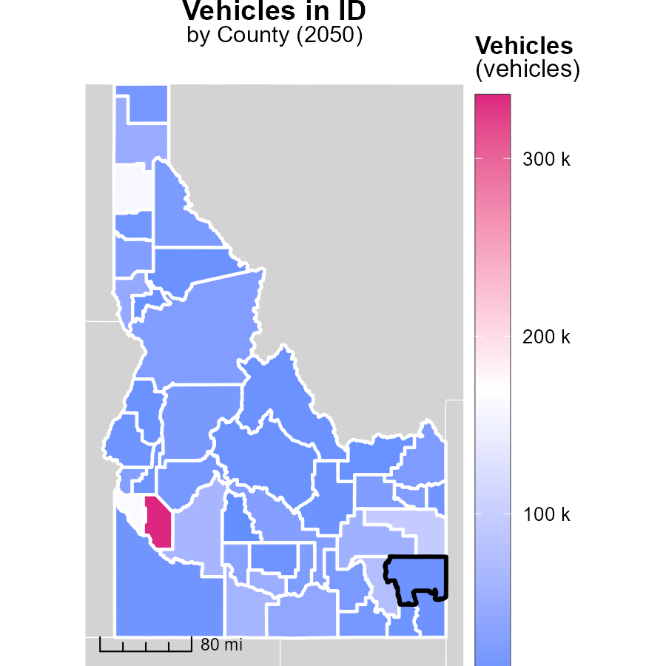

## Findings

* The highest number of vehicles emissions in Ada County, ID, reached 335.6k.
* Shoshone County, ID, had a median vehicle emission of 22.4k.
* Camas County, ID, had the lowest vehicle emissions with 3.5k.

## Recommendations

To reduce emissions, encourage the use of public transportation and carpooling in Ada County. Implement emission testing regulations. In Shoshone County, promote electric vehicle adoption by installing charging stations. Encourage biking or walking as alternatives in Camas County.

# Idling in My Region

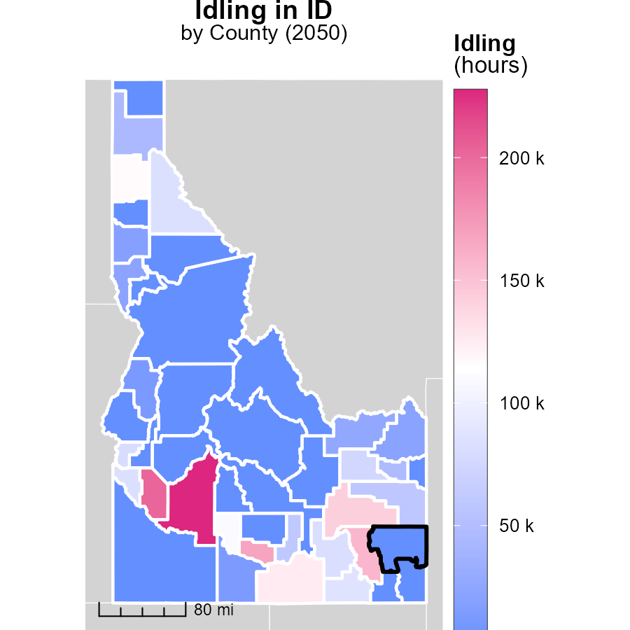

## Findings

* Idling hours in Elmore County, ID, reached a maximum of 227.5 thousand hours in 2050.
* The median idling hours in Latah County, ID, were 19.0 thousand hours in 2050.
* Washington County, ID, reported no idling hours in 2050, the minimum in the region.

## Recommendations

To lower emissions from idling in Elmore County, strategies could include implementing idling reduction campaigns for vehicles, promoting remote start technology, and enforcing anti-idling policies. In Latah County, introducing incentives for reduced idling, educating the public on the impact of idling, and improving public transportation options could be beneficial. Finally, in Washington County, ID, continuing to maintain an idling-free status through effective monitoring and enforcement measures can help keep emissions minimized.

# Vehicle Miles Traveled by Area over Time

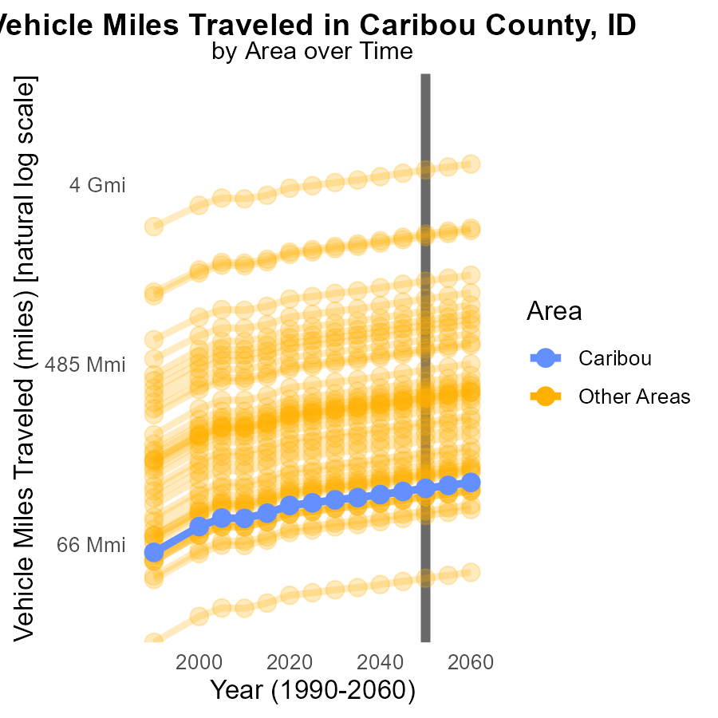

## Findings

* In 2050, the maximum county traveled 4.2 billion miles, the minimum county traveled 45.3 million miles, and the target county traveled 122.8 million miles.
* Compared to 2050, there was no difference in miles traveled by the maximum, minimum, and target counties in the year range of 2040-2060.

## Recommendations

To lower emissions, focus on implementing public transportation systems, carpooling incentives, and promoting eco-friendly vehicles to reduce the miles traveled by vehicles.

# Emissions Rate (per vehicle) by Regulatory Class over Time

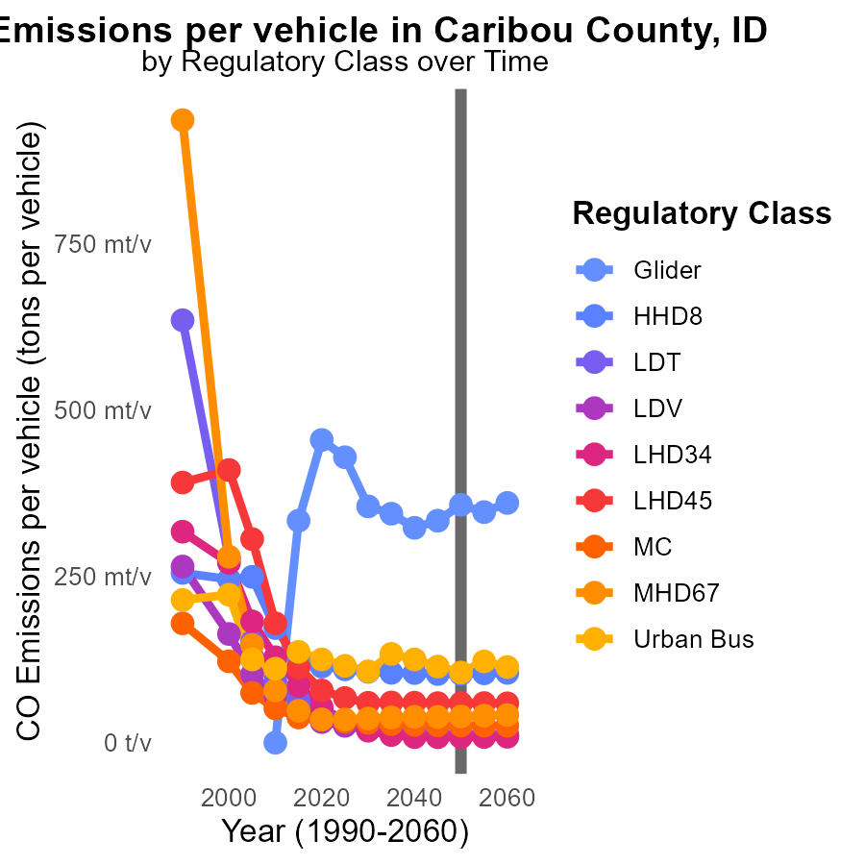

## Findings

* Between 2040 and 2060, Glider emissions per vehicle ranged from 322.6 to 360.0 tons, with a maximum increase of 3.45% compared to 2050.
* Urban Bus emissions decreased from 125.0 tons in 2040 to 113.6 tons in 2060, showing a reduction of 8.3% relative to 2050.
* In 2050, Regulatory Class LDV emitted 10.7 tons per vehicle, remaining stable with zero differentiation from the 2050 value.

## Recommendations

To reduce emissions, focus on improving efficiency in Glider vehicles to mitigate the increasing trend observed. Encourage the transition to lower-emission Urban Bus models. Implement measures to maintain LDV emissions at the current level for sustainability.

# Areas Ranked by Emissions Rate (per capita)

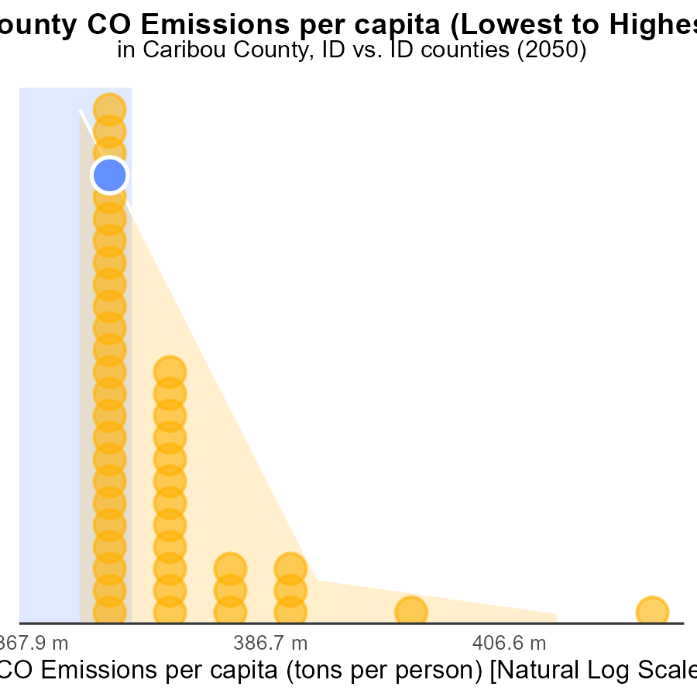

## Findings

* Clark county has the highest CO emissions per capita at 146.0 tons per person.
* Gem county has the lowest CO emissions per capita at 10.0 tons per person.
* Caribou, Boundary, and Minidoka counties have similar CO emissions per capita ranging from 20.6 to 21.2 tons per person.

## Recommendations

To lower emissions, focus on initiatives like promoting renewable energy sources, implementing energy-efficient practices, and encouraging public transportation to reduce the use of personal vehicles.

# Areas Ranked by Emissions Rate (per mile)

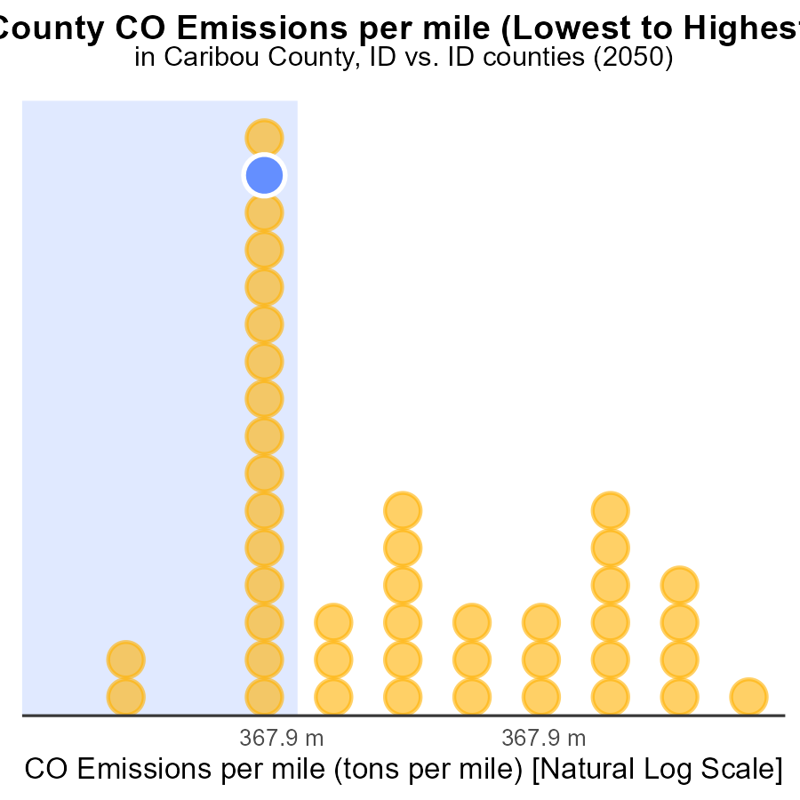

## Findings

* Oneida county has the highest CO emissions per mile at 1.4 tons per mile.
* Canyon county has the lowest CO emissions per mile at 1.1 tons per mile, ranking 1st with only 2.3% of all counties.
* Counties Caribou, Butte, and Lewis have similar CO emissions per mile at 1.2 tons per mile, with rankings between 16th and 18th.

## Recommendations

To reduce emissions, high-ranking counties like Oneida should focus on promoting carpooling and public transportation. Lower-ranking counties should invest in infrastructure for electric vehicles and biking.

# Conclusion

In conclusion, the data from Caribou County, ID, in 2050 reveals key insights into CO emissions from on-road transportation. The top 5 emitters contribute significantly to the total CO emissions, highlighting the need for targeted efforts to reduce emissions in these counties. By implementing stricter regulations for diesel auxiliary sources and focusing on sustainable transportation initiatives like promoting electric vehicles and improving public transportation infrastructure, a substantial decrease in CO emissions can be achieved. Notably, the projected decline in emissions over the next few decades indicates progress towards a more environmentally sustainable future.

To maintain the downward trend in emissions, policymakers should prioritize measures such as stricter vehicle emission standards, promoting electric vehicles, and investing in public transportation infrastructure. Additionally, encouraging the use of carpooling and biking, along with reducing idling hours and miles traveled, are essential strategies to further lower emissions. It is evident that collaborative efforts at both the county and state levels are crucial in addressing CO emissions from on-road transportation in Caribou County, ID, and achieving a cleaner and healthier environment for all residents.

# About This Report

Data based on MOVES estimates collected by the Climate Action in Transportation program at Cornell University. Demographic data sourced from the US Census's American Community Survey 5-year estimates. This report was generated with the help of AI.

# References

* U.S. Census Bureau. (2023). American Community Survey 5-year estimates: Detailed tables. Retrieved from https://data.census.gov
* U.S. Environmental Protection Agency. (2024). Motor Vehicle Emission Simulator (MOVES 4.0) [Software]. Retrieved from https://www.epa.gov/moves