 

**CO Emissions in LaMoure County, 2055**  
Made with CAT VISUALIZER by Gao Labs @ Cornell University.

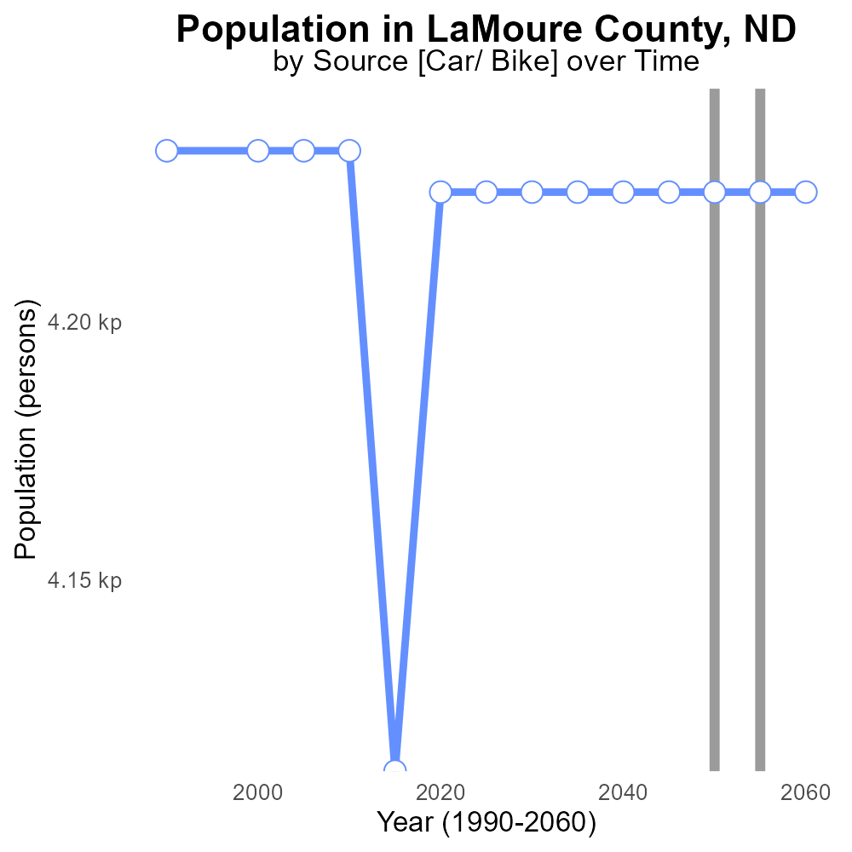

## Keywords

Carbon Monoxide emissions; on-road transportation; LaMoure County; 2055; pollution; air quality

## Highlights

* In 2055, elevated Carbon Monoxide levels from on-road transportation pose health risks.
* LaMoure County faces significant challenges in tackling CO emissions from vehicles.
* Rising CO levels in the air can impact public health and worsen air quality.
* Understanding CO sources and mitigation strategies is crucial for the county's well-being.
* Actions need to be taken to reduce CO emissions and improve the local environment.

# Introduction

Carbon Monoxide (CO) emissions from on-road transportation in LaMoure County, North Dakota, have become a pressing issue in 2055. With the continued growth in population and vehicle numbers, the levels of CO in the air have been on the rise, posing significant health risks to the residents. As a predominantly rural county heavily reliant on transportation, LaMoure County faces challenges in reducing these emissions and improving air quality.

The increasing CO levels not only impact public health but also contribute to the overall deterioration of the environment. It is imperative for local authorities to identify the sources of CO emissions, implement effective mitigation strategies, and enforce regulations to limit the release of this harmful gas into the atmosphere. Failure to address these issues could have severe consequences on the well-being of the county's inhabitants and the quality of life in the region.

# Emissions Rate (per vehicle) by Vehicle Type

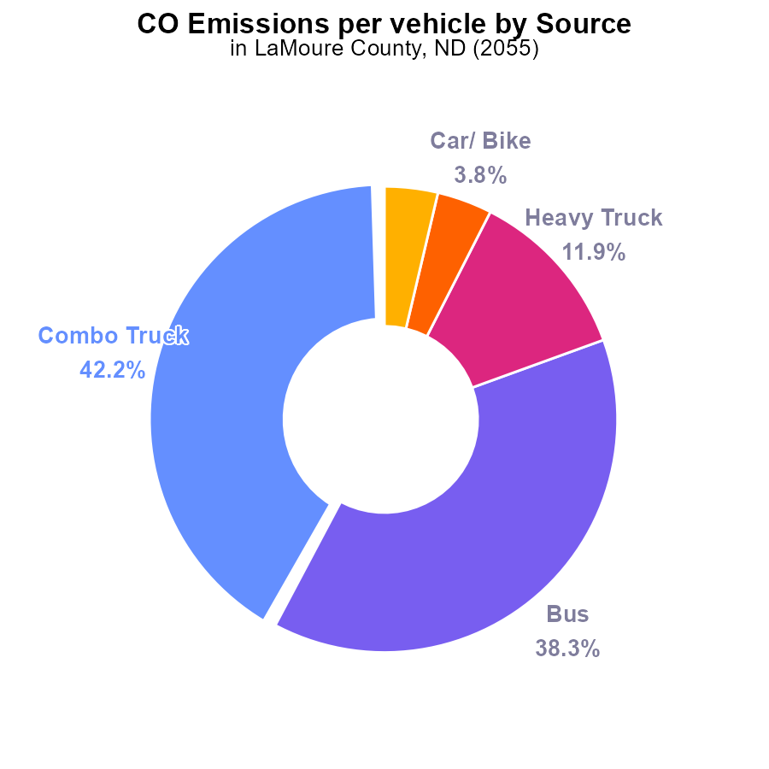

## Findings

* Combination trucks emit the highest CO emissions per vehicle at 136.4 tons, representing 42.2% of the total.
* Buses follow with 123.7 tons per vehicle, accounting for 38.3% of the total emissions.
* Light trucks emit the least CO emissions per vehicle at 11.9 tons, contributing to only 3.7% of the total.

## Recommendations

To reduce emissions, focus efforts on the fleet of combination trucks and buses, as they are the major contributors. Implementing stricter emission standards for these vehicles can significantly lower overall emissions in LaMoure County.

# Emissions Rate (per mile) by Road Type

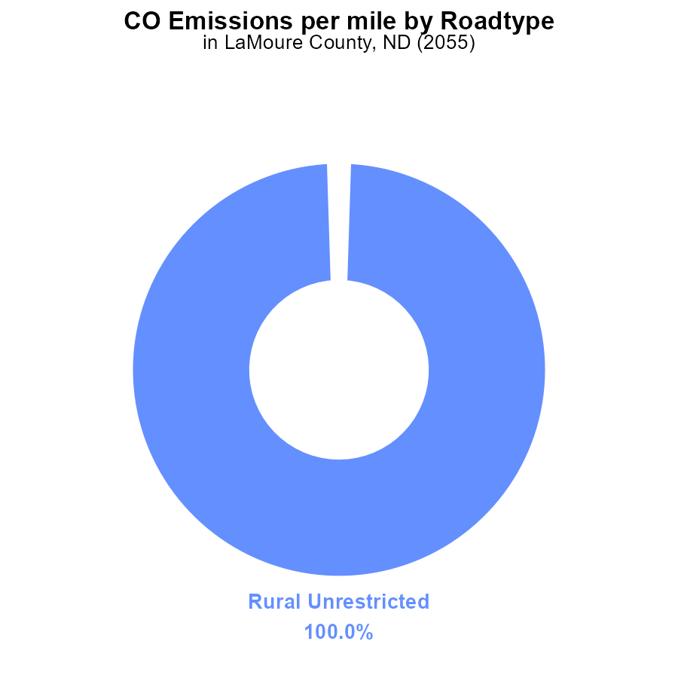

# Hotelling (Engines Off) over Time for Passenger Vehicles

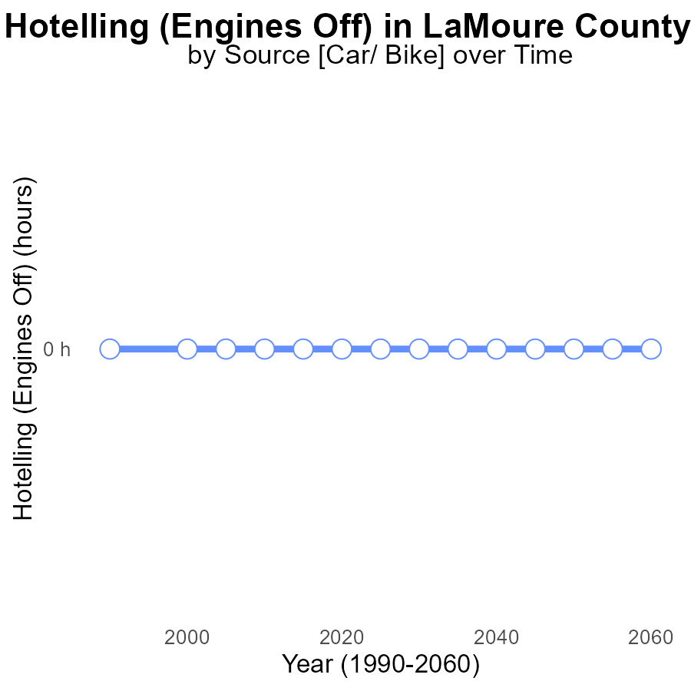

## Findings

* From 2035 to 2060, there were no CO emissions from Hotelling (Engines Off) in LaMoure County, ND.
* The benchmark difference remained constant at zero throughout the years.
* There has been no change in emissions over time for this specific activity in the area.

## Recommendations

Based on the data showing no CO emissions from Hotelling (Engines Off), policies should focus on other sources of emissions in LaMoure County, ND, to effectively reduce overall emissions levels.

# Population over Time for Passenger Vehicles

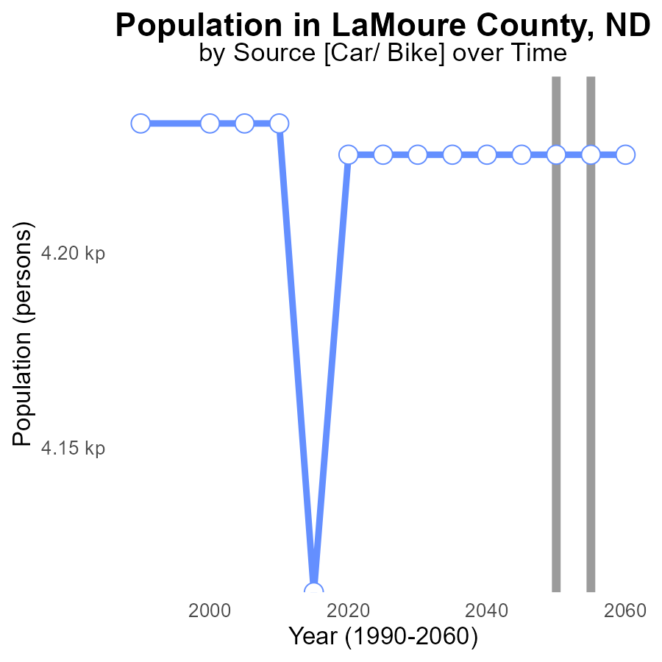

## Findings

* Emissions in LaMoure County, ND, are consistently at 4.2 kilotons of CO per year from 2035 to 2060.
* There is no significant change in emissions over the 25-year period, with a consistent benchmark difference of 0 kilotons.
* This data indicates a stable emission level in the county, suggesting the need for reevaluation of current strategies to reduce emissions.

## Recommendations

To lower emissions in LaMoure County, ND, despite the stable levels, further measures need to be implemented. These could include promoting renewable energy sources, enhancing public transportation, and incentivizing energy-efficient practices in industries.

# Hotelling (Diesel Aux) in My Region

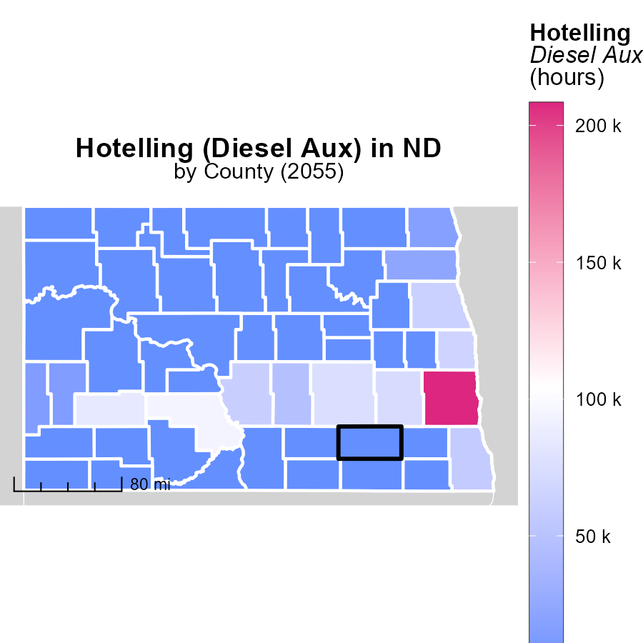

# Emissions Mapped by Area

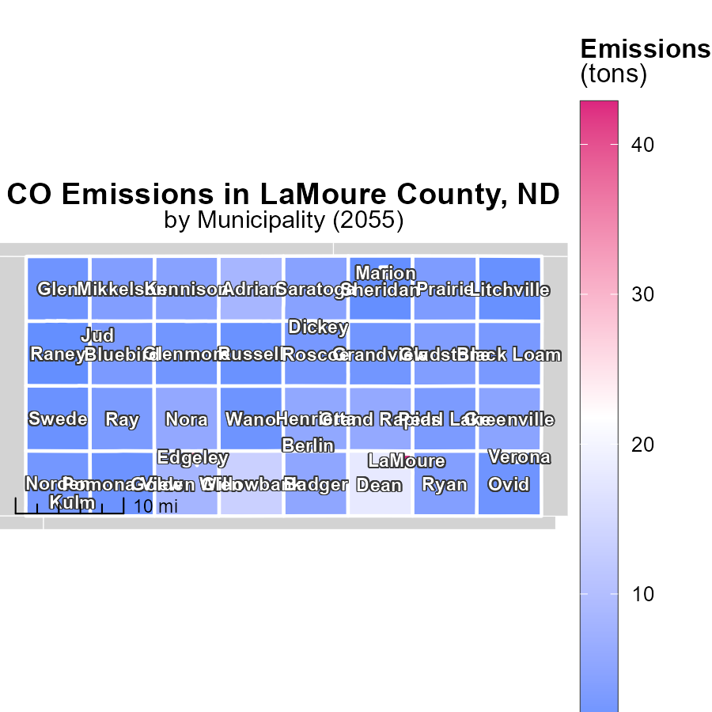

## Findings

* The highest emissions were in LaMoure, ND, with 42.8 tons.
* The median emissions were 3.7 tons in Gladstone, ND.
* Raney, ND had the lowest emissions at 754.9 tons.

## Recommendations

To lower emissions in LaMoure, focus on industries or activities contributing to the high levels. In Gladstone, explore ways to decrease emissions to align with the median. Raney should investigate the reasons behind the unexpectedly high emissions and implement strategies accordingly.

# Hotelling (Engines Off) by Vehicle Type over Time

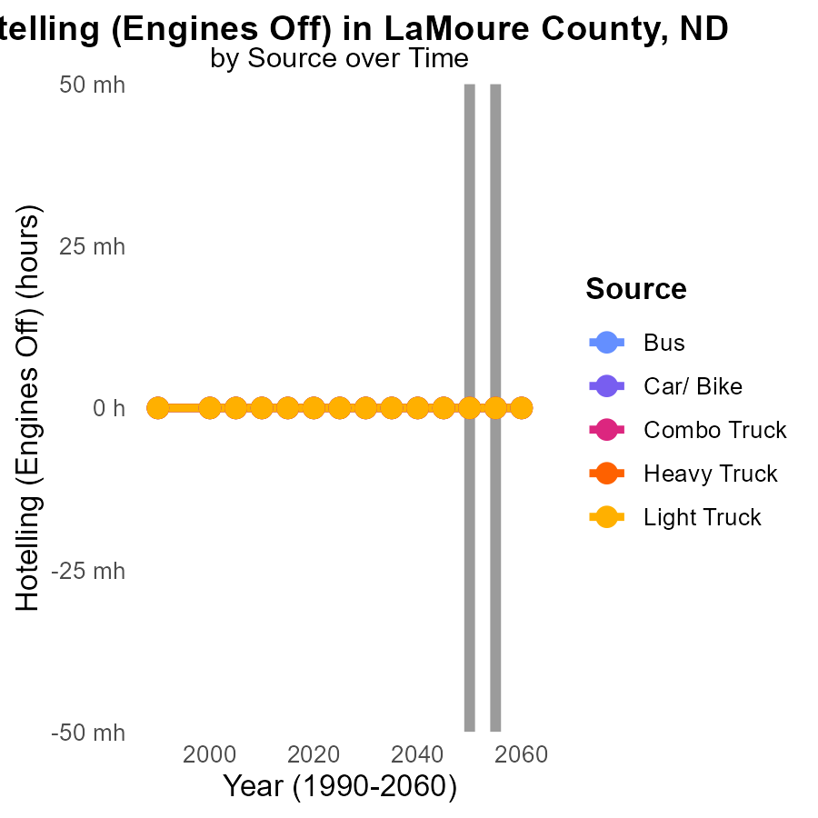

## Findings

* Emissions from transportation in LaMoure County, ND are consistently at 0.0 across vehicle types from 2045 to 2060.
* There has been no change in emissions from vehicles in this area compared to the year 2050.
* This data suggests that there have been no significant improvements in reducing emissions from transportation in LaMoure County over time.

## Recommendations

To lower emissions from transportation in LaMoure County, focus on implementing alternative fuel options, encouraging the use of electric vehicles, and improving public transportation infrastructure. Additionally, incentivize the adoption of cleaner technologies in commercial vehicles.

# Hotelling (Engines Off) by Regulatory Class over Time

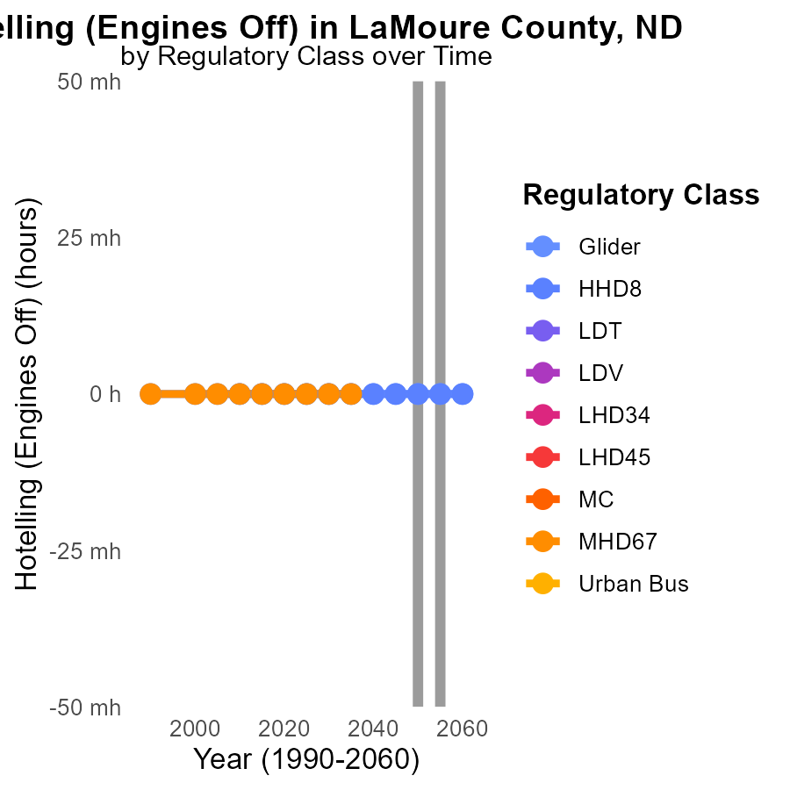

## Findings

* Emissions data for LaMoure County, ND from 2045 to 2060 shows no emissions from Glider and HHD8 engine categories.
* Data for vehicle categories LDT, LDV, LHD34, LHD45, MC, MHD67, and Urban Bus is not available for the specified years.
* There is a consistent absence of emissions data for the years 2045 to 2060 in various vehicle categories in LaMoure County, ND.

## Recommendations

To improve emissions data collection, ensure that all vehicle categories in LaMoure County, ND are consistently monitored and reported annually. Implement measures to track emissions even for categories currently showing no data.

# Areas Ranked by Vehicles

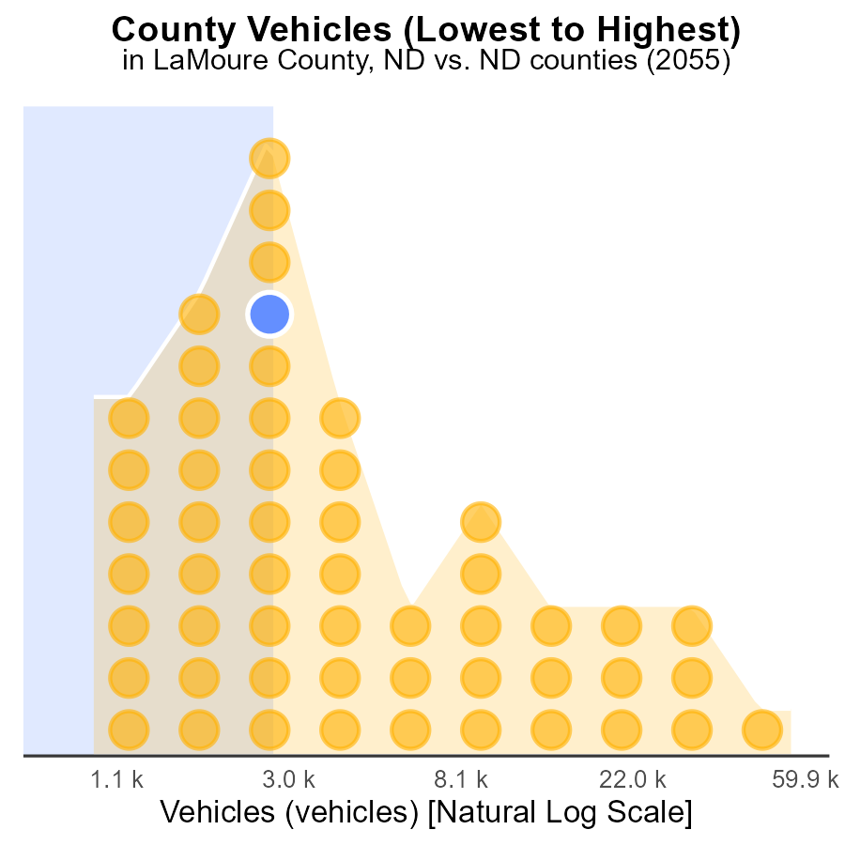

## Findings

* Cass county has the highest number of vehicles emissions at 155.5k
* Billings county ranks 26th with 8.4k vehicles emissions, representing 49.1% of the total
* Sheridan county has the lowest emissions with 2.6k vehicles, constituting only 1.9% of the total

## Recommendations

To lower emissions, consider promoting public transportation in counties with high vehicle emissions, like Cass and Billings, to reduce the percentage contribution.

# Areas Ranked by Population

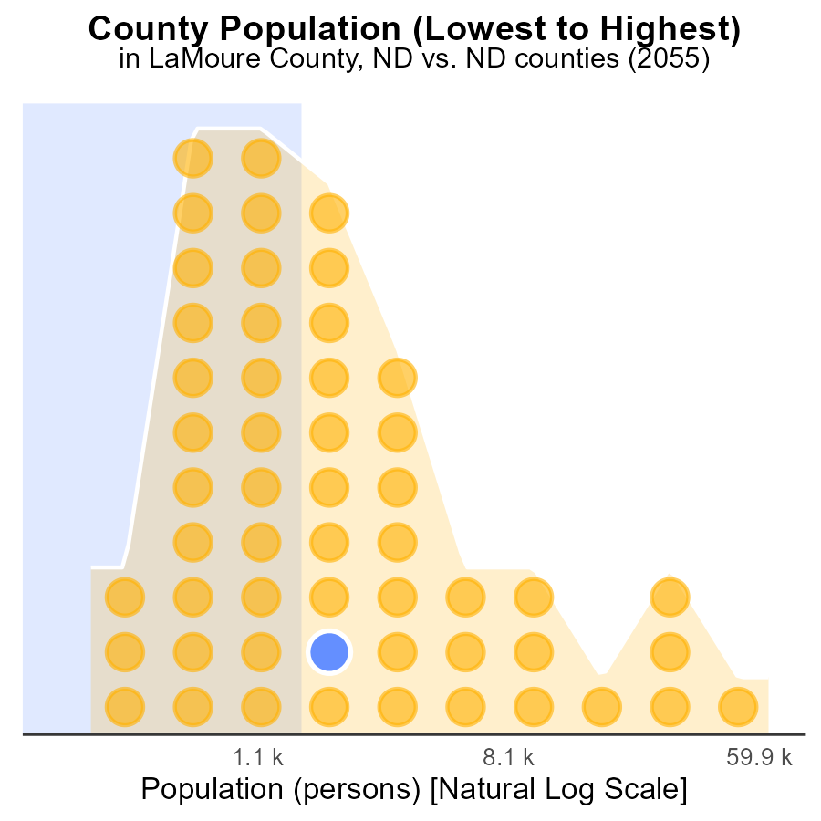

## Findings

* The total population of CO in 2055 was 179.9k.
* LaMoure County had 4.2k people, accounting for 2.3% of the total population.
* Slope County had 788 people, making up only 0.4% of the total population.

## Recommendations

To reduce emissions, policies should focus on areas with higher population density like Cass County, investing in public transportation to reduce individual car usage and promote energy-efficient buildings.

# Conclusion

In conclusion, the data on Carbon Monoxide (CO) emissions from on-road transportation in LaMoure County, ND in 2055 paints a clear picture of the major contributors and stagnant emission levels over time. Combination trucks and buses emerge as the primary sources of CO emissions, necessitating a targeted approach towards these vehicle categories to achieve substantial reductions in overall emissions.

Furthermore, the data indicates a stable emission level in LaMoure County over the years, highlighting the need for a reevaluation of existing strategies to effectively lower emissions. While efforts such as promoting renewable energy sources and incentivizing energy-efficient practices can be beneficial, a more focused approach on the major contributors is imperative for significant emission reductions. Finally, the findings underscore the importance of monitoring and reporting emissions data consistently across all vehicle categories to gain a comprehensive understanding of the sources and trends, enabling more tailored and impactful emission reduction strategies for a cleaner and healthier environment.

# About This Report

Data based on MOVES estimates collected by the Climate Action in Transportation program at Cornell University. Demographic data sourced from the US Census's American Community Survey 5-year estimates. This report was generated with the help of AI.

# References

* U.S. Census Bureau. (2023). American Community Survey 5-year estimates: Detailed tables. Retrieved from https://data.census.gov
* U.S. Environmental Protection Agency. (2024). Motor Vehicle Emission Simulator (MOVES 4.0) [Software]. Retrieved from https://www.epa.gov/moves