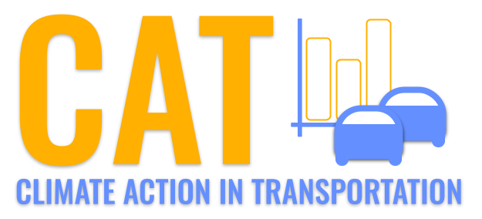 

**VOC Emissions in Clark County, 2060**  
Made with CAT VISUALIZER by Gao Labs @ Cornell University.

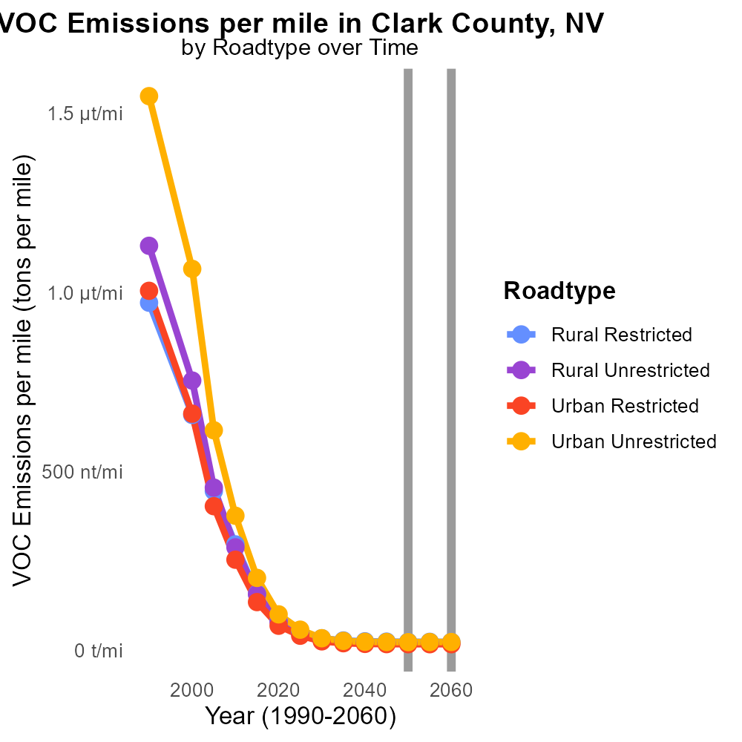

## Keywords

Volatile Organic Compounds; emissions; on-road transportation; Clark County; NV; 2060

## Highlights

* Analyzing VOC emissions from on-road transportation in Clark County, NV.
* Insight into potential impacts on air quality and public health.
* Consideration of future trends and mitigation strategies for VOC emissions.
* Addressing concerns about environmental sustainability in the transportation sector.
* Exploring the evolving relationship between transportation technology and emissions.

# Introduction

In 2060, the issue of Volatile Organic Compounds (VOC) emissions from on-road transportation in Clark County, NV has garnered significant attention due to its potential impacts on air quality and public health. As the population grows and transportation demands increase, understanding and mitigating these emissions have become crucial for ensuring environmental sustainability in the region.

By analyzing the current trends and projecting future scenarios, this report aims to provide valuable insights into the sources, levels, and effects of VOC emissions from on-road transportation in Clark County. Additionally, it will explore potential strategies and technologies that can be implemented to reduce these emissions and promote a cleaner, healthier environment for the residents of the county.

# Emissions Rate (per capita) by Road Type

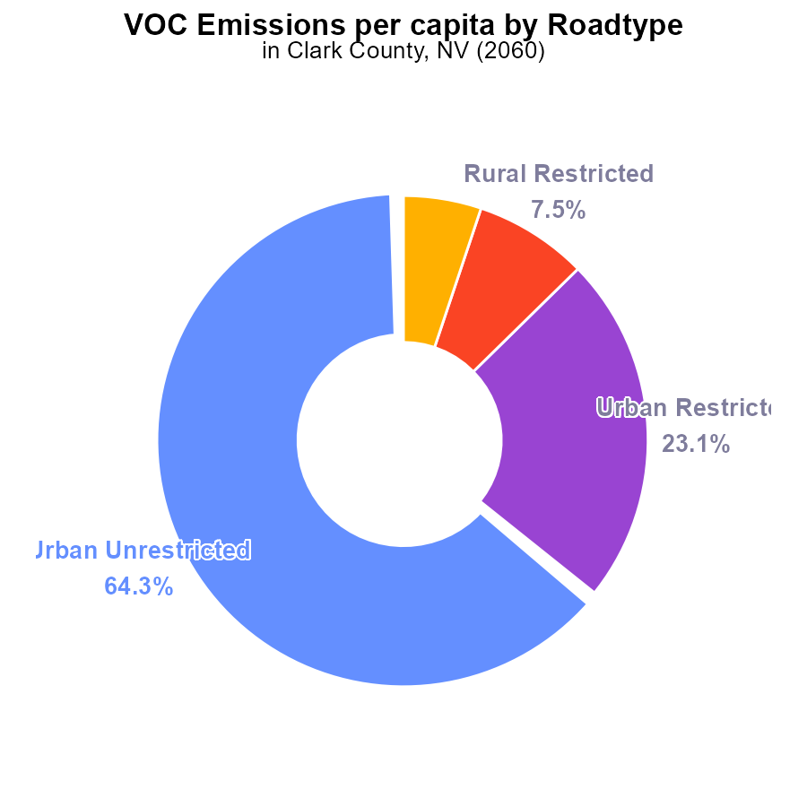

## Findings

* Urban Unrestricted areas contribute 64.3% of VOC emissions per capita.
* Urban Restricted areas contribute 23.1% of VOC emissions per capita.
* Rural areas, both restricted and unrestricted, contribute a combined total of 12.6% of VOC emissions per capita.

## Recommendations

To lower VOC emissions, focus efforts on reducing emissions in Urban Unrestricted areas due to their significant contribution. Implement stricter regulations and incentives for cleaner technologies.

# Vehicles by Fuel Type

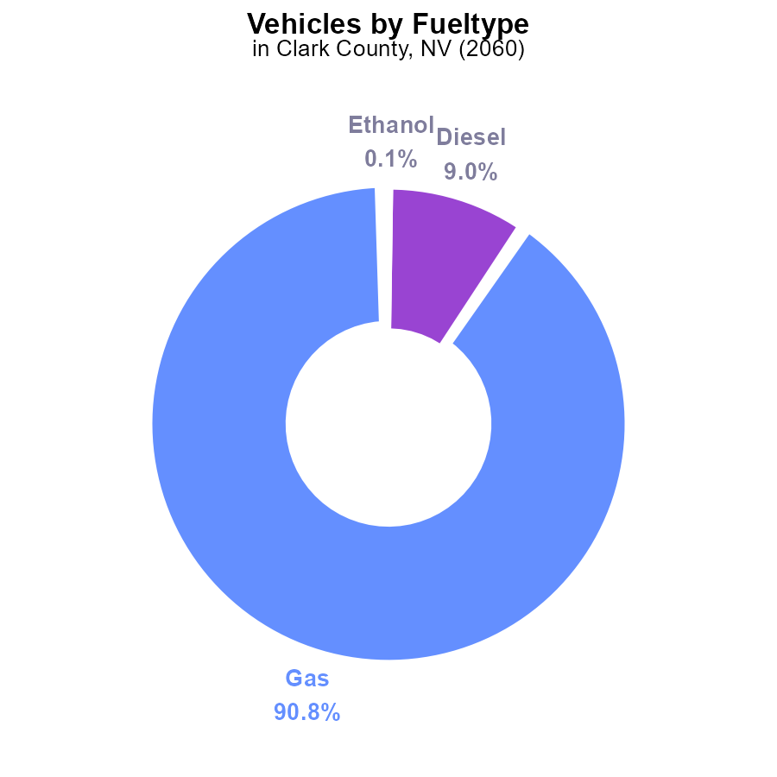

## Findings

* Gasoline vehicles account for 90.8% of VOC emissions in Clark County in 2060.
* Diesel vehicles contribute to 9.0% of VOC emissions in the area.
* Ethanol and CNG vehicles combined only make up 0.2% of the total VOC emissions.

## Recommendations

To lower VOC emissions in Clark County, focus should be placed on reducing gasoline vehicle usage as they are the main contributor. Encouraging the transition to cleaner fuel sources for vehicles can help decrease emissions significantly.

# Vehicles over Time for Buses

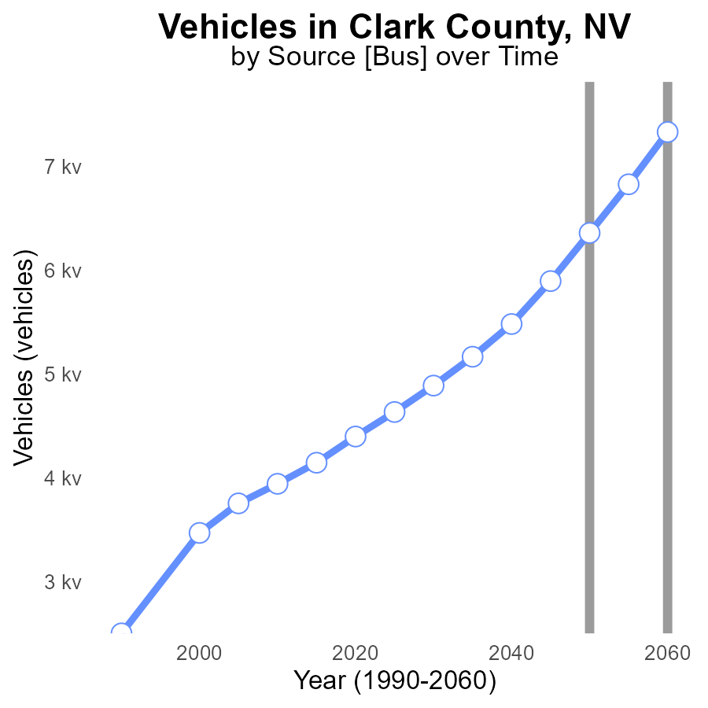

## Findings

* By 2060, vehicle VOC emissions in Clark County are projected to reach 7.3k, with a decrease of 971.1 from the 2050 level.
* The most significant reduction is expected between 2050 and 2055, with a decrease of 468.3 in vehicle VOC emissions.
* Between 2040 and 2060, there is an overall decrease of 94.5 in vehicle VOC emissions in Clark County.

## Recommendations

To further reduce vehicle VOC emissions in Clark County, policies should focus on promoting electric vehicles, enhancing public transportation infrastructure, and incentivizing carpooling to continue the decreasing trend observed from 2040 to 2060.

# Hotelling (Engines Off) Overall over Time

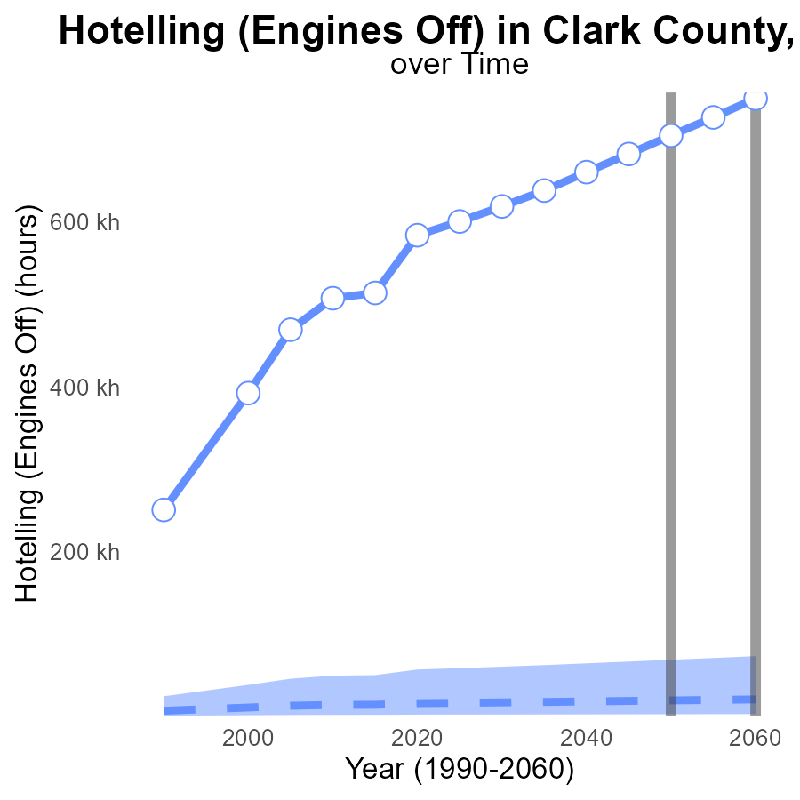

## Findings

* VOC emissions in Clark County, NV are significantly higher than the median area, with an increase over time.
* By 2060, VOC emissions are projected to exceed the upper 75th percentile of areas by approximately 44,930 hours.
* The benchmark difference indicates that current VOC emissions need to decrease by 22,018 hours to match the median area by 2055.

## Recommendations

To lower VOC emissions, consider implementing stricter regulations on vehicle emissions, promoting the use of electric vehicles, improving public transportation, and enhancing green spaces.

# Vehicle Starts Mapped by Area

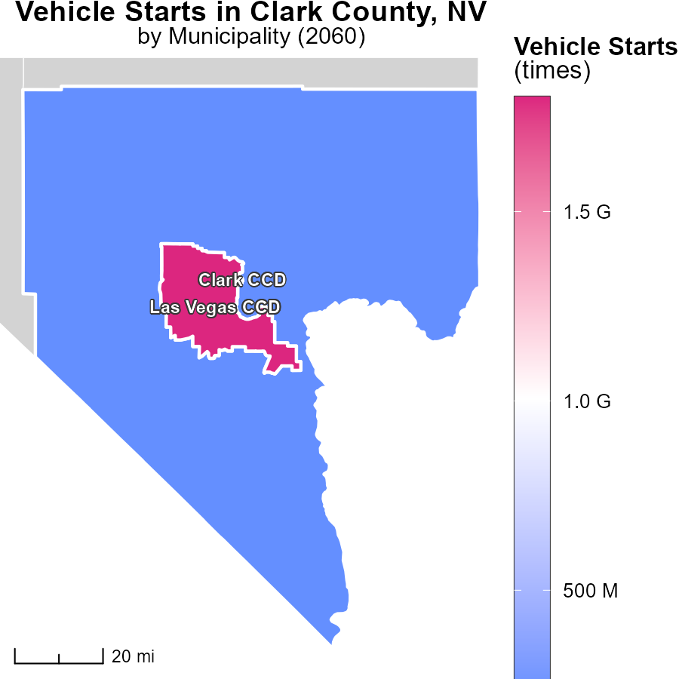

## Findings

* Vehicle starts in Las Vegas CCD, NV reach a maximum of 1.8 billion times in 2060.
* The median vehicle starts in Clark CCD, NV is 213.8 million times in the same year.

## Recommendations

To lower emissions, policymakers should incentivize the use of public transportation, implement stricter vehicle emission standards, and promote carpooling to reduce the number of vehicle starts.

# Emissions Rate (per vehicle) in My Region

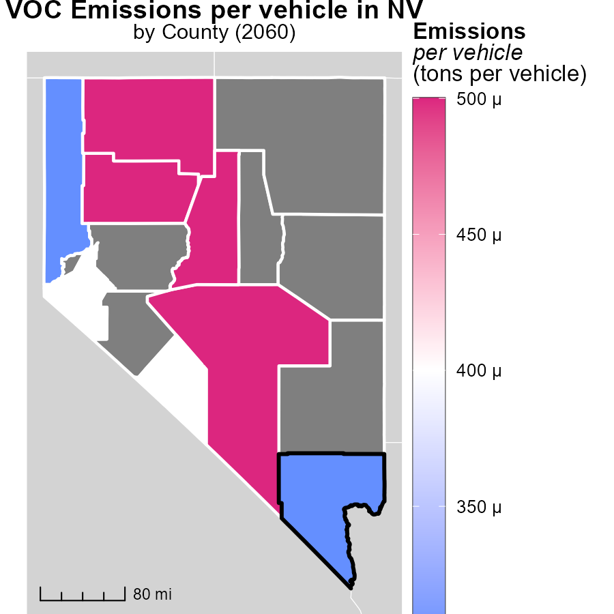

## Findings

* Humboldt County, NV has the highest emissions per vehicle at 487.6 tons.
* Esmeralda County, NV has a median emissions level of 446.0 tons per vehicle.
* Washoe County, NV has the lowest emissions per vehicle at 252.2 tons.

## Recommendations

To lower emissions levels, policymakers should focus on implementing stricter vehicle emission standards, incentivizing the adoption of electric vehicles, and promoting public transportation and carpooling initiatives.

# Emissions Rate (per mile) by Road Type over Time

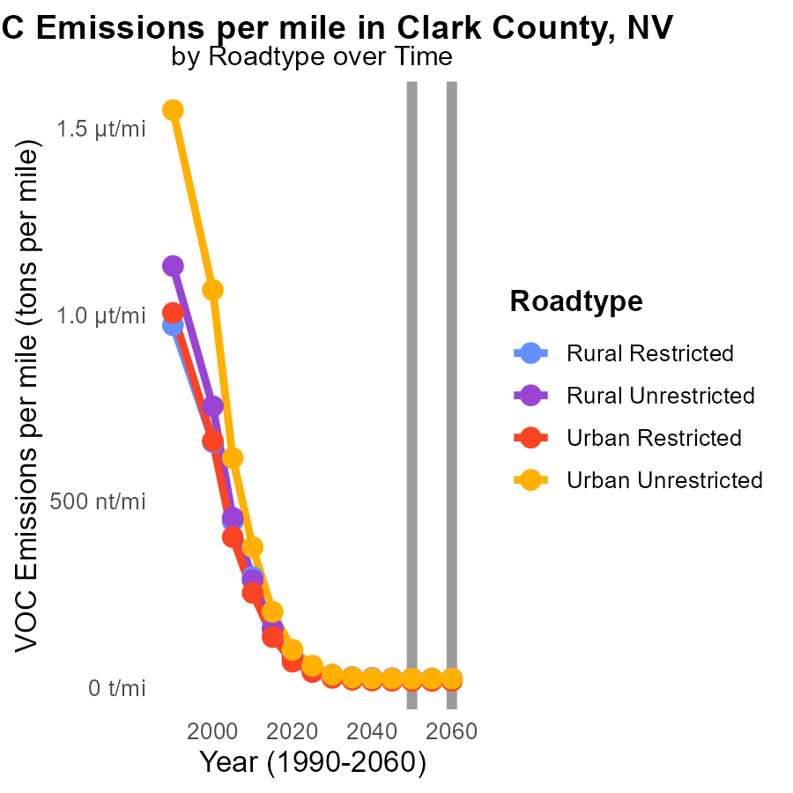

## Findings

* Emissions per mile decreased slightly from 2050 to 2060 across all road types in Clark County, NV.
* Rural Unrestricted roads had the lowest emissions per mile in 2060, at 21.1 tons.
* Urban Unrestricted roads experienced an increase in emissions per mile from 2055 to 2060, reaching 24.0 tons.

## Recommendations

To further reduce emissions, focus on enhancing rural road infrastructure to maintain low levels. Implement targeted strategies for urban unrestricted roads to prevent emission increases.

# Vehicles by Vehicle Type over Time

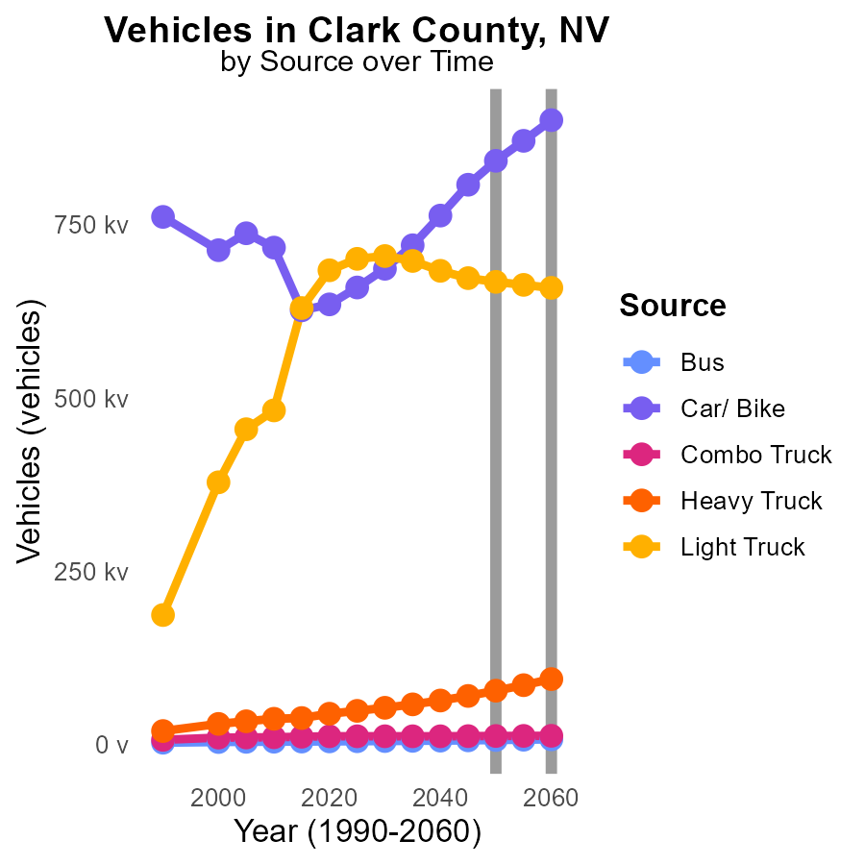

## Findings

* VOC emissions from buses are projected to decrease by 971.1 tons from 2050 to 2060.
* Car/ Bike emissions are expected to decrease by 58,670.7 tons between 2050 and 2060.
* Light trucks emissions are forecasted to increase by 8,621.9 tons from 2055 to 2060.

## Recommendations

To reduce VOC emissions from vehicles in Clark County, NV, the focus should be on promoting the adoption of cleaner fuel technologies and increasing the use of public transportation. Encouraging the transition to electric vehicles and implementing stricter emission standards for trucks are vital steps to minimize the environmental impact.

# Areas Ranked by Emissions Rate (per capita)

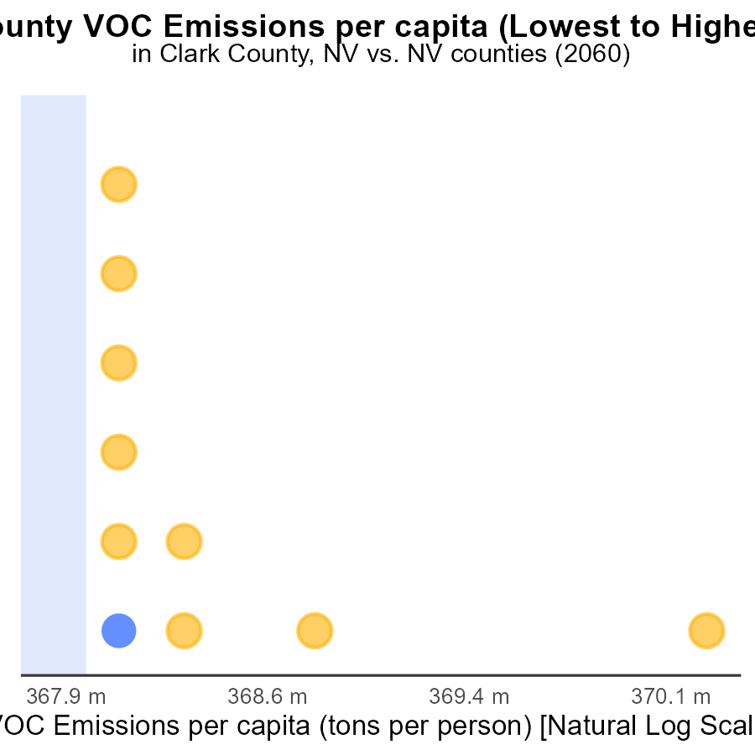

## Findings

* Clark county has the highest VOC emissions per capita of 213.9 tons per person.
* Esmeralda county has the lowest VOC emissions per capita with 6.7 tons per person.
* Washoe county ranks second with VOC emissions per capita of 215.0 tons per person.

## Recommendations

To reduce emissions, policymakers should focus on implementing cleaner energy sources, promoting public transportation, and enforcing stricter regulations on industrial emissions.

# Areas Ranked by Hotelling (Engines Off)

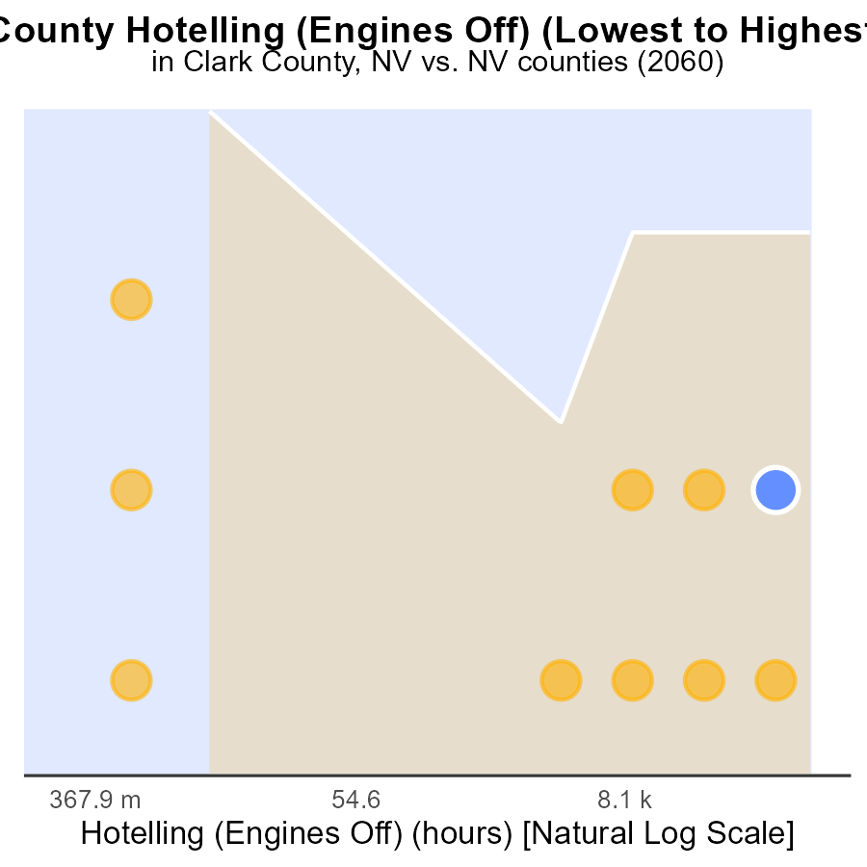

## Findings

* Clark County has the highest VOC emissions from Hotelling, ranking 10th at 100.0%.
* Douglas County has the lowest VOC emissions at 0.0, ranking 1st at 30.0%.
* Washoe County ranks 9th in VOC emissions from Hotelling at 90.0%.

## Recommendations

To reduce VOC emissions from Hotelling activities, focus on implementing stricter regulations and encouraging the use of alternative technologies such as electric vehicles in Clark and Washoe Counties. In Douglas County, maintain and continue efforts to keep VOC emissions low.

# Conclusion

In conclusion, the data reveals that urban unrestricted areas are the largest contributors to VOC emissions per capita in Clark County, NV in 2060. Gasoline vehicles are identified as the primary sources of emissions, emphasizing the need to focus on reducing their usage through the promotion of cleaner fuel technologies. Projections show a decrease in vehicle VOC emissions over time, with significant reductions expected between 2050 and 2055.

To further mitigate VOC emissions, policies should prioritize the adoption of electric vehicles, improvements in public transportation infrastructure, and incentives for carpooling. Clark County's emissions per capita surpass the median level, indicating the urgency to implement stricter regulations on vehicle emissions and enhance sustainable transportation options. As efforts continue, emphasis on cleaner energy sources, public transportation, and stringent industrial emission controls should be maintained to achieve a significant reduction in VOC emissions in the region.

# About This Report

Data based on MOVES estimates collected by the Climate Action in Transportation program at Cornell University. Demographic data sourced from the US Census's American Community Survey 5-year estimates. This report was generated with the help of AI.

# References

* U.S. Census Bureau. (2023). American Community Survey 5-year estimates: Detailed tables. Retrieved from https://data.census.gov
* U.S. Environmental Protection Agency. (2024). Motor Vehicle Emission Simulator (MOVES 4.0) [Software]. Retrieved from https://www.epa.gov/moves