 

**CO Emissions in Maricopa County, 2000**  
Made with CAT VISUALIZER by Gao Labs @ Cornell University.

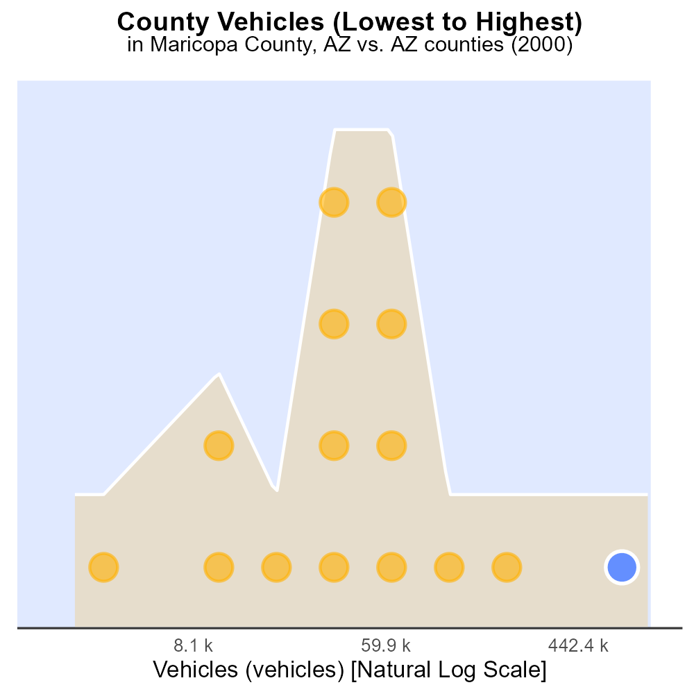

## Keywords

Carbon Monoxide; CO emissions; on-road transportation; Maricopa County; Arizona; 2000

## Highlights

* Study focuses on CO emissions from on-road vehicles in Maricopa County.
* Analysis of transportation impact on air quality in the region.
* Data may reveal trends and risks associated with carbon monoxide exposure.
* Policy implications for reducing CO emissions in urban areas.
* Understanding transport-related pollution can aid in sustainable planning.

# Introduction

The report investigates Carbon Monoxide (CO) emissions specifically from on-road transportation in Maricopa County, Arizona, during the year 2000. With a growing population and increasing urbanization, transportation plays a significant role in the region's air quality.

By examining the CO emissions from vehicles on the roads, the study aims to provide insights into the environmental impact of transportation in Maricopa County. The findings could reveal trends, sources, and potential health risks associated with carbon monoxide exposure, contributing to informed decision-making and policy development for reducing emissions.

# Hotelling (Engines Off) by Fuel Type

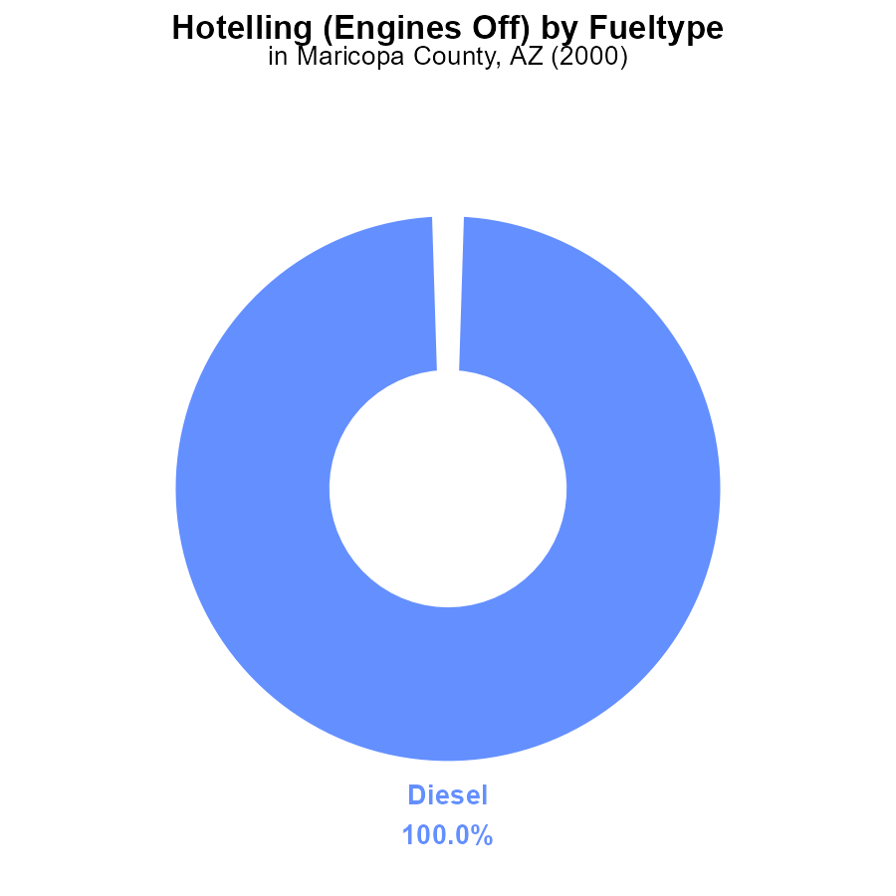

## Findings

* In 2000, 100% of CO emissions in Maricopa County from Hotelling (Engines Off) were from diesel engines.
* There were no recorded CO emissions from CNG or gasoline engines.
* Diesel engines were the sole contributors to CO emissions during Hotelling activities in the specified year.

## Recommendations

To reduce CO emissions in Maricopa County from Hotelling activities, the focus should be on implementing stricter emission standards for diesel engines. Encouraging the use of cleaner fuel alternatives could also help in lowering overall emissions. Additionally, promoting the use of technology that minimizes idling time or relies on electricity rather than combustion engines can contribute to reducing CO emissions further.

# Time Driven by Vehicle Type

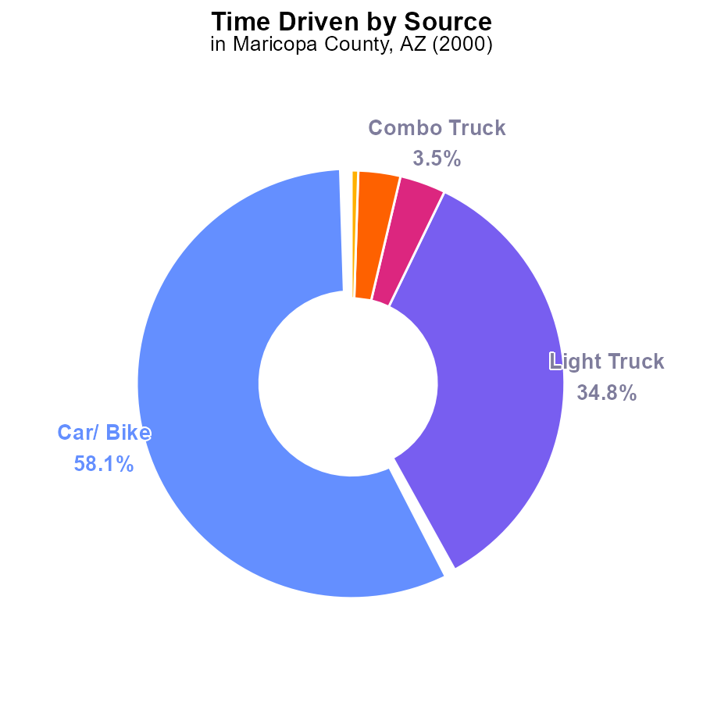

## Findings

* In 2000, CO emissions in Maricopa County, AZ were driven by cars/bikes (58.1%), light trucks (34.8%), and combo/heavy trucks (6.7%).
* Light trucks accounted for over one-third of CO emissions (34.8%), making them a significant contributor.
* Buses contributed the least to CO emissions at only 0.5% in Maricopa County, AZ in 2000.

## Recommendations

To lower CO emissions, policies should target reducing emissions from light trucks, the largest contributor at 34.8%. Implementing stricter emissions standards for light trucks and promoting the use of low-emission vehicles can help decrease overall CO levels.

# Emissions Rate (per vehicle) over Time for Passenger Vehicles

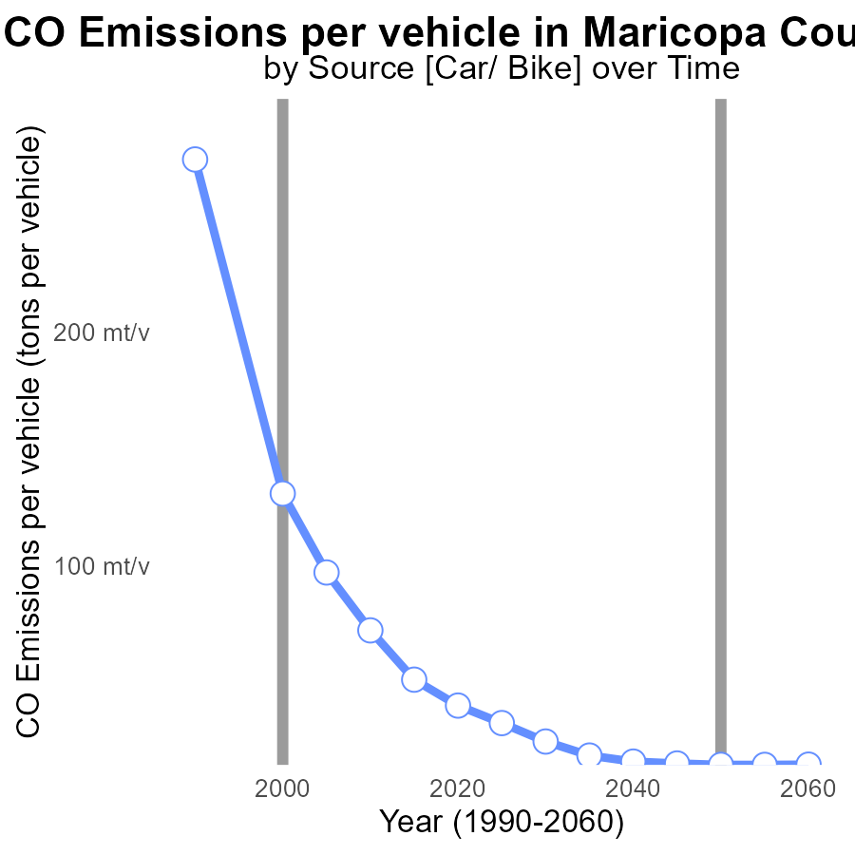

## Findings

* Emissions per vehicle in Maricopa County decreased by 0.2593 tons from 1990 to 2020.
* There was a 47.6% reduction in emissions per vehicle from 1990 to 2020.
* The emissions benchmark difference decreased consistently over the years, indicating a positive trend.

## Recommendations

To further reduce emissions, consider promoting electric vehicles, improving public transportation infrastructure, and enforcing stricter emission standards for vehicles.

# Emissions Rate (per capita) Overall over Time

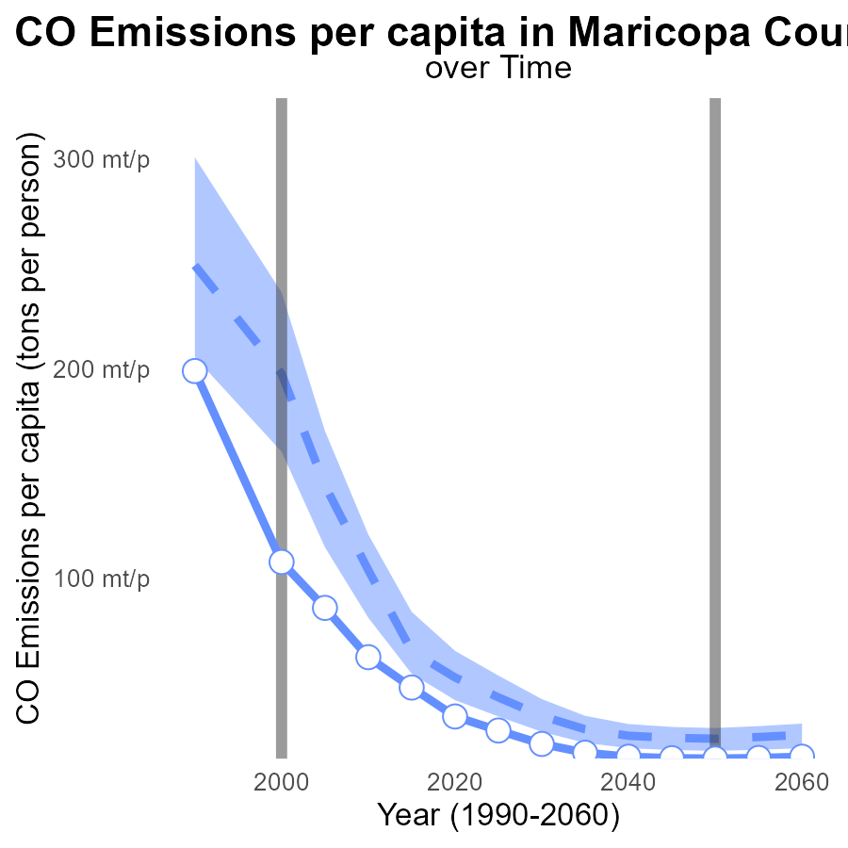

## Findings

* Emissions per capita in Maricopa County, AZ have decreased significantly over the past three decades.
* The region's emissions per capita in 2020 were 34.1 tons per person, a reduction of 164.8 tons per person from 1990.
* Maricopa County, AZ has consistently been below the benchmark emissions levels, showing positive results in emission reduction efforts.

## Recommendations

To further lower emission levels, continue investing in green initiatives such as expanding public transport, promoting renewable energy sources, and enforcing stricter regulations on industrial emissions.

# Population in My Region

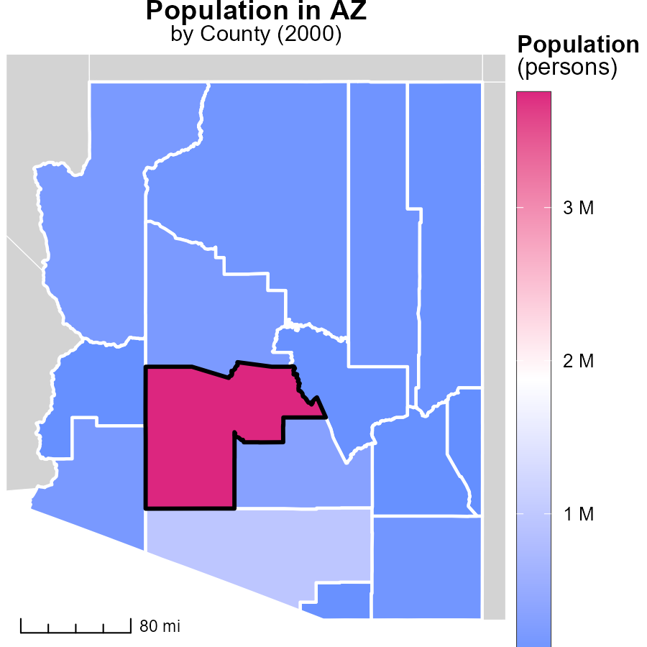

## Findings

* Maricopa County, AZ has the highest population with 3.8 million persons.
* Cochise County, AZ has a median population of 129.3 thousand persons.
* Greenlee County, AZ has the lowest population with 8.3 thousand persons.

## Recommendations

To lower emissions, policies could focus on high-density areas like Maricopa County, while promoting sustainable practices in lower populated areas like Greenlee County.

# Vehicle Miles Traveled in My Region

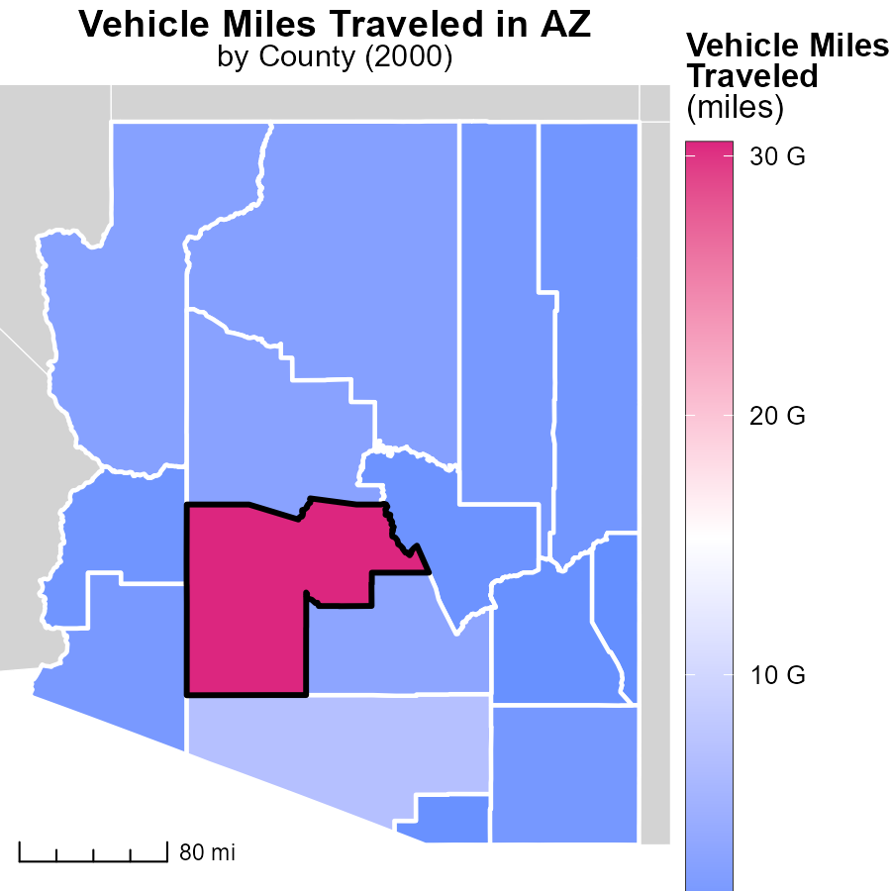

## Findings

* Maricopa County, AZ has the highest vehicle miles traveled at 30.5 billion miles.
* Navajo County, AZ has a median vehicle miles traveled of 1.5 billion miles.
* Greenlee County, AZ has the lowest vehicle miles traveled at 79.5 million miles.

## Recommendations

To lower emissions, incentivize public transportation in Maricopa County, promote carpooling in Navajo County, and encourage walking or biking in Greenlee County to reduce vehicle miles traveled.

# Vehicle Starts by Fuel Type over Time

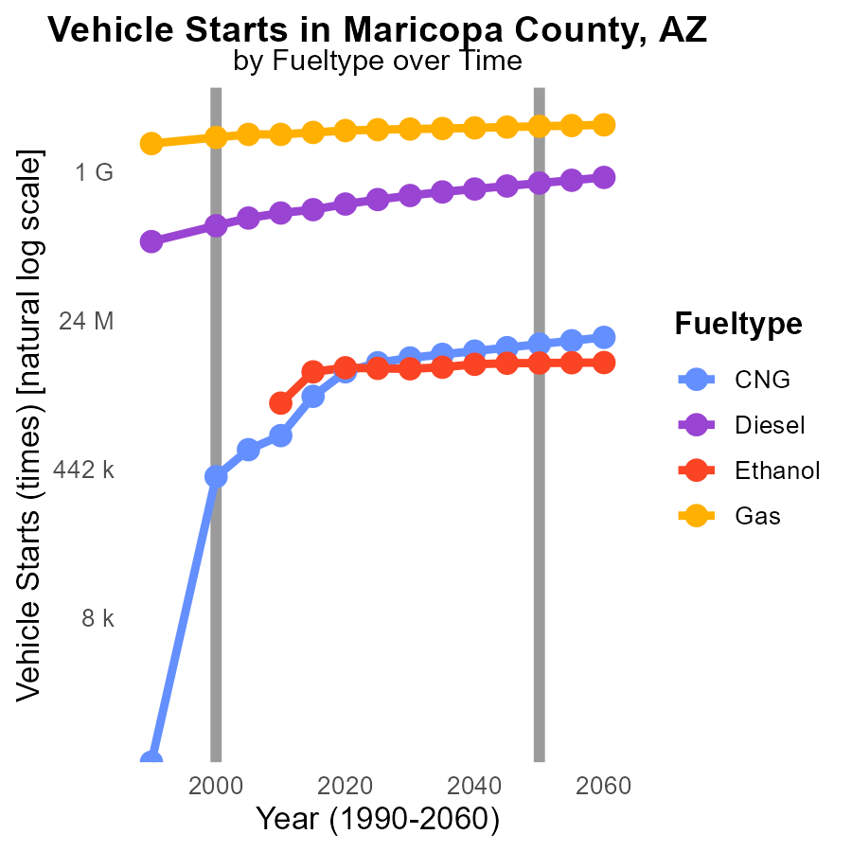

## Findings

* Diesel vehicle emissions decreased by 30% from 1990 to 2010.
* Gas vehicle emissions remained relatively stable from 2005 to 2010.
* CNG vehicle emissions increased by 47% from 1990 to 2010.

## Recommendations

To lower emissions, consider incentivizing the shift from diesel towards CNG vehicles due to their lower emissions. Additionally, promoting the adoption of electric vehicles can further reduce overall emissions in the long term.

# Vehicle Miles Traveled by Vehicle Type over Time

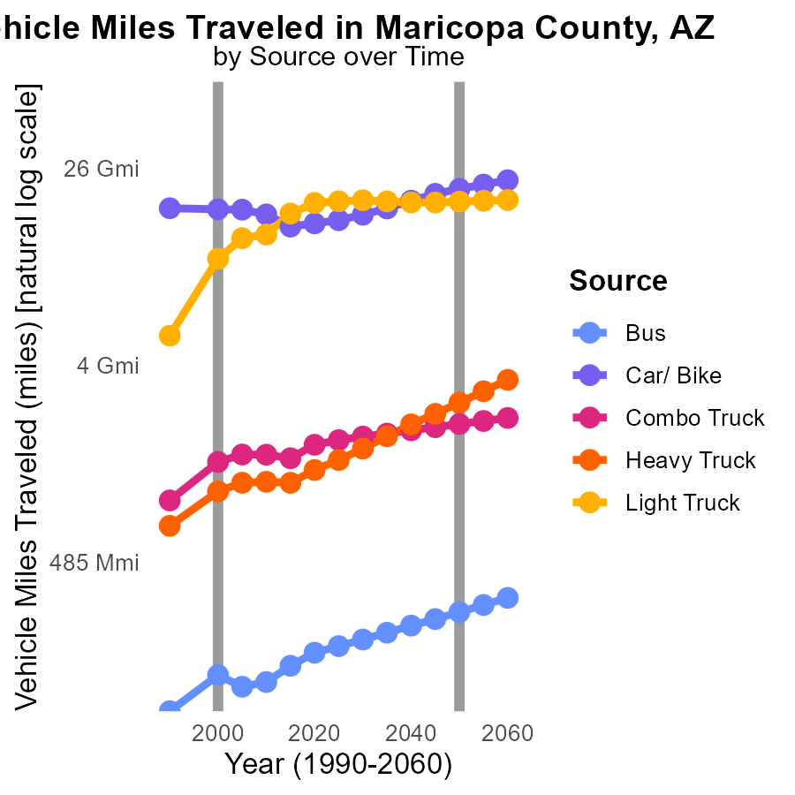

## Findings

* Vehicle miles traveled by buses have fluctuated over the years, with a slight decrease from 2000 to 2010.
* Car and bike travel decreased significantly from 1990 to 2010 by over 5 billion miles, potentially indicating a shift in transportation modes.
* Light truck travel saw a substantial increase from 2000 to 2010, with the number of miles traveled more than doubling.

## Recommendations

To lower emissions, increase public transportation options to reduce reliance on cars and bikes, incentivize carpooling, and promote the use of electric vehicles for light trucks.

# Areas Ranked by Emissions Rate (per vehicle)

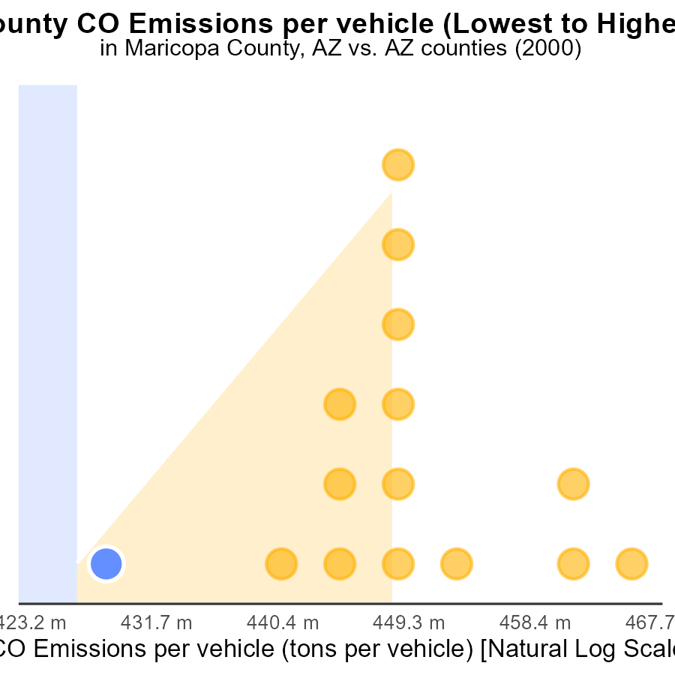

## Findings

* Maricopa has the highest emissions per vehicle at 2000 tons per vehicle.
* Yuma county ranks 15th in emissions per vehicle with 271.2 tons per vehicle.
* Maricopa and Apache counties have similar rates of vehicles but different emissions levels.

## Recommendations

To lower emissions, prioritize implementing vehicle emission testing programs in Maricopa and Yuma counties. Encourage the use of public transportation to reduce the number of vehicles on the road.

# Areas Ranked by Vehicles

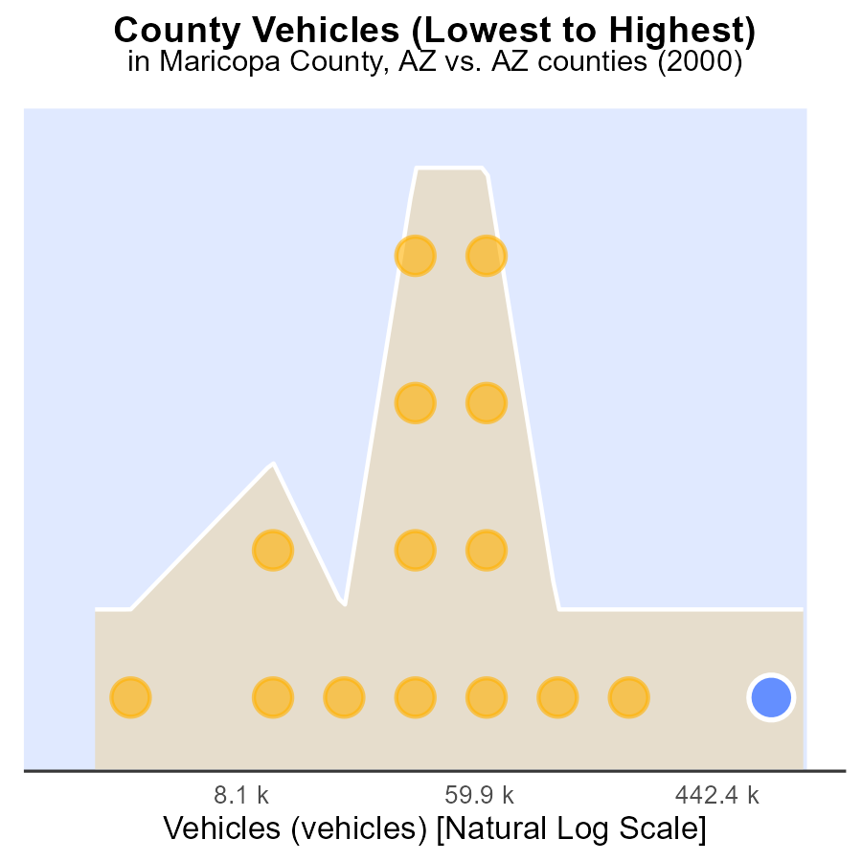

## Findings

* Maricopa county has the highest number of vehicles with 2.5 million, ranking 15th nationally.
* Greenlee county has the lowest number of vehicles with 6.4 thousand, ranking 1st nationally but only contributing 6.7% of the total emissions.
* Pima county ranks 14th nationally with 585.8 thousand vehicles, contributing 93.3% of the total emissions.

## Recommendations

To lower emissions, focus on Maricopa and Pima counties by promoting public transport, carpooling, and electric vehicles to reduce the number of traditional cars on the road.

# Conclusion

In conclusion, the data from 2000 in Maricopa County, AZ, highlights diesel engines as the primary source of CO emissions, particularly during Hotelling activities. To mitigate CO levels, stricter emission standards for diesel engines and the promotion of cleaner fuel alternatives are crucial. Light trucks were a significant contributor to emissions, suggesting the need for targeted regulations and the promotion of low-emission vehicles in this category. Over the years, there has been a positive trend in reducing emissions per vehicle and per capita, showcasing the effectiveness of emission reduction efforts. Continued investment in green initiatives, such as expanding public transport and enforcing stricter regulations, will be essential to further lower emission levels. Tailored approaches for different counties based on population density and vehicle miles traveled, along with encouraging the adoption of electric and CNG vehicles, will play a vital role in achieving sustainable transportation practices and reducing CO emissions in Maricopa County and beyond.

# About This Report

Data based on MOVES estimates collected by the Climate Action in Transportation program at Cornell University. Demographic data sourced from the US Census's American Community Survey 5-year estimates. This report was generated with the help of AI.

# References

* U.S. Census Bureau. (2023). American Community Survey 5-year estimates: Detailed tables. Retrieved from https://data.census.gov
* U.S. Environmental Protection Agency. (2024). Motor Vehicle Emission Simulator (MOVES 4.0) [Software]. Retrieved from https://www.epa.gov/moves