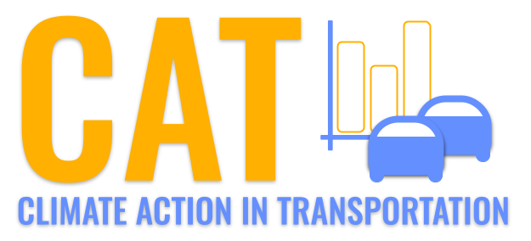 

**VOC Emissions in Lake County, 2045**  
Made with CAT VISUALIZER by Gao Labs @ Cornell University.

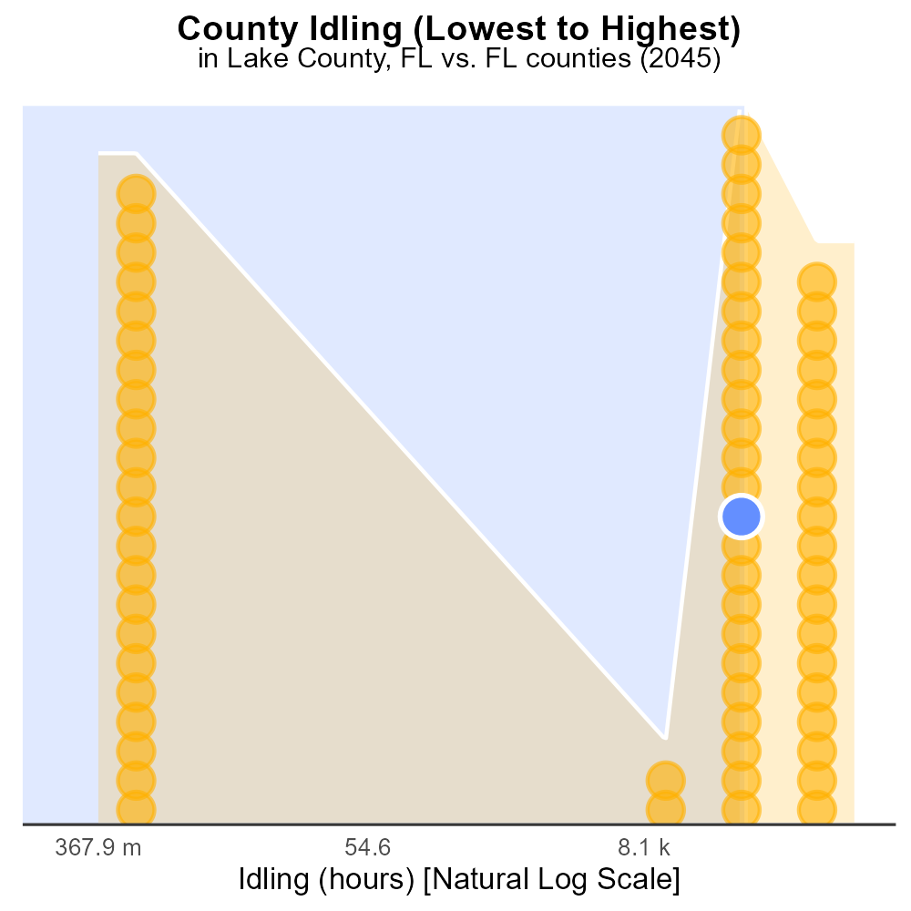

## Keywords

Volatile Organic Compounds; emissions; on-road transportation; Lake County; FL; 2045

## Highlights

* VOC emissions linked to air pollution and health concerns.
* Lake County, FL, experiencing increased transportation growth.
* Monitoring VOC emissions crucial for environmental impact assessment.
* VOC levels in 2045 compared to current data for trend analysis.
* Recommendations for mitigation strategies to reduce VOC emissions.

# Introduction

In 2045, the issue of Volatile Organic Compounds (VOC) emissions from on-road transportation in Lake County, FL, has become a critical concern. VOCs are a key component of air pollution and have been associated with various health risks, making their monitoring and regulation essential for public health and environmental well-being.

With Lake County experiencing rapid growth in transportation infrastructure, understanding the levels and sources of VOC emissions becomes increasingly important. This report aims to analyze the VOC emissions data for 2045 in Lake County and compare it to historical data to identify trends and assess the effectiveness of current mitigation efforts. Additionally, recommendations will be provided for implementing strategies to reduce VOC emissions and improve air quality in the region.

# Idling by Fuel Type

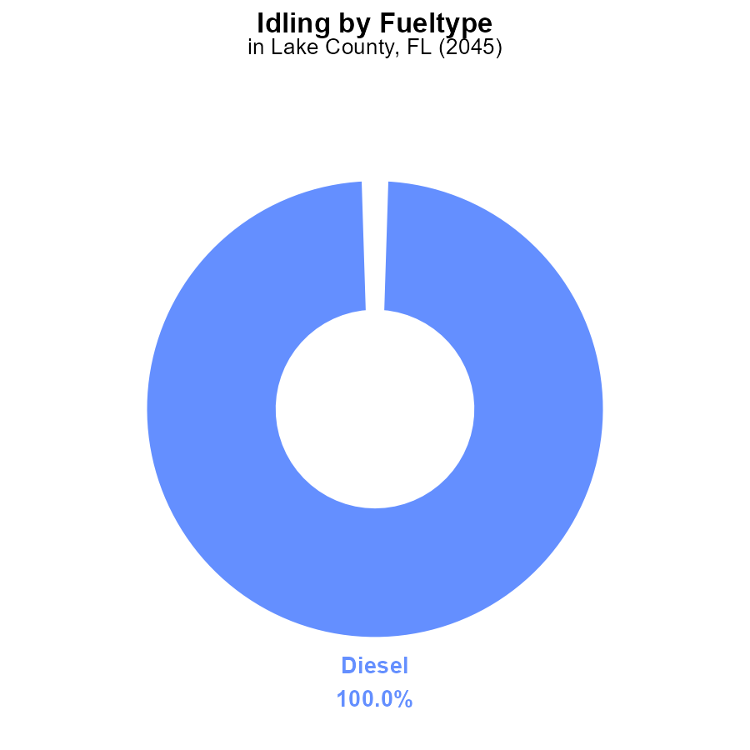

## Findings

* Diesel vehicles in Lake County, FL emitted 138.3 k VOC while idling in 2045.
* VOC emissions from CNG, Ethanol, and Gas vehicles were not reported for idling in 2045.

## Recommendations

To lower VOC emissions, Lake County should prioritize reducing idling time for diesel vehicles through targeted educational campaigns and implementing strict idling policies.

# Time Driven by Fuel Type

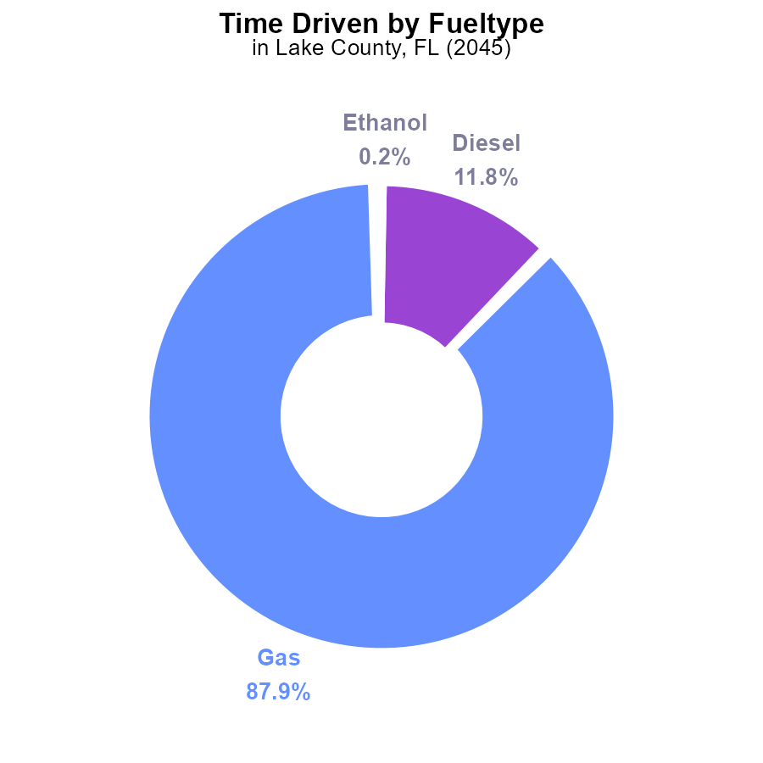

## Findings

* In 2045, Lake County, FL, emitted 140.4 million kg of VOCs.
* Gasoline was responsible for 87.9% of the total VOC emissions, with 123.6 million kg.
* Diesel emissions contributed 16.6 million kg, accounting for 11.8% of the overall VOC emissions.

## Recommendations

To reduce VOC emissions, policies should focus on reducing gasoline and diesel usage through promoting electric vehicles, improving public transportation, and incentivizing carpooling.

# Vehicle Starts Overall over Time

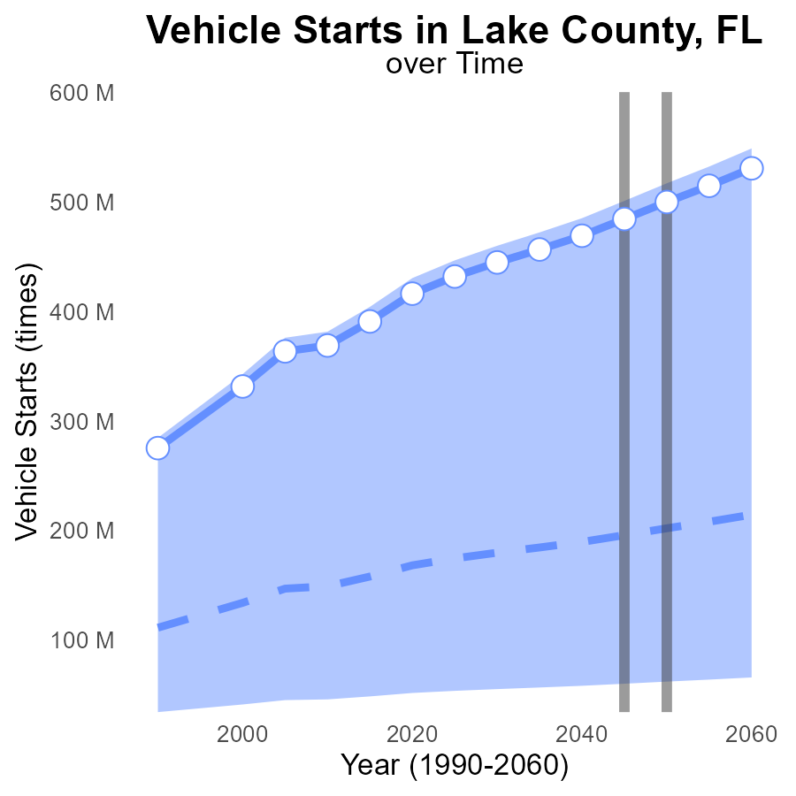

## Findings

* Vehicle starts in Lake County, FL are increasing steadily over the years.
* The area exceeds the upper 75th percentile benchmark by 55.08% in 2060.
* In 2055, benchmark difference is negative indicating a need for emission reduction strategies.

## Recommendations

To lower emission levels, it is crucial to introduce and promote the use of eco-friendly vehicles in Lake County. Implement stricter emission regulations for vehicles entering the area and encourage the use of public transportation to reduce the number of vehicle starts.

# Emissions Rate (per mile) over Time for Passenger Vehicles

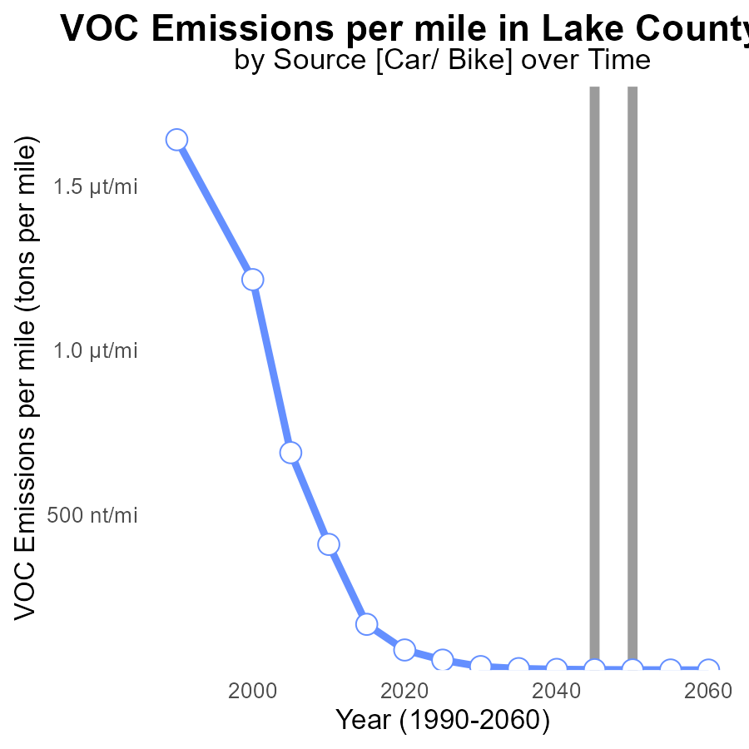

## Findings

* VOC emissions per mile have decreased steadily from 57.5 tons in 2025 to 27.3 tons in 2060.
* There is a consistent decline in emissions, with a 52.5% reduction from 2025 to 2060.
* Lake County has successfully met the emissions reduction goals with no benchmark differences.

## Recommendations

To further lower VOC emissions, continue investing in sustainable transportation methods like public transit and incentivizing electric vehicle adoption. Implement stricter emissions standards for industries.

# Vehicle Starts in My Region

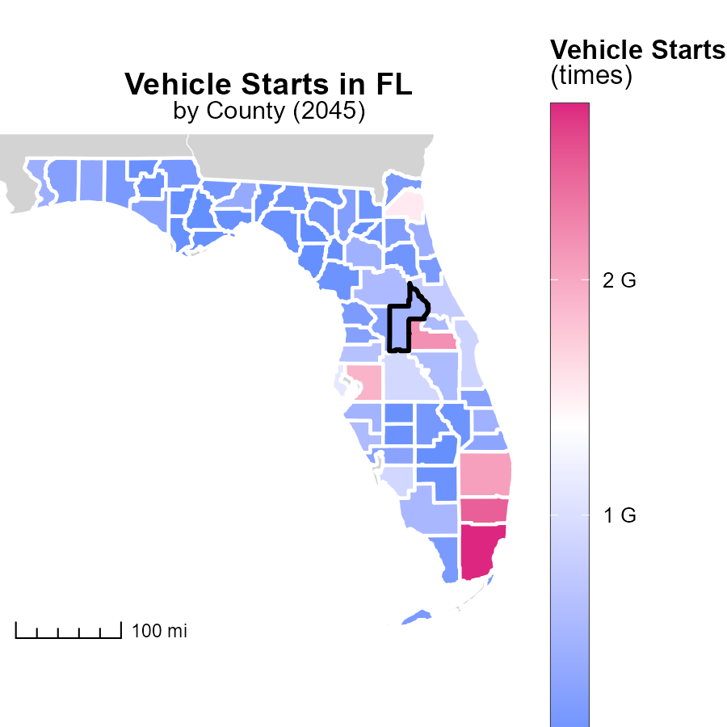

## Findings

* Miami-Dade County, FL has the highest vehicle starts with 2.7 billion times.
* Clay County, FL has a median of 195.8 million vehicle starts.
* Liberty County, FL has the lowest vehicle starts at 11.6 million times.

## Recommendations

To lower emissions, focus on improving public transportation in Miami-Dade County to reduce the high number of vehicle starts. In Clay County, promote carpooling initiatives. In Liberty County, incentivize the use of electric vehicles.

# Vehicles Mapped by Area

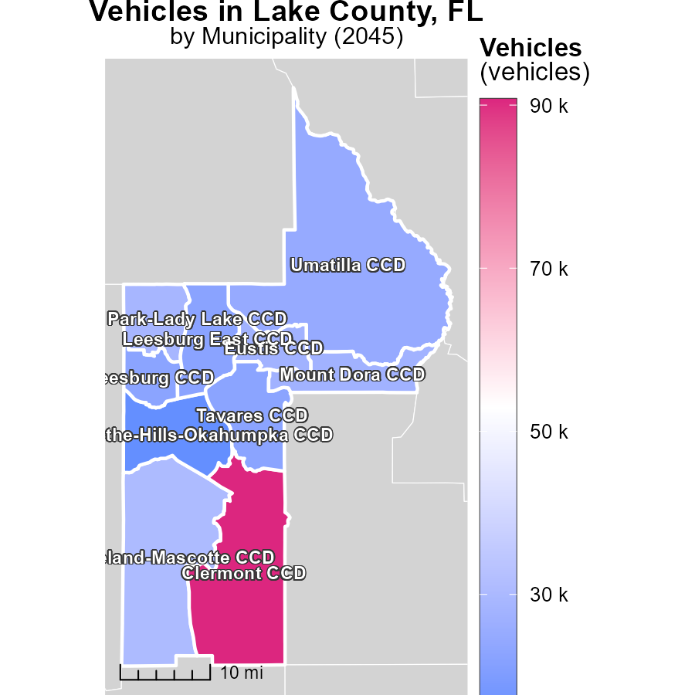

## Findings

* The highest emissions in Clermont CCD, FL, are 90.7 k tons.
* Umatilla CCD, FL, has a median emission level of 25.0 k tons.
* Howey-in-the-Hills-Okahumpka CCD, FL, has the lowest emissions at 15.2 k tons.

## Recommendations

To lower emissions, encourage the adoption of electric vehicles, promote carpooling initiatives, and invest in public transportation infrastructure in these areas to reduce the reliance on high-emission vehicles and minimize overall emissions.

# Vehicle Miles Traveled by Road Type over Time

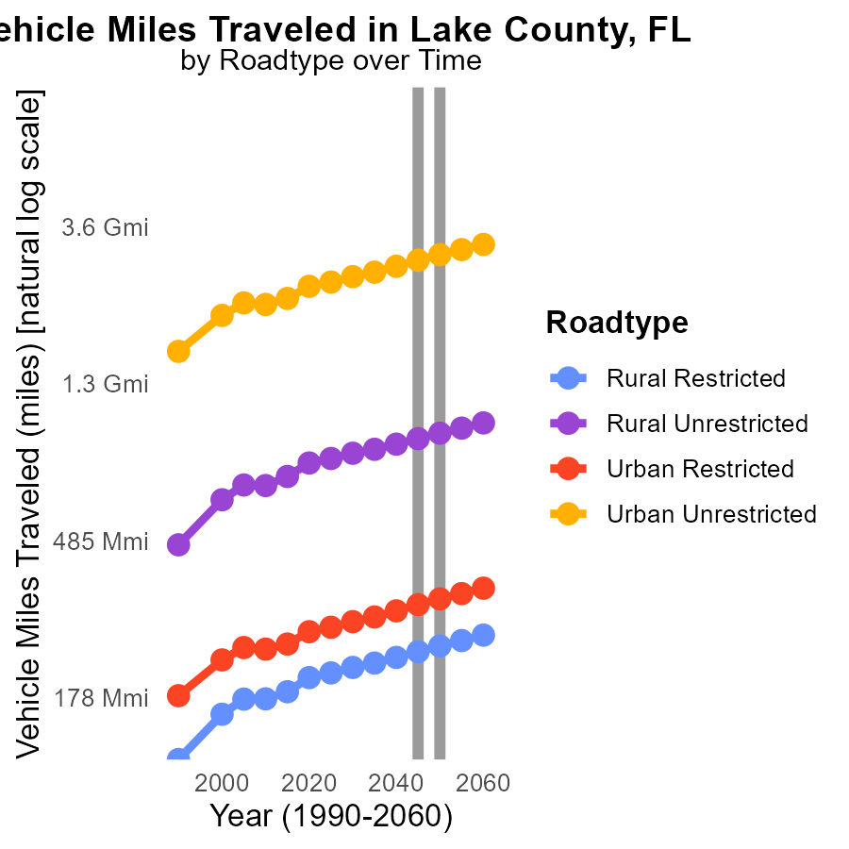

## Findings

* VOC emissions in Lake County are highest in urban unrestricted areas.
* Vehicle miles traveled are projected to increase in all road types between 2035-2055.
* By 2055, rural unrestricted areas are expected to have a 3.1 billion miles increase in vehicle miles traveled.

## Recommendations

To lower emissions, policymakers should focus on implementing public transportation options, promoting carpooling initiatives, and investing in infrastructure for walking and biking. Additionally, incentives for electric vehicles could help reduce VOC emissions significantly.

# Vehicle Starts by Fuel Type over Time

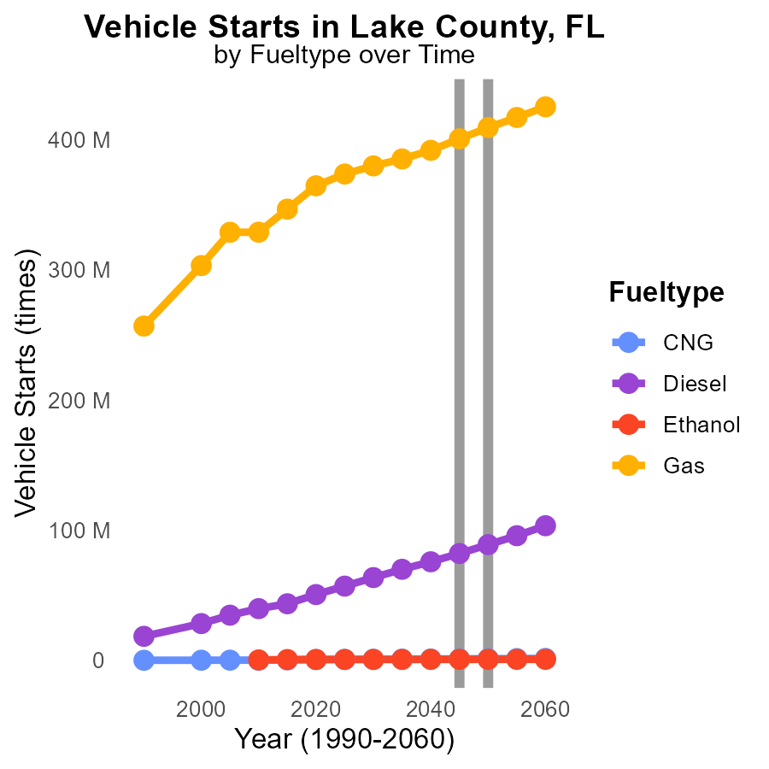

## Findings

* Diesel emissions increase until 2050 before decreasing slightly by 2055.
* Gasoline emissions steadily decrease from 2035 to 2055.
* CNG emissions show a consistent increase until 2050, followed by a slight decrease by 2055.

## Recommendations

To reduce emissions, consider increasing the use of alternative fuels like CNG and Ethanol, which have shown potential for emission reductions. Implement strict regulations to encourage the adoption of cleaner fuel types and incentivize the use of electric vehicles.

# Areas Ranked by Emissions Rate (per capita)

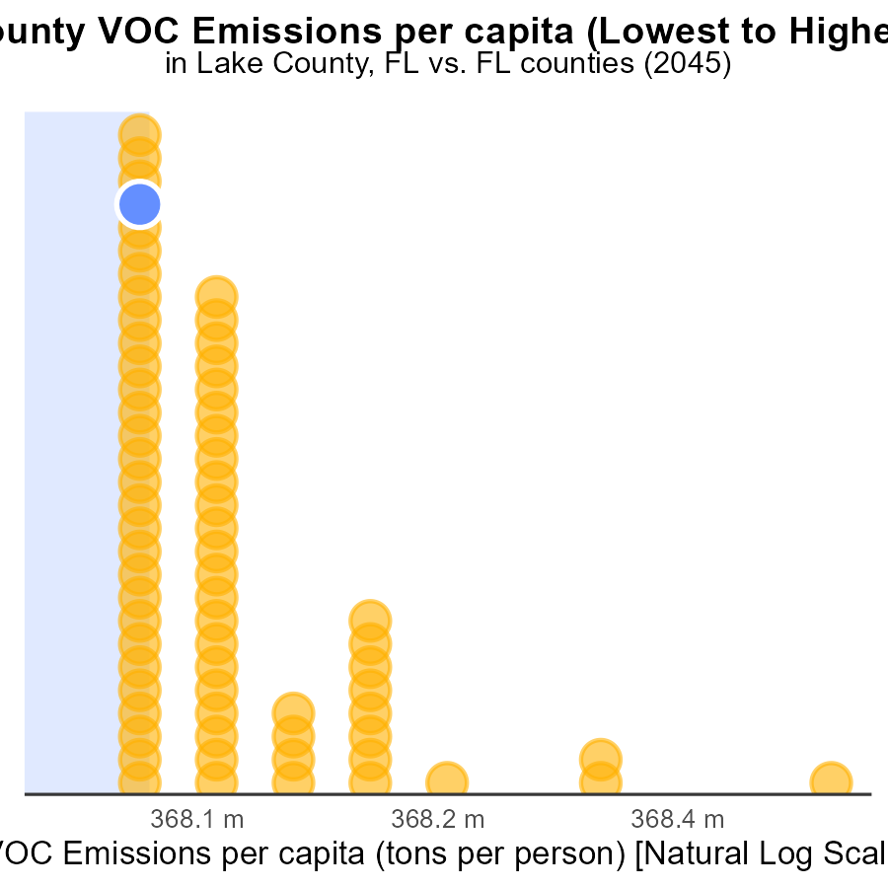

## Findings

* Miami-Dade has the lowest VOC emissions per capita with 295.0 tons per person.
* Hamilton county has the highest VOC emissions per capita with 1.9 million tons per person.
* Putnam and Lake counties have high VOC emissions per capita, ranking 27th and 26th respectively.

## Recommendations

To lower VOC emissions, prioritize Hamilton county for significant reductions due to its excessively high rate. Implement targeted emission reduction policies in Putnam and Lake counties to address their above-average emission levels.

# Areas Ranked by Idling

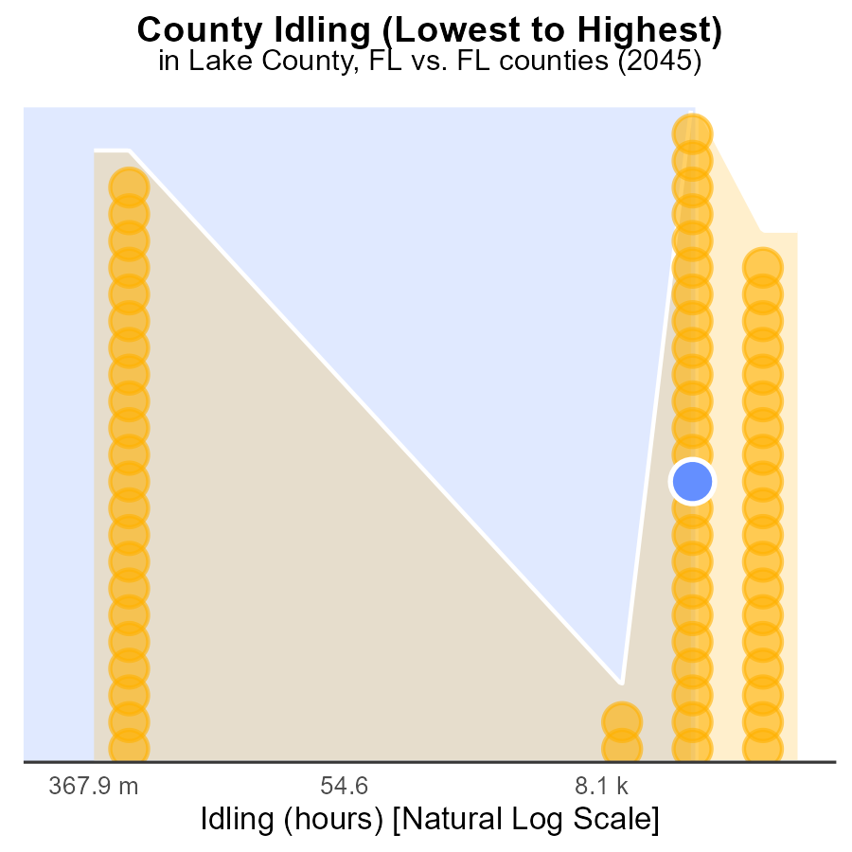

## Findings

* Broward County had the highest idling hours with 1.0 million, ranking 67th and representing 100.0% of the total idling hours.
* Bay County had the lowest idling hours with 0.0, ranking 1st and contributing to 32.8% of all idling hours.
* The top 3 counties with the highest idling hours were Broward, Nassau, and Lake, contributing to more than half of the statewide idling time.

## Recommendations

To reduce emissions from idling vehicles, targeted strategies such as implementing anti-idling policies, promoting the use of electric vehicles, and providing incentives for alternative transportation methods should be considered. Broward, Nassau, and Lake counties should focus on specific campaigns to decrease idling time.

# About This Report

Data based on MOVES estimates collected by the Climate Action in Transportation program at Cornell University. Demographic data sourced from the US Census's American Community Survey 5-year estimates. This report was generated with the help of AI.

# References

* U.S. Census Bureau. (2023). American Community Survey 5-year estimates: Detailed tables. Retrieved from https://data.census.gov
* U.S. Environmental Protection Agency. (2024). Motor Vehicle Emission Simulator (MOVES 4.0) [Software]. Retrieved from https://www.epa.gov/moves