 

**NOx Emissions in Kane County, 2060**  
Made with CAT VISUALIZER by Gao Labs @ Cornell University.

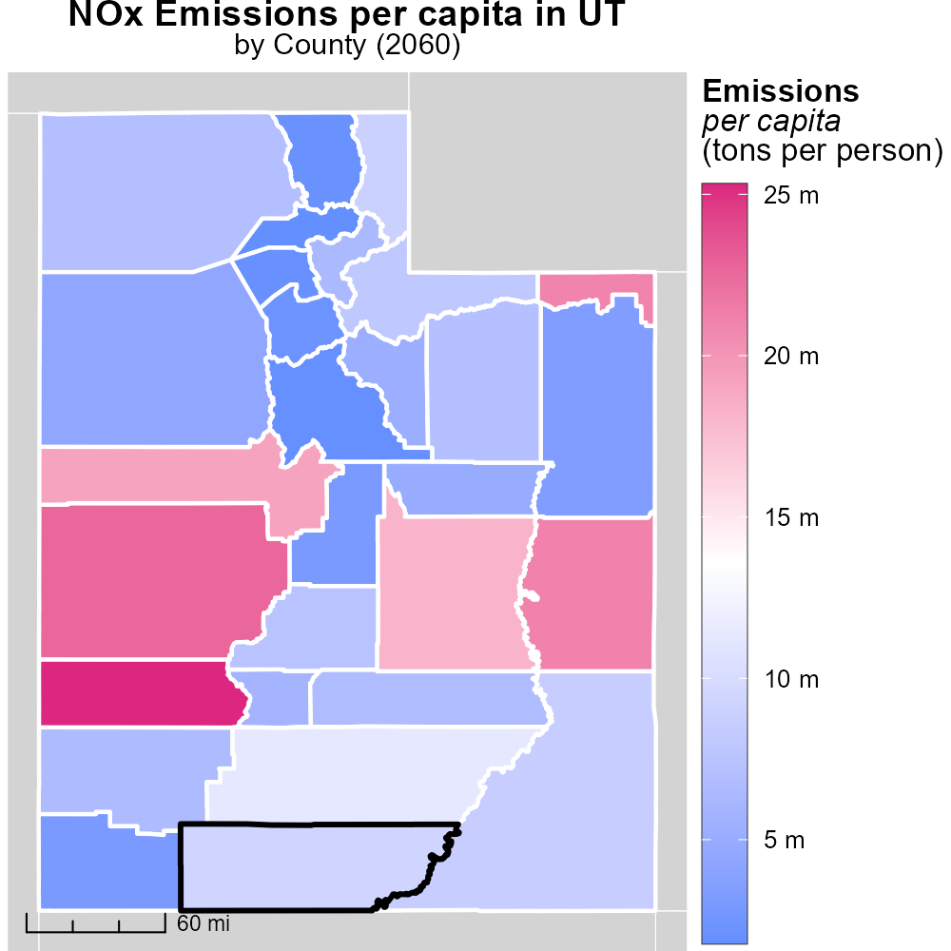

## Keywords

Oxides of Nitrogen; NOx emissions; on-road transportation; Kane County, UT; 2060

## Highlights

* Impact of NOx emissions from transport in Kane County, UT.
* Analysis of on-road transportation contribution to NOx.
* Future projections for NOx levels in 2060.
* Addressing environmental concerns in Kane County.
* Strategies for mitigating NOx emissions from vehicles.

# Introduction

In 2060, addressing the issue of Oxides of Nitrogen (NOx) emissions from on-road transportation in Kane County, UT is crucial for environmental sustainability and public health. NOx is a key air pollutant and its impact on air quality and human health cannot be understated.

The report will focus on analyzing the contribution of on-road transportation to NOx emissions in Kane County, projecting future NOx levels by 2060, and proposing strategies to mitigate these emissions and combat environmental concerns in the region. By understanding the sources and impacts of NOx, effective policies can be implemented to reduce its harmful effects on the environment and the community.

# Hotelling (Diesel Aux) by Road Type

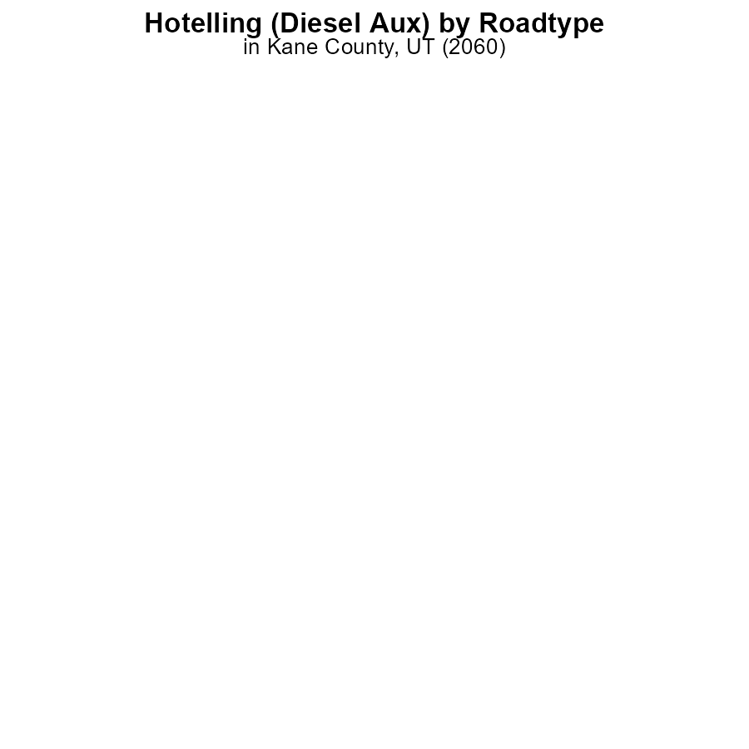

## Findings

* In 2060, NOx emissions in Kane County, UT from Hotelling (Diesel Aux) operation were 0.0 hours.
* There were no NOx emissions from Hotelling (Diesel Aux) operation in any of the specified areas: Rural Restricted, Rural Unrestricted, Urban Restricted, Urban Unrestricted.

## Recommendations

Given the absence of NOx emissions from Hotelling (Diesel Aux) operation in 2060, continued monitoring and maintenance of equipment should be implemented to sustain this zero-emission status. Additionally, exploring the feasibility of transitioning to cleaner energy sources can help further reduce emissions.

# Vehicle Miles Traveled by Fuel Type

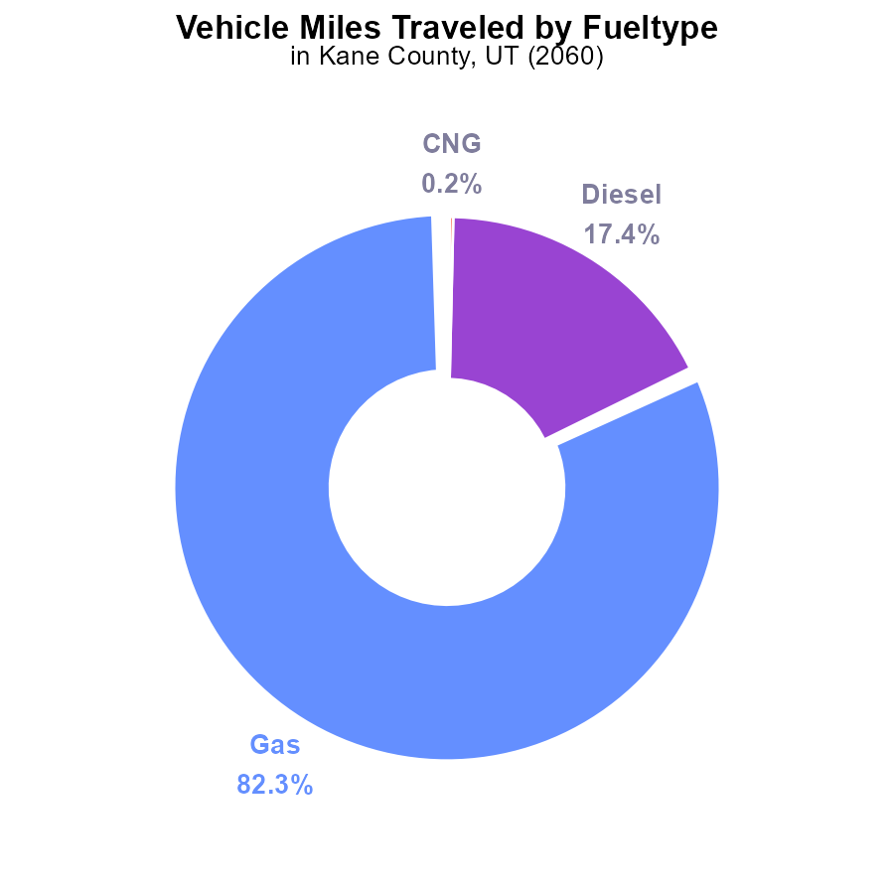

## Findings

* Gas vehicles contribute to 82.3% of NOx emissions from Vehicle Miles Traveled in Kane County, UT in 2060.
* Diesel vehicles account for 17.4% of NOx emissions, significantly lower than gas vehicles.
* CNG and Ethanol vehicles combined contribute only 0.4% to NOx emissions.

## Recommendations

To lower NOx emissions, focus on reducing the usage of gas and diesel vehicles by promoting electric or hybrid alternatives. Incentivize the adoption of cleaner fuel technologies to decrease overall NOx emissions.

# Time Driven over Time for Buses

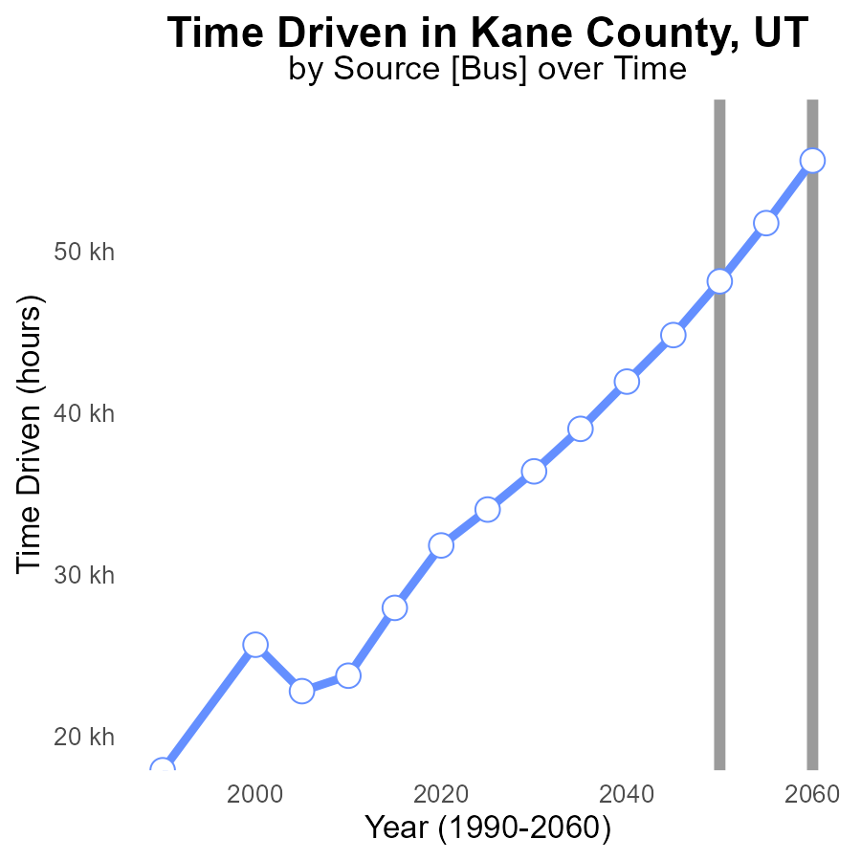

## Findings

* NOx emissions in Kane County, UT, have been increasing over the years until 2050.
* A significant reduction of 12.6% in NOx emissions is seen between 2050 and 2060.
* By 2060, NOx emissions are still 13.5% higher than those in 2040.

## Recommendations

To lower NOx emissions, consider implementing stricter regulations on high-emission vehicles, promoting the use of electric vehicles, and incentivizing public transportation to reduce the use of personal vehicles. Additionally, investing in renewable energy sources for power generation can further decrease emissions.

# Emissions Rate (per capita) over Time for Buses

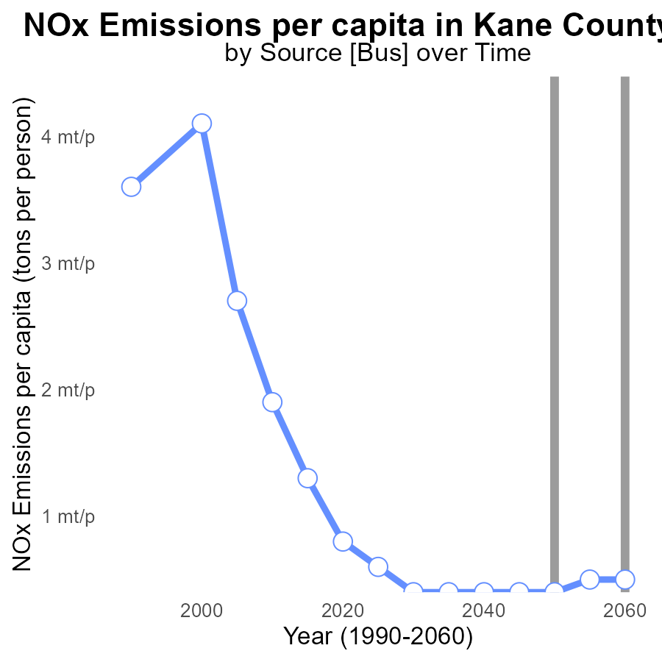

## Findings

* NOx emissions per capita have been increasing over the years in Kane County, UT.
* There has been a slight decrease in emissions compared to the benchmark starting in 2055.
* By 2060, emissions per capita are projected to be 496.2 tons per person in this area.

## Recommendations

To lower the NOx emissions in Kane County, UT, policies should focus on implementing stricter emission standards for industries and promoting the use of cleaner transportation methods. Additionally, investing in renewable energy sources and promoting energy efficiency programs can help reduce emissions further.

# Emissions Rate (per capita) in My Region

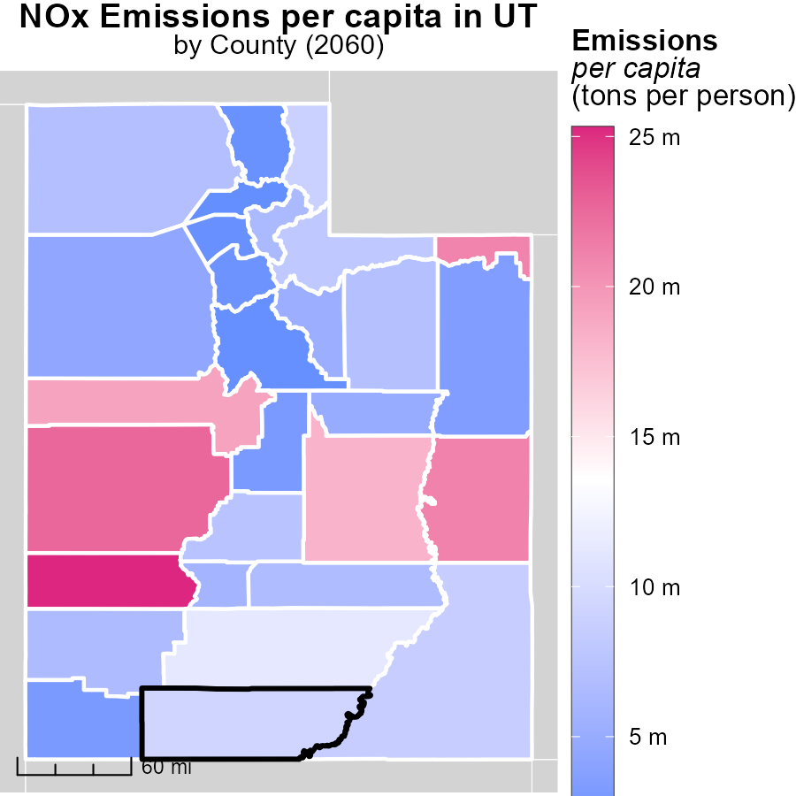

## Findings

* Beaver County, UT has the highest per capita emissions at 25.3 tons per person.
* Wayne County, UT has a median per capita emissions of 6.7 tons per person.
* Weber County, UT has the lowest per capita emissions at 1.8 tons per person.

## Recommendations

To lower emissions levels, targeted strategies should focus on Beaver County to reduce the 25.3 tons per person to a more sustainable level. Additionally, efforts should be made to maintain Wayne County's median level at 6.7 tons per person and possibly implement policies to ensure other regions do not surpass this amount. Furthermore, Weber County's successful emission reduction strategies should be studied and replicated in other areas to achieve similar low per capita emissions.

# Emissions Rate (per capita) Mapped by Area

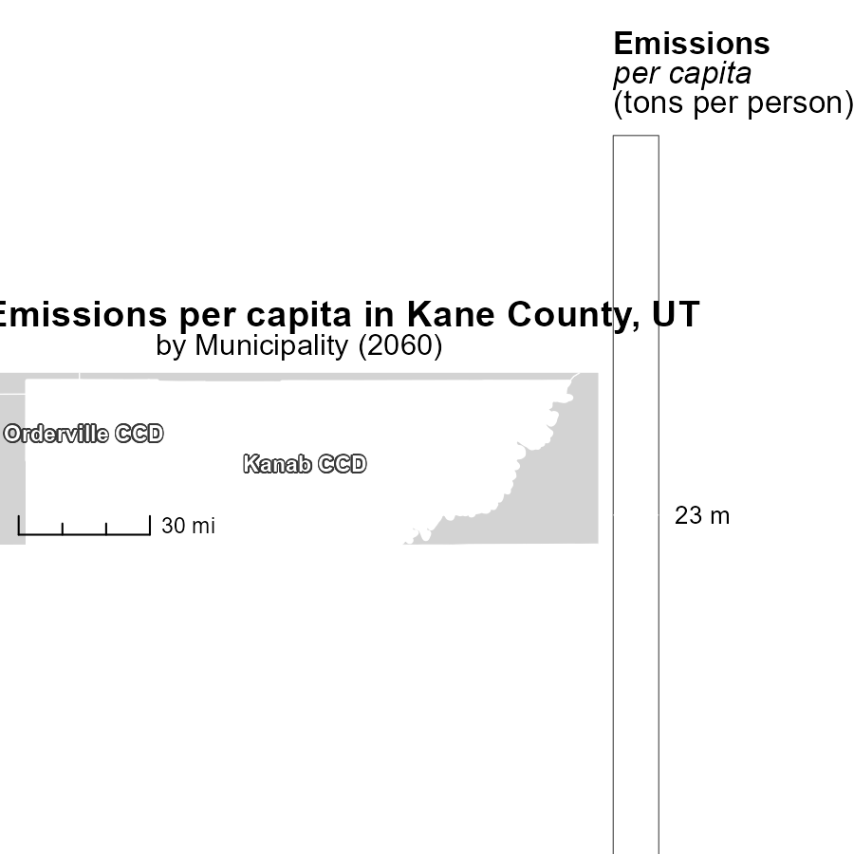

## Findings

* The maximum emissions per capita in Kanab CCD, UT, were 23.2 tons per person.
* The median emissions per capita in Orderville CCD, UT, were 23.2 tons per person.

## Recommendations

To lower emissions in Kanab CCD, UT, targeted initiatives should be implemented to reduce the average emissions per person. In Orderville CCD, UT, efforts should focus on maintaining or further reducing the emissions to ensure sustainability.

# Population by Vehicle Type over Time

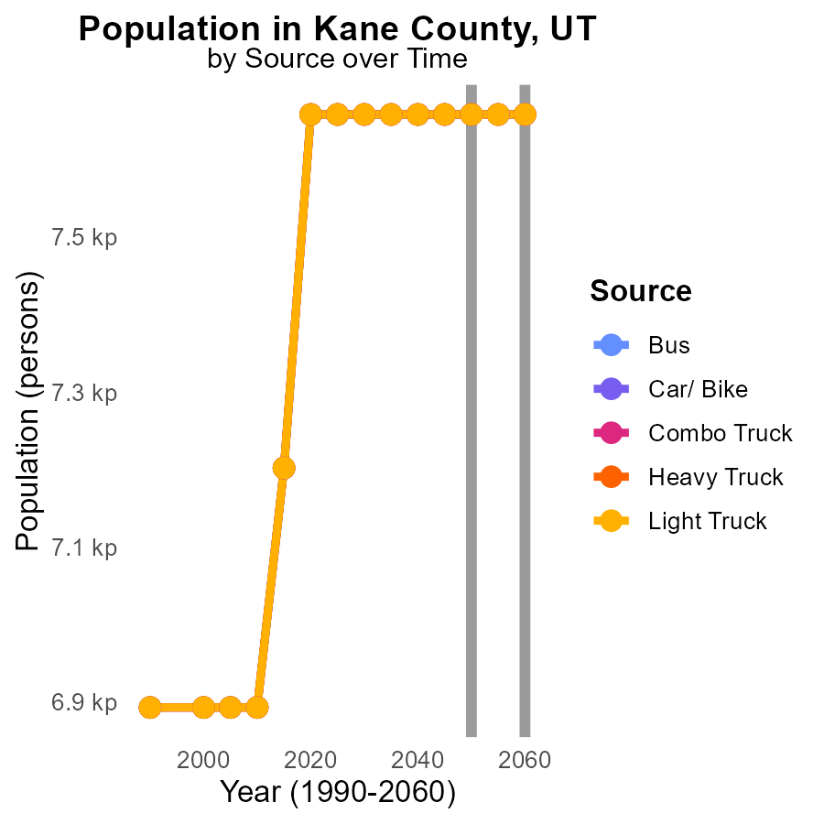

## Findings

* NOx emissions in Kane County, UT, from different vehicle types are consistent over the years 2050-2060. Each type emits 7.7 k in that period.
* There is no anticipated decrease in NOx emissions from 2050 to 2060 across all vehicle types, showing stagnation in reduction efforts.
* Population data is missing; however, emissions per person remain constant, indicating that individual behaviors have not altered significantly.

## Recommendations

To lower NOx emissions in Kane County, diversify transportation options to reduce reliance on traditional vehicles. Invest in infrastructure for electric and hybrid vehicles, promote public transportation, and encourage cycling and walking.

# Population by Fuel Type over Time

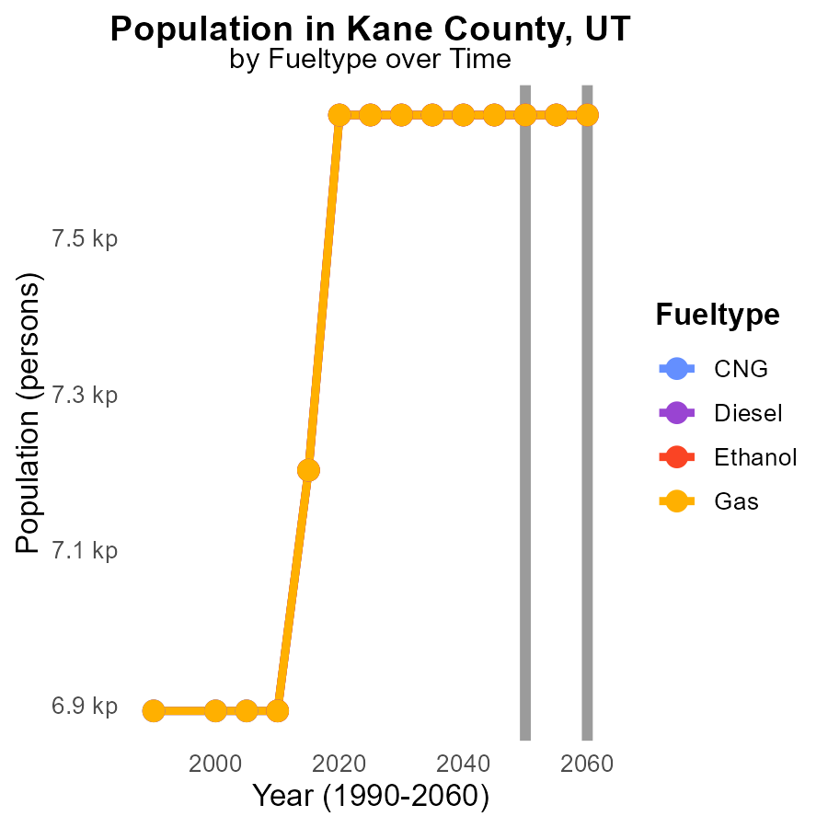

## Findings

* NOx emissions are consistent at 7.7 k for CNG, Diesel, Ethanol, and Gas from 2050 to 2060 in Kane County, UT.
* There is no difference in emissions between the fuel types over the specified timeframe.
* Population data is missing, making it challenging to assess per capita emissions.

## Recommendations

To lower NOx emissions in Kane County, UT, there should be an emphasis on transitioning to cleaner fuel sources and implementing stricter emission regulations for all fuel types.

# Areas Ranked by Emissions Rate (per mile)

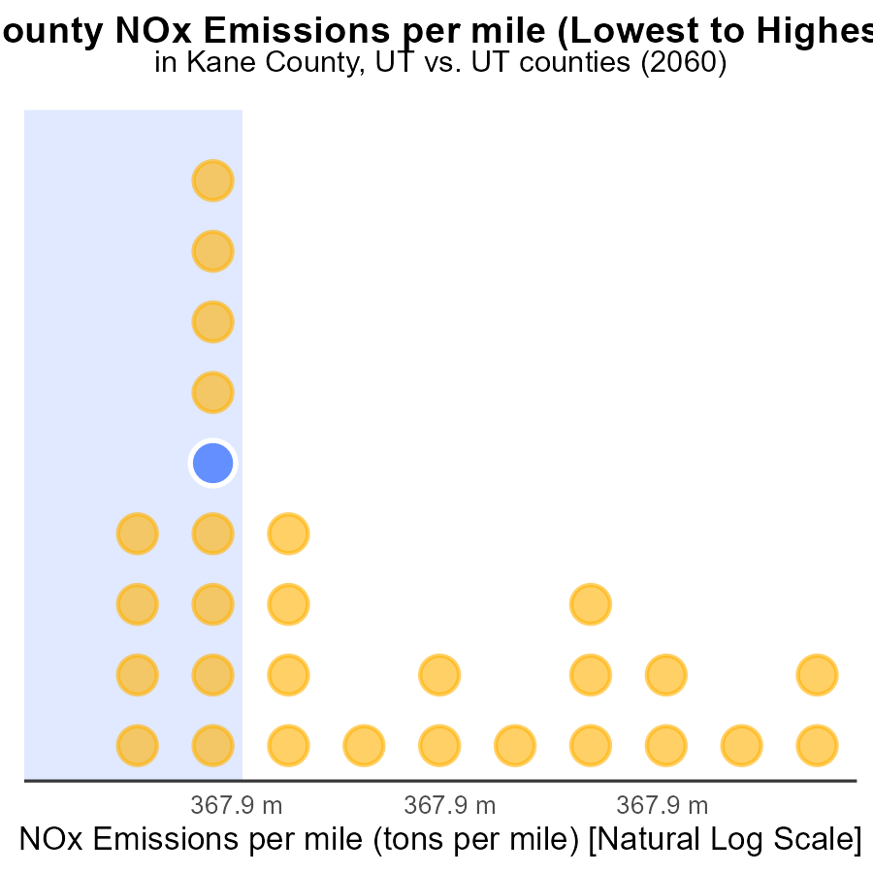

## Findings

* Davis County has the lowest NOx emissions per mile at 3.4 tons per mile.
* Beaver County has the highest NOx emissions per mile at 100.0 tons per mile.
* On average, NOx emissions per mile in the mentioned counties range from 3.4% to 100.0%.

## Recommendations

To lower NOx emissions per mile, counties should consider implementing stricter vehicle emission standards, promoting electric vehicles, enhancing public transportation infrastructure, and encouraging carpooling.

# Areas Ranked by Population

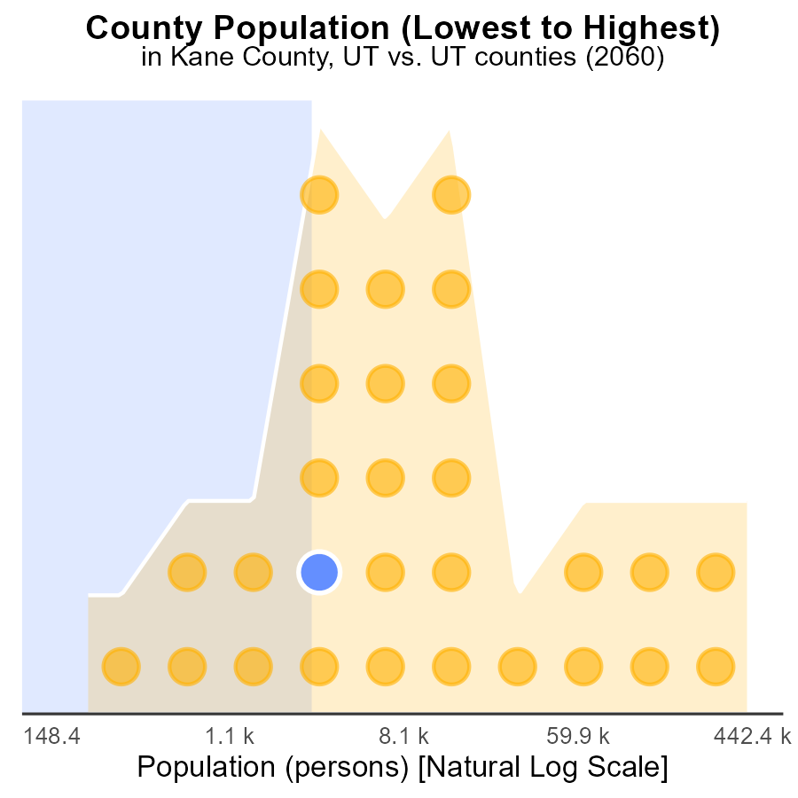

## Findings

* Salt Lake County has the highest population at 1.1 million.
* Kane County has the lowest population at 7.7 thousand.
* Daggett County has a small population, ranking 2nd with 590 individuals.

## Recommendations

To lower NOx emissions, focus on Salt Lake County due to its high population. Implement stricter regulations on vehicle emissions and promote the use of electric vehicles.

# Conclusion

In conclusion, the data on NOx emissions from on-road transportation in Kane County, UT in 2060 reveals some promising developments and areas for improvement. The absence of NOx emissions from Hotelling (Diesel Aux) operation signifies the success of current monitoring and maintenance practices. Moving forward, sustaining this zero-emission status should be a priority through continued vigilance and exploring cleaner energy sources. Gas vehicles remain the primary contributors to NOx emissions, highlighting the urgent need to promote electric or hybrid alternatives. Diesel vehicles, while lower in contribution, still demand attention for further reduction.

Although a notable 12.6% reduction in NOx emissions is observed between 2050 and 2060, overall emissions remain higher than those in 2040. To address this, stricter regulations on high-emission vehicles, greater adoption of electric vehicles, and incentivizing public transportation are recommended. Additionally, efforts should be directed towards implementing stricter emission standards for industries and improving transportation methods to reduce emissions per capita, which are projected to be 496.2 tons per person by 2060. Tailored strategies for regions with varying emission levels, such as Beaver County with the highest per capita emissions, are essential. Future endeavors should focus on diversifying transportation options, investing in cleaner fuel sources, and maintaining low per capita emissions.

Furthermore, the stagnation in NOx emissions from different vehicle types indicates the need for renewed focus and innovative solutions to drive reductions. Despite consistent emissions per mile in different counties, varying population sizes necessitate tailored approaches to achieve lower emissions. By emphasizing stricter regulations, promoting electric vehicles, and enhancing public transportation infrastructure, Kane County, along with Salt Lake County with the highest population, can make significant strides in lowering NOx emissions in the region.

# About This Report

Data based on MOVES estimates collected by the Climate Action in Transportation program at Cornell University. Demographic data sourced from the US Census's American Community Survey 5-year estimates. This report was generated with the help of AI.

# References

* U.S. Census Bureau. (2023). American Community Survey 5-year estimates: Detailed tables. Retrieved from https://data.census.gov
* U.S. Environmental Protection Agency. (2024). Motor Vehicle Emission Simulator (MOVES 4.0) [Software]. Retrieved from https://www.epa.gov/moves