 

**CO Emissions in Pueblo County, 2050**  
Made with CAT VISUALIZER by Gao Labs @ Cornell University.

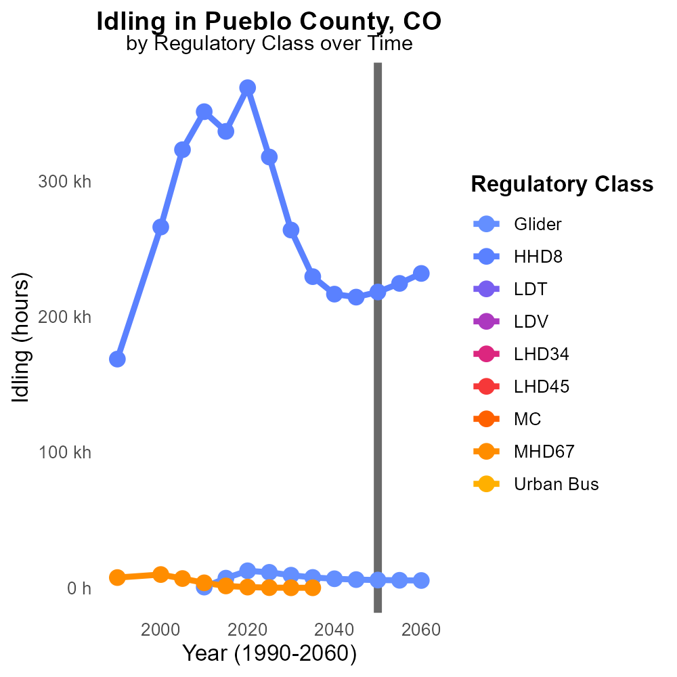

## Keywords

Carbon Monoxide emissions; on-road transportation; Pueblo County; 2050

## Highlights

* Pueblo County's on-road CO emissions in 2050 warrant analysis.
* The impact of transportation on air quality is of concern.
* Studying CO emissions can inform future environmental policies.
* Findings may suggest strategies to reduce harmful pollutants.
* A comprehensive report on CO emissions is crucial for public health.

# Introduction

In 2050, Pueblo County, Colorado, faces a critical juncture in managing Carbon Monoxide (CO) emissions originating from on-road transportation. As the county's population and infrastructure continue to grow, the impact of vehicular emissions on air quality is set to become an increasingly pressing concern. Understanding the trends, sources, and levels of CO emissions is essential for formulating effective environmental policies and safeguarding public health. This report aims to analyze the current state of CO emissions from on-road transportation in Pueblo County, projecting future trajectories and proposing strategies for mitigating the harmful effects of this pollutant on the region's air quality and community well-being.

# Vehicle Miles Traveled by Fuel Type

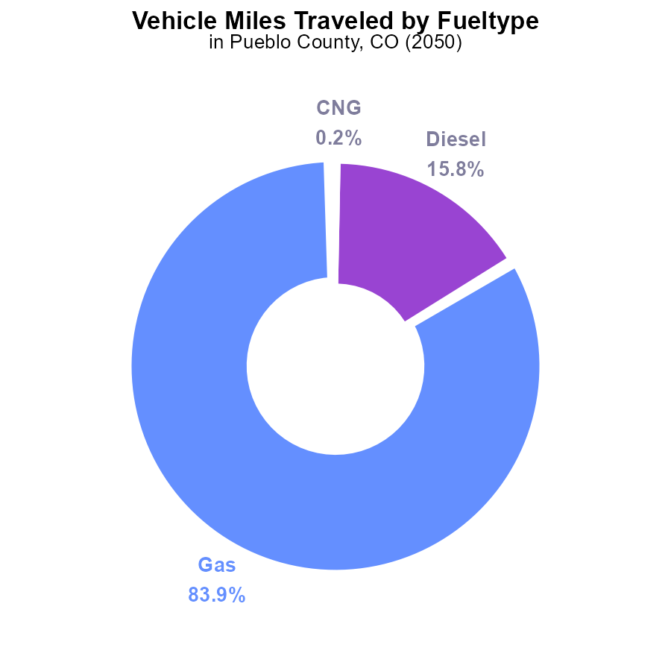

## Findings

* 83.9% of vehicle miles traveled in Pueblo County came from gasoline vehicles.
* Diesel vehicles accounted for 15.8% of the total vehicle miles traveled.
* CNG and Ethanol vehicles contributed only 0.2% and 0.1%, respectively, to the emissions from vehicle miles traveled.

## Recommendations

To lower emissions from vehicle miles traveled in Pueblo County, focus on reducing gasoline and diesel vehicle usage by incentivizing the transition to alternative fuel vehicles such as CNG and Ethanol to decrease emissions significantly.

# Hotelling (Diesel Aux) by Fuel Type

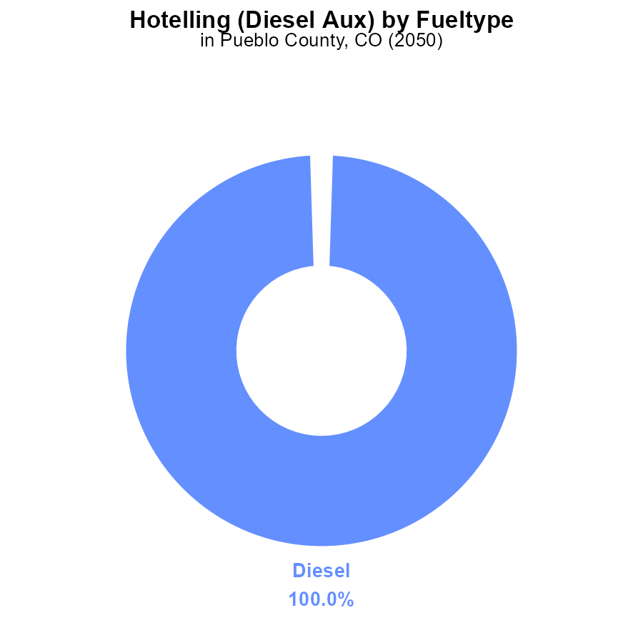

## Findings

* In 2050, Pueblo County, CO reported 197.8 k units of Diesel emissions, making up 100.0% of the total reported emissions.
* No data was available for CNG, Ethanol, or Gas emissions in the area for the same year.
* Diesel emissions from Hotelling (Diesel Aux) activities constitute the sole source of emissions reported for Pueblo County, CO in 2050.

## Recommendations

To lower emissions in Pueblo County, CO, a shift towards cleaner energy sources such as CNG, Ethanol, or Gas should be encouraged to reduce the reliance on Diesel Aux activities and mitigate environmental impact.

# Vehicle Starts over Time for Buses

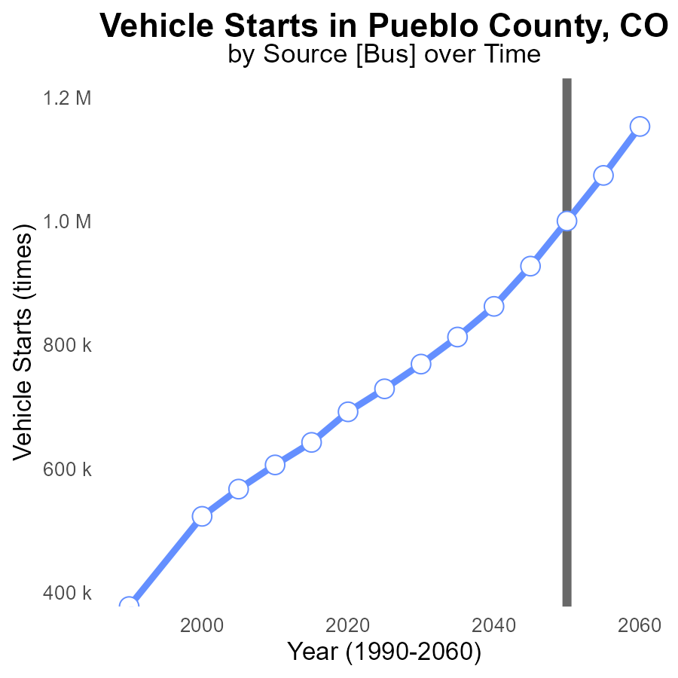

## Findings

* Vehicle starts are projected to increase steadily in Pueblo County, CO from 768.9k in 2030 to 1.2M in 2060.
* There is a consistent decrease in benchmark emissions from 231,122.9 in 2030 to -152,758.6 in 2060.
* The biggest drop in emissions difference occurs from 2045 to 2050, with a decline of around 72,871.2 units.

## Recommendations

To lower emissions, consider incentivizing the transition to electric vehicles, improving public transportation, and promoting carpooling to manage the increase in vehicle starts. Additionally, invest in infrastructure for alternative fuel vehicles.

# Vehicle Miles Traveled Overall over Time

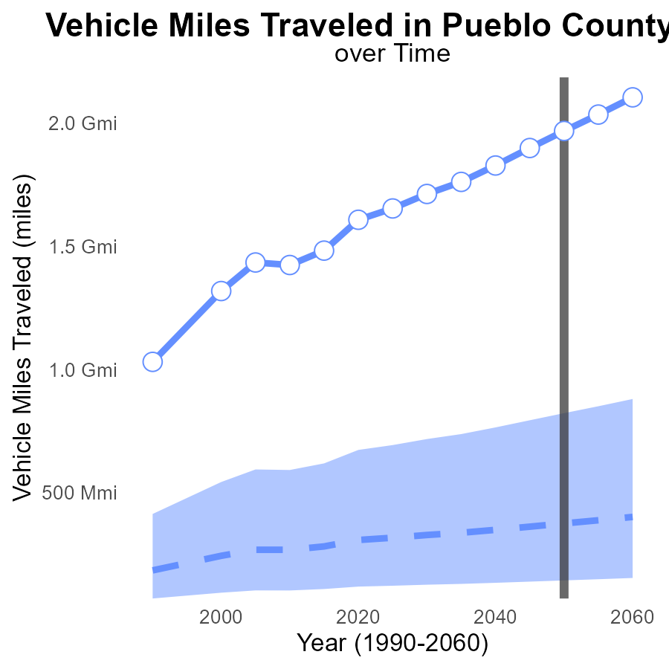

## Findings

* Vehicle miles traveled in Pueblo County are expected to increase consistently over the next three decades.
* Pueblo County's vehicle miles traveled are consistently above the median area and upper 75th percentile.
* The benchmark difference shows a potential for significant reduction in vehicle miles traveled.

## Recommendations

To lower emissions, encourage alternative transportation like public transit, biking, and walking. Implement policies to reduce single-occupancy vehicle usage.

# Emissions Mapped by Area

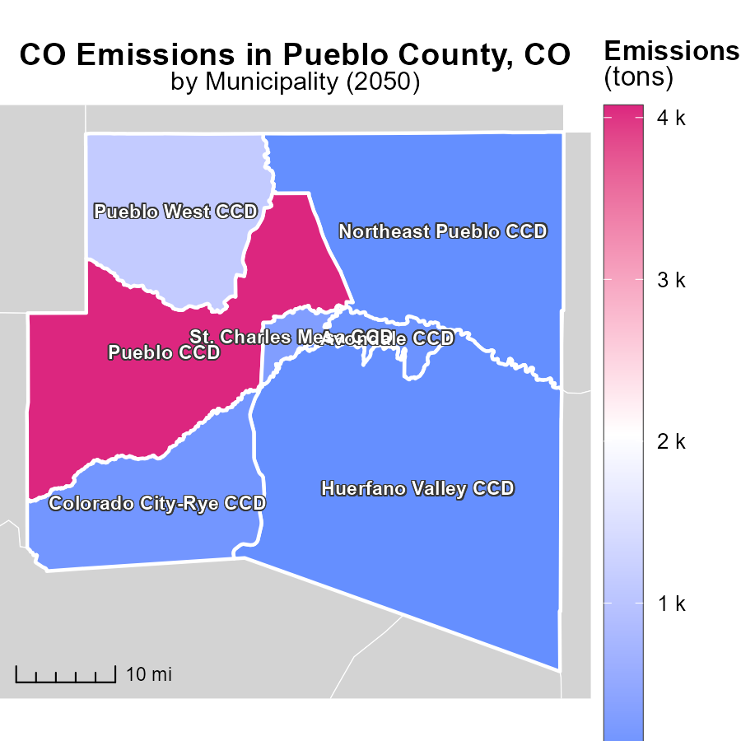

## Findings

* The maximum emissions in Pueblo CCD, CO were 4.1 kilotons.
* The median emissions in Colorado City-Rye CCD, CO were 156.6 tons.
* The minimum emissions in Northeast Pueblo CCD, CO were 15.6 tons.

## Recommendations

To lower emissions, focus on emissions reductions in Colorado City-Rye CCD, which has a high median emission level. Implement stricter regulations and promote sustainable practices in the area.

# Emissions Rate (per capita) Mapped by Area

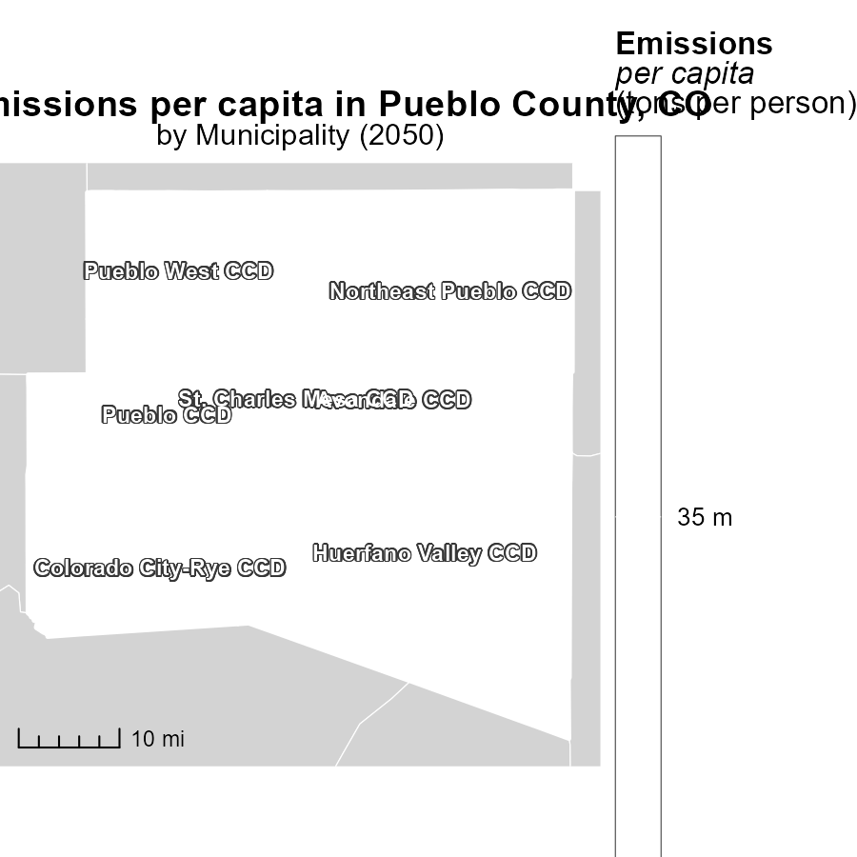

## Findings

* The maximum emissions per capita in Avondale CCD, CO is 34.7 tons per person.
* The median emissions per capita in Northeast Pueblo CCD, CO is 34.7 tons per person.
* The minimum emissions per capita in St. Charles Mesa CCD, CO is 34.7 tons per person.

## Recommendations

To lower emissions levels, targeted measures should be implemented in areas with high per capita emissions like Avondale CCD, CO. Policies focusing on transitioning to renewable energy sources and promoting energy efficiency can help reduce emissions in all areas.

# Idling by Regulatory Class over Time

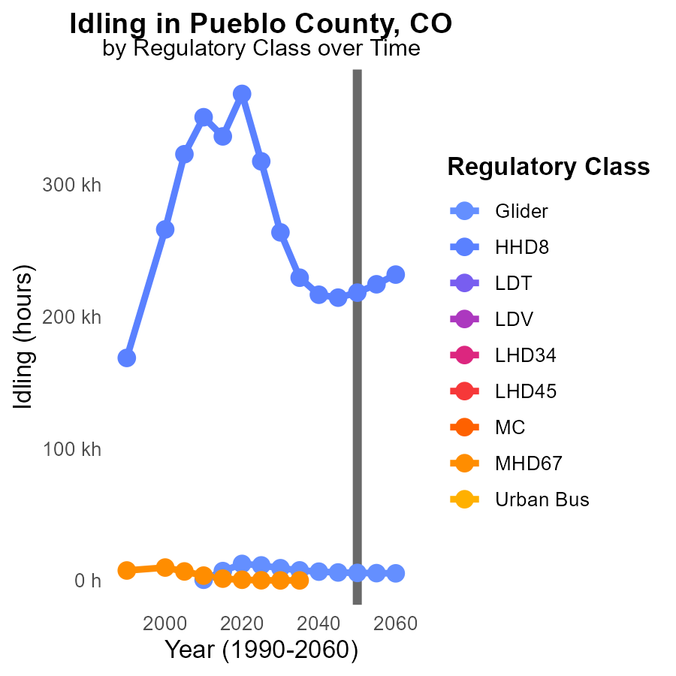

## Findings

* By 2060, glider emissions will decrease to 5.4 k hours, a reduction of 331.7 hours from 2050 levels.
* HHD8 emissions will peak in 2060 at 231.8 k hours, increasing by 13682 hours compared to 2050.
* Other vehicle types show no data available for the specified years, impeding comprehensive analysis.

## Recommendations

To reduce emissions, encourage the adoption of cleaner technologies for glider vehicles to maintain the decreasing trend. Implement stricter regulations for HHD8 vehicles to curb the sharp increase observed. Expand data collection to include other vehicle types for a holistic approach to emission reductions.

# Emissions Rate (per mile) by Road Type over Time

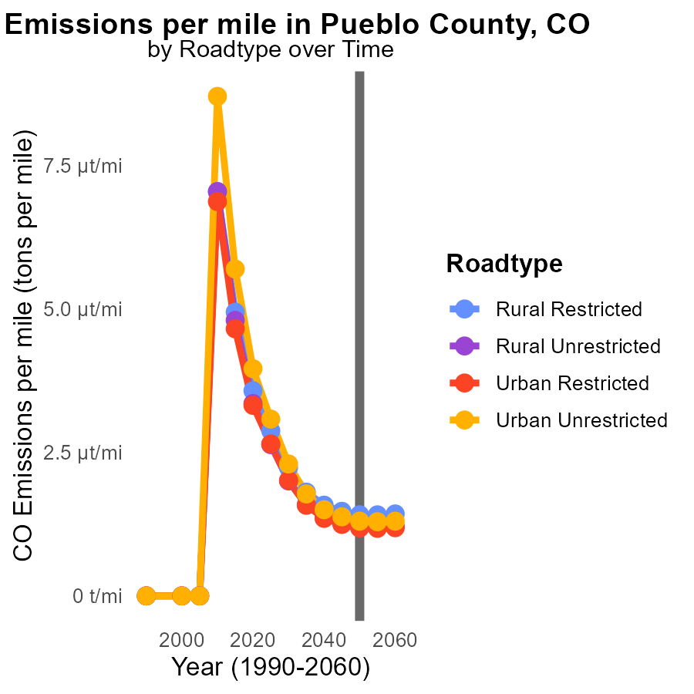

## Findings

* By 2050, emissions per mile are projected to decrease by 0.2 tons in all road types compared to 2040 values.
* The difference in emissions between Rural Restricted and Urban Unrestricted road types is 0.2 tons per mile in 2040.
* Emissions in Urban Unrestricted roads are estimated to be 0.2 tons higher per mile than in Urban Restricted roads by 2050.

## Recommendations

To lower emissions, focus on improving fuel efficiency standards for vehicles in Urban areas and explore implementing stricter emission controls in Rural areas to mitigate the difference observed.

# Areas Ranked by Emissions Rate (per capita)

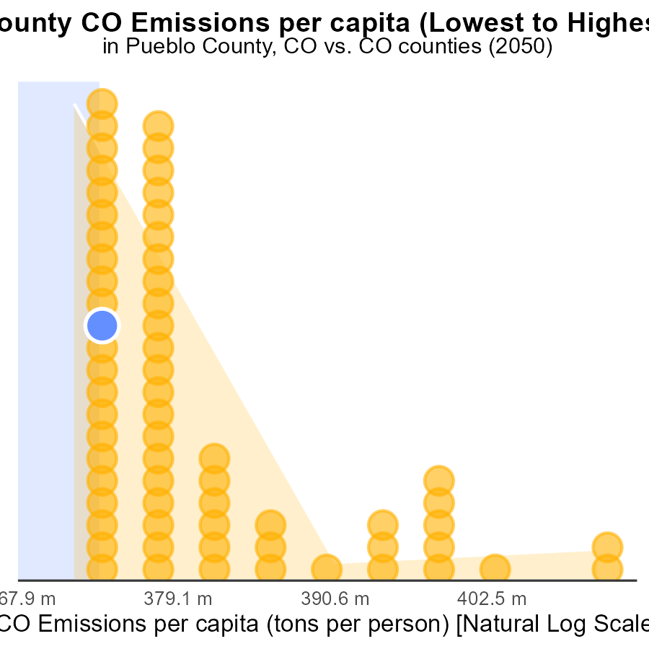

## Findings

* Mineral county has the highest CO emissions per capita
* Arapahoe county has the lowest CO emissions per capita
* Fremont and Pueblo counties have relatively high CO emissions per capita

## Recommendations

To reduce emissions, Mineral county should focus on implementing strict emission control measures and transitioning to cleaner energy sources. Arapahoe county can share best practices, while Fremont and Pueblo counties should prioritize energy efficiency and renewable energy projects.

# Areas Ranked by Vehicle Starts

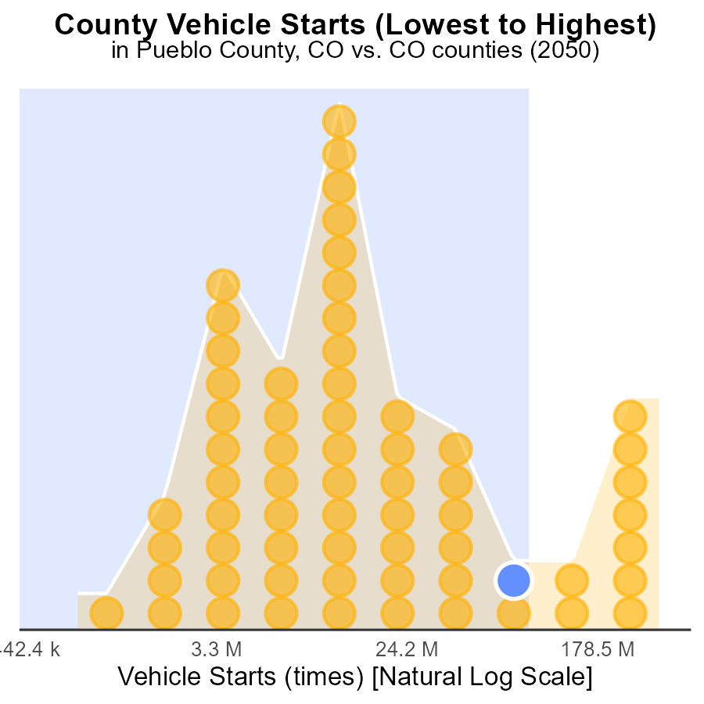

## Findings

* Denver emitted the highest CO with 924.7 M vehicle starts in 2050.
* Hinsdale had the lowest CO emissions with 2.1 M vehicle starts in 2050.
* Top three counties emitting CO were Denver, Boulder, and Pueblo, contributing to 2719 M vehicle starts in 2050.

## Recommendations

To reduce CO emissions, policymakers should focus on promoting public transport, carpooling, and investing in electric vehicles. Implementing stricter vehicle emission standards and encouraging telecommuting can also help lower the emission levels indicated by the high number of vehicle starts.

# About This Report

Data based on MOVES estimates collected by the Climate Action in Transportation program at Cornell University. Demographic data sourced from the US Census's American Community Survey 5-year estimates. This report was generated with the help of AI.

# References

* U.S. Census Bureau. (2023). American Community Survey 5-year estimates: Detailed tables. Retrieved from https://data.census.gov
* U.S. Environmental Protection Agency. (2024). Motor Vehicle Emission Simulator (MOVES 4.0) [Software]. Retrieved from https://www.epa.gov/moves