 

**PM10 Emissions in Houston County, 2010**  
Made with CAT VISUALIZER by Gao Labs @ Cornell University.

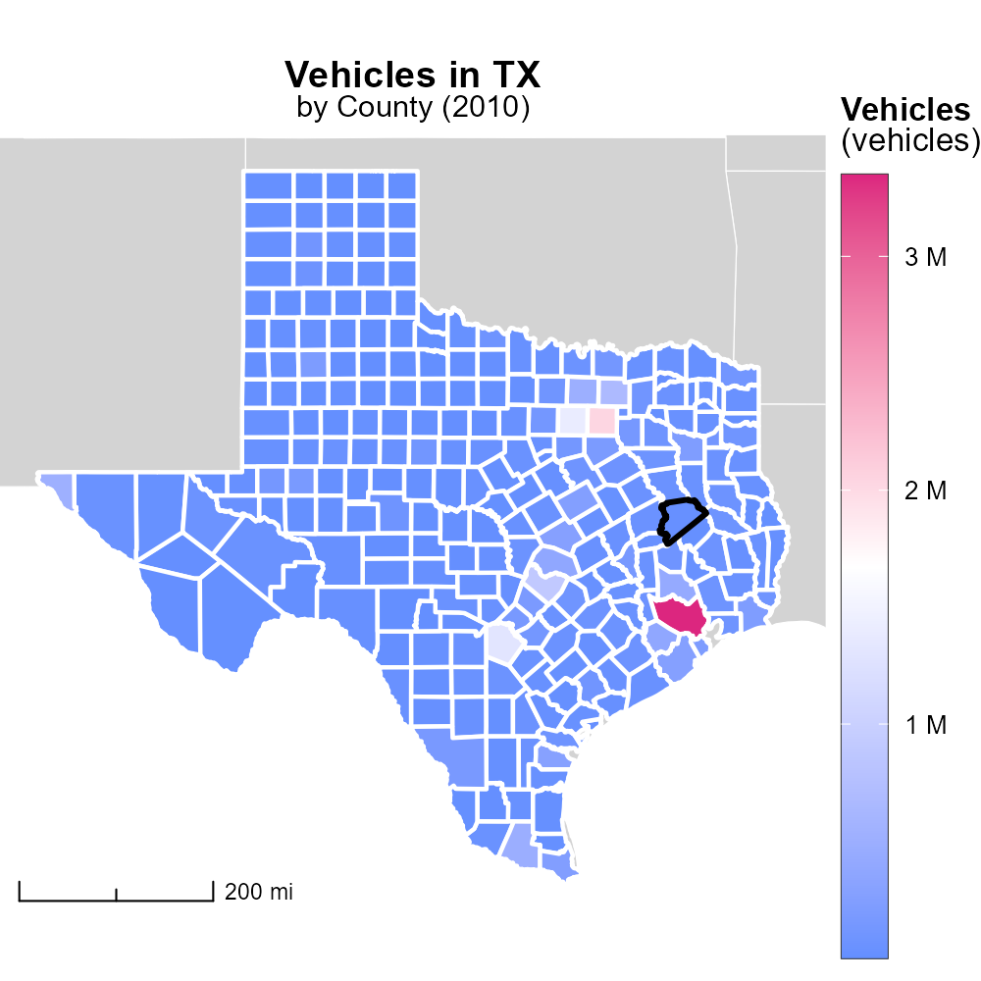

## Keywords

Primary exhaust PM10; Total emissions; On-road transportation; Houston County; TX; 2010

## Highlights

* Examine PM10 emissions from on-road transport in Houston County, TX.
* Analyze primary exhaust sources contributing to PM10 levels in 2010.
* Assess the total impact of transportation on air quality in the county.
* Identify key findings regarding PM10 emissions from on-road vehicles.
* Recommendations for mitigating PM10 pollution in Houston County.

# Introduction

The objective of this report is to investigate the primary exhaust particulate matter (PM10) emissions from on-road transportation in Houston County, Texas, during the year 2010. PM10, a harmful air pollutant, can have significant impacts on public health and the environment. By focusing on emissions from on-road vehicles, we aim to understand the sources contributing to air pollution in the county and assess their total impact.

Our analysis will delve into the various factors influencing PM10 emissions, such as vehicle types, traffic volume, and driving conditions. Through this study, we aim to provide valuable insights into the levels of PM10 pollution generated by on-road transportation in Houston County, TX, and offer recommendations for reducing these emissions to improve air quality and protect public health.

# Vehicles by Road Type

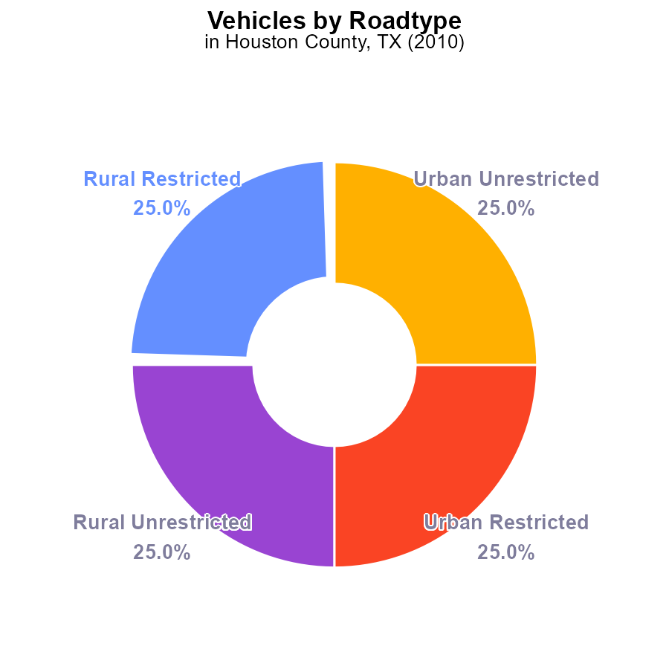

## Findings

* PM10 emissions in Houston County, TX in 2010 were primarily from vehicles (100%).
* Each category contributed equally to the total emissions (25% each).
* Rural and urban areas had the same emission levels in both restricted and unrestricted zones.

## Recommendations

To lower PM10 emissions from vehicles in Houston County, TX, implementing stricter vehicle emission standards and promoting the use of public transportation could be effective. Additionally, investing in infrastructure to support electric vehicles and encouraging carpooling can help reduce overall emissions.

# Hotelling (Engines Off) by Road Type

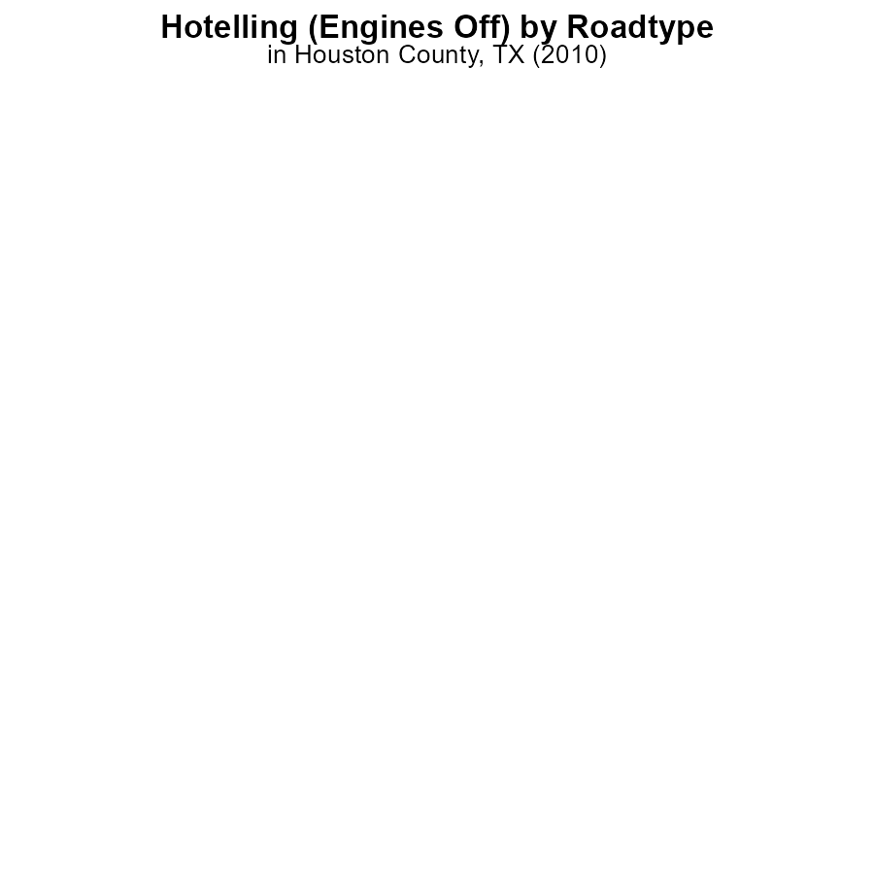

## Findings

* There were 0.0 units of PM10 emissions in Houston County, TX in 2010.
* All types of areas (rural restricted, rural unrestricted, urban restricted, urban unrestricted) had the same emission level of 0.0 units.
* Engines off (Hotelling) resulted in no PM10 emissions during the hours reported.

## Recommendations

To maintain the low emission level of 0.0 units, continue promoting practices like Hotelling to keep engines off when not in use. Regularly monitor and enforce regulations to ensure compliance.

# Hotelling (Diesel Aux) over Time for Passenger Vehicles

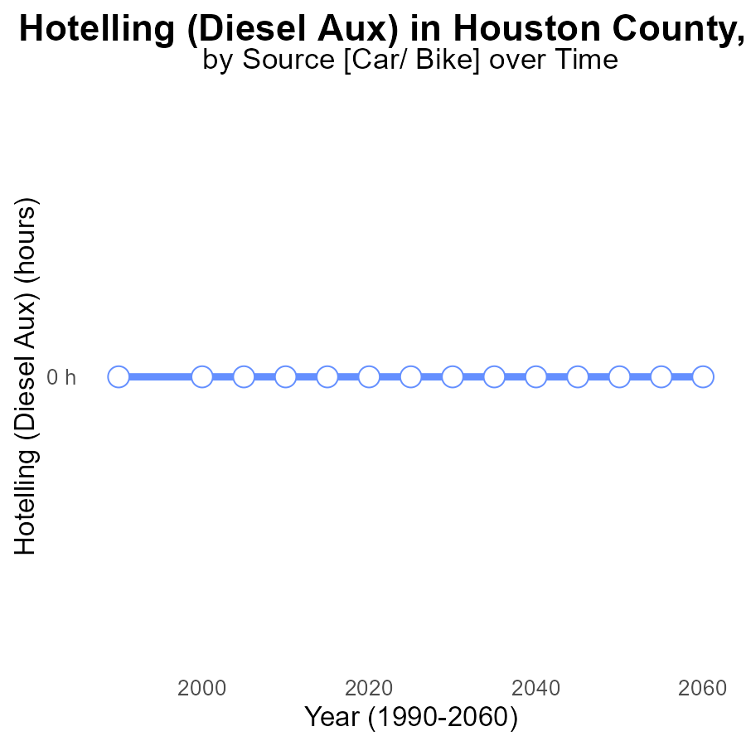

## Findings

* No emissions of PM10 from Hotelling (Diesel Aux) in Houston County, TX from 1990 to 2030.
* Consistent zero emission levels suggest no contribution to air pollution in the area.
* This data indicates a lack of environmental impact from Hotelling (Diesel Aux) activities in this region.

## Recommendations

Based on the consistently low emissions shown in the data, continue monitoring emissions to ensure they remain at zero. Consider implementing clean energy alternatives for future development to maintain the current emission-free status.

# Hotelling (Diesel Aux) over Time for Buses

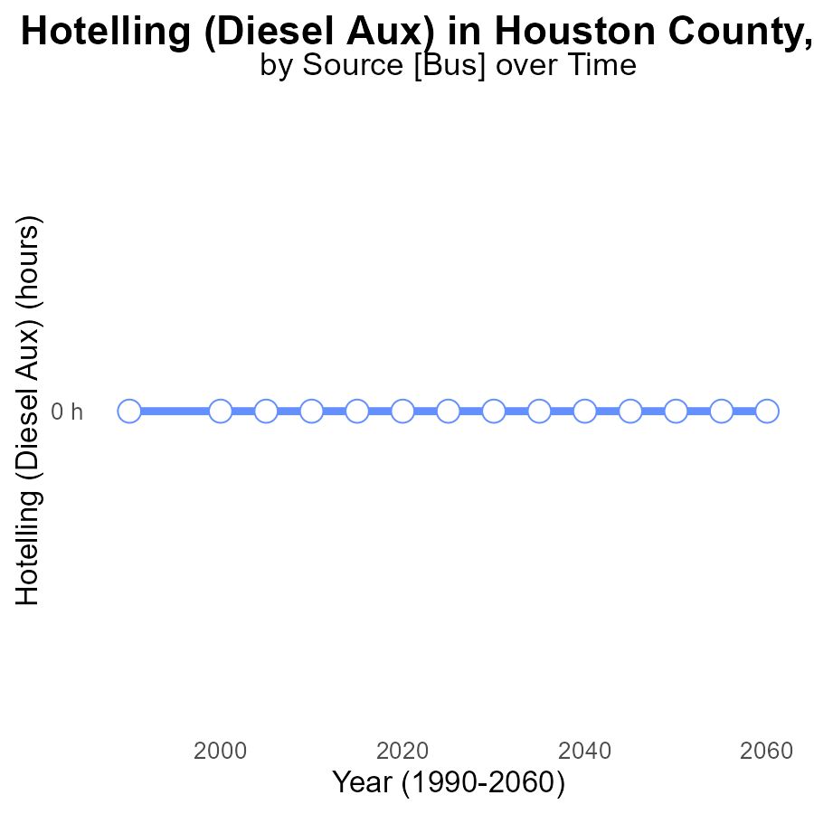

## Findings

* There has been no reported PM10 emissions from Hotelling (Diesel Aux) in Houston County, TX from 1990 to 2030.

## Recommendations

Given the consistent zero emissions reported, there seems to be effective measures in place. Continue monitoring and enforcing emission control regulations to maintain the current emission levels.

# Emissions Rate (per vehicle) Mapped by Area

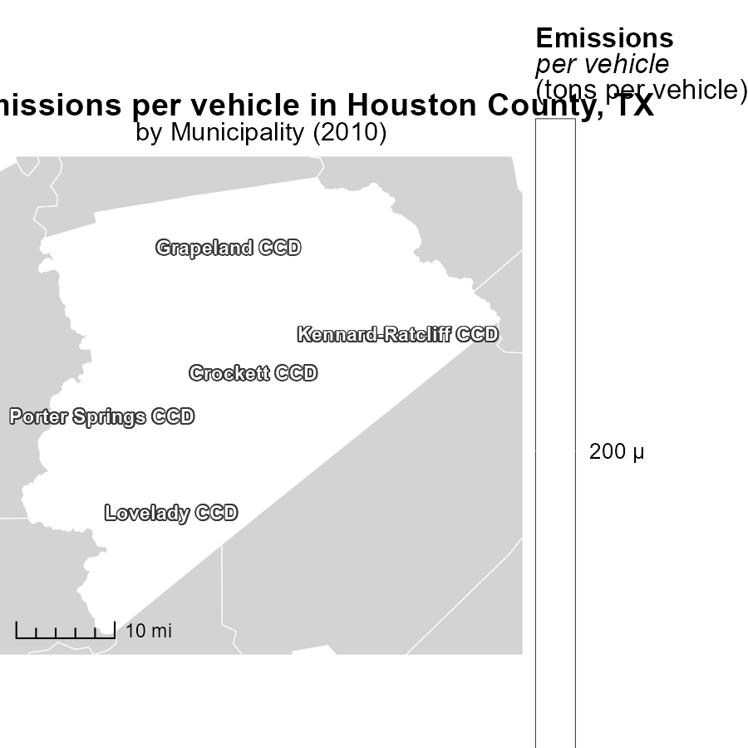

## Findings

* The maximum emissions per vehicle in 2010 for Crockett CCD, TX, were 191.2 tons.
* The median emissions per vehicle in 2010 for Kennard-Ratcliff CCD, TX, were 191.2 tons.
* The minimum emissions per vehicle in 2010 for Porter Springs CCD, TX, were 191.2 tons.

## Recommendations

To lower emissions, policymakers should implement fuel-efficient vehicle programs and promote the use of public transportation in these regions to decrease the emissions per vehicle.

# Vehicles in My Region

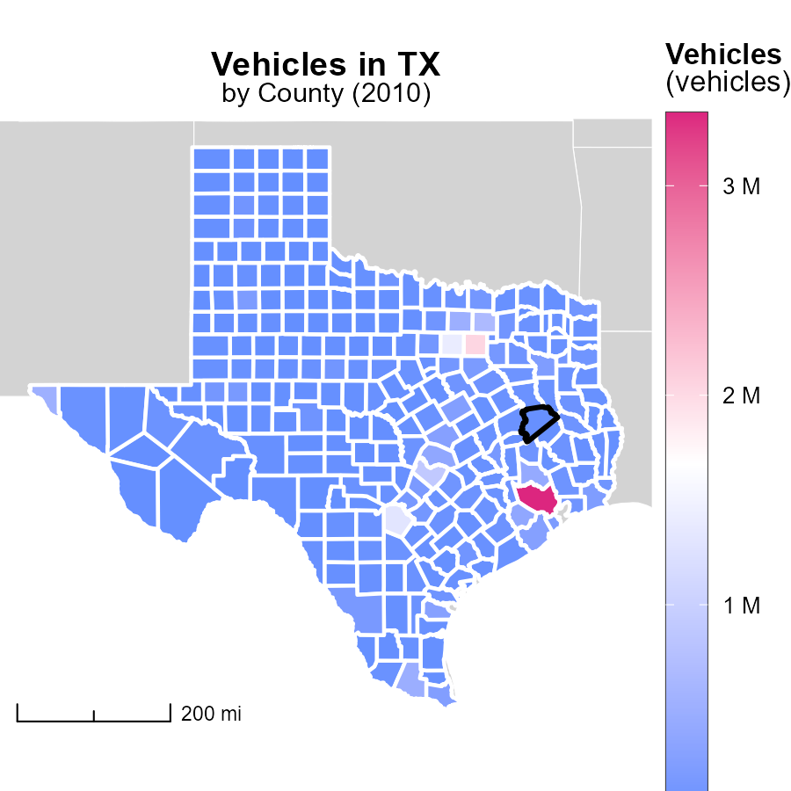

## Findings

* Harris County, TX had 3.3 million vehicle emissions in 2010.
* Falls County, TX had a median of 29,000 vehicle emissions in 2010.
* Briscoe County, TX had the minimum of 1,800 vehicle emissions in 2010.

## Recommendations

To lower emissions, policymakers in Harris County can promote public transportation. Falls County could encourage carpooling, while Briscoe County should focus on promoting electric vehicles.

# Emissions by Fuel Type over Time

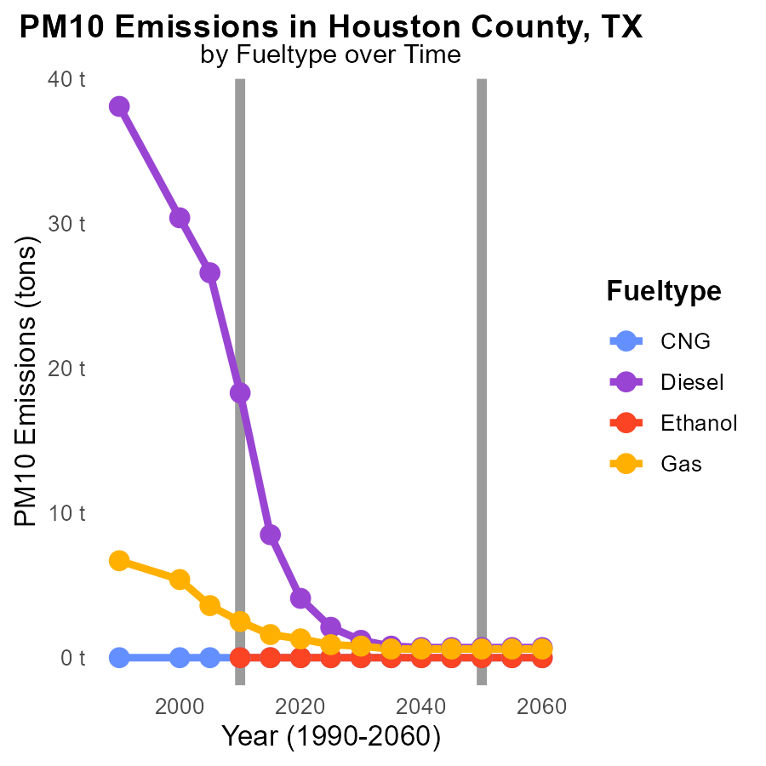

## Findings

* The PM10 emissions in Houston County, TX, from Diesel decreased by 26.3 tons (86.5%) from 2000 to 2020.
* Gas emissions saw a reduction of 4.1 tons (75.9%) during the same period.
* CNG and Ethanol had consistently low emissions from 2000 to 2020, with no significant changes observed.

## Recommendations

To further decrease emissions, prioritize transitioning vehicles from Diesel to cleaner fuels like CNG or Ethanol. Encourage the use of public transportation and promote electric vehicles to reduce Gas emissions.

# Vehicles by Regulatory Class over Time

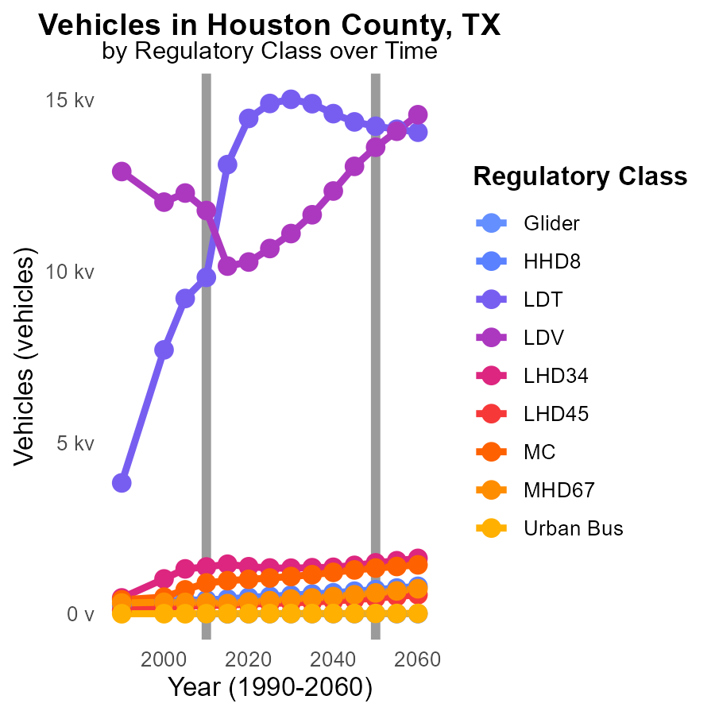

## Findings

* PM10 emissions from vehicles in Houston County, TX have decreased from 2000 to 2020 for all vehicle types.
* The largest decrease was observed in the Heavy Heavy Duty category, with a reduction of 296.1 units from 2010 to 2020.
* Despite fluctuations, Light Duty Trucks showed a steady increase in emissions from 2000 to 2015 but decreased by 228.4 units by 2020.

## Recommendations

To lower PM10 emissions in Houston County, TX further, policies should focus on incentivizing the transition to cleaner vehicle technologies, promoting public transportation use to reduce the reliance on personal vehicles, and enforcing stricter emission standards for all vehicle classes.

# Areas Ranked by Population

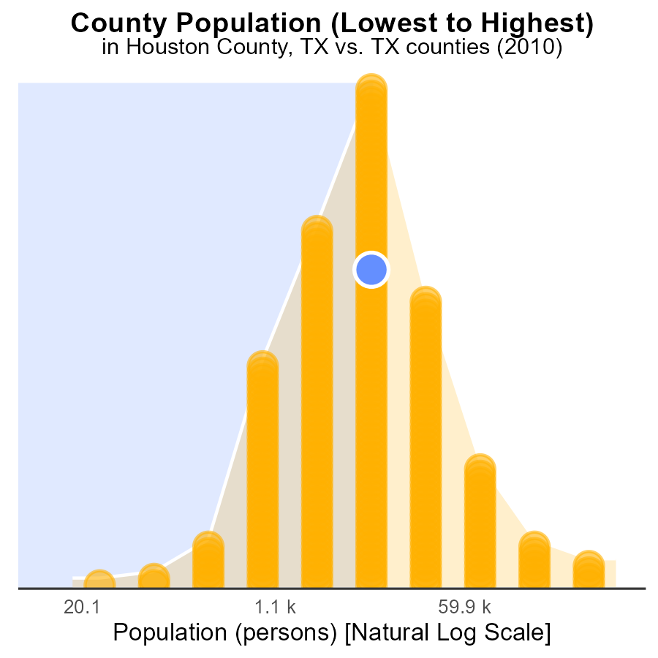

## Findings

* Houston had 23.6k PM10 emissions in 2010, ranking 302nd nationally, representing 59.4% of the population.
* Loving emitted 41.0 PM10 units in 2010, ranking 2nd, which is 0.4% of its population.
* Harris released 4.0M PM10 units in 2010, placing it 508th nationally, accounting for 100.0% of its population.

## Recommendations

To lower emissions, Houston could focus on reducing PM10 sources like industrial processes and transportation. Loving should consider stricter regulations on local industries to reduce emissions. Harris should implement policies to monitor and mitigate PM10 emissions from various sectors.

# Areas Ranked by Emissions Rate (per mile)

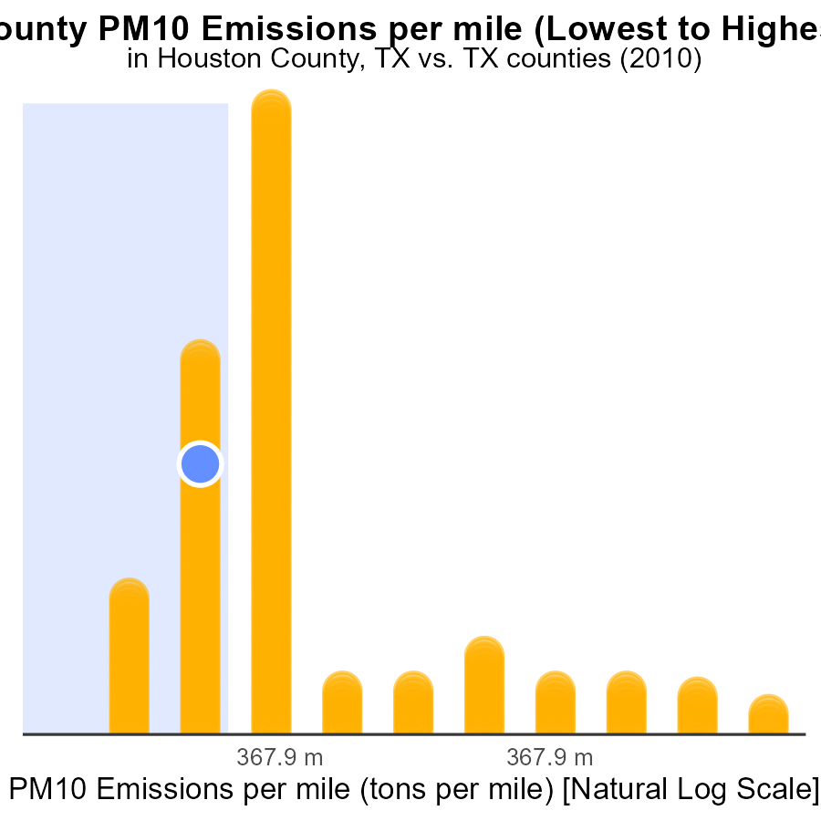

## Findings

* Hudspeth county has the highest PM10 emissions per mile in 2010.
* Hidalgo county has the lowest PM10 emissions per mile in 2010.
* Houston and Cass counties have very similar PM10 emissions per mile in 2010.

## Recommendations

To lower emissions, focus on areas with high rates like Hudspeth. Implement stricter emissions regulations and promote cleaner transportation methods. Encourage public transportation and carpooling.

# Conclusion

In conclusion, the data from the report on Primary Exhaust PM10 - Total emissions from on-road transportation in Houston County, TX in 2010 reveals valuable insights into the sources and levels of PM10 emissions in the region. The report identifies vehicles as the primary source of PM10 emissions, with rural and urban areas contributing equally to the total emissions. Implementing stricter vehicle emission standards and promoting the use of public transportation could be effective strategies to lower PM10 emissions. Additionally, investing in infrastructure to support electric vehicles, encouraging carpooling, and enforcing regulations can further reduce emissions.

Furthermore, the report indicates that engines off (Hotelling) resulted in no PM10 emissions during the reported hours, suggesting an eco-friendly practice that could be promoted to maintain low emission levels. The consistently low emissions from Hotelling activities and the decrease in Diesel and Gas emissions from 2000 to 2020 showcase the effectiveness of current emission control measures. To sustain these achievements, continued monitoring, enforcement of regulations, and transitioning to cleaner fuels and vehicle technologies are recommended. By focusing on these strategies, Houston County, TX, can strive towards a cleaner and healthier environment for its residents.

# About This Report

Data based on MOVES estimates collected by the Climate Action in Transportation program at Cornell University. Demographic data sourced from the US Census's American Community Survey 5-year estimates. This report was generated with the help of AI.

# References

* U.S. Census Bureau. (2023). American Community Survey 5-year estimates: Detailed tables. Retrieved from https://data.census.gov
* U.S. Environmental Protection Agency. (2024). Motor Vehicle Emission Simulator (MOVES 4.0) [Software]. Retrieved from https://www.epa.gov/moves