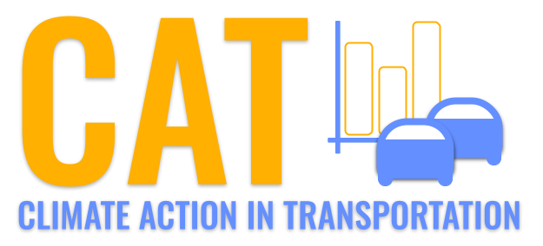 

**PM2.5 Emissions in Beaufort County, 2045**  
Made with CAT VISUALIZER by Gao Labs @ Cornell University.

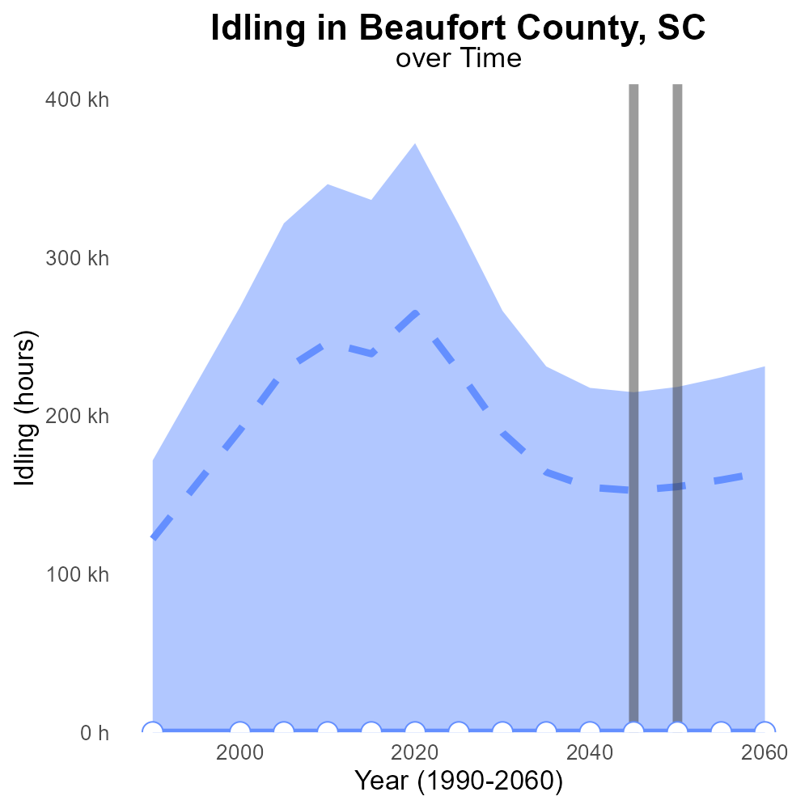

## Keywords

Exhaust PM2.5; on-road transportation; Beaufort County; SC; 2045; emissions

## Highlights

* Primary Exhaust PM2.5 emissions from on-road transportation in Beaufort County, SC in 2045 are a significant concern.
* Understanding these emissions is crucial for addressing air quality and public health in the region.
* The report aims to analyze and quantify the total emissions to inform policy and regulatory decisions.
* Data from 2045 will provide insights into future trends and potential mitigation strategies.
* The findings will help stakeholders develop sustainable transportation solutions for a cleaner environment.

# Introduction

In 2045, the levels of Primary Exhaust Particulate Matter (PM2.5) emissions from on-road transportation in Beaufort County, South Carolina, have become a pressing issue due to their impact on air quality and public health. This report presents a comprehensive analysis of the total emissions in the county to shed light on the extent of the problem and the potential solutions. By focusing on the specific source of on-road transportation, the report aims to provide valuable data for policymakers, regulators, and stakeholders to make informed decisions.

The data collected for this report offer a glimpse into the future trends of exhaust PM2.5 emissions, enabling a proactive approach towards environmental protection and public health in Beaufort County. By understanding the scale and sources of these emissions, stakeholders can work towards implementing sustainable transportation strategies that could lead to a cleaner and healthier environment for the residents of the county.

# Vehicle Starts by Road Type

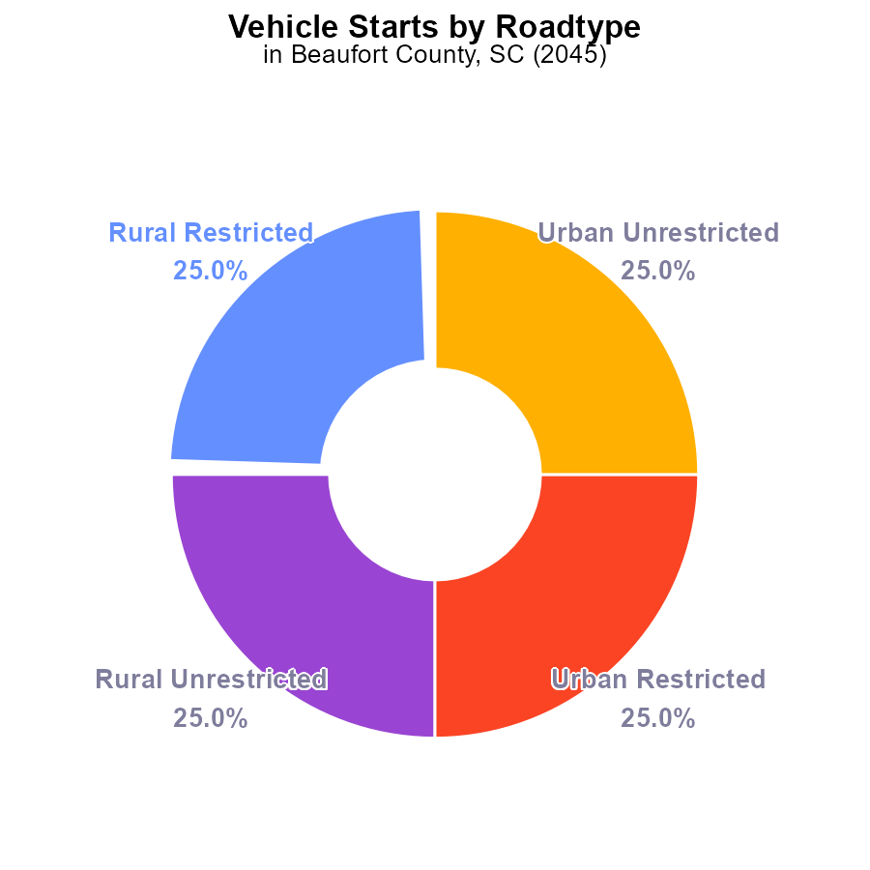

## Findings

* In 2045, PM2.5 emissions from vehicle starts in Beaufort County, SC were approximately 857.6 million times.
* Each area type - Rural Restricted, Rural Unrestricted, Urban Restricted, Urban Unrestricted - contributed equally at 25% each to the total emissions.
* There were no significant variations in emissions between different areas in Beaufort County for PM2.5 from vehicle starts.

## Recommendations

To reduce PM2.5 emissions from vehicle starts in Beaufort County, a county-wide approach focusing on improving vehicle technologies and promoting public transportation could be beneficial. Implementing stricter emission standards for vehicles can also help lower overall emissions.

# Hotelling (Engines Off) Overall by Area

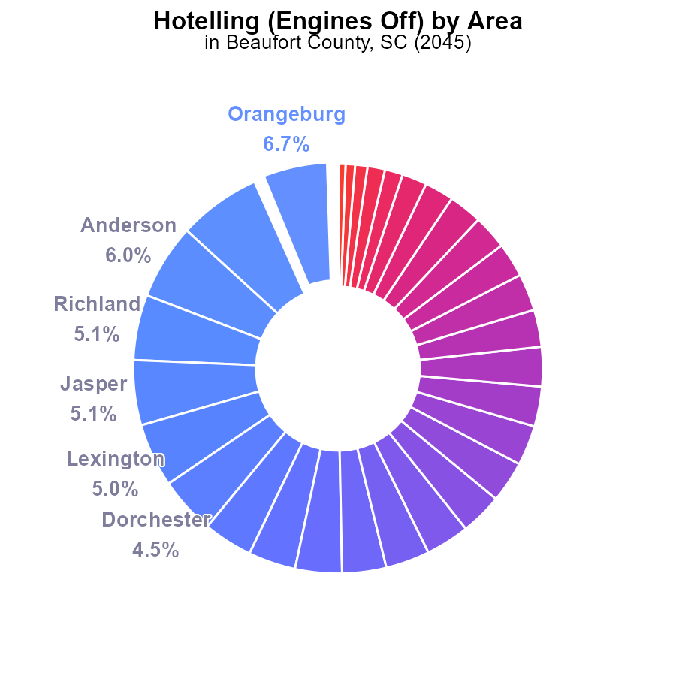

## Findings

* Orangeburg has the highest PM2.5 emissions at 6.7% (225.3k hours), followed closely by Spartanburg and Anderson at 6.5% and 6.0% respectively.
* The top 10 counties contribute to 49.8% of the total emissions, with Richland, Jasper, and Lexington among the highest contributors.
* Beaufort County, along with 16 other counties, shows 0.0% PM2.5 emissions, indicating low contribution to the overall total.

## Recommendations

To reduce emissions, focus on Orangeburg, Spartanburg, and Anderson initially due to their significant contributions. Implement stricter regulations and incentives for emission control technologies in these high-emitting areas. Encourage the adoption of cleaner fuel sources to lower PM2.5 levels.

# Idling Overall over Time

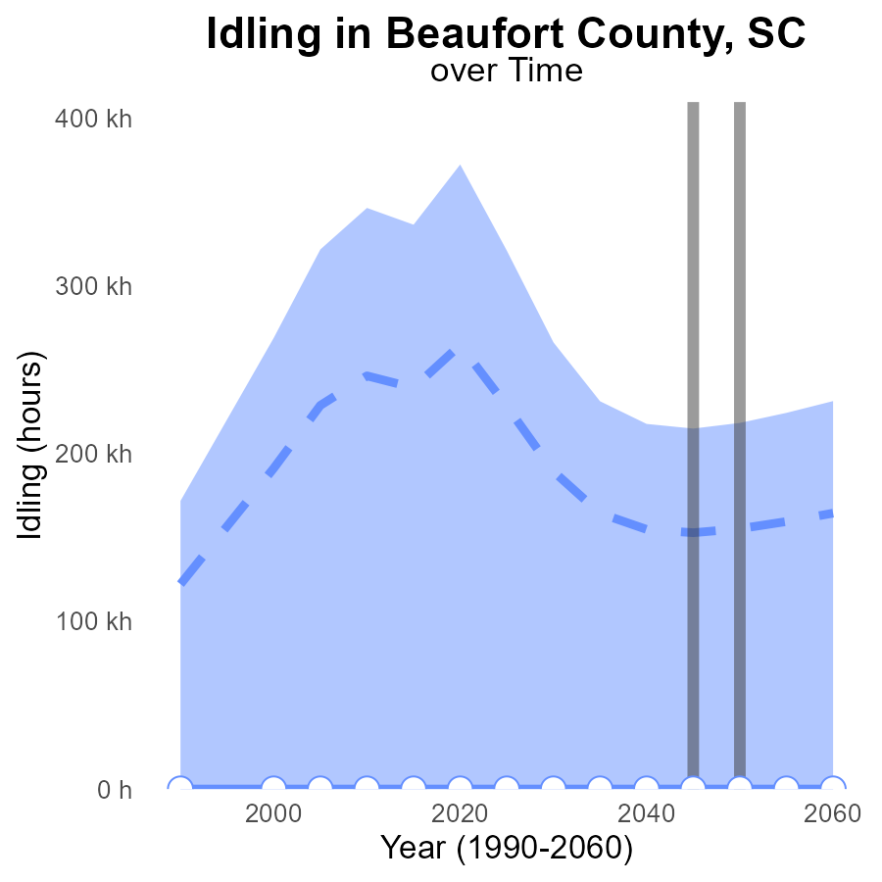

# Hotelling (Engines Off) over Time for Passenger Vehicles

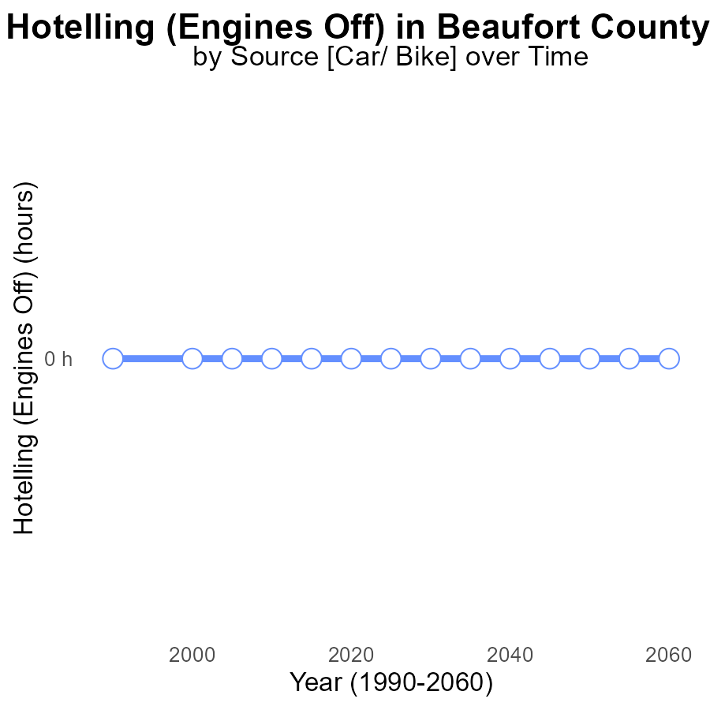

## Findings

* From 2025 to 2060, there were no emissions (0.0) of PM2.5 from Hotelling (Engines Off) activities in Beaufort County, SC.
* Benchmark difference remained constant at 0 throughout the period, indicating no deviations from expected emission levels.
* Consistent adherence to zero emissions suggests successful environmental management in controlling PM2.5 from Hotelling (Engines Off) sources.

## Recommendations

Given the consistent lack of emissions in the area, policymakers should continue enforcing strict regulations on Hotelling (Engines Off) activities to maintain the current emission-free status. Monitoring and implementing innovative technologies for emission reduction can further ensure sustained environmental quality.

# Vehicle Miles Traveled Mapped by Area

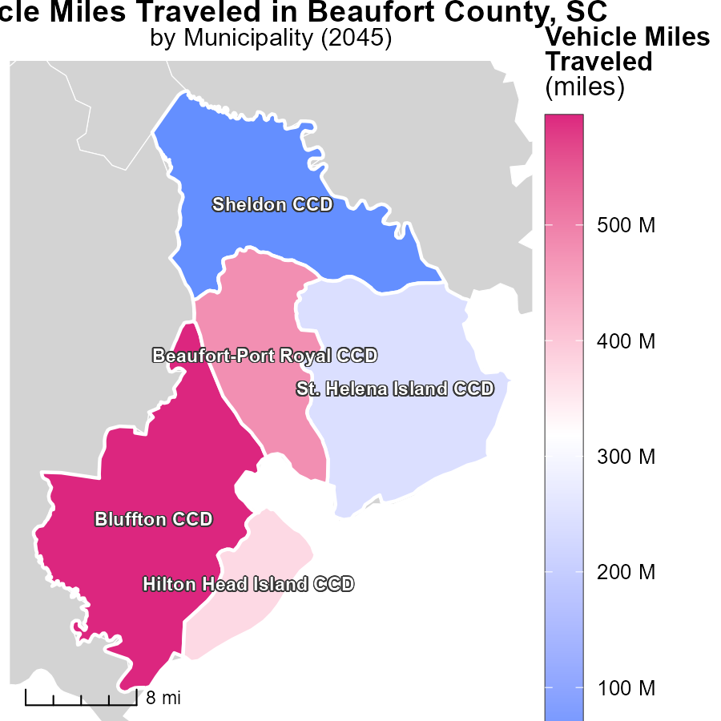

## Findings

* Bluffton CCD, SC has the highest vehicle miles traveled with 594.7 million miles.
* The median vehicle miles traveled is 373.2 million miles in Hilton Head Island CCD, SC.
* Sheldon CCD, SC has the lowest vehicle miles traveled at 42.3 million miles.

## Recommendations

To lower emissions, focus on reducing vehicle miles traveled in areas like Bluffton and Hilton Head Island. Invest in public transportation, promote carpooling, and incentivize the use of electric vehicles.

# Hotelling (Engines Off) in My Region

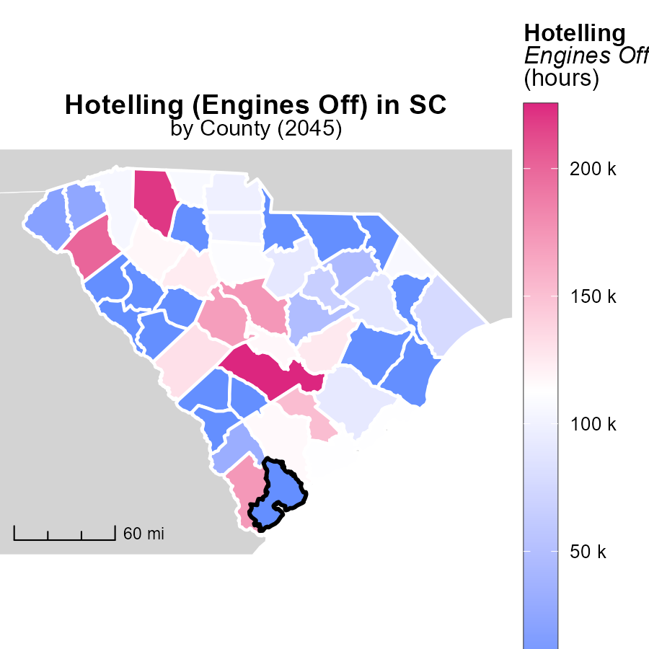

## Findings

* Orangeburg County, SC has the highest emissions at 225.3k hours.
* Horry County, SC has median emissions at 77.5k hours.
* Williamsburg County, SC has minimal emissions with 0.0 hours.

## Recommendations

To decrease emissions, focus on reducing idle time for vehicles in Orangeburg County. Implement fuel-saving technologies in Horry County. Encourage the use of alternative transportation modes in Williamsburg County.

# Time Driven by Area over Time

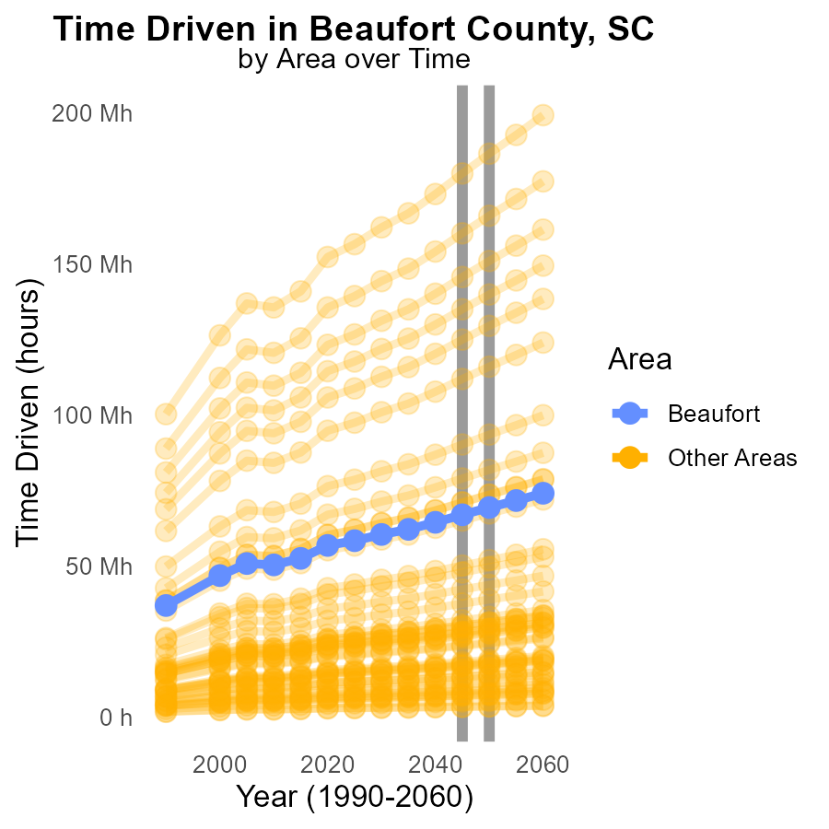

## Findings

* In 2045, min_county emissions were 3.2 million, an increase of 114,594.3 from 2050.
* In target_county, emissions reached 66.9 million in 2045, rising by 2,410,778.9 from 2050.
* Max_county saw emissions of 179.9 million in 2045, a rise of 6,531,697.0 from 2050.

## Recommendations

To reduce emissions: incentivize cleaner technologies in high-emission areas; enforce stricter emission standards; promote public transport and carpooling.

# Population by Road Type over Time

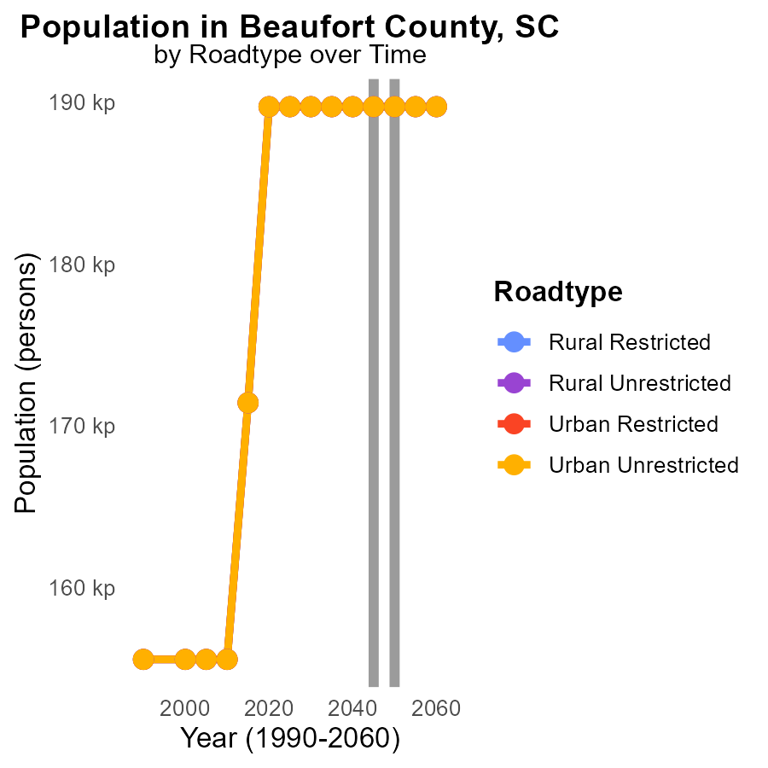

## Findings

* PM2.5 emissions in Beaufort County, SC are consistent over the years 2035 to 2055 for all road types and population groups.
* The PM2.5 emissions in Beaufort County, SC in 2035 are 189.7 k for all road types and population groups.
* There has been no change in PM2.5 emissions compared to 2050 in Beaufort County, SC for all road types and population groups.

## Recommendations

To lower PM2.5 emissions in Beaufort County, SC, strategies must focus on long-term planning and implementation of sustainable transportation practices, ensuring that emission levels are continuously monitored to assess the effectiveness of interventions.

# Areas Ranked by Hotelling (Engines Off)

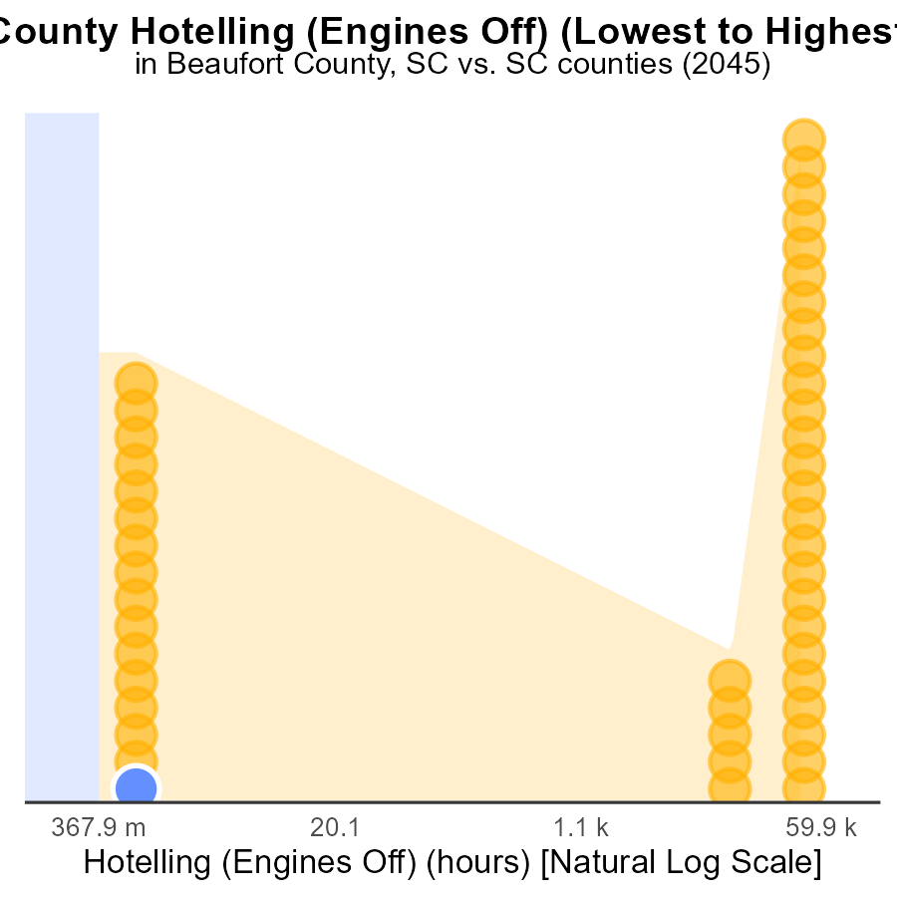

## Findings

* In Beaufort, engines off hotelling led to 0.0 PM2.5 emissions.
* Abbeville followed with 0.0 PM2.5 emissions as well.
* However, Orangeburg had 225.3k PM2.5 emissions, ranking 46th.

## Recommendations

To lower emissions, encourage the use of engines off hotelling in areas with high pollution. Implement stricter regulations for idling vehicles in Orangeburg to reduce emissions significantly.

# Areas Ranked by Vehicle Starts

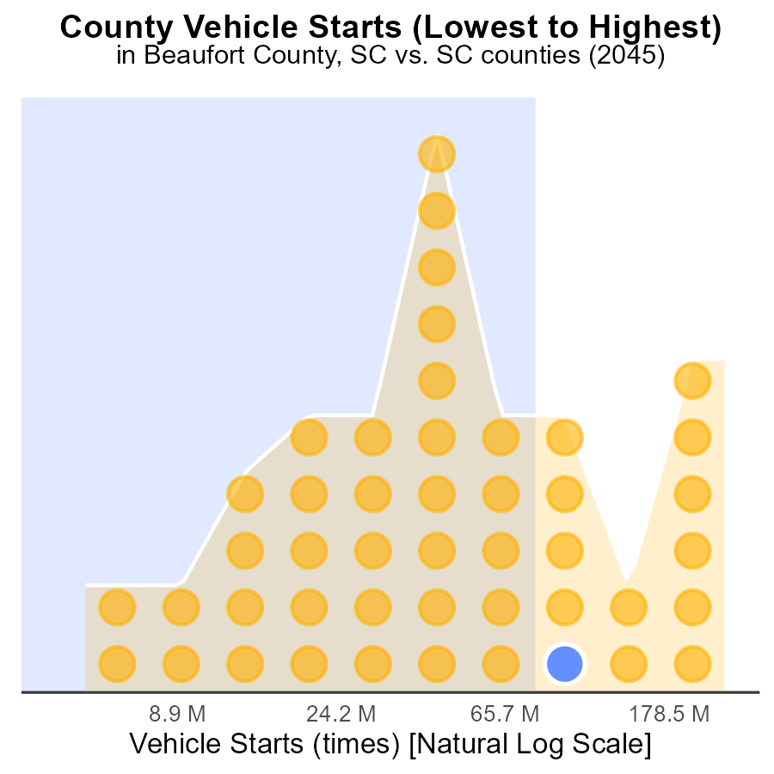

# Conclusion

In conclusion, the 2045 data on primary exhaust PM2.5 emissions from on-road transportation in Beaufort County, SC revealed a total of approximately 857.6 million tons. The distribution of emissions across different area types showed an equal contribution of 25% each, indicating no significant variation in PM2.5 emissions levels among areas within the county. To combat these emissions, a county-wide approach emphasizing improved vehicle technologies, public transportation promotion, and stringent emission standards appears to be crucial.

Furthermore, the analysis highlighted specific high-emission areas such as Orangeburg, Spartanburg, and Anderson, whose targeted focus could lead to substantial reductions in overall PM2.5 emissions. Implementing stricter regulations and encouraging cleaner fuel sources in these regions, alongside promoting the use of electric vehicles and public transport, will be vital steps towards mitigating emissions. Continuous monitoring and adoption of innovative technologies will play a pivotal role in maintaining environmental quality and ensuring sustainable transportation practices in Beaufort County moving forward.

# About This Report

Data based on MOVES estimates collected by the Climate Action in Transportation program at Cornell University. Demographic data sourced from the US Census's American Community Survey 5-year estimates. This report was generated with the help of AI.

# References

* U.S. Census Bureau. (2023). American Community Survey 5-year estimates: Detailed tables. Retrieved from https://data.census.gov
* U.S. Environmental Protection Agency. (2024). Motor Vehicle Emission Simulator (MOVES 4.0) [Software]. Retrieved from https://www.epa.gov/moves