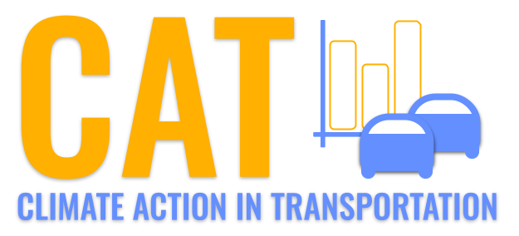 

**SO2 Emissions in Somerset County, 2060**  
Made with CAT VISUALIZER by Gao Labs @ Cornell University.

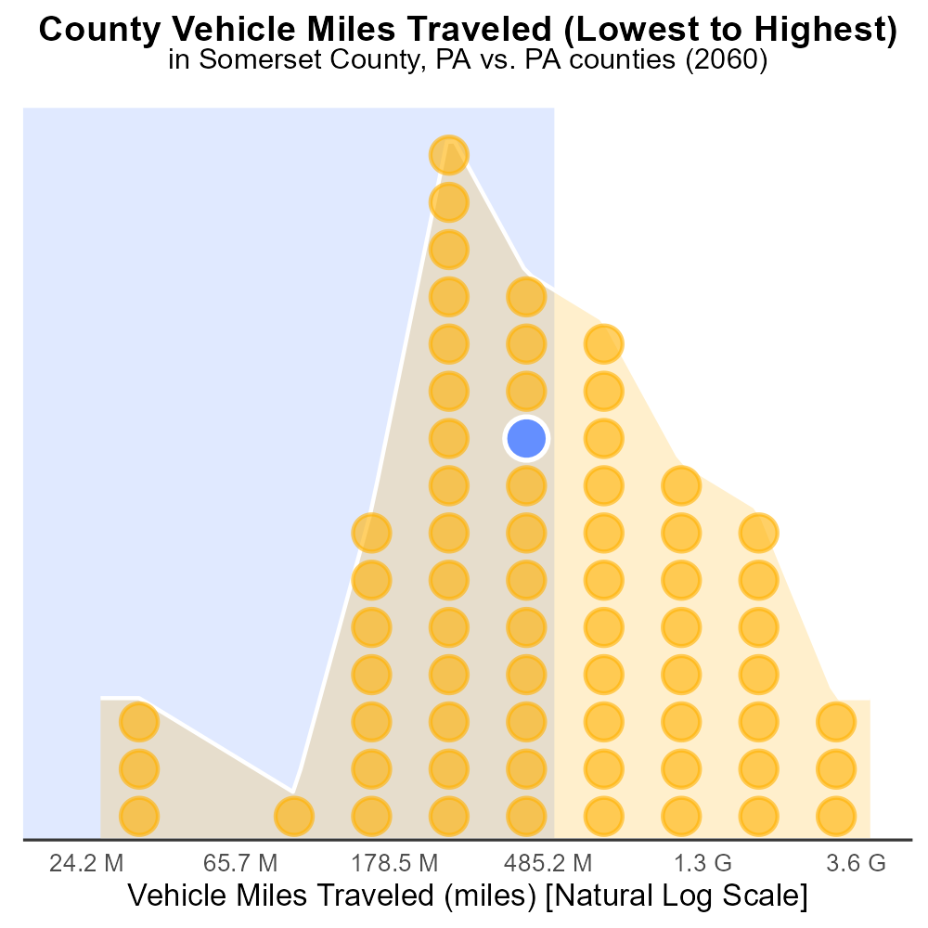

## Keywords

Sulfur Dioxides emissions; on-road transportation; Somerset County; PA; 2060

## Highlights

* SO2 emissions from on-road transport in Somerset County, PA.
* Examined effects of transportation on air quality in 2060.
* Potential impact on environment and public health.
* Focus on strategies to reduce emissions and improve air quality.
* Significance of addressing transportation pollution in Somerset County.

# Introduction

In 2060, the issue of Sulfur Dioxide (SO2) emissions from on-road transportation in Somerset County, PA, has become a critical concern. This report delves into the impact of transportation activities on air quality and the environment within the county. The rising levels of SO2 emissions from on-road vehicles pose significant challenges that can affect both the environment and public health.

With a focus on the year 2060, this report aims to address the importance of implementing strategies to reduce SO2 emissions from transportation sources in Somerset County. The findings of this analysis will provide valuable insights into the current state of air quality, the potential risks associated with high levels of SO2 emissions, and the necessity of taking proactive measures to improve air quality and protect public health.

# Hotelling (Engines Off) by Vehicle Type

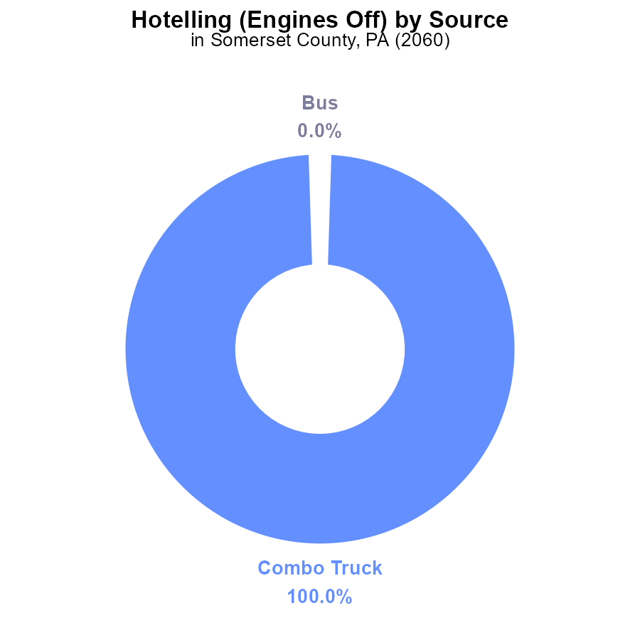

## Findings

* In Somerset County, PA in 2060, Combo Trucks emit 144.6 k SO2 with engines off.
* Combo Trucks account for 100% of the SO2 emissions, while other vehicle types have 0% contribution.
* There are no emissions of SO2 from Buses, Cars/Bikes, Heavy Trucks, or Light Trucks with engines off in this scenario.

## Recommendations

To lower SO2 emissions in Somerset County, PA, policies should focus on reducing emissions from Combo Trucks by promoting engine efficiency, alternative fuels, or a shift to cleaner transportation options. Initiatives such as stricter emission standards or incentivizing the adoption of electric vehicles can also significantly decrease overall emissions.

# Emissions Rate (per mile) Overall by Area

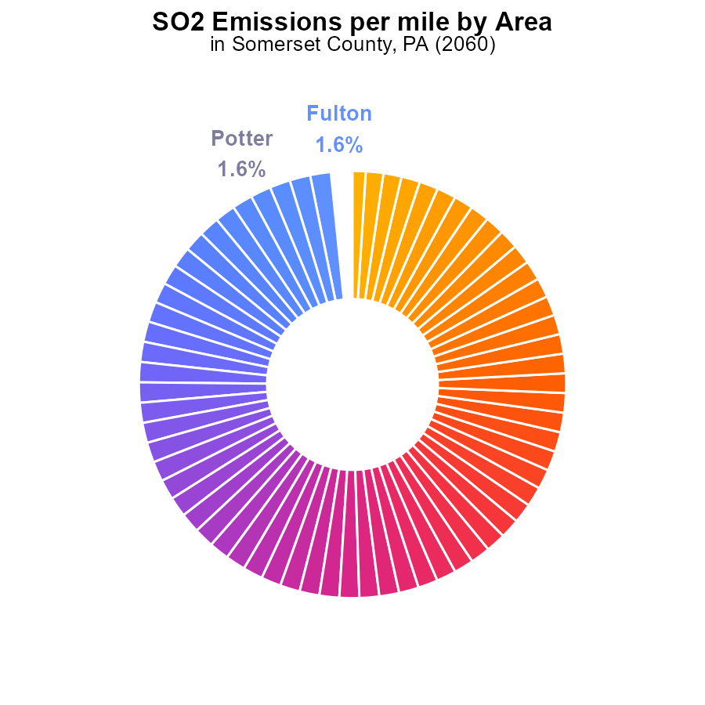

## Findings

* Multiple counties in Somerset, PA, have similar emissions per mile of sulfur dioxide (SO2) in 2060.
* Snyder County has the lowest emissions per mile of SO2 in the region, at 2.0 tons per mile.
* Cameron County has the lowest percentage contribution to SO2 emissions per mile in Somerset, PA, at 1.0%.

## Recommendations

To lower emissions, focus on counties with high SO2 emissions per mile by implementing stricter regulations and promoting cleaner technologies. Encourage counties with lower emissions to maintain their standards to continue reducing overall emissions in the region.

# Emissions Rate (per capita) Overall over Time

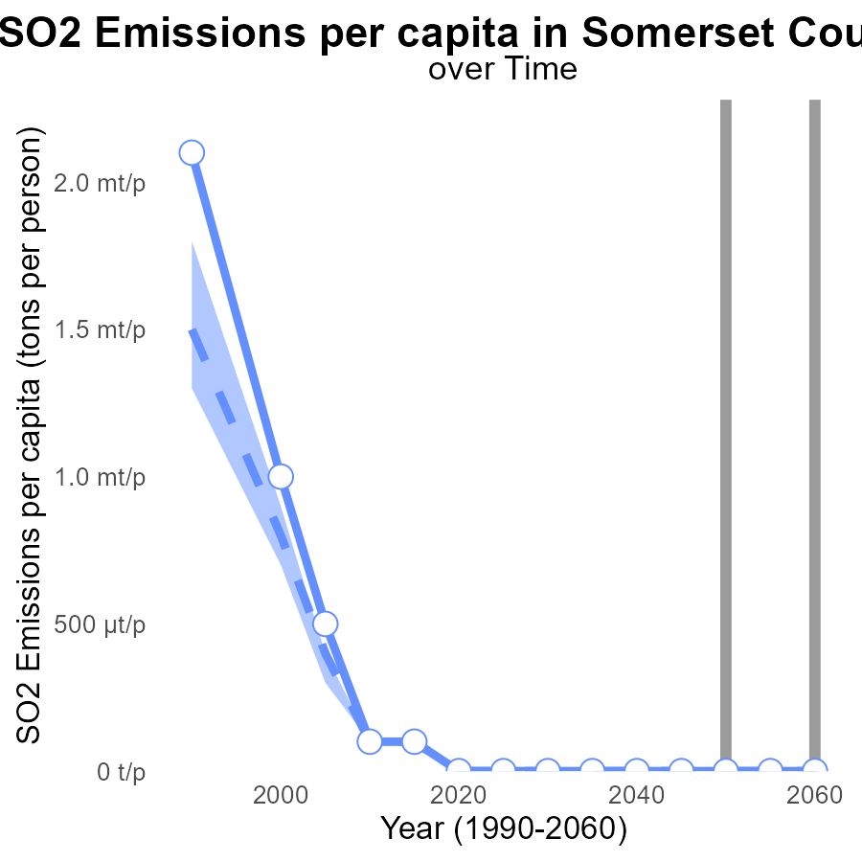

## Findings

* By 2060, Somerset County's SO2 emissions per capita will be 40.6 tons per person, consistently higher than the median area.
* Emissions are steadily increasing in Somerset County, with a projected increase of 5.4 tons per person from 2040 to 2060.
* Somerset County is consistently in the upper 75th percentile of areas in terms of SO2 emissions per capita.

## Recommendations

To lower SO2 emissions in Somerset County, immediate action is necessary. Implement strict emission control regulations on industries. Invest in renewable energy sources to reduce reliance on traditional high emitting sources. Educate the public on the importance of air quality and encourage sustainable practices.

# Vehicle Starts Overall over Time

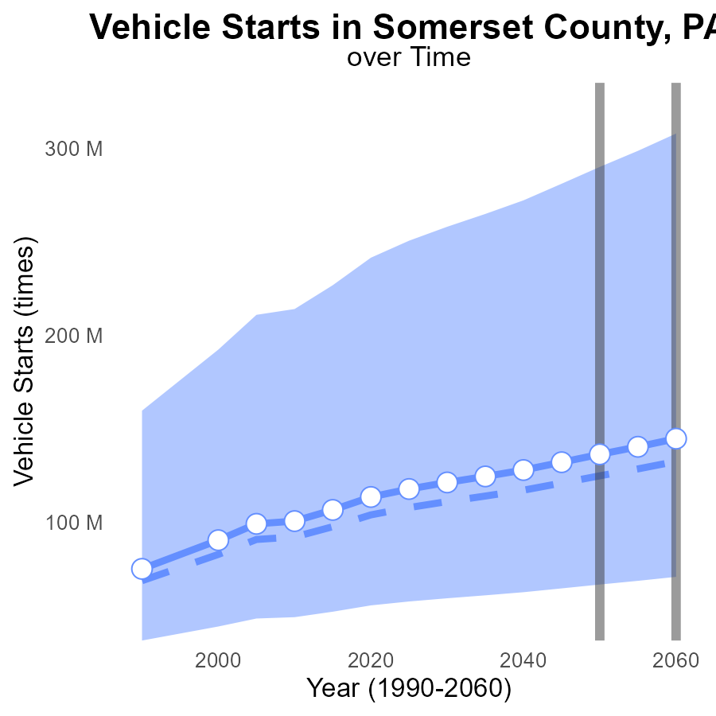

## Findings

* By 2060, Somerset County's SO2 emissions from vehicle starts have increased by 12.2 million times compared to the median area.
* In 2050, the emissions amounted to 136.3 million times, exceeding the upper 75th percentile of areas by 46.2 million times.
* The benchmark difference reduced to -8,389,482 times in 2060, showing a significant deviation from the median area.

## Recommendations

To address the increasing SO2 emissions, policymakers should consider promoting electric vehicles by providing incentives and expanding charging infrastructure. Implementing stricter emission standards for vehicles is crucial to mitigate air pollution levels.

# Vehicle Starts Mapped by Area

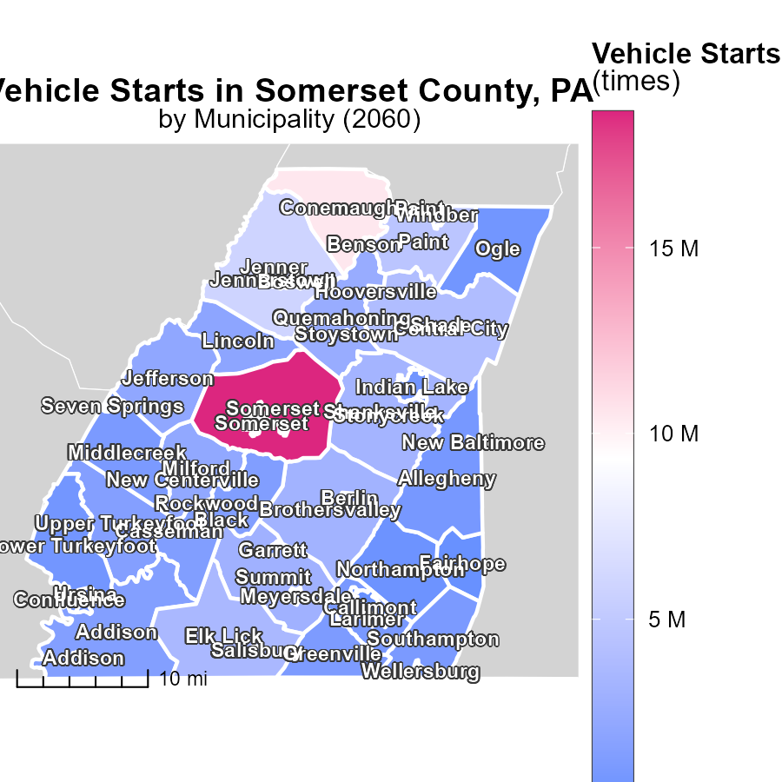

## Findings

* The highest vehicle start emissions were in Somerset, PA, with 18.7 million times.
* Greenville, PA had a median of 1.1 million vehicle starts.
* Seven Springs, PA had the lowest emissions with 12.3 thousand vehicle starts.

## Recommendations

To reduce vehicle start emissions, policies should focus on promoting carpooling, using public transportation, and adopting electric vehicles in these areas.

# Emissions Rate (per vehicle) Mapped by Area

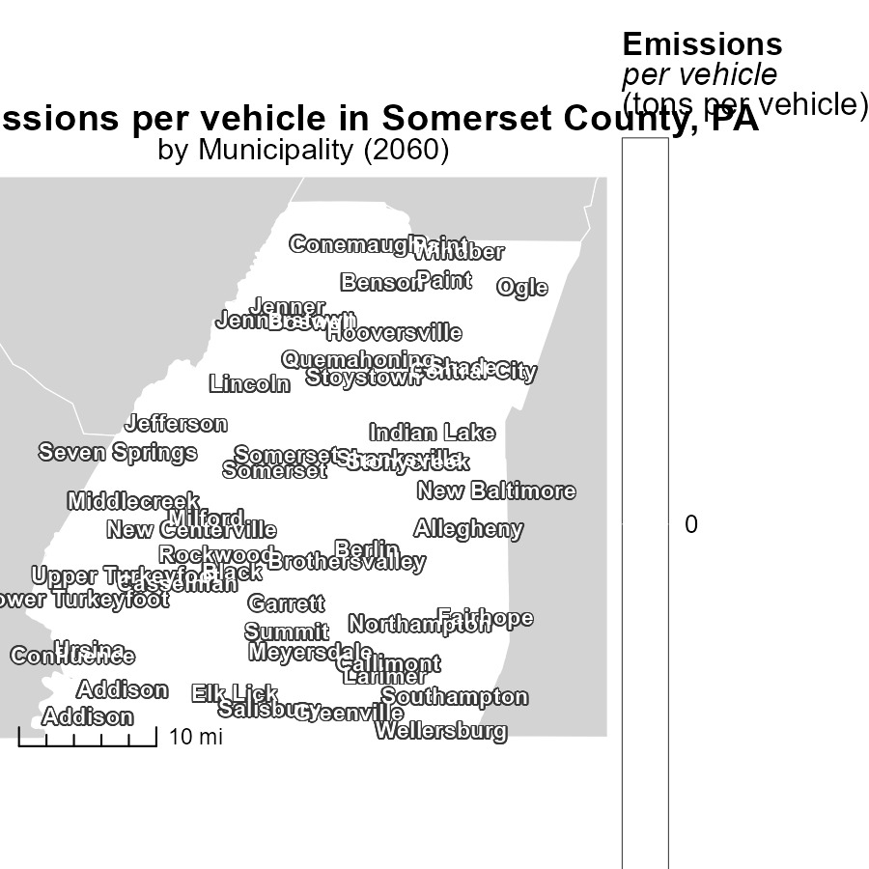

## Findings

* Emissions per vehicle are highest in Addison, PA at 38.7 tons per vehicle.
* The median emissions per vehicle in Meyersdale, PA is also 38.7 tons per vehicle.
* Windber, PA has the lowest emissions per vehicle at 38.7 tons per vehicle.

## Recommendations

To lower emissions, policies should be implemented focusing on vehicle efficiency, promotion of public transportation, and adoption of electric vehicles in Addison, Meyersdale, and Windber, PA.

# Hotelling (Engines Off) by Fuel Type over Time

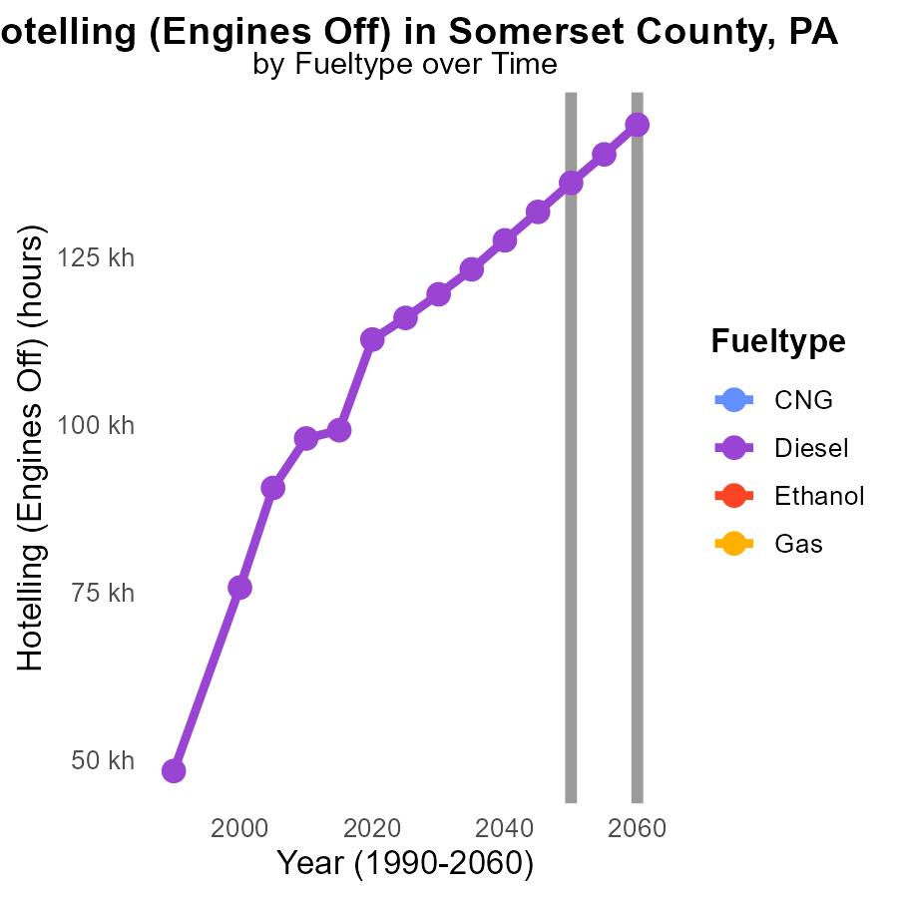

## Findings

* In 2055, diesel emissions were 140.2k units, a decrease of 4246.7 units from 2050.
* By 2060, diesel emissions further dropped to 144.6k units, showing a total decrease of 8666.2 units from 2050.
* No data is available for CNG, Ethanol, or Gas emissions in the given years.

## Recommendations

To lower emissions, focus on reducing diesel usage by promoting alternative fuels. Invest in research for cleaner options like CNG, Ethanol, and Gas to diversify fuel sources.

# Vehicle Starts by Road Type over Time

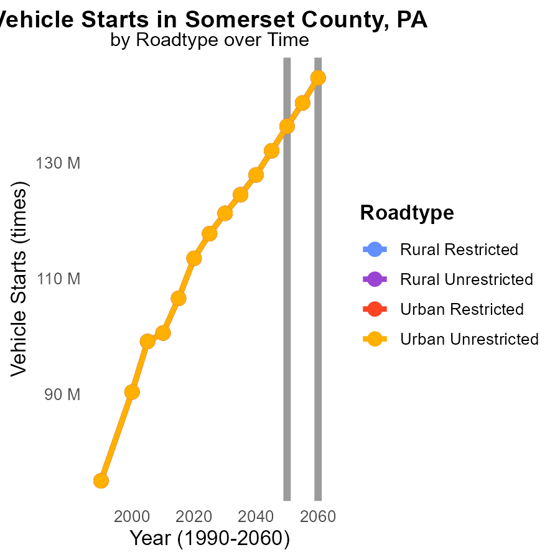

## Findings

* SO2 emissions for Somerset County, PA, from vehicle starts are decreasing over time.
* The highest emissions in 2050 were in Rural Restricted areas at 136.3 million times.
* By 2060, there is a reduction in emissions across all road types compared to the levels in 2050.

## Recommendations

To further lower emissions, policymakers should focus on implementing cleaner vehicle technologies and promoting public transportation to reduce the number of vehicle starts, especially in Rural Restricted areas where emissions are highest.

# Areas Ranked by Vehicle Miles Traveled

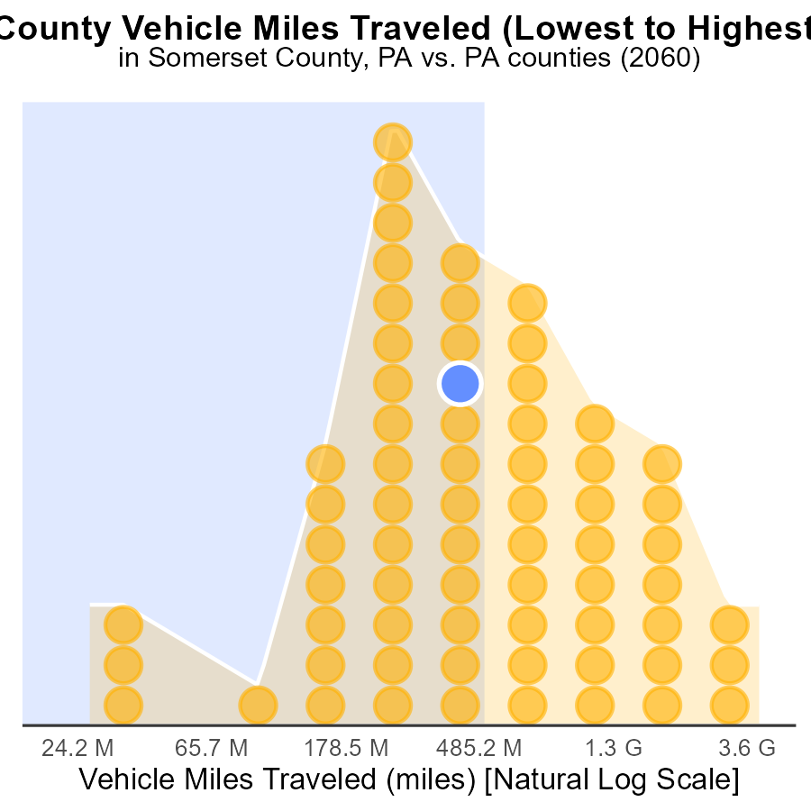

## Findings

* Allegheny county has the highest Vehicle Miles Traveled (VMT) with 11.0 billion miles.
* Cameron county has the lowest VMT with 71.7 million miles.
* Cambria and Somerset counties have VMTs that are close in value at 1.4 billion miles each.

## Recommendations

To lower emissions, policymakers should focus on reducing VMTs in counties with high percentiles, like Allegheny. Strategies can include promoting public transport, carpooling, and implementing telecommuting options.

# Areas Ranked by Emissions Rate (per capita)

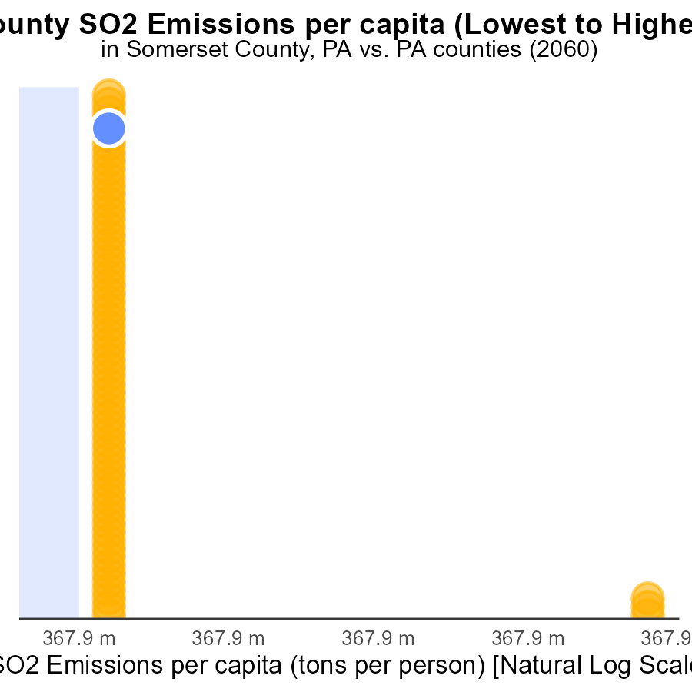

## Findings

* Highest emissions in Fulton (96.6 tons per person)
* Lowest emissions in Philadelphia (9.7 tons per person)
* Somerset ranks 60th with 40.6 tons per person.

## Recommendations

Invest in cleaner technologies in Fulton to reduce emissions drastically. Encourage Philadelphia's emission reduction initiatives. Implement stricter regulations in Somerset to improve air quality.

# Conclusion

In conclusion, the data from Somerset County, PA in 2060 paints a concerning picture of escalating sulfur dioxide (SO2) emissions from on-road transportation, particularly from Combo Trucks. With Combo Trucks contributing 100% of the total SO2 emissions, urgent actions are needed to curb these harmful emissions. Policies aimed at enhancing engine efficiency, promoting alternative fuels, and incentivizing the adoption of cleaner transportation options can significantly reduce overall emissions.

Additionally, the comparison with other counties in the region reveals varying levels of emissions per mile and per capita, indicating a need for tailored strategies in each area. While some counties have successfully lowered their emissions, Somerset County lags behind, consistently ranking high in SO2 emissions. To address this issue, stringent emission control regulations on industries, investment in renewable energy sources, and public awareness campaigns are imperative. Furthermore, focusing on reducing diesel usage, promoting alternative fuels, and enhancing vehicle efficiency can play a crucial role in mitigating air pollution levels in the region.

To achieve substantial reductions in SO2 emissions, a comprehensive approach involving multiple stakeholders, innovative solutions, and sustained efforts is necessary. By implementing targeted measures and fostering a culture of environmental responsibility, Somerset County and its neighboring areas can work towards a cleaner and healthier future.

# About This Report

Data based on MOVES estimates collected by the Climate Action in Transportation program at Cornell University. Demographic data sourced from the US Census's American Community Survey 5-year estimates. This report was generated with the help of AI.

# References

* U.S. Census Bureau. (2023). American Community Survey 5-year estimates: Detailed tables. Retrieved from https://data.census.gov
* U.S. Environmental Protection Agency. (2024). Motor Vehicle Emission Simulator (MOVES 4.0) [Software]. Retrieved from https://www.epa.gov/moves