 

**NOx Emissions in Harnett County, 2010**  
Made with CAT VISUALIZER by Gao Labs @ Cornell University.

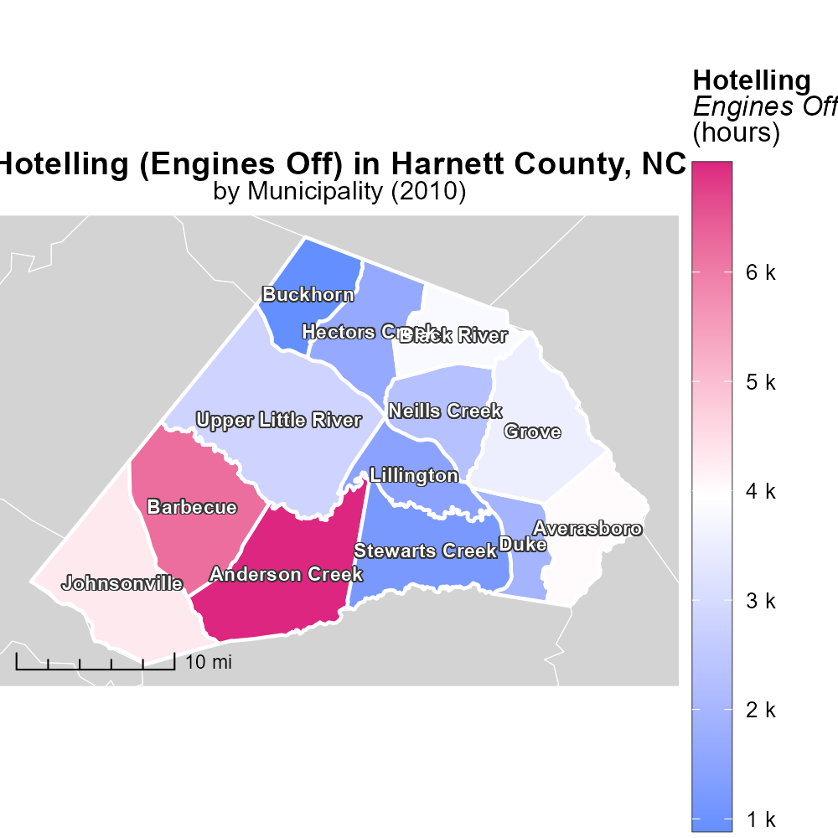

## Keywords

Oxides of Nitrogen; NOx emissions; on-road transportation; Harnett County; North Carolina; 2010

## Highlights

* Study on NOx emissions from transportation in Harnett County, NC in 2010.
* Focus on impact of on-road vehicles on air quality.
* Analysis of data to understand pollution levels in the region.
* Findings to inform future emission control strategies.
* Importance of addressing NOx emissions for environmental health.

# Introduction

In 2010, Harnett County, North Carolina, witnessed a significant level of Oxides of Nitrogen (NOx) emissions originating from on-road transportation. As a key component of air pollution, NOx emissions have been of growing concern due to their detrimental effects on air quality and public health.

This report aims to provide a comprehensive analysis of the NOx emissions generated by on-road vehicles in Harnett County in 2010. By examining the data and trends, we seek to gain insights into the extent of pollution caused by transportation activities in the region and evaluate the impact of NOx emissions on the environmental landscape and the health of the local population.

# Vehicle Miles Traveled by Vehicle Type

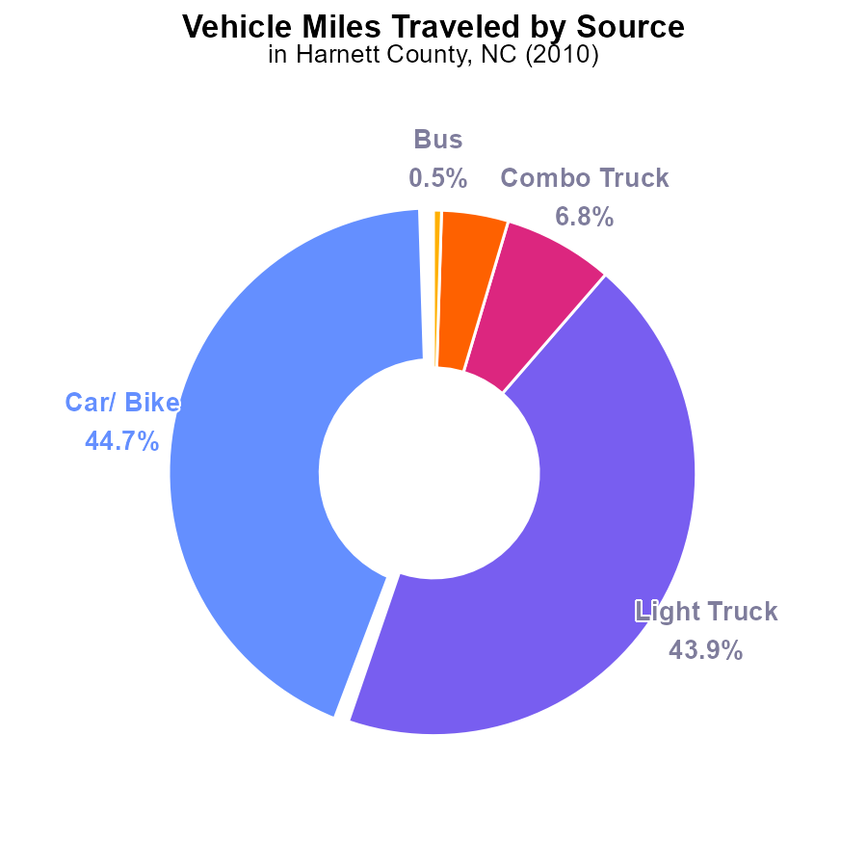

## Findings

* In 2010, NOx emissions from vehicles in Harnett County were primarily from Cars/ Bikes and Light Trucks.
* Combining all types of trucks (Light, Combo, and Heavy) accounted for 55.2% of total NOx emissions.
* Buses contributed to only 0.5% of the total NOx emissions from vehicles.

## Recommendations

To lower NOx emissions, prioritize reducing the emissions from Cars/ Bikes and Light Trucks, which contribute the most. Implement emission reduction strategies targeted at trucks and enhance public transportation to reduce Bus emissions.

# Vehicle Miles Traveled Overall by Area

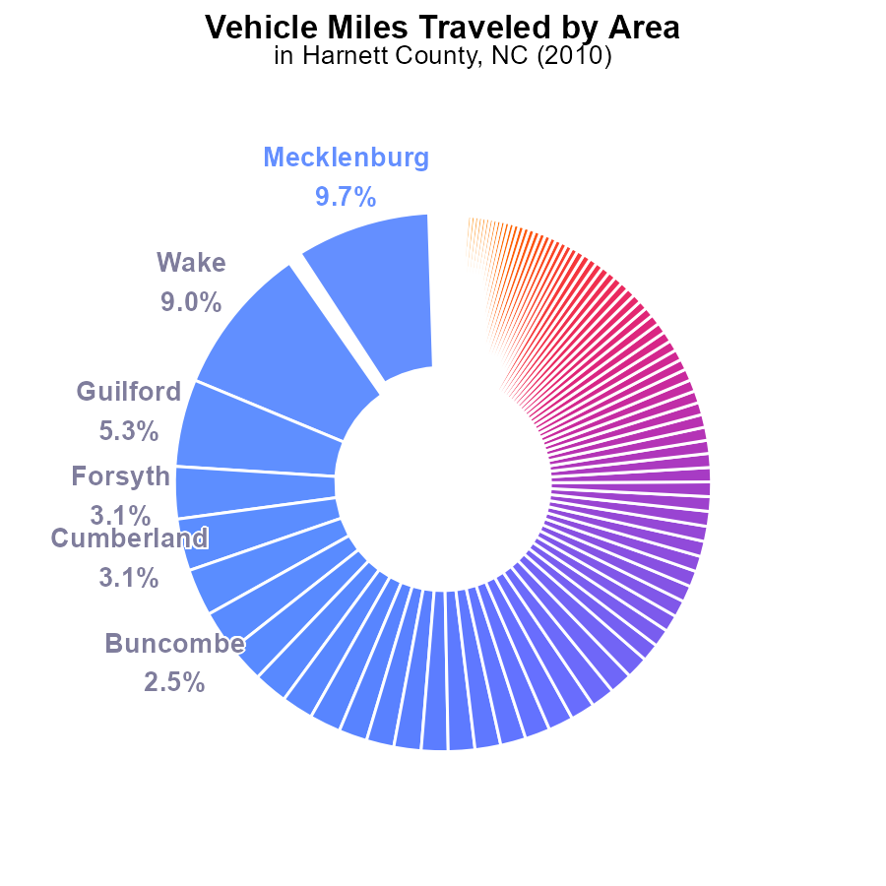

## Findings

* Top 3 contributors are Mecklenburg (9.7%), Wake (9.0%), and Guilford (5.3%) counties
* Bottom 3 contributors, Tyrrell, Hyde, and Graham, combine for just 0.3% of total NOx emissions
* Vehicle Miles Traveled varies greatly, with Cleveland (1.0%) markedly lower than Mecklenburg (9.7%)

## Recommendations

Encourage carpooling and the use of public transportation in high-emission counties like Mecklenburg and Wake to reduce NOx emissions. Invest in cleaner public transit options. Implement stricter vehicle emission standards to cut emissions in high VMT counties like Mecklenburg.

Consider implementing congestion pricing or low-emission zones in urban areas to reduce the incentive for vehicle travel in counties like Wake and Mecklenburg. Promote the use of electric vehicles and bicycles to decrease NOx emissions in these regions. Collaborate with relevant stakeholders for effective implementation.

# Idling over Time for Passenger Idling

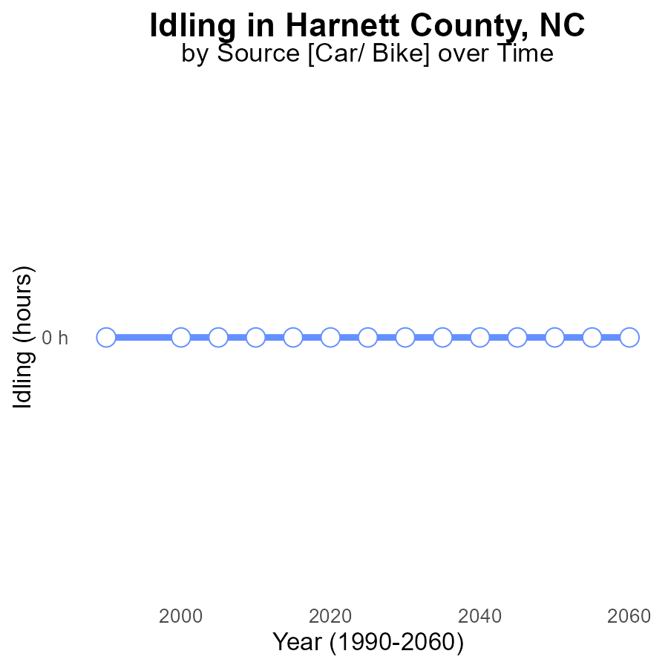

## Findings

* NOx emissions from idling in Harnett County, NC have been consistently at 0.0 hours since 1990.
* There is no difference between the area's idling NOx emissions and the benchmark values over the years.
* The county has maintained a stable level of idling NOx emissions, showing no significant change or improvement.

## Recommendations

Since NOx emissions from idling have remained at zero, it is crucial to continue implementing and enforcing existing idle reduction measures. Regular monitoring and promoting alternative transportation methods are also recommended to maintain the current low emission levels.

# Time Driven Overall over Time

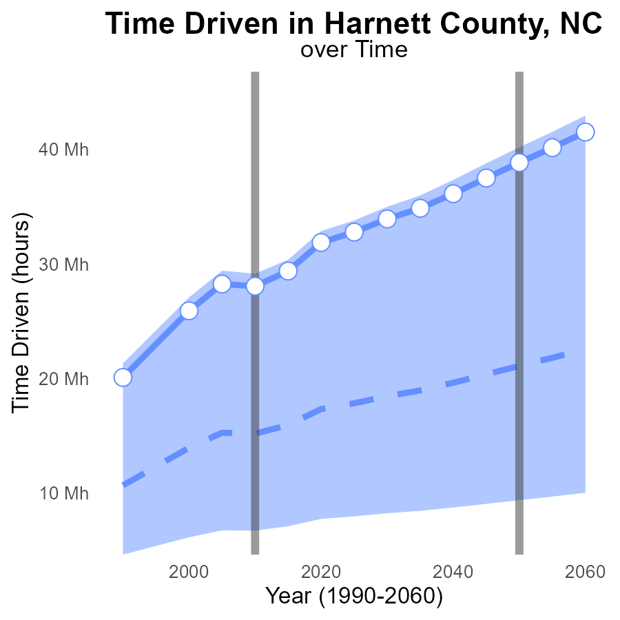

## Findings

* NOx emissions in Harnett County, NC have consistently increased over the years, with a +15.5 M difference from the median area in 2030.
* The upper 75th percentile of NOx emissions in the area significantly exceeds the median area's emissions, suggesting a potential issue.
* Benchmark differences show a consistent gap between current emissions and desired lower levels throughout the years.

## Recommendations

To lower NOx emissions, policymakers should consider implementing stricter environmental regulations, investing in cleaner technologies, and promoting public transportation to reduce reliance on vehicles.

# Hotelling (Engines Off) Mapped by Area

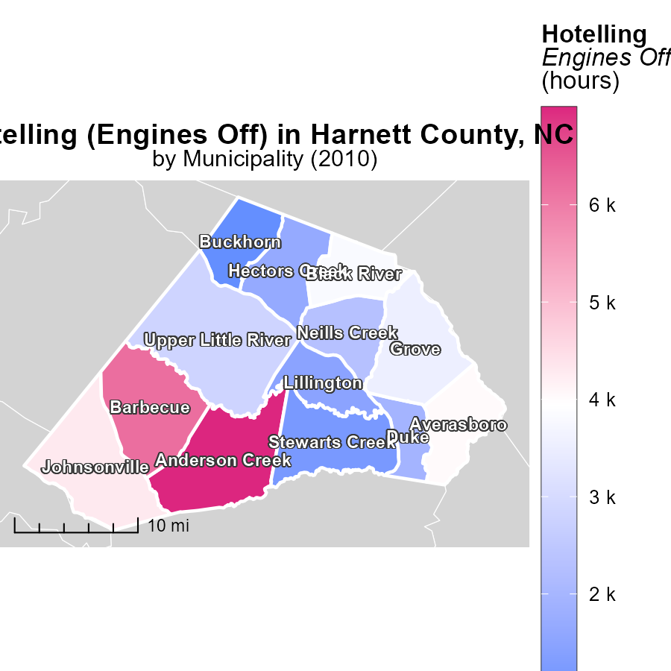

## Findings

* In 2010, the maximum emissions from Hotelling (Engines Off) in Anderson Creek, NC were 7.0 k hours.
* The median emissions were 2.8 k hours in Upper Little River, NC in the same year.
* On the other hand, emissions were at a minimum of 889.8 hours in Buckhorn, NC.

## Recommendations

To reduce emissions, initiatives like promoting carpooling or using cleaner transportation options can be implemented in areas with higher emission levels, while encouraging the adoption of eco-friendly practices and technologies in regions with lower emissions.

# Hotelling (Diesel Aux) Mapped by Area

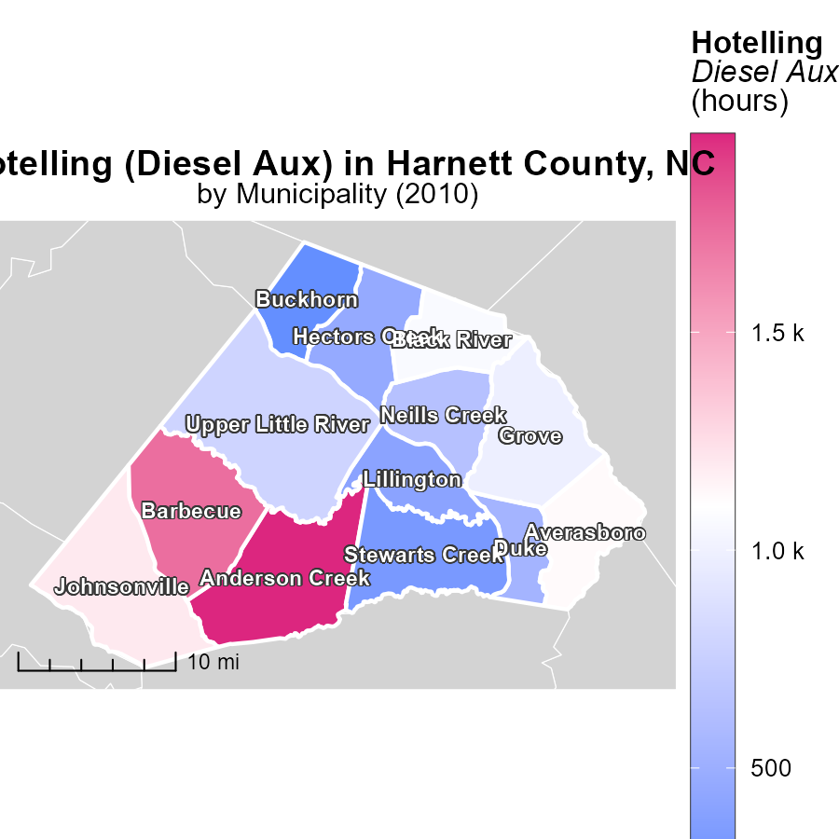

## Findings

* In 2010, Anderson Creek, NC had the highest hotelling emissions of 2.0k hours
* Upper Little River, NC had a median hotelling emissions of 786.6 hours in 2010
* Buckhorn, NC had the lowest hotelling emissions of 248.4 hours in 2010

## Recommendations

To lower emissions, policymakers should focus on reducing hotelling hours in areas with high emissions like Anderson Creek, NC. Implementing stricter regulations and promoting fuel-efficient practices can help decrease emissions in both Upper Little River, NC and Buckhorn, NC.

# Idling by Vehicle Type over Time

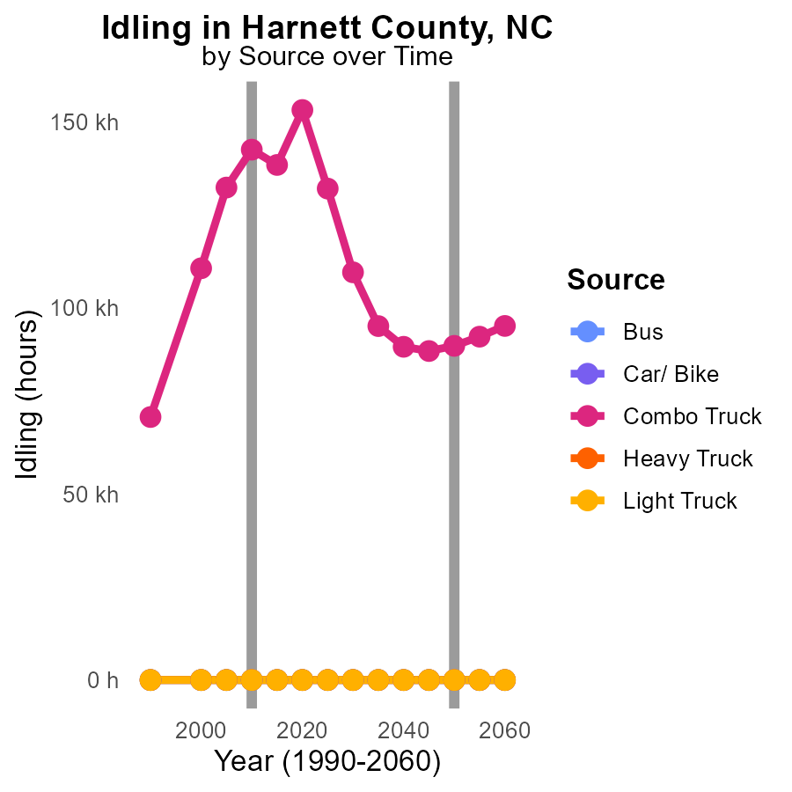

## Findings

* Bus emissions have remained at 0.0 for the years 2000-2020.
* Combination truck emissions decreased by 33.7% from 2000 to 2020.
* There were no emissions from Heavy and Light Trucks from 2000 to 2020.

## Recommendations

To further reduce emissions in Harnett County, focus on implementing stricter regulations and incentives for upgrading older combination trucks to newer, cleaner models. Additionally, promoting the use of alternative fuels and electric vehicles for buses can help maintain the zero emissions trend. Moreover, considering policies to encourage the use of public transportation can contribute to reducing emissions from other vehicle types.

# Emissions by Regulatory Class over Time

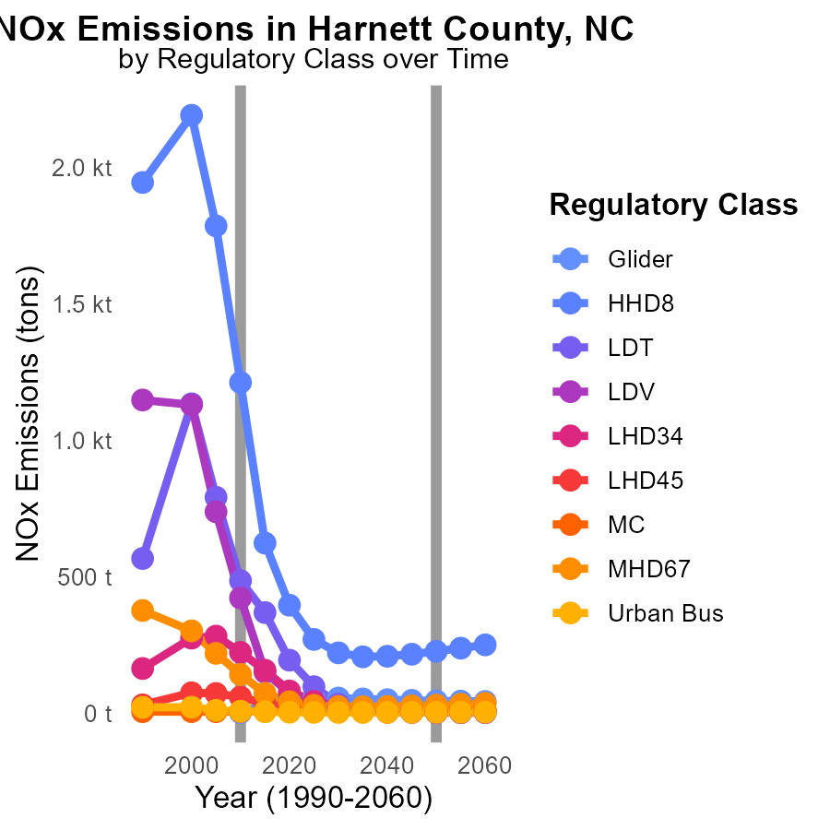

# Areas Ranked by Vehicle Miles Traveled

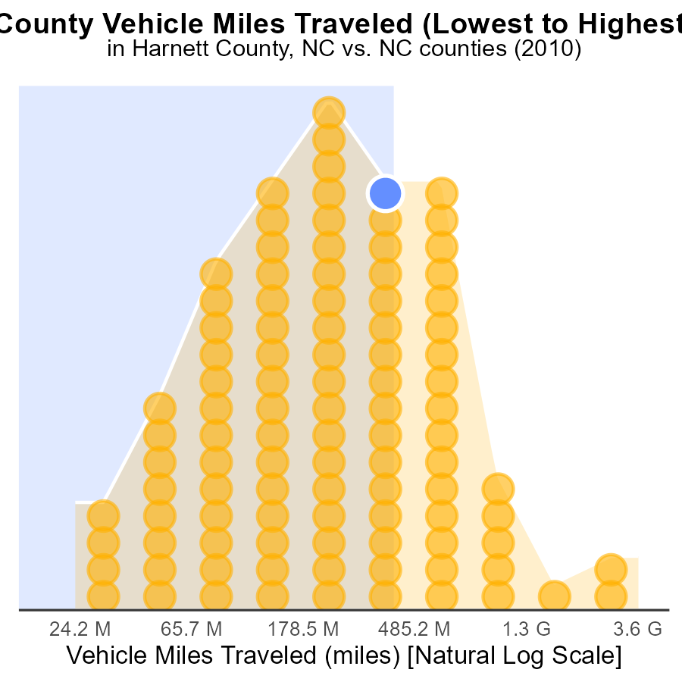

## Findings

* Mecklenburg county had the highest NOx emissions in 2010, at 9.9 billion miles.
* Hyde county had the lowest NOx emissions in 2010, accounting for only 1% of the total emissions.
* The top 5 counties with the highest NOx emissions together produced 43.5% of the total emissions in 2010.

## Recommendations

To lower NOx emissions, focusing on reducing vehicle miles traveled in high-emission counties like Mecklenburg and Randolph is crucial. Implementing stricter vehicle emission standards and promoting public transportation can significantly reduce emissions.

# Areas Ranked by Time Driven

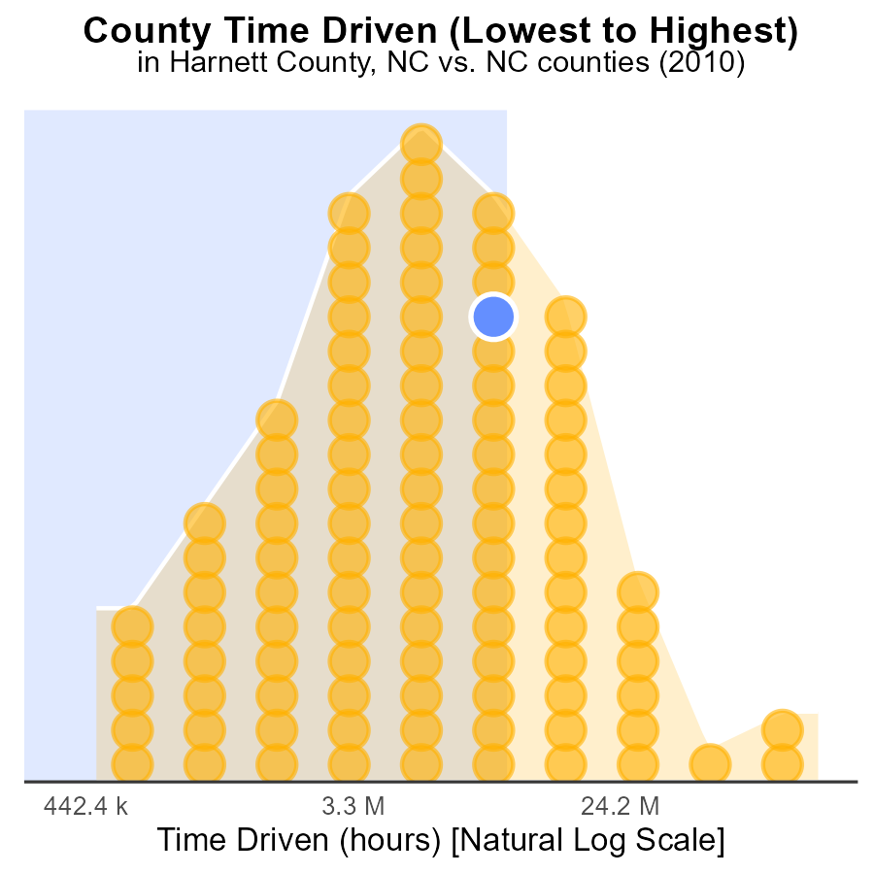

## Findings

* Mecklenburg has the highest NOx emissions in 2010 at 288.8 million source-hours.
* Hyde County has the lowest NOx emissions in 2010, with only 1.3 million source-hours.
* The top three counties with the highest NOx emissions are Mecklenburg, Wayne, and Harnett.

## Recommendations

To lower NOx emissions, policies should focus on reducing emissions from the top three counties: Mecklenburg, Wayne, and Harnett. Implementing stricter regulations on sources contributing to NOx emissions in these areas can help in significantly reducing overall emissions.

# Conclusion

In conclusion, the analysis of NOx emissions from on-road transportation in Harnett County, NC in 2010 reveals important insights for emission reduction strategies. Vehicles such as cars, bikes, and light trucks were the primary contributors to NOx emissions, warranting a targeted approach towards reducing emissions from these sources. It is advisable to prioritize implementing emission reduction strategies for trucks and enhancing public transportation to mitigate bus emissions. Furthermore, collaboration with stakeholders and the promotion of cleaner transportation options like electric vehicles and bicycles are recommended to lower NOx emissions in counties with high emission levels. Although idling NOx emissions have been consistently at zero, maintaining existing idle reduction measures and encouraging alternative transportation methods are crucial to sustain low emission levels. Policymakers should consider implementing stricter environmental regulations, investing in cleaner technologies, and promoting public transportation to effectively reduce NOx emissions in the region.

Efforts to lower NOx emissions should also focus on areas with the highest emissions, such as Mecklenburg, Wayne, and Harnett counties. Implementing stricter regulations on emission sources in these counties can contribute significantly to reducing overall emissions. Additionally, initiatives like promoting carpooling, adopting cleaner transportation options, and upgrading older vehicles to newer, cleaner models can help in achieving emission reduction goals. By combining targeted strategies with policy interventions and technological advancements, it is possible to effectively mitigate NOx emissions from on-road transportation in Harnett County and contribute to a cleaner and healthier environment.

# About This Report

Data based on MOVES estimates collected by the Climate Action in Transportation program at Cornell University. Demographic data sourced from the US Census's American Community Survey 5-year estimates. This report was generated with the help of AI.

# References

* U.S. Census Bureau. (2023). American Community Survey 5-year estimates: Detailed tables. Retrieved from https://data.census.gov
* U.S. Environmental Protection Agency. (2024). Motor Vehicle Emission Simulator (MOVES 4.0) [Software]. Retrieved from https://www.epa.gov/moves