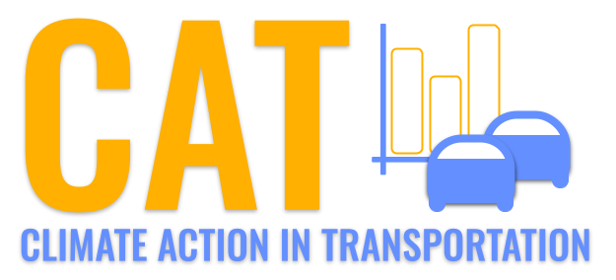 

**VOC Emissions in Talbot County, 2025**  
Made with CAT VISUALIZER by Gao Labs @ Cornell University.

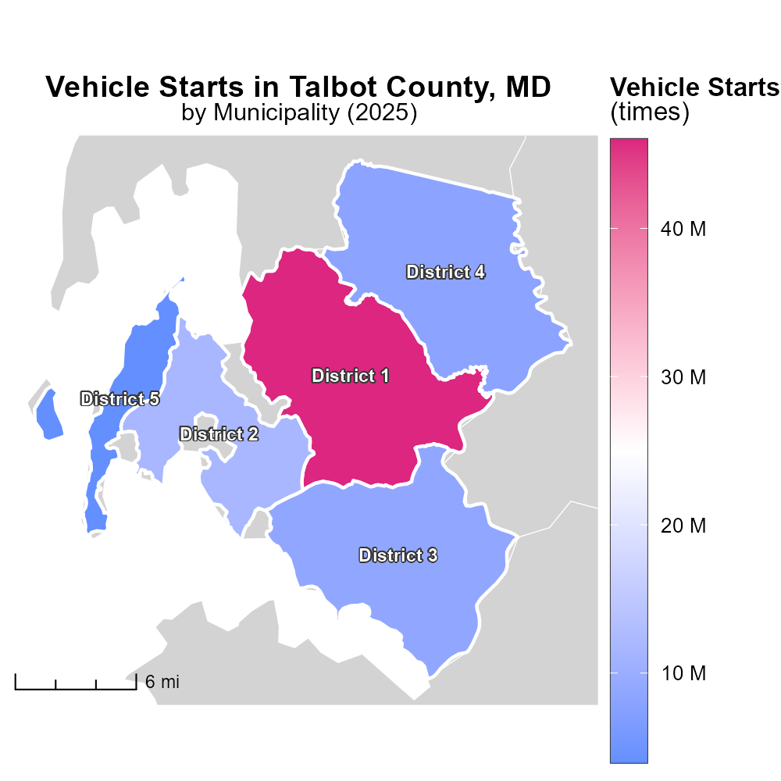

## Keywords

Volatile Organic Compounds; emissions; on-road transportation; Talbot County; MD; 2025

## Highlights

* Study assesses VOC emissions in Talbot County from on-road transportation.
* Data from 2025 provides insights into environmental impact.
* Analysis crucial for developing strategies to reduce pollution levels.
* Focus on understanding sources and implications of VOC emissions.
* Findings aim to guide policy decisions for sustainable transport planning.

# Introduction

In 2025, a comprehensive examination of Volatile Organic Compounds (VOC) emissions from on-road transportation in Talbot County, Maryland, was conducted to evaluate the environmental impact of pollutant releases. This report details the findings from the study, which are crucial for understanding the sources, concentrations, and implications of VOC emissions in the region.

By analyzing data specific to 2025, this report aims to provide valuable insights that can guide policymakers and stakeholders in developing effective strategies to mitigate the adverse effects of VOC emissions. Understanding the dynamics of on-road transportation-related VOC emissions is essential for devising sustainable transport plans and policies that prioritize environmental conservation and public health in Talbot County.

# Vehicle Miles Traveled by Fuel Type

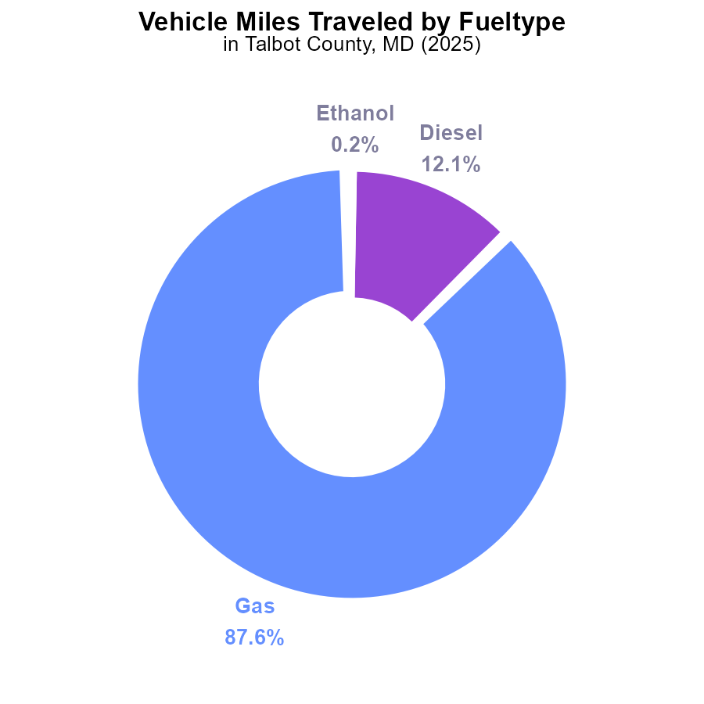

## Findings

* Gasoline vehicles contribute to 87.6% of VOC emissions from vehicle miles traveled in Talbot County, MD in 2025.
* Diesel vehicles contribute to 12.1% of VOC emissions from vehicle miles traveled in Talbot County, MD in 2025.
* Alternative fuel types like ethanol and CNG contribute minimally, with 0.2% and 0.1% respectively, to VOC emissions in Talbot County, MD in 2025.

## Recommendations

To lower VOC emissions, policymakers should focus on reducing gasoline and diesel vehicle usage through incentives for electric vehicles and public transportation. Encouraging the adoption of alternative fuels like ethanol and CNG can also help further reduce emissions.

# Emissions Rate (per capita) by Fuel Type

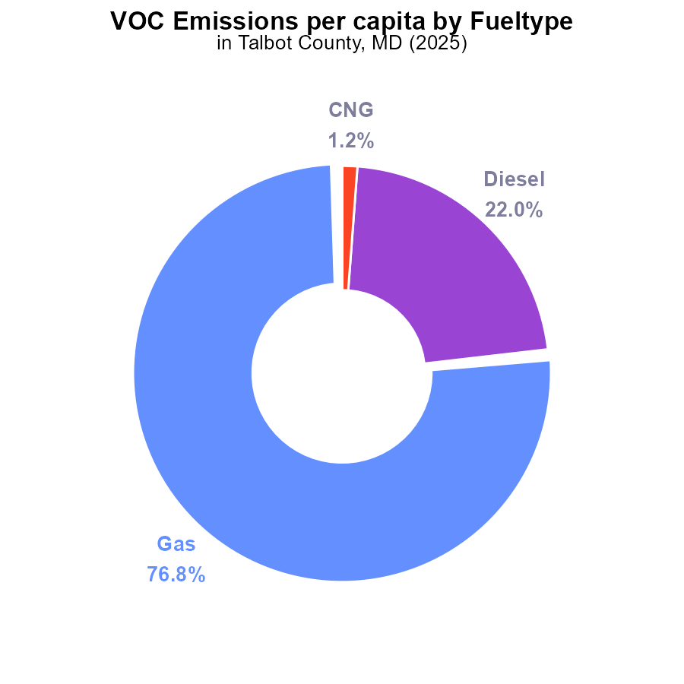

## Findings

* The highest VOC emissions per capita in Talbot County, MD in 2025 are from Gas at 1.2 tons per person, accounting for 76.8%.
* Diesel follows with 347.8 kilograms per person at 22.0%.
* CNG emissions per capita are the lowest at 18.9 kilograms per person, constituting 1.2%.

## Recommendations

To lower VOC emissions in Talbot County, MD, strategies should focus on reducing emissions from Gas and Diesel sources, which collectively contribute to 98.8% of total VOC emissions. Implementing stricter emission standards for vehicles, promoting the use of public transportation, and incentivizing the adoption of electric vehicles can significantly reduce the emissions per capita.

# Vehicle Miles Traveled Overall over Time

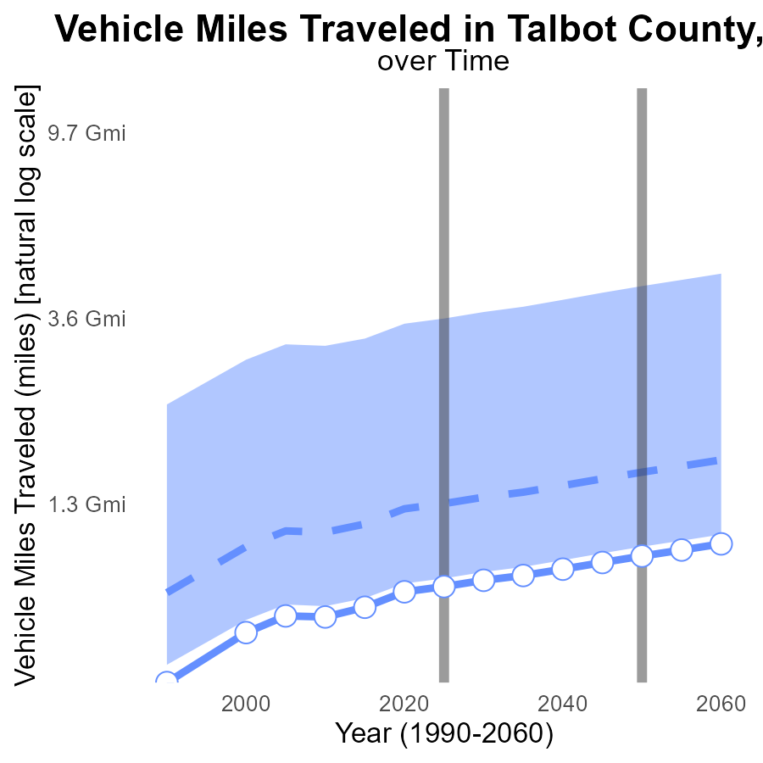

## Findings

* Vehicle miles traveled in Talbot County increased by 33.6% from 2005 to 2045.
* Talbot County's vehicle miles traveled consistently ranked below the median and upper 75th percentile of areas.
* Benchmark difference reduced by 87.6% from 2005 to 2045, showing improvement in emissions efficiency.

## Recommendations

To lower emissions levels, promote public transportation, carpooling, and biking. Invest in infrastructure to support these alternatives. Implement policies like congestion pricing to reduce vehicle usage.

# Emissions Rate (per vehicle) Overall over Time

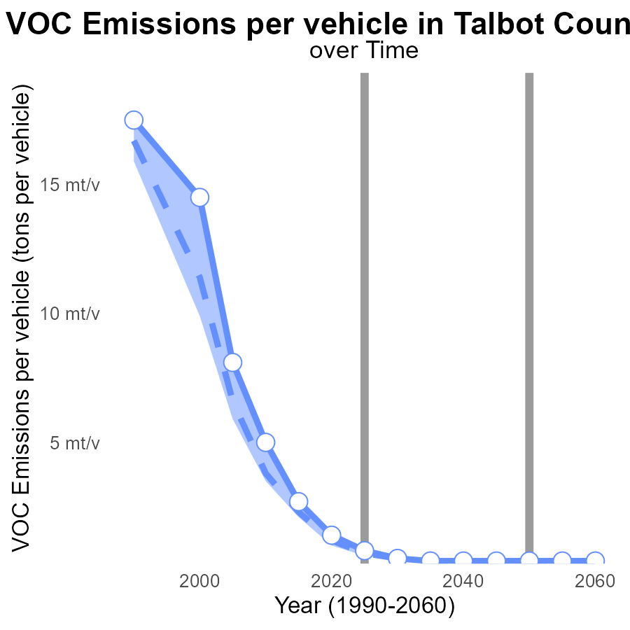

## Findings

* VOC emissions per vehicle in Talbot County, MD have decreased significantly over the years.
* Talbot County's VOC emissions per vehicle have consistently been above the median and upper 75th percentile.
* There is a decreasing trend in VOC emissions per vehicle up to 2045, aligning with the lower 25th percentile target.

## Recommendations

To further lower VOC emissions, Talbot County should prioritize initiatives such as introducing stricter vehicle emission standards, promoting electric vehicles, and enhancing public transportation. Additionally, implementing regular vehicle emission inspections can help identify and address high-emitting vehicles, contributing to the overall reduction in emissions.

# Vehicle Starts Mapped by Area

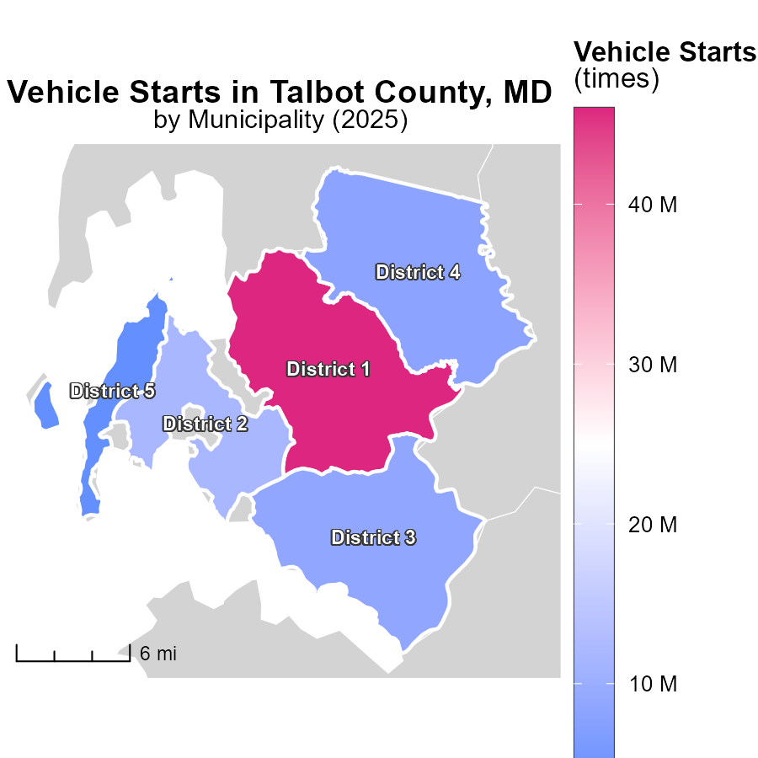

## Findings

* District 1, MD had the highest vehicle starts in 2025 with 46.0 million.
* District 3, MD had a moderate number of vehicle starts in 2025 with 8.8 million.
* District 5, MD had the lowest vehicle starts in 2025 with 4.0 million.

## Recommendations

To decrease emissions, focus on promoting public transportation and carpooling in District 1. Implement stricter emission standards for vehicles in District 3. Encourage the use of electric vehicles in District 5 to reduce emission levels.

# Vehicles in My Region

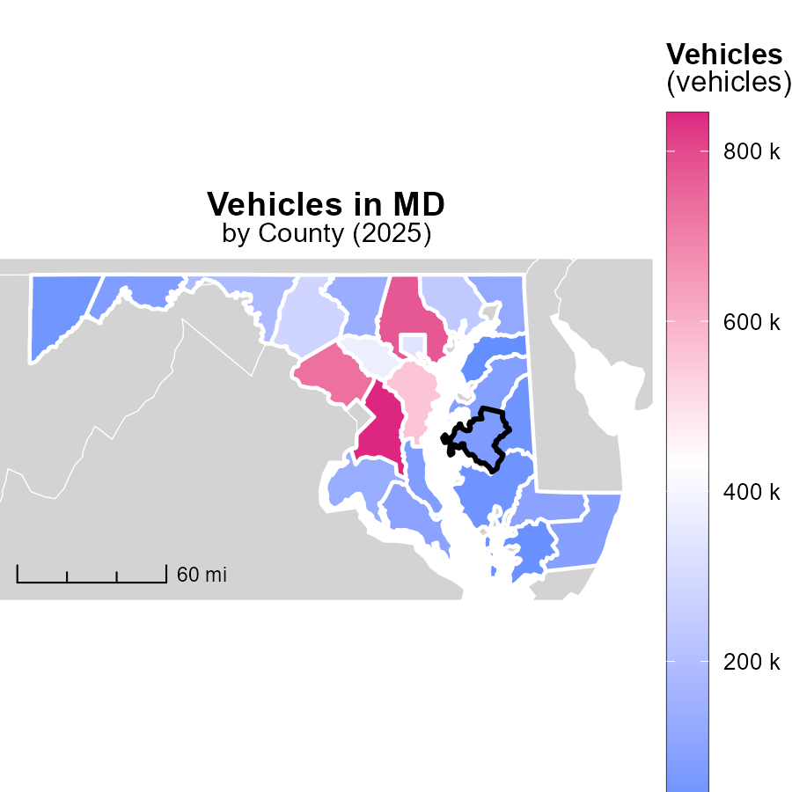

## Findings

* Prince George's County has the highest vehicle emissions with 844.7k tons.
* Cecil County has median vehicle emissions at 120.0k tons.
* Kent County has the lowest vehicle emissions at 19.4k tons.

## Recommendations

To reduce emissions, initiatives like promoting public transport, implementing carpooling schemes, and investing in electric vehicles could be beneficial for counties with higher emissions like Prince George's County. For counties with lower emissions like Kent County, efforts to maintain and encourage the use of cleaner transportation modes can help sustain their lower emission levels.

# Emissions Rate (per capita) by Area over Time

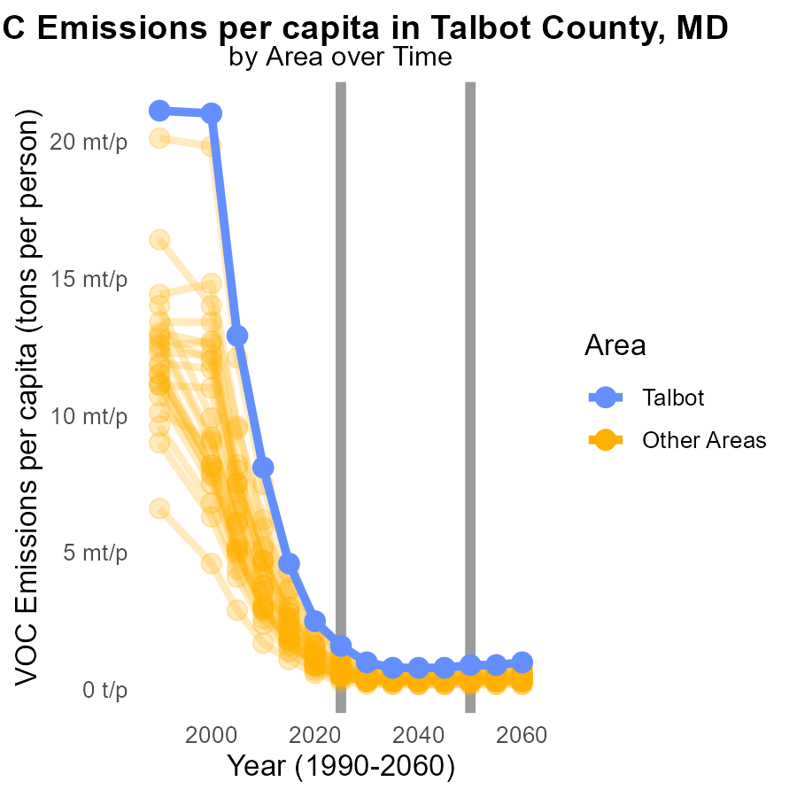

## Findings

* In 2025, the minimum VOC emissions per capita was 341.5 tons per person, a decrease of 0.0001 tons compared to 2050.
* In 2025, the maximum VOC emissions per capita reached 1.6 million tons per person, a reduction of 0.0007 tons compared to 2050.

## Recommendations

To lower VOC emissions, focus on counties with high per capita emissions and implement targeted reduction measures. Monitor progress towards achieving emissions reduction goals annually.

# Emissions by Road Type over Time

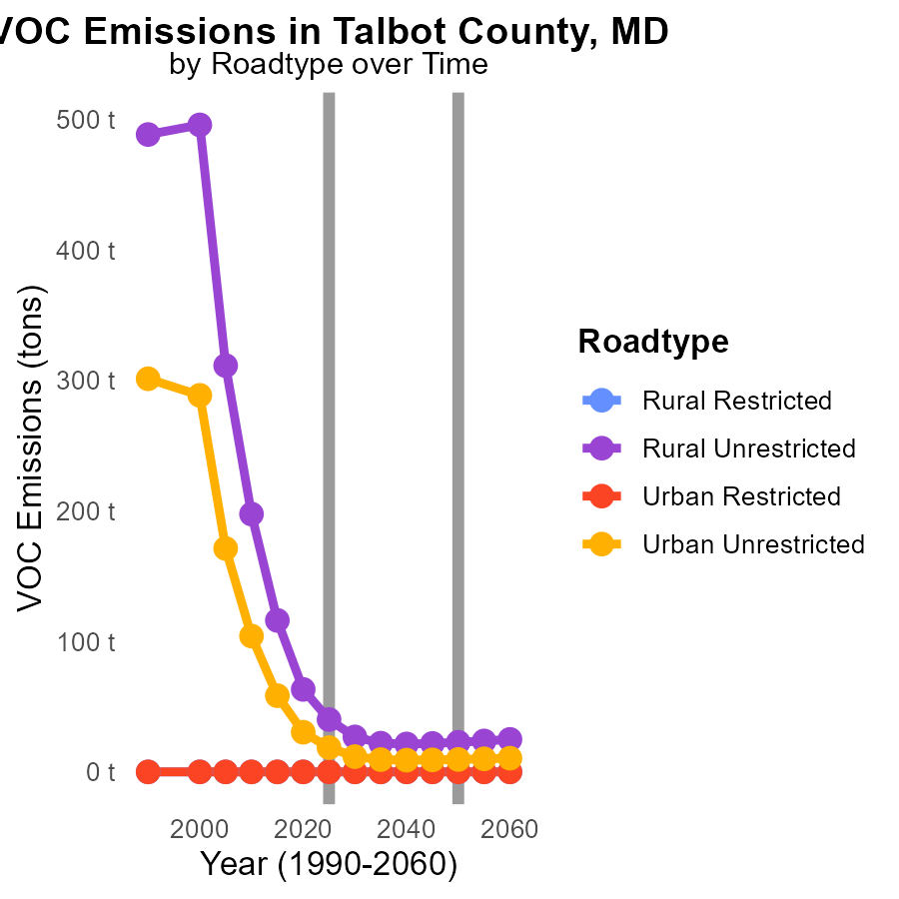

## Findings

* Rural Unrestricted areas showed a significant decrease in VOC emissions from 116.1 tons in 2015 to 22.0 tons in 2035.
* Urban Unrestricted areas also experienced a notable reduction in emissions from 58.4 tons in 2015 to 9.4 tons in 2035.
* No VOC emissions were reported in Urban Restricted and Rural Restricted areas throughout the years 2015 to 2035.

## Recommendations

To further reduce VOC emissions in Talbot County, focus on promoting and incentivizing the use of eco-friendly transportation modes such as public transport, cycling, and electric vehicles in both rural and urban unrestricted areas. Implement stricter regulations on industrial emissions to maintain the current zero-emission levels in urban and rural restricted areas.

# Areas Ranked by Time Driven

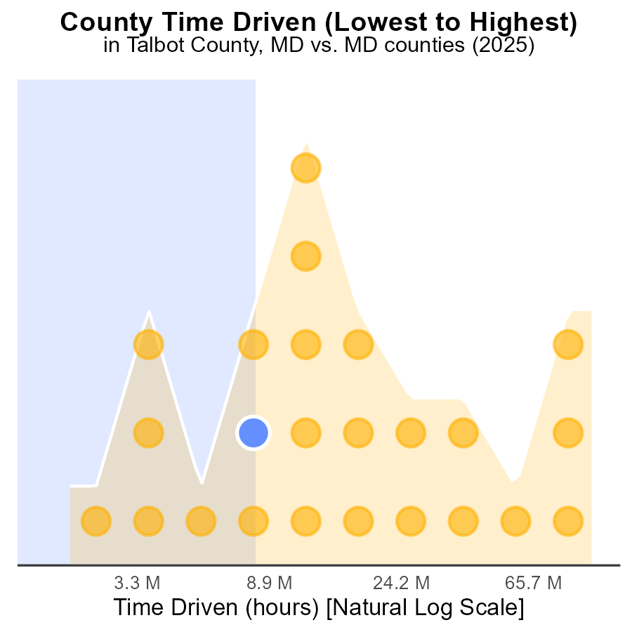

## Findings

* Prince George's had the highest VOC emissions with 282.7 M hours, representing 100.0% of the total.
* Allegany ranked 8th in VOC emissions, with 24.7 M hours, accounting for 33.3% of the total.
* Kent had the lowest VOC emissions with 5.3 M hours, representing 4.2% of the total.

## Recommendations

To lower VOC emissions, focus on high-emitting counties like Prince George's and Allegany by implementing stricter regulations for VOC sources. Encourage the adoption of cleaner technologies to reduce emissions.

# Areas Ranked by Idling

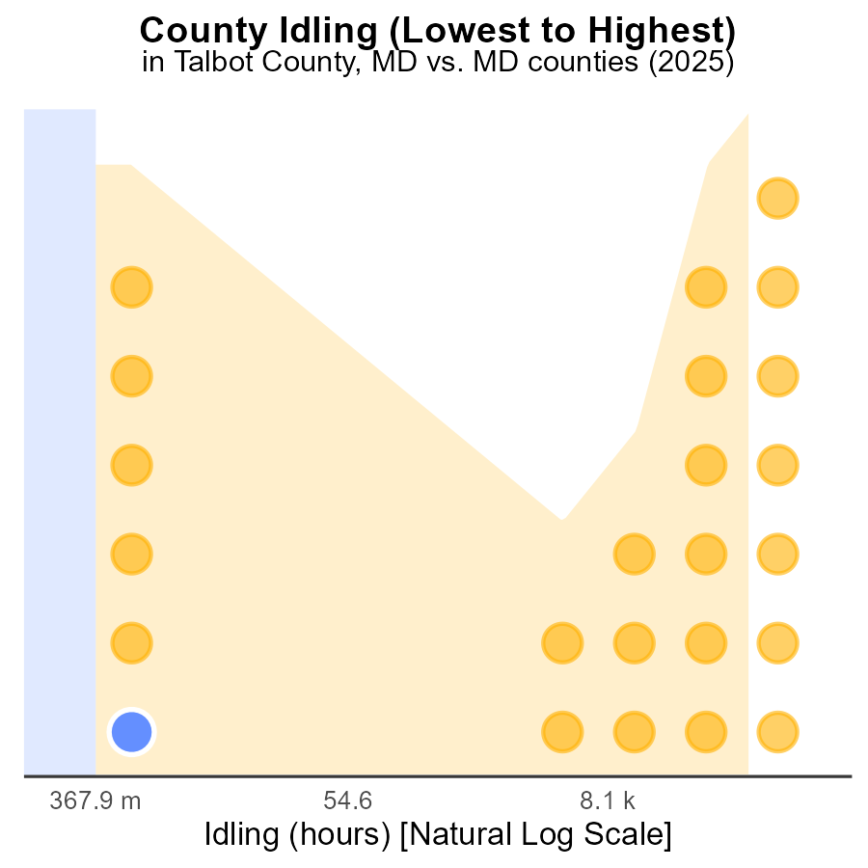

## Findings

* Talbot county has the lowest idle hours with 0.0, ranking 1st at 25.0%.
* Baltimore county has the highest idle hours with 1.2 million, ranking 24th at 100.0%.
* Most counties have no idling hours, with a majority at the 25.0% percentile.

## Recommendations

To reduce emissions, encourage other counties to adopt idling reduction strategies similar to Talbot county. Implement idling reduction policies in high-emission areas like Baltimore county.

# Conclusion

In conclusion, the data from Talbot County, MD in 2025 highlights the significant contribution of gasoline and diesel vehicles to VOC emissions, with alternative fuel types like ethanol and CNG playing a minimal role. The per capita emissions from gasoline and diesel sources are notably high, emphasizing the need for targeted strategies to reduce emissions in these categories. Initiatives focusing on incentivizing electric vehicles, promoting public transportation, and encouraging the adoption of alternative fuels can lead to substantial emissions reductions.

Furthermore, the analysis demonstrates a decreasing trend in VOC emissions per vehicle and per capita, indicating progress towards lower emission levels. To sustain and accelerate this trend, policymakers should prioritize the implementation of stricter vehicle emission standards, the promotion of electric vehicles, and the enhancement of public transportation infrastructure. Targeting high-emitting areas such as District 1 and Prince George's County with tailored emission reduction measures can significantly contribute to achieving overall emissions reduction goals and improving air quality in Talbot County.

# About This Report

Data based on MOVES estimates collected by the Climate Action in Transportation program at Cornell University. Demographic data sourced from the US Census's American Community Survey 5-year estimates. This report was generated with the help of AI.

# References

* U.S. Census Bureau. (2023). American Community Survey 5-year estimates: Detailed tables. Retrieved from https://data.census.gov
* U.S. Environmental Protection Agency. (2024). Motor Vehicle Emission Simulator (MOVES 4.0) [Software]. Retrieved from https://www.epa.gov/moves