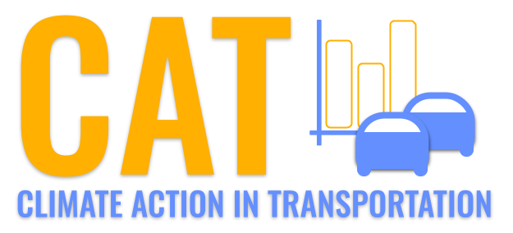 

**PM2.5 Emissions in Clark County, 2050**  
Made with CAT VISUALIZER by Gao Labs @ Cornell University.

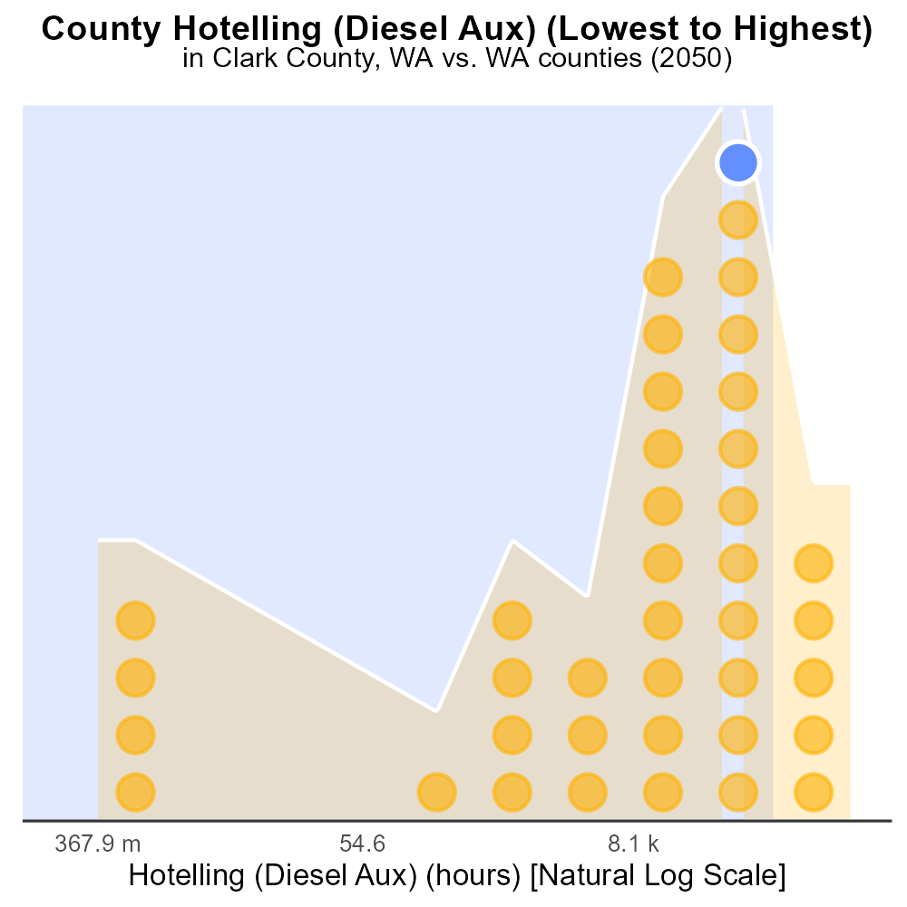

## Keywords

Primary Exhaust PM2.5; Total emissions; Clark County; on-road transportation; 2050; Washington

## Highlights

* Evaluating PM2.5 emissions from transportation in Clark County, WA by 2050.
* Impact of on-road transportation on air quality in the region.
* Assessment of primary exhaust sources and emission levels.
* Analysis of potential strategies to reduce PM2.5 emissions.
* Understanding future challenges and opportunities for air pollution control.

# Introduction

In this report, we delve into the assessment of Primary Exhaust PM2.5 emissions from on-road transportation in Clark County, Washington, projected for the year 2050. With a growing population and increased reliance on vehicles, understanding the impact of transportation on air quality is crucial for sustainable development. This study aims to analyze the total emissions of PM2.5 originating from primary exhaust sources in the region, providing insights into the level of pollution attributable to on-road vehicles.

The report will not only highlight the current state of air quality in Clark County but also explore potential strategies and interventions to mitigate the adverse effects of PM2.5 emissions. By identifying key sources and trends, we aim to offer recommendations for policymakers and stakeholders to promote cleaner transportation practices and enhance air quality for the future.

# Vehicle Starts by Vehicle Type

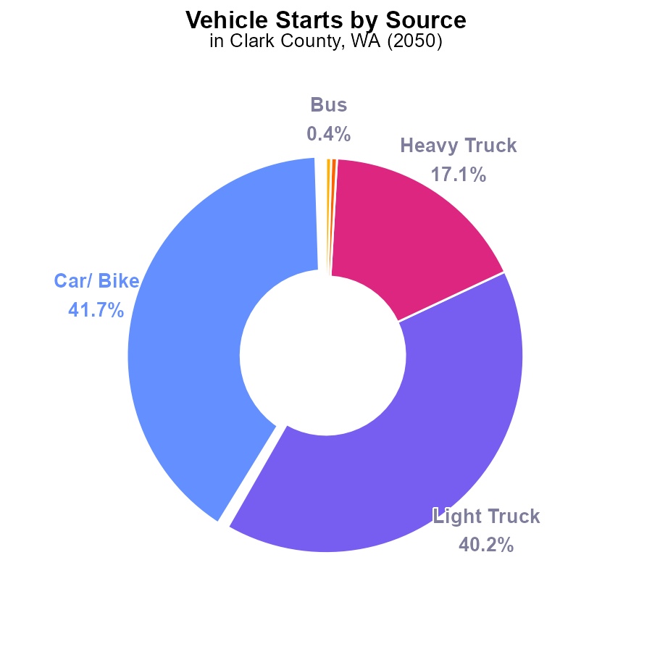

## Findings

* Cars and bikes contribute 41.7% of PM2.5 emissions from vehicle starts in Clark County in 2050.
* Heavy trucks are responsible for 17.1% of PM2.5 emissions.
* Buses and combo trucks combined contribute only 0.9% of the total PM2.5 emissions.

## Recommendations

To lower PM2.5 emissions, policies should focus on reducing emissions from cars and light trucks, which collectively contribute 81.9% of the pollution. Implementing stricter emissions standards for these vehicles can significantly decrease overall emissions.

# Idling by Vehicle Type

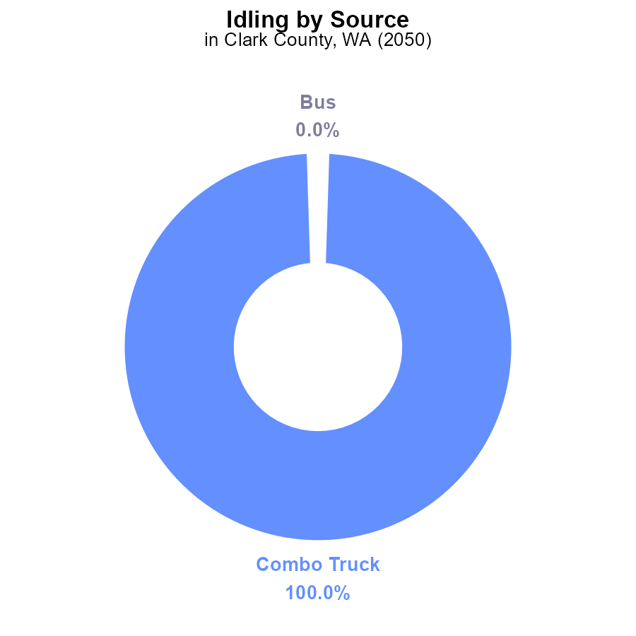

## Findings

* The majority (100%) of PM2.5 emissions in Clark County in 2050 from idling are from Combo Trucks (337.0 k hours).

## Recommendations

To reduce PM2.5 emissions, focus on minimizing idling time for Combo Trucks through incentivizing the use of idle-reduction technologies and enforcing anti-idling regulations.

# Hotelling (Engines Off) over Time for Passenger Vehicles

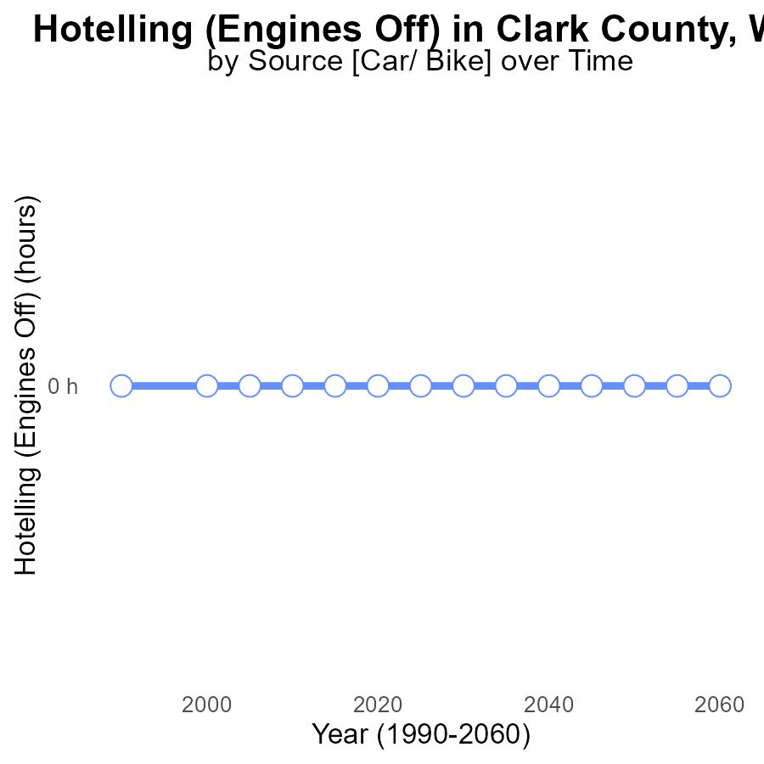

## Findings

* From 2030 to 2060, PM2.5 emissions from Hotelling (Engines Off) in Clark County, WA, are 0.0 hours annually.
* There has been no change in PM2.5 emissions over time, with a consistent benchmark difference of 0 hours.
* The data indicates a successful maintenance of zero PM2.5 emissions from Hotelling (Engines Off) in the area throughout the years 2030 to 2060.

## Recommendations

Given the consistent zero emissions from Hotelling (Engines Off), continue implementing and enforcing policies incentivizing this practice. Encourage the adoption of engine-off practices in other sectors to maintain the current low emission levels.

# Time Driven over Time for Passenger Time Driven

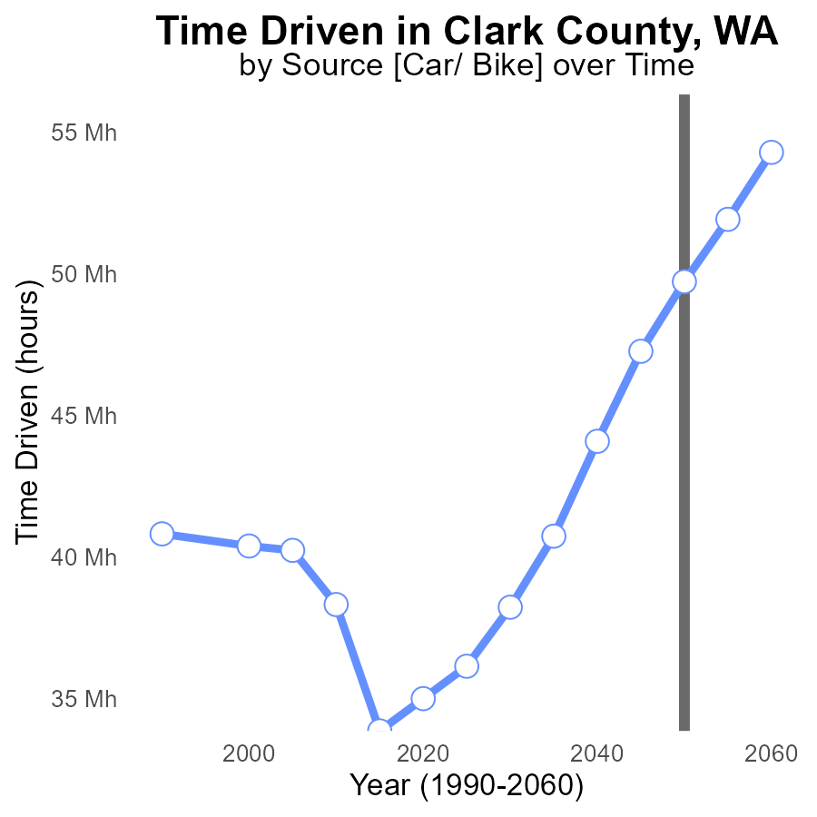

## Findings

* PM2.5 emissions in Clark County are projected to increase by 29% from 2030 to 2060.
* By 2050, emissions are expected to surpass 49.7 million hours, with a 31.8% difference from the benchmark.
* Between 2050 and 2060, there is a 9% reduction in PM2.5 emissions.

## Recommendations

To lower PM2.5 emissions in Clark County, immediate actions should focus on reducing transportation-related pollution by promoting electric vehicles and enhancing public transportation infrastructure. Additionally, enforcing stricter emission standards for industries will be crucial in achieving cleaner air quality.

# Vehicle Miles Traveled in My Region

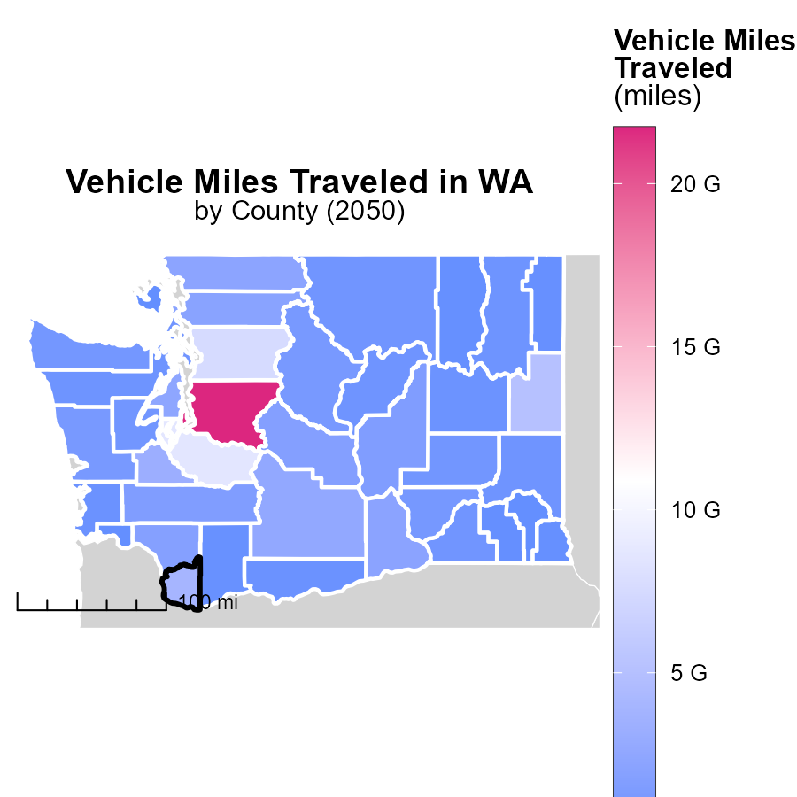

## Findings

* King County has the highest vehicle miles traveled with 21.7 billion miles.
* Mason County has a median of 781.9 million miles driven per year.
* San Juan County has the lowest vehicle miles traveled with 63.7 million miles.

## Recommendations

To lower emissions, measures like promoting public transport, carpooling, and cycling can be encouraged in high-traffic counties like King and Mason to reduce vehicle miles traveled.

# Hotelling (Engines Off) in My Region

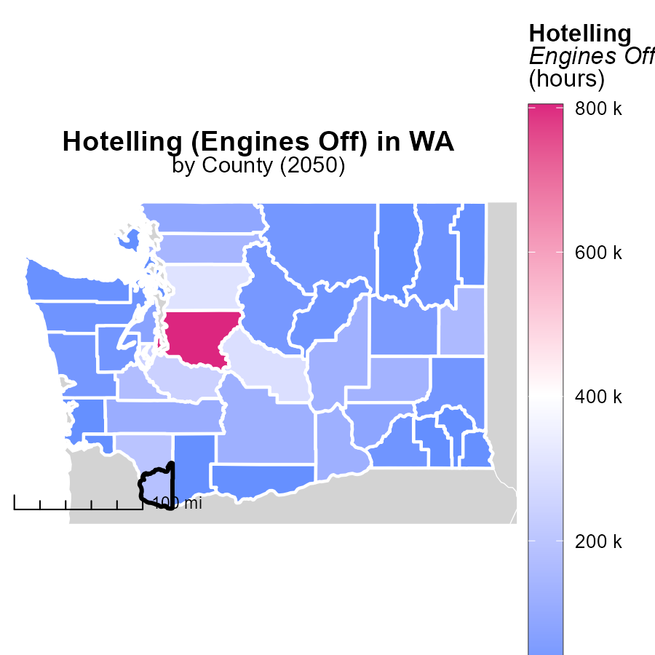

## Findings

* In King County, WA, the maximum emissions from idling engines were 804.0 k hours.
* Grays Harbor County, WA had a median of 32.1 k hours of emissions from idling engines.
* Wahkiakum County, WA had the lowest emissions from idling engines at 0.0 hours.

## Recommendations

To lower emissions, encourage implementing anti-idling policies, promoting the use of electric vehicles, and providing incentives for using alternative transportation methods.

# Time Driven by Road Type over Time

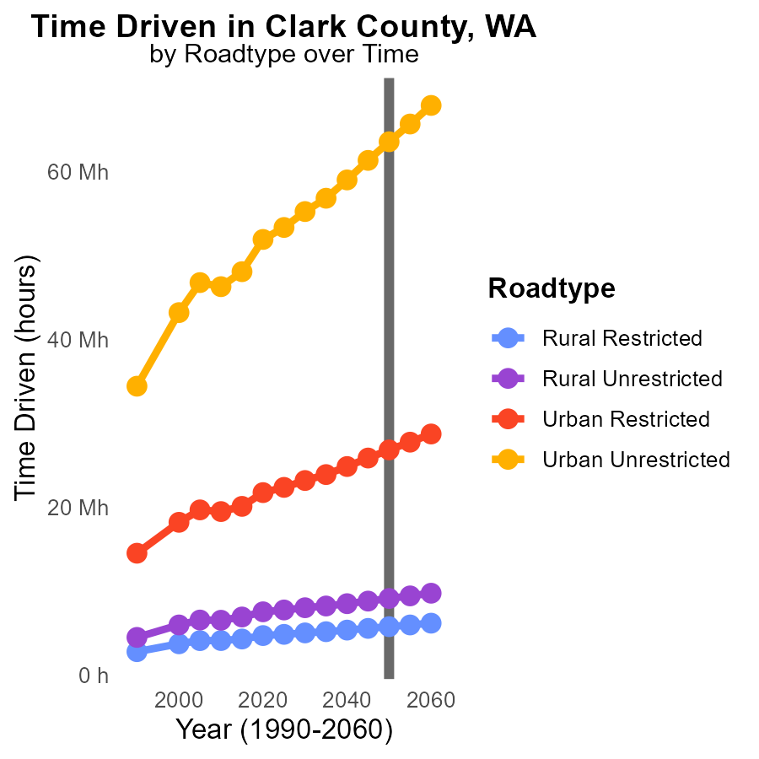

## Findings

* From 2040 to 2060, PM2.5 emissions are projected to increase for all road types in Clark County, WA.
* Rural Unrestricted roads show the highest emissions by 2060, with an increase of 67.9 million hours driven compared to 2050.
* Urban Restricted roads exhibit the most significant decrease in emissions, with a reduction of 1.9 million hours driven by 2060 from 2050 levels.

## Recommendations

To lower PM2.5 emissions, policy interventions should focus on transitioning to cleaner vehicle technologies, promoting public transportation, and implementing strategies to reduce traffic congestion, especially on Rural Unrestricted roads.

# Emissions Rate (per mile) by Road Type over Time

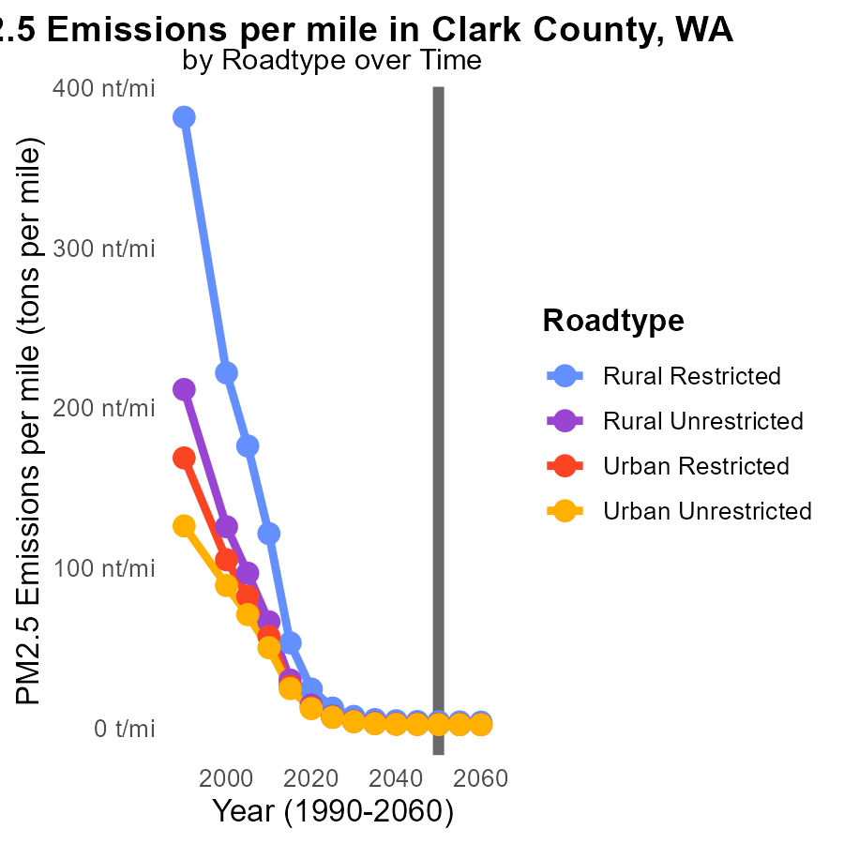

## Findings

* The PM2.5 emissions per mile are highest for Rural Restricted roads, with a decrease from 4.8 tons in 2040 to 3.9 tons in 2060.
* Urban Unrestricted roads have the lowest PM2.5 emissions per mile, ranging from 2.3 to 2.5 tons from 2040 to 2060.
* Overall, there is a consistent reduction in PM2.5 emissions per mile across road types from 2040 to 2060.

## Recommendations

To further reduce PM2.5 emissions, focus should be placed on transitioning to cleaner fuel sources for vehicles, implementing stricter emission standards, and promoting public transportation and carpooling to decrease the number of vehicles on the road.

# Areas Ranked by Hotelling (Engines Off)

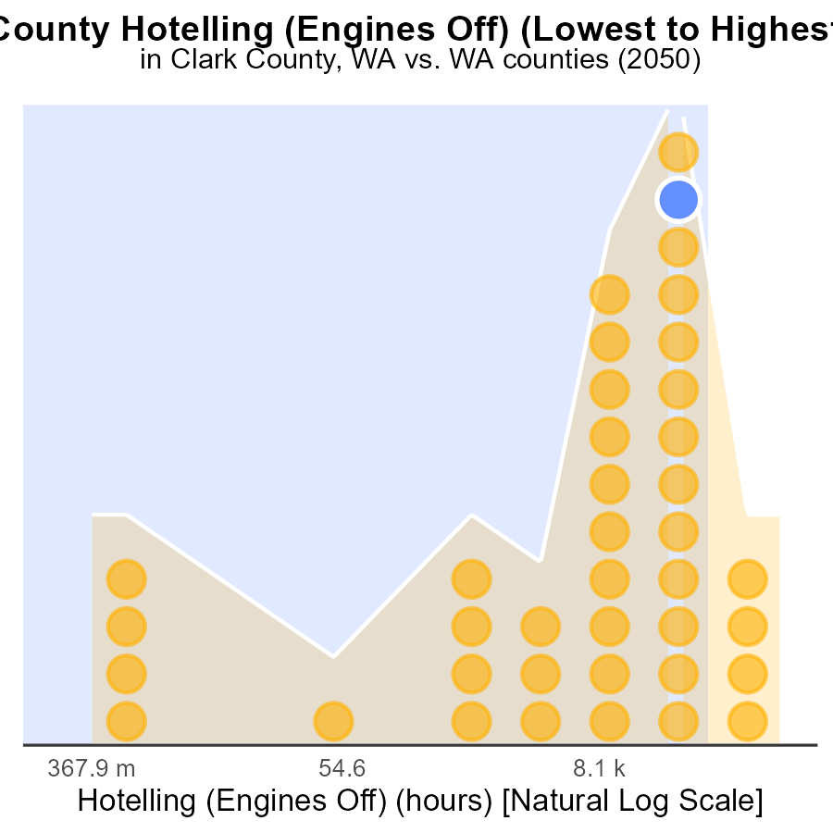

## Findings

* King county has the highest PM2.5 emissions with 804.0k hours.
* Columbia county has the lowest emissions with 0.0 hours.
* Overall, the counties have high percentiles of engine-off emissions, surpassing 80%.

## Recommendations

To lower PM2.5 emissions, encourage engine-off practices and promote the use of cleaner energy sources in these counties to reduce emissions and improve air quality.

# Areas Ranked by Hotelling (Diesel Aux)

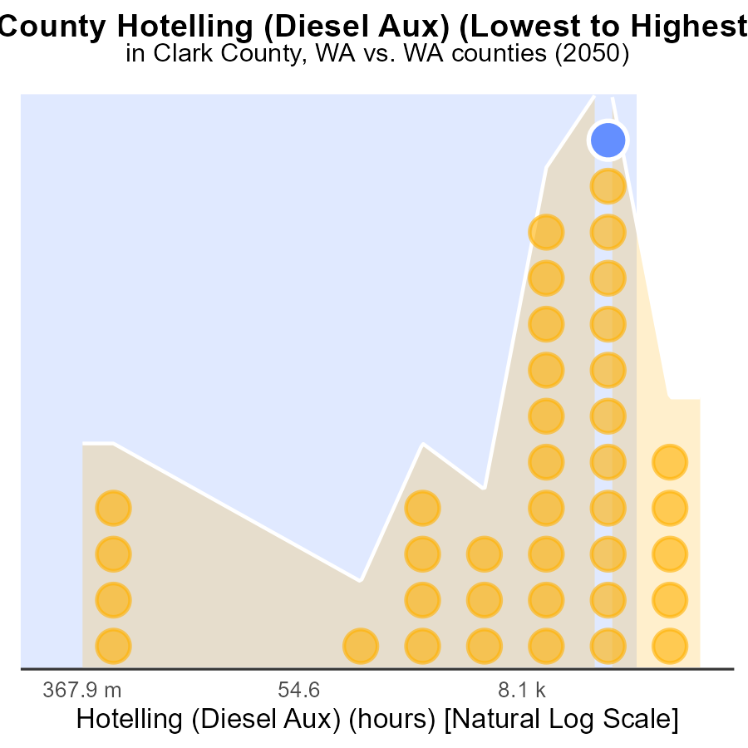

## Findings

* King county has the highest PM2.5 emissions at 1.3 million hours.
* Columbia county has the lowest PM2.5 emissions at 0.0 hours.
* The majority of counties have emissions above the 80th percentile, with Clark county at 87.2%, Thurston at 84.6%, and Cowlitz at 89.7%.

## Recommendations

To lower emissions, actions must focus on high-emitting counties, especially King, Clark, Thurston, and Cowlitz. Implement stricter regulations and incentivize cleaner energy sources to reduce PM2.5 levels.

# Conclusion

In conclusion, the data analysis of Primary Exhaust PM2.5 emissions from on-road transportation in Clark County, WA in 2050 reveals some critical insights. The majority of PM2.5 emissions are attributed to cars and light trucks, indicating a significant area for emissions reduction through the implementation of stricter standards for these vehicles. Combating idling emissions from Combo Trucks is also crucial, with all idling emissions coming from this category. It is commendable that there have been consistent zero PM2.5 emissions from Hotelling (Engines Off) in the area from 2030 to 2060, showcasing successful maintenance of clean air practices.

Looking ahead, the projected increase in PM2.5 emissions underscores the urgent need for immediate actions to promote cleaner transportation methods like electric vehicles and enhance public transportation infrastructure. Furthermore, the data highlights the importance of addressing high-traffic counties like King, Clark, Thurston, and Cowlitz to bring down emissions levels. By enforcing stricter regulations and encouraging the adoption of cleaner energy sources, significant progress can be made towards reducing PM2.5 pollution and improving air quality in the region.

# About This Report

Data based on MOVES estimates collected by the Climate Action in Transportation program at Cornell University. Demographic data sourced from the US Census's American Community Survey 5-year estimates. This report was generated with the help of AI.

# References

* U.S. Census Bureau. (2023). American Community Survey 5-year estimates: Detailed tables. Retrieved from https://data.census.gov
* U.S. Environmental Protection Agency. (2024). Motor Vehicle Emission Simulator (MOVES 4.0) [Software]. Retrieved from https://www.epa.gov/moves