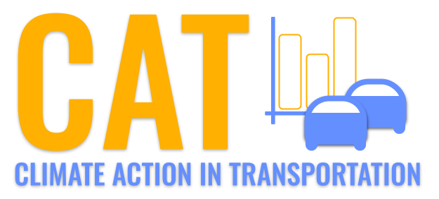 

**NOx Emissions in Covington city, Virginia County, 2015**  
Made with CAT VISUALIZER by Gao Labs @ Cornell University.

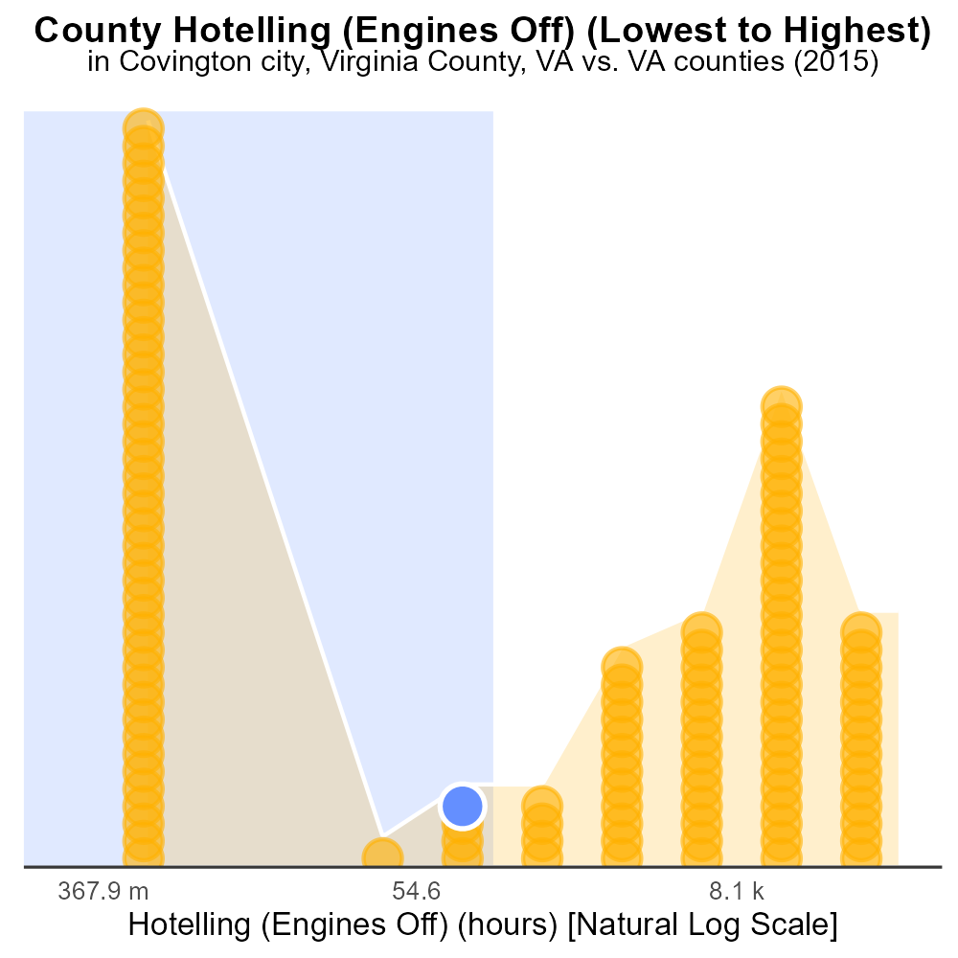

## Keywords

Oxides of Nitrogen; NOx emissions; on-road transportation; Covington city; Virginia County; 2015

## Highlights

* NOx emissions from on-road transportation impact Covington city, VA in 2015.
* Understanding the levels and sources of NOx emissions is crucial for environmental planning.
* Transportation sector is a significant contributor to NOx pollution in urban areas.
* Increasing concern over air quality has put a spotlight on NOx emissions.
* Evaluating NOx levels in Covington city can provide insights for targeted interventions.

# Introduction

Oxides of Nitrogen (NOx) emissions from on-road transportation have been a growing concern in urban areas like Covington city, located in Virginia County, VA. In the year 2015, these emissions posed a significant challenge to local air quality and public health. Understanding the sources, levels, and impacts of NOx in this region is crucial for effective environmental planning and management. The transportation sector, including vehicles such as cars, trucks, and buses, is a major contributor to NOx pollution in urban settings.

The increasing concern over air quality and its implications for human health and the environment has put a spotlight on NOx emissions. Therefore, evaluating the NOx levels specifically in Covington city during the year 2015 can provide valuable insights for implementing targeted interventions and strategies to mitigate the harmful effects of these pollutants on the local population and ecosystem.

# Emissions Rate (per vehicle) by Road Type

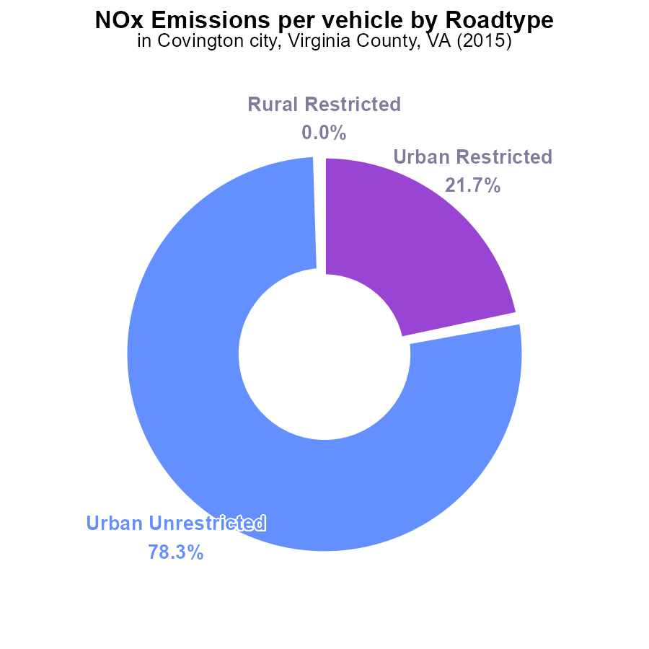

## Findings

* The majority of NOx emissions in Covington city, VA in 2015 are from Urban Unrestricted vehicles (78.3%).
* Urban Restricted vehicles contribute to 21.7% of NOx emissions.
* Rural areas in Covington city, VA did not contribute to NOx emissions in 2015.

## Recommendations

To lower NOx emissions in Covington city, VA, policies should focus on reducing emissions from Urban Unrestricted vehicles, which are the primary source. Implementing vehicle emission standards and promoting public transportation can help decrease emissions from these vehicles.

# Time Driven Overall by Area

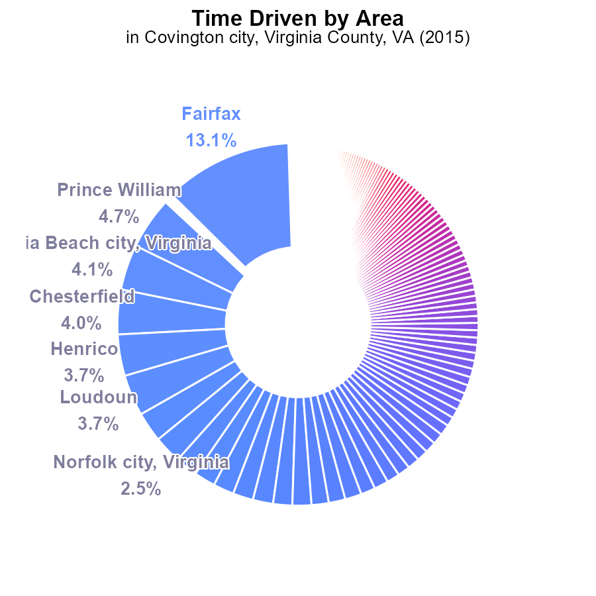

## Findings

* Top NOx emitters in Covington city, VA in 2015 were Fairfax, Prince William, and Virginia Beach.
* Fairfax contributed the highest at 13.1%, followed by Prince William at 4.7% and Virginia Beach at 4.1%.
* Smaller contributors included Lexington city, VA (0.0%), Buena Vista city, VA (0.0%), and Highland (0.0%).

## Recommendations

To reduce NOx emissions, pinpoint major contributors like Fairfax and implement targeted emission reduction strategies. Encourage smaller emitters to adopt cleaner technologies through incentives and regulations.

# Emissions Rate (per mile) over Time for Buses

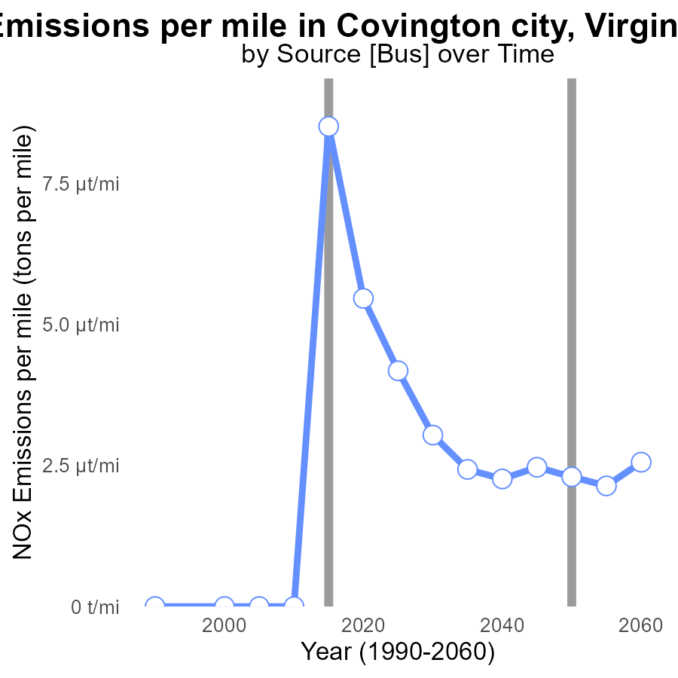

## Findings

* NOx emissions per mile in Covington have decreased from 26.8 µ tons in 2000 to 2.4 µ tons in 2035.
* There has been a consistent reduction in emissions per mile over the years, with a total decrease of 24.4 µ tons.
* The benchmark difference has improved by magnitudes, showing significant progress in lowering emissions per mile.

## Recommendations

To continue the downward trend in emissions, Covington should prioritize expanding public transportation, promoting vehicle electrification, and implementing stricter emission standards for industries.

# Population Overall over Time

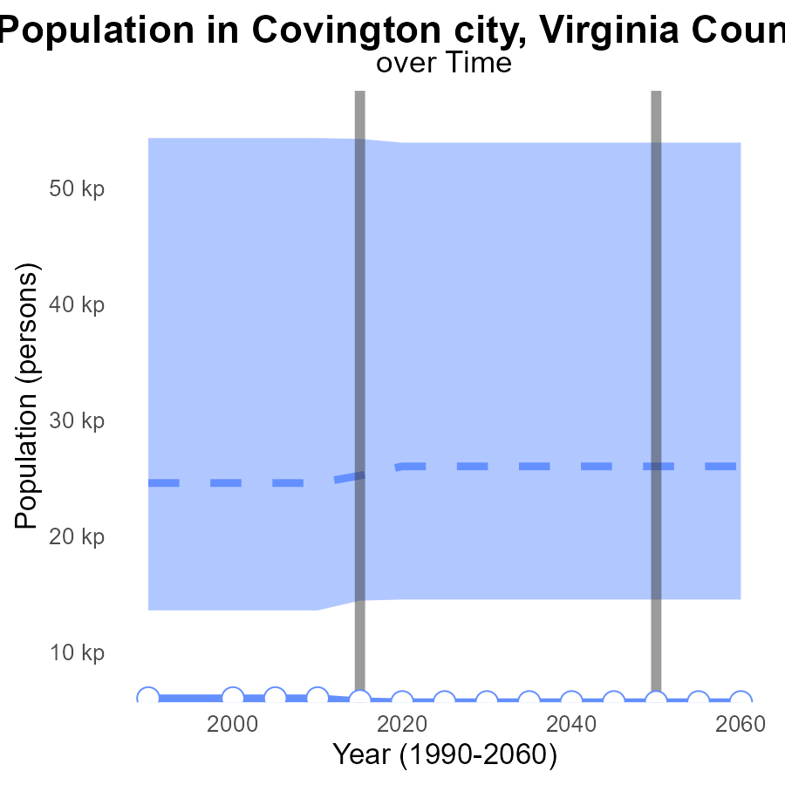

## Findings

* NOx emissions in Covington city decreased by 5% from 2000 to 2015.
* Between 2015 and 2020, NOx emissions remained constant.
* The benchmark difference for NOx emissions in 2025-2035 is 0, indicating no improvement.

## Recommendations

To further reduce NOx emissions, consider investing in cleaner transportation methods and enforcing stricter emission standards for industries in Covington city. Monitoring mechanisms should be put in place to ensure compliance.

# Emissions Rate (per vehicle) in My Region

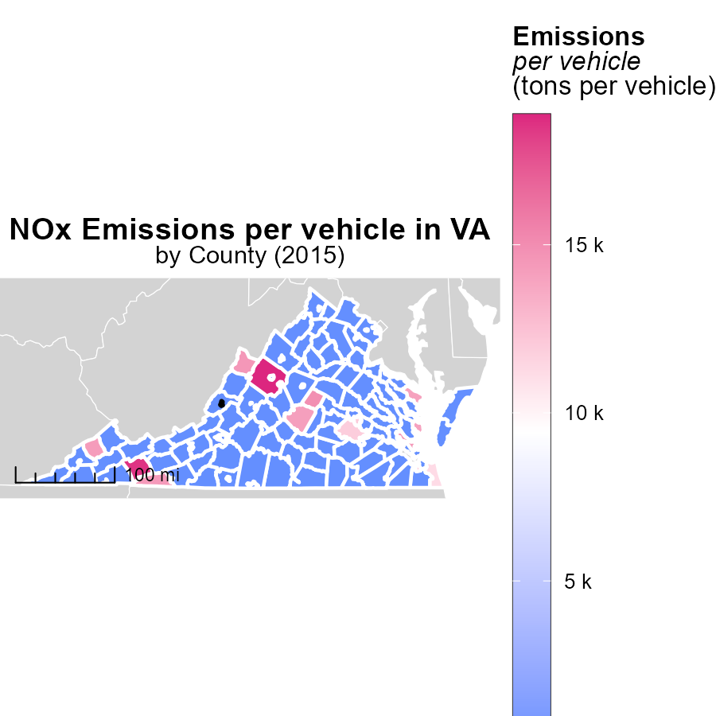

## Findings

* Augusta County, VA had the highest emissions per vehicle at 18.9 tons per vehicle.
* Lee County, VA had median emissions per vehicle at 15.5 tons per vehicle.
* Manassas city, Virginia County, VA had the lowest emissions per vehicle at 11.0 tons per vehicle.

## Recommendations

To decrease emissions, focus on high emitting areas like Augusta County by introducing stricter vehicle emissions standards and promoting electric vehicles. Implement community programs to raise awareness and incentivize eco-friendly modes of transportation.

# Hotelling (Engines Off) in My Region

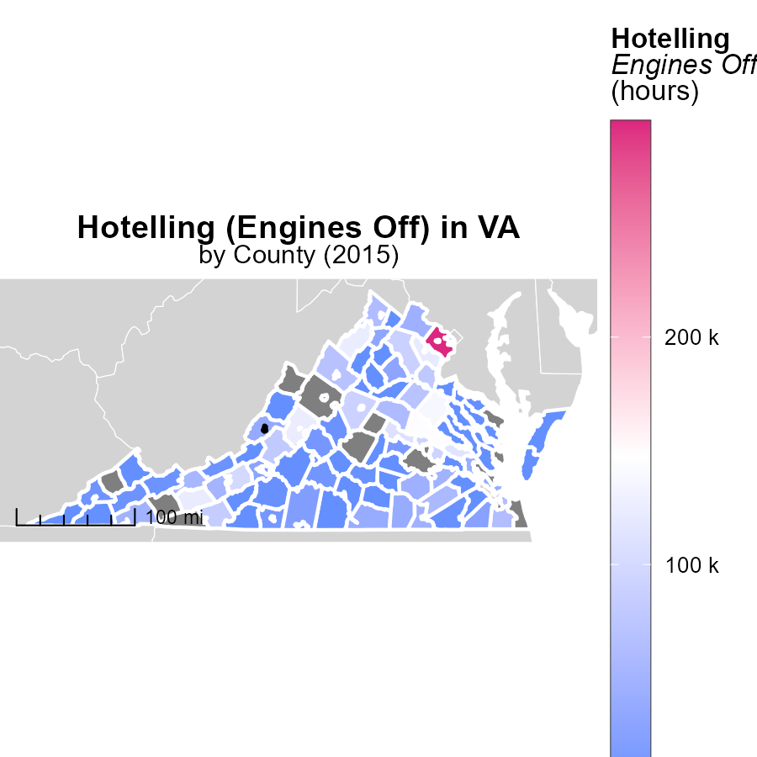

## Findings

* The maximum hotelling emissions in Fairfax County, VA in 2015 were 294.9 kilo hours.
* The median hotelling emissions in Norton city, VA in 2015 were 1.3 kilo hours.
* Virginia Beach had the lowest hotelling emissions in 2015 as the data is not available.

## Recommendations

To reduce hotelling emissions, jurisdictions can implement policies to promote engine-off practices during idle times, conduct awareness campaigns, and provide incentives for using alternative transportation methods.

# Vehicles by Road Type over Time

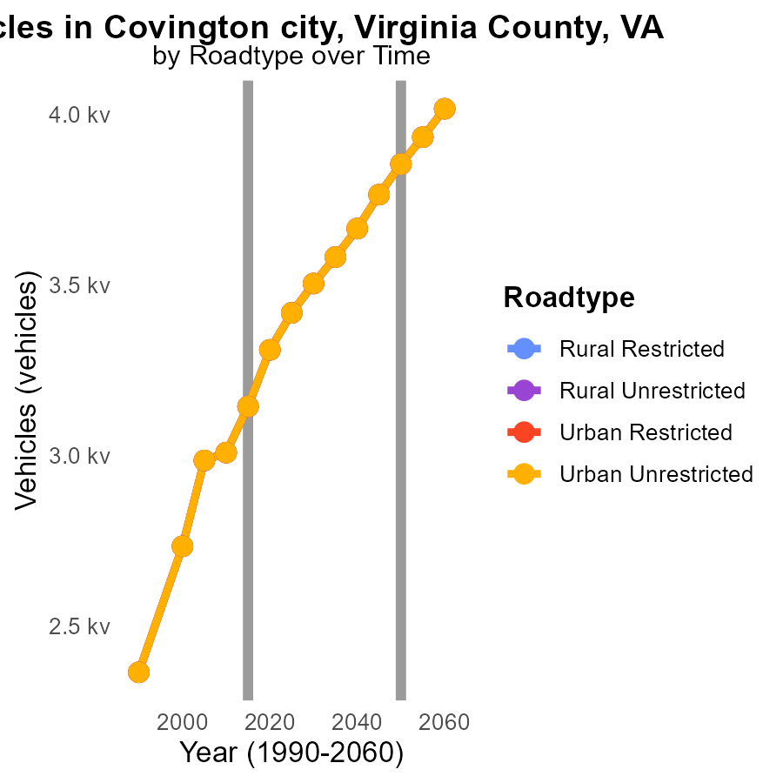

## Findings

* NOx emissions have consistently decreased from 2005 to 2025 in Covington city, VA across all road types.
* The highest NOx emissions in 2025 are from Urban Unrestricted roads with 3.4k, a percentage decrease of 20.6% from 2005.
* Rural Restricted roads show a 31.3% emission decrease in NOx from 2005 to 2025, with levels at 3.4k in 2025.

## Recommendations

To further reduce NOx emissions, policymakers should invest in promoting alternative transportation modes, implementing stricter vehicle emission standards, and enhancing public transportation infrastructure.

# Idling by Regulatory Class over Time

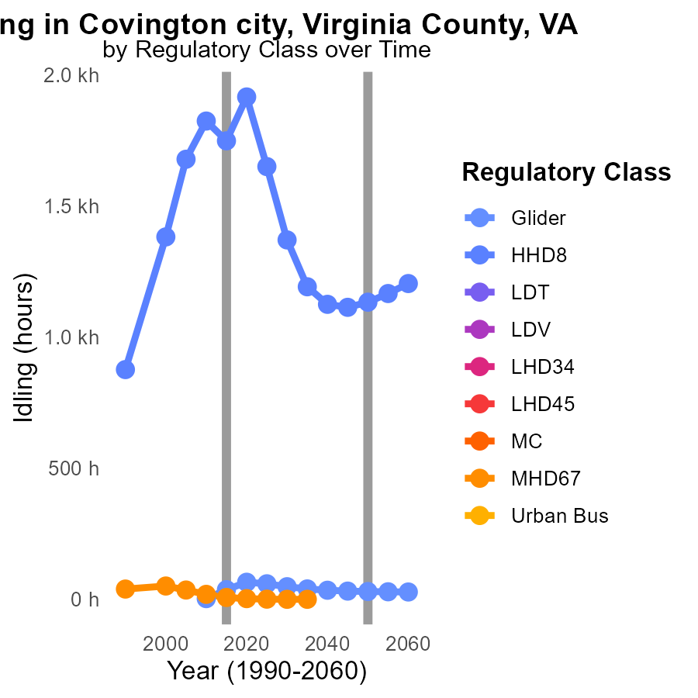

## Findings

* NOx emissions from Glider vehicles decreased by an average of 25% from 2010 to 2025.
* HHD8 vehicles showed a significant decrease of NOx emissions from 2005 to 2025 by approximately 550 units.
* Other vehicle types, such as LDT, LDV, and MC, did not have data available for NOx emissions from 2005 to 2025.

## Recommendations

To further reduce NOx emissions in Covington City, focus on promoting the adoption of vehicles with decreasing NOx emissions like Gliders and HHD8. Implement stricter regulations for vehicles producing higher levels of NOx to ensure a consistent decline in emissions.

# Areas Ranked by Vehicle Starts

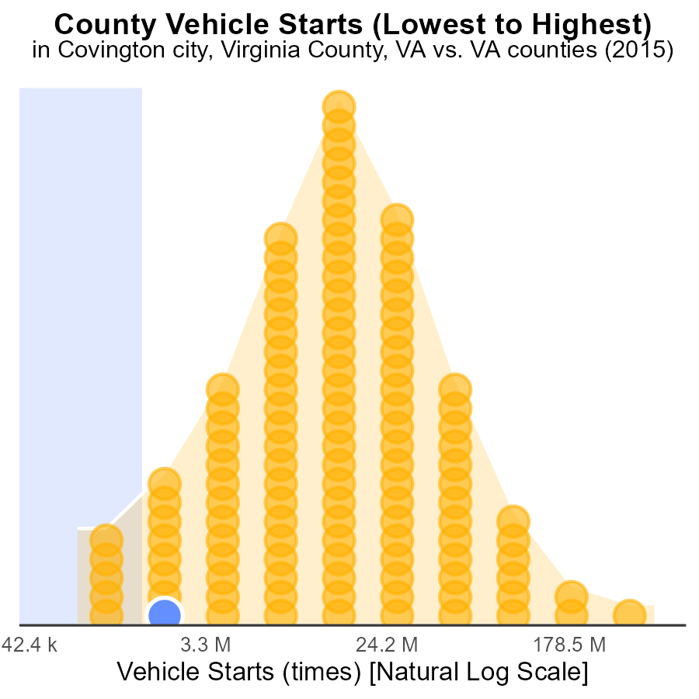

## Findings

* Covington city, Virginia had 4.4 million vehicle starts in 2015
* Norton city, Virginia had the highest percentage of vehicle starts for NOx emissions at 5.9%
* Craig had 3.8 million vehicle starts and ranked 5th in NOx emissions

## Recommendations

To lower NOx emissions, consider implementing vehicle start reduction programs in areas with high vehicle start numbers and percentages. Encouraging carpooling, using public transportation, and promoting electric vehicles can also help reduce emissions.

# Areas Ranked by Hotelling (Engines Off)

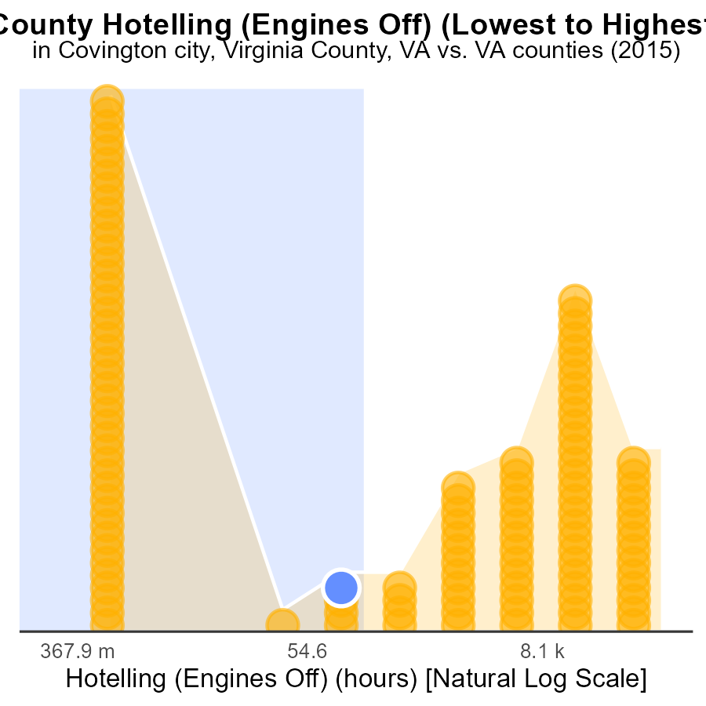

## Findings

* Covington city, Virginia had the highest NOx emissions at 469.2 hours.
* Salem city, Virginia had the lowest NOx emissions at 556.4 hours.
* NOx emissions percentile ranged from 39.5% to 41.2% among the counties.

## Recommendations

To lower NOx emissions, Covington city, Virginia could explore engine retrofitting technologies, while Salem city, Virginia should monitor and maintain existing engines. All counties should consider implementing emission control measures.

# Conclusion

In conclusion, the analysis of NOx emissions from on-road transportation in Covington city, Virginia County, VA in 2015 reveals several key insights that can inform targeted strategies for emission reduction.

The data indicates that Urban Unrestricted vehicles are the primary source of NOx emissions in the area, with a significant majority contribution of 78.3%. Efforts to lower NOx emissions should, therefore, focus on implementing emission standards and promoting public transportation for these vehicles. Additionally, identifying major emitters like Fairfax and introducing tailored reduction strategies can lead to substantial improvements. While NOx emissions per mile have shown a consistent decrease, the stagnation in emissions from 2015 to 2020 calls for renewed efforts, including expanding public transportation and enforcing stricter industry standards.

To further drive down emissions, targeted measures such as stricter vehicle emission standards, promoting electric vehicles, and incentivizing eco-friendly transportation modes can be adopted. By prioritizing emission reduction strategies for high-emitting areas like Augusta County, coupled with community programs and awareness campaigns, significant progress can be made in achieving cleaner air quality in Covington city, Virginia County, VA.

# About This Report

Data based on MOVES estimates collected by the Climate Action in Transportation program at Cornell University. Demographic data sourced from the US Census's American Community Survey 5-year estimates. This report was generated with the help of AI.

# References

* U.S. Census Bureau. (2023). American Community Survey 5-year estimates: Detailed tables. Retrieved from https://data.census.gov
* U.S. Environmental Protection Agency. (2024). Motor Vehicle Emission Simulator (MOVES 4.0) [Software]. Retrieved from https://www.epa.gov/moves