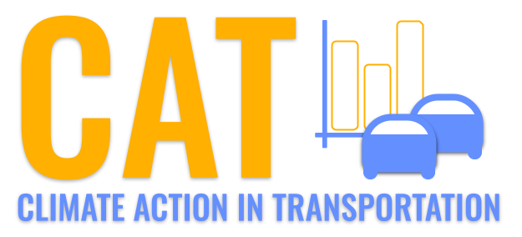 

**PM10 Emissions in Grand Traverse County, 2040**  
Made with CAT VISUALIZER by Gao Labs @ Cornell University.

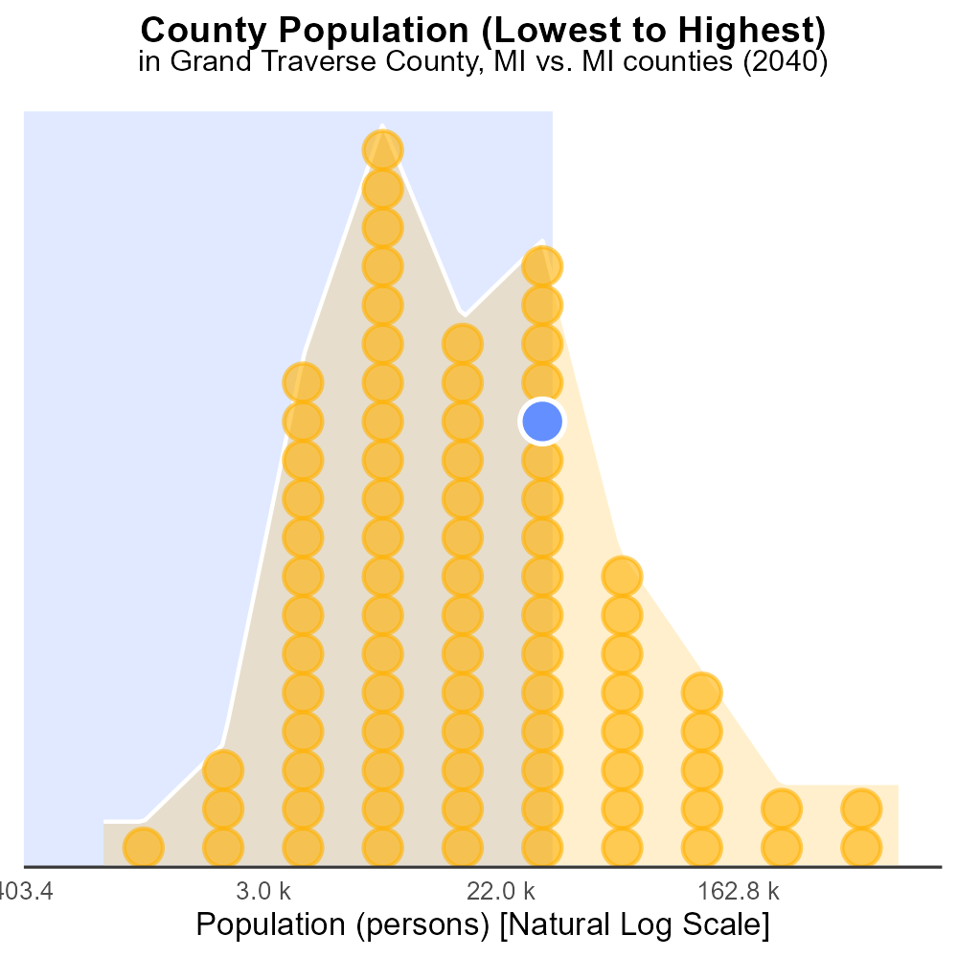

## Keywords

Primary Exhaust PM10; Total Emissions; On-Road Transportation; Grand Traverse County; 2040

## Highlights

* Analysis of PM10 emissions from transportation in Grand Traverse County.
* Focus on primary exhaust sources and total emissions for 2040.
* Implications for air quality and public health in the county.
* Assessment of trends and projections for on-road transportation.
* Recommendations for mitigation strategies and policy interventions.

# Introduction

The following report provides an in-depth analysis of Primary Exhaust PM10 emissions originating from on-road transportation in Grand Traverse County, Michigan, projected for the year 2040. This study focuses on understanding the sources and magnitude of total emissions, aiming to assess their impact on local air quality and public health. By examining trends and making projections, this report offers valuable insights into the future of transportation-related pollution in the county.

Furthermore, the report delves into the implications of the findings and presents recommendations for implementing effective mitigation strategies and policy interventions to combat the anticipated rise in emissions. The information contained herein serves as a crucial resource for stakeholders and decision-makers seeking to address environmental challenges associated with on-road transportation in Grand Traverse County.

# Hotelling (Engines Off) by Vehicle Type

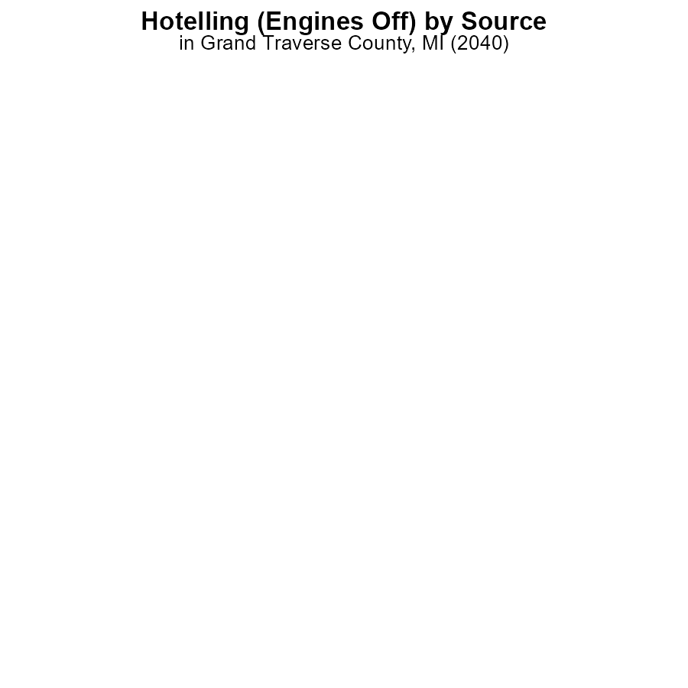

## Findings

* No PM10 emissions were reported from Bus, Car/Bike, Combo Truck, Heavy Truck, or Light Truck in Grand Traverse County, MI for 2040 while idling with engines off.

## Recommendations

To maintain PM10 emissions at zero levels for vehicles idling with engines off, continue monitoring and enforcing idling regulations. Consider incentivizing the adoption of cleaner vehicle technologies.

# Idling by Regulatory Class

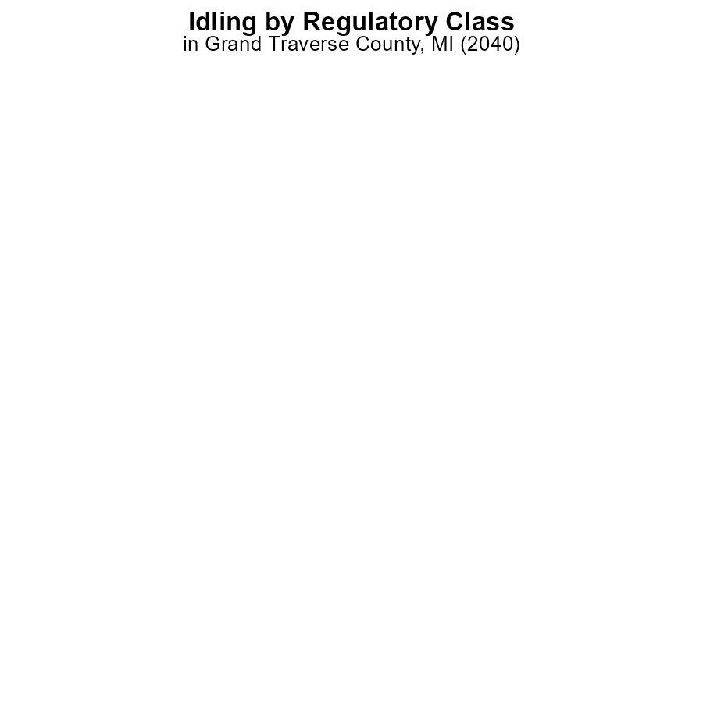

## Findings

* There were no emissions of PM10 from gliders, HHD8, and urban buses due to idling by 2040 in Grand Traverse County, MI.
* There was no data available for LDT, LDV, LHD34, LHD45, MC, and MHD67 regarding emissions of PM10 due to idling by 2040 in Grand Traverse County, MI.

## Recommendations

To further reduce emissions, focus on monitoring and regulating idling in vehicle types with missing data. Encourage the use of cleaner technologies to eliminate PM10 emissions.

# Vehicle Miles Traveled over Time for Passenger Vehicles

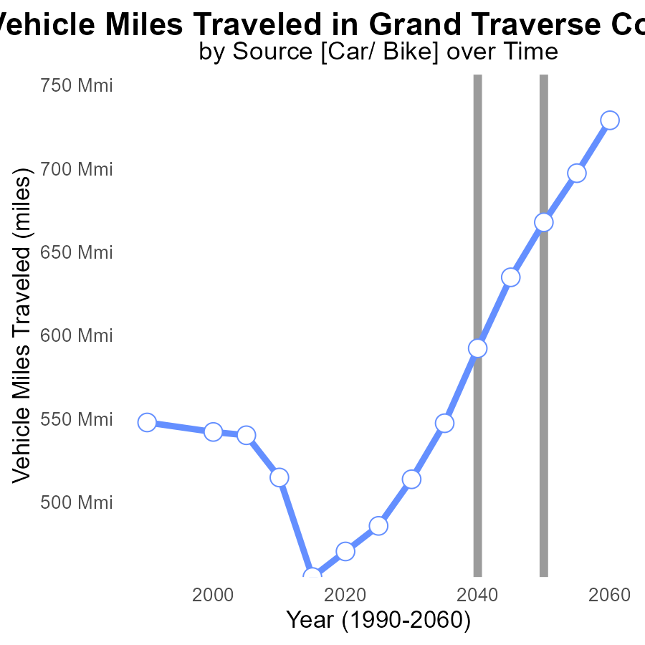

## Findings

* Vehicle miles traveled in Grand Traverse County, MI are projected to increase by 41.2% from 2020 to 2060.
* Emissions are expected to reduce steadily over the years, with the largest drop of 23.6% between 2045 and 2050.
* Benchmark differences indicate a decreasing trend, with the most significant improvement seen from 2040 to 2060.

## Recommendations

To lower PM10 emissions in Grand Traverse County, MI, strategies should focus on reducing vehicle miles traveled. Encouraging the use of public transportation, promoting carpooling, advocating for remote work policies, and investing in infrastructure to support walking and cycling can all contribute to decreasing emissions.

# Vehicle Miles Traveled Overall over Time

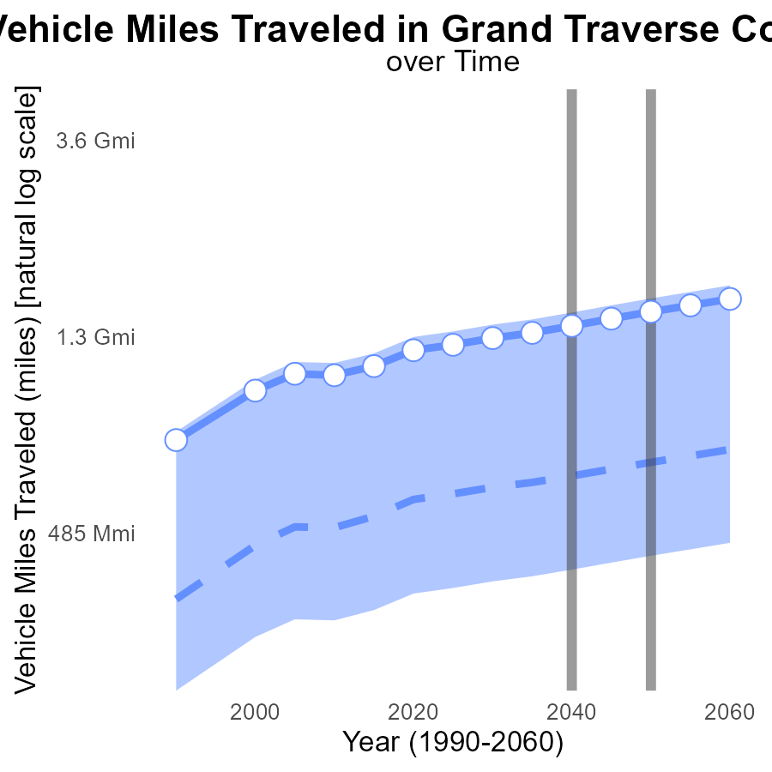

## Findings

* Emissions from vehicle miles traveled in Grand Traverse County are consistently increasing over the years.
* The benchmark difference decreases over time, with a significant drop between 2040 and 2050.
* Upper 75th percentile of vehicle miles traveled in 2055 is 165% of the median value in 2055.

## Recommendations

To lower emissions, policy measures such as promoting public transportation, carpooling, and adopting electric vehicles should be implemented. Additionally, investing in infrastructure for biking and walking can reduce the dependency on vehicles.

# Vehicle Starts in My Region

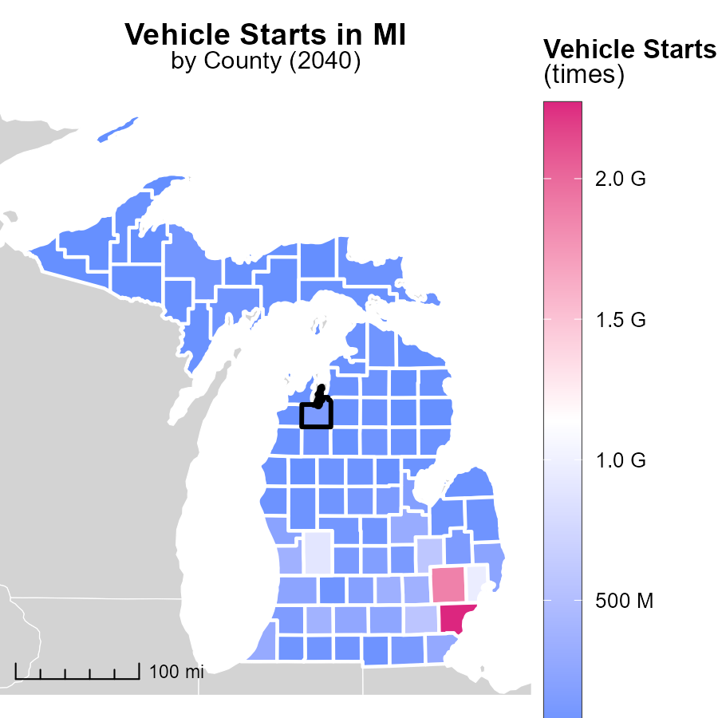

## Findings

* Barry County has the highest number of vehicle starts with 62.4 million.
* Wayne County has 2.3 billion vehicle starts, the maximum among the counties.
* Keweenaw County has the lowest vehicle starts with 7.5 million.

## Recommendations

To lower emissions, focus on implementing electric vehicle incentives in Barry County due to the high number of vehicle starts. Explore public transportation options in Wayne County to reduce the impact of the large number of vehicle starts. Promote carpooling initiatives in Keweenaw County to decrease emissions from vehicles.

# Idling Mapped by Area

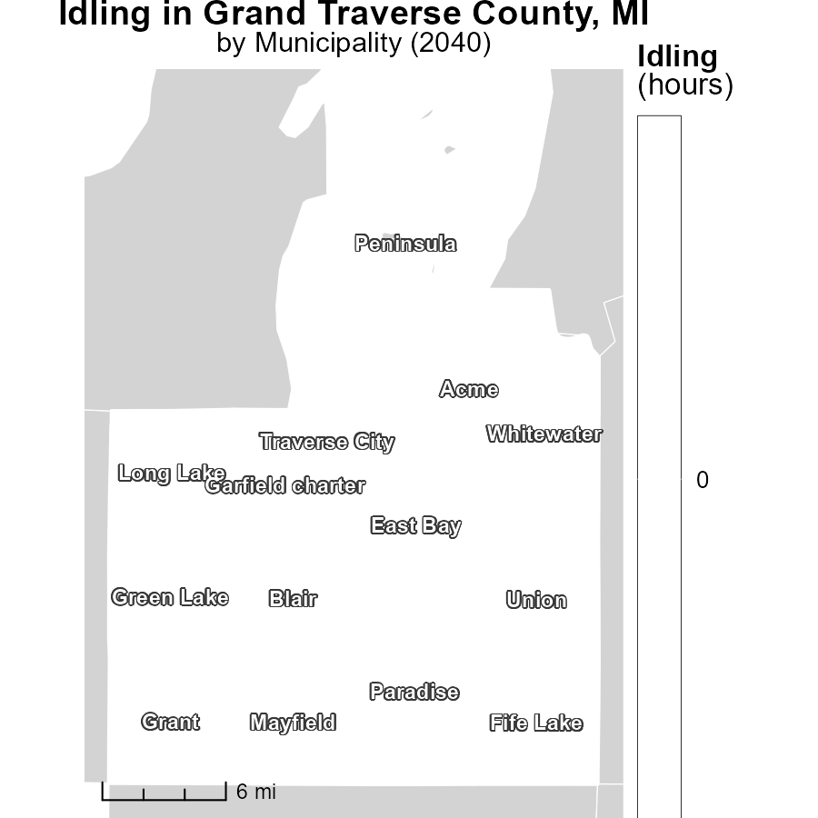

## Findings

* The maximum idling hours in ..., MI in 2040 is 0.0 hours.
* The median idling hours in Green Lake, MI in 2040 is 0.0 hours.
* The minimum idling hours in Whitewater, MI in 2040 is 0.0 hours.

## Recommendations

To lower emissions from idling, encourage policies promoting the use of idle-reduction technologies. Implement educational campaigns to raise awareness about the environmental impacts of idling.

# Emissions Rate (per vehicle) by Regulatory Class over Time

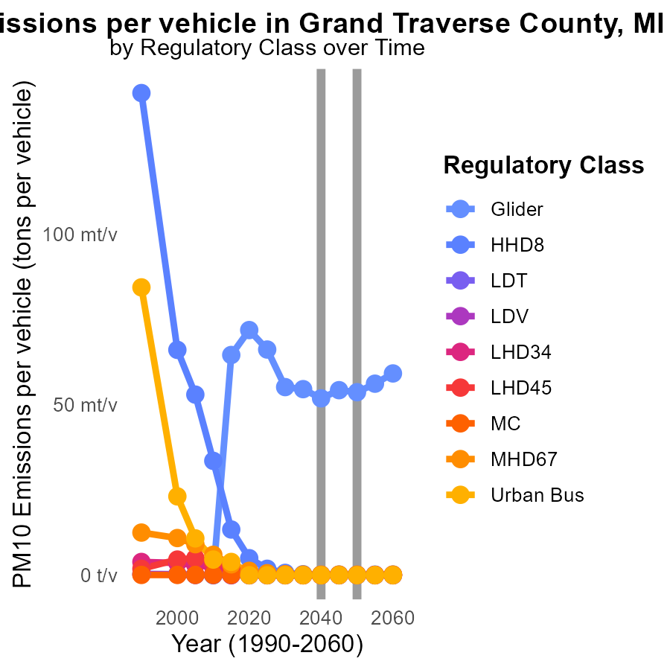

## Findings

* Emissions for PM10 are decreasing over the years for all vehicle types.
* The largest decrease in emissions by 2050 is seen in the Glider category, with a reduction of 0.0015 tons per vehicle compared to 2030.
* Urban Bus emissions remain consistently at 0.0 tons per vehicle from 2030 to 2050.

## Recommendations

To further reduce emissions, focus on technological advancements and regulatory measures to achieve continual decreases like those seen in the Glider category. Consider promoting the transition to cleaner fuel types for all vehicles.

# Vehicles by Fuel Type over Time

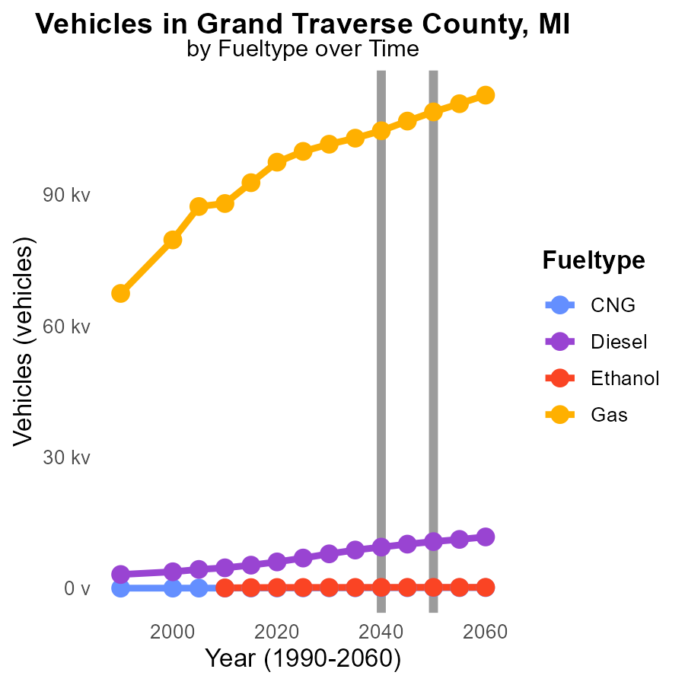

## Findings

* By 2050, CNG emissions from vehicles are projected to decrease by about 40% compared to 2030 levels.
* Diesel emissions are expected to decrease by 577.5 units from 2045 to 2050, a 5.4% reduction.
* Gas vehicles are forecasted to decrease emissions by 7392.5 units from 2030 to 2050, a reduction of approximately 7%.

## Recommendations

To lower emissions further, consider promoting the use of CNG vehicles due to their significant reduction potential. Encouraging the transition to cleaner fuel types like Ethanol can help cut emissions significantly. Additionally, incentivize the shift from Gas to alternative fuels to achieve substantial emissions reductions.

# Areas Ranked by Vehicles

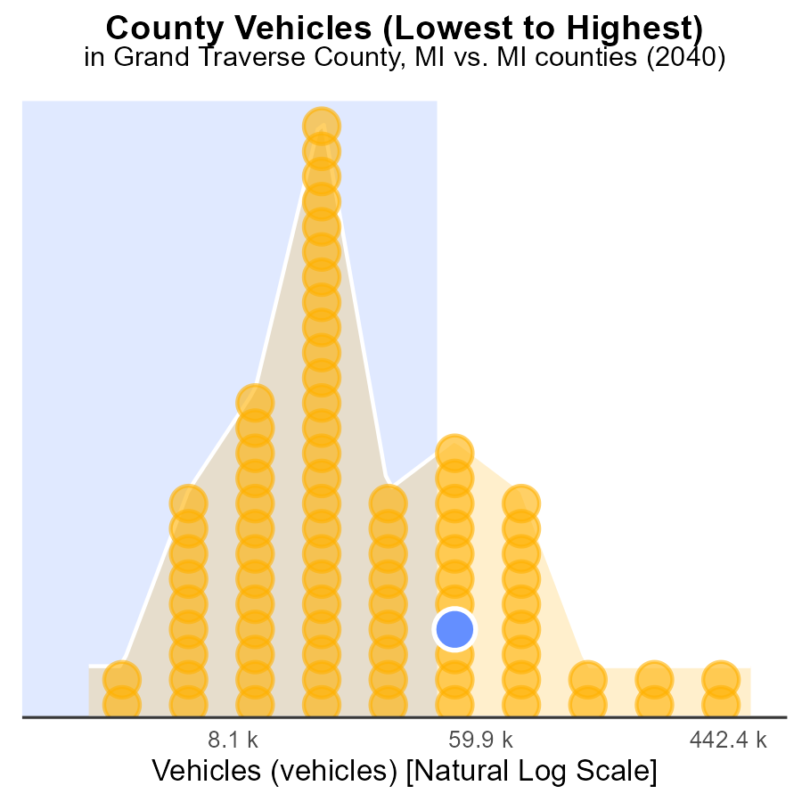

## Findings

* Wayne county has the highest number of vehicles emitting PM10, with 1.5 million vehicles.
* Keweenaw county has the lowest number of vehicles emitting PM10, with only 6.8 thousand vehicles.
* Lapeer county has the highest percentile of vehicles emitting PM10 at 74.7%.

## Recommendations

To reduce emissions, incentivize Wayne county to promote public transportation and carpooling options to reduce vehicle usage, prioritize stricter vehicle emission standards, and invest in electric vehicle infrastructure.

# Areas Ranked by Population

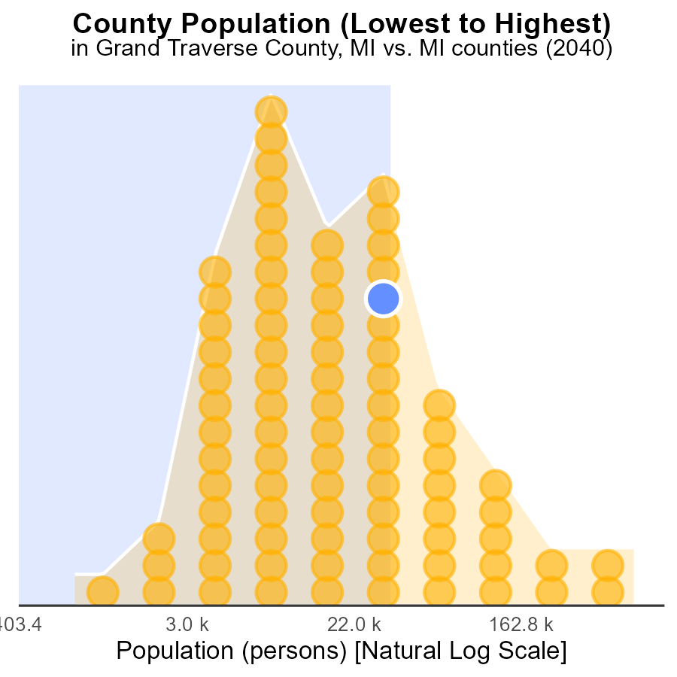

## Findings

* Grand Traverse County has 92.6 thousand people with PM10 emissions, ranking 124th, contributing to 74.7% of the total.
* Keweenaw County has 2.1 thousand people with PM10 emissions, ranking 2nd, contributing to 1.2% of the total.
* Wayne County has 1.8 million people with PM10 emissions, ranking 166th, contributing to 100% of the total.

## Recommendations

To reduce emissions in Grand Traverse, investing in sustainable transportation and enforcing air quality standards should be considered. Encouraging the use of electric vehicles can also help.

In Keweenaw, implementing strict regulations on industrial emissions and promoting clean energy initiatives are essential to lower pollution levels significantly.

Wayne should focus on enhancing public transportation systems and promoting green urban planning to curb emissions effectively. Implementing policies to reduce traffic congestion can also aid in lowering pollution levels.

# About This Report

Data based on MOVES estimates collected by the Climate Action in Transportation program at Cornell University. Demographic data sourced from the US Census's American Community Survey 5-year estimates. This report was generated with the help of AI.

# References

* U.S. Census Bureau. (2023). American Community Survey 5-year estimates: Detailed tables. Retrieved from https://data.census.gov
* U.S. Environmental Protection Agency. (2024). Motor Vehicle Emission Simulator (MOVES 4.0) [Software]. Retrieved from https://www.epa.gov/moves