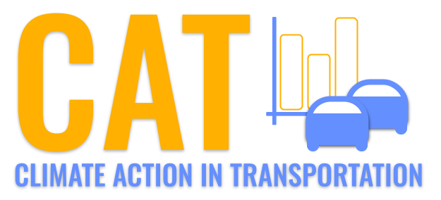 

**SO2 Emissions in Leavenworth County, 2045**  
Made with CAT VISUALIZER by Gao Labs @ Cornell University.

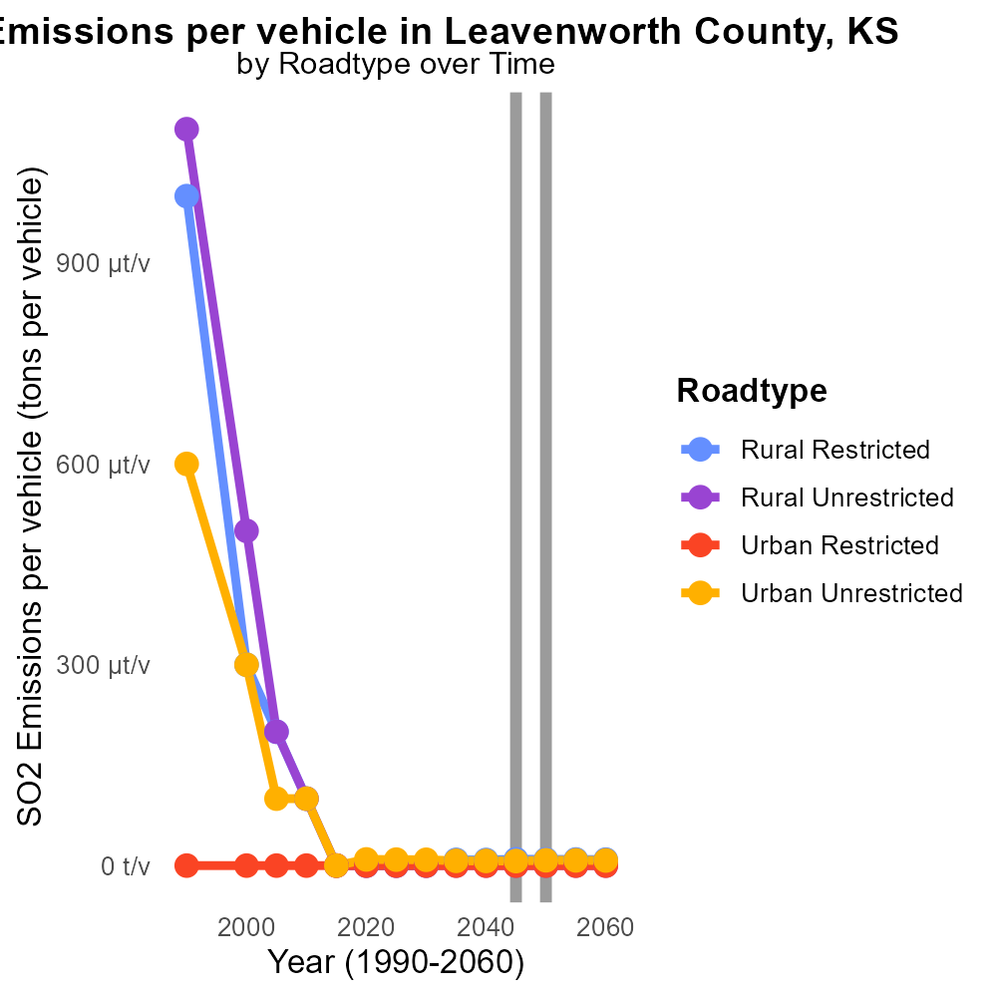

## Keywords

Sulfur Dioxides emissions; On-road transportation; Leavenworth County; Kansas; 2045

## Highlights

* Increase in on-road transportation contributes to SO2 emissions.
* Leavenworth County faces air quality challenges due to high SO2 emissions.
* Monitoring and controlling SO2 emissions from transportation is crucial.
* Impacts of SO2 emissions on public health and environment are significant.
* Regulatory measures needed to address rising SO2 emissions.

# Introduction

In 2045, the issue of Sulfur Dioxides (SO2) emissions from on-road transportation in Leavenworth County, Kansas has become a growing concern. The exponential increase in the number of vehicles on the roads has directly contributed to the rising levels of SO2 emissions in the county. As a result, Leavenworth County now faces significant air quality challenges, with detrimental effects on the health and environment of its residents.

It is imperative to closely monitor and control the levels of SO2 emissions from on-road transportation to mitigate the adverse impacts. The high concentrations of SO2 can lead to respiratory problems, acid rain, and environmental damage. Regulatory measures and sustainable practices must be implemented to address the escalating issue of SO2 emissions and safeguard the well-being of the community.

# Hotelling (Diesel Aux) by Road Type

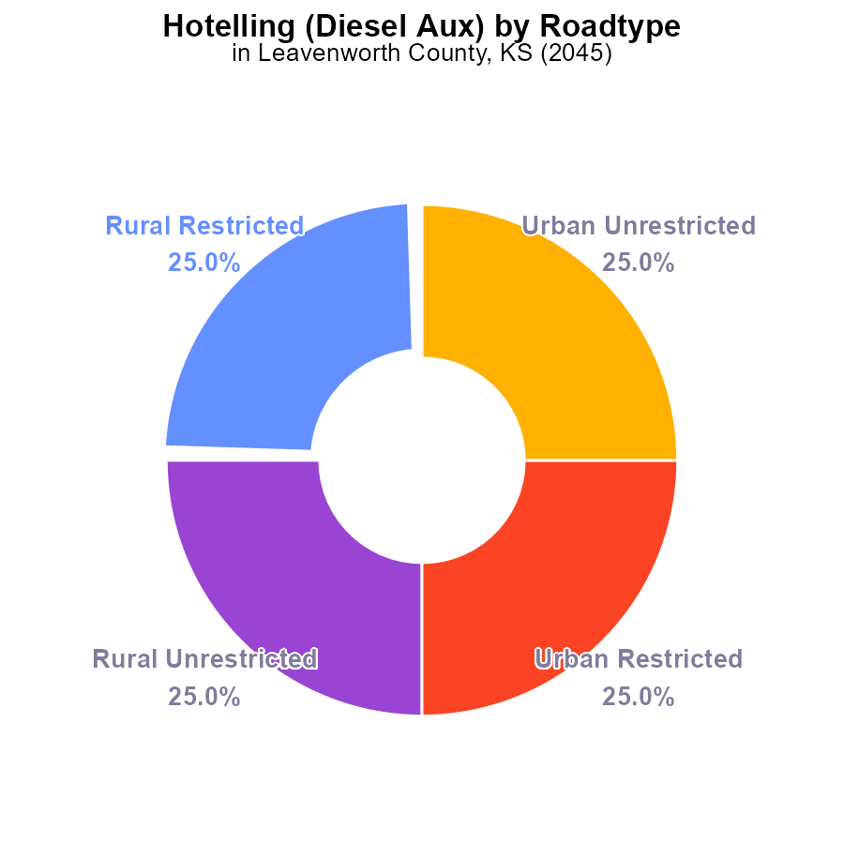

## Findings

* The emissions of SO2 in Leavenworth County in 2045 are 396.0 k hours.
* The highest contribution comes from the Rural Restricted and Urban Restricted areas, each accounting for 25.0% of the total SO2 emissions.
* The Urban Unrestricted area also contributes 25.0% to the total SO2 emissions.

## Recommendations

To lower the SO2 emissions, focus on implementing cleaner technologies in both Rural and Urban Restricted areas where the highest contributions are observed. Encouraging the adoption of cleaner fuels and regular maintenance of diesel auxiliary sources can help reduce emissions.

# Hotelling (Engines Off) by Fuel Type

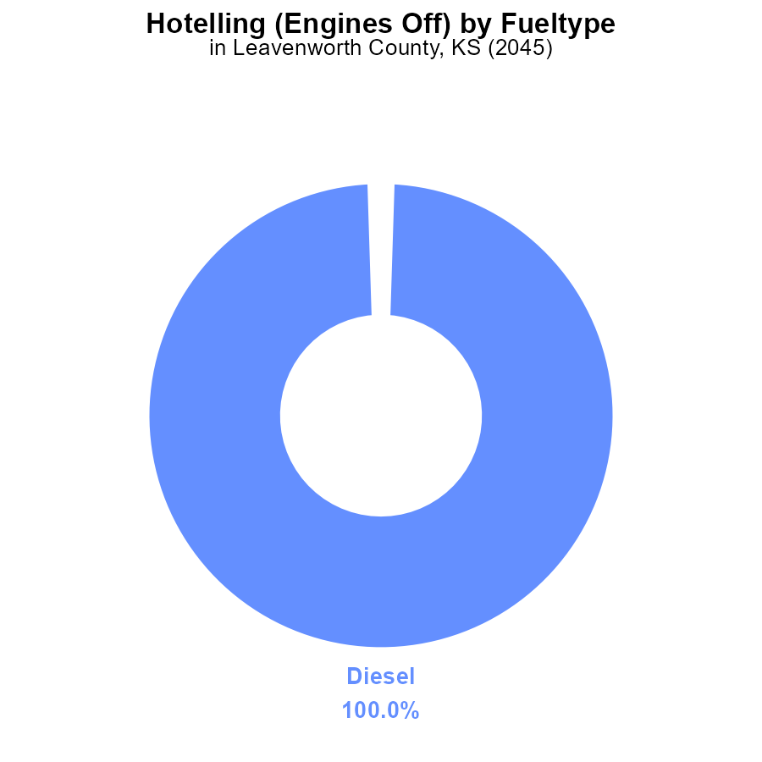

## Findings

* Diesel engines contributed 62.7 k hours of SO2 emissions in Leavenworth County in 2045.
* Diesel engines accounted for 100% of the total SO2 emissions from Hotelling activities in the county.
* No emissions data was reported for CNG, ethanol, or gas engines in the given dataset.

## Recommendations

To lower the SO2 emissions from diesel engines, incentivize the use of cleaner fuels or electric alternatives. Implement stricter emission standards for diesel vehicles to reduce pollution.

# Vehicle Starts Overall over Time

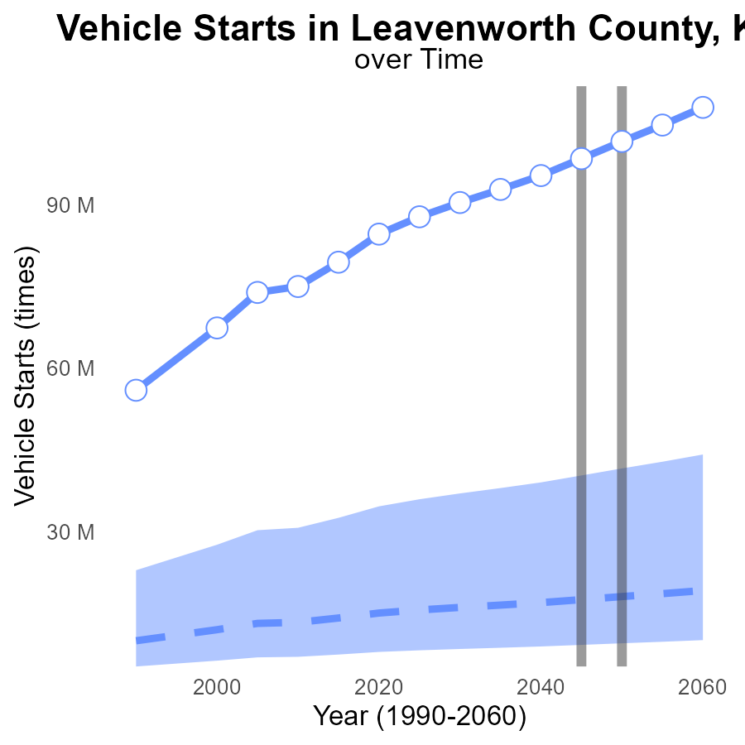

## Findings

* SO2 emissions in Leavenworth County are increasing steadily over time, from 87.8M in 2025 to 107.9M in 2060.
* The emissions are consistently above the upper 75th percentile of all areas, indicating a high level of pollution compared to other regions.
* There is a significant difference between Leavenworth County's emissions and the benchmark, especially by 2060, suggesting a need for urgent action.

## Recommendations

To lower SO2 emissions, policymakers should implement strict emission control measures on vehicles, possibly including mandatory emission testing and incentivizing the use of electric vehicles to align with the benchmark values and reduce the emissions level over the coming years.

# Idling Overall over Time

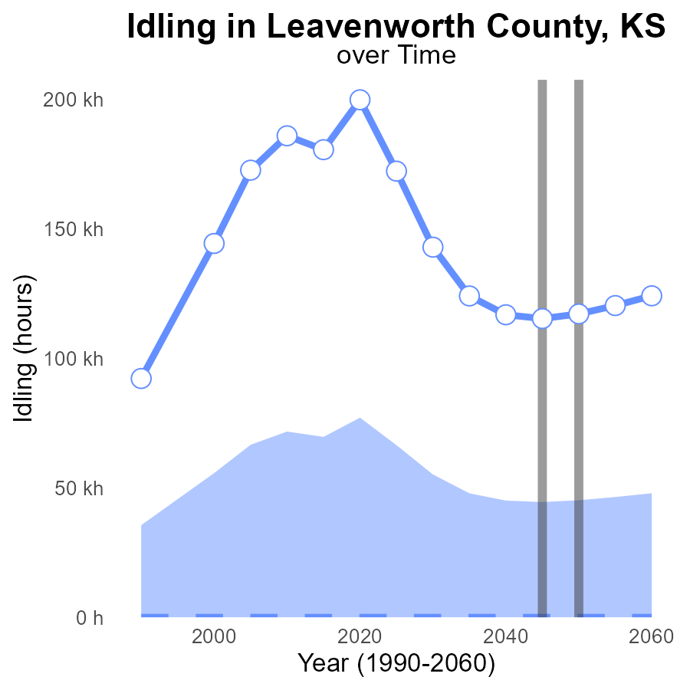

## Findings

* SO2 emissions in Leavenworth County have been consistently above the median area levels, with an increase over time.
* Idling hours show a steady rise over the years, indicating a potential trend of increased emissions.
* The benchmark difference is shrinking gradually, suggesting progress but still not meeting the upper 75th percentile of areas.

## Recommendations

To lower SO2 emissions in Leavenworth County, consider implementing stricter regulations on idling, promoting use of electric vehicles, and investing in public transport infrastructure.

# Emissions Rate (per mile) in My Region

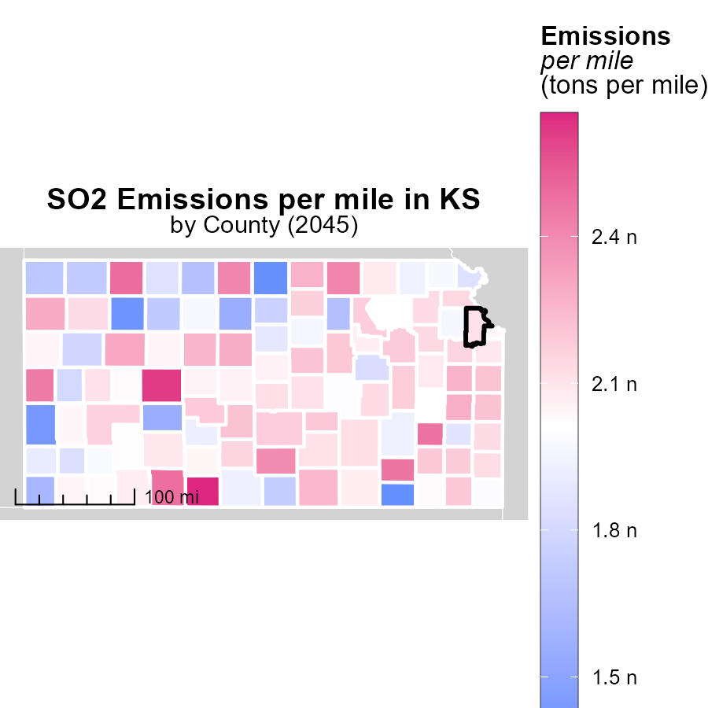

## Findings

* The highest emissions per mile were in Comanche County, KS, at 2.7 tons per mile.
* The median emissions per mile were 2.1 tons in Marshall County, KS.
* Chautauqua County, KS had the lowest emissions per mile at 1.4 tons.

## Recommendations

To lower emissions per mile, policymakers should focus on implementing stricter vehicle emission standards, promoting the use of public transportation, and incentivizing the adoption of electric vehicles in these counties.

# Vehicles Mapped by Area

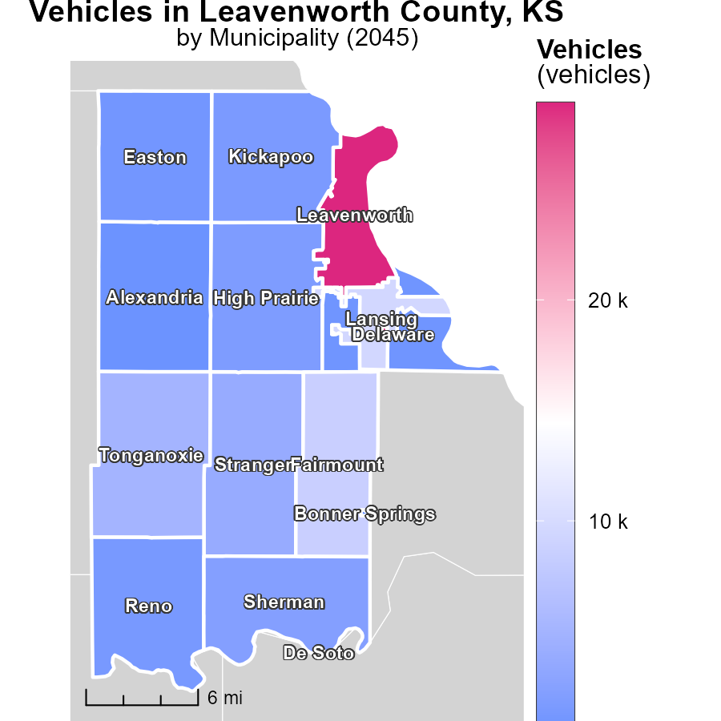

## Findings

* The highest emissions of vehicles were reported in Leavenworth, KS, with 28.9 thousand units.
* Kickapoo, KS had a median level of vehicle emissions, reporting 1.6 thousand units.
* De Soto, KS had the lowest level of vehicle emissions, reporting no units.

## Recommendations

To lower vehicle emissions, strategies can include promoting the use of public transportation, implementing vehicle emissions testing, and incentivizing the adoption of electric vehicles in areas like De Soto, KS.

# Emissions Rate (per vehicle) by Road Type over Time

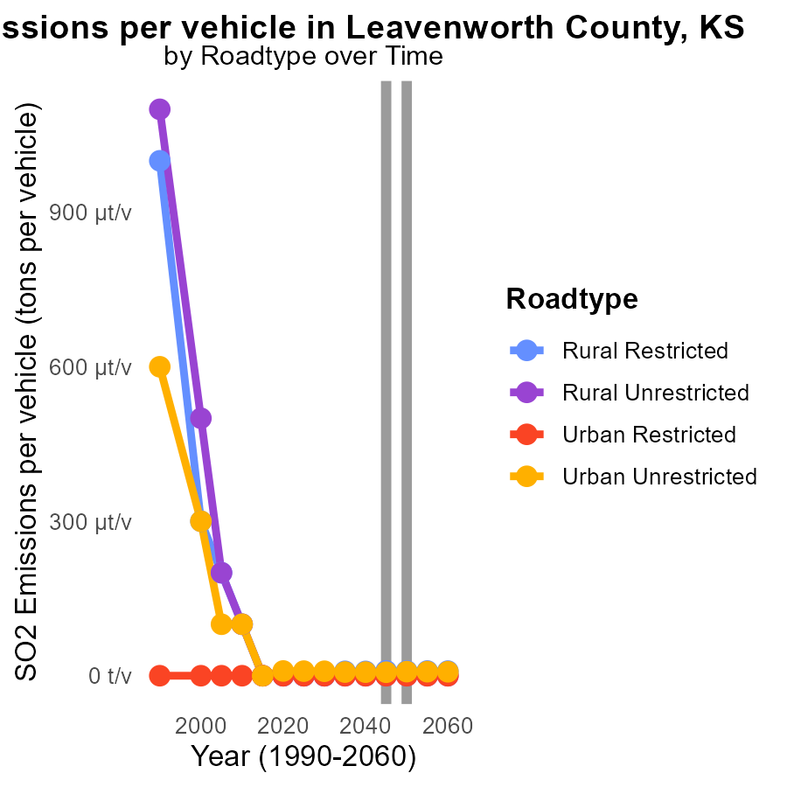

## Findings

* SO2 emissions are higher in rural areas compared to urban areas.
* SO2 emissions per vehicle are relatively stable over the years.
* A slight increase in SO2 emissions is projected for Urban Unrestricted areas by 2055.

## Recommendations

To reduce overall SO2 emissions, focus on implementing stricter emission standards in rural areas, where levels are consistently higher. Invest in cleaner technologies for vehicles to maintain the stability in emissions per vehicle. Monitor and address the projected increase in Urban Unrestricted areas promptly to prevent further escalation.

# Idling by Area over Time

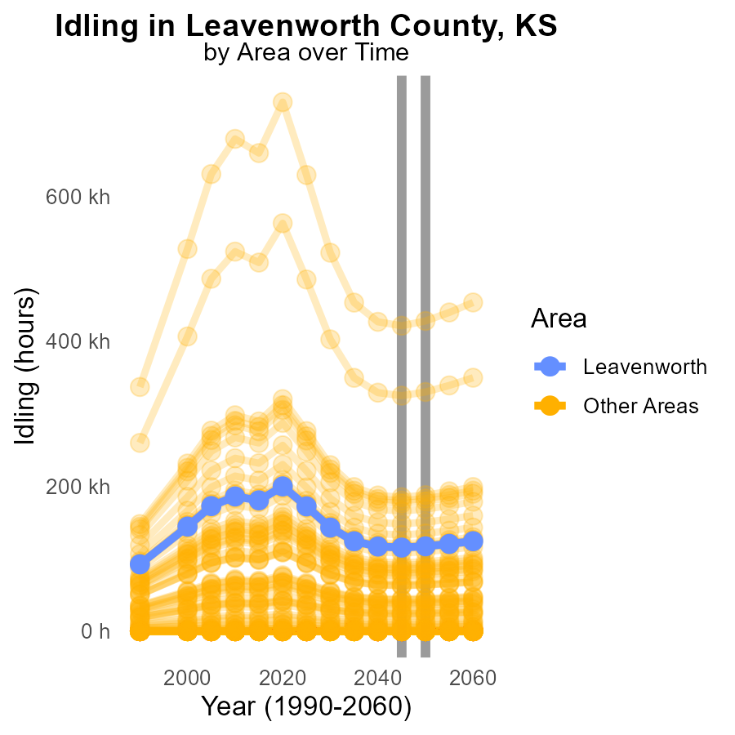

## Findings

* Zero SO2 emissions were recorded in min_county in 2045.
* Significant SO2 emissions of 421.5 k were reported in max_county in 2045.
* Target_county emitted 115.3 k SO2 in 2045, a decrease of 1806.4 k compared to 2050.

## Recommendations

To reduce SO2 emissions, focus on implementing pollution control measures in counties with high emissions like max_county while maintaining the low emission levels in min_county and target_county.

# Areas Ranked by Hotelling (Engines Off)

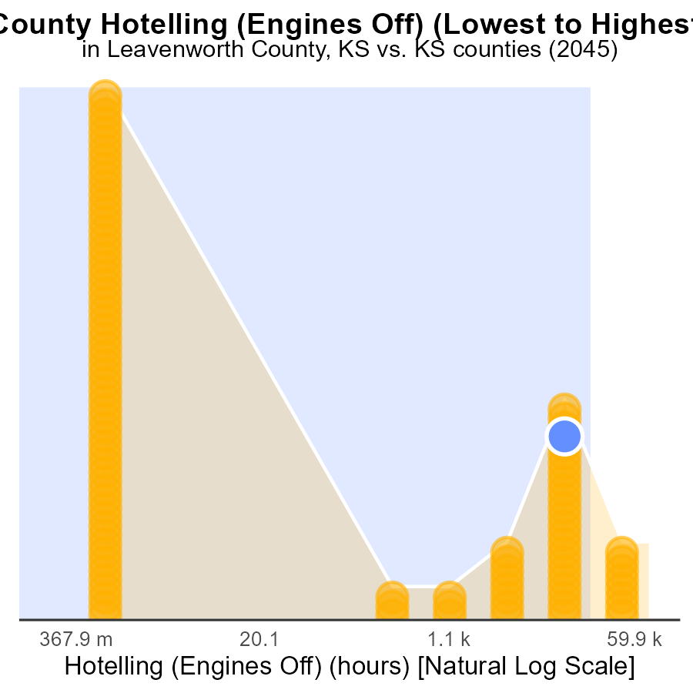

## Findings

* Johnson county has the highest sulfur dioxide (SO2) emissions with 229.4k hours.
* Leavenworth county has the lowest emissions with 62.7k hours.
* Johnson county ranks 105th in emissions percentile, being at full capacity.

## Recommendations

To lower emissions, Johnson county should focus on reducing engine usage, potentially through stricter regulations or incentives for alternative transportation methods.

# Areas Ranked by Emissions Rate (per capita)

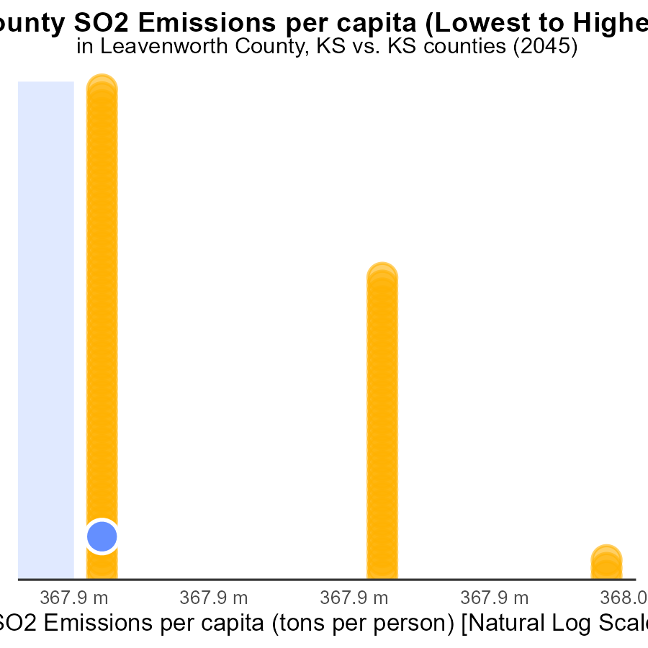

## Findings

* The highest emissions per capita were in Chase county with 230.4 tons per person.
* Riley county had the lowest emissions per capita at 18.9 tons per person.
* Leavenworth, Shawnee, and Atchison counties had similar mid-range emissions per capita ranging from 24.3 to 24.7 tons per person.

## Recommendations

To lower emissions, target initiatives at the most significant contributors; focus on reducing emissions in Chase county by implementing stricter regulations or transitioning to cleaner energy sources. Encourage sustainably focused practices in all counties.

# Conclusion

In conclusion, the analysis of SO2 emissions from on-road transportation in Leavenworth County, KS in 2045 reveals some concerning trends. With a total of 396.0 k hours of SO2 emissions, the county faces challenges in reducing pollution levels, particularly in Rural Restricted and Urban Restricted areas that contribute significantly to the emission totals. Diesel engines are identified as the main source of SO2 emissions, calling for immediate action to incentivize cleaner fuels and stricter emission standards. While Leavenworth County has the lowest emissions among nearby counties, the consistent increase over the years and projections for the future emphasize the need for urgent measures to tackle pollution.

Moving forward, policymakers should prioritize implementing cleaner technologies in high-emission areas, promoting the adoption of electric vehicles, and enforcing stricter regulations on diesel engines to curb SO2 emissions. Additionally, monitoring idling hours, increasing public transportation options, and investing in sustainable infrastructure can collectively contribute to reducing emissions per mile and per vehicle. By focusing on targeted strategies and aligning with benchmark values, Leavenworth County can work towards a cleaner and healthier environment for its residents.

# About This Report

Data based on MOVES estimates collected by the Climate Action in Transportation program at Cornell University. Demographic data sourced from the US Census's American Community Survey 5-year estimates. This report was generated with the help of AI.

# References

* U.S. Census Bureau. (2023). American Community Survey 5-year estimates: Detailed tables. Retrieved from https://data.census.gov
* U.S. Environmental Protection Agency. (2024). Motor Vehicle Emission Simulator (MOVES 4.0) [Software]. Retrieved from https://www.epa.gov/moves