 

**CO Emissions in Essex County, 2040**  
Made with CAT VISUALIZER by Gao Labs @ Cornell University.

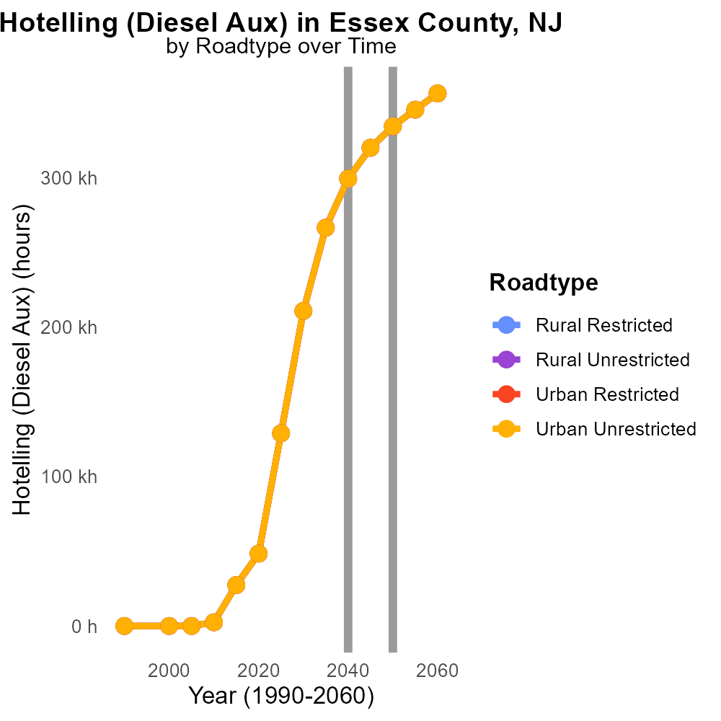

## Keywords

Carbon Monoxide emissions; on-road transportation; Essex County; NJ; 2040

## Highlights

* Study of CO emissions in Essex County, NJ in 2040.
* Focus on on-road transportation sources.
* Analysis of impact on air quality and public health.
* Policy recommendations for reducing CO emissions.
* Implications for sustainable urban planning.

# Introduction

This report presents a comprehensive analysis of Carbon Monoxide (CO) emissions specifically from on-road transportation sources in Essex County, New Jersey, projected for the year 2040.

The study aims to assess the current levels of CO emissions, predict the future trends, and evaluate their implications on air quality and public health in the region. Additionally, the report offers recommendations for policy interventions and strategies to curb CO emissions from on-road transportation, emphasizing the importance of sustainable urban planning to reduce environmental impact and improve public health outcomes in Essex County.

# Emissions Rate (per capita) Overall by Area

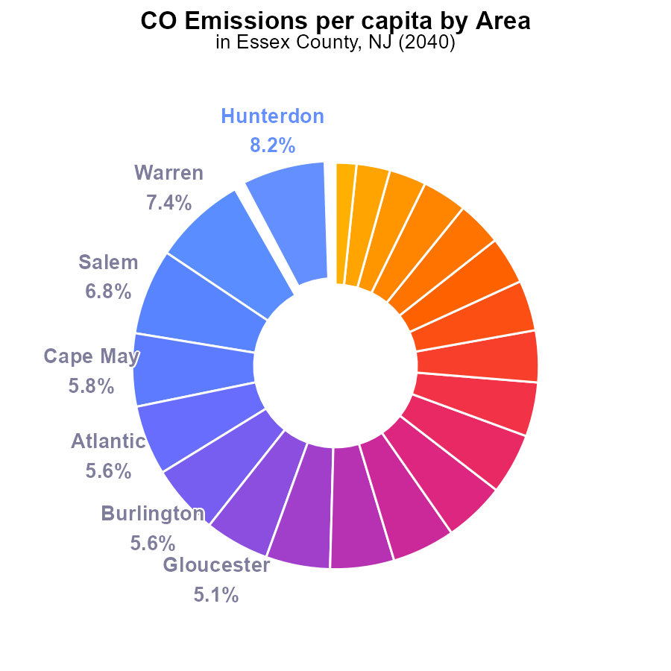

## Findings

* Essex County has the lowest CO emissions per capita in New Jersey at 8.3 tons per person, representing 2.9% of the total.
* Hunterdon County has the highest CO emissions per capita at 23.1 tons per person, comprising 8.2% of the total.
* The top five counties (Hunterdon, Warren, Salem, Cape May, and Atlantic) collectively contribute 33.5% of CO emissions in New Jersey.

## Recommendations

To lower emissions, Essex County should focus on specific initiatives to reduce CO emissions further. Counties with high emissions need targeted policies aimed at decreasing emissions per capita to align with state emission reduction targets.

# Population by Fuel Type

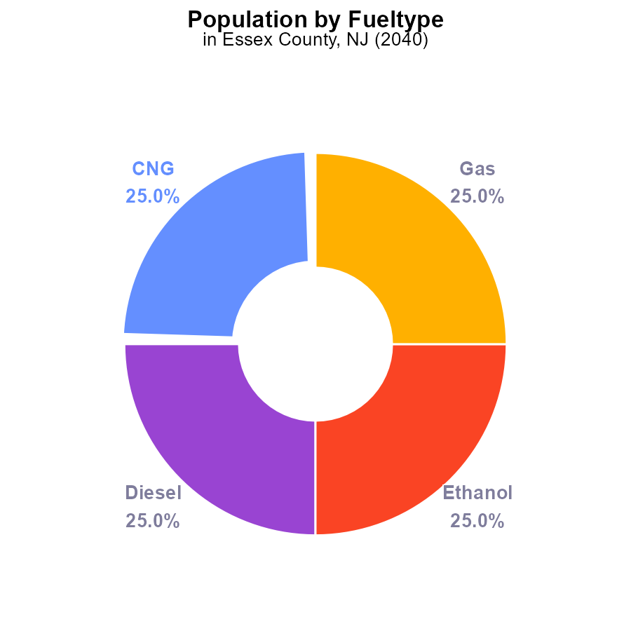

## Findings

* In Essex County, NJ in 2040, each type of fuel emission (CNG, Diesel, Ethanol, Gas) contributes 25.0% to the total CO emissions.
* The total CO emissions for each fuel type (CNG, Diesel, Ethanol, Gas) is approximately 798.7 kilotons.
* The population in Essex County, NJ emitting CO in 2040 is not specified.

## Recommendations

To lower the CO emissions in Essex County, NJ, focus on transitioning to cleaner energy sources like electric vehicles. Implement policies to promote public transportation and carpooling to reduce individual reliance on high-emission vehicles.

# Time Driven over Time for Passenger Time Driven

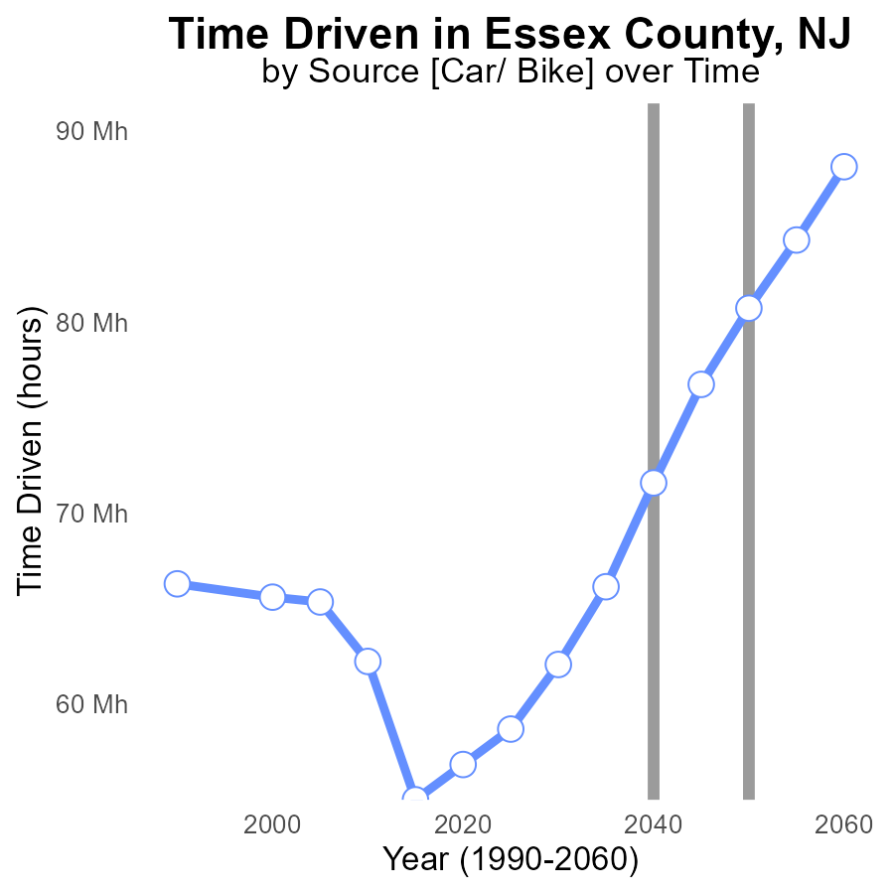

## Findings

* Emissions in Essex County, NJ have increased steadily over the years, from 56.8 million in 2020 to 88.1 million in 2060.
* The benchmark difference shows a significant decrease from 23893867 in 2020 to -7407350 in 2060.
* The peak emission year was 2060, with 88.1 million tons of CO2 emitted.

## Recommendations

To lower emissions, policymakers should focus on implementing cleaner energy sources, enhancing public transportation, and promoting energy efficiency measures in buildings and industries. Setting strict emission targets and incentivizing green practices is crucial.

# Emissions Rate (per vehicle) over Time for Buses

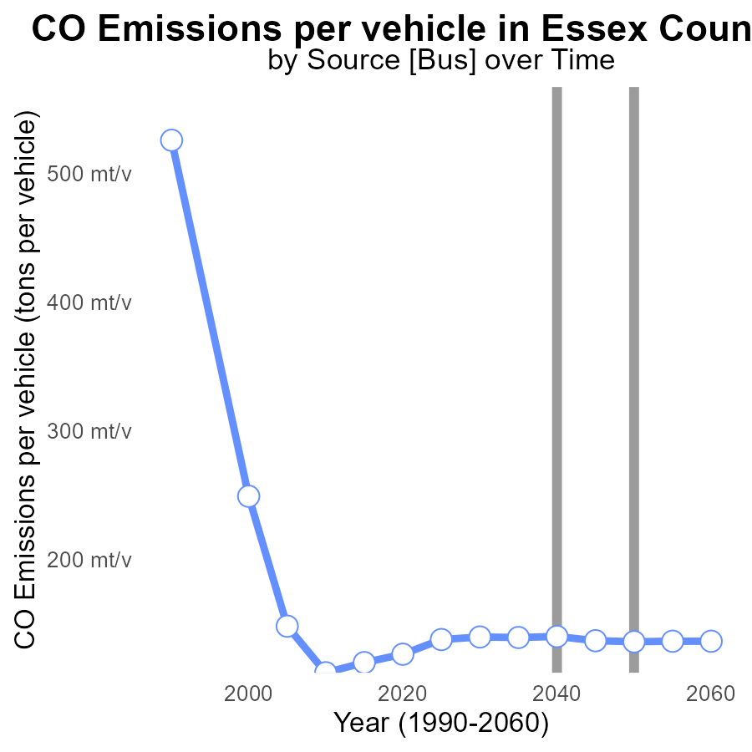

## Findings

* Emissions per vehicle in Essex County, NJ have decreased over the years.
* The largest decrease in emissions per vehicle occurred between 2020 and 2030.
* Despite fluctuations, emissions per vehicle have generally shown a decreasing trend from 2020 to 2060.

## Recommendations

To further reduce emissions per vehicle in Essex County, efforts should focus on promoting the adoption of electric vehicles, implementing stricter emission standards for vehicles, expanding public transportation options, and investing in infrastructure to support alternative fuel vehicles.

# Hotelling (Diesel Aux) in My Region

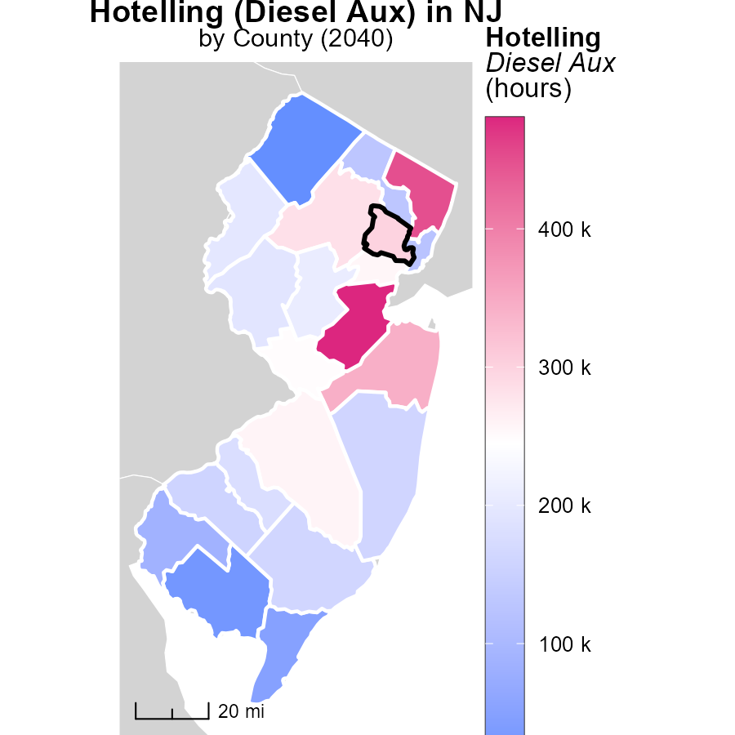

## Findings

* Middlesex County, NJ emitted 480.4 kilotons of emissions, the highest among the three.
* Hunterdon County, NJ had a median emissions level of 193.1 kilotons.
* Sussex County, NJ had the lowest emissions level at 9.4 kilotons.

## Recommendations

To lower emissions, Middlesex County should implement stricter regulations on diesel auxiliary emissions. Hunterdon County should invest in cleaner technologies. Sussex County should focus on reducing emissions from diesel auxiliary sources.

# Vehicles in My Region

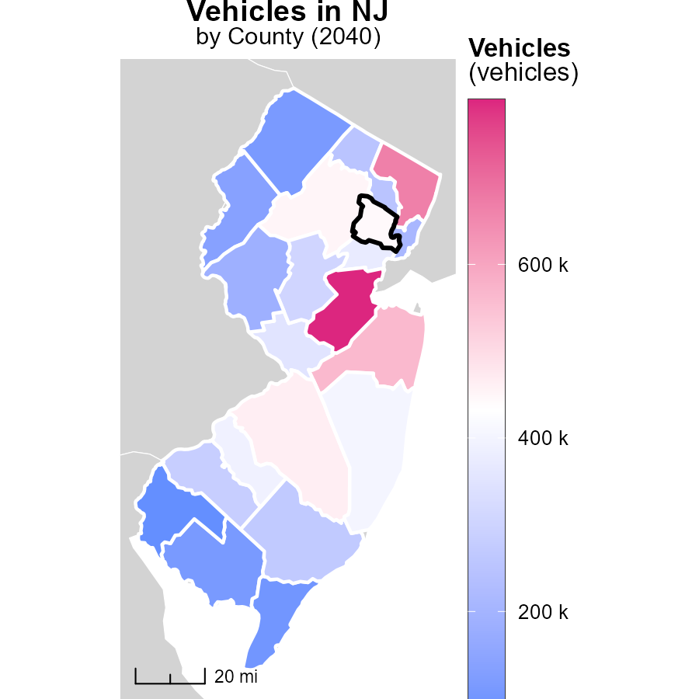

## Findings

* Middlesex County, NJ has the highest vehicle emissions with 789.6k
* Somerset County, NJ has median vehicle emissions at 305.4k
* Salem County, NJ has the lowest vehicle emissions with 75.9k

## Recommendations

To lower vehicle emissions, incentivize the adoption of electric vehicles in Middlesex County to reduce the highest emissions. Implement car-sharing programs in Somerset County to decrease median emissions. Promote public transportation in Salem County to further reduce the already low emissions.

# Hotelling (Diesel Aux) by Road Type over Time

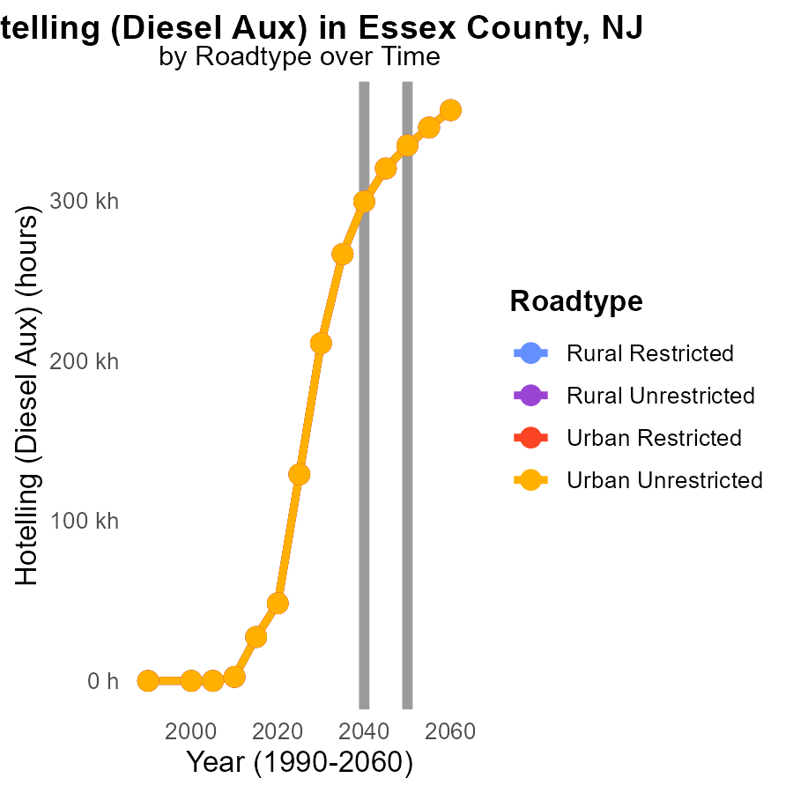

## Findings

* Emissions for Hotelling (Diesel Aux) in Essex County, NJ are highest in 2030 at 210.7k units.
* The emissions decrease year by year, reaching the lowest in 2050 at 334.2k units, showing a reduction of 123485.8k units from 2030.
* Across all road types and areas, emissions drop significantly by 2050, with Urban Unrestricted area having the largest reduction of 123485.8k units from 2030.

## Recommendations

To lower emissions, policy interventions are vital. Increasing the adoption of cleaner fuels and technologies in transportation systems can lead to substantial reductions. Implementing stricter emission standards for vehicles and promoting public transportation can also contribute to achieving emission reduction targets.

# Idling by Area over Time

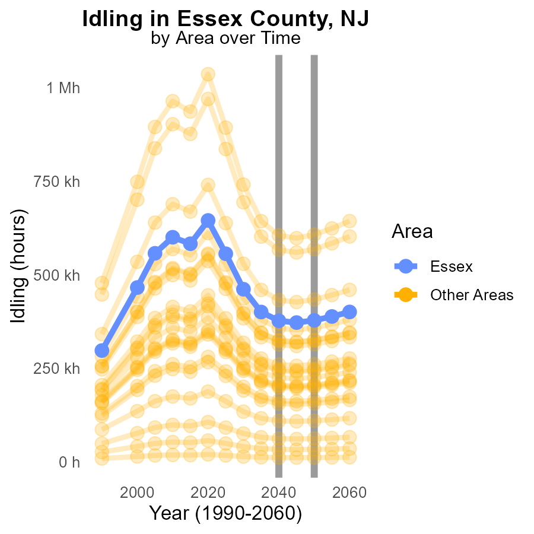

## Findings

* In 2040, the target county emitted 377.1 thousand tons of CO from idling, a 1053.0 ton decrease by 2050.
* In 2040, the county with the highest emissions released 605.6 thousand tons of CO due to idling.
* The county with the lowest emissions in 2040 only emitted 11.8 thousand tons of CO from idling.

## Recommendations

To reduce CO emissions from idling: promote anti-idling campaigns, implement idling reduction technologies in vehicles, and introduce idling reduction policies such as time limits on engine idling.

# Areas Ranked by Hotelling (Diesel Aux)

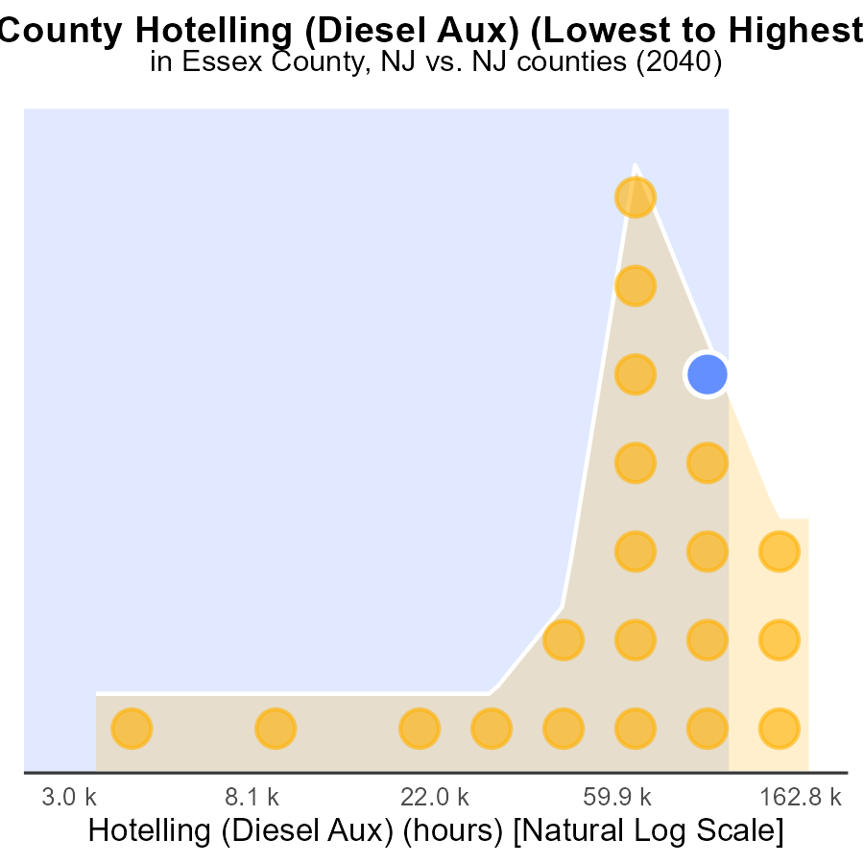

## Findings

* Highest emissions in Middlesex County with 480.4k hours.
* Lowest emissions in Sussex County with 9.4k hours.
* Morris County ranked 17th with 283.5k hours, contributing 81.0% to the total emissions.

## Recommendations

To reduce emissions, focus on Middlesex County by implementing stricter emission controls on diesel auxiliary sources, promoting the use of cleaner energy sources, and investing in public transportation to reduce overall vehicle emissions in the county.

# Areas Ranked by Time Driven

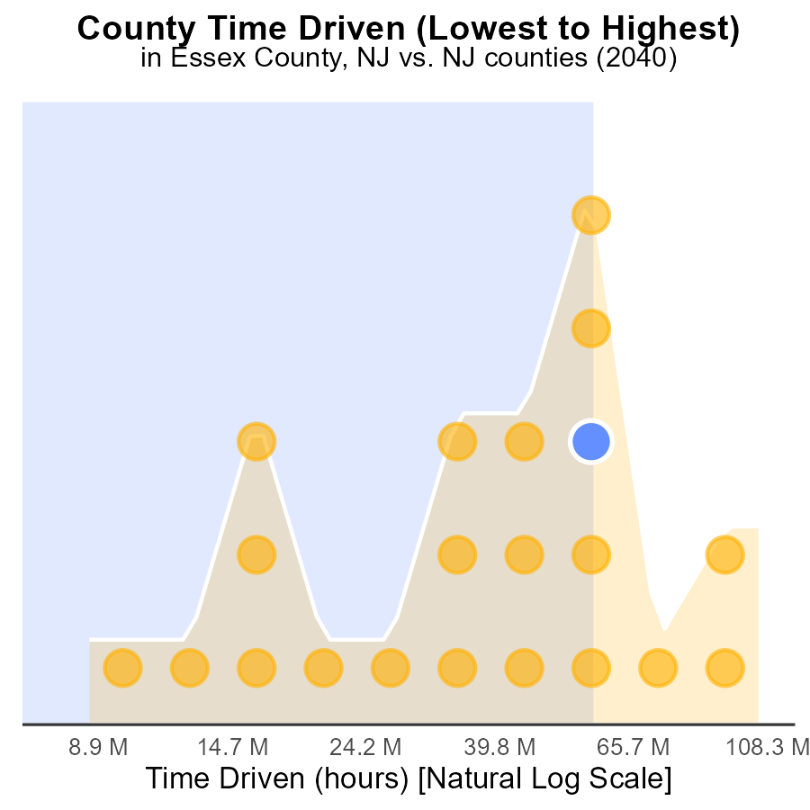

## Findings

* Middlesex county has the highest source hours with 284.6 million, ranking 21st and contributing 100.0% to emissions data.
* Morris county ranks 17th with 158.7 million source hours, contributing 81.0% to emissions data.
* Salem county has the lowest source hours with 23.3 million, ranking 1st and contributing 4.8% to emissions data.

## Recommendations

To lower emissions, focus on counties with the highest source hours like Middlesex and Morris. Implement time-driven strategies to reduce emissions from these counties significantly.

# About This Report

Data based on MOVES estimates collected by the Climate Action in Transportation program at Cornell University. Demographic data sourced from the US Census's American Community Survey 5-year estimates. This report was generated with the help of AI.

# References

* U.S. Census Bureau. (2023). American Community Survey 5-year estimates: Detailed tables. Retrieved from https://data.census.gov
* U.S. Environmental Protection Agency. (2024). Motor Vehicle Emission Simulator (MOVES 4.0) [Software]. Retrieved from https://www.epa.gov/moves