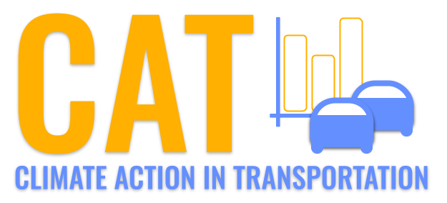 

**Carbon Emissions in Marlboro County, 2035**  
Made with CAT VISUALIZER by Gao Labs @ Cornell University.

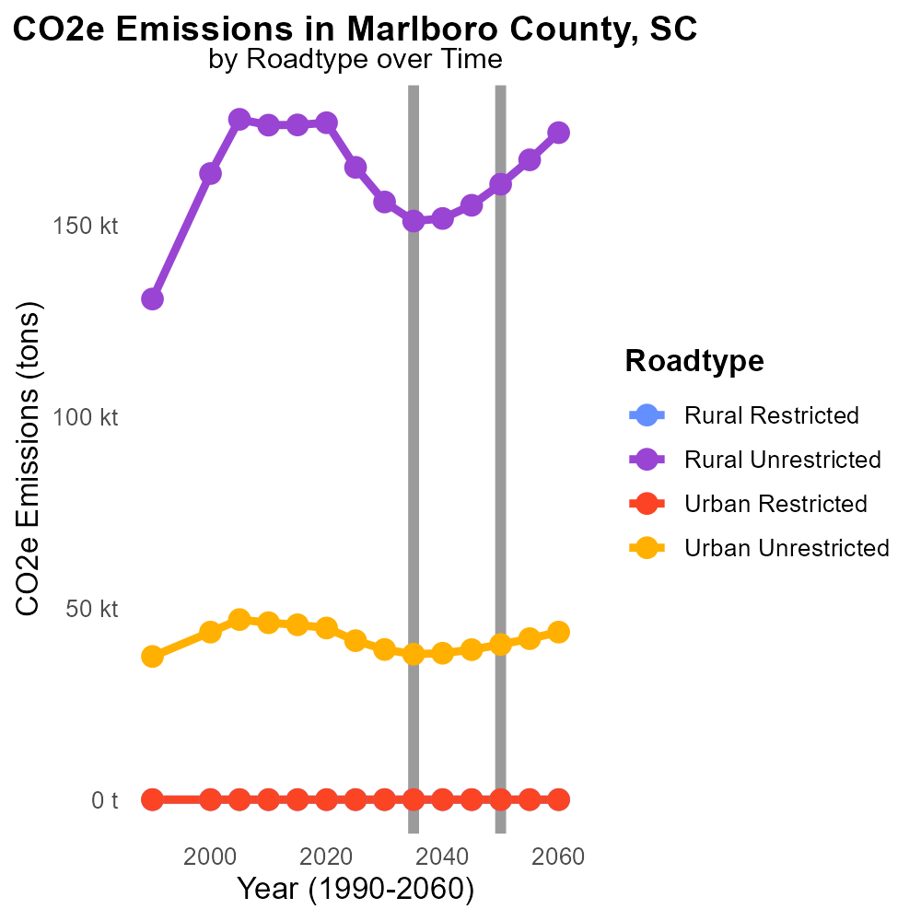

## Keywords

CO2 Equivalent emissions; on-road transportation; Marlboro County; SC; 2035

## Highlights

* Assessing CO2 Equivalent emissions from on-road transportation in Marlboro County, SC.
* Exploring the environmental impact of transportation in 2035.
* Analyzing trends and projections for carbon emissions in the county.
* Understanding the implications for climate change mitigation strategies.
* Proposing recommendations for sustainable transportation solutions.

# Introduction

In 2035, Marlboro County, SC, faces a pressing issue of CO2 Equivalent emissions from on-road transportation. This report delves into the comprehensive assessment of carbon emissions related to the county's transportation sector, examining the environmental impact and projecting future trends. By analyzing data and forecasting potential scenarios, we aim to gain insights into the implications of these emissions for the local environment and climate.

The findings of this report will provide valuable information for policymakers, urban planners, and environmentalists in Marlboro County as they work towards implementing sustainable transportation solutions and formulating strategies to mitigate the effects of climate change. This investigation aims to pave the way for a greener, more environmentally friendly future for on-road transportation in the county.

# Population by Vehicle Type

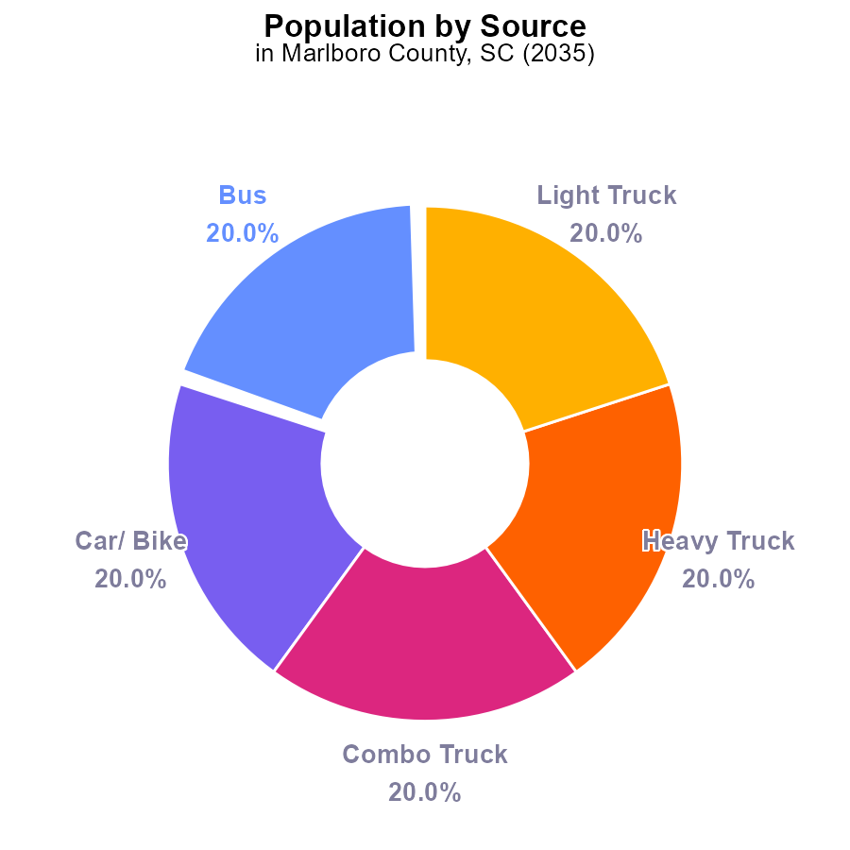

## Findings

* Bus emissions: 26.4 k CO2e, 20.0% of total
* Car/ Bike emissions: 26.4 k CO2e, 20.0% of total
* Combo Truck, Heavy Truck, Light Truck emissions: 79.2 k CO2e, 60.0% of total

## Recommendations

To reduce emissions in Marlboro County, SC, focus on improving the transportation sector by promoting the use of low-emission vehicles and enhancing public transportation infrastructure. Implementing vehicle emission testing programs can help monitor and control pollutants effectively.

# Vehicle Starts by Regulatory Class

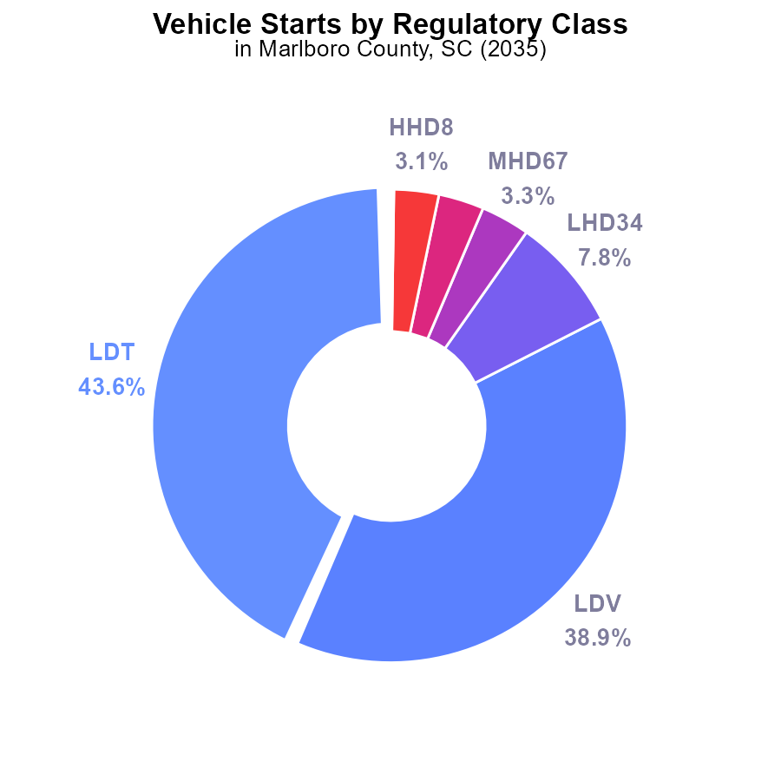

## Findings

* Light-duty trucks (LDT) and Light-duty vehicles (LDV) are responsible for over 80% of vehicle start CO2 emissions in Marlboro County, SC.
* Medium and Heavy-duty vehicle categories (LHD34, MHD67, LHD45, HHD8) contribute to less than 20% of the total emissions.
* Motorcycles (MC), Urban Buses, and Gliders combined only make up less than 1% of the total emissions in the county.

## Recommendations

To lower emissions, focus efforts on reducing CO2e from LDT and LDV categories by promoting electric vehicles, improving public transportation systems, and incentivizing carpooling to decrease the number of vehicle starts.

# Hotelling (Diesel Aux) over Time for Passenger Vehicles

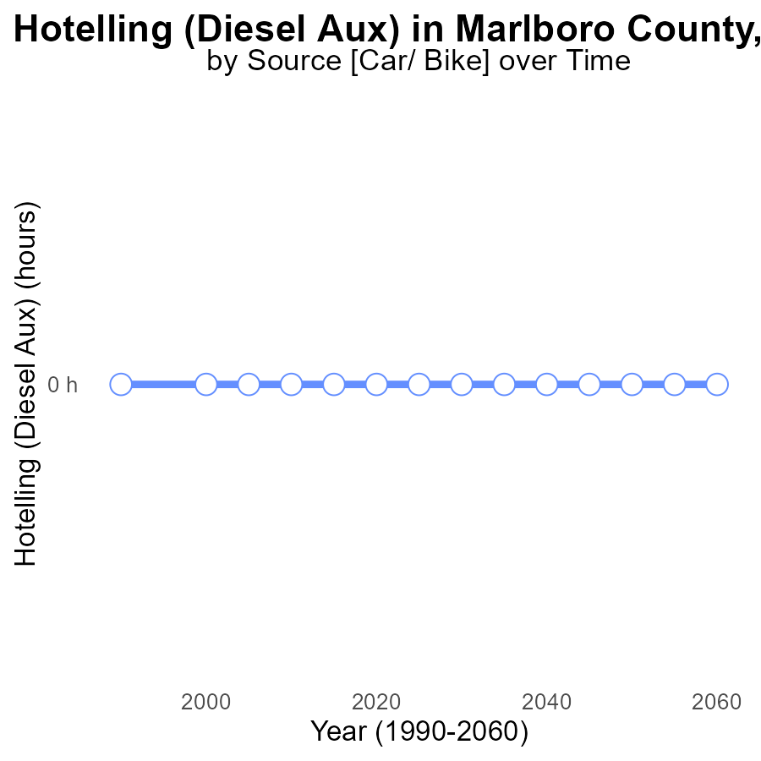

## Findings

* From 2015 to 2055, emissions from Hotelling (Diesel Aux) in Marlboro County, SC have remained consistently at 0.0 CO2e.
* There has been no change in emissions for this source over the 40-year period analyzed.
* The benchmark difference has consistently remained at 0, indicating no deviation from expected emission levels.

## Recommendations

As emissions have plateaued at 0.0 CO2e for Hotelling (Diesel Aux) in Marlboro County, continuing current practices is encouraged. Consider monitoring future technological advancements for emissions reduction.

# Population over Time for Buses

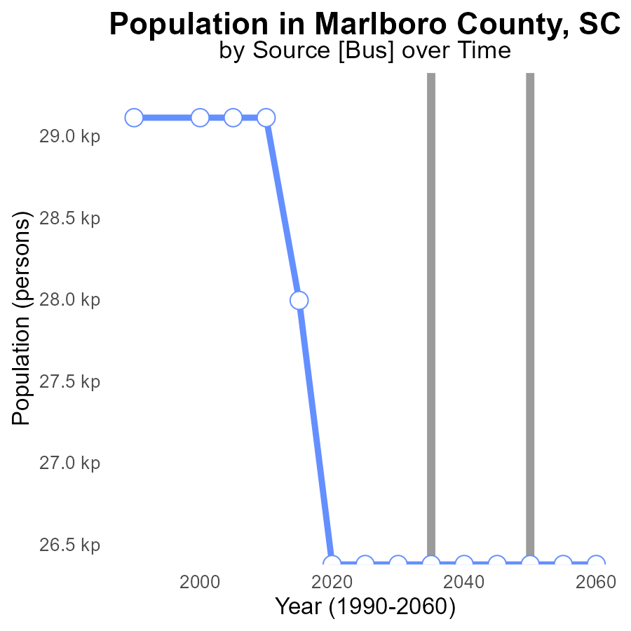

## Findings

* CO2e emissions decreased from 28.0 k in 2015 to 26.4 k in 2020.
* Following years show a sustained CO2e emissions level at 26.4 k.
* The benchmark difference indicates a reduction of 1617 persons in emissions by 2020.

## Recommendations

To maintain the decreased CO2e emissions, continue promoting energy efficiency programs and renewable energy sources. Implement strict emission regulations for industries and incentivize public transportation.

# Emissions Mapped by Area

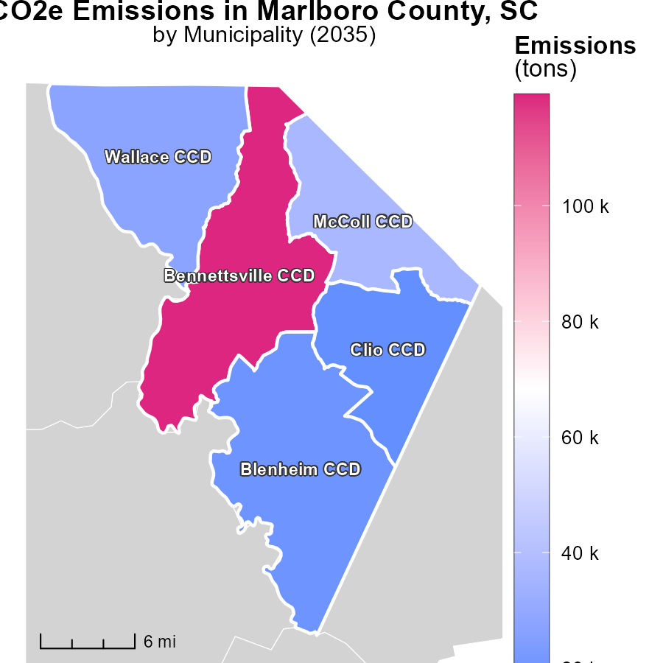

## Findings

* The highest emissions were in Bennettsville CCD, SC at 119.2 k tons.
* Wallace CCD, SC had a median emission of 27.6 k tons.
* Clio CCD, SC had the lowest emissions at 17.6 k tons.

## Recommendations

To lower emissions, focus on improving energy efficiency in industries and promote public transportation to reduce individual car usage in these regions.

# Hotelling (Diesel Aux) Mapped by Area

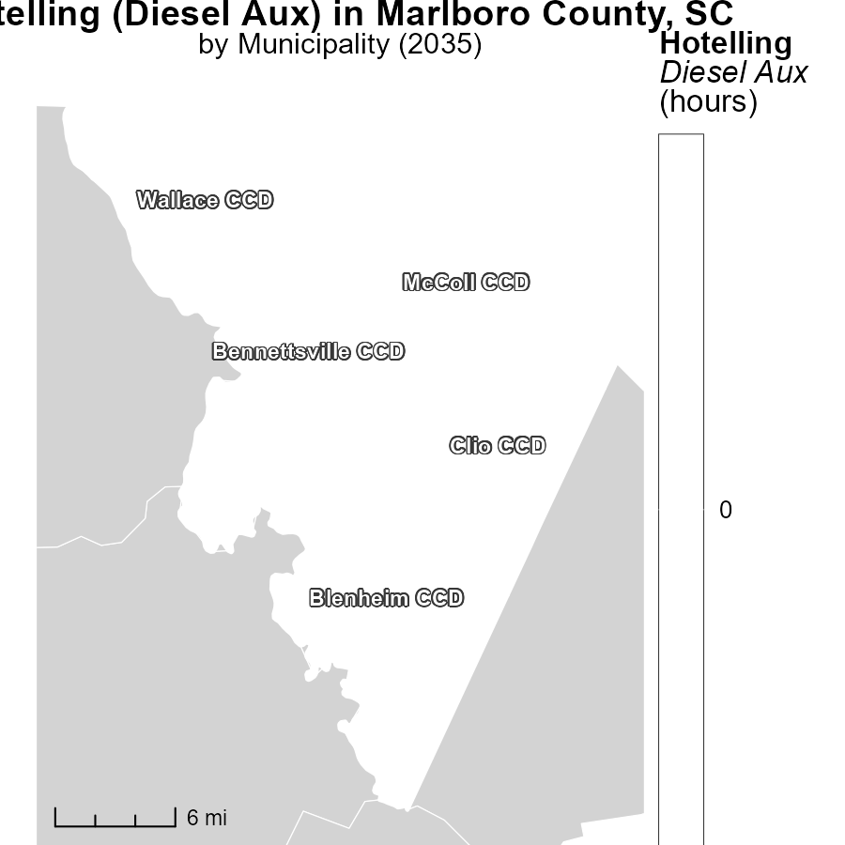

## Findings

* In Bennettsville CCD, SC, the maximum emissions for Hotelling (Diesel Aux) in 2035 were 0.0 hours.
* In Clio CCD, SC, the median emissions for Hotelling (Diesel Aux) in 2035 were 0.0 hours.
* In Wallace CCD, SC, the minimum emissions for Hotelling (Diesel Aux) in 2035 were 0.0 hours.

## Recommendations

To further reduce emissions, consider promoting alternative energy sources or implementing stricter regulations on diesel auxiliary usage.

# Emissions by Road Type over Time

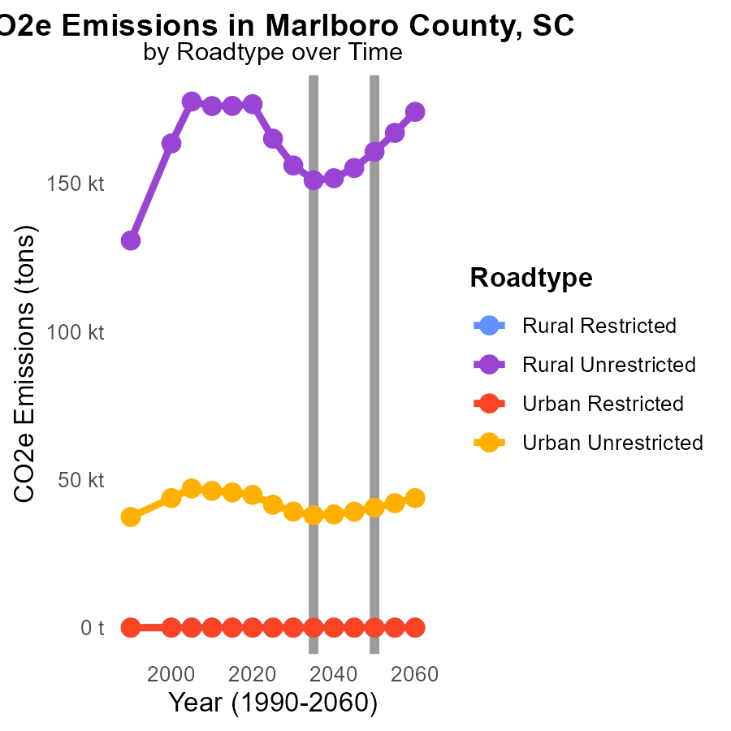

## Findings

* Rural Unrestricted areas have the highest CO2e emissions, peaking at 165.1 k tons in 2025.
* Urban Unrestricted areas exhibit a decreasing trend in emissions over the years, with 41.5 k tons in 2025 and 39.2 k tons in 2030.
* Rural areas account for the most significant reduction in emissions by 2045, with 15.2 k tons less than in 2025.

## Recommendations

To lower emissions levels, focus on implementing stricter regulations and promoting the use of cleaner transportation options in rural unrestricted areas. Encourage urban areas to continue their decreasing trend by investing in public transportation and infrastructure for zero-emission vehicles.

# Emissions by Regulatory Class over Time

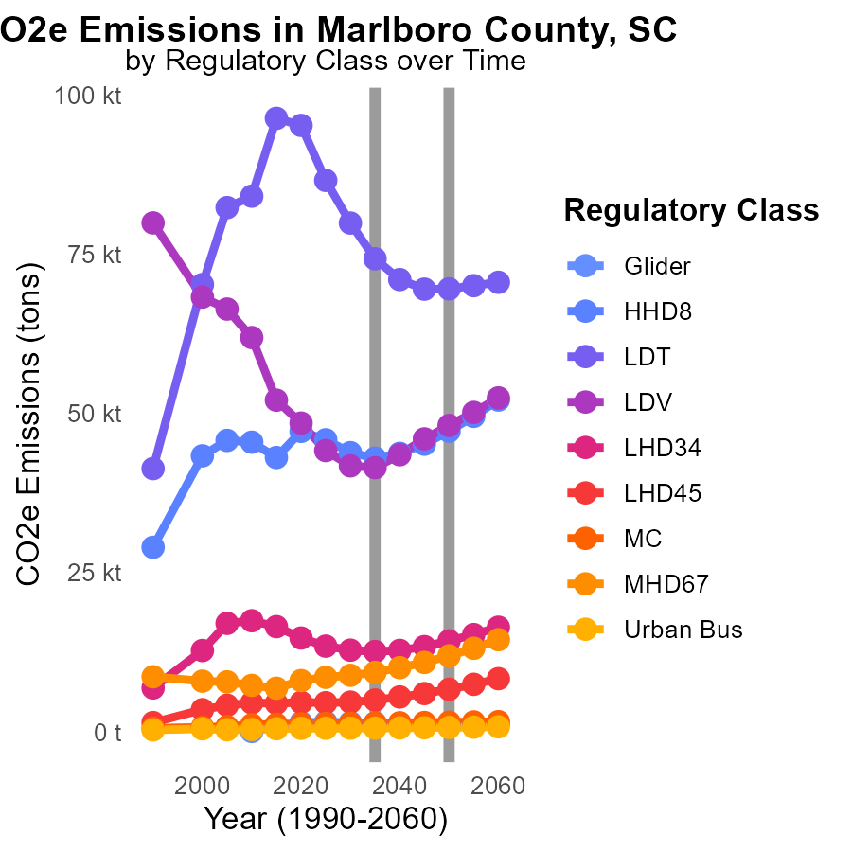

## Findings

* The largest emissions in Marlboro County, SC are from Light-Duty Trucks (LDT), with a decrease from 86.5k tons in 2025 to 69.5k tons in 2045.
* Urban Buses show a steady increase in emissions from 576.4 tons in 2025 to 659.3 tons in 2045.
* Most vehicle types show a downward trend in emissions, with some minor exceptions such as Medium Combustion (MC) vehicles.

## Recommendations

To reduce emissions, focus on transitioning Urban Buses to cleaner alternatives. Invest in technologies to lower emissions from Light-Duty Trucks further. Implement stricter regulations for Medium Combustion vehicles.

# Areas Ranked by Emissions Rate (per mile)

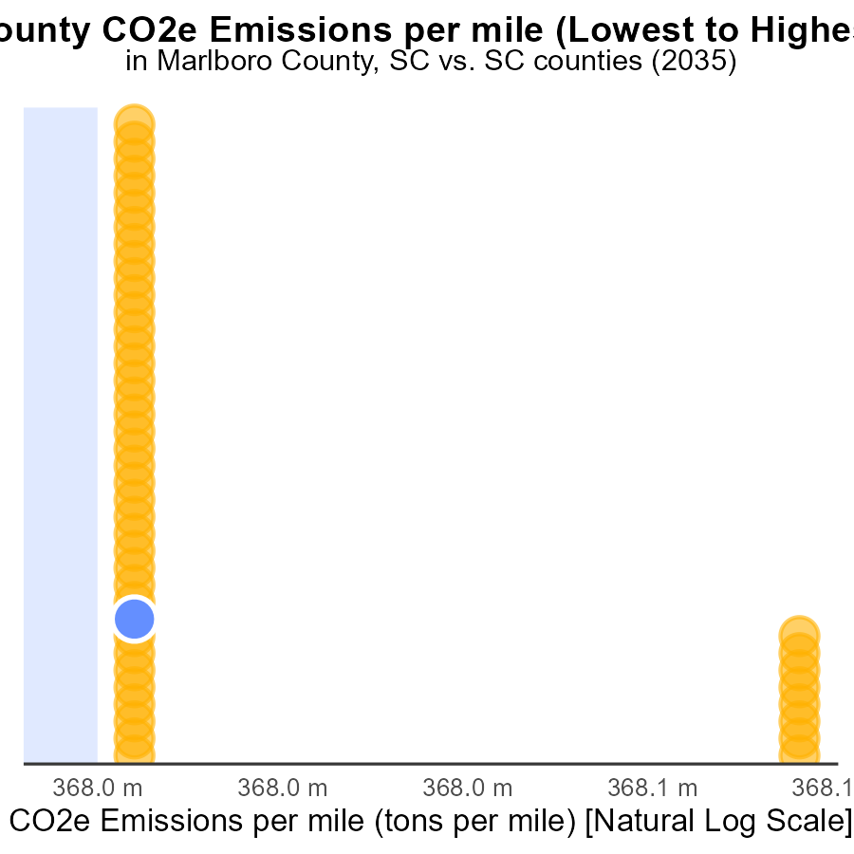

## Findings

* Calhoun county has the highest emissions per mile at 476.1 tons, ranking 46th.
* Greenville county has the lowest emissions per mile at 392.4 tons, ranking 1st.
* Union county ranks 10th with emissions per mile at 397.4 tons, representing 21.7% of total emissions.

## Recommendations

To lower emissions, focus on strategies like promoting cleaner transportation options, increasing public transportation, and implementing policies to reduce vehicle miles traveled in counties with high emission levels.

# Areas Ranked by Vehicle Starts

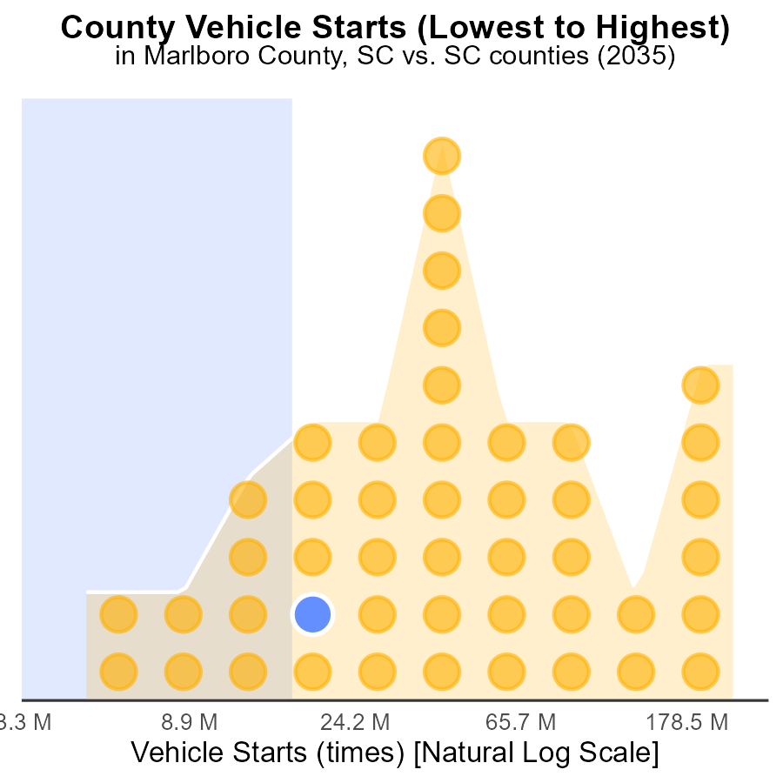

## Findings

* Greenville has the highest number of vehicle starts with 640.7 million.
* Williamsburg ranks 11st in vehicle starts, accounting for 23.9% of the total starts.
* Allendale has the lowest number of vehicle starts with 13.0 million, making up 2.2% of the total.

## Recommendations

To reduce emissions, focus on incentivizing public transportation in high-ranking counties like Greenville and Williamsburg to lower vehicle starts. Promote carpooling and invest in electric vehicle infrastructure to lower emissions in these counties.

# Conclusion

In conclusion, the data on CO2 Equivalent emissions from on-road transportation in Marlboro County, SC in 2035 reveals key insights that can guide emission reduction strategies. Light-Duty Trucks (LDT) and Light-Duty Vehicles (LDV) are major contributors to emissions, highlighting the need to promote electric vehicles and enhance public transportation infrastructure. While Hotelling (Diesel Aux) emissions have plateaued at 0.0 CO2e, continued monitoring is advised to track technological advancements. Efforts to reduce emissions should prioritize Urban Buses and Light-Duty Trucks, while also implementing stricter regulations for Medium Combustion vehicles.

Moreover, specific regions like Bennettsville CCD, SC, Wallace CCD, SC, and Clio CCD, SC exhibit varying emission levels, necessitating tailored strategies for each area. Rural Unrestricted areas have historically high emissions, requiring stringent regulations and cleaner transportation options. Conversely, Urban Unrestricted areas show a positive trend, indicating the effectiveness of current emission reduction measures. By focusing on promoting energy efficiency, investing in public transportation, and incentivizing cleaner vehicle technologies, Marlboro County can continue its path towards a sustainable and environmentally friendly transportation sector.

# About This Report

Data based on MOVES estimates collected by the Climate Action in Transportation program at Cornell University. Demographic data sourced from the US Census's American Community Survey 5-year estimates. This report was generated with the help of AI.

# References

* U.S. Census Bureau. (2023). American Community Survey 5-year estimates: Detailed tables. Retrieved from https://data.census.gov
* U.S. Environmental Protection Agency. (2024). Motor Vehicle Emission Simulator (MOVES 4.0) [Software]. Retrieved from https://www.epa.gov/moves