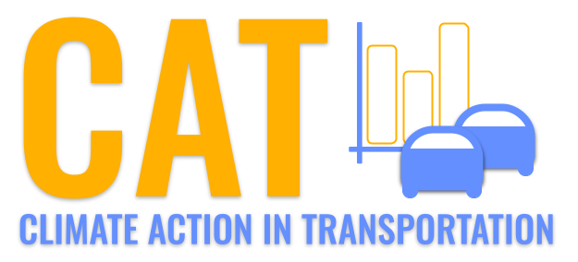 

**VOC Emissions in Chilton County, 2040**  
Made with CAT VISUALIZER by Gao Labs @ Cornell University.

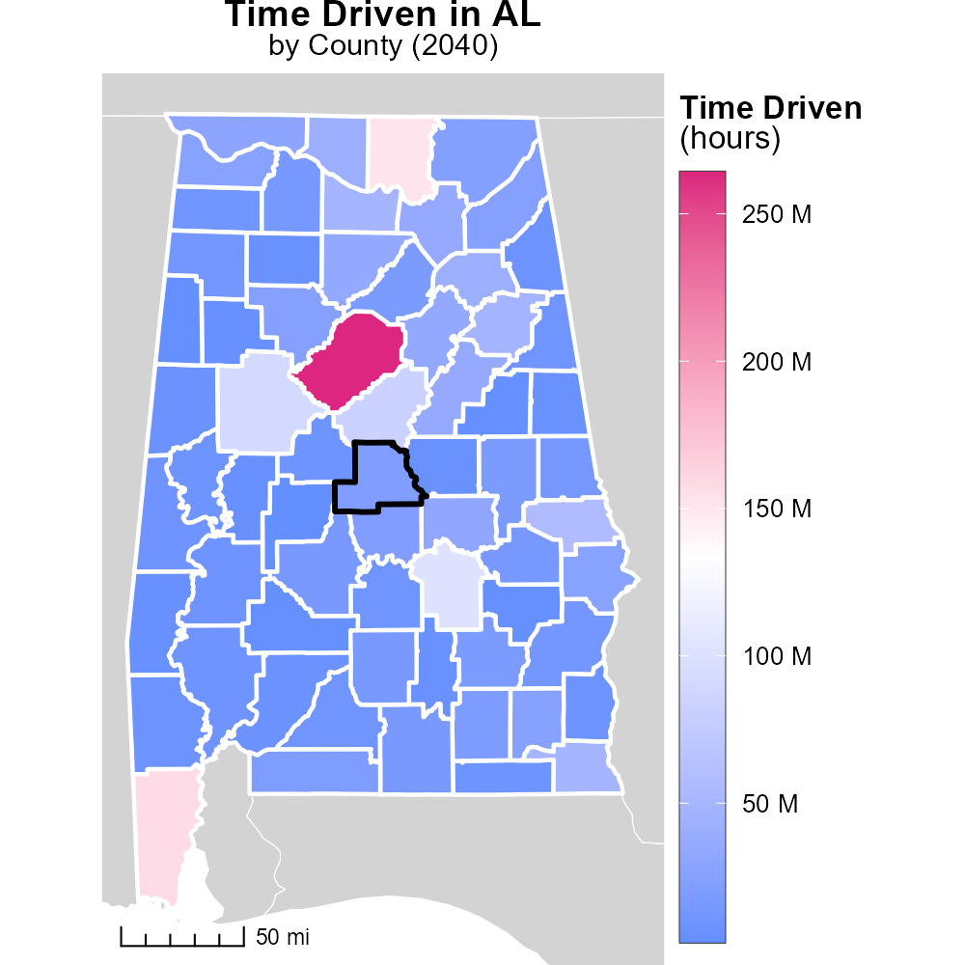

## Keywords

Volatile Organic Compounds; on-road transportation; Chilton County; AL; emissions; 2040

## Highlights

* VOC emissions from transportation in Chilton County, AL in 2040.
* Effects of VOC emissions on air quality and public health.
* Trends and projections of on-road transportation emissions.
* Mitigation strategies for reducing VOC emissions.
* Importance of addressing transportation-related VOC emissions.

# Introduction

The report investigates the trends and projections of Volatile Organic Compounds (VOC) emissions from on-road transportation in Chilton County, Alabama, in the year 2040. With a growing emphasis on environmental sustainability and public health, understanding the sources and impact of VOC emissions becomes crucial.

Analyzing the data on transportation-related VOC emissions provides valuable insights into the potential effects on air quality and public health. By exploring various mitigation strategies, policymakers and stakeholders can work towards reducing the environmental footprint and improving the overall well-being of the community.

# Vehicle Miles Traveled by Road Type

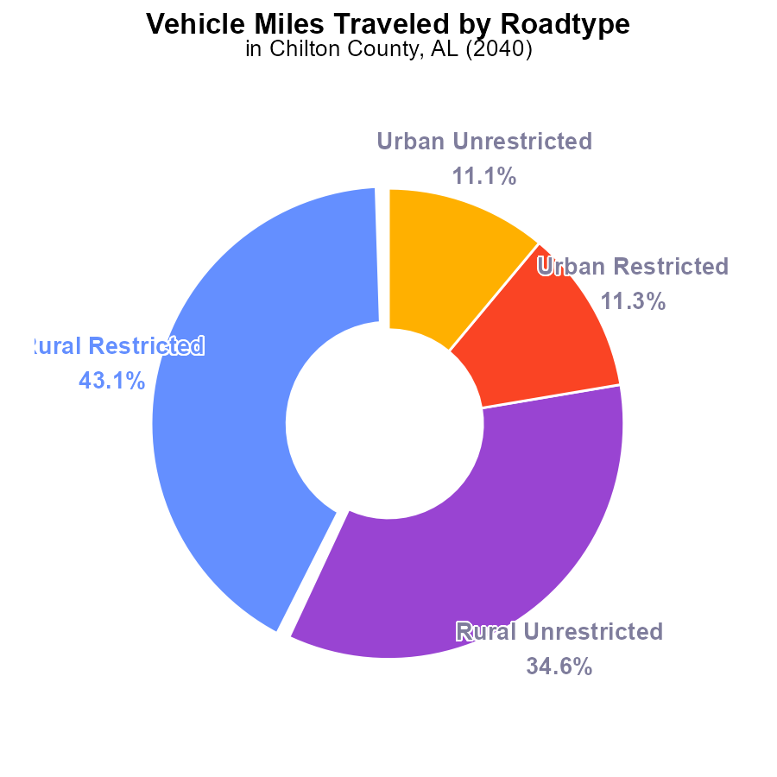

## Findings

* Rural areas contribute to 77.7% of VOC emissions from vehicle miles traveled in Chilton County.
* Urban areas account for 22.4% of VOC emissions from vehicle miles traveled in Chilton County.
* Restricted areas contribute to 54.4% of VOC emissions from vehicle miles traveled in Chilton County.

## Recommendations

To lower VOC emissions in Chilton County, policymakers should focus on implementing emission reduction strategies in rural areas, which are the primary contributors to pollution. Initiatives such as promoting public transportation, carpooling, and improving vehicle efficiency can help mitigate emissions from vehicle miles traveled in both urban and rural settings.

# Idling by Fuel Type

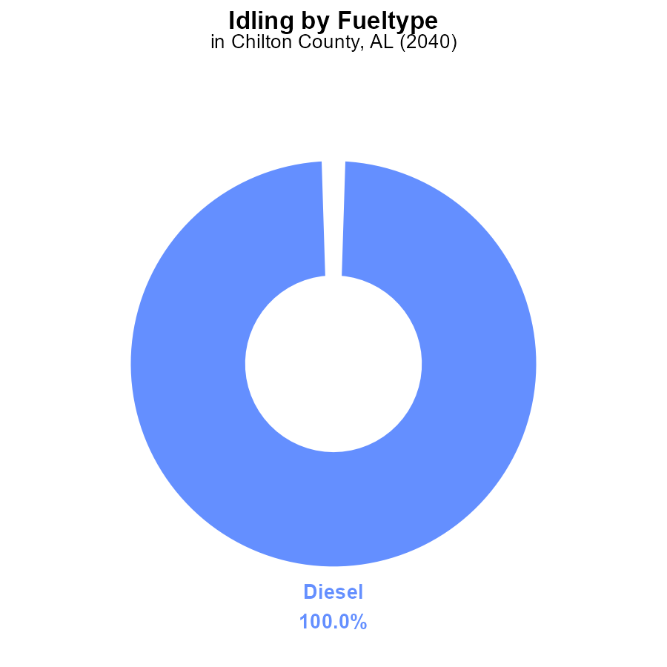

## Findings

* Diesel vehicles contribute 100% of VOC emissions from idling in Chilton County, AL in 2040.

## Recommendations

Encourage the use of alternative fuel vehicles to reduce VOC emissions from idling, focusing on replacing diesel vehicles.

# Population over Time for Passenger Vehicles

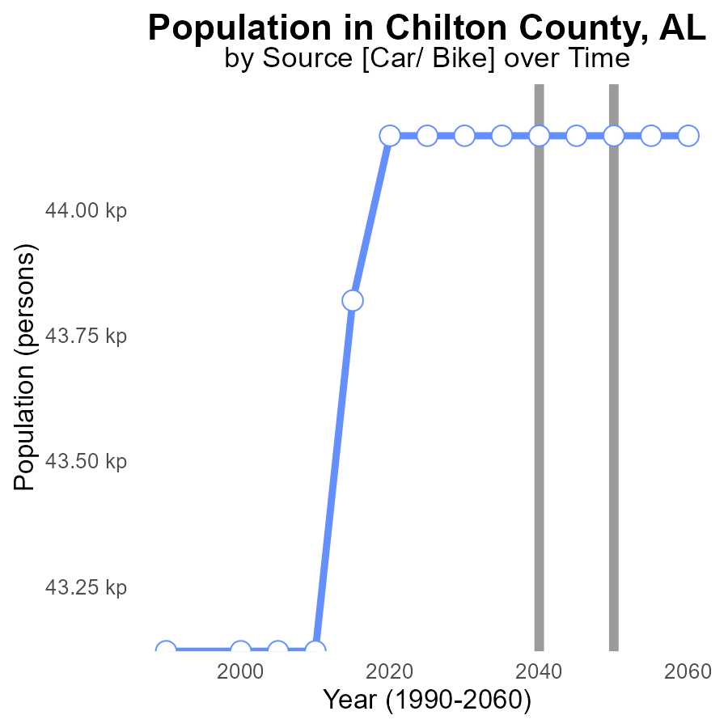

## Findings

* Chilton County, AL's VOC emissions have remained constant at 44.1 k persons from 2020 to 2060.
* There has been no change in VOC emissions compared to the benchmark in this period.
* The population of Chilton County, AL has not affected VOC emissions from 2020 to 2060.

## Recommendations

Since VOC emissions have stagnated, focus on implementing stricter regulations for industries and promoting the use of cleaner technologies to reduce emissions further. Encouraging public transportation and carpooling can also help lower VOC levels in the area.

# Time Driven Overall over Time

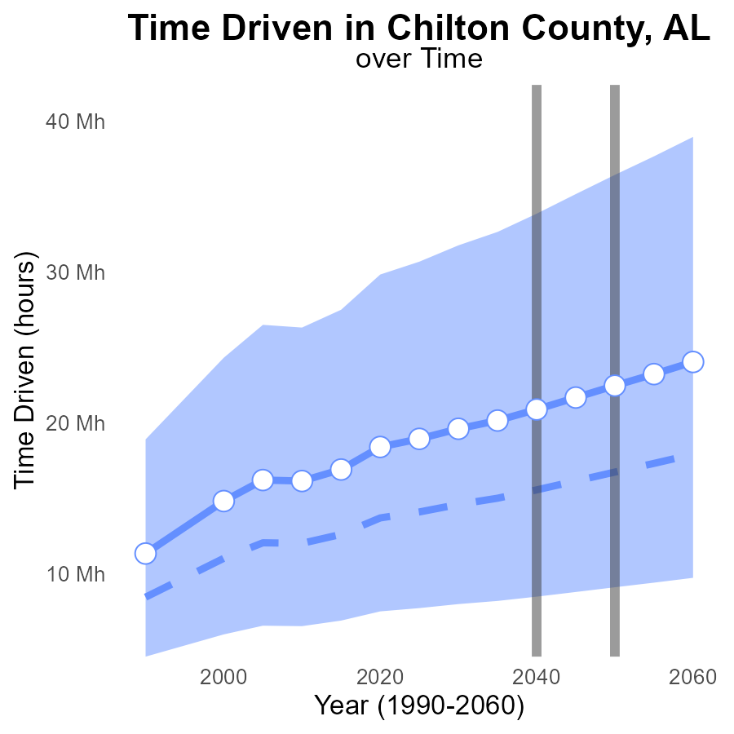

## Findings

* Emissions in Chilton County, AL are projected to increase consistently over the next 40 years.
* The amount of VOC emissions is forecasted to be always above the median area level.
* The benchmark difference shows a decreasing trend, indicating progress but still room for improvement.

## Recommendations

To lower emissions, policymakers could consider implementing stricter regulations on VOC emissions, incentivizing businesses to adopt cleaner technologies, and promoting public transportation to reduce individual car usage.

# Time Driven in My Region

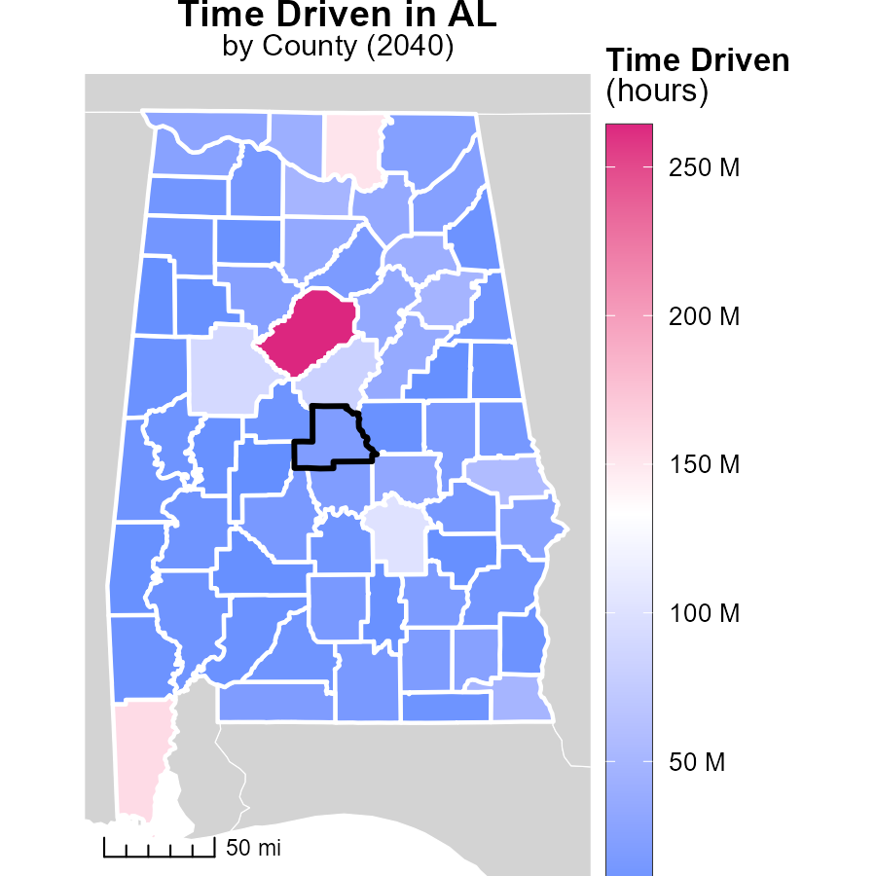

## Findings

* Jefferson County, AL emits the highest amount of emissions at 264.1 million hours.
* Butler County, AL emits a median amount of emissions at 15.6 million hours.
* Perry County, AL emits the lowest amount of emissions at 2.9 million hours.

## Recommendations

To lower emissions, implement efficient transportation systems in Jefferson County, AL. Encourage carpooling or public transportation. In Butler County, focus on promoting fuel-efficient vehicles. For Perry County, explore options for renewable energy sources to decrease emissions.

# Hotelling (Engines Off) Mapped by Area

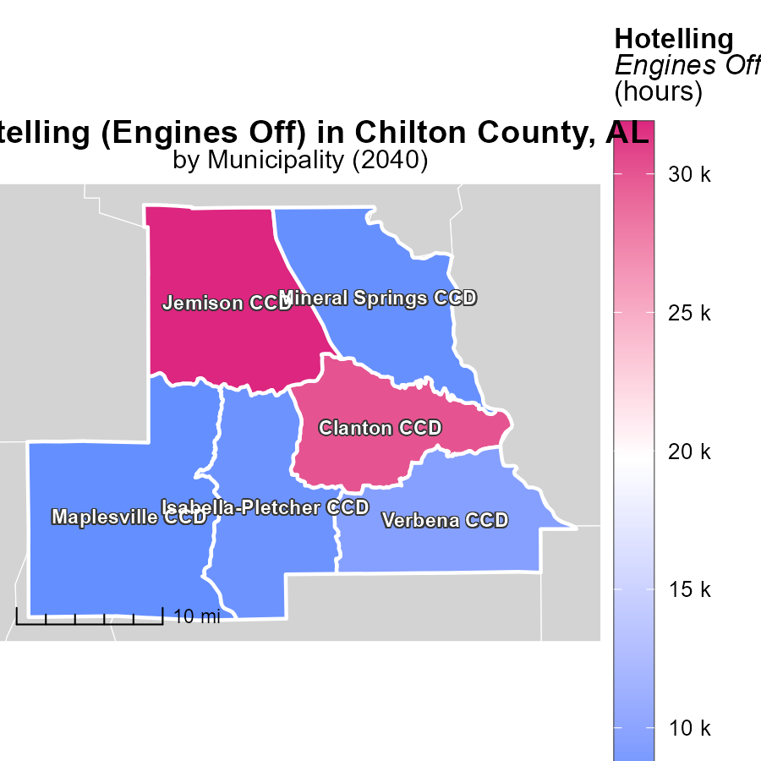

## Findings

* Jemison CCD, AL has the highest emissions at 31.9k hours.
* Isabella-Pletcher CCD, AL has a median emission level of 8.0k hours.
* Maplesville CCD, AL has the lowest emissions at 7.5k hours.

## Recommendations

To reduce emissions, focus on areas with high levels like Jemison CCD by implementing stricter regulations or promoting the use of cleaner technologies. Encourage energy-efficient practices in all areas to lower overall emissions.

# Hotelling (Engines Off) by Area over Time

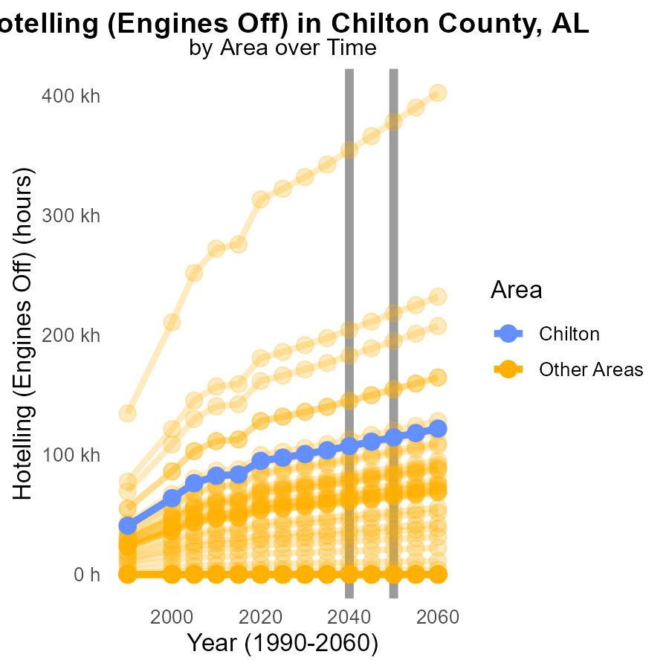

## Findings

* In 2040, the VOC emissions in max_county were 354.1 k, which was 99.9% higher than min_county with 0.0 emissions.
* Target_county had 107.2 k VOC emissions in 2040, 7201.6 higher than min_county's emissions of 0.0.
* In 2040, there was a notable difference in emissions between max_county and min_county, showing the need for targeted interventions.

## Recommendations

To decrease emissions, implement stricter regulations in areas with higher emissions like max_county. Encourage the adoption of cleaner technologies in target_county to reduce the gap between high and low emitting areas.

# Emissions Rate (per capita) by Fuel Type over Time

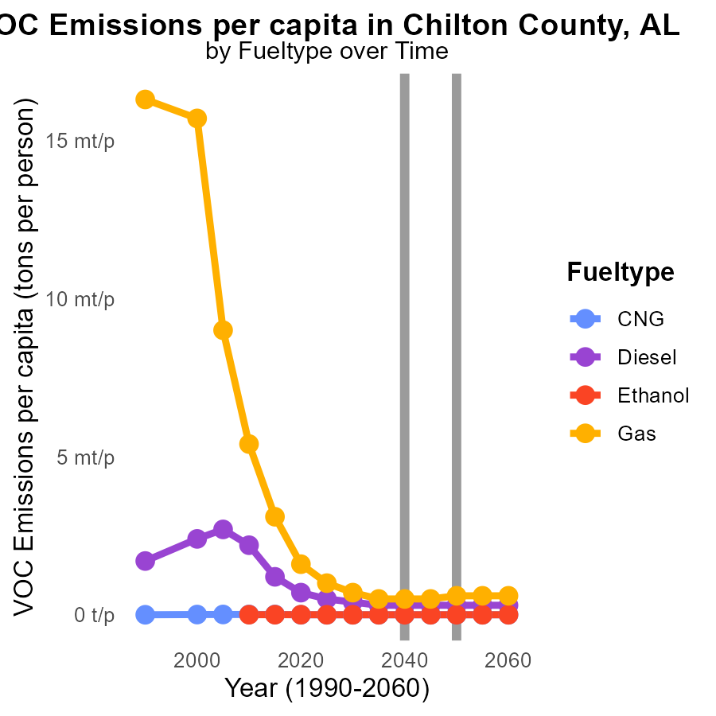

## Findings

* In 2030, CNG emissions were 18.1 tons per person, with no change through 2050.
* The emissions from Diesel decreased from 353.4 µ in 2030 to 294.5 µ in 2050.
* Gas emissions fluctuated but slightly increased from 672.8 µ in 2030 to 566.3 µ in 2050.

## Recommendations

To lower emissions, focus on promoting cleaner fuel types like CNG and Diesel that show reductions over the years. Implement policies to stabilize Gas emissions which experienced fluctuations.

# Areas Ranked by Vehicle Starts

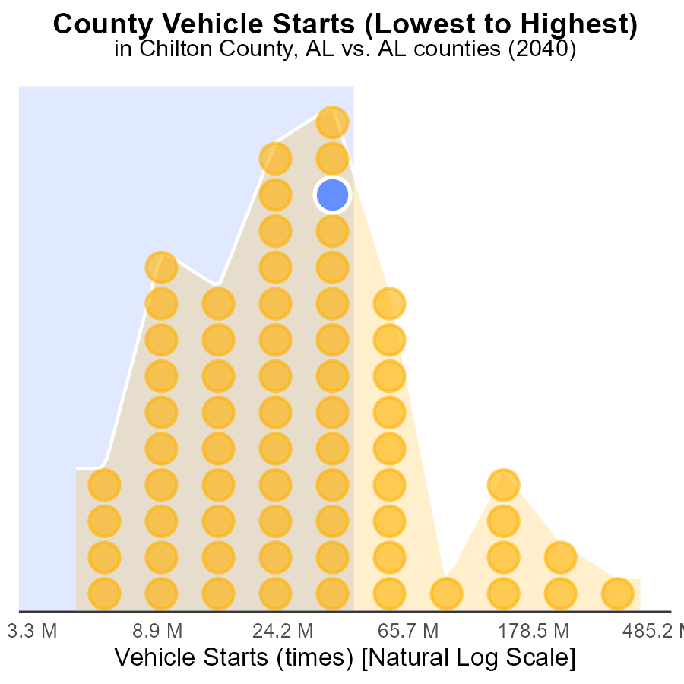

## Findings

* Jefferson county has the highest VOC emissions from vehicle starts at 1.2 G.
* Perry county has the lowest VOC emissions, accounting for only 1.5% of the total.
* Chilton, Marshall, and Walker counties contribute similarly to VOC emissions, ranging from 70.1% to 73.1%.

## Recommendations

To lower VOC emissions from vehicle starts, focus on implementing stricter emission standards for vehicles in high-ranking counties like Jefferson. Encourage the use of electric and hybrid vehicles in lower-ranking counties such as Perry to reduce overall emissions.

# Areas Ranked by Emissions Rate (per mile)

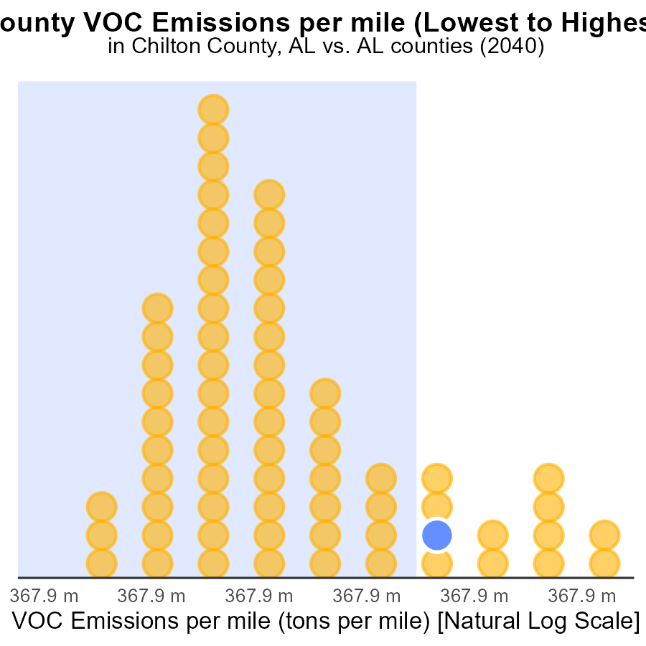

## Findings

* Jefferson County has the lowest VOC emissions per mile at 32.3 tons/mile.
* Conecuh County has the highest rate of VOC emissions per mile, ranking 67th with 37.5 tons/mile.
* Overall, counties like Chilton, Marion, and Autauga have high VOC emissions per mile, ranging from 35.5 to 35.8 tons/mile.

## Recommendations

To lower VOC emissions, focus should be on implementing carpooling initiatives in counties with high emissions per mile like Chilton, Marion, and Autauga. In areas like Conecuh County, targeted efforts are needed to improve vehicle efficiency and promote alternative transportation methods.

# Conclusion

In conclusion, the analysis of Volatile Organic Compounds (VOC) emissions from on-road transportation in Chilton County, AL in 2040 reveals several key insights. Rural areas are the primary contributors to VOC emissions, showcasing the need for targeted strategies in these regions. Diesel vehicles significantly impact emissions from idling, emphasizing the importance of promoting alternative fuel vehicles.

Despite the stagnant VOC emissions in the county over the years, projections indicate a consistent increase in the future, necessitating stricter regulations and the adoption of cleaner technologies. Variations in emissions among different counties highlight the importance of tailored interventions based on their specific emission levels. By focusing on reducing emissions from high-ranking areas and promoting cleaner fuel types, Chilton County can work towards a more sustainable transportation sector.

# About This Report

Data based on MOVES estimates collected by the Climate Action in Transportation program at Cornell University. Demographic data sourced from the US Census's American Community Survey 5-year estimates. This report was generated with the help of AI.

# References

* U.S. Census Bureau. (2023). American Community Survey 5-year estimates: Detailed tables. Retrieved from https://data.census.gov
* U.S. Environmental Protection Agency. (2024). Motor Vehicle Emission Simulator (MOVES 4.0) [Software]. Retrieved from https://www.epa.gov/moves