 

**PM2.5 Emissions in Grafton County, 2035**  
Made with CAT VISUALIZER by Gao Labs @ Cornell University.

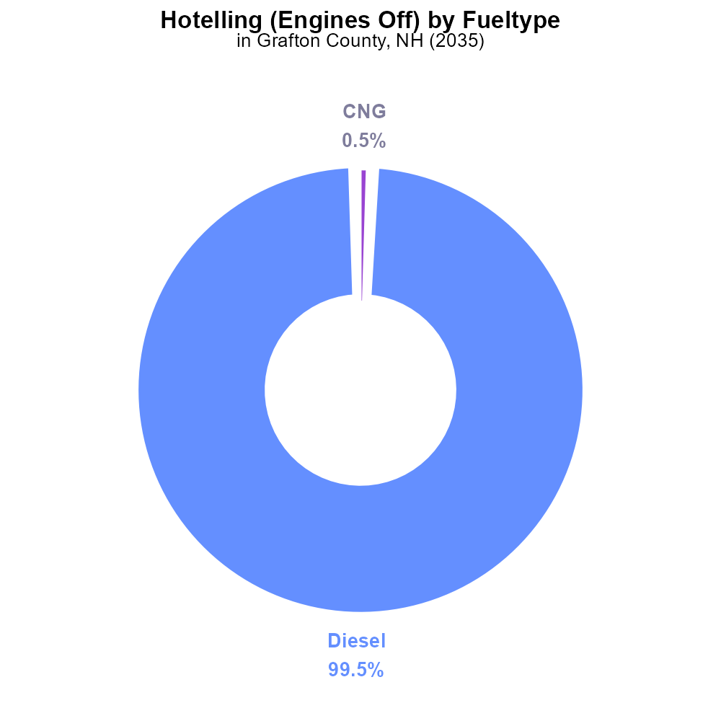

## Keywords

Primary Exhaust; PM2.5; Total emissions; on-road transportation; Grafton County; 2035

## Highlights

* Examination of PM2.5 emissions from on-road transportation in Grafton County.
* Analysis extended to predictions for the year 2035.
* Focus on primary exhaust sources and their contribution to pollution levels.
* Implications for air quality and public health in the region.
* Insights to inform future policies and initiatives for pollution control.

# Introduction

In this report, we delve into the realm of primary exhaust PM2.5 emissions arising from on-road transportation activities within Grafton County, New Hampshire. The study not only examines the current state of emissions but also extends its analysis to make predictions for the year 2035. By focusing on primary exhaust sources, the report aims to shed light on the significant contributors to PM2.5 pollution in the region.

This investigation holds critical implications for the air quality and public health of residents in Grafton County. By understanding the sources and trends of PM2.5 emissions, policymakers and stakeholders can gain valuable insights to formulate and implement effective strategies for pollution control and mitigation, ensuring a healthier and more sustainable environment for future generations.

# Idling by Vehicle Type

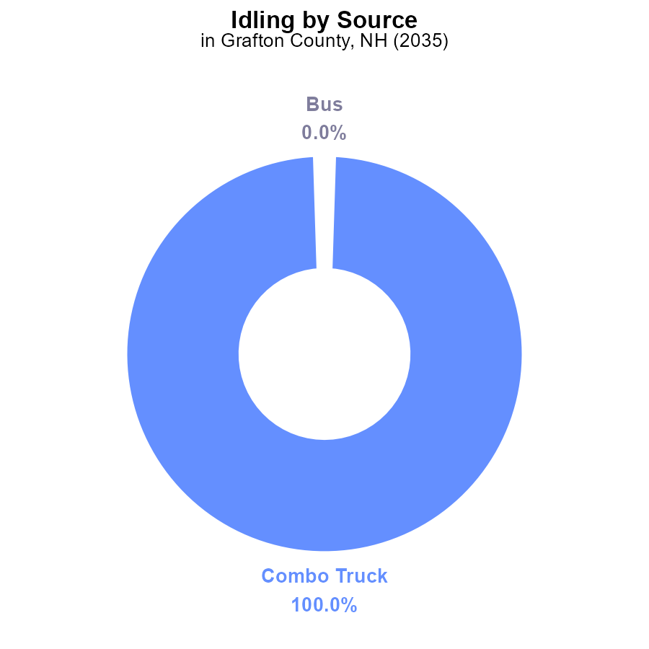

## Findings

* In 2035, Combo Trucks in Grafton County, NH contributed 100.0% of PM2.5 emissions from idling.
* Buses, Cars/Bikes, Heavy Trucks, and Light Trucks did not contribute to PM2.5 emissions from idling in 2035.

## Recommendations

To lower PM2.5 emissions from idling in Grafton County, NH, focus on reducing idling time and promoting the use of cleaner technologies in Combo Trucks.

# Hotelling (Engines Off) by Fuel Type

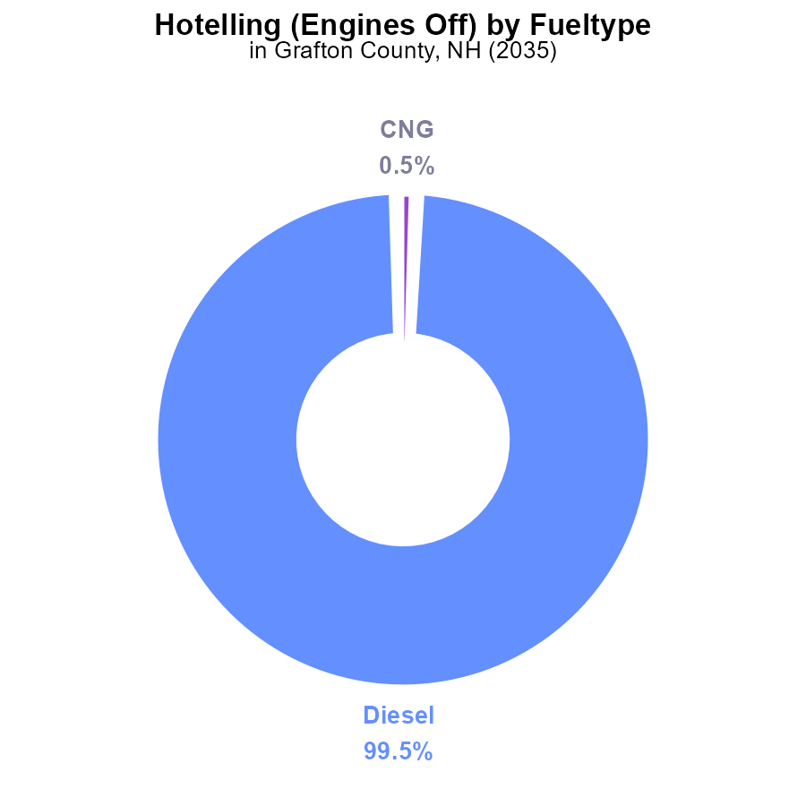

## Findings

* Diesel engines contribute to 99.5% of PM2.5 emissions from vehicles with engines off in Grafton County in 2035.
* CNG engines contribute to 0.5% of PM2.5 emissions from vehicles in the same category.
* No PM2.5 emissions are reported from ethanol or gasoline vehicles with engines off in the region.

## Recommendations

To lower PM2.5 emissions in Grafton County, policies should focus on reducing diesel engine use through incentives for low-emission alternatives like CNG or electric vehicles.

# Emissions over Time for Buses

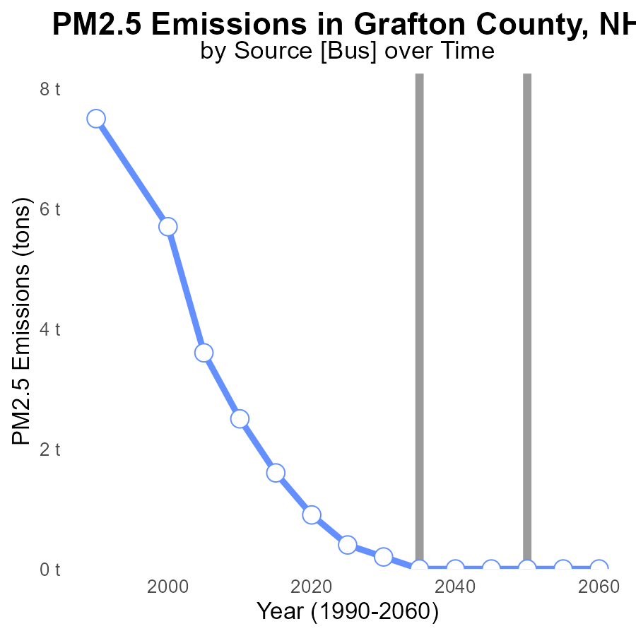

## Findings

* PM2.5 emissions in Grafton County reduced from 1.6 tons in 2015 to 0 tons in 2035.
* The most significant decrease occurred between 2015 and 2020 when emissions dropped from 1.6 tons to 900 tons.
* Emissions are projected to remain at 0 tons from 2035 to 2055.

## Recommendations

To maintain and further improve the current emission levels, policymakers can focus on promoting clean energy initiatives, enforcing stricter emission regulations for industries, and investing in public transportation to reduce individual vehicle emissions.

# Population over Time for Passenger Vehicles

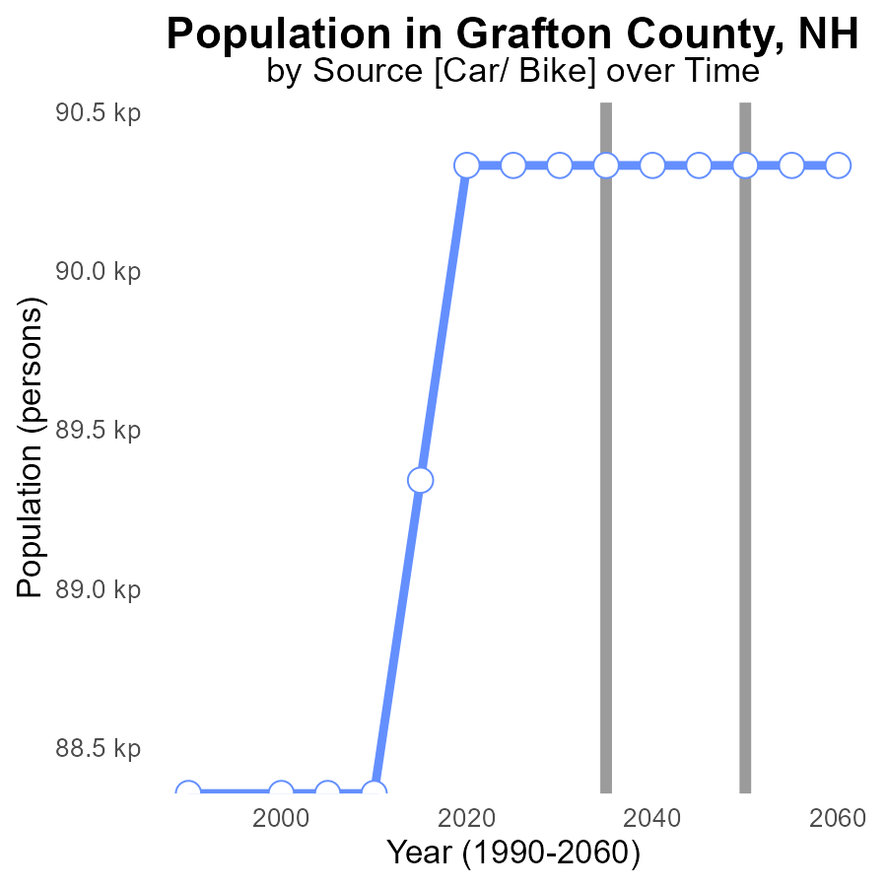

## Findings

* PM2.5 emissions in Grafton County, NH remained constant at 90.3k persons from 2020 to 2055.
* Benchmark difference decreased by 990 persons from 2015 to 2020.
* No further reduction in benchmark difference is projected from 2020 to 2055.

## Recommendations

To lower PM2.5 emissions in Grafton County, NH, it is crucial to implement strict pollution control measures. Encouraging the use of public transportation, promoting energy-efficient practices, and investing in renewable energy sources can aid in reducing emissions.

# Time Driven Mapped by Area

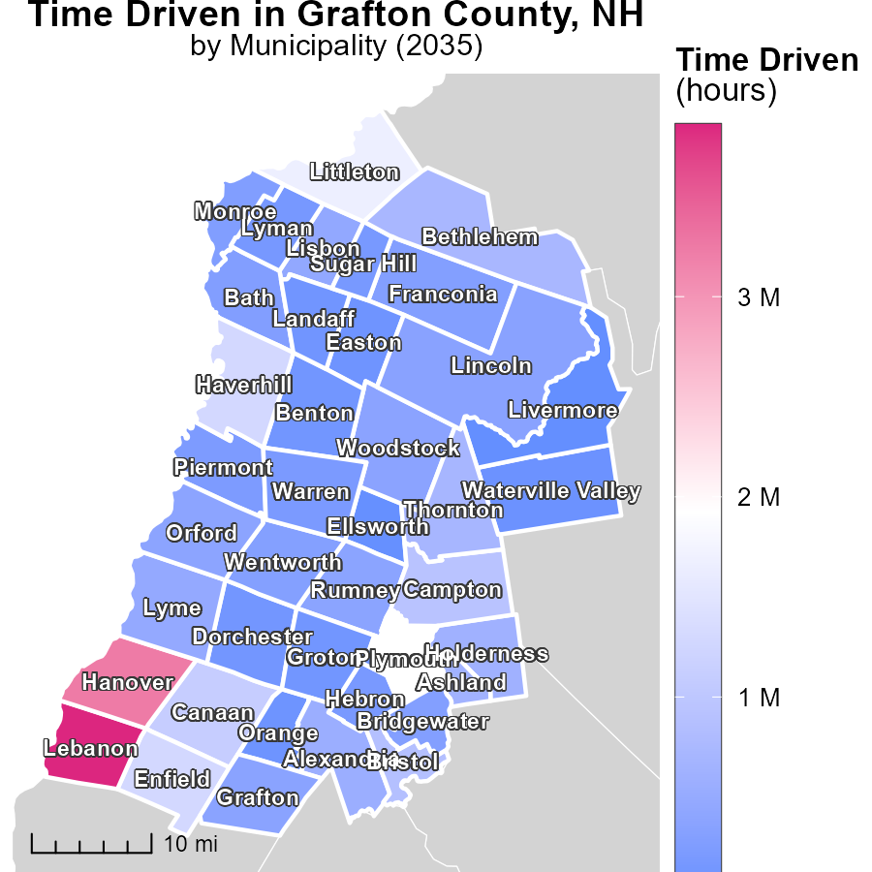

## Findings

* The maximum emissions in Lebanon, NH are 3.9 million hours.
* Grafton, NH has a median emission rate of 363.8 thousand hours.
* Livermore, NH recorded no emissions during the period.

## Recommendations

To reduce emissions, focus on decreasing activity in Lebanon, NH, which has the highest emissions. Implement measures to lower emissions in Grafton, NH as well. Encourage sustainable practices to maintain zero emissions in Livermore, NH.

# Idling Mapped by Area

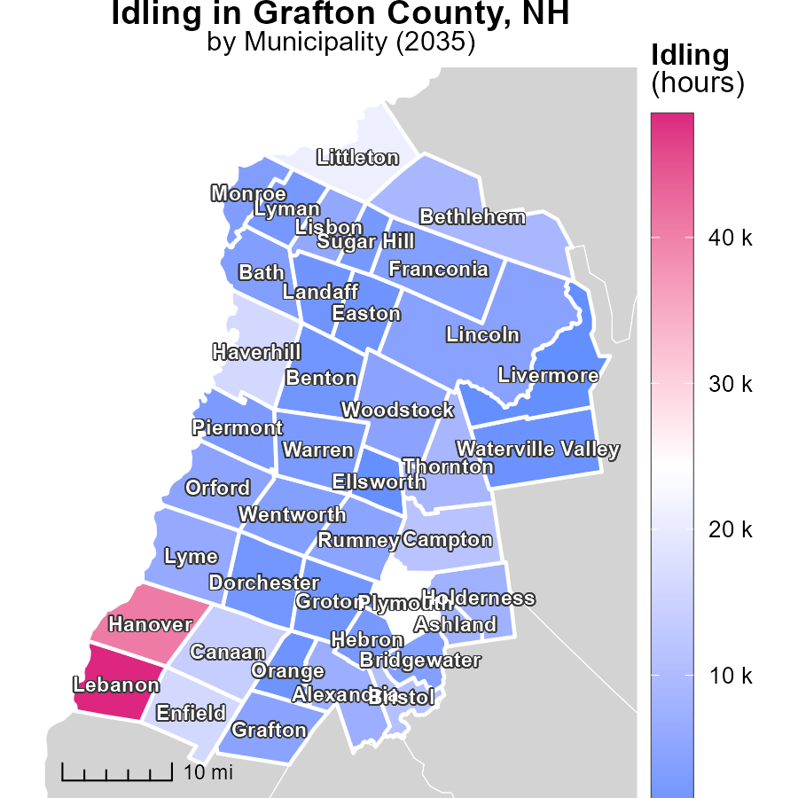

## Findings

* Lebanon, NH has the highest idling hours with 48.5k, Grafton, NH has a median of 4.6k, while Livermore, NH shows no idling hours
* Overall, idling emissions in NH contribute significantly to air pollution
* Reducing idling time in these areas can effectively lower emissions levels

## Recommendations

To lower idling emissions, implement idling reduction campaigns in high idling areas like Lebanon, NH. Encourage the use of anti-idling technologies in vehicles and promote education on the environmental impacts of excessive idling.

# Vehicle Miles Traveled by Regulatory Class over Time

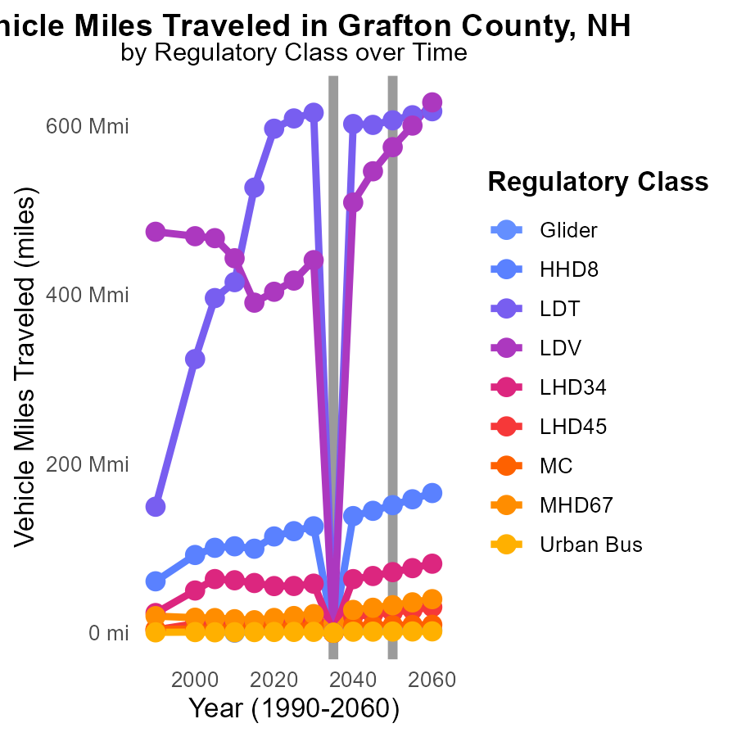

## Findings

* Vehicle miles traveled for PM2.5 show varied trends over the years 2025 to 2045.
* HHD8 emissions are expected to increase significantly by 151.02 million from 2035 to 2040.
* LDV emissions show a sharp increase of 574.57 million from 2035 to 2040.

## Recommendations

To reduce emissions, policymakers can promote the use of electric vehicles, improve public transportation infrastructure, and implement stricter vehicle emissions regulations, especially for high-emission vehicle classes such as HHD8 and LDV.

# Time Driven by Area over Time

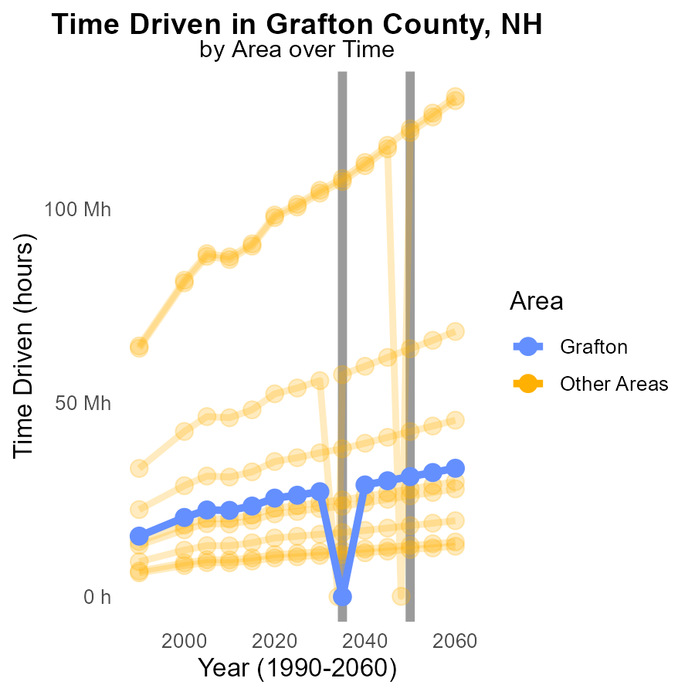

## Findings

* In 2035, the minimum county emitted 5.9 thousand PM2.5 units.
* During the same year, the maximum county emitted 107.7 million PM2.5 units.

## Recommendations

To reduce emissions, focus on the maximum emitting county by implementing stricter pollution control measures and promoting cleaner production methods. Develop emission reduction strategies targeting specific industries or activities in that county.

# Areas Ranked by Vehicles

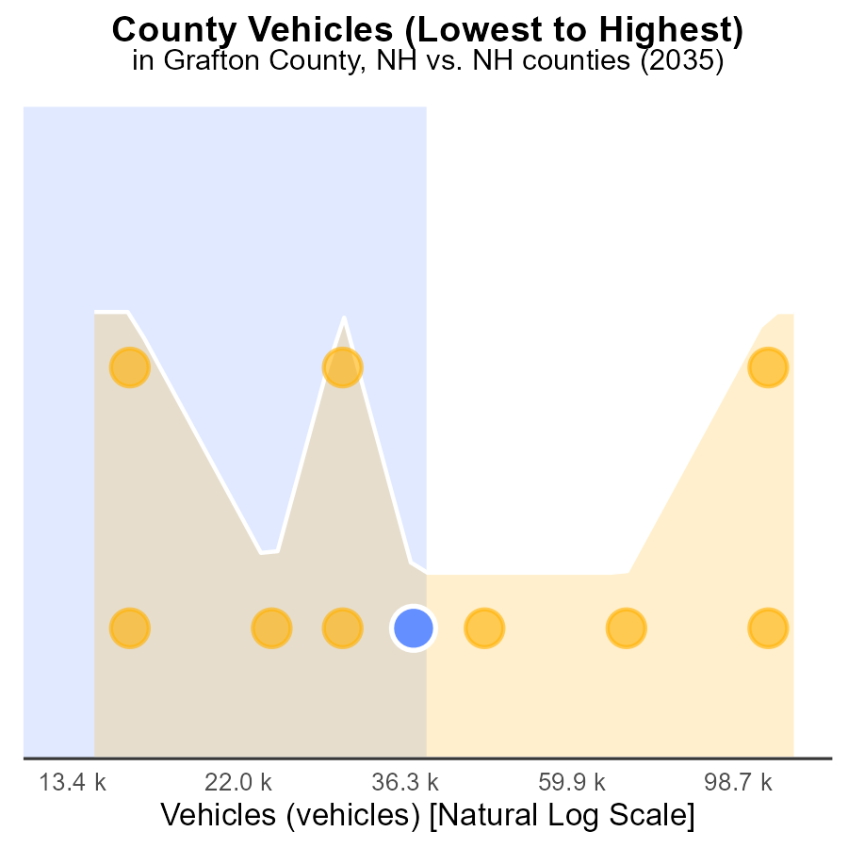

## Findings

* Rockingham has the highest number of vehicles with 326.5k, ranking 10th.
* Strafford ranks 7th with 113.8k vehicles, comprising 70.0% of total vehicles.
* Sullivan has 38.8k vehicles, ranking 1st with the lowest number comprising 10.0% of total vehicles.

## Recommendations

To decrease PM2.5 emissions from vehicles, prioritize Rockingham as the highest contributor. Invest in green transportation alternatives and infrastructure, implement vehicle emission standards, and promote public transportation.

# Areas Ranked by Idling

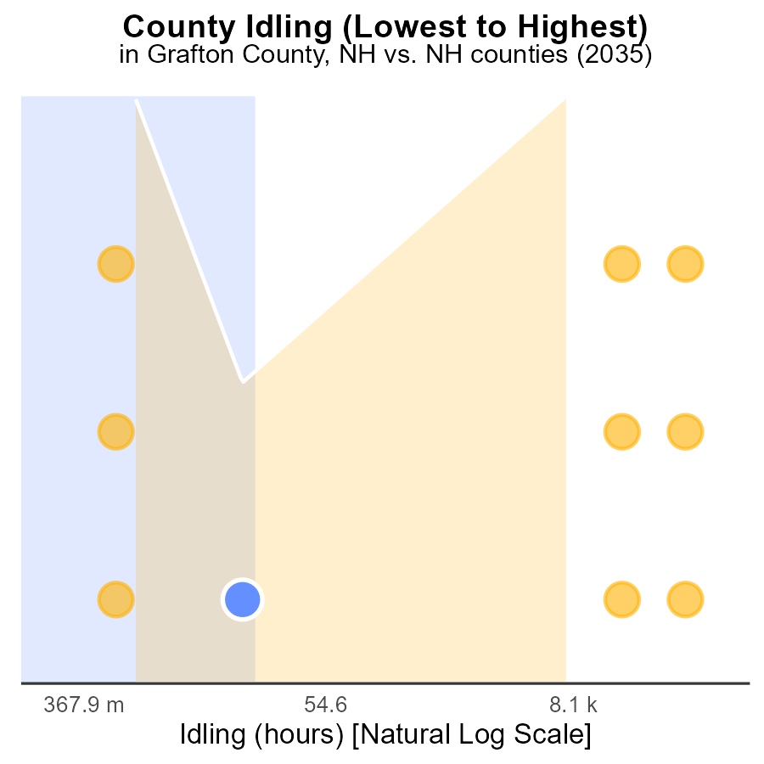

## Findings

* Merrimack county has the highest idling emissions at 415.7k hours, ranking 10th.
* Strafford county follows with 41.4k idle hours, ranking 5th.
* Carroll and Coos counties have zero idling emissions, ranking 1st and 3rd, respectively.

## Recommendations

To lower emissions, promote anti-idling campaigns in Grafton and Strafford counties, targeting high idle hour areas to lower emissions significantly.

# Conclusion

In conclusion, the report on Primary Exhaust PM2.5 - Total emissions from on-road transportation in Grafton County, NH in 2035 has provided valuable insights into the sources and trends of PM2.5 emissions. It is evident that a significant reduction in emissions has been achieved over the years, leading to a projection of zero tons of emissions from 2035 to 2055. The data highlights the importance of focusing on reducing idling time, promoting cleaner technologies in Combo Trucks, and encouraging the use of low-emission alternatives like CNG or electric vehicles to further decrease PM2.5 emissions in the region.

Furthermore, the report emphasizes the need for strict pollution control measures, investment in renewable energy sources, and promotion of energy-efficient practices to maintain and improve the current emission levels. By implementing idling reduction campaigns in high idling areas, promoting anti-idling technologies in vehicles, and raising awareness about the environmental impacts of excessive idling, significant progress can be made in lowering emissions levels. Policymakers can also prioritize Rockingham County as the highest contributor to vehicle emissions and focus on implementing emission reduction strategies targeting specific industries or activities in high-emitting areas.

# About This Report

Data based on MOVES estimates collected by the Climate Action in Transportation program at Cornell University. Demographic data sourced from the US Census's American Community Survey 5-year estimates. This report was generated with the help of AI.

# References

* U.S. Census Bureau. (2023). American Community Survey 5-year estimates: Detailed tables. Retrieved from https://data.census.gov
* U.S. Environmental Protection Agency. (2024). Motor Vehicle Emission Simulator (MOVES 4.0) [Software]. Retrieved from https://www.epa.gov/moves