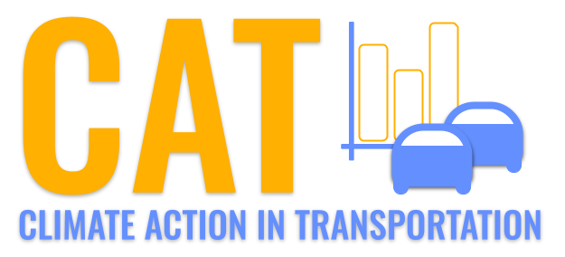 

**Carbon Emissions in Mercer County, 2060**  
Made with CAT VISUALIZER by Gao Labs @ Cornell University.

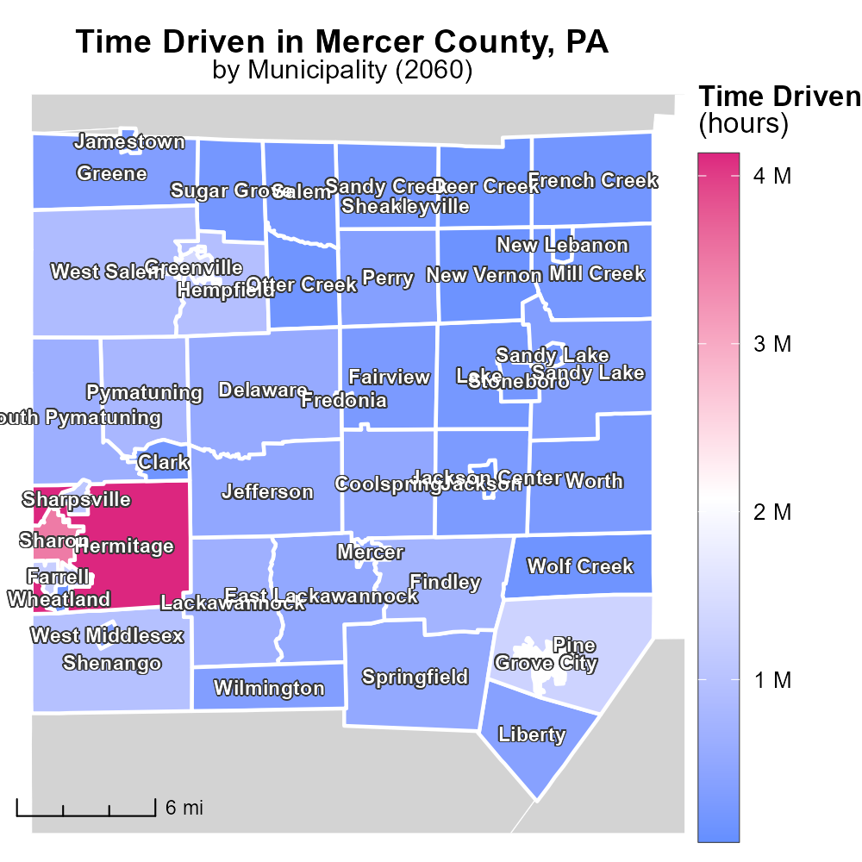

## Keywords

CO2 equivalent emissions; on-road transportation; Mercer County; 2060; environmental impact; carbon footprint

## Highlights

* In 2060, on-road transportation in Mercer County emitted significant CO2 equivalent gases.
* The report analyzes the environmental impact of on-road transportation in the county.
* Understanding the carbon footprint can help in developing sustainable transportation policies.
* Mercer County faces challenges in reducing CO2 emissions from transportation.
* Recommendations for mitigating CO2 emissions are crucial for future environmental sustainability.

# Introduction

The report focuses on the CO2 equivalent emissions resulting from on-road transportation in Mercer County, Pennsylvania, in the year 2060. As the county's population grows and economic activities increase, the demand for transportation also rises, leading to a higher carbon footprint. By examining the emissions data, we can assess the environmental impact of on-road transportation and identify areas for improvement.

Mercer County is at a critical juncture in addressing the challenges posed by CO2 emissions from transportation. Developing strategies to curb these emissions is essential for sustainable development and to mitigate the effects of climate change. This report aims to provide insights and recommendations to policymakers to help in reducing the carbon footprint of on-road transportation in Mercer County.

# Population by Road Type

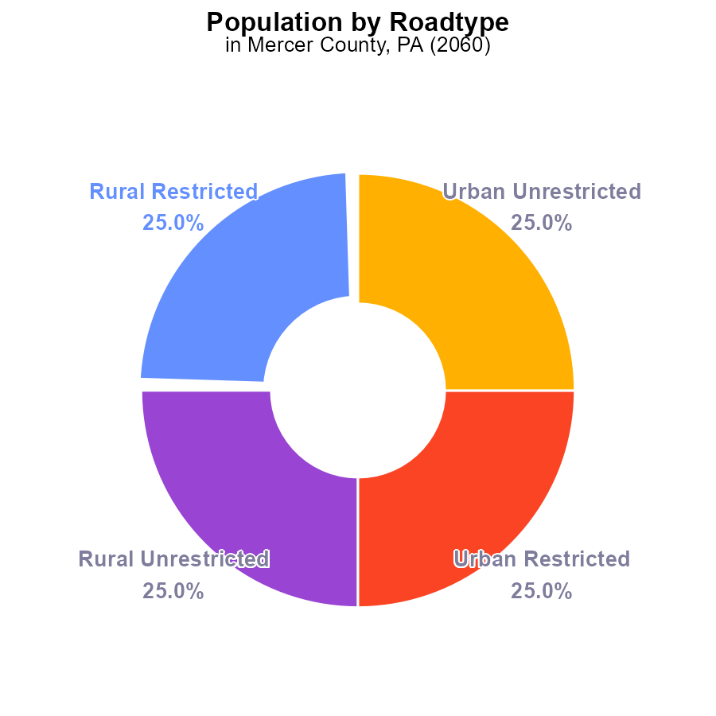

## Findings

* CO2e emissions in Mercer County, PA in 2060 totaled 442,000 persons.
* Rural and urban areas each contributed 50% of the total emissions.
* Both restricted and unrestricted areas emitted an equal amount of CO2e, totaling 221,000 persons each.

## Recommendations

To lower emissions, focus on reducing energy consumption through efficiency programs in all areas. Encourage public transportation and carpooling to decrease individual carbon footprints.

# Hotelling (Diesel Aux) by Vehicle Type

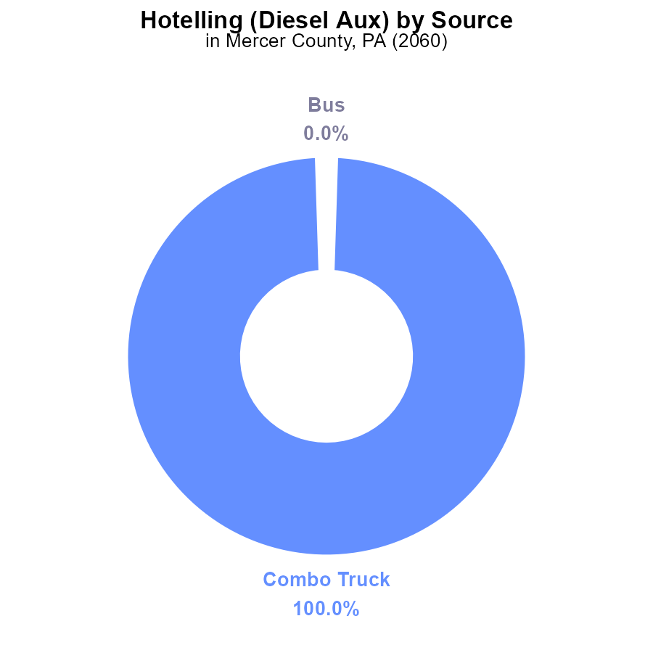

## Findings

* In 2060, the Combo Truck emitted 267.1 k CO2e in Mercer County, PA.
* No emissions were recorded for Bus, Car/Bike, Heavy Truck, or Light Truck in the same period.
* The Combo Truck accounted for 100% of the CO2e emissions in the Hotelling (Diesel Aux) category.

## Recommendations

To lower emissions, consider optimizing the Combo Truck's fuel efficiency or exploring alternative fuel sources. Monitor and incentivize emission reductions for other vehicle types.

# Time Driven over Time for Passenger Time Driven

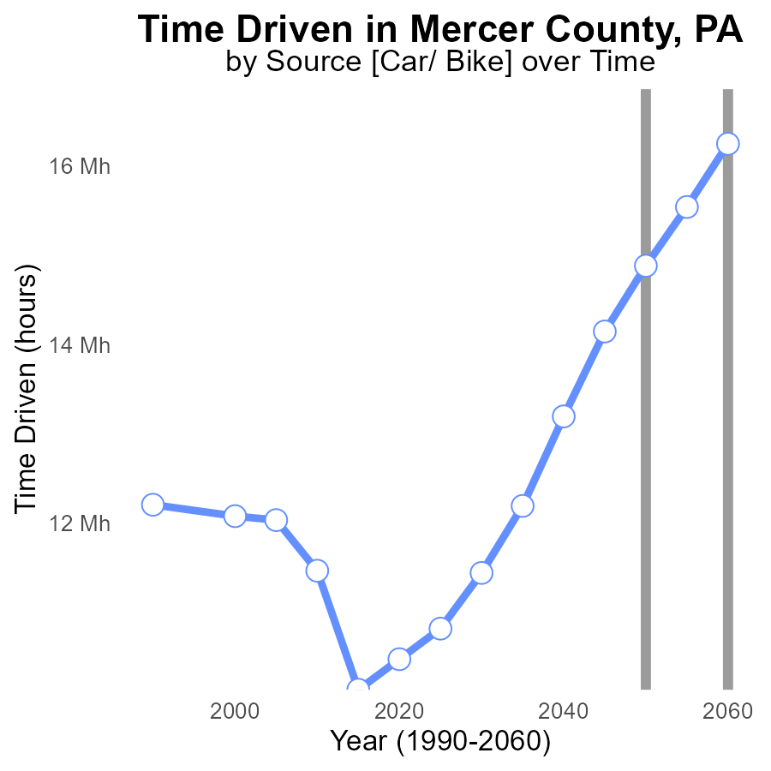

## Findings

* CO2e emissions in Mercer County, PA have been increasing over time, reaching 16.2 M in 2060.
* There was a significant decrease in emissions from 2050 to 2055, with a reduction of 657596.7 units.
* By 2060, emissions were 1364421.7 units lower compared to 2050, indicating a positive trend towards emission reduction.

## Recommendations

To further reduce emissions in Mercer County, PA, it is imperative to focus on the strategies that have proven successful in the past, particularly those that led to the significant decrease in emissions between 2050 and 2055. Encouraging the adoption of clean energy sources and promoting energy efficiency initiatives can contribute to a sustained reduction in CO2e emissions. Additionally, implementing policies to incentivize the use of electric vehicles and promoting public transportation can help mitigate emissions from the transportation sector.

# Vehicles Overall over Time

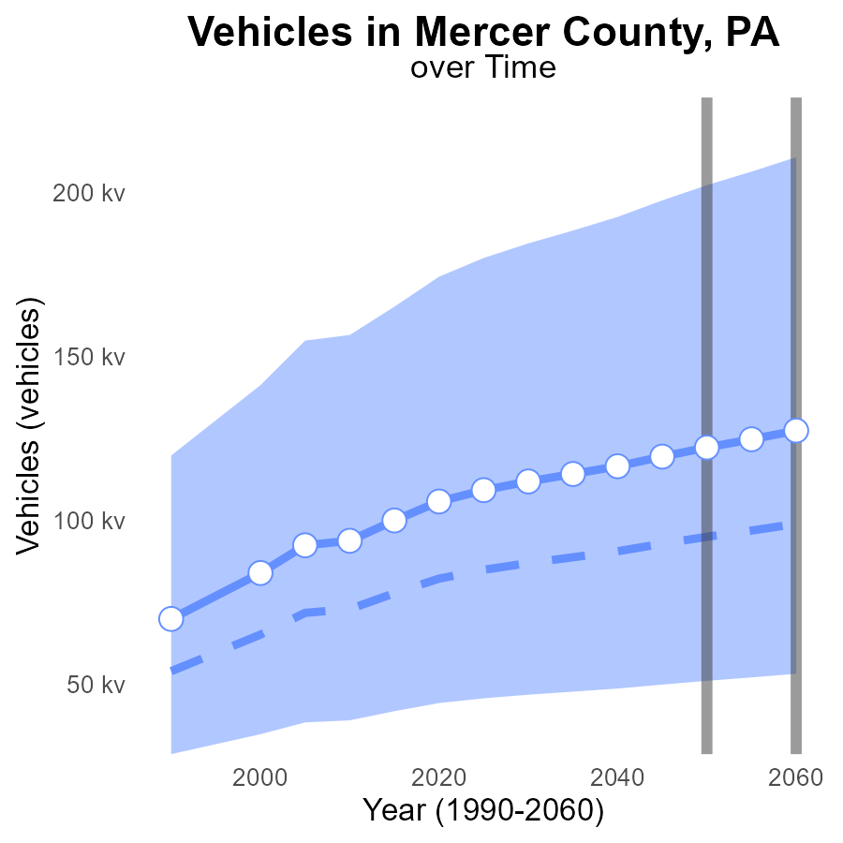

## Findings

* By 2060, Mercer County's CO2e emissions from vehicles are projected to reach 127.5 k, with a 28.5 k difference from the median area.
* In 2050, emissions are expected to be 122.4 k, 27.2 k above the median area and no significant difference from the upper 75th percentile of areas.
* Emissions surpass the lower 25th percentile benchmark (51177.45 k) each year from 2040 to 2060, reaching a peak of 127.5 k in 2060.

## Recommendations

To reduce CO2e emissions from vehicles in Mercer County, it is essential to implement policies that promote electric vehicle adoption, improve public transportation infrastructure, and incentivize carpooling. Encouraging biking and walking can also contribute to lowering emissions.

# Time Driven Mapped by Area

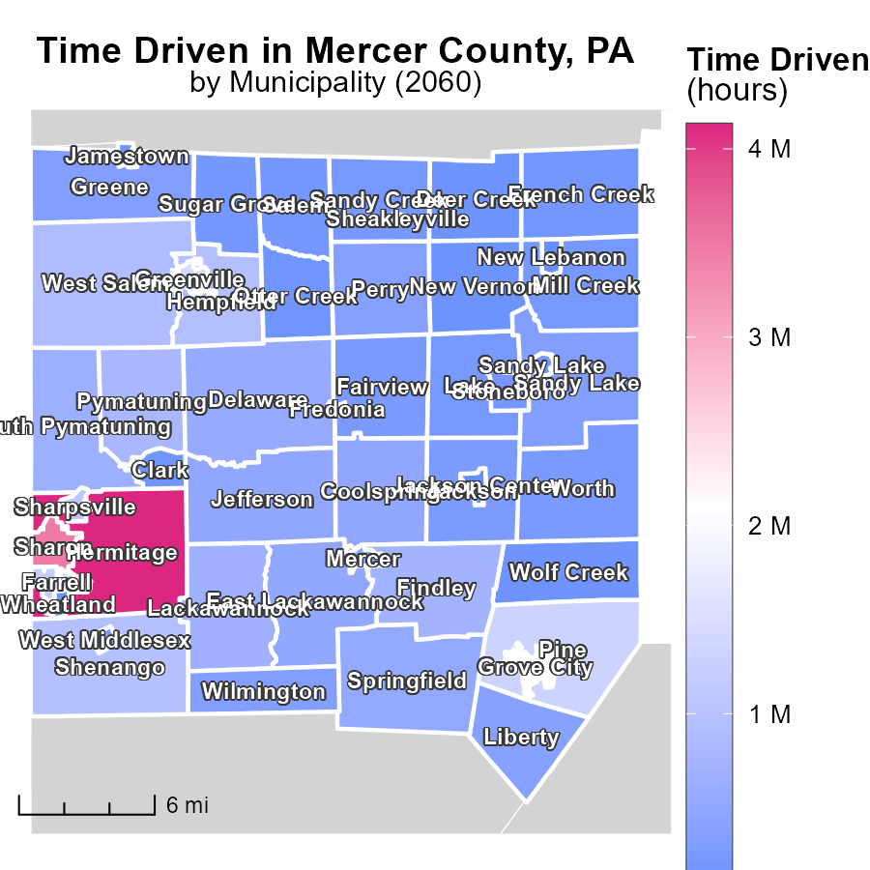

## Findings

* Hermitage, PA emitted 4.1 million tons of emissions, the highest among the locations.
* Sandy Lake, PA emitted 335.4 thousand tons, which is the median value of emissions.
* Sheakleyville, PA emitted the lowest amount of CO2 with 37.1 thousand tons.

## Recommendations

To reduce emissions, focus on high emitters like Hermitage, PA, by implementing stricter regulations and promoting cleaner energy sources. Encourage medium emitters like Sandy Lake, PA, to adopt sustainable practices. Provide support to low emitters like Sheakleyville, PA, to maintain their low emission levels.

# Emissions Rate (per capita) Mapped by Area

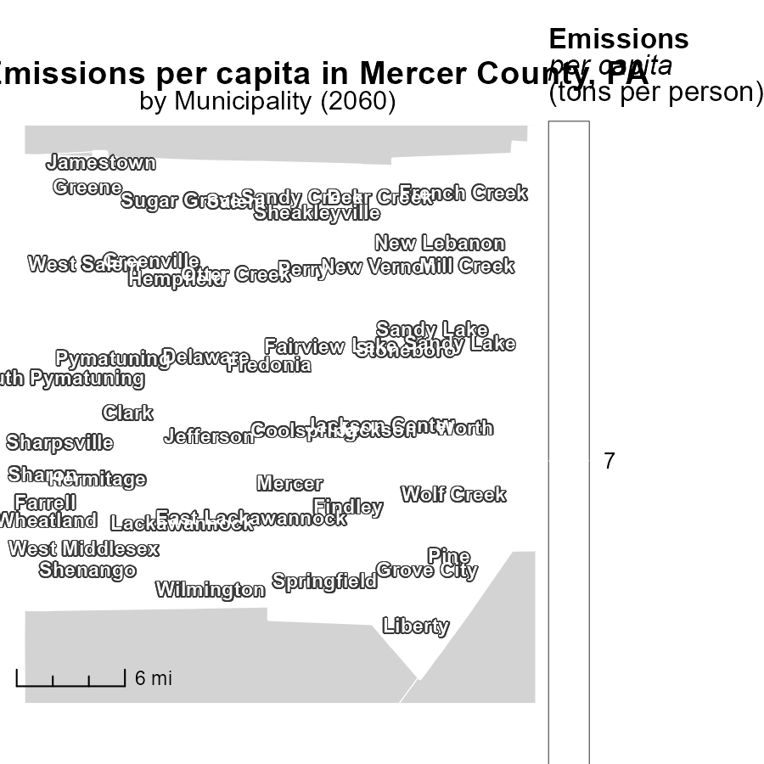

## Findings

* Clark, PA has the highest emissions per capita at 7.0 tons per person.
* Mill Creek, PA and Worth, PA also have emissions per capita of 7.0 tons per person.
* There is no variance in emissions per capita among Clark, PA, Mill Creek, PA, and Worth, PA.

## Recommendations

To address the uniform high emissions per capita in Clark, PA, Mill Creek, PA, and Worth, PA, implementing community-wide initiatives aimed at reducing carbon footprints is recommended. This could include promoting public transportation, energy-efficient practices, and renewable energy sources within these areas.

# Hotelling (Engines Off) by Vehicle Type over Time

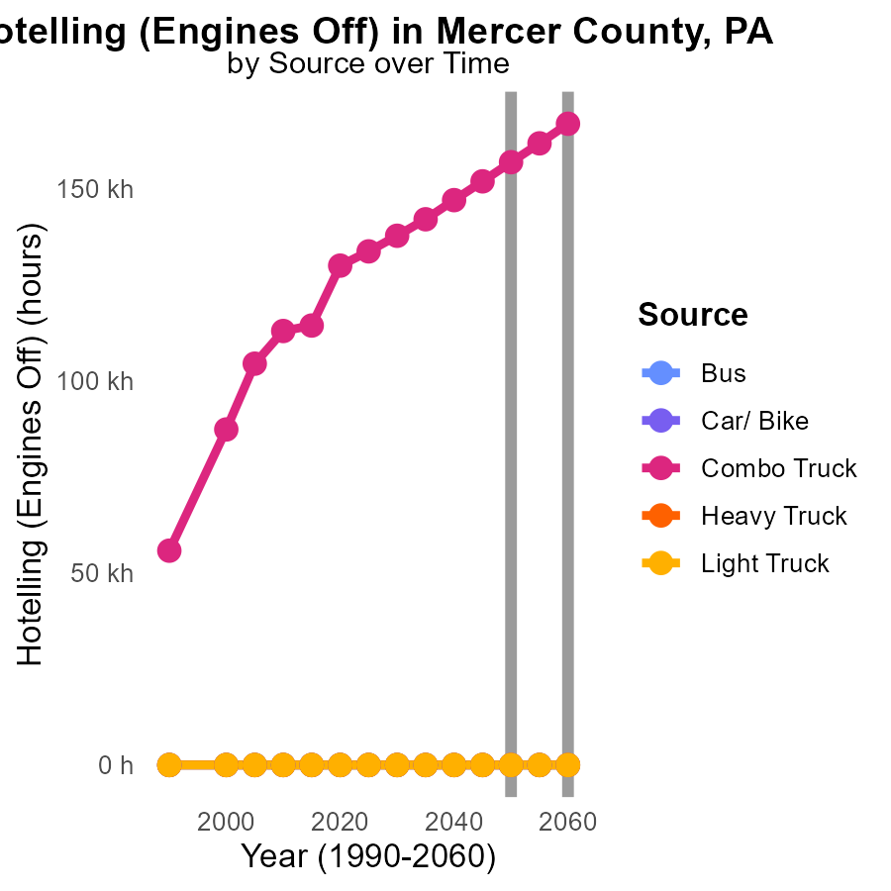

## Findings

* Combo Truck emissions increase from 156.9k to 166.9k CO2e between 2050-2060.
* Significant reductions seen in Heavy and Light Trucks emissions from 2050-2060.
* Bus and Car/Bike emissions remain consistently low from 2050-2060.

## Recommendations

To lower emissions levels in Mercer County, PA, focus on improving fuel efficiency in Combo Trucks to reduce the increasing emissions trend. Additionally, continue promoting the use of low-emission vehicles in the Heavy and Light Truck categories to maintain the significant reduction seen. Encouraging alternative transportation methods for the public, such as public transportation and biking, can help sustain the low emissions in Bus and Car/Bike categories.

# Emissions Rate (per capita) by Vehicle Type over Time

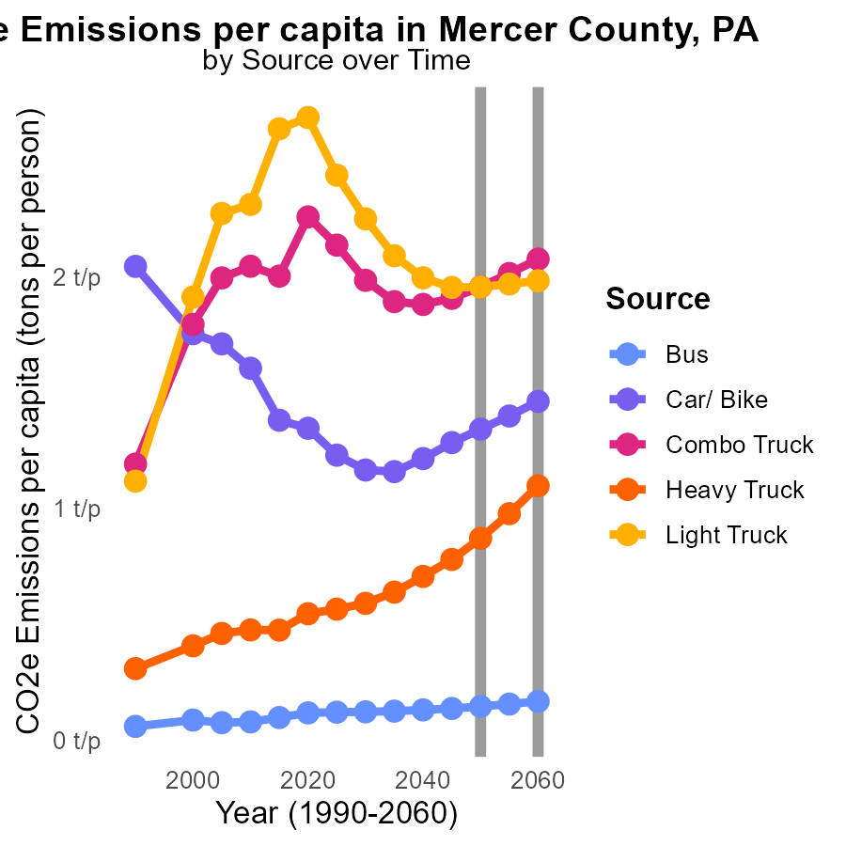

## Findings

* Emissions from Heavy Trucks show a decline by 22.57% from 2050 to 2060.
* Emissions per capita from Cars/ Bikes decrease by 11.95% between 2050 and 2060.
* There is consistency in emissions from Light Trucks, remaining at 2.0 tons per person from 2055 to 2060.

## Recommendations

To further reduce emissions, focus on transitioning to electric vehicles across all vehicle types. Encourage public transportation and cycling. Implement stricter emission standards for trucks.

# Areas Ranked by Emissions

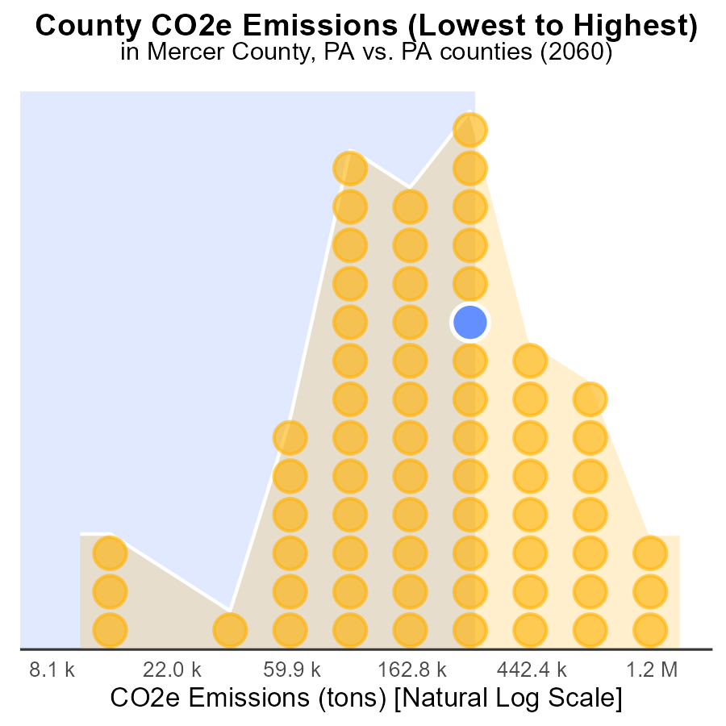

## Findings

* Allegheny county has the highest emissions at 4.1 million tons, ranking 67th nationally.
* Franklin county ranks 45th with 799.8 thousand tons of emissions, at 67.2% percentile.
* Cameron county has the lowest emissions at 27.8 thousand tons, ranking 1st nationally, at 1.5% percentile.

## Recommendations

To reduce emissions, focus on sectors contributing most in high-emission counties. Implement stricter regulations, promote renewable energy sources, and incentivize sustainable practices.

# Areas Ranked by Emissions Rate (per mile)

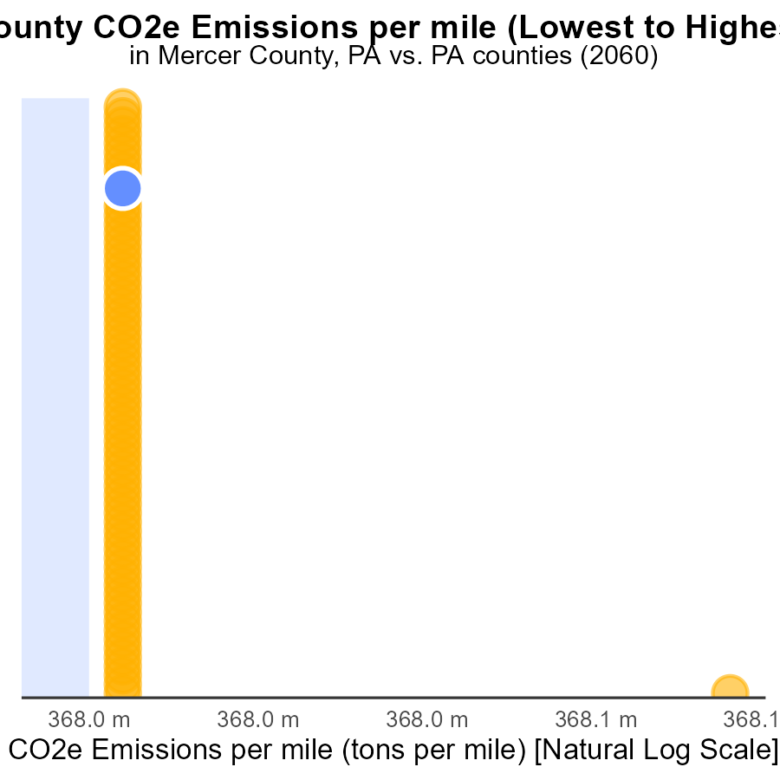

## Findings

* Counties vary significantly in emissions per mile, from 375.7 to 463.0 tons per mile.
* Montgomery County has the lowest emissions per mile, ranking 1st with 1.5% percentile.
* Fulton County has the highest emissions per mile, ranking 67th and affecting 100.0% emissions compared to the other counties.

## Recommendations

To lower emissions, focus on high-emission counties like Fulton by promoting cleaner transportation methods, improving public transportation, and implementing vehicle emission standards to reduce emissions per mile.

# Conclusion

In conclusion, the data from Mercer County, PA in 2060 highlights the pressing need to address CO2e emissions from on-road transportation. With total emissions reaching 442,000 persons, a balanced focus between rural and urban areas is essential for effective mitigation strategies. The disparities in emissions across vehicle types underscore the importance of targeted interventions, such as enhancing the fuel efficiency of Combo Trucks and promoting electric vehicles in leading emission categories like Heavy Trucks.

To achieve sustained emission reductions, leveraging successful past strategies, encouraging public transportation, and fostering community-wide initiatives are crucial steps. Additionally, addressing high-emission locations like Hermitage, PA, promoting sustainable practices in medium emitters like Sandy Lake, PA, and supporting low emitters such as Sheakleyville, PA can collectively contribute to a comprehensive approach towards emission reduction. By prioritizing cleaner energy sources, fuel-efficient vehicles, and public transportation enhancements, Mercer County can work towards a more sustainable and environmentally conscious future.

# About This Report

Data based on MOVES estimates collected by the Climate Action in Transportation program at Cornell University. Demographic data sourced from the US Census's American Community Survey 5-year estimates. This report was generated with the help of AI.

# References

* U.S. Census Bureau. (2023). American Community Survey 5-year estimates: Detailed tables. Retrieved from https://data.census.gov
* U.S. Environmental Protection Agency. (2024). Motor Vehicle Emission Simulator (MOVES 4.0) [Software]. Retrieved from https://www.epa.gov/moves