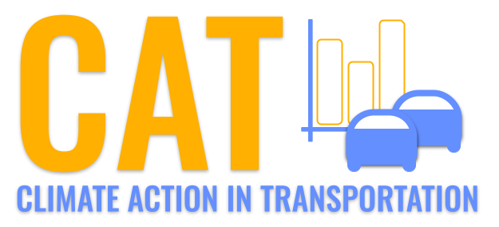 

**CO Emissions in Somerset County, 2010**  
Made with CAT VISUALIZER by Gao Labs @ Cornell University.

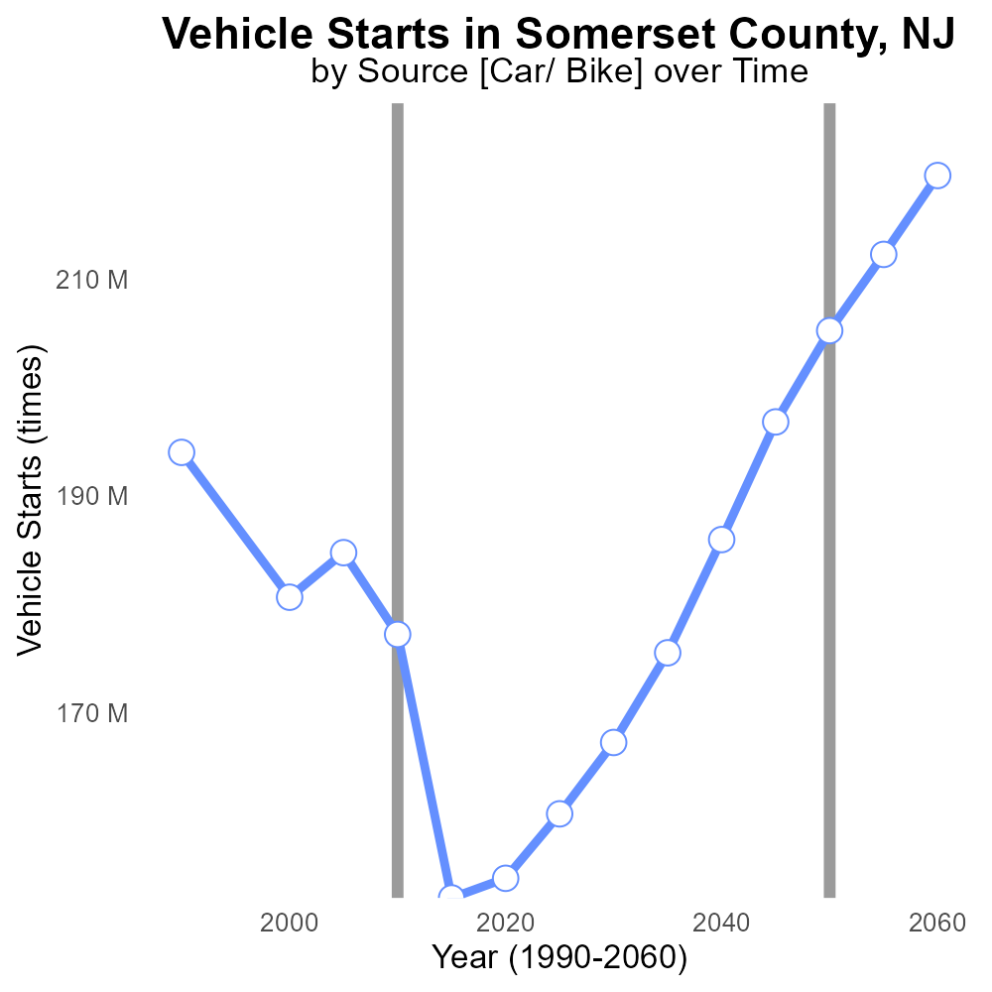

## Keywords

Carbon Monoxide emissions; on-road transportation; Somerset County; NJ; 2010; environmental impact

## Highlights

* CO emissions from on-road transportation in Somerset County in 2010.
* Analysis of environmental impact of transportation emissions.
* Comparison of CO levels with air quality standards.
* Implications for public health and policy recommendations.
* Data-driven approach to understanding CO emission trends.

# Introduction

The report examines Carbon Monoxide (CO) emissions from on-road transportation in Somerset County, NJ, for the year 2010. CO is a dangerous pollutant generated primarily from the incomplete combustion of carbon-based fuels, and its impact on air quality and public health is a growing concern.

By analyzing the levels of CO emissions in Somerset County, the report aims to shed light on the environmental consequences of transportation activities in the region, comparing the data with established air quality standards. The findings will offer insights into the potential health risks associated with high CO levels and provide recommendations for policy interventions to mitigate its negative effects on the community.

# Vehicle Starts by Regulatory Class

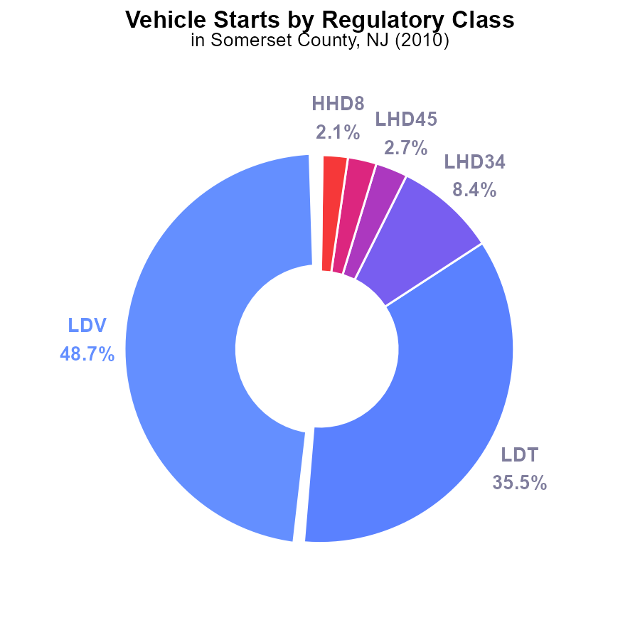

## Findings

* Light-duty vehicles (LDV) account for 48.7% of CO emissions in Somerset County in 2010.
* Together, LDV and light-duty trucks (LDT) contribute to 84.2% of CO emissions.
* Motorcycles (MC) and buses have minimal contributions of 0.2% and 0.0% respectively.

## Recommendations

To lower CO emissions, prioritize reducing LDV and LDT usage through incentives for electric vehicles, improved public transportation, and promoting carpooling to minimize vehicle starts.

# Emissions by Regulatory Class

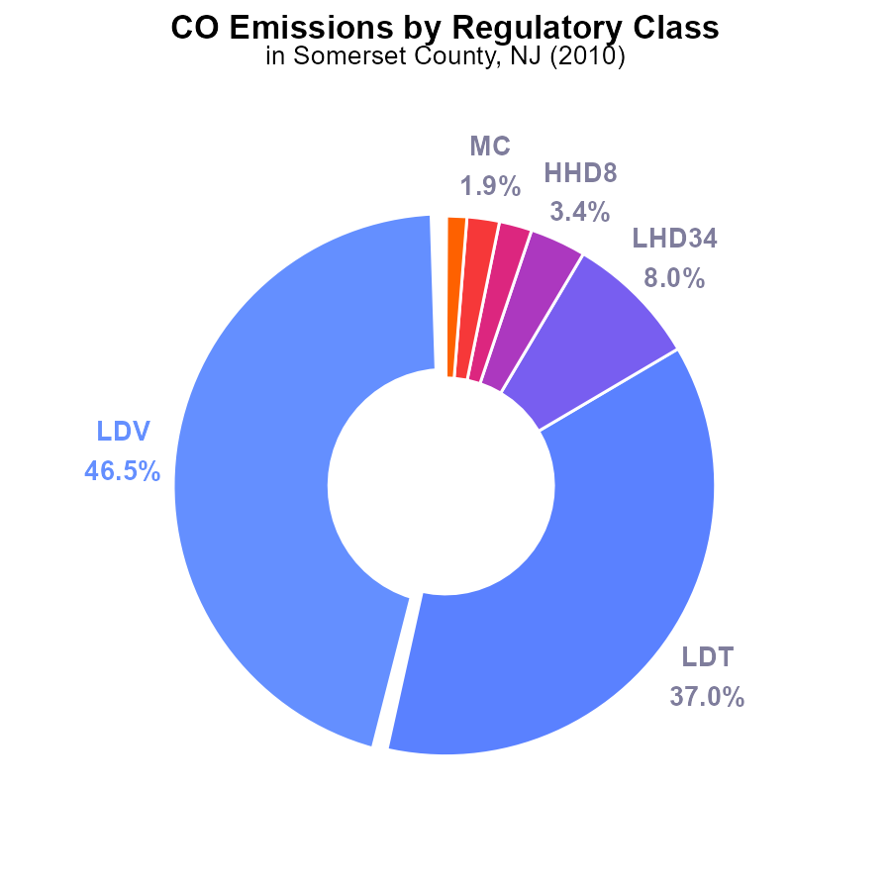

## Findings

* The highest contributors to CO emissions in Somerset County in 2010 were LDV and LDT vehicles at 46.5% and 37.0%, respectively.
* Heavy-duty vehicles such as LHD34 and HHD8 combined accounted for 11.4% of the total CO emissions in the county.
* Motorcycles (MC) and medium-heavy duty trucks (MHD67) contributed to 3.1% of the CO emissions.

## Recommendations

To reduce CO emissions, policymakers should focus on implementing stricter emission standards for LDVs and LDTs, promoting the use of electric vehicles, and investing in public transportation to decrease reliance on personal vehicles.

# Time Driven over Time for Buses

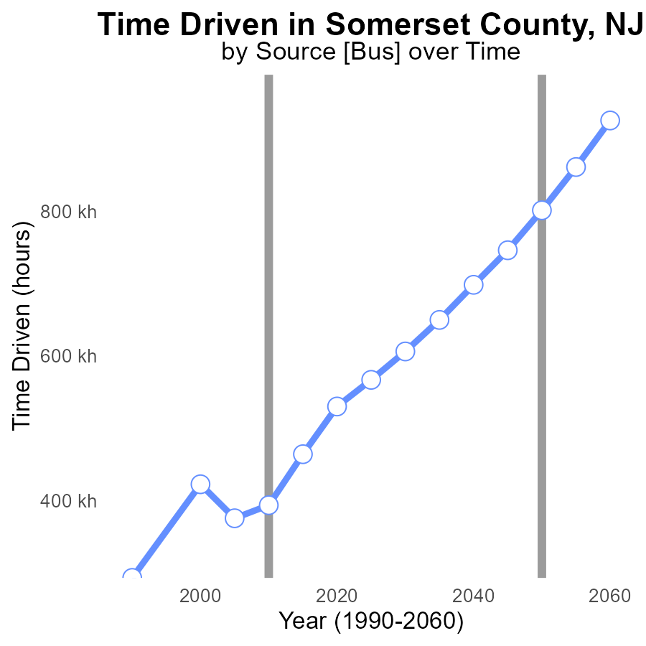

## Findings

* CO emissions in Somerset County, NJ have increased steadily from 1990 to 2030.
* The benchmark difference has decreased consistently over the same period.
* The highest CO emissions were recorded in the year 2030 at 606.3 k.

## Recommendations

To lower CO emissions in Somerset County, NJ, initiatives to reduce driving hours should be implemented, such as promoting public transportation, carpooling, and supporting telecommuting options. Additionally, investing in infrastructure to support walking and biking can help decrease the reliance on cars.

# Vehicle Starts over Time for Passenger Vehicle Starts

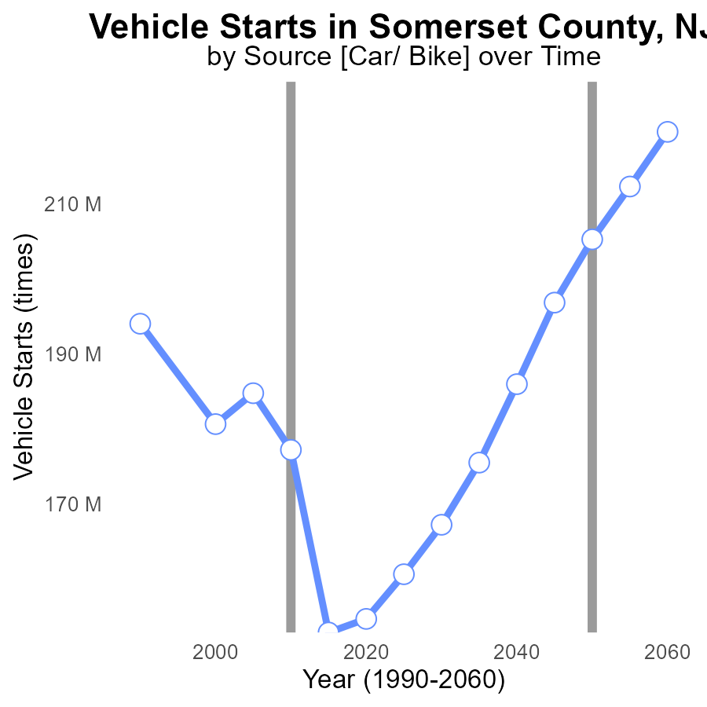

## Findings

* Vehicle starts decreased by 41.1 million times from 1990 to 2020.
* There was a 26.6% increase in vehicle starts between 2000 and 2030.
* By 2030, the benchmark difference is projected to drop to 37.9 million compared to 1990.

## Recommendations

To lower emissions, consider promoting public transportation, carpooling, and electric vehicles. Implement policies to reduce vehicle starts and encourage the use of alternative transportation methods.

# Idling Mapped by Area

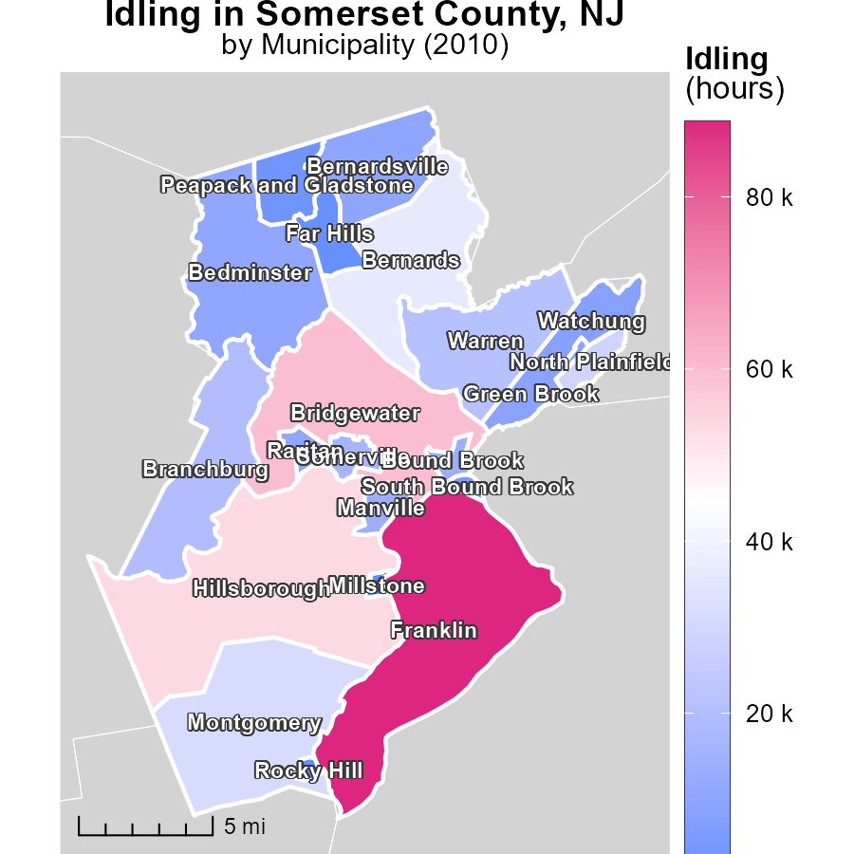

## Findings

* The maximum idling hours in Franklin, NJ, in 2010 was 88.7 thousand hours.
* The median idling hours in Manville, NJ, in 2010 was 13.7 thousand hours.
* The minimum idling hours in Millstone, NJ, in 2010 was 772.6 hours.

## Recommendations

To lower emissions from idling in these areas, strategies such as implementing idling reduction policies, promoting the use of electric vehicles, and increasing public transportation options could be effective.

# Population Mapped by Area

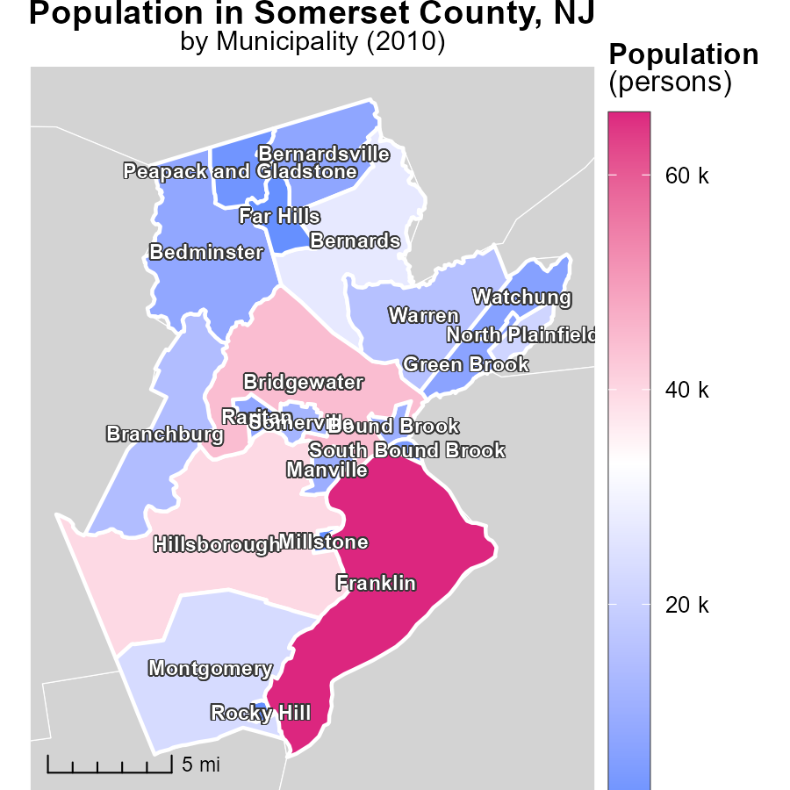

## Findings

* Franklin, NJ has the highest population at 65.8k in 2010.
* Manville, NJ has a population of 10.2k in 2010, making it the median.
* Millstone, NJ had a population of 573 in 2010, the lowest among the three locations.

## Recommendations

To lower emissions, focus on highly populated areas like Franklin. Implement green initiatives for transportation and industries. In small towns like Millstone, promote renewable energy sources for sustainable growth.

# Emissions Rate (per mile) by Regulatory Class over Time

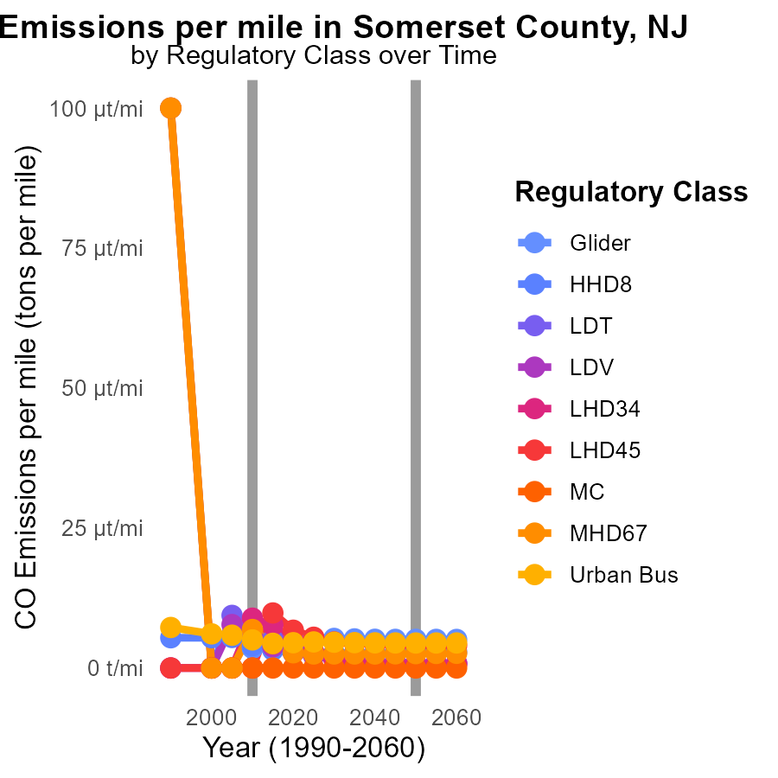

## Findings

* Emissions per mile have significantly decreased for most vehicle types in Somerset County, NJ from 2000 to 2020.
* The largest reduction in emissions per mile occurred in the 'MC' vehicle category, with a decrease from 33.3 µ tons per mile in 2000 to 14.0 µ tons per mile in 2020.
* Despite some fluctuations, emissions for 'Urban Bus' vehicles remained relatively stable with a slight decrease from 6.1 µ tons per mile in 2000 to 4.5 µ tons per mile in 2020.

## Recommendations

To further reduce emissions, policymakers should prioritize incentives for transitioning to cleaner fuel sources and implementing stricter emissions standards for all vehicle types in Somerset County. Additionally, investing in public transportation infrastructure could help reduce emissions from 'Urban Bus' vehicles.

# Time Driven by Fuel Type over Time

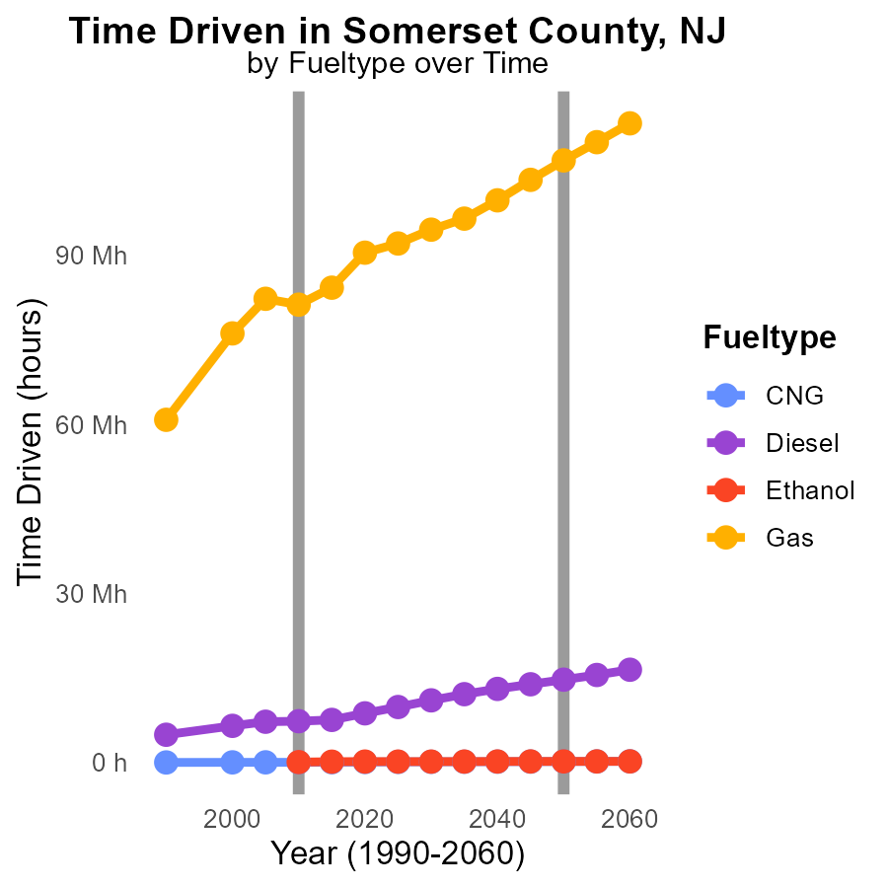

## Findings

* Gas emissions in Somerset County, NJ have steadily increased from 76.2 million in 2000 to 90.5 million in 2020.
* Diesel emissions also rose over the years, peaking at 8.7 million in 2020.
* CNG and Ethanol emissions show a decrease in emissions over time, with CNG dropping significantly from 79.3 thousand in 2020.

## Recommendations

To lower emissions, there should be a shift to promote CNG and Ethanol usage while gradually phasing out Gas and Diesel. Implement stricter emission standards for Gas and Diesel vehicles to curb emissions effectively.

# Areas Ranked by Vehicle Miles Traveled

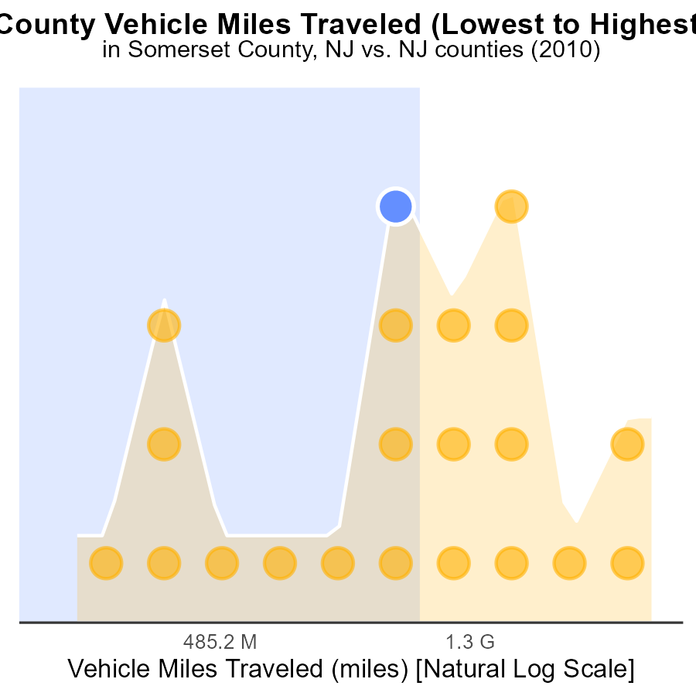

## Findings

* Middlesex county had the highest vehicle miles traveled with 7.6 billion miles, representing 100% of the total percentile.
* Salem county had the lowest vehicle miles traveled with 743.1 million miles, accounting for only 4.8% of the total percentile.
* Mercer county ranked 12nd in VMT with 3.4 billion miles, corresponding to 57.1% of the total percentile.

## Recommendations

To reduce emissions, policies could focus on promoting alternative transportation methods in Middlesex where VMT is highest, encouraging carpooling or using public transport. In areas with lower VMT like Salem, initiatives could include promoting walking or biking. Mercer could benefit from a combination of these strategies and incentives for hybrid or electric vehicles.

# Areas Ranked by Emissions

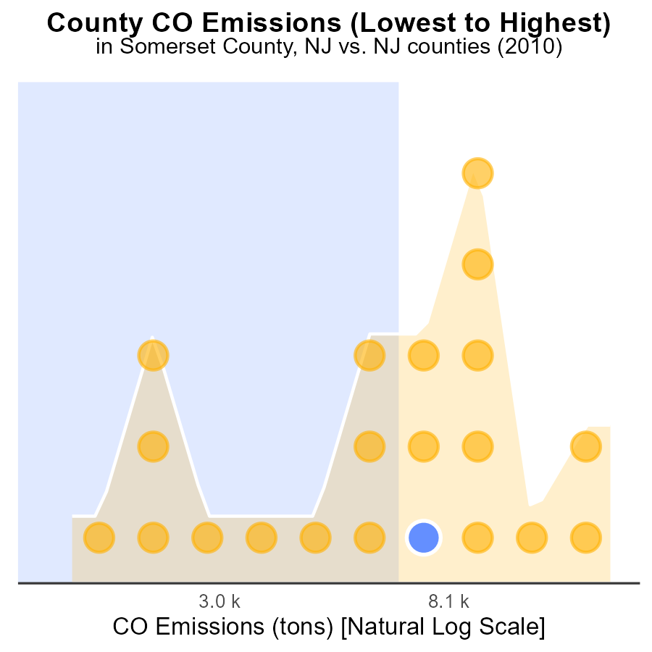

## Findings

* Middlesex county had the highest CO emissions in 2010 with 45.1 thousand tons, reaching 100% percentile.
* Somerset county ranked 11th with 17.7 thousand tons, representing 52.4% of the total CO emissions.
* Salem county had the lowest emissions in 2010 with 4.3 thousand tons, accounting for only 4.8% of the total CO emissions.

## Recommendations

To lower CO emissions, focus on reducing industrial and transportation emissions in Middlesex county. Encourage Somerset to improve its emissions control. Implement strict emission regulations in Salem.

# About This Report

Data based on MOVES estimates collected by the Climate Action in Transportation program at Cornell University. Demographic data sourced from the US Census's American Community Survey 5-year estimates. This report was generated with the help of AI.

# References

* U.S. Census Bureau. (2023). American Community Survey 5-year estimates: Detailed tables. Retrieved from https://data.census.gov
* U.S. Environmental Protection Agency. (2024). Motor Vehicle Emission Simulator (MOVES 4.0) [Software]. Retrieved from https://www.epa.gov/moves