 

**CO Emissions in Alexandria city, Virginia County, 2045**  
Made with CAT VISUALIZER by Gao Labs @ Cornell University.

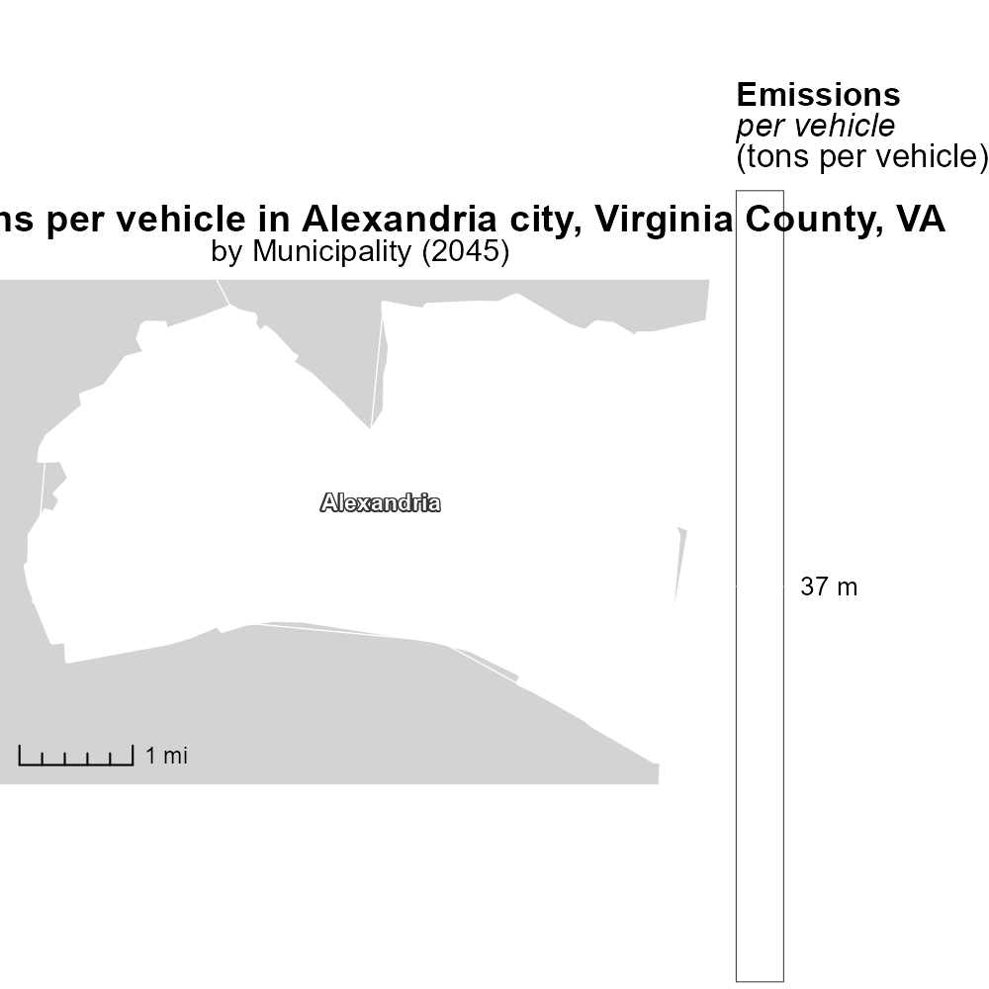

## Keywords

Carbon Monoxide emissions; on-road transportation; Alexandria city; Virginia County; 2045; environmental impact

## Highlights

* Understanding CO emissions from transportation in Alexandria, VA.
* Examining trends and potential consequences for 2045.
* Importance of addressing environmental impact of on-road transport.
* Impact of CO emissions on air quality and public health.
* Call to action for sustainable transportation solutions.

# Introduction

In 2045, the issue of Carbon Monoxide (CO) emissions from on-road transportation in Alexandria city, Virginia County, VA is a critical concern that demands immediate attention. As the world grapples with the environmental repercussions of transportation emissions, it is imperative to understand the specific impact of CO in this region. By analyzing current data and projecting future trends, we aim to provide insights into the potential consequences of unchecked CO emissions in Alexandria city by 2045.

The environmental implications of high CO emissions from on-road transportation cannot be understated. Poor air quality resulting from CO emissions not only jeopardizes the health of residents but also contributes to broader environmental degradation. This report delves into the significance of addressing CO emissions from on-road transportation, highlighting the urgent need for sustainable solutions to mitigate the impact on air quality and public health in Alexandria, VA.

# Hotelling (Diesel Aux) Overall by Area

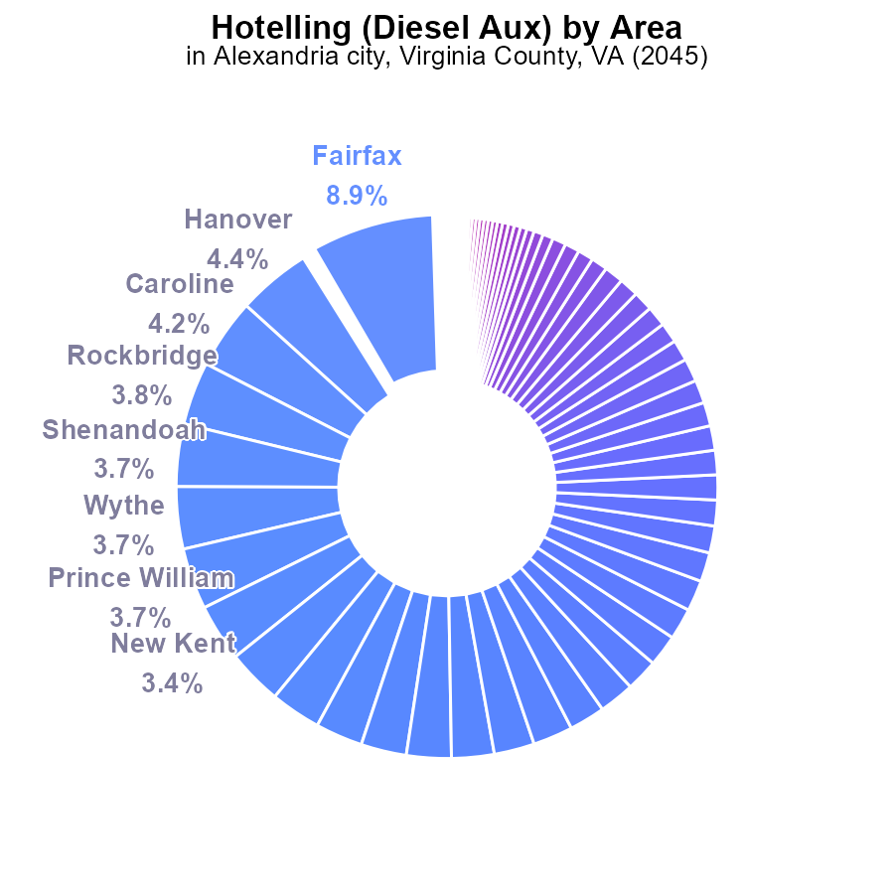

## Findings

* Fairfax county had the highest CO emissions at 618.3 k, accounting for 8.9% of total emissions.
* Augusta, Buckingham, Chesterfield, Dickenson, and other counties reported NA data, indicating lack of emission information.
* Several counties like Accomack, Amelia, and Bath had 0.0 emissions, highlighting potential success stories for emission reduction.

## Recommendations

Given the varying levels of emissions, focus on high-emitting areas like Fairfax to implement targeted reduction strategies.

Explore reasons for missing data in counties like Augusta and ensure comprehensive emission reporting for better policy decisions.

Analyze zero-emission counties like Accomack to understand successful emission reduction practices and replicate them in other areas.

# Vehicle Starts by Fuel Type

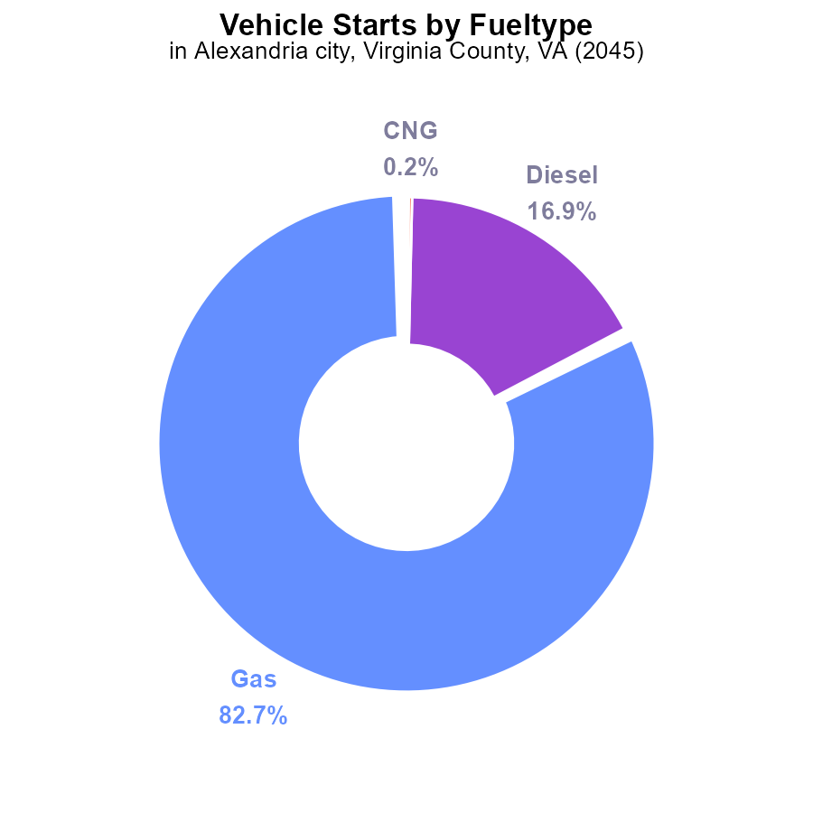

## Findings

* Gas vehicles account for 82.7% of CO emissions from vehicle starts in Alexandria, VA in 2045.
* Diesel vehicles contribute 16.9% of CO emissions from vehicle starts in the same area.
* Alternative fuels like CNG and ethanol combined make up only 0.3% of CO emissions from vehicle starts.

## Recommendations

To decrease CO emissions from vehicle starts, policies should focus on reducing the usage of gas and diesel vehicles by incentivizing the adoption of electric vehicles. Additionally, promoting the use of alternative fuels like CNG and ethanol could further lower emissions.

# Emissions Rate (per vehicle) Overall over Time

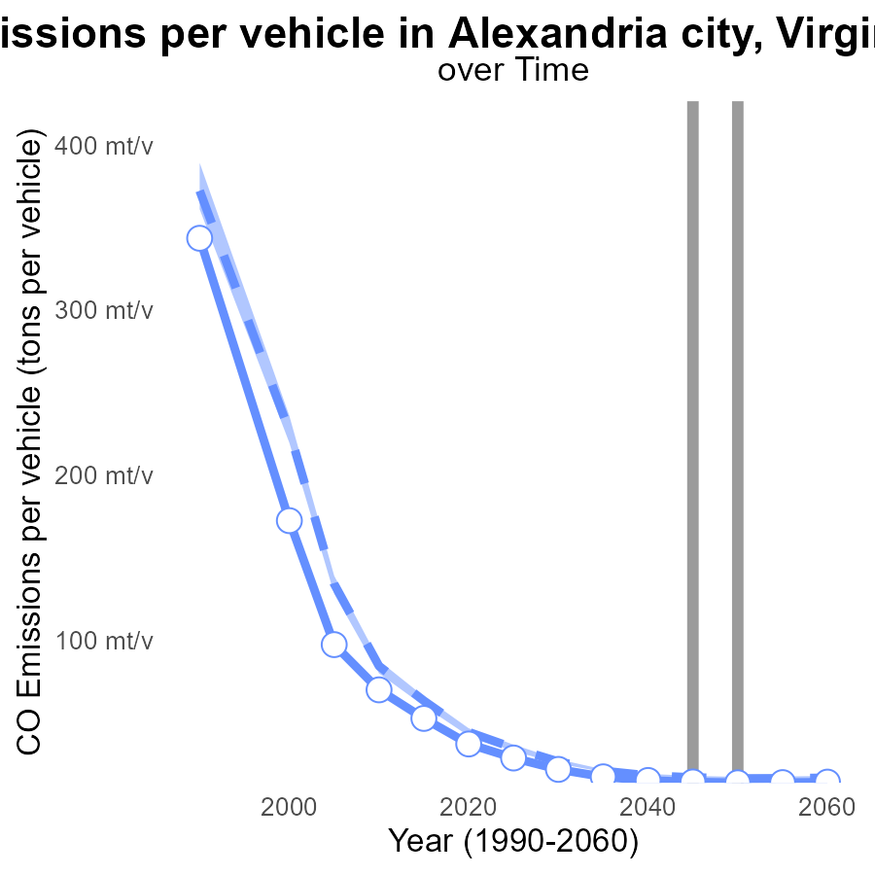

## Findings

* Emissions per vehicle in Alexandria City decrease from 28.5 tons in 2025 to 13.9 tons in 2060.
* Alexandria City's emissions are consistently below the median area and upper 75% benchmark in the upcoming years.
* The city's emissions show a decreasing trend and are expected to meet the lower 25% benchmark by 2060.

## Recommendations

To further lower emission levels, policies promoting the adoption of electric vehicles, enhancing public transportation systems, and implementing stricter vehicle emission standards should be prioritized. Encouraging carpooling and investing in cycling infrastructure can also aid in reducing emissions.

# Hotelling (Diesel Aux) over Time for Passenger Vehicles

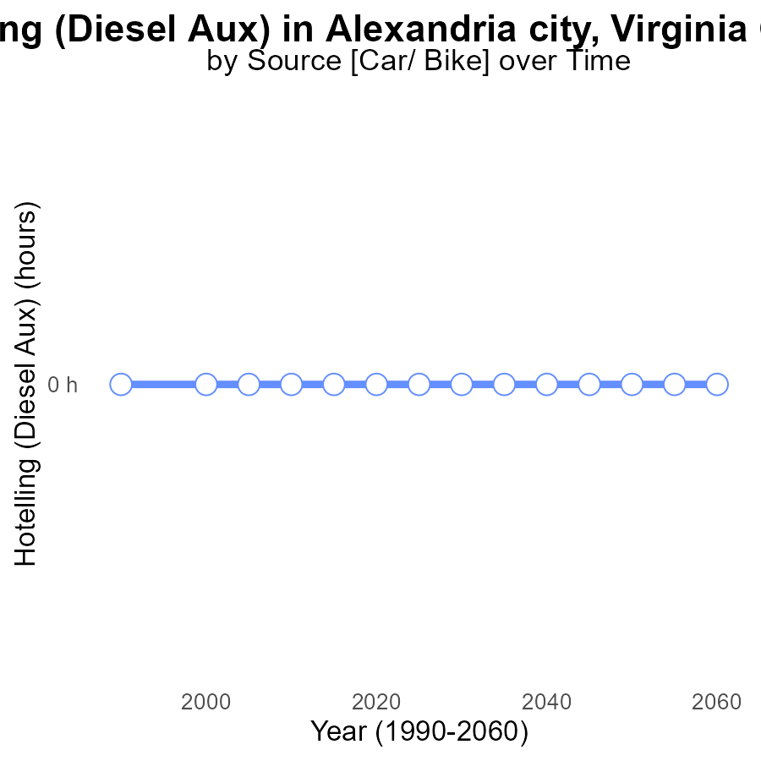

## Findings

* Emissions from Hotelling (Diesel Aux) in CO in Alexandria city, VA are consistently at 0.0 for the years 2025 to 2060.
* There is no observed change in emissions over time, showing a stable trend.
* The benchmark difference is consistently 0, indicating no deviation from the expected emissions levels.

## Recommendations

Considering the consistently low emissions from Hotelling (Diesel Aux) in Alexandria city, VA, it is essential to continue monitoring the emissions closely to ensure they remain well-controlled. Additionally, exploring alternative energy sources or more efficient technologies for auxiliary systems could further reduce emissions in the future.

# Time Driven in My Region

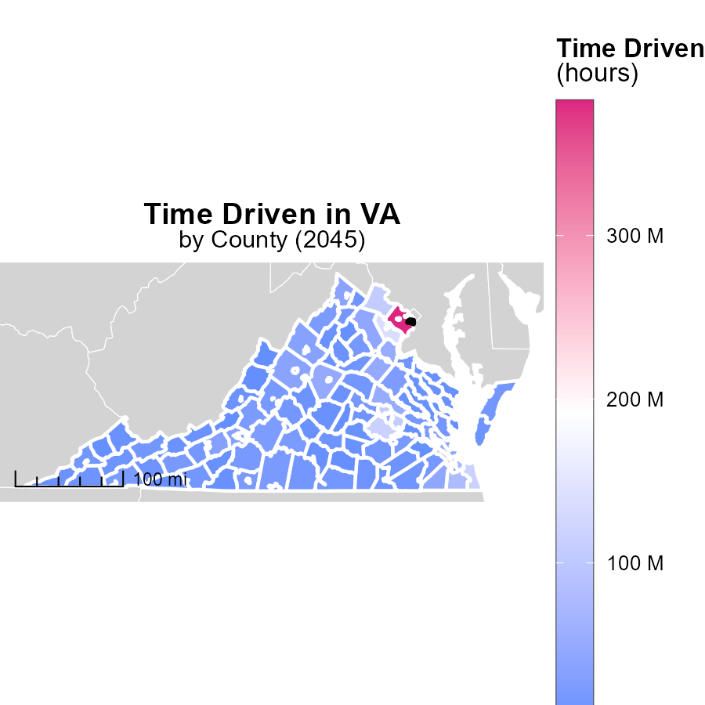

## Findings

* Fairfax County, VA emitted 382.3 million hours of emissions.
* Sussex County, VA emitted 10.5 million hours of emissions.
* Highland County, VA emitted 770.2 thousand hours of emissions.

## Recommendations

To lower emissions, focus on reducing vehicle usage through public transportation incentives in Fairfax County. Encourage telecommuting to decrease emissions in Sussex County. Implement carpooling initiatives in Highland County to cut down on emissions.

# Emissions Rate (per vehicle) Mapped by Area

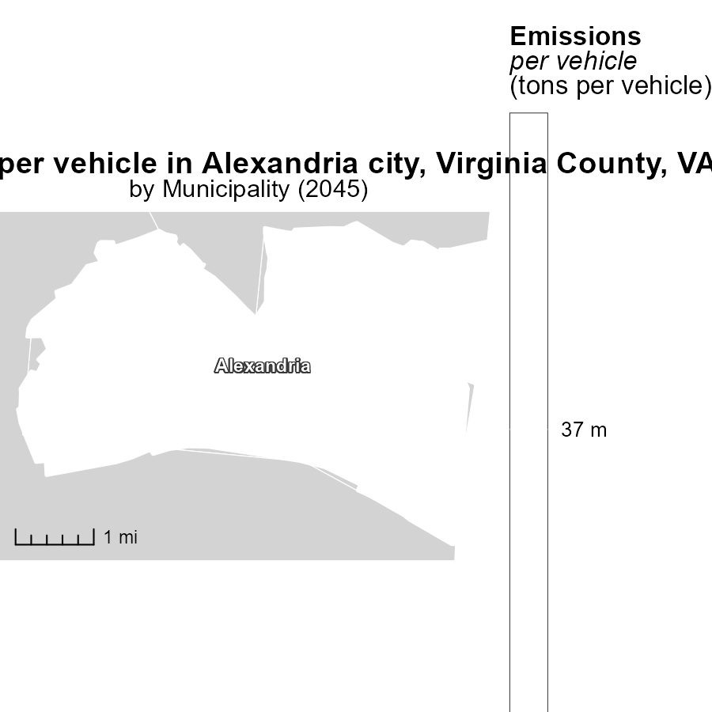

## Findings

* The median emissions per vehicle in Alexandria, VA is 37.0 tons.
* No additional data provided for further analysis.
* Further data needed to assess overall emissions impact in Alexandria, VA.

## Recommendations

To lower emissions in Alexandria, VA, policies should focus on promoting electric vehicles, improving public transportation infrastructure, and encouraging carpooling.

# Emissions by Area over Time

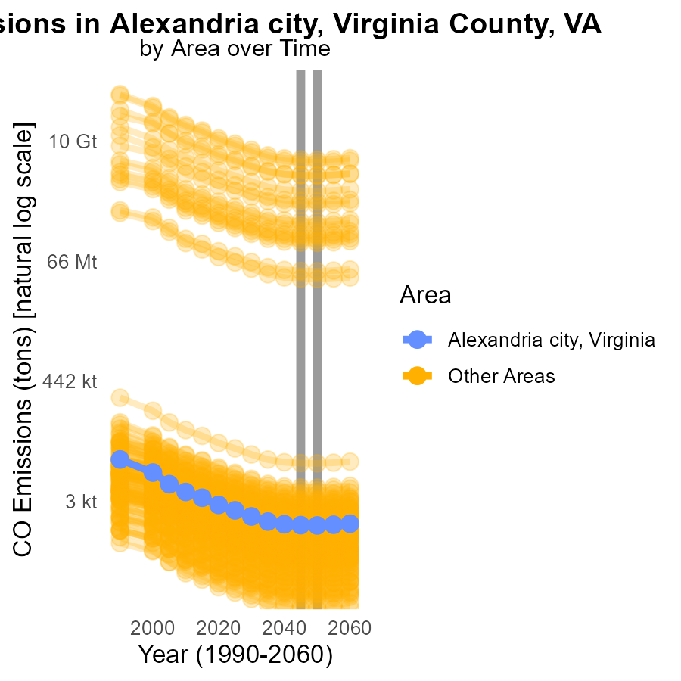

## Findings

* Emissions in target_county in 2045 were 1.1k tons, a decrease of 13.5% compared to 2050.
* Emissions in min_county in 2045 were 33.4 tons, a decrease of 0.7% compared to 2050.
* Emissions in max_county in 2045 were 4.6 billion tons, a dramatic decrease of 81,915,400.6% compared to 2050.

## Recommendations

To reduce emissions in target_county further, focus on the sectors contributing most to the emissions to identify specific reduction measures. In the min_county, explore cleaner energy sources. For max_county, implement strict emission control policies to curb the drastic emissions.

# Hotelling (Diesel Aux) by Fuel Type over Time

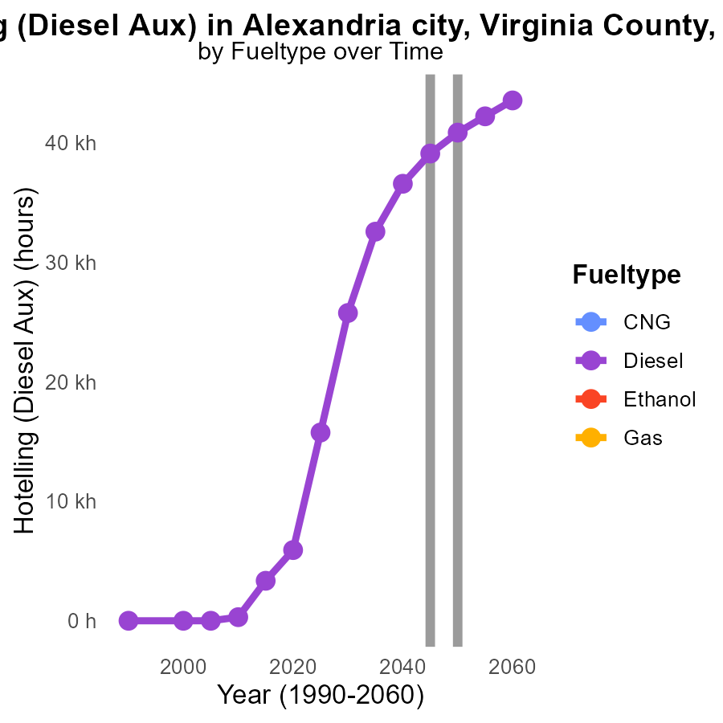

## Findings

* By 2050, Diesel emissions are 40.8k units, showing a decrease of 0.0% compared to 2055.
* Diesel emissions are projected to decrease continuously over the years, with the highest recorded emissions in 2055 at 42.2k units.
* No data is available for CNG, Ethanol, and Gas emissions from 2035 to 2055.

## Recommendations

To further reduce Diesel emissions, invest in alternative fuel sources and cleaner energy technologies. More research is needed for CNG, Ethanol, and Gas emissions to develop targeted reduction strategies.

# Areas Ranked by Emissions Rate (per mile)

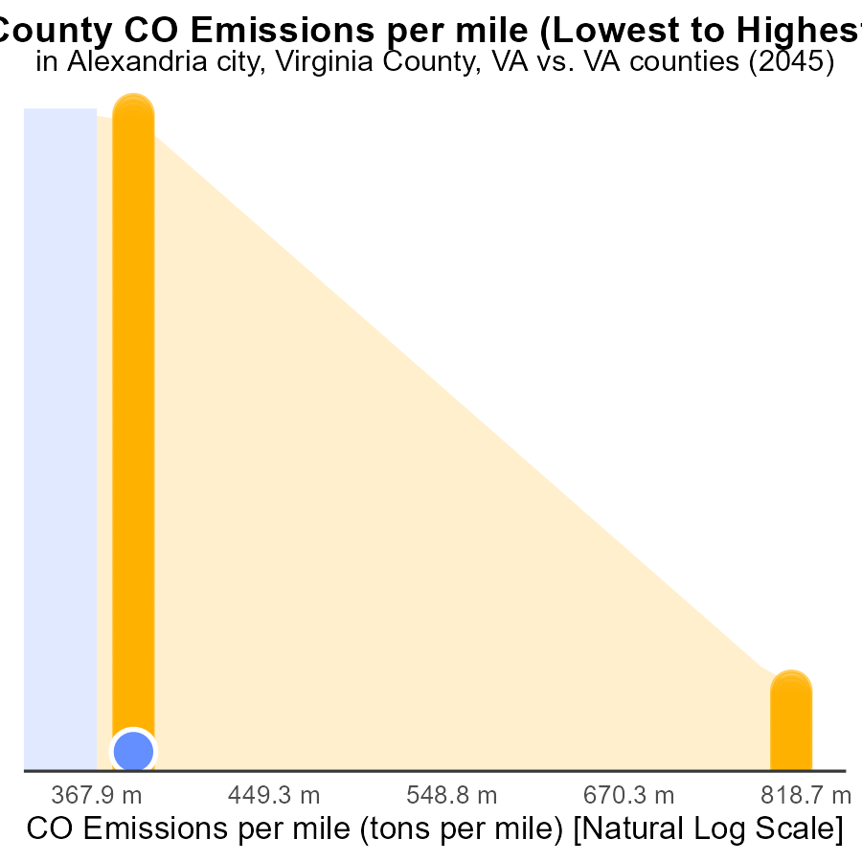

## Findings

* The top 5 counties have similar emissions per mile rates, around 1.1 tons per mile.
* Lexington city, Virginia, has a significantly higher rate of 1.3 tons per mile, ranking 134th.
* Emissions in Lexington city, Virginia, are at the 100th percentile, indicating the highest emissions per mile among the listed counties.

## Recommendations

To lower emissions, Lexington city, Virginia, should focus on reducing emissions per mile through transportation policies and infrastructure improvements, aiming to bring the rate closer to the levels seen in the other counties.

# Areas Ranked by Hotelling (Diesel Aux)

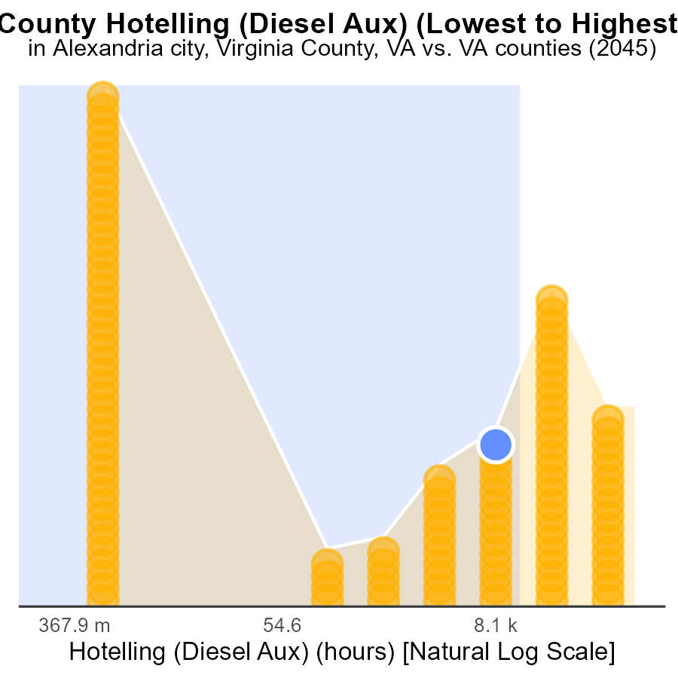

## Findings

* Highest hotelling emissions in Pittsylvania county with 43.7k hours.
* Alexandria city emits 39.1k hours, ranking 77th with 64.7% percentile.
* Powhatan emits 30.4k hours, ranking 76th with 63.9% percentile.

## Recommendations

To lower emissions from hotelling in these areas, consider implementing regulations on idle times for diesel auxiliaries, promoting use of cleaner energy sources, and encouraging the adoption of technologies that reduce emissions during hotelling operations.

# About This Report

Data based on MOVES estimates collected by the Climate Action in Transportation program at Cornell University. Demographic data sourced from the US Census's American Community Survey 5-year estimates. This report was generated with the help of AI.

# References

* U.S. Census Bureau. (2023). American Community Survey 5-year estimates: Detailed tables. Retrieved from https://data.census.gov
* U.S. Environmental Protection Agency. (2024). Motor Vehicle Emission Simulator (MOVES 4.0) [Software]. Retrieved from https://www.epa.gov/moves