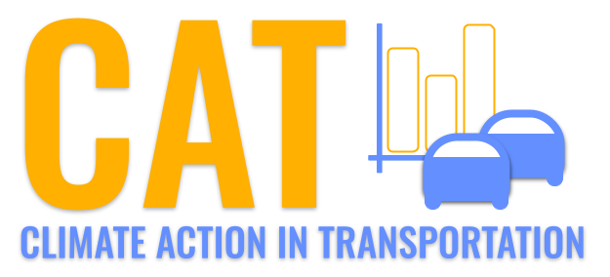 

**NOx Emissions in Benton County, 2050**  
Made with CAT VISUALIZER by Gao Labs @ Cornell University.

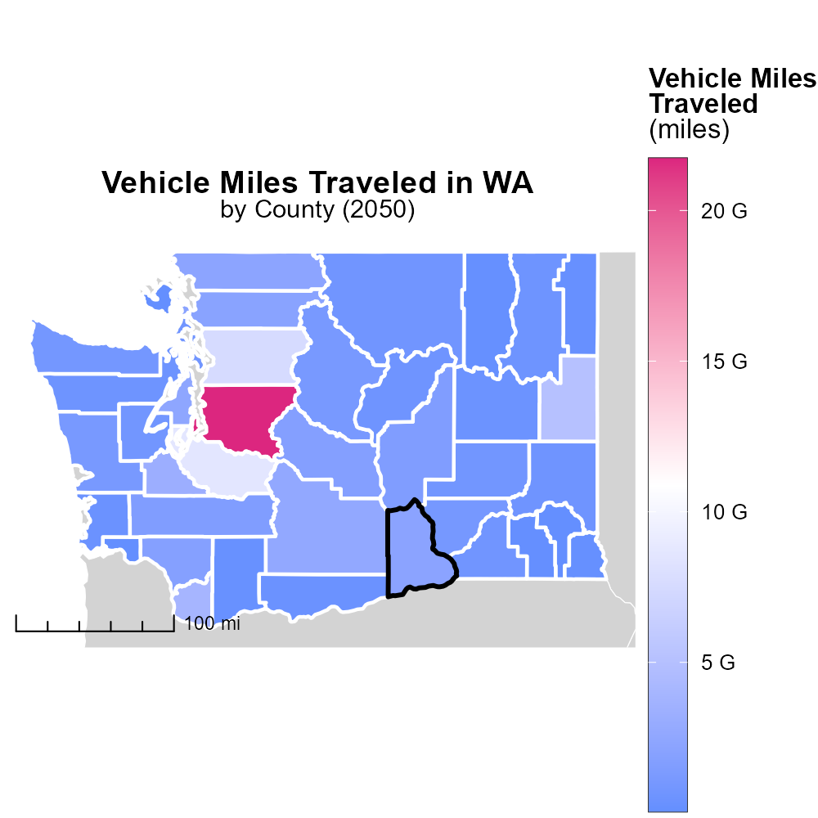

## Keywords

Oxides of Nitrogen; NOx emissions; on-road transportation; Benton County; 2050

## Highlights

* Study on NOx emissions from on-road transportation in Benton County, WA in 2050.
* Focus on impact of transportation on air quality and public health.
* Analysis of measures to reduce NOx emissions in the county.
* Identification of future trends and challenges related to NOx emissions.
* Importance of addressing NOx emissions for sustainable development.

# Introduction

In 2050, the issue of Oxides of Nitrogen (NOx) emissions from on-road transportation in Benton County, Washington has become a pressing concern. The increase in population, urbanization, and economic activities has significantly contributed to the rise in NOx emissions, impacting air quality and public health.

This report aims to analyze the current state of NOx emissions from on-road transportation in Benton County, projecting future trends and challenges that may arise by 2050. It will also explore potential measures and technologies that could help reduce NOx emissions, highlighting the importance of addressing this issue for the sustainable development of the county and the well-being of its residents.

# Hotelling (Diesel Aux) by Regulatory Class

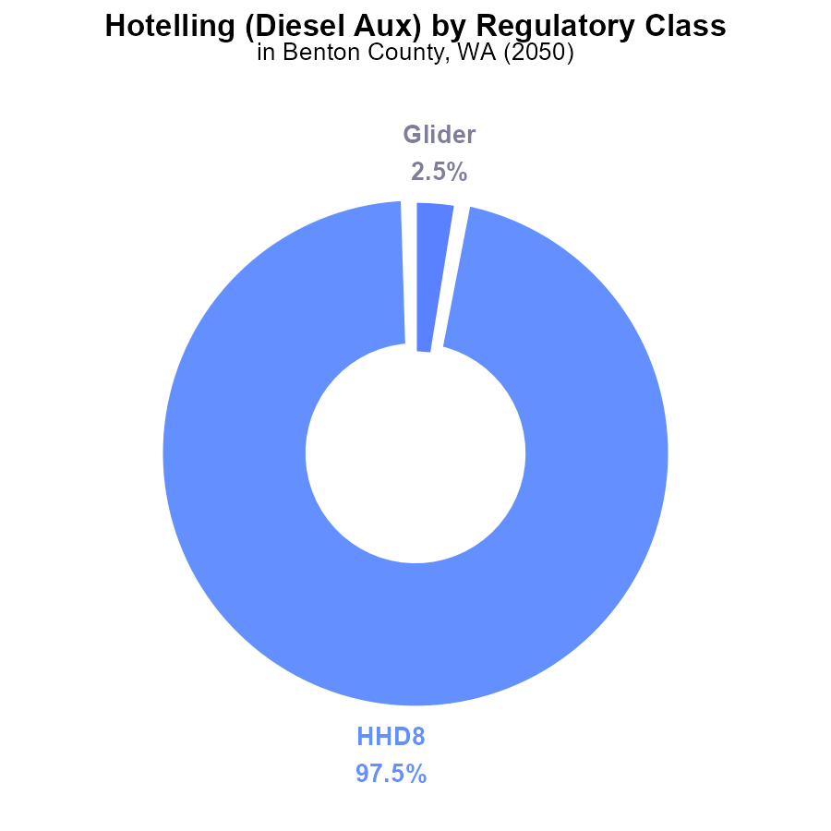

## Findings

* 97.5% of NOx emissions in Benton County are from HHD8 vehicles with a label value of 194.4 k
* Only 2.5% of NOx emissions come from Glider vehicles with a label value of 5.1 k
* There are no NOx emissions data available for Light Duty Trucks, Light Duty Vehicles, Heavy-Duty Trucks, Medium-Heavy Duty Trucks, or Urban Buses

## Recommendations

To lower NOx emissions in Benton County, focus on reducing emissions from HHD8 vehicles, which contribute significantly. Implement stricter emission standards for these vehicles to decrease overall NOx levels.

# Emissions Rate (per mile) by Regulatory Class

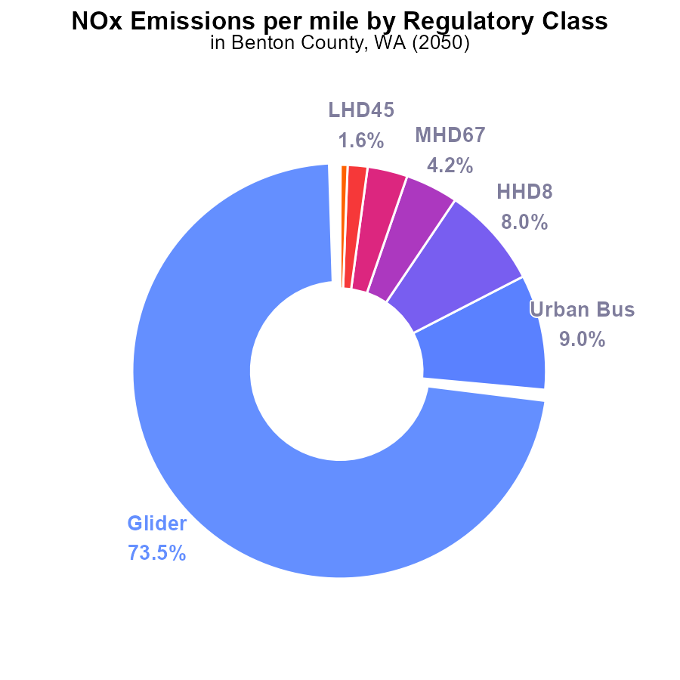

## Findings

* The Glider vehicle type is responsible for 73.5% of NOx emissions per mile.
* Urban Buses contribute 9.0% of the total NOx emissions per mile in Benton County.
* Light-duty trucks (LDT) and light-duty vehicles (LDV) have minimal impact on NOx emissions per mile, each accounting for 0.0%.

## Recommendations

To lower NOx emissions, a targeted approach should focus on reducing emissions from Gliders, Urban Buses, and Heavy-duty trucks (HHD8 and MHD67). Implementing stricter emission standards and promoting the adoption of cleaner fuel technologies for these vehicle types can lead to a significant reduction in overall emissions.

# Emissions Overall over Time

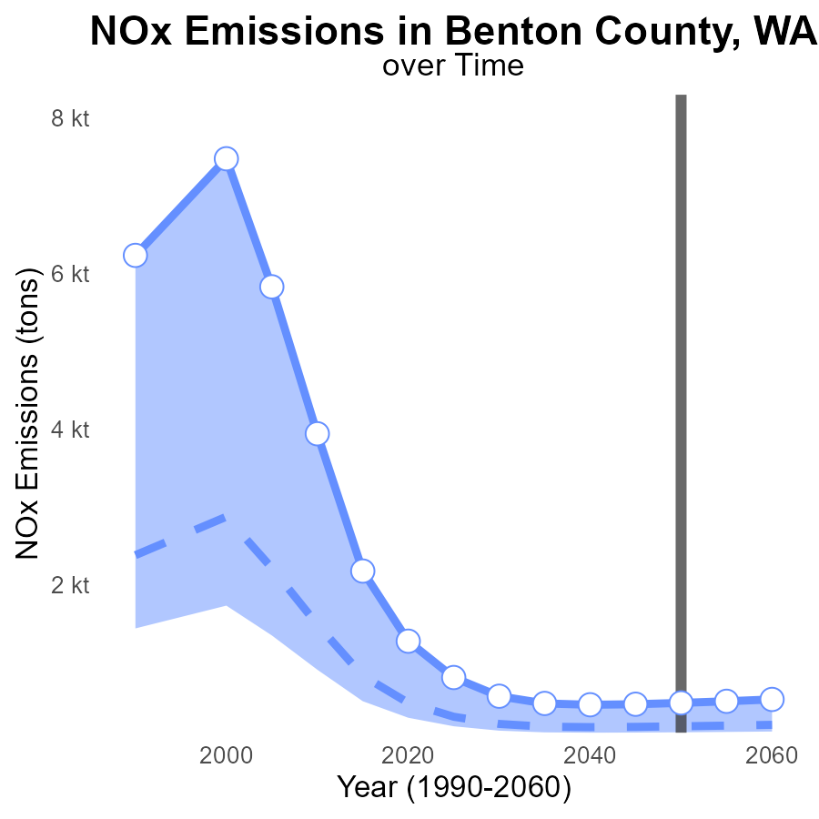

## Findings

* NOx emissions in Benton County are consistently higher than the median area, peaking at 532.1 tons in 2060.
* By 2060, the area's emissions are 44.6 tons above the upper 75th percentile of areas.
* Despite a fluctuating trend, emissions show a general increase over the years, indicating a concerning upward trajectory.

## Recommendations

To lower emissions, Benton County should invest in cleaner technologies and promote policies that target NOx reduction, aiming to bring levels below the median area. Establishing stricter emission standards for industries and implementing incentives for adopting green practices are crucial steps in mitigating NOx pollution. Long-term planning for sustainable development and regular monitoring of emission sources are essential to track progress and ensure compliance with set targets.

# Vehicle Starts over Time for Buses

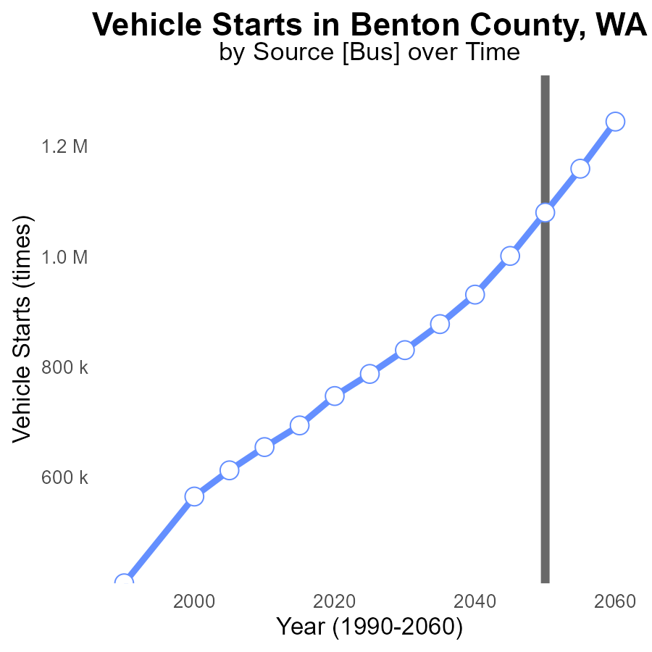

## Findings

* NOx emissions in Benton County from vehicle starts are expected to increase steadily from 830.2 k times in 2030 to 1.2 M times in 2060.
* By 2050, the NOx emissions level is projected to reach its peak at 1.1 M times, with a notable decrease in the following years.
* There is a consistent reduction in NOx emissions compared to the benchmark, indicating a positive trend in emissions control efforts.

## Recommendations

To lower NOx emissions in Benton County, it is crucial to implement stricter vehicle emission standards, promote the adoption of electric vehicles, and invest in public transportation infrastructure. Furthermore, incentivizing carpooling and telecommuting could help reduce the number of vehicle starts and subsequently decrease NOx emissions even further.

# Vehicle Miles Traveled in My Region

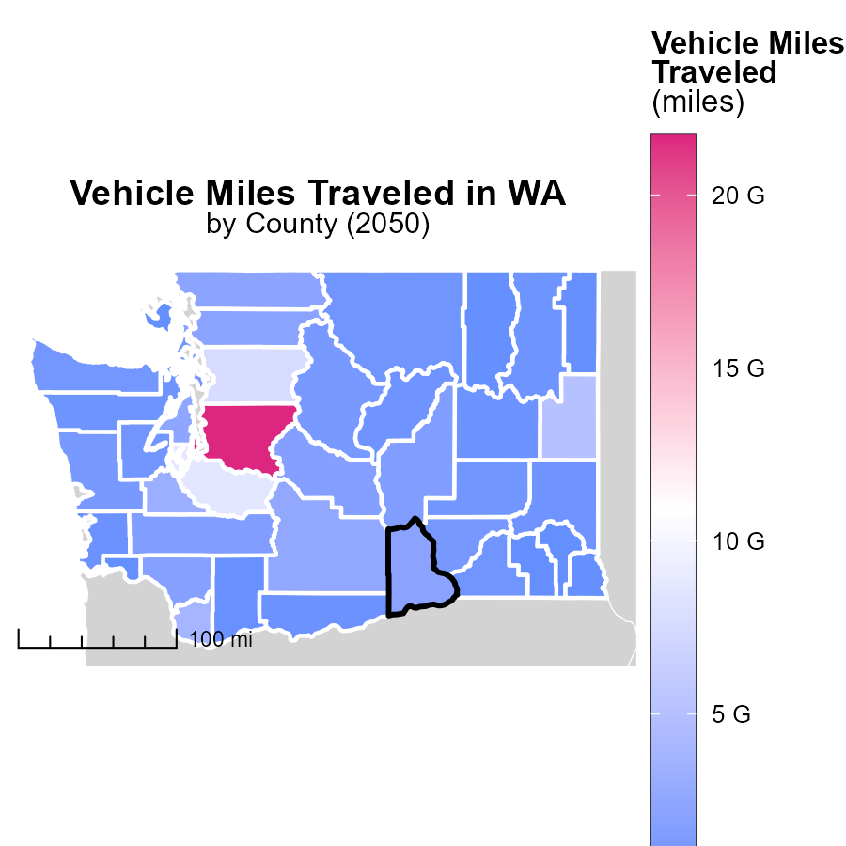

## Findings

* King County, WA has the highest vehicle miles traveled at 21.7 billion miles.
* Mason County, WA has a median of 781.9 million miles traveled.
* San Juan County, WA has the lowest vehicle miles traveled at 63.7 million miles.

## Recommendations

To lower emissions, King County should invest in public transportation to reduce car usage for long distances. Mason County could benefit from carpooling incentives and improving infrastructure for biking. San Juan County should focus on promoting electric vehicle usage and car-sharing programs.

# Emissions Rate (per vehicle) in My Region

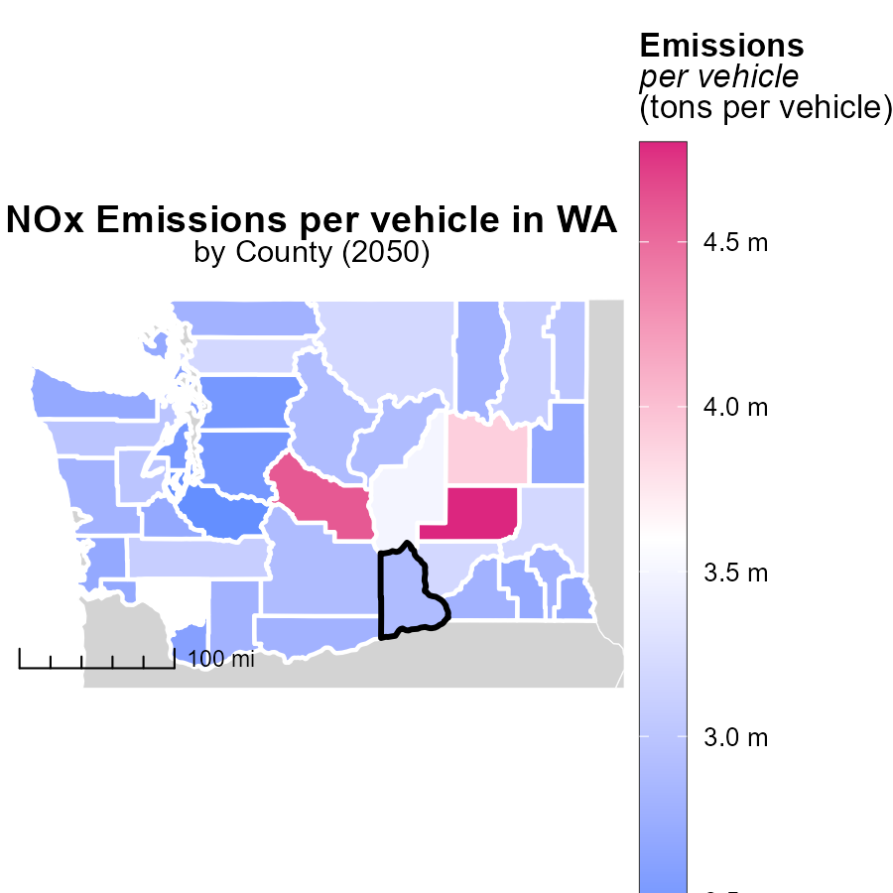

## Findings

* Adams County, WA has the highest emissions per vehicle at 4.8 tons
* Garfield County, WA has median emissions per vehicle at 2.8 tons
* Pierce County, WA has the lowest emissions per vehicle at 2.4 tons

## Recommendations

To lower emissions, focus on reducing vehicle usage and promoting the use of electric or hybrid vehicles in Adams County. Encourage carpooling and public transportation in Garfield County. Implement vehicle emission testing and promote fuel-efficient driving habits in Pierce County.

# Hotelling (Diesel Aux) by Fuel Type over Time

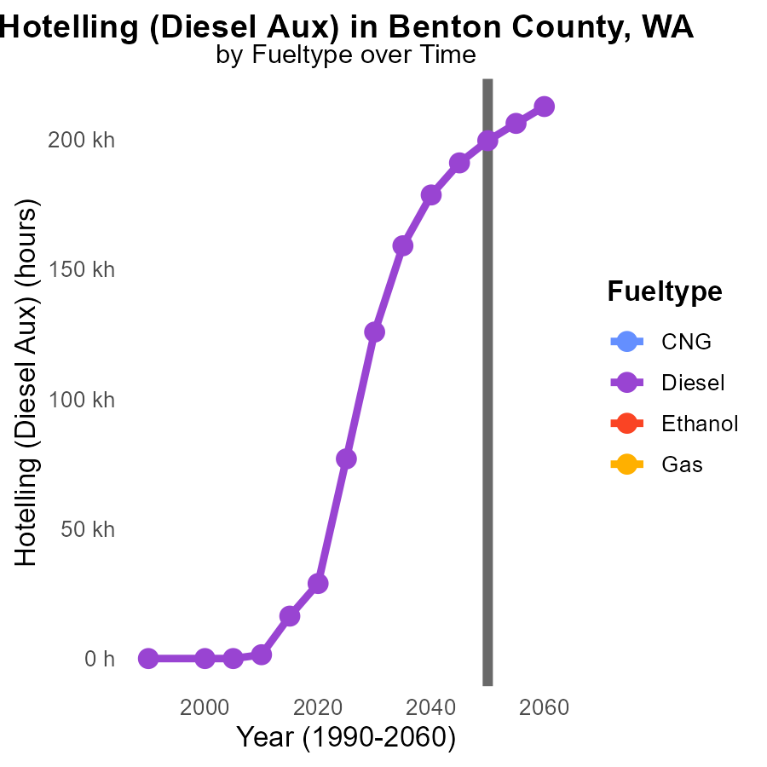

## Findings

* By 2060, diesel auxiliary engines in Benton County are projected to emit 212.6 kilotons of NOx annually.
* Emissions from diesel auxiliary engines are expected to decrease by 6.6% from 2050 to 2055.
* There is currently no data available for NOx emissions from CNG, ethanol, or gas fuel types in Benton County.

## Recommendations

To lower NOx emissions in Benton County, policymakers should consider transitioning diesel auxiliary engines to cleaner fuel sources like CNG or ethanol. Additionally, investing in technology to improve the efficiency of diesel engines can help mitigate emissions.

# Vehicle Starts by Area over Time

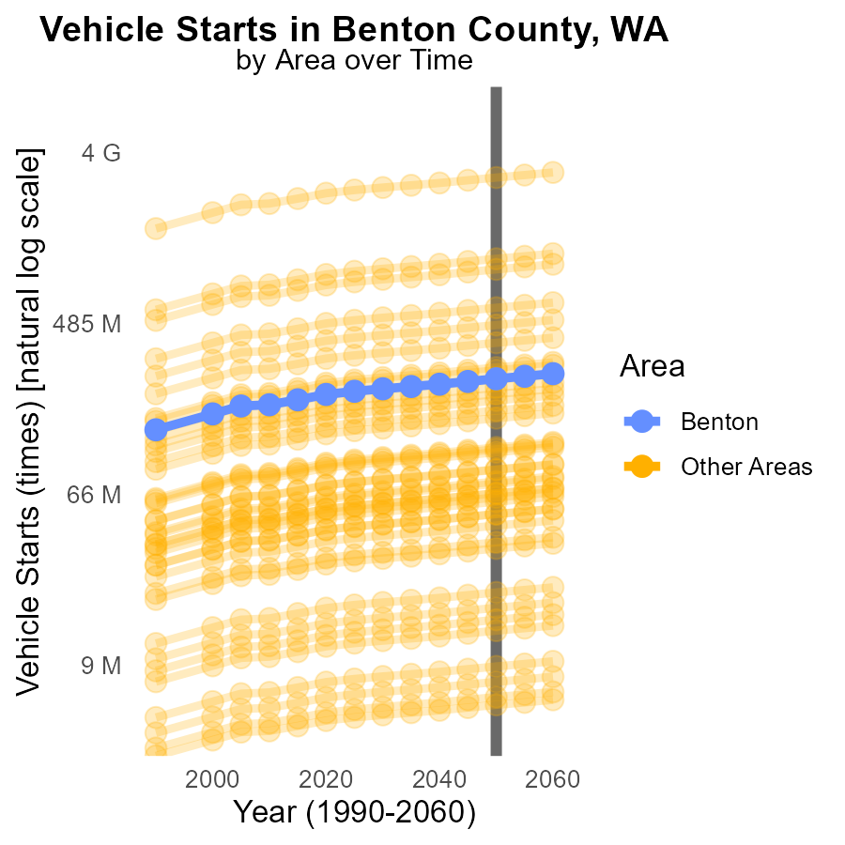

## Findings

* In 2050, the target county emitted 254.4 million times more NOx during vehicle starts.
* In 2050, the maximum county emitted 2.7 billion times more NOx than the target county during vehicle starts.
* In 2050, the minimum county emitted 5.6 million times more NOx than the target county during vehicle starts.

## Recommendations

To reduce NOx emissions, implementing stricter vehicle emissions standards, promoting widespread adoption of electric vehicles, and investing in public transportation infrastructure are crucial. Local governments should also consider implementing policies to reduce vehicle miles traveled.

# Areas Ranked by Vehicle Starts

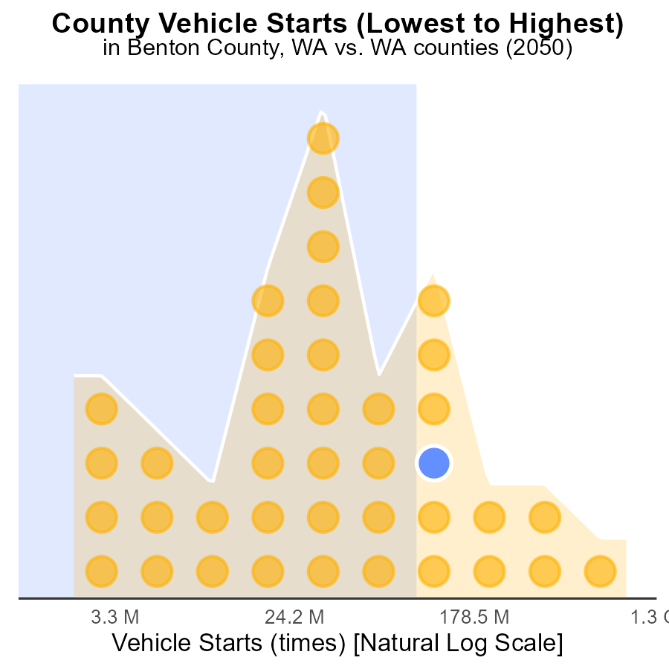

## Findings

* King county has the highest number of vehicle starts with 2.7 billion in 2050.
* San Juan county has the lowest number of vehicle starts with 5.6 million in 2050.
* On average, the counties in the data have 78.2% of vehicle starts compared to King county.

## Recommendations

To reduce NOx emissions from vehicle starts, strategies such as promoting public transportation, incentivizing electric vehicles, and improving infrastructure for walking and biking should be implemented. Additionally, enhancing carpooling programs and introducing stricter emission standards for vehicles can further aid in lowering emission levels.

# Areas Ranked by Emissions Rate (per mile)

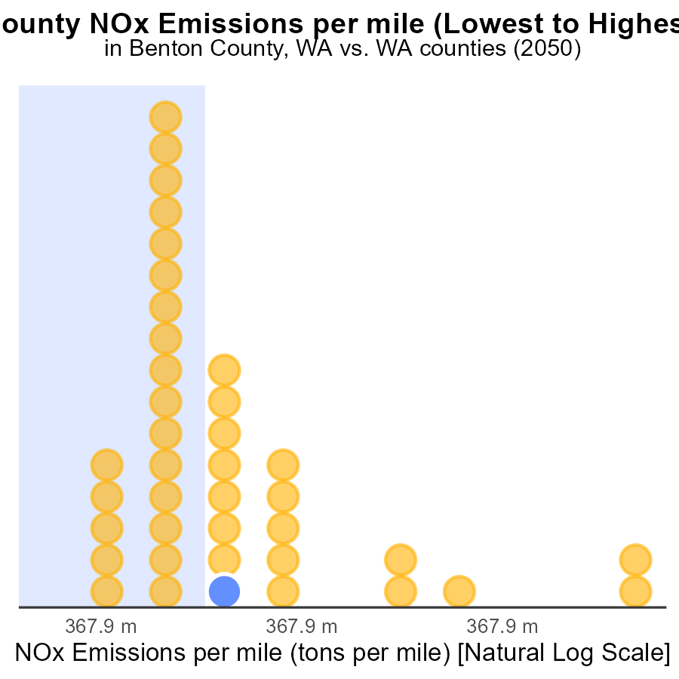

## Findings

* Adams county has the highest NOx emissions per mile at 340.5 tons.
* Pierce county has the lowest NOx emissions per mile at 194.2 tons.
* Douglas county ranks 23rd with NOx emissions per mile at 227.0 tons.

## Recommendations

To lower the NOx emissions, Adams should focus on implementing stricter vehicle emission standards. Pierce should continue promoting the use of electric vehicles. Douglas should invest in public transportation infrastructure to reduce individual vehicle usage.

# Conclusion

The data on Oxides of Nitrogen (NOx) emissions from on-road transportation in Benton County, WA in 2050 highlights the significant contribution of Heavy Heavy-Duty 8 (HHD8) vehicles to the overall NOx levels, accounting for 97.5% of emissions. Glider vehicles also play a role, contributing 2.5% of NOx emissions per mile. Urban buses add 9.0% of the total NOx emissions per mile. To effectively reduce NOx emissions in the county, targeted measures should focus on implementing stricter emission standards for HHD8 and Glider vehicles, as well as promoting cleaner fuel technologies.

Continued efforts to lower emissions from Gliders, Urban Buses, and other heavy-duty vehicles can lead to a substantial reduction in NOx levels. By monitoring progress and enforcing emission standards for industries and vehicles, Benton County can work towards bringing emissions below the median area levels and ensuring a sustainable environment for the future.

# About This Report

Data based on MOVES estimates collected by the Climate Action in Transportation program at Cornell University. Demographic data sourced from the US Census's American Community Survey 5-year estimates. This report was generated with the help of AI.

# References

* U.S. Census Bureau. (2023). American Community Survey 5-year estimates: Detailed tables. Retrieved from https://data.census.gov
* U.S. Environmental Protection Agency. (2024). Motor Vehicle Emission Simulator (MOVES 4.0) [Software]. Retrieved from https://www.epa.gov/moves