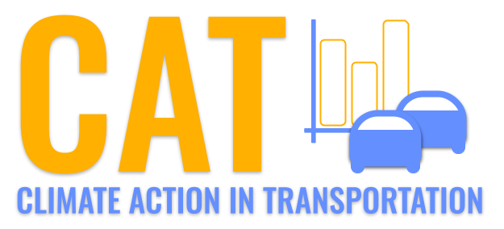 

**PM2.5 Emissions in Union County, 2040**  
Made with CAT VISUALIZER by Gao Labs @ Cornell University.

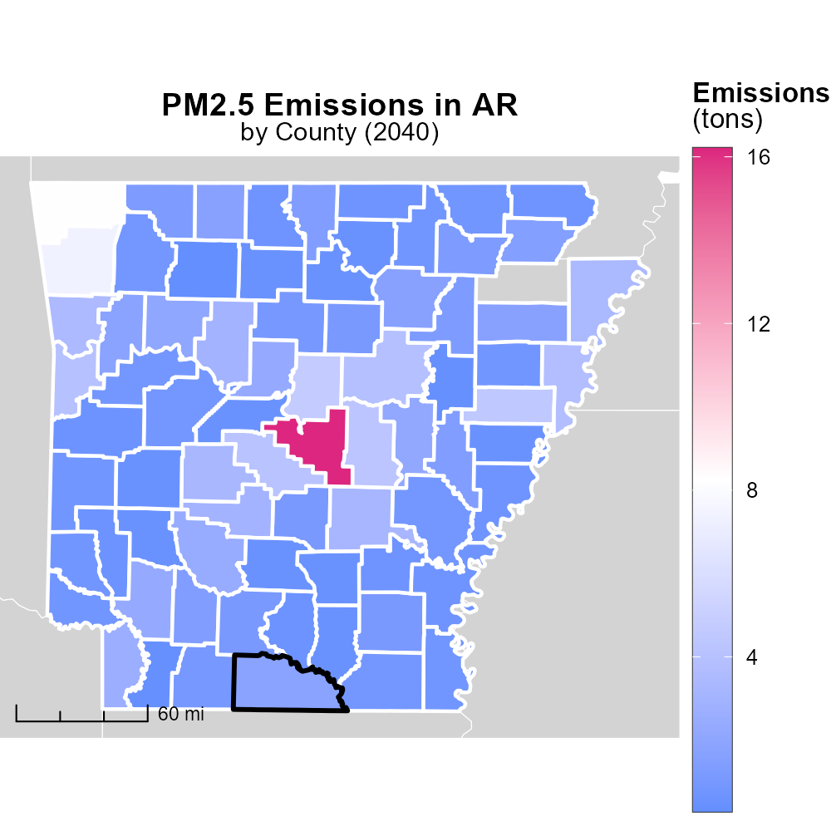

## Keywords

Primary Exhaust PM2.5; Total emissions; on-road transportation; Union County; AR; 2040

## Highlights

* Analysis of on-road transportation emissions in Union County, AR.
* Focus on PM2.5 from primary exhaust sources.
* Projection of emissions for 2040.
* Implications for air quality and public health.
* Recommendations for mitigation strategies.

# Introduction

The following report presents a comprehensive analysis of primary exhaust PM2.5 emissions from on-road transportation in Union County, Arkansas, with a specific focus on the projected total emissions for the year 2040. This study aims to provide a detailed overview of the sources, trends, and potential impacts of PM2.5 emissions in the region, highlighting the significance of addressing this environmental concern.

Considering the potential implications of high PM2.5 levels on air quality and public health, this report also includes recommendations for mitigation strategies that can help reduce emissions and improve overall environmental conditions. By examining the current situation and projecting into the future, this study aims to inform policymakers, stakeholders, and the general public about the importance of taking proactive measures to combat on-road transportation emissions in Union County.

# Vehicle Miles Traveled by Road Type

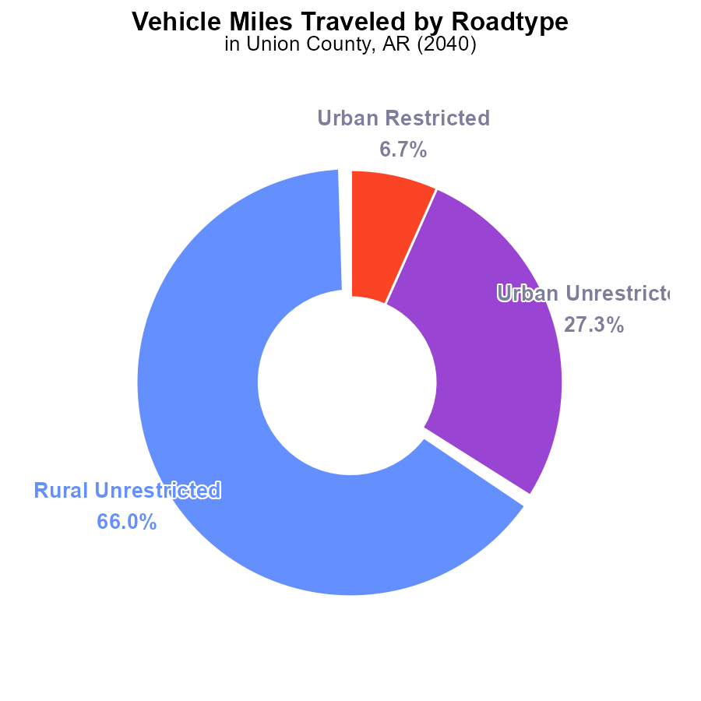

## Findings

* Most PM2.5 emissions in Union County, AR in 2040 come from Rural Unrestricted vehicle miles traveled (66.0%).
* Urban Unrestricted sources contribute 27.3% to the total emissions in the area.
* The Urban Restricted and Rural Restricted categories have minimal to no contribution to PM2.5 emissions.

## Recommendations

To reduce PM2.5 emissions, policies should focus on regulating Rural Unrestricted vehicle miles traveled, such as promoting carpooling, adopting cleaner fuel technologies, and investing in public transportation in rural areas.

# Population by Vehicle Type

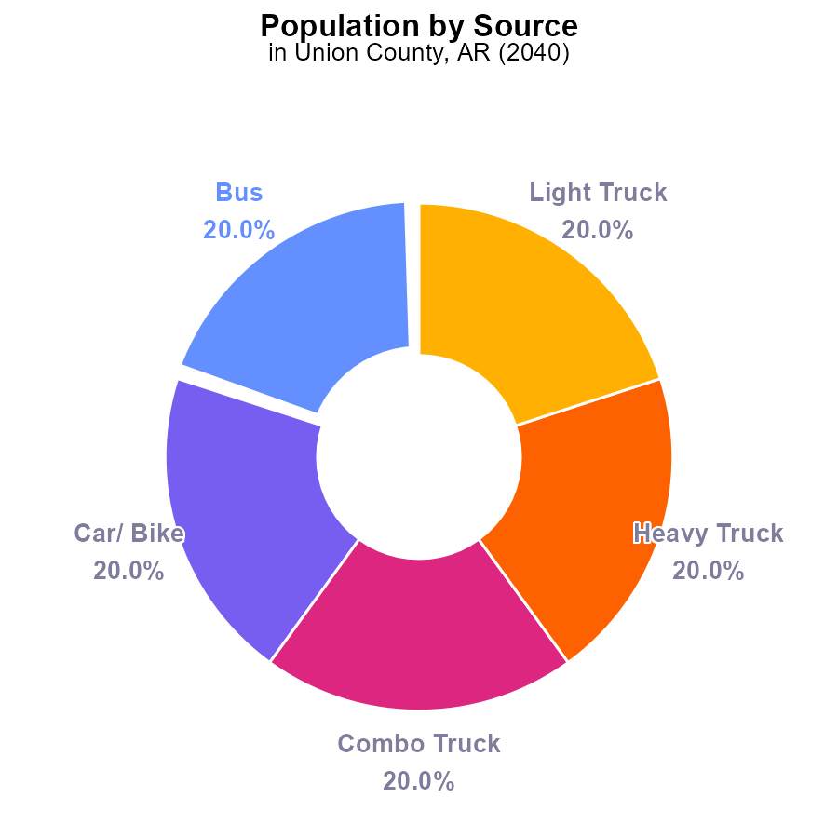

## Findings

* Bus, Car/Bike, Combo Truck, Heavy Truck, and Light Truck each contribute 39.1 k to PM2.5 emissions, making up 100% collectively.

## Recommendations

To lower PM2.5 emissions in Union County, a focus on reducing emissions from all vehicle types is necessary, such as implementing stricter emission standards, promoting electric vehicles, and improving public transportation to reduce the usage of individual cars.

# Vehicle Starts over Time for Passenger Vehicle Starts

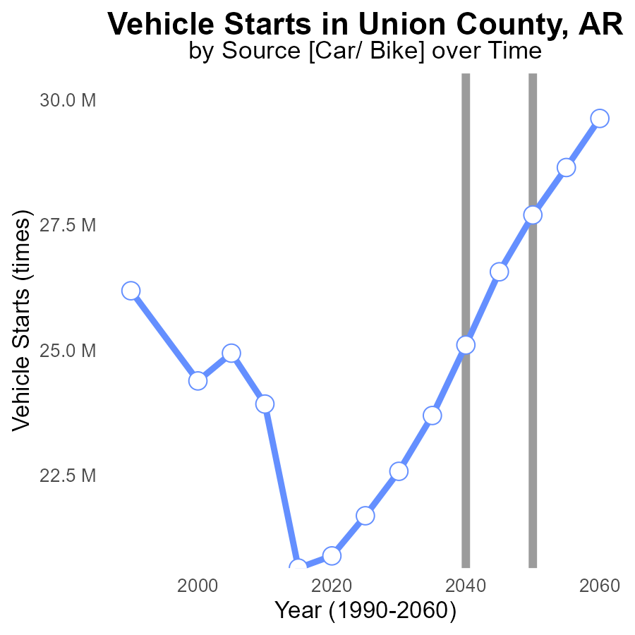

## Findings

* PM2.5 emissions from vehicle starts in Union County, AR are projected to increase over time.
* The benchmark difference is decreasing annually, indicating a reduction in emissions compared to the previous year.
* Emissions are expected to peak in 2060 before declining by 1930027.2 times in 2060 compared to 2055.

## Recommendations

To lower PM2.5 emissions from vehicle starts, policymakers should incentivize the adoption of electric vehicles, improve public transportation infrastructure, and promote telecommuting to reduce the number of vehicle starts.

# Emissions Rate (per vehicle) over Time for Buses

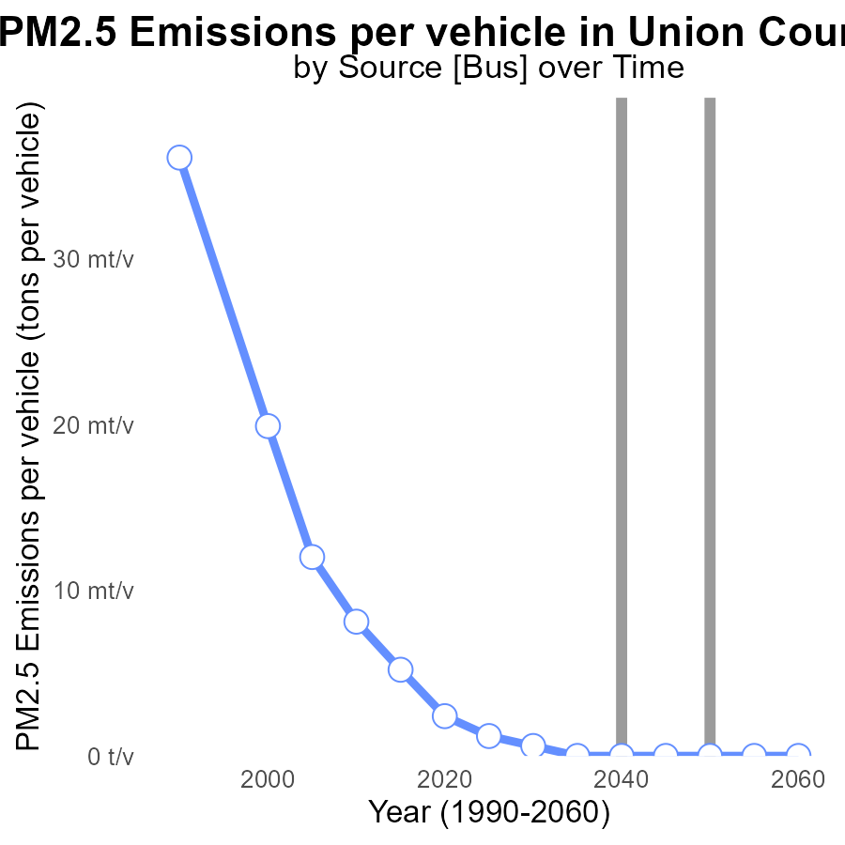

## Findings

* PM2.5 emissions per vehicle in Union County, AR decreased from 2.4 tons in 2020 to 550.1 kg in 2030.
* By 2030, there is a projected reduction of 0.0006 tons per vehicle compared to the benchmark.
* From 2035 onwards, the emissions per vehicle are at 0 tons, indicating a significant improvement in air quality.

## Recommendations

To maintain this positive trend, policymakers could incentivize the adoption of electric vehicles, promote carpooling, and invest in public transportation.

# Emissions in My Region

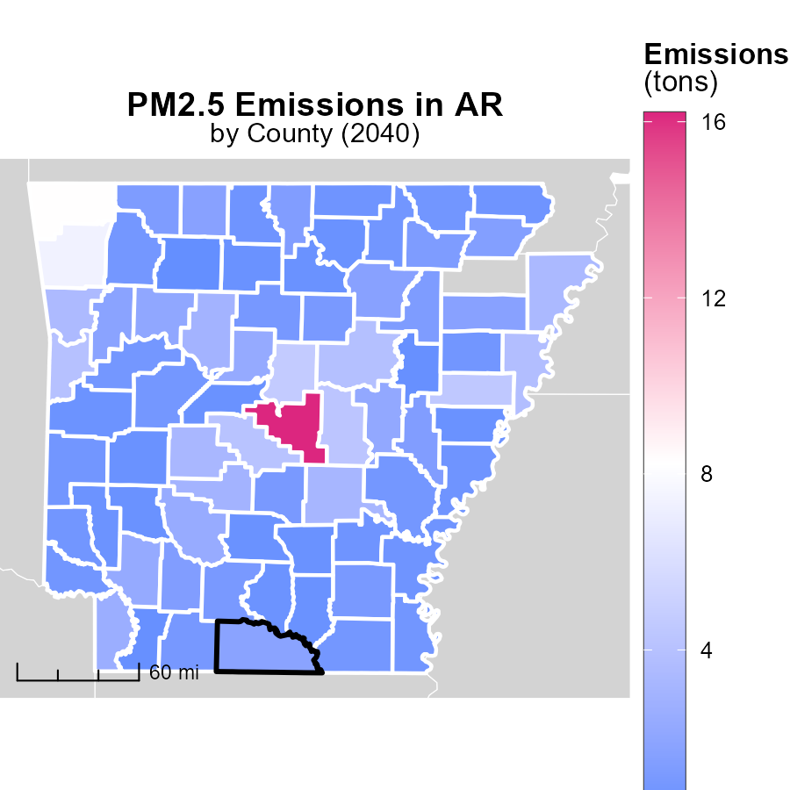

## Findings

* Pulaski County, AR has the highest emissions at 16.2 tons in 2040.
* Grant County, AR has a median emission level of 1.1 tons in 2040.
* Newton County, AR has the lowest emissions among the three counties, at 300.0 tons in 2040.

## Recommendations

To reduce emissions, focus on Pulaski County, AR, by implementing stricter emission control measures in industries and promoting public transportation. Grant County, AR's median level can be further lowered by encouraging renewable energy sources. Newton County, AR's emissions can be significantly reduced by implementing sustainable agricultural practices and promoting reforestation efforts.

# Emissions Rate (per mile) Mapped by Area

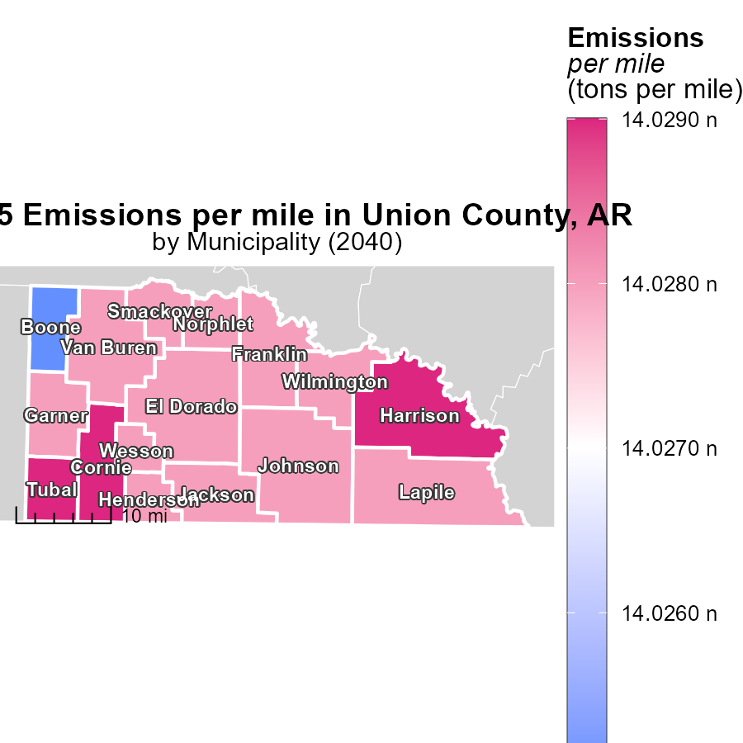

## Findings

* The maximum emissions per mile in Cornie, AR, are 14.0 tons.
* The median emissions per mile in Jackson, AR, are 14.0 tons.
* The minimum emissions per mile in Boone, AR, are 14.0 tons.

## Recommendations

To lower emissions, focus on efficient transportation methods, promote carpooling, and invest in electric vehicles. Implementing stricter emissions regulations can also help decrease pollution.

# Vehicle Starts by Road Type over Time

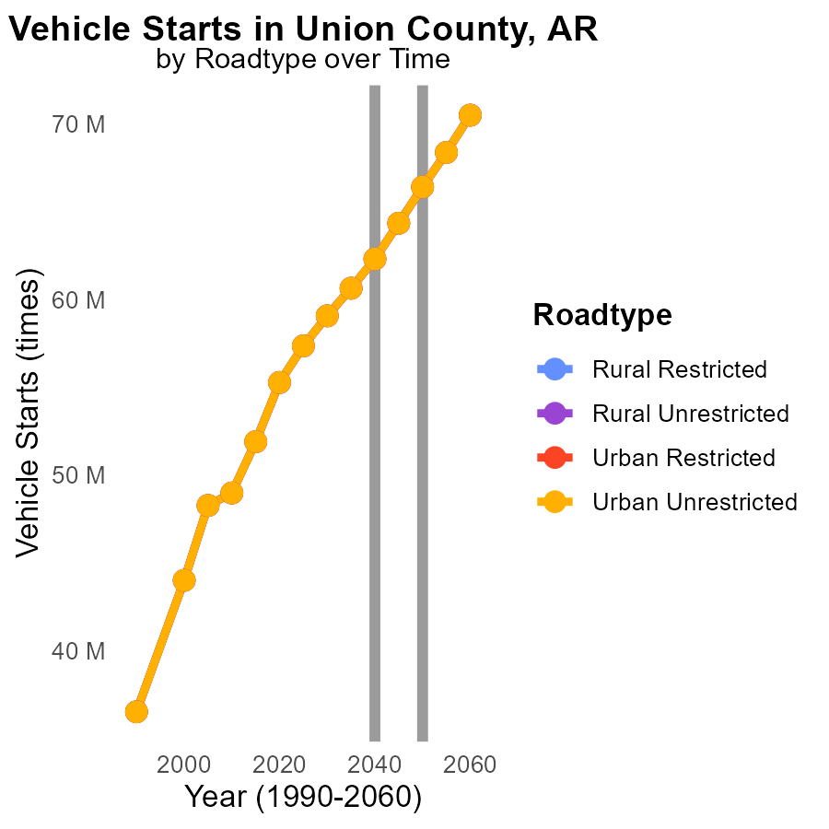

## Findings

* PM2.5 emissions from vehicle starts in Union County, AR are projected to increase consistently from 2030 to 2050 across all road types and area types.
* The highest emissions are forecasted in 2050 for both Rural Restricted and Urban Unrestricted areas, each at 66.4 million starts.
* There is a notable decrease in emissions by 2050 compared to 2030, with a reduction in starts ranging from 7.2% to 7.5% across different area and road types.

## Recommendations

To lower PM2.5 emissions, implementing stricter regulations on vehicle emissions and promoting the use of electric vehicles in Union County could be effective. Additionally, investing in public transportation infrastructure to reduce the number of private vehicle starts would contribute significantly to decreasing emissions.

# Hotelling (Engines Off) by Vehicle Type over Time

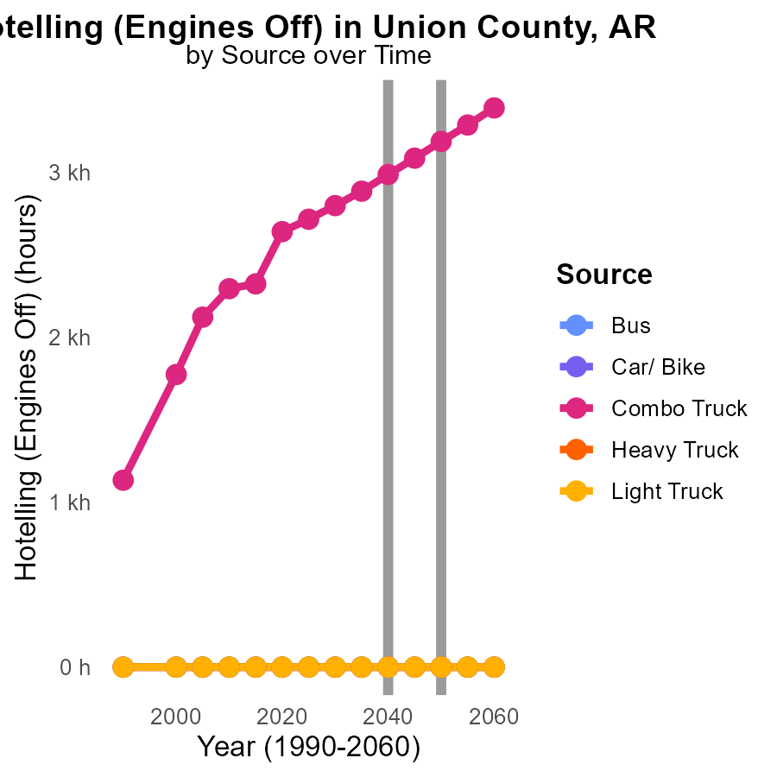

## Findings

* Combo trucks are projected to increase emissions by 389.0% from 2030 to 2050.
* Heavy trucks are forecasted to keep emissions at zero until 2050.
* Other vehicles, like buses and light trucks, are expected to maintain emissions at zero throughout the years.

## Recommendations

To lower emissions, focus on implementing stricter regulations for combo trucks to reduce the significant increase projected. Encourage the use of cleaner fuel sources and technologies, while promoting public transportation to reduce the overall impact.

# Areas Ranked by Hotelling (Diesel Aux)

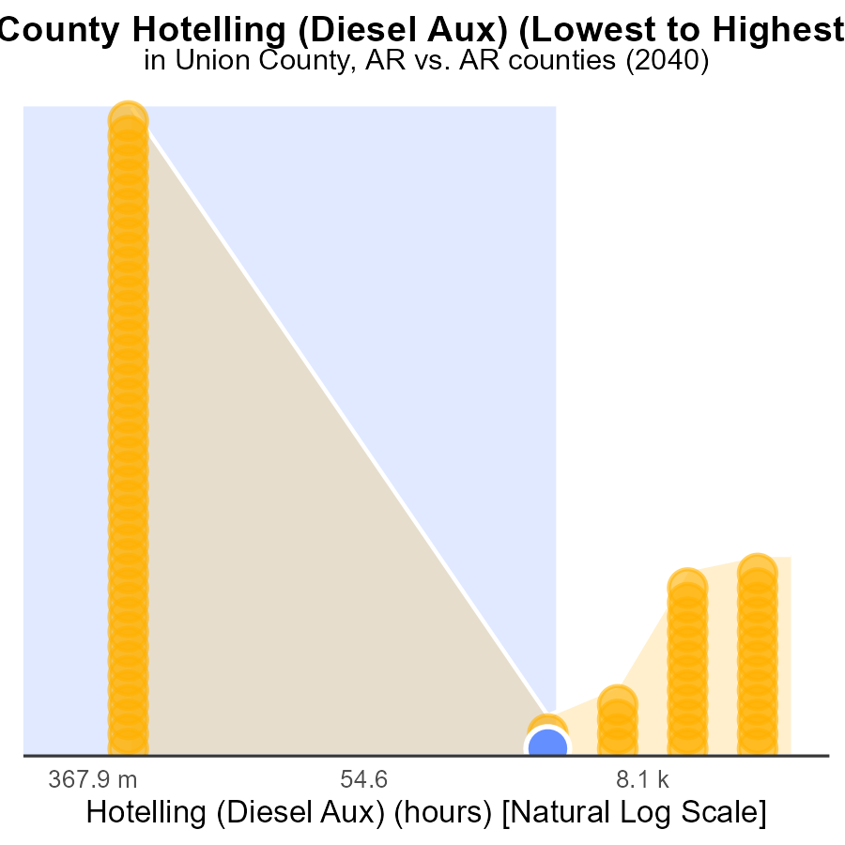

## Findings

* Pulaski county has the highest PM2.5 emissions at 337.0k hours.
* Union county follows with 4.6k hours of emissions.
* Arkansas and Yell counties have the lowest emissions with 0.0 hours each.

## Recommendations

To lower emissions, focus policies on reducing diesel auxiliary usage in high-emitting areas like Pulaski and Union counties, while maintaining low-emission standards in Arkansas and Yell counties.

# Areas Ranked by Emissions Rate (per vehicle)

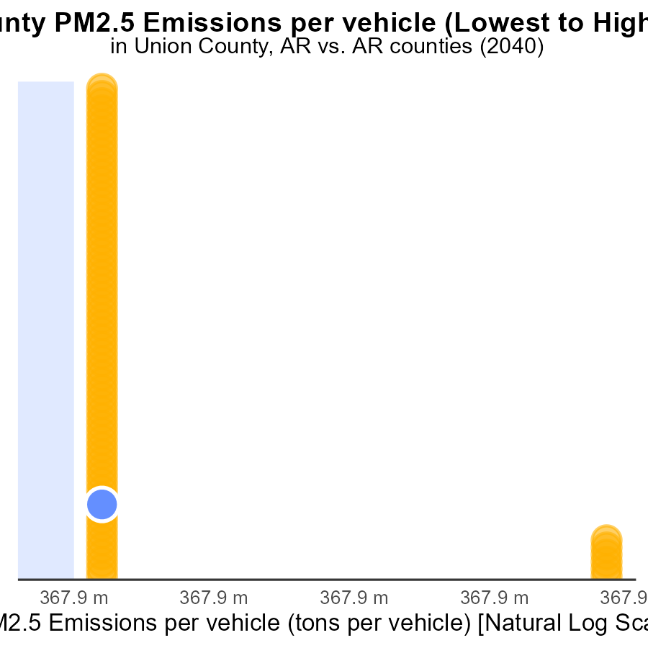

## Findings

* St. Francis county has the highest PM2.5 emissions per vehicle at 56.7 tons per vehicle.
* Benton county has the lowest PM2.5 emissions per vehicle at 33.3 tons per vehicle.
* Union county has a PM2.5 emissions rate of 35.3 tons per vehicle, ranking 11th in the dataset.

## Recommendations

To lower PM2.5 emissions, prioritizing interventions in St. Francis county based on the highest rate is crucial. Implementing stricter vehicle emission standards and promoting public transportation can help reduce emissions in Benton county. Union county should focus on enhancing vehicle maintenance and promoting clean fuel alternatives to decrease emissions.

# Conclusion

In conclusion, the data reveals that PM2.5 emissions from on-road transportation in Union County, AR in 2040 predominantly stem from Rural Unrestricted vehicle miles traveled. Efforts to reduce these emissions should target this specific category through initiatives such as promoting carpooling, adopting cleaner fuel technologies, and investing in public transportation in rural areas. Additionally, focusing on reducing emissions from all vehicle types, including buses, trucks, and cars, is crucial in mitigating air pollution levels. The projected increase in PM2.5 emissions over the coming years underscores the urgency for policymakers to implement stricter emission standards, incentivize the adoption of electric vehicles, and improve public transportation infrastructure to curb the rise in vehicle starts and emissions. By learning from the data insights and implementing targeted strategies, Union County can work towards improving air quality and creating a more sustainable environment for its residents.

# About This Report

Data based on MOVES estimates collected by the Climate Action in Transportation program at Cornell University. Demographic data sourced from the US Census's American Community Survey 5-year estimates. This report was generated with the help of AI.

# References

* U.S. Census Bureau. (2023). American Community Survey 5-year estimates: Detailed tables. Retrieved from https://data.census.gov
* U.S. Environmental Protection Agency. (2024). Motor Vehicle Emission Simulator (MOVES 4.0) [Software]. Retrieved from https://www.epa.gov/moves