 

**NOx Emissions in Caledonia County, 2040**  
Made with CAT VISUALIZER by Gao Labs @ Cornell University.

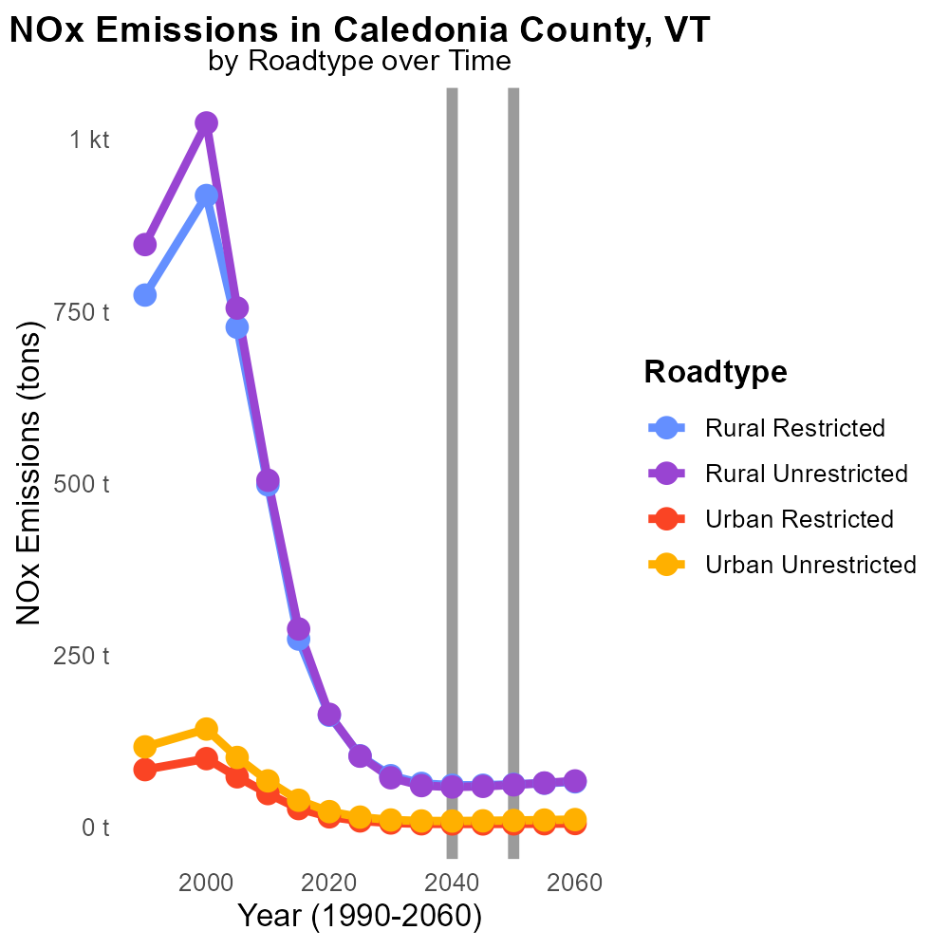

## Keywords

Oxides of Nitrogen; NOx emissions; on-road transportation; Caledonia County; VT; 2040

## Highlights

* Impact of NOx emissions on air quality in Caledonia County.
* Forecasted trends of NOx emissions from transportation.
* Strategies for reducing NOx emissions in on-road vehicles.
* Data on NOx levels and their implications for public health.
* Significance of studying NOx emissions in a specific region like Caledonia County.

# Introduction

Oxides of Nitrogen (NOx) emissions from on-road transportation have become a significant environmental concern in Caledonia County, VT. As we look towards the year 2040, the impact of NOx emissions on air quality and public health is a crucial area of study.

This report aims to analyze the trends, challenges, and potential solutions related to NOx emissions in on-road vehicles specifically in Caledonia County. By examining data on NOx levels and their implications for public health, we can better understand the need for targeted strategies to reduce these harmful emissions and pave the way for a cleaner and healthier future for the region.

# Emissions Rate (per capita) by Regulatory Class

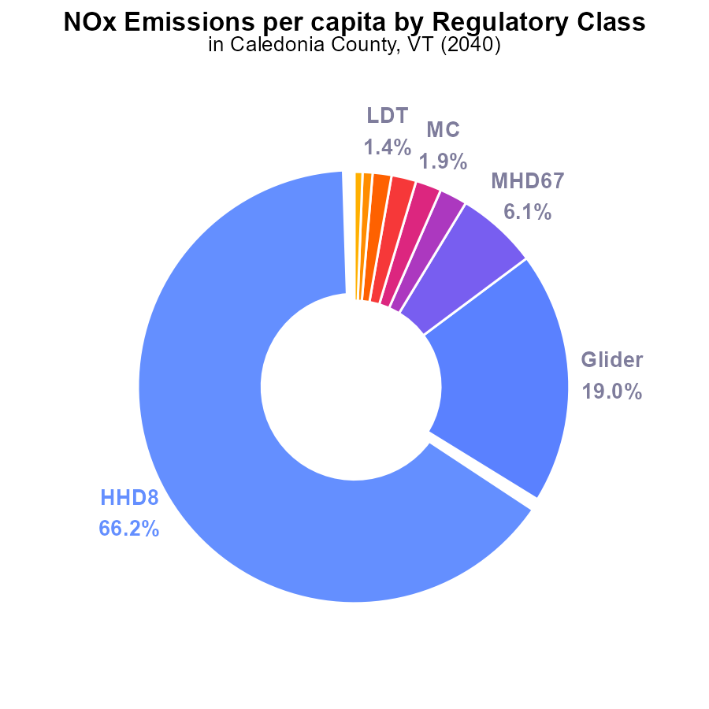

## Findings

* The highest NOx emissions per capita in Caledonia County, VT are from HHD8 at 3.0 tons per person, representing 66.2%.
* Glider emissions follow, at 845.9 µ (19.0%); MHD67 at 273.1 µ (6.1%) comes next.
* Overall, top 3 sources (HHD8, Glider, MHD67) contribute to 91.3% of NOx emissions per capita in the region.

## Recommendations

To reduce emissions, strategies focusing on the top contributors, such as HHD8, Gliders, and MHD67, should be prioritized. These may include enforcing stricter emission standards, promoting the use of cleaner technologies, and incentivizing public transportation.

# Vehicle Starts by Road Type

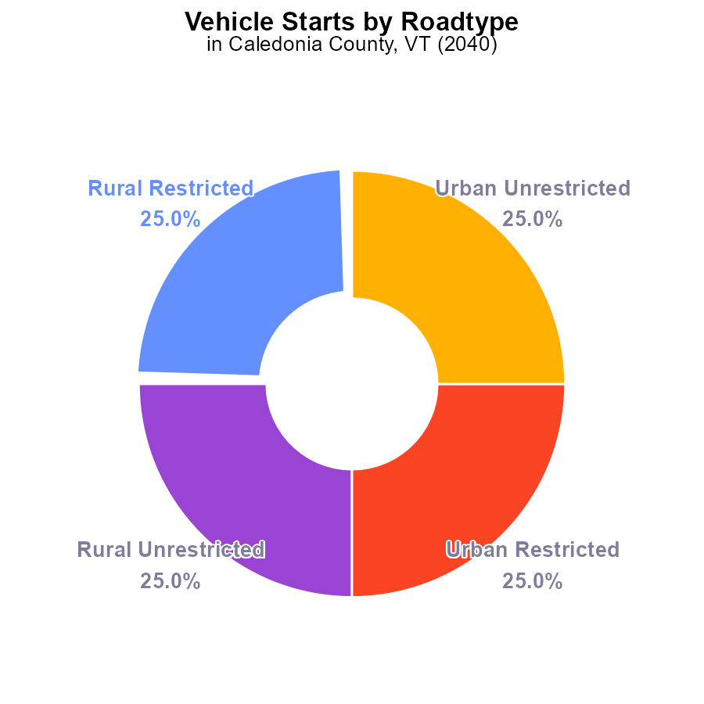

# Population Overall over Time

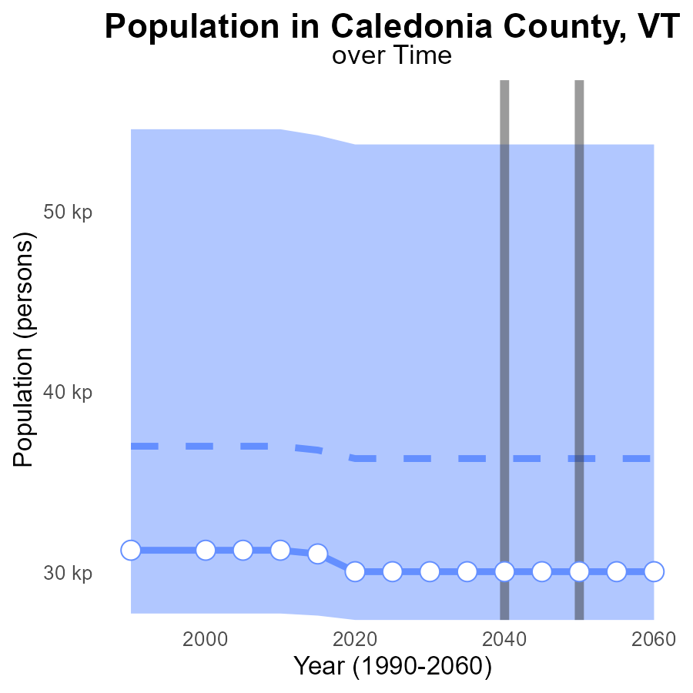

## Findings

* NOx emissions in Caledonia County, VT are consistently 30.0 k persons from 2020 to 2060.
* The emissions differ by -6.3 k from the median area population of 36298 persons.
* Caledonia County, VT falls within the lower 25th percentile range for NOx emissions compared to other areas.

## Recommendations

To lower NOx emissions, targeted efforts should focus on reducing emissions from transportation and industrial sources. Implementing stricter emission standards and promoting the adoption of cleaner technologies can help improve air quality.

# Vehicle Starts over Time for Passenger Vehicle Starts

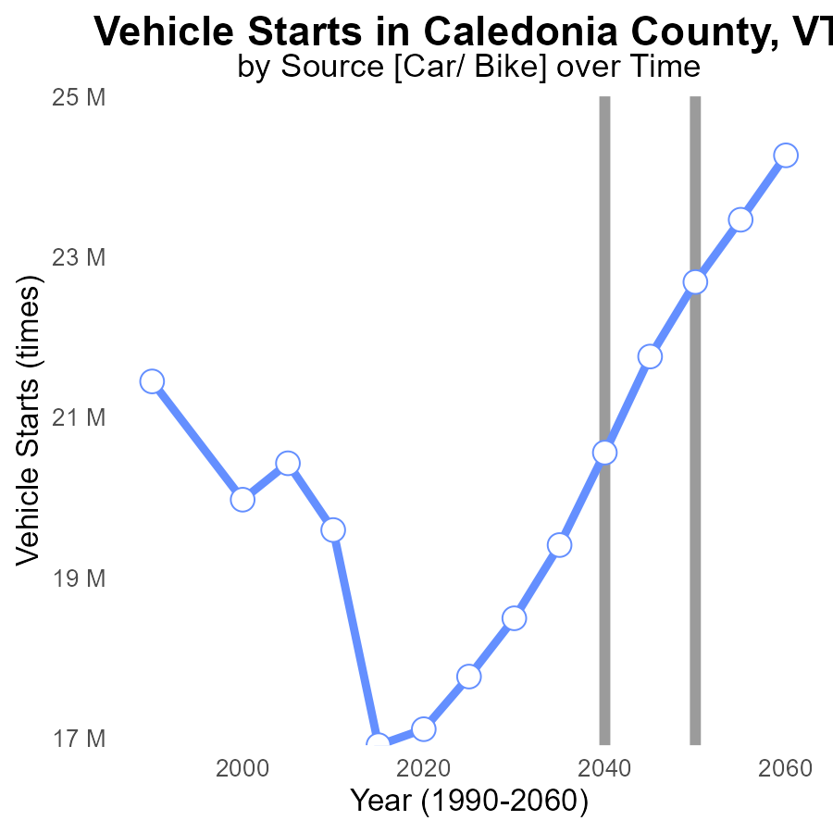

## Findings

* NOx emissions in Caledonia County, VT are projected to increase from 17.1 M in 2020 to 24.3 M in 2060.
* The difference from the benchmark decreases over time, starting at 5581659.6 in 2020 and reaching -1580875.0 in 2060.
* A significant reduction in NOx emissions is observed between 2040 and 2050, dropping from 20.6 M to 22.7 M.

## Recommendations

To lower NOx emissions in Caledonia County, VT, it is crucial to implement stricter vehicle emission standards alongside promoting the adoption of electric vehicles. Developing and encouraging the use of public transportation can also play a pivotal role in reducing emissions.

# Emissions Rate (per capita) in My Region

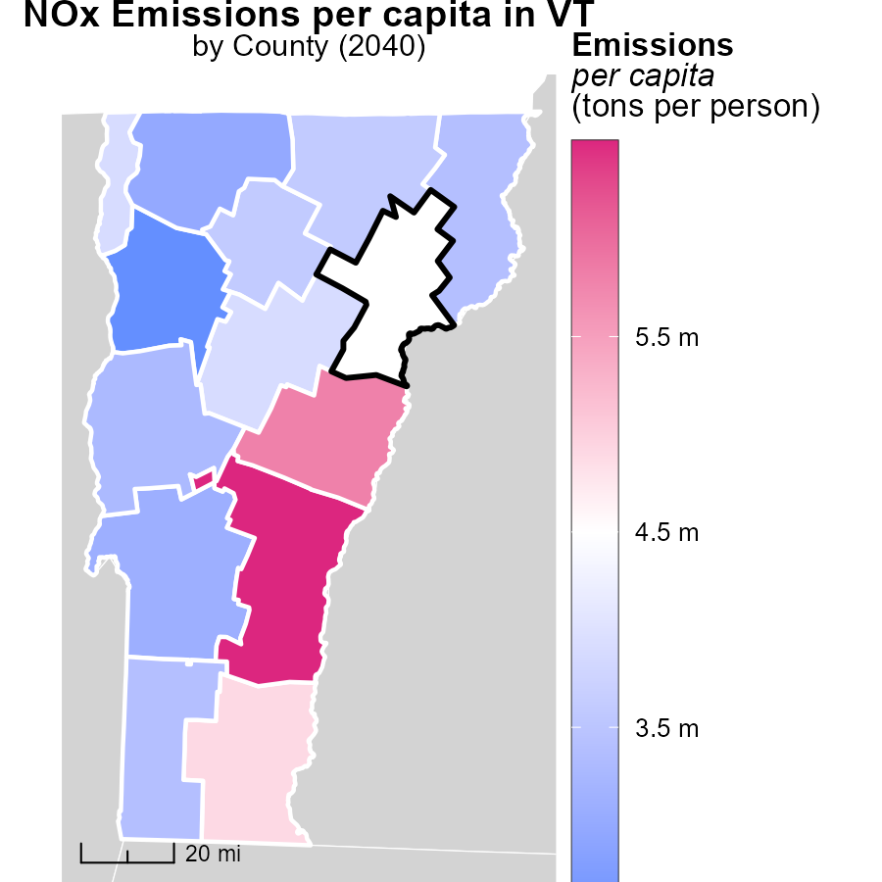

## Findings

* The highest emissions per capita in Windsor County, VT are 6.5 tons per person.
* Orleans County, VT has median emissions at 3.6 tons per person.
* Chittenden County, VT boasts the lowest emissions per capita at 2.5 tons per person.

## Recommendations

To lower emissions, Windsor County, VT could implement stricter carbon footprint reduction programs, Orleans County, VT should focus on sustainable transport, and Chittenden County, VT could promote energy-efficient practices.

# Hotelling (Diesel Aux) Mapped by Area

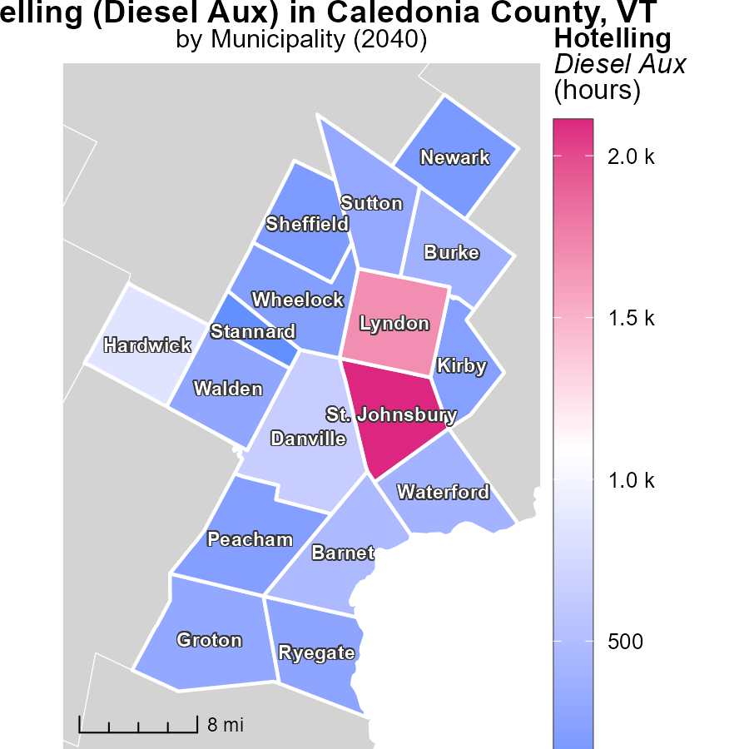

## Findings

* The highest emissions were recorded in St. Johnsbury, VT, with 2.1 k hours.
* Groton, VT, had median emissions of 305.3 hours.
* In contrast, Stannard, VT, showed the lowest emissions at 60.1 hours.

## Recommendations

To lower emissions in areas like St. Johnsbury, VT, investing in cleaner technologies could be beneficial. For areas like Groton, VT, implementing measures to reduce idle times of diesel auxiliaries can lower emissions. Stannard, VT, with the lowest emissions, can still benefit from regular maintenance to sustain its low emission level.

# Vehicles by Road Type over Time

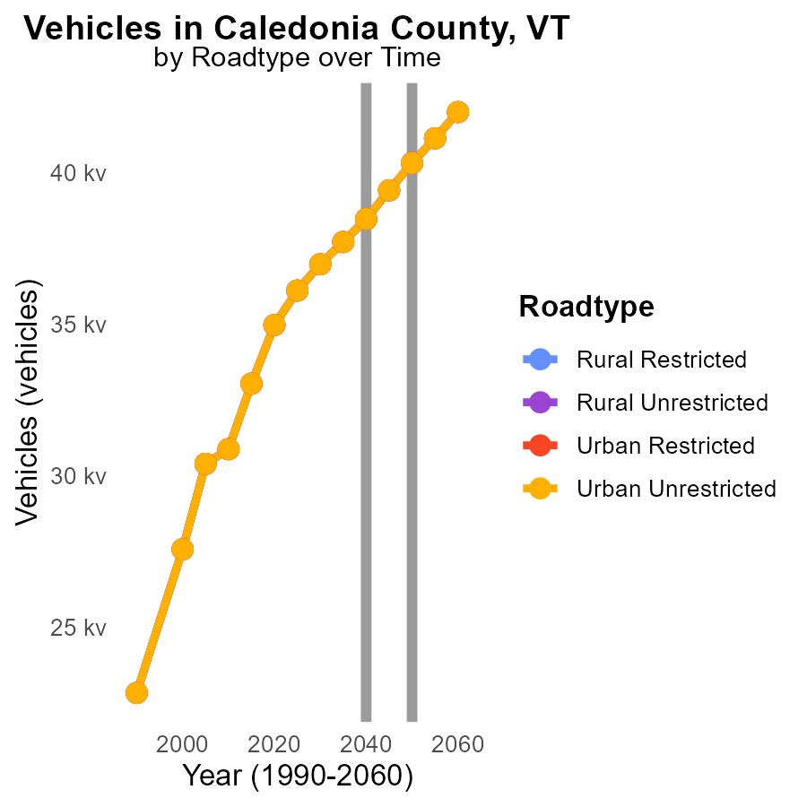

## Findings

* NOx emissions for all vehicle types in Caledonia County, VT are projected to increase from 2030 to 2050.
* By 2050, Rural Unrestricted vehicles are expected to emit the largest amount of NOx, with a total of 40.3 k.
* Urban areas show lower NOx emissions compared to Rural areas, with Urban Unrestricted vehicles emitting the least NOx by 2050.

## Recommendations

To lower NOx emissions in Caledonia County, VT, it is essential to implement stricter vehicle emission standards, invest in public transportation to reduce private vehicle usage, and promote the adoption of electric vehicles.

# Emissions by Road Type over Time

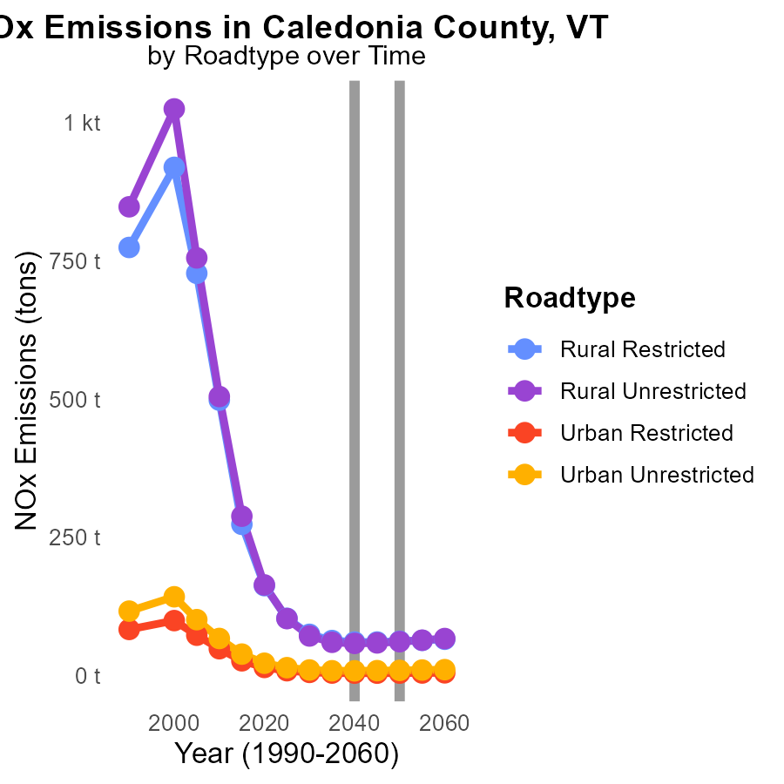

## Findings

* The NOx emissions for Caledonia County show a decreasing trend in all road types from 2030 to 2050.
* Rural Unrestricted areas had the highest NOx emissions in 2030 but saw a larger reduction compared to other areas by 2050.
* Urban areas had significantly lower NOx emissions compared to rural areas with decreasing trends over the years.

## Recommendations

To further reduce NOx emissions, focus on implementing stricter emission standards for vehicles in rural areas, invest in public transportation to reduce individual car usage, and promote the adoption of electric vehicles across all road types.

# Areas Ranked by Vehicle Miles Traveled

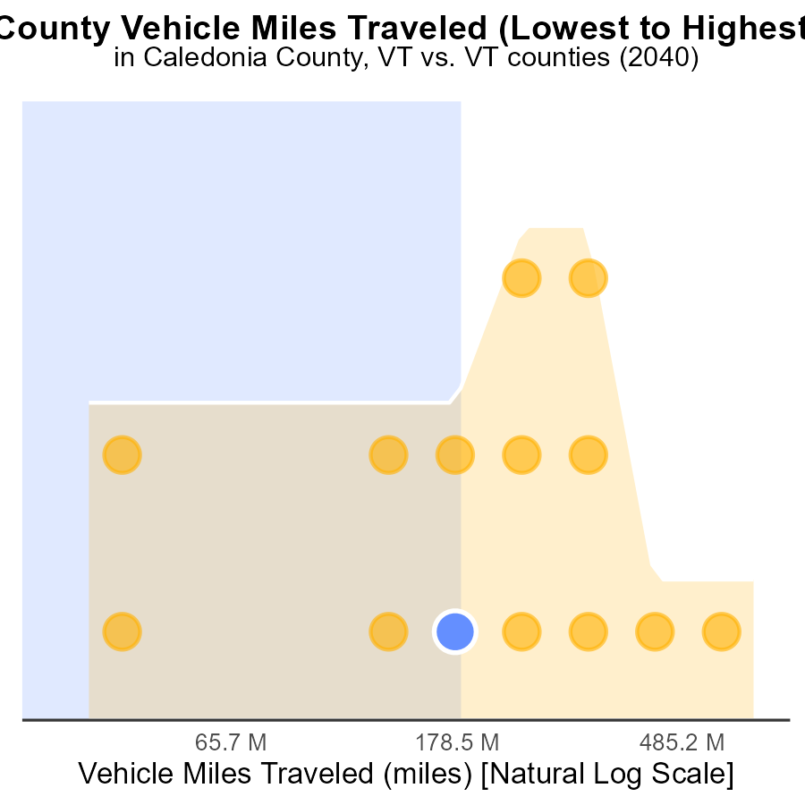

## Findings

* Chittenden county has the highest vehicle miles traveled with 1.8 billion miles in 2040.
* Orange county has the highest NOx emissions with 42.9% when compared to other counties.
* Essex county has the lowest vehicle miles traveled with 94.8 million miles in 2040.

## Recommendations

To reduce NOx emissions, efforts should focus on counties like Orange with high emissions. Implementing carpooling schemes, improving public transportation, and promoting electric vehicles can help lower emissions in these areas. Additionally, investing in infrastructure to reduce travel distances can also be beneficial.

# Areas Ranked by Hotelling (Diesel Aux)

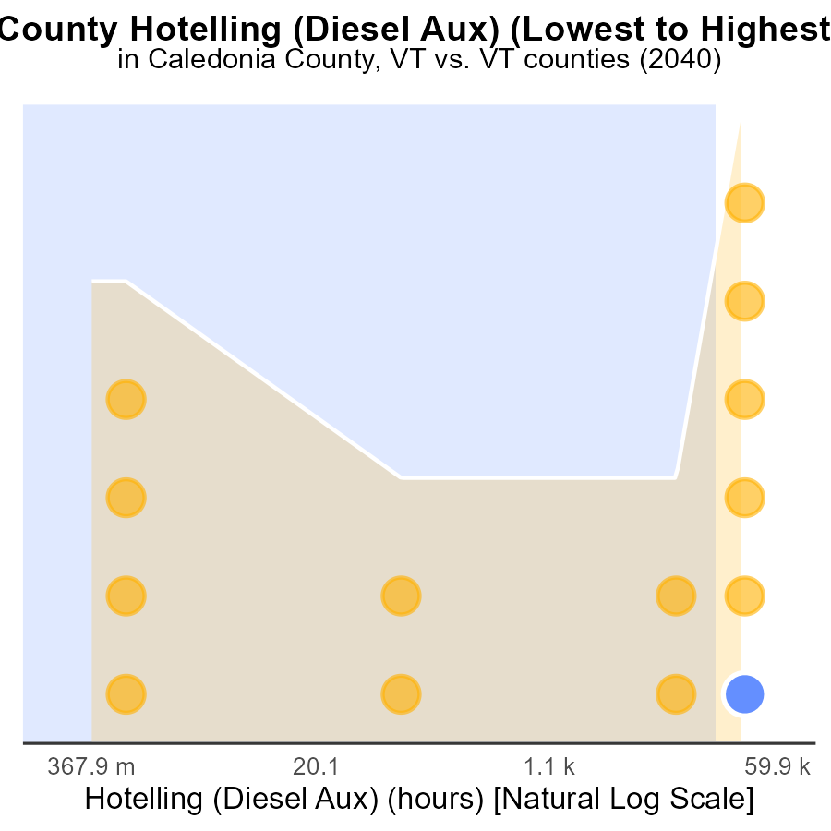

## Findings

* Windsor has the highest NOx emissions at 166.7 k hours.
* Addison has the lowest NOx emissions with 0.0 k hours.
* Most counties are below 60% in the emissions percentile ranking.

## Recommendations

To lower NOx emissions, focus on reducing Hotelling hours for diesel auxiliary in counties with high percentiles like Windsor while exploring ways to maintain the low emissions levels in counties like Addison.

# Conclusion

In conclusion, NOx emissions in Caledonia County, VT in 2040 remain a significant concern, with HHD8, Gliders, and MHD67 being the primary contributors. Efforts aimed at these sources are crucial to effectively reduce emissions. Enforcing stricter emission standards, promoting cleaner technologies, and incentivizing public transportation usage are key strategies to address this issue.

The data indicates a consistent level of emissions per capita over the years, with projections showing a slight increase by 2060. Comparing NOx emissions across counties shows varying levels, with Windsor County having the highest emissions per capita and Chittenden County the lowest. Targeted approaches tailored to each county's specific challenges can contribute to overall emission reductions. Implementing strict vehicle emissions standards, investing in public transportation, and encouraging the adoption of electric vehicles are vital steps towards achieving sustainable air quality in Caledonia County, VT and beyond.

# About This Report

Data based on MOVES estimates collected by the Climate Action in Transportation program at Cornell University. Demographic data sourced from the US Census's American Community Survey 5-year estimates. This report was generated with the help of AI.

# References

* U.S. Census Bureau. (2023). American Community Survey 5-year estimates: Detailed tables. Retrieved from https://data.census.gov
* U.S. Environmental Protection Agency. (2024). Motor Vehicle Emission Simulator (MOVES 4.0) [Software]. Retrieved from https://www.epa.gov/moves