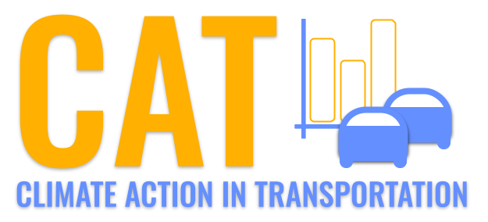 

**VOC Emissions in Penobscot County, 2040**  
Made with CAT VISUALIZER by Gao Labs @ Cornell University.

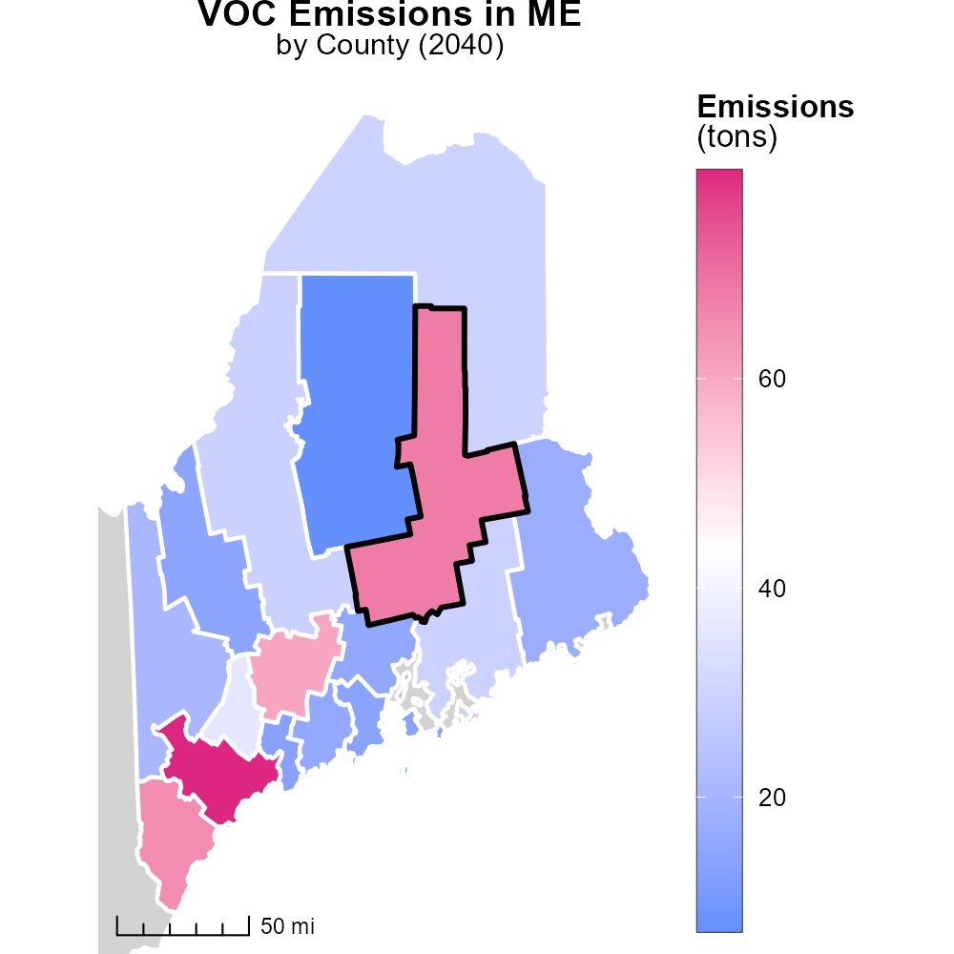

## Keywords

Volatile Organic Compounds; emissions; on-road transportation; Penobscot County; ME; 2040

## Highlights

* Study on VOC emissions from transportation in Penobscot County, ME in 2040.
* Impacts of on-road transportation on air quality and environment.
* Trends and projections of VOC emissions in the county by 2040.
* Potential strategies to reduce VOC emissions from on-road vehicles.
* Importance of addressing transportation emissions for public health and sustainability.

# Introduction

This report investigates the Volatile Organic Compounds (VOC) emissions from on-road transportation in Penobscot County, Maine, in the year 2040. With increasing concerns about air quality and environmental impact, understanding the sources and trends of VOC emissions becomes crucial.

The study aims to analyze the current scenario, project future trends, and propose mitigation strategies to address the challenge of rising VOC emissions from on-road vehicles. By examining the dynamics of transportation emissions in Penobscot County, this report intends to provide insights into the potential impacts on public health and the environment, emphasizing the need for sustainable practices in the transportation sector.

# Hotelling (Engines Off) Overall by Area

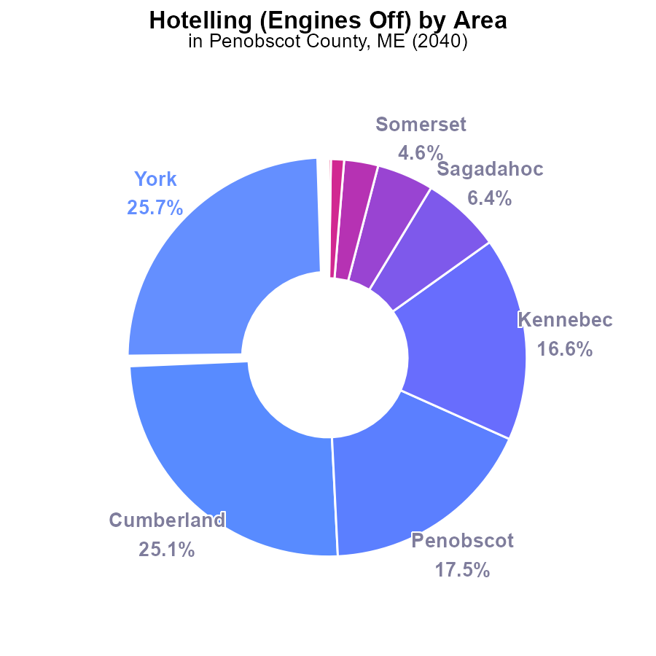

## Findings

* The top 4 counties account for 85% of VOC emissions, with York and Cumberland leading.
* Penobscot County ranks third, contributing 17.5% of VOC emissions.
* Smaller counties like Waldo, Franklin, and Hancock have negligible to zero VOC emissions.

## Recommendations

To lower VOC emissions, focus on reducing vehicle idling in high-contributing counties like York and Cumberland. Implement public awareness campaigns and incentivize the use of electric vehicles. Target industries and transportation services for increased regulations.

# Emissions Rate (per capita) by Vehicle Type

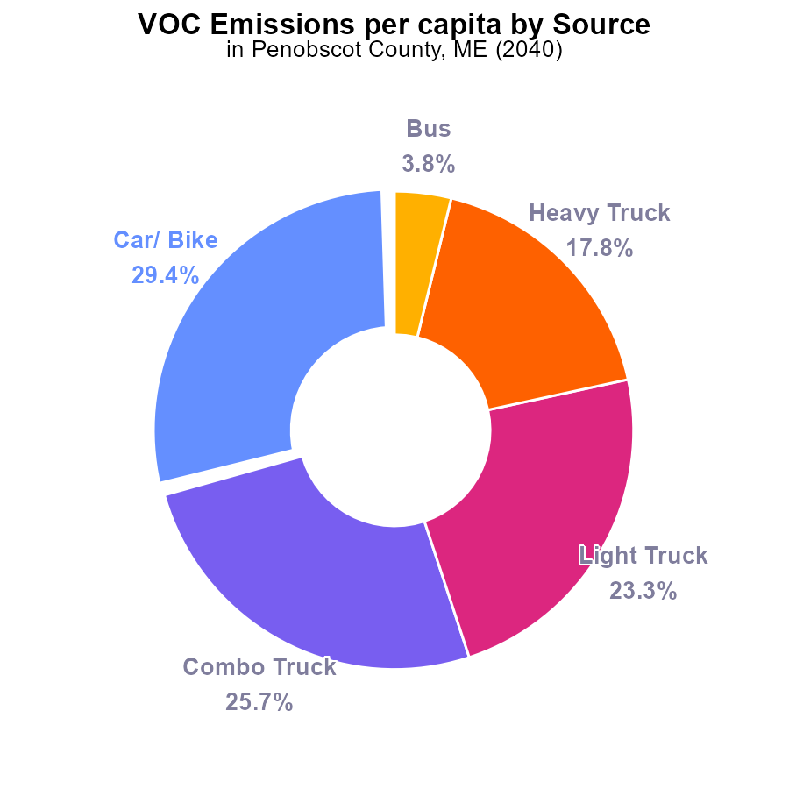

## Findings

* Car/ Bike emit the highest VOC emissions per capita at 29.4%
* Collectively, trucks (Combo, Light, Heavy) contribute to 66.8% of VOC emissions per capita
* Buses have the lowest contribution to VOC emissions per capita at 3.8%

## Recommendations

To reduce VOC emissions per capita in Penobscot County, policymakers should focus on promoting alternative transportation modes like biking and public transportation. Implementing vehicle emission standards for trucks can also significantly reduce emissions.

# Vehicles over Time for Passenger Vehicles

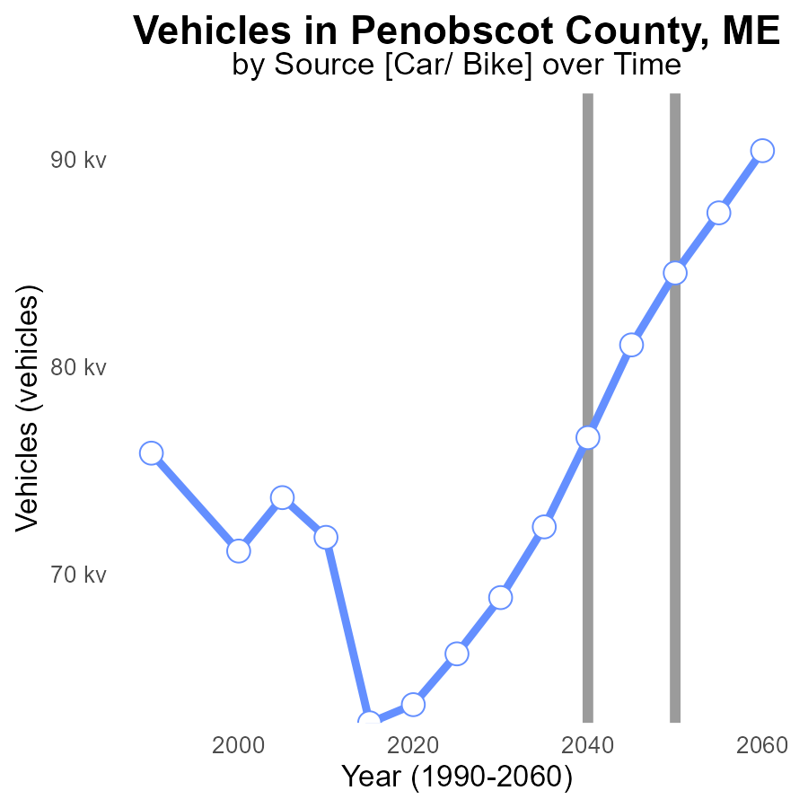

## Findings

* Vehicle emissions in Penobscot County are projected to increase by 33.3% from 2020 to 2060.
* By 2050, emissions are expected to be 7930.7 tons lower than in 2020.
* A significant reduction of 5888.5 tons is projected in vehicle emissions from 2050 to 2060.

## Recommendations

To lower vehicle emissions in Penobscot County, a comprehensive strategy is required. Implementing stricter emission standards for vehicles, promoting the adoption of electric vehicles, expanding public transportation, and investing in infrastructure to support active transportation modes are vital steps to achieve emission reduction targets.

# Emissions Rate (per vehicle) over Time for Passenger Vehicles

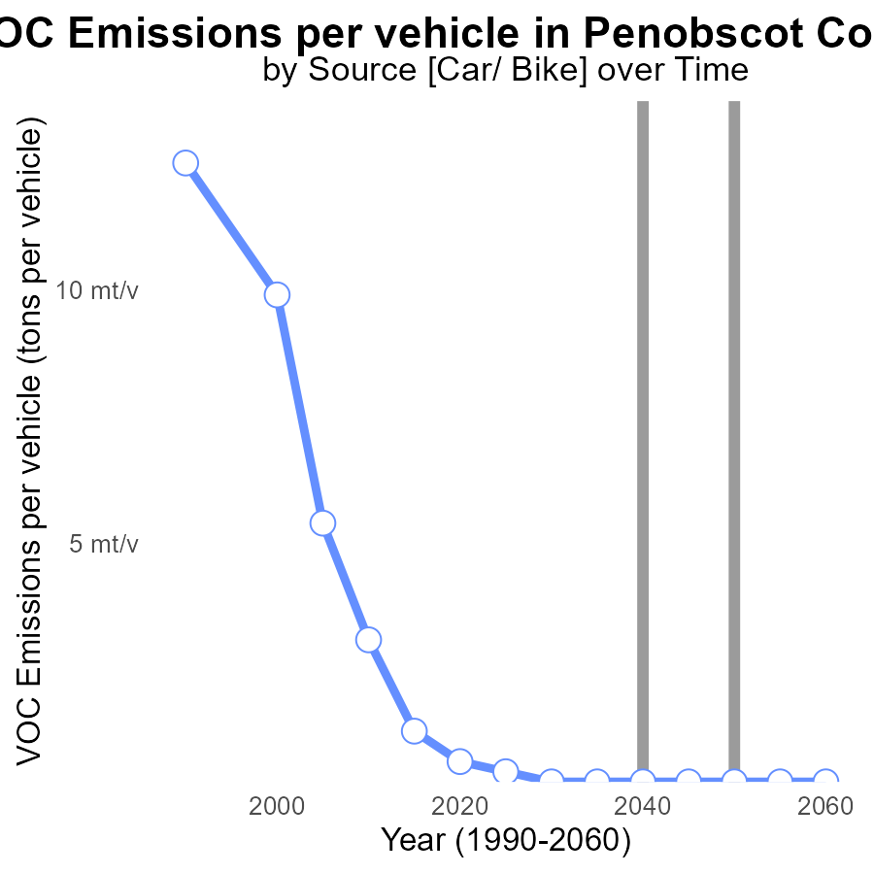

## Findings

* Emissions per vehicle in Penobscot County, ME have decreased from 715.6 µ tons in 2020 to 253.3 µ tons in 2060.
* The benchmark difference shows a consistent reduction over the years, reaching zero by 2030.
* Steady progress is observed in lowering VOC emissions per vehicle over the decades in this area.

## Recommendations

To further decrease emissions, policymakers should focus on promoting the adoption of cleaner vehicle technologies and stricter emission standards. Encouraging the use of public transportation and carpooling can also help reduce per vehicle emissions.

# Emissions in My Region

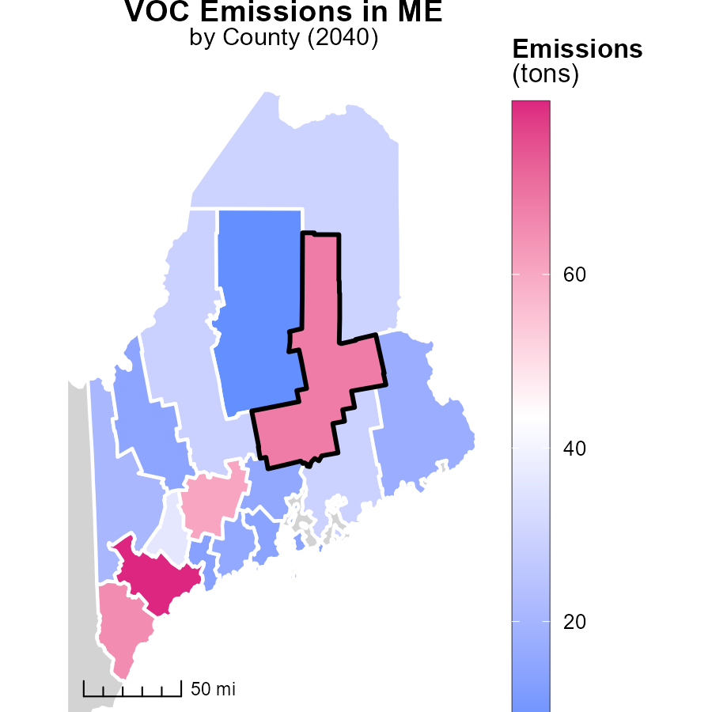

## Findings

* Cumberland County, ME has the highest emissions at 79.9 tons.
* Somerset County, ME has a median emission level of 29.3 tons.
* Piscataquis County, ME showcases the lowest emissions at 7.2 tons.

## Recommendations

To decrease emissions: 1) Implement carbon pricing policies in Cumberland County. 2) Encourage the use of renewable energy sources in Somerset County. 3) Promote energy efficiency programs in Piscataquis County.

# Hotelling (Diesel Aux) Mapped by Area

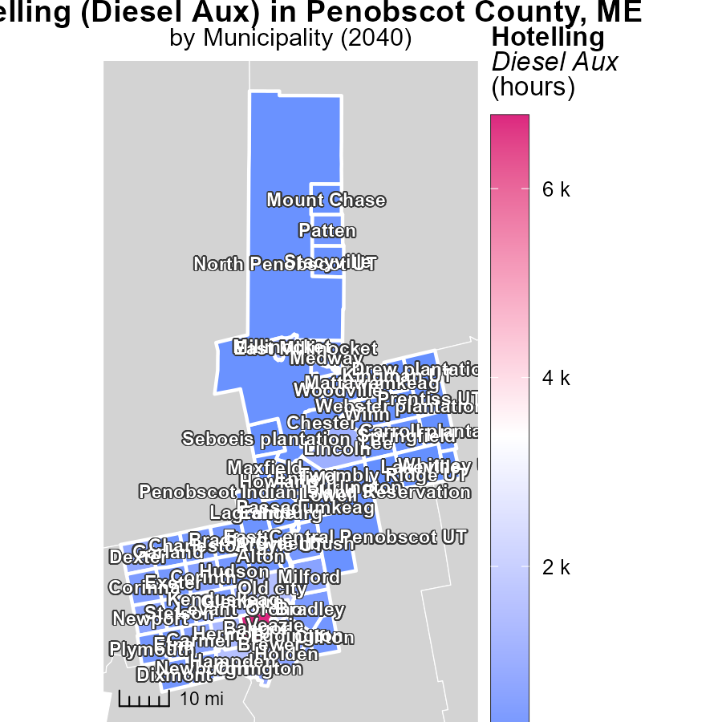

## Findings

* Maine's Howland has a median of 251.2 hours of emissions in 2040.
* Bangor, ME, showed a peak of 6.8k hours of emissions from Hotelling (Diesel Aux) in 2040.
* Whitney UT, ME, recorded the lowest emissions at 0.0 hours in 2040.

## Recommendations

To lower emissions, focus on reducing usage in areas with high emission hours like Bangor, ME, implement cleaner alternatives to reduce median emissions in Howland, ME, and try to maintain low emission levels seen in Whitney UT, ME.

# Idling by Vehicle Type over Time

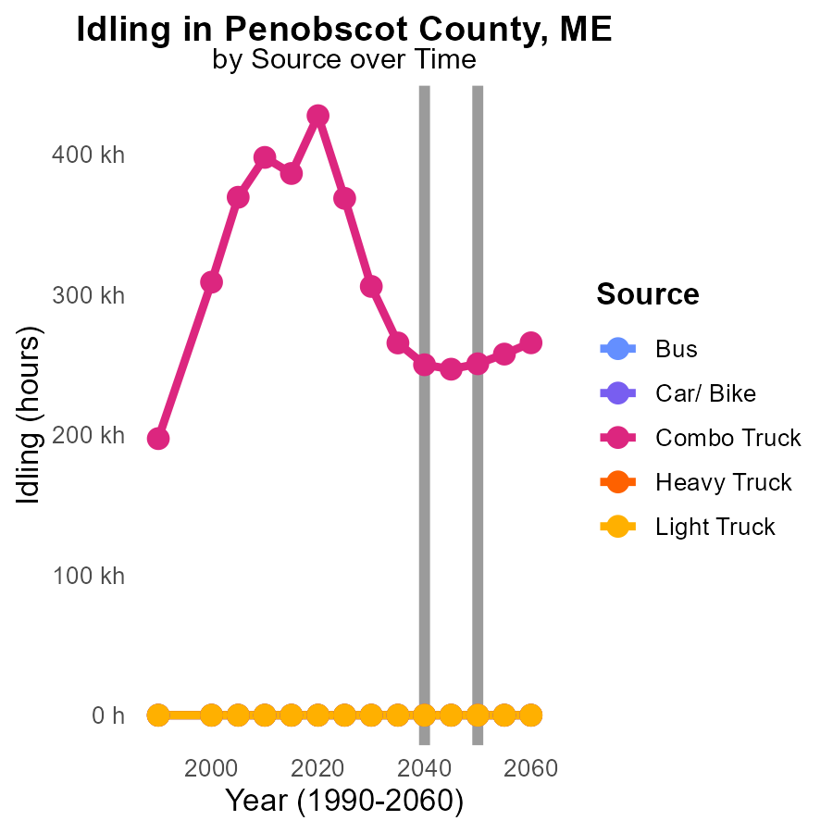

## Findings

* VOC emissions from Combo Trucks will decrease from 305.8 k in 2030 to 250.7 k in 2050.
* There are no VOC emissions from Bus, Car/Bike, Heavy Truck, or Light Truck throughout the years 2030 to 2050.
* For Combo Trucks, the biggest reduction in VOC emissions will occur between 2030 and 2035.

## Recommendations

To further reduce VOC emissions in Penobscot County, focus on implementing policies that encourage the adoption of cleaner fuel technologies in Combo Trucks. Additionally, incentivize the use of vehicles with lower idling times.

# Emissions by Regulatory Class over Time

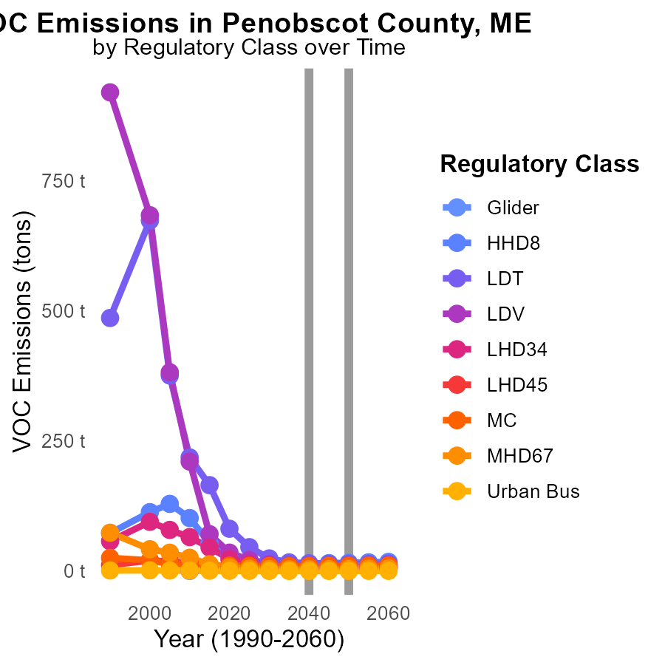

## Findings

* From 2030 to 2050, VOC emissions from Gliders decreased by 15.9%.
* LDT emissions reduced by 44.0% from 2030 to 2050, with a continuous decline over the period.
* For Urban Buses, emissions remained constant at 200.0 tons from 2030 to 2050.

## Recommendations

To further reduce VOC emissions, incentivize the transition to cleaner transport options like electric vehicles for Gliders and LDTs. Implement stricter regulations and regular maintenance checks for existing Urban Bus fleets to ensure emission levels are kept low.

# Areas Ranked by Emissions Rate (per capita)

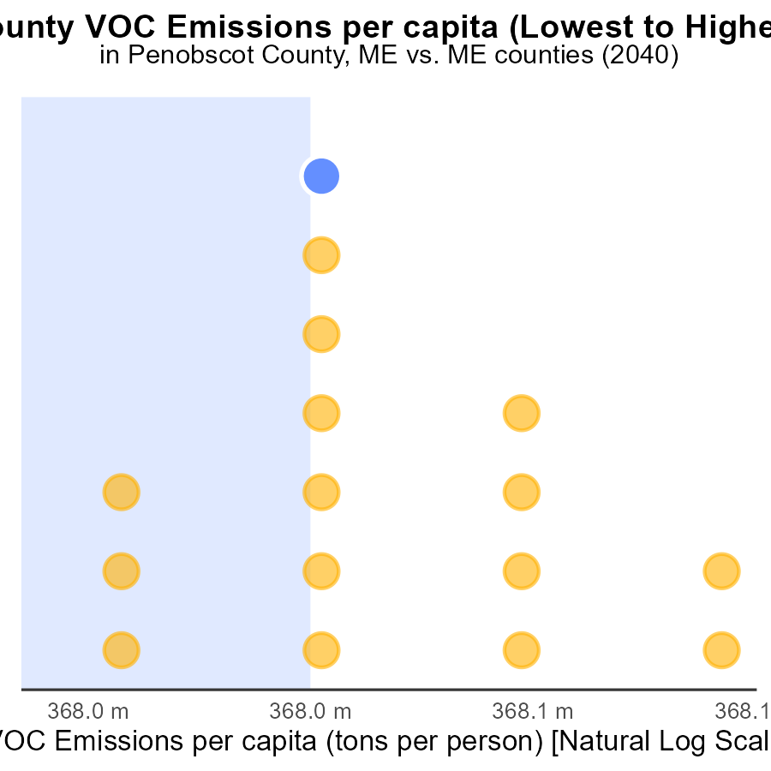

# Areas Ranked by Emissions

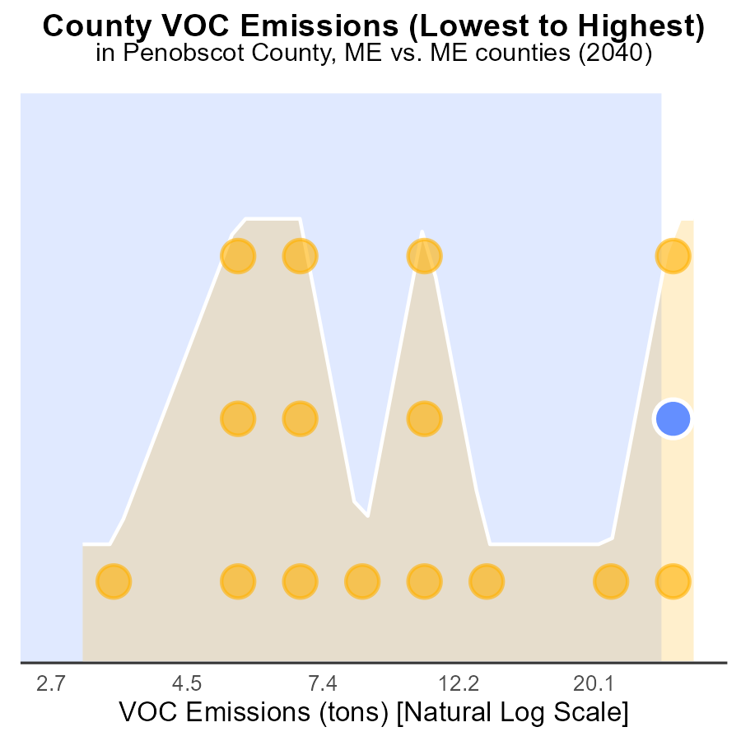

## Findings

* Cumberland has the highest VOC emissions with 79.9 tons.
* Piscataquis has the lowest VOC emissions with 7.2 tons.
* Penobscot and York emit relatively close amounts of VOC, at 68.1 and 65.0 tons respectively.

## Recommendations

To lower VOC emissions, focus on reducing industrial emissions in Cumberland County which has the highest levels. Implement stricter regulations for industrial activities. Encourage the use of cleaner technologies and incentivize the adoption of green practices in the region.

# Conclusion

In conclusion, the data presented highlights the significant impact of Volatile Organic Compounds (VOC) emissions from on-road transportation in Penobscot County, ME in 2040. While the county ranks third in VOC contributions, it is crucial to address this issue proactively to mitigate environmental concerns and public health risks. The insights reveal a pressing need to focus on reducing vehicle idling, promoting alternative transportation modes, and enforcing stricter emission standards for vehicles.

To achieve substantial reductions in VOC emissions, policymakers must prioritize the adoption of cleaner vehicle technologies, expand public transportation infrastructure, and incentivize the use of electric vehicles. Furthermore, targeting high-emission areas like Cumberland County for industrial emission reductions and implementing carbon pricing policies are essential steps towards achieving emission reduction goals. By taking comprehensive and targeted actions, it is possible to achieve a sustainable decrease in VOC emissions from on-road transportation in Penobscot County, ME.

# About This Report

Data based on MOVES estimates collected by the Climate Action in Transportation program at Cornell University. Demographic data sourced from the US Census's American Community Survey 5-year estimates. This report was generated with the help of AI.

# References

* U.S. Census Bureau. (2023). American Community Survey 5-year estimates: Detailed tables. Retrieved from https://data.census.gov
* U.S. Environmental Protection Agency. (2024). Motor Vehicle Emission Simulator (MOVES 4.0) [Software]. Retrieved from https://www.epa.gov/moves