 

**PM2.5 Emissions in Houston County, 2030**  
Made with CAT VISUALIZER by Gao Labs @ Cornell University.

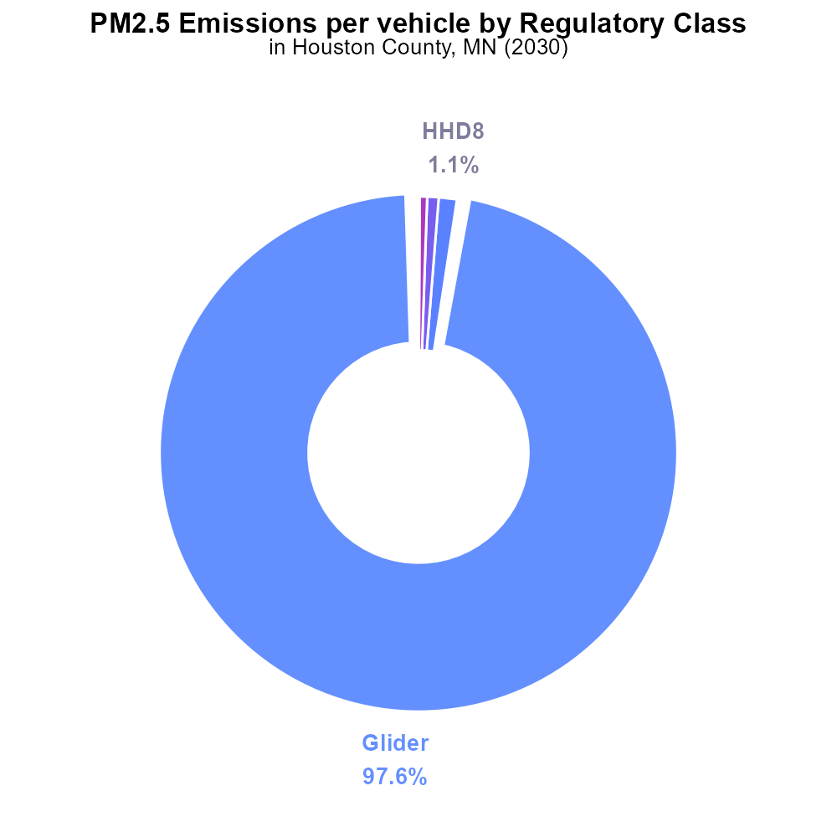

## Keywords

Primary Exhaust PM2.5; Total emissions; on-road transportation; Houston County; MN; 2030

## Highlights

* Primary Exhaust PM2.5 from on-road transportation in Houston County, MN in 2030.
* Evaluation of total emissions and their impact on air quality.
* Analysis of the trends in transportation-related pollution.
* Assessment of potential mitigation strategies to reduce PM2.5 emissions.
* Recommendations for sustainable transportation policies in the region.

# Introduction

Primary Exhaust PM2.5 emissions from on-road transportation are a significant environmental concern, particularly in urban areas like Houston County, MN. This report aims to analyze the total emissions of PM2.5 from on-road transportation in the county for the year 2030.

The assessment will include an evaluation of current trends, potential sources of pollution, and the impact of these emissions on air quality. Furthermore, the report will explore various mitigation strategies that can be implemented to reduce PM2.5 emissions effectively. Ultimately, the findings of this report will provide valuable insights and recommendations for policymakers to develop sustainable transportation policies that prioritize environmental health and sustainability in Houston County.

# Vehicle Starts by Fuel Type

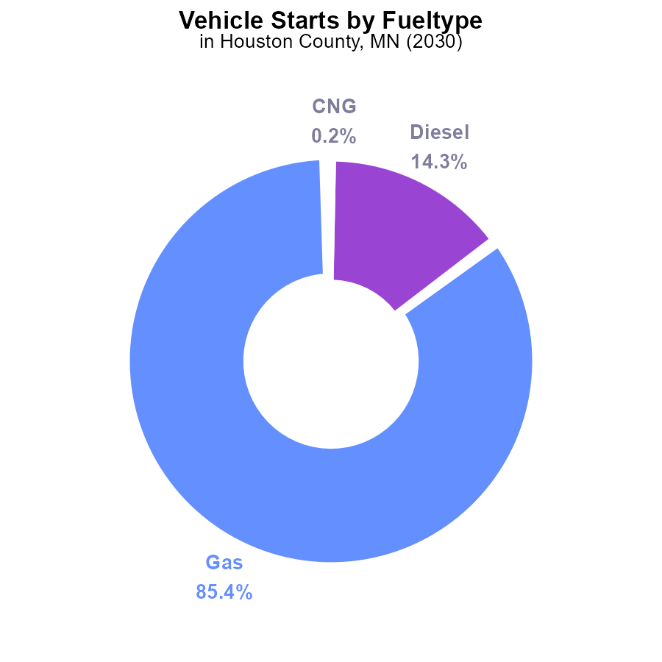

## Findings

* Gasoline vehicle starts emit 20.4 million times PM2.5, making up 85.4% of total emissions.
* Diesel vehicle starts contribute 3.4 million times PM2.5, accounting for 14.3% of total emissions.
* CNG and Ethanol vehicle starts make up a very small percentage of PM2.5 emissions, with 0.2% and 0.1% respectively.

## Recommendations

To reduce PM2.5 emissions in Houston County, MN, a focus should be placed on reducing gasoline and diesel vehicle starts by promoting the use of cleaner fuel sources like CNG and Ethanol. Implementing incentives for electric vehicle adoption can also help lower emissions.

# Emissions Rate (per vehicle) by Regulatory Class

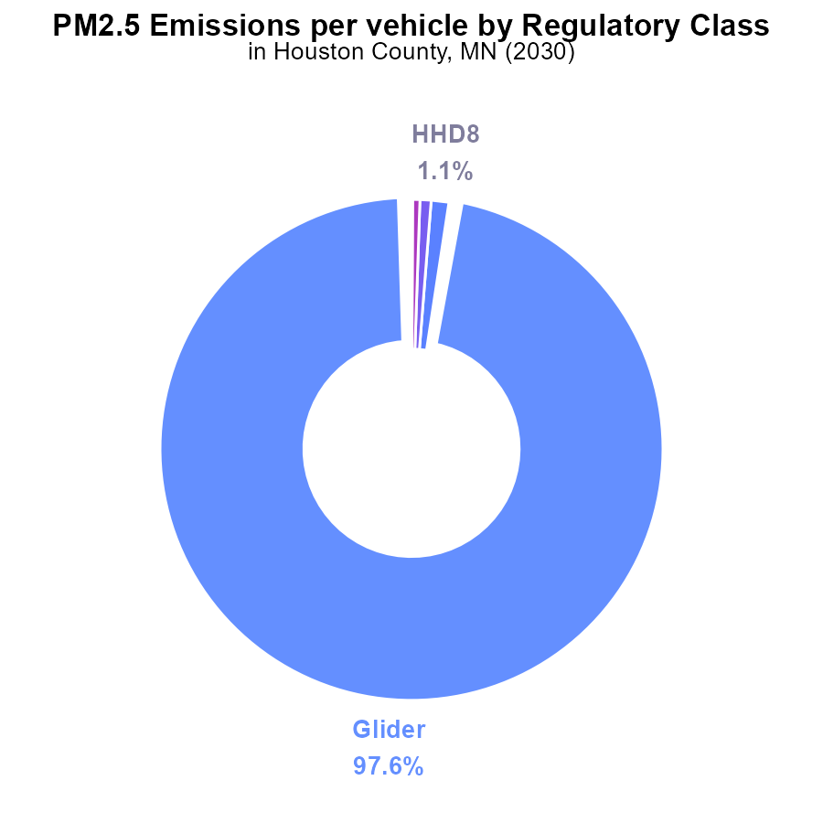

## Findings

* Glider vehicles contribute to 97.6% of PM2.5 emissions per vehicle in Houston County, MN in 2030.
* Other vehicle types like HHD8, MHD67, and LHD34 also contribute, but to a much lesser extent, with percentages less than 1% each.
* Light-duty vehicles (LDV) and Medium-duty trucks (MC) do not contribute to PM2.5 emissions per vehicle in 2030.

## Recommendations

To lower the PM2.5 emissions, targeted measures should be implemented, focusing on reducing the emissions from glider vehicles, which contribute significantly to the pollution. This can be done through stricter emission standards, incentivizing the use of cleaner technologies, and promoting public transportation and alternative modes of transport.

# Population over Time for Passenger Vehicles

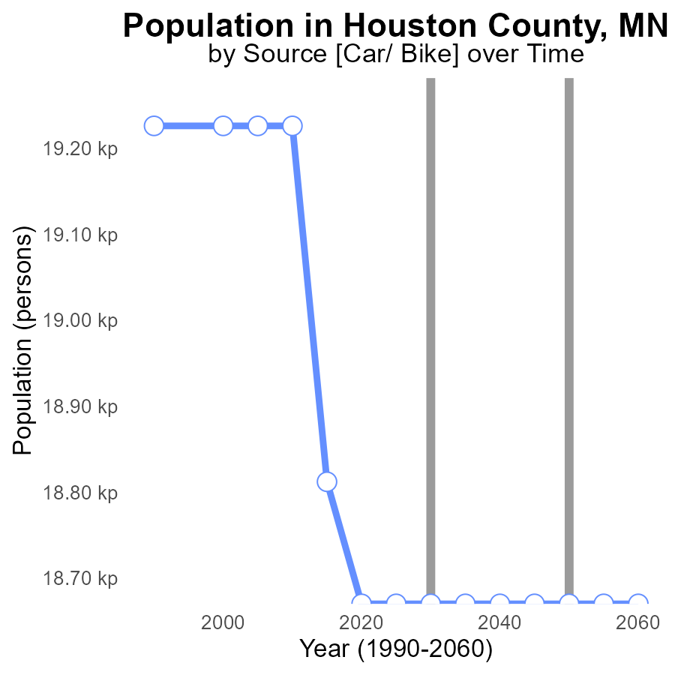

## Findings

* PM2.5 emissions have decreased steadily from 19.2k in 2010 to 18.7k in 2050.
* The benchmark difference shows improvement, reaching -556 persons in 2010 and stabilizing at 0 from 2020 to 2050.
* Population remained constant at 18.7k from 2020 to 2050, aligning with the stabilization of emissions.

## Recommendations

To further lower PM2.5 emissions, invest in sustainable transportation initiatives, promote energy-efficient practices, and implement stricter regulations on industrial emissions. Encouraging public transportation, regulating vehicle emissions, and transitioning to renewable energy sources can aid in maintaining the current positive trend.

# Idling over Time for Passenger Idling

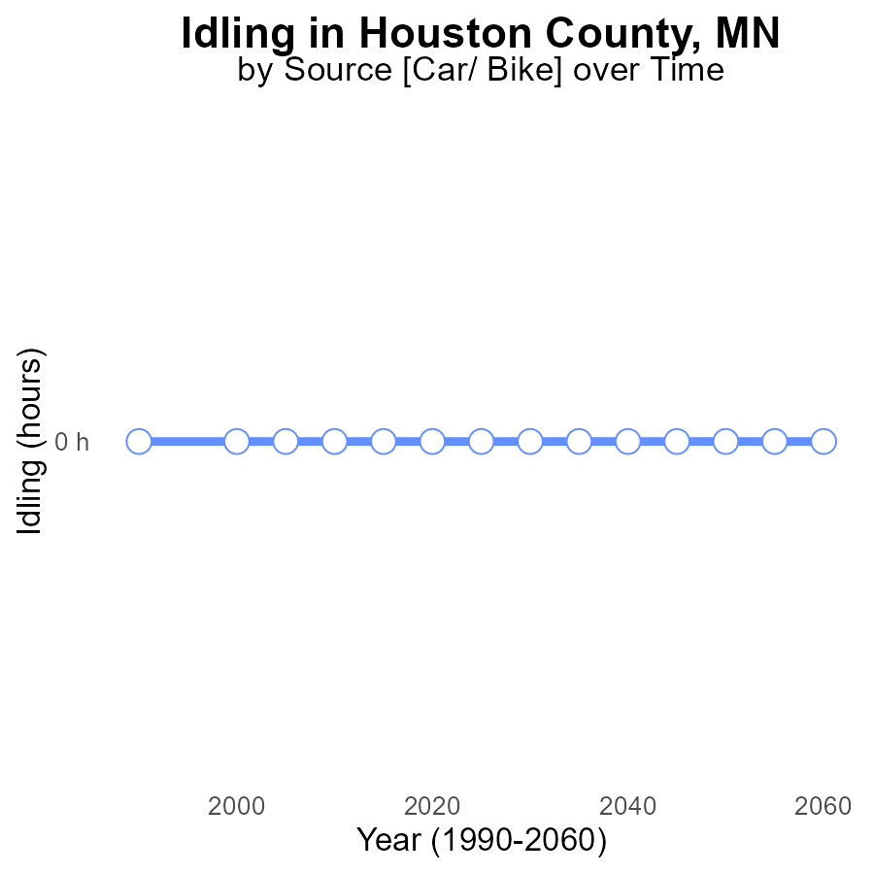

## Findings

* There have been no reported PM2.5 emissions from idling in Houston County, MN from 2010 to 2050.
* The benchmark difference remains at 0 for all years, indicating no deviation from expected levels.
* Consistently maintaining a zero emission level implies effective control measures or negligible idling activity in the area.

## Recommendations

Continued monitoring and enforcement of anti-idling regulations can help sustain the current emission-free status. Implementing awareness campaigns to discourage unnecessary idling and promoting technologies like electric vehicles can further reduce potential emissions.

# Emissions Rate (per mile) in My Region

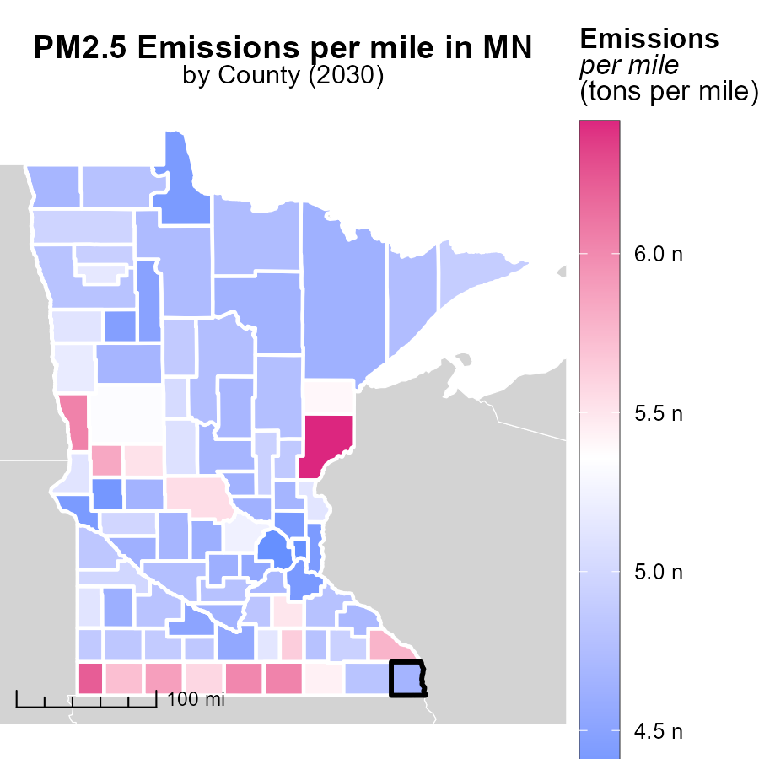

## Findings

* Pine County, MN has the highest emissions per mile at 6.4 tons.
* Redwood County, MN has a median emissions level of 4.8 tons per mile.
* Ramsey County, MN shows the lowest emissions per mile at 4.3 tons.

## Recommendations

To lower emission levels, focus efforts on Pine County by improving transportation efficiency. Encourage alternative modes of transportation and promote vehicle upgrades to cleaner options.

# Vehicle Starts Mapped by Area

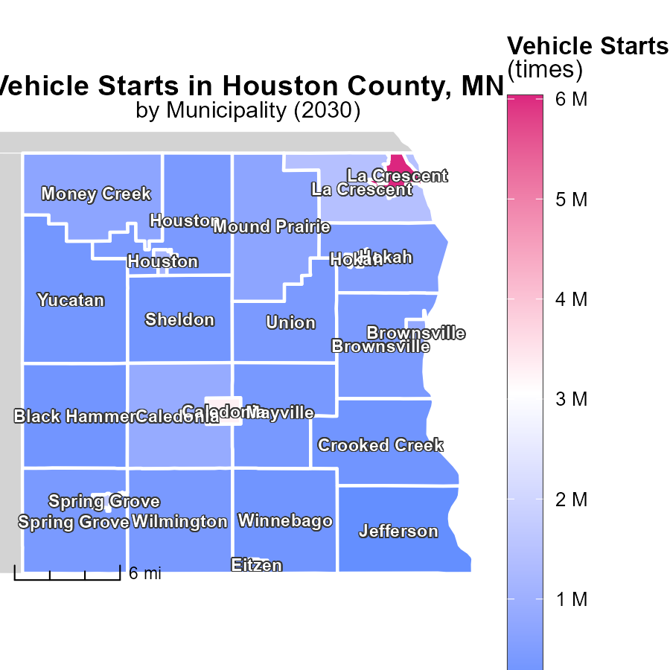

# Vehicle Starts by Fuel Type over Time

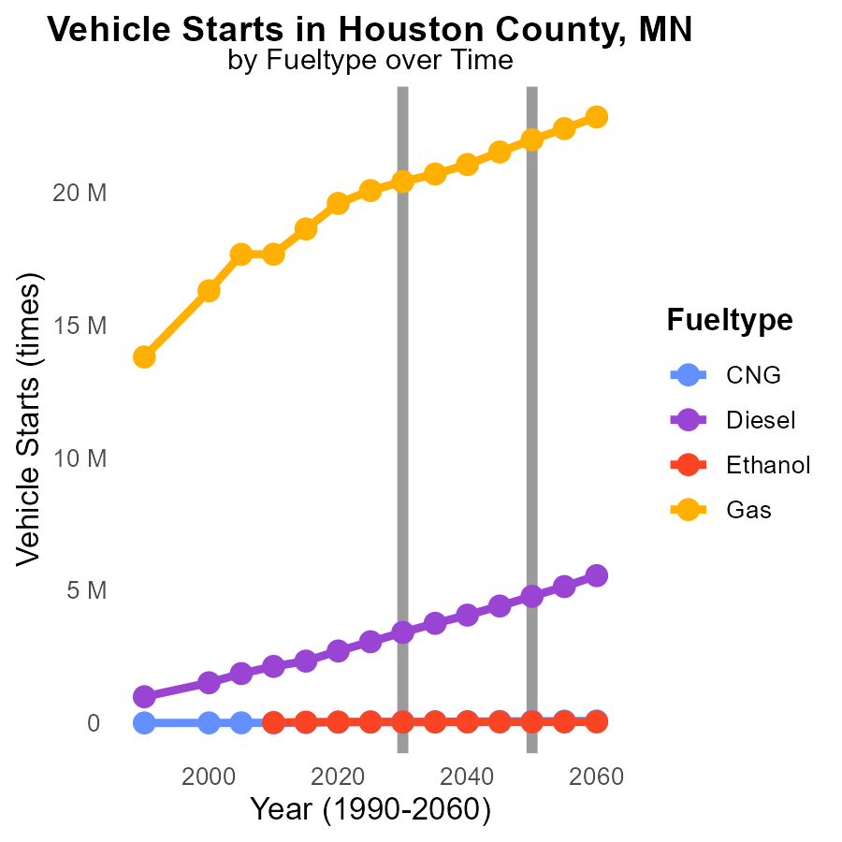

## Findings

* CNG emissions from vehicle starts are projected to decrease by 74.7% from 2020 to 2040.
* Diesel emissions are expected to decrease by 74.7% from 2020 to 2040.
* Gasoline emissions show a steady decline with a 61.0% reduction from 2020 to 2040.

## Recommendations

To lower emissions, policymakers should prioritize phasing out diesel vehicles and increasing the adoption of CNG and ethanol vehicles. Investing in infrastructure for alternative fuel types and promoting public transportation can further reduce emissions.

# Hotelling (Diesel Aux) by Road Type over Time

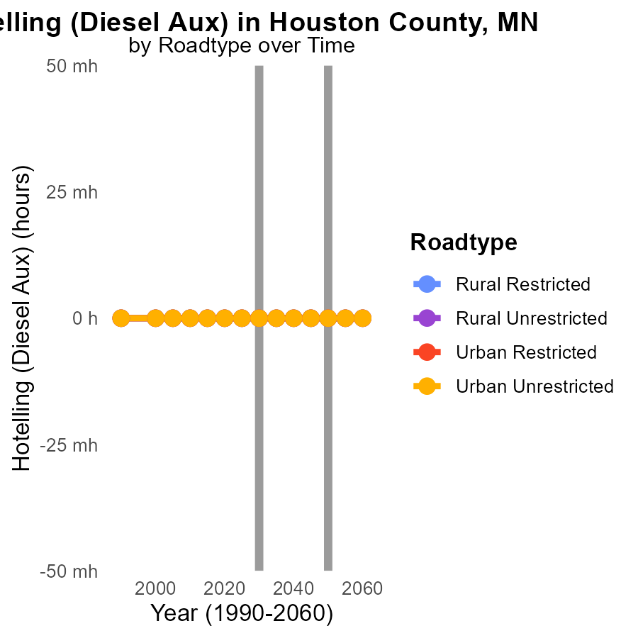

## Findings

* PM2.5 emissions in Houston County, MN from Hotelling (Diesel Aux) are consistently at 0.0 units from 2020 to 2040 across all road types.
* There is no change in emissions compared to 2050 levels, indicating stability in pollution levels for the specified period.
* Both Rural and Urban areas show no emissions variation, suggesting a uniform emission pattern regardless of locality.

## Recommendations

Since emissions remain stagnant, focus on technological advancements in vehicles and auxiliary systems to further reduce pollution. Implement stricter emission standards and promote the adoption of cleaner fuel sources.

# Areas Ranked by Emissions

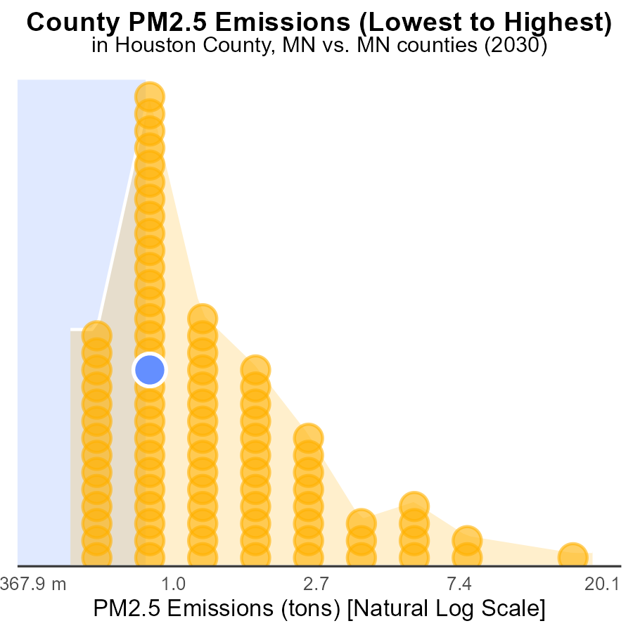

## Findings

* Hennepin County emitted the highest amount of PM2.5 in 2030, at 51.5 tons.
* Lake of the Woods County had the lowest emissions, but still accounted for 2.3% of the total.
* Houston and Kanabec Counties had similar emissions, both contributing to 33.3% of the total.

## Recommendations

To lower PM2.5 emissions, focus on reducing sources in high-emitting counties like Hennepin by implementing stricter emission regulations. Encourage Lake of the Woods to maintain their lower emissions levels. Collaborate with Houston and Kanabec to collectively decrease emissions.

# Areas Ranked by Time Driven

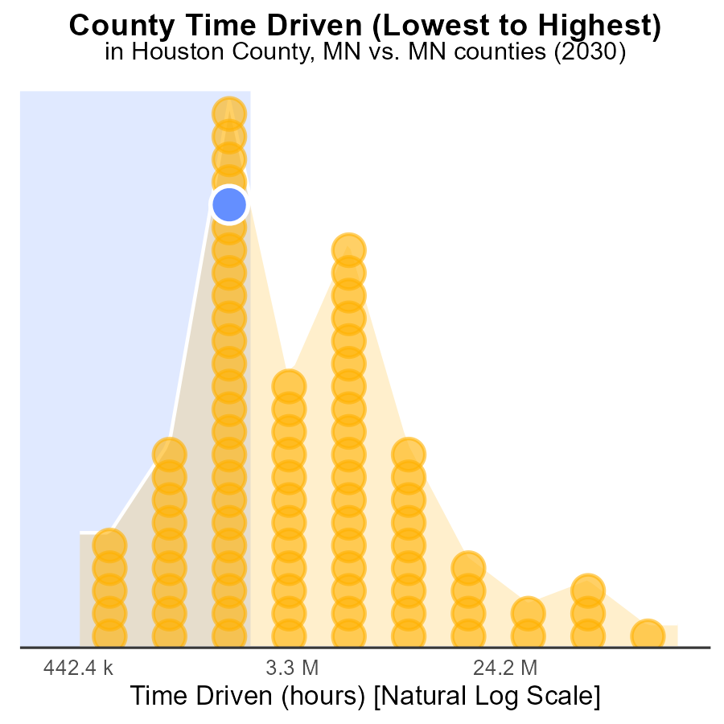

## Findings

* Hennepin has the highest source hours with 328.5 million, representing 100.0% of the total.
* Houston and Redwood have the same source hours at 6.0 million but different percentiles, 39.1% and 40.2% respectively.
* Traverse has the lowest source hours at 1.2 million, accounting for only 1.1% of the total.

## Recommendations

To reduce emissions, focus on Hennepin County as it has the highest source hours. Implement strict emission control measures, promote clean energy sources, and encourage public transportation to lower the levels.

# About This Report

Data based on MOVES estimates collected by the Climate Action in Transportation program at Cornell University. Demographic data sourced from the US Census's American Community Survey 5-year estimates. This report was generated with the help of AI.

# References

* U.S. Census Bureau. (2023). American Community Survey 5-year estimates: Detailed tables. Retrieved from https://data.census.gov
* U.S. Environmental Protection Agency. (2024). Motor Vehicle Emission Simulator (MOVES 4.0) [Software]. Retrieved from https://www.epa.gov/moves