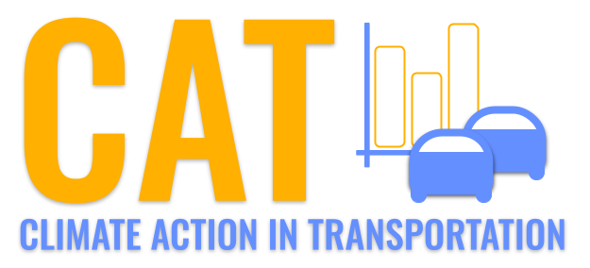 

**PM10 Emissions in Stanley County, 2010**  
Made with CAT VISUALIZER by Gao Labs @ Cornell University.

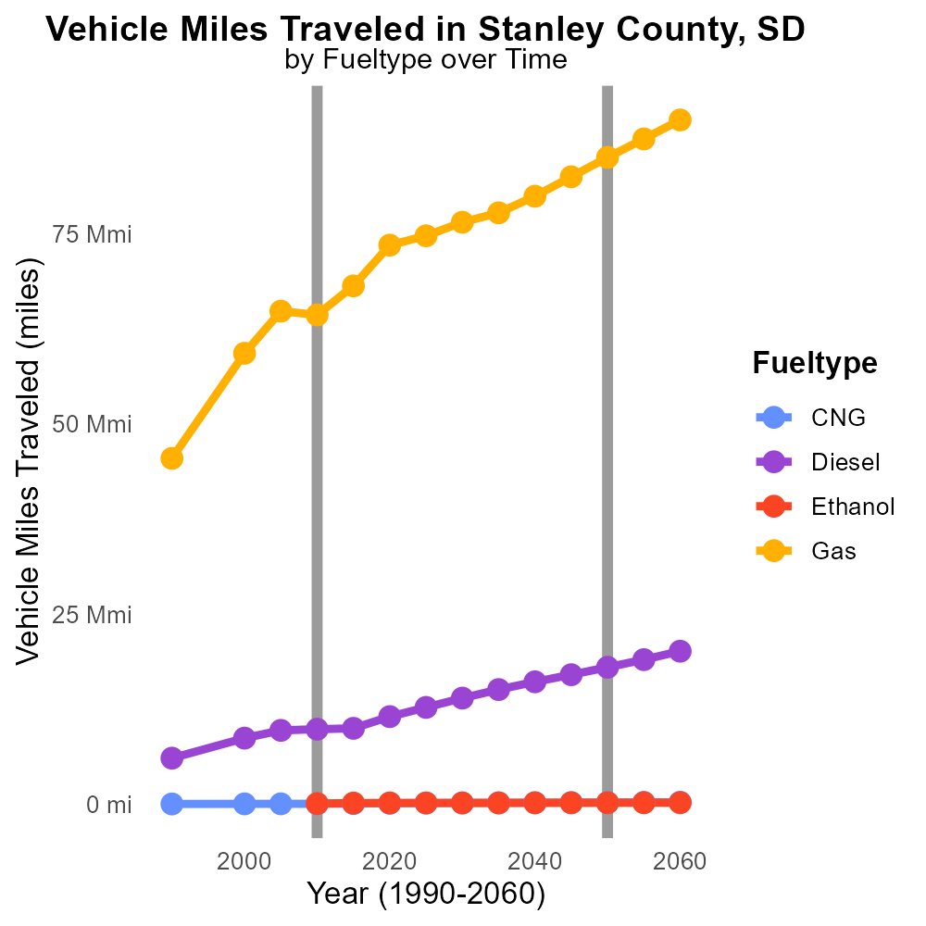

## Keywords

Primary Exhaust PM10; Total emissions; on-road transportation; Stanley County; SD; 2010

## Highlights

* Study of PM10 emissions from transport in Stanley County, SD.
* Analysis of primary exhaust emissions in on-road transportation.
* Impact of transportation on air quality in 2010.
* Focus on PM10 emissions and their sources.
* Data on primary exhaust PM10 emissions in Stanley County.

# Introduction

The following report provides an in-depth analysis of Primary Exhaust PM10 - Total emissions from on-road transportation in Stanley County, South Dakota, in the year 2010. This study aims to shed light on the contribution of on-road transportation to the overall PM10 emissions in this region.

Examining the primary exhaust PM10 emissions is crucial in understanding the environmental impact of vehicles on air quality. By focusing on Stanley County, we aim to assess the sources and levels of PM10 emissions generated by on-road transportation in the specified year. This data will offer valuable insights into the state of air quality and the environmental challenges posed by vehicular emissions.

# Emissions Rate (per vehicle) Overall by Area

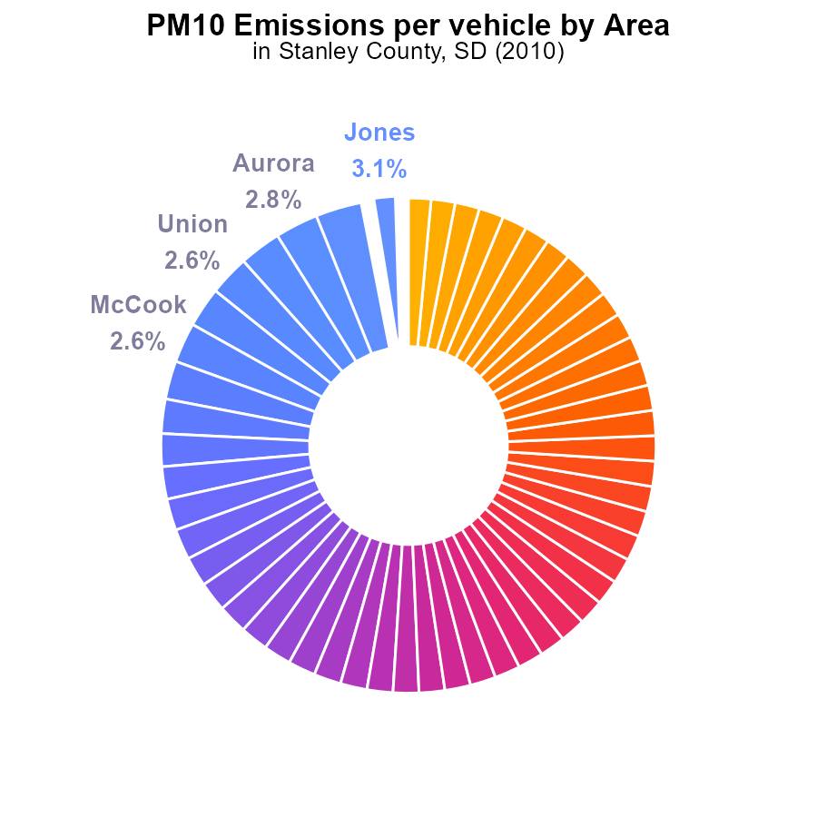

## Findings

* The top 5 counties with the highest PM10 emissions per vehicle are Jones, Lyman, Aurora, Brule, and Union.
* Hughes County has the lowest PM10 emissions per vehicle among all counties.
* Over 70% of the counties have PM10 emissions per vehicle ranging from 1.0 to 1.6 tons.

## Recommendations

To reduce PM10 emissions, focus on counties with higher emissions like Jones, Lyman, Aurora, Brule, and Union by promoting cleaner transportation methods. Encourage counties in the 1.0 to 1.6 tons range to maintain or lower their current emission levels.

# Population by Regulatory Class

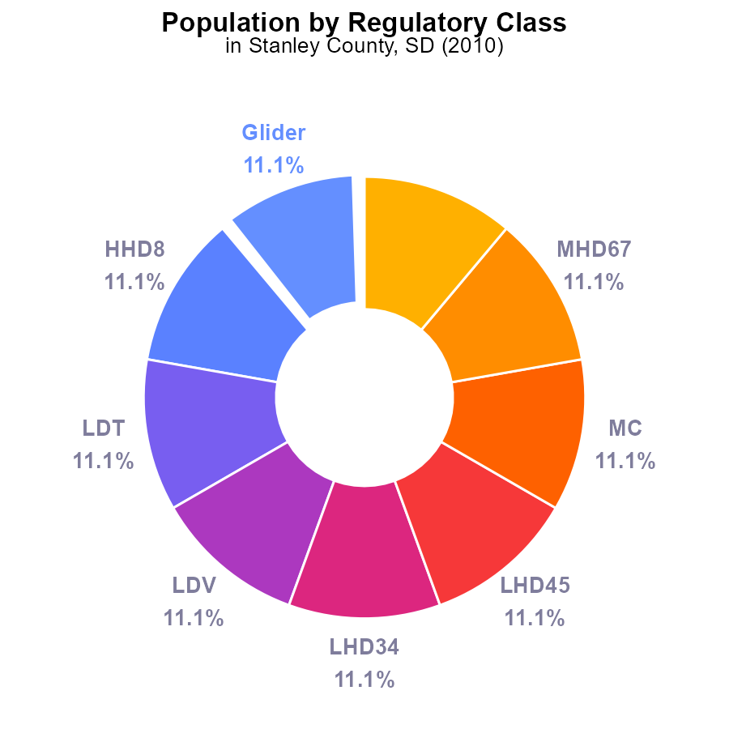

# Emissions Rate (per mile) over Time for Buses

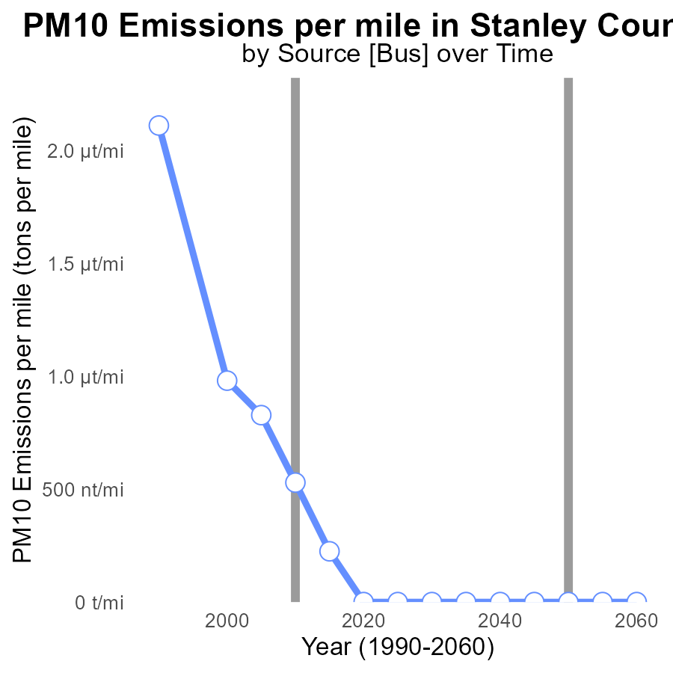

## Findings

* Emissions per mile decreased steadily from 2.1 µ in 1990 to 224.9 n in 2015
* Significant improvements were made by 2020, with emissions reduced to zero
* Projections show the trend continuing with zero emissions per mile from 2020 to 2030

## Recommendations

To maintain zero emissions achieved in 2020 and continue the declining trend, policymakers should focus on promoting electric vehicles, enforcing stricter emission standards for industries, and investing in renewable energy sources.

# Hotelling (Diesel Aux) over Time for Buses

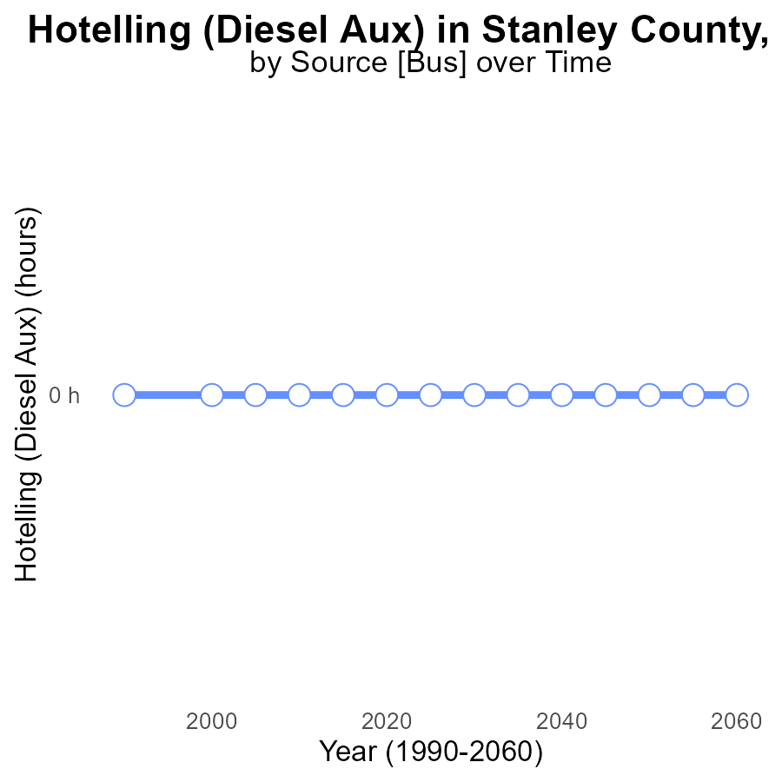

## Findings

* There have been no PM10 emissions from Hotelling (Diesel Aux) in Stanley County, SD, from 1990 to 2030.

## Recommendations

To maintain the current emission levels of PM10 from Hotelling (Diesel Aux) in Stanley County, SD, continue monitoring and enforcing regulations on diesel auxiliary engines.

# Hotelling (Engines Off) Mapped by Area

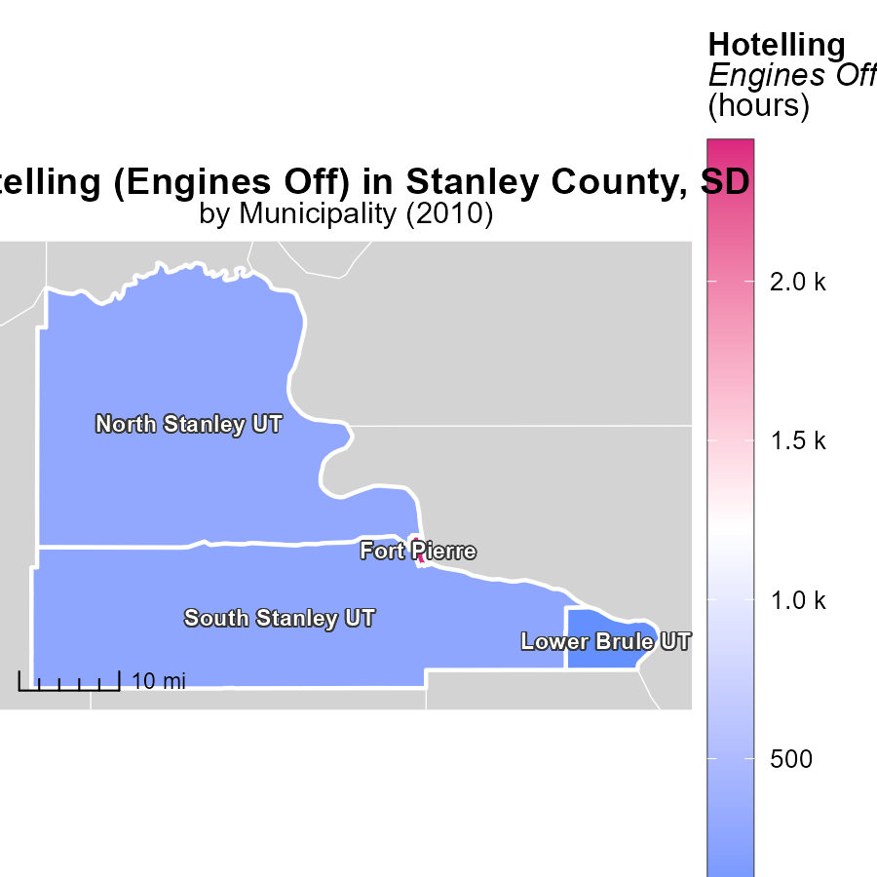

## Findings

* The median hours with engines off in North Stanley UT, SD in 2010 was 288.8.
* Lower Brule UT, SD had the lowest hours with engines off at 982.2 million in 2010.
* Fort Pierre, SD had the highest hours with engines off at 2.4 thousand in 2010.

## Recommendations

To lower emissions from idling engines, targeted initiatives like promoting anti-idling campaigns in high idling areas such as North Stanley UT, SD and Lower Brule UT, SD could be implemented. Additionally, investing in technology that automatically shuts off idling engines after a certain period of time can be beneficial. Education and awareness programs on the environmental impact of idling engines should also be considered.

# Population in My Region

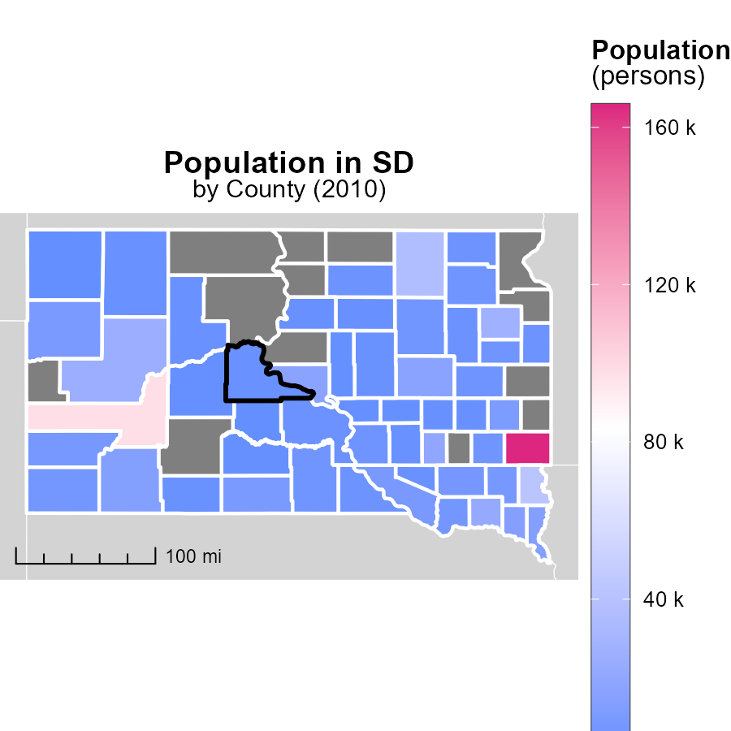

## Findings

* Minnehaha County, SD had the highest population in 2010 with 165.8k persons.
* McCook County, SD had a median population of 5.6k persons in 2010.
* Jones County, SD had the lowest population in 2010 with 1.1k persons.

## Recommendations

To lower emissions, focus efforts on highly populated areas like Minnehaha County by improving public transport and promoting energy-efficient practices. In smaller counties like Jones, support sustainable development to mitigate emissions.

# Vehicle Miles Traveled by Fuel Type over Time

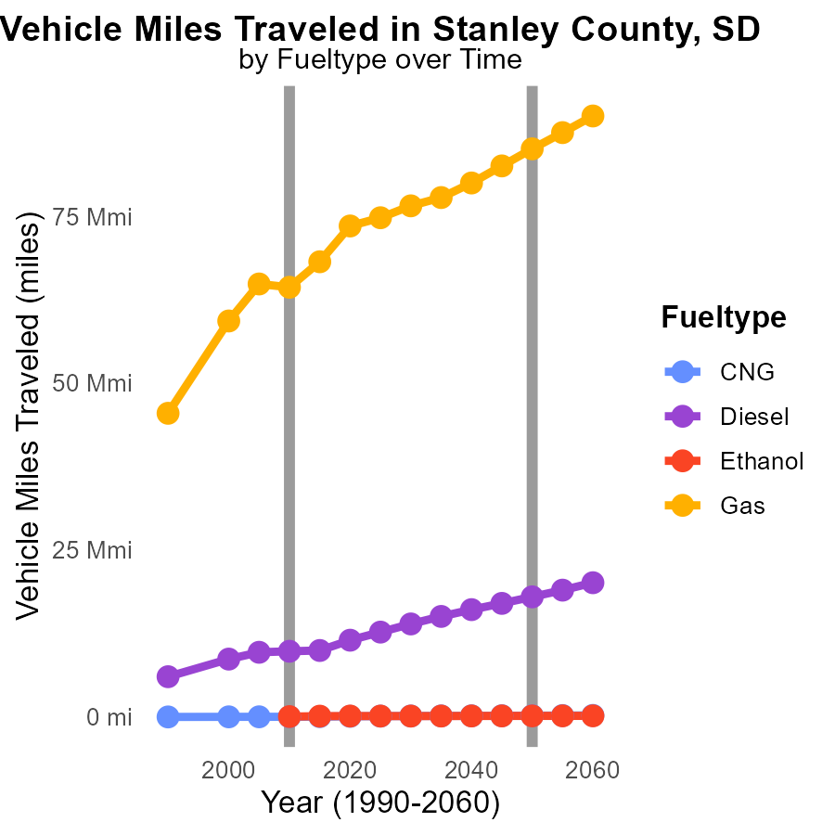

## Findings

* Vehicle miles traveled have increased for all fuel types from 2000 to 2020.
* Diesel consumption has consistently risen, with a 32.6% increase from 2000 to 2020.
* Gasoline consumption has increased by 23.5% from 2000 to 2020.

## Recommendations

To reduce emissions: promote CNG usage to offset the rise in diesel consumption, incentivize electric vehicles to reduce gasoline consumption, and invest in public transportation to decrease overall vehicle miles traveled.

# Idling by Vehicle Type over Time

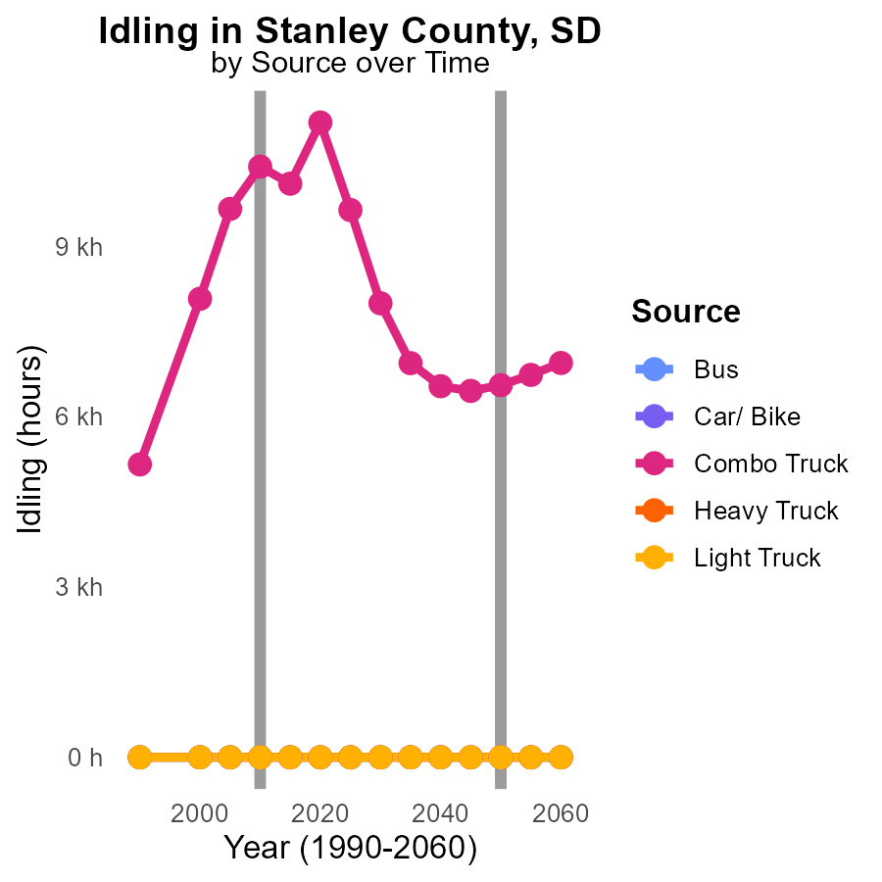

## Findings

* Combo trucks showed an increase in PM10 emissions from 8.1k in 2000 to 11.2k in 2020.
* Other vehicle types - buses, cars/bikes, heavy trucks, and light trucks - maintained 0.0 emissions consistently from 2000 to 2020.
* The difference in PM10 emissions of Combo Trucks from 2000 to 2020 decreased significantly by 4624.4 indicating positive progress.

## Recommendations

To reduce PM10 emissions in Stanley County, SD, focus on regulating Combo Truck emissions further while maintaining the zero-emission status of other vehicles. Encouraging the adoption of cleaner fuels, implementing more stringent emission standards for Combo Trucks, and promoting the use of electric vehicles can all contribute to continued emission reductions.

# Areas Ranked by Time Driven

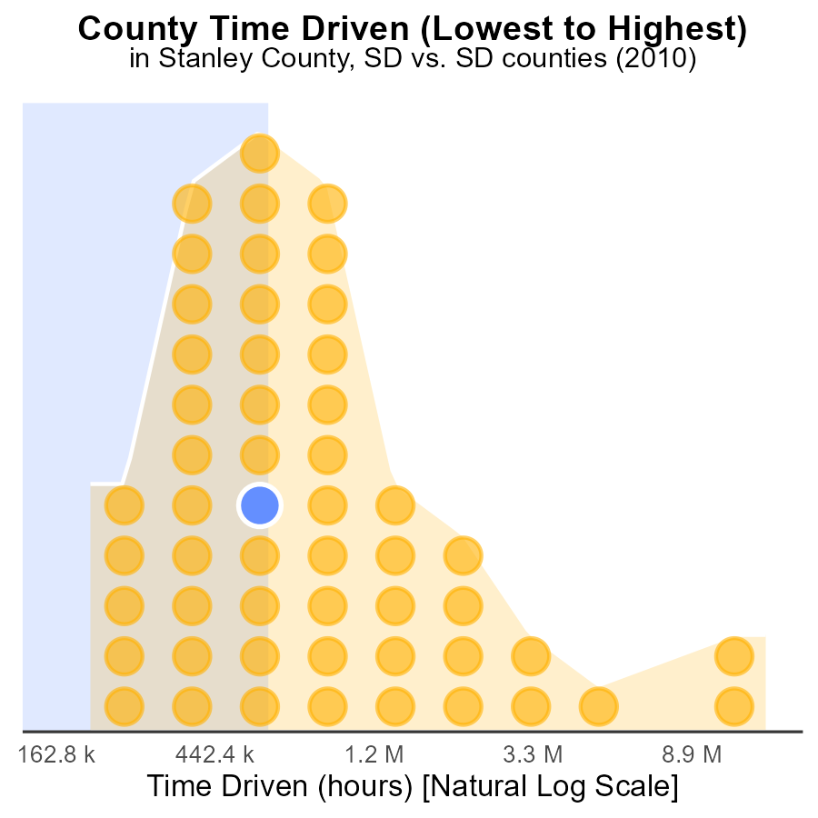

## Findings

* Minnehaha county has the highest PM10 emissions at 39.0 million hours.
* Buffalo county has the lowest PM10 emissions at 548.0 thousand hours.
* Minnehaha county represents 100.0% of the total PM10 emissions among the listed counties.

## Recommendations

To lower PM10 emissions, focus on reducing sources in Minnehaha County first. Implement stricter regulations and invest in cleaner technologies in high-ranking counties.

# Areas Ranked by Emissions Rate (per mile)

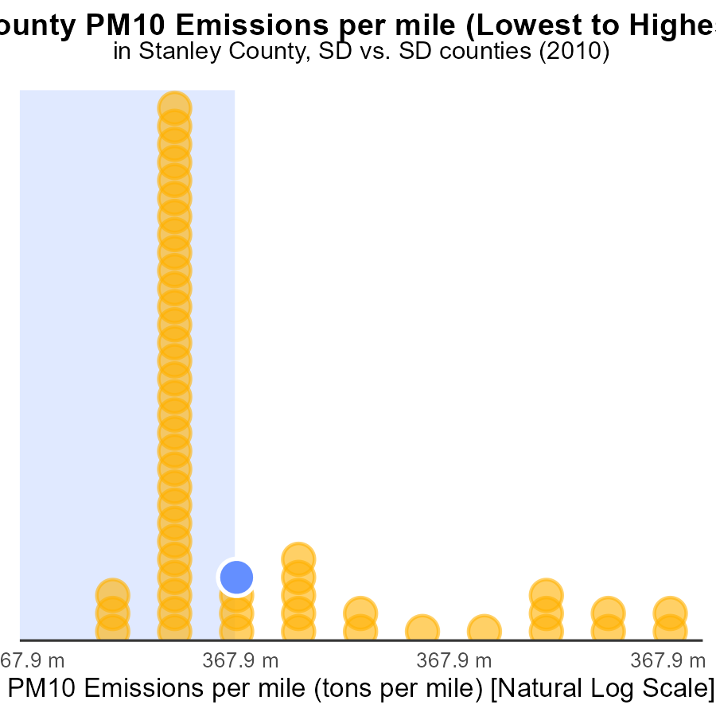

## Findings

* Jones County has the highest PM10 emissions per mile with 123.1 tons, ranking 53rd.
* Hughes County has the lowest emissions per mile with 65.1 tons, ranking 1st at 1.9%.
* All counties are in the upper percentiles for emissions, ranging from 67.9% to 100.0%.

## Recommendations

To lower emissions, implement stricter vehicle emission standards, promote public transport, and encourage carpooling to reduce VMT.

# About This Report

Data based on MOVES estimates collected by the Climate Action in Transportation program at Cornell University. Demographic data sourced from the US Census's American Community Survey 5-year estimates. This report was generated with the help of AI.

# References

* U.S. Census Bureau. (2023). American Community Survey 5-year estimates: Detailed tables. Retrieved from https://data.census.gov
* U.S. Environmental Protection Agency. (2024). Motor Vehicle Emission Simulator (MOVES 4.0) [Software]. Retrieved from https://www.epa.gov/moves