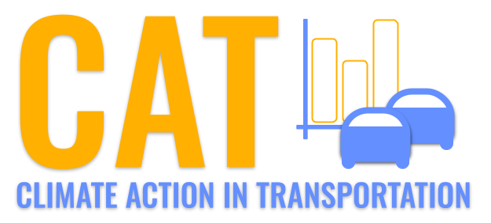 

**SO2 Emissions in Fulton County, 2005**  
Made with CAT VISUALIZER by Gao Labs @ Cornell University.

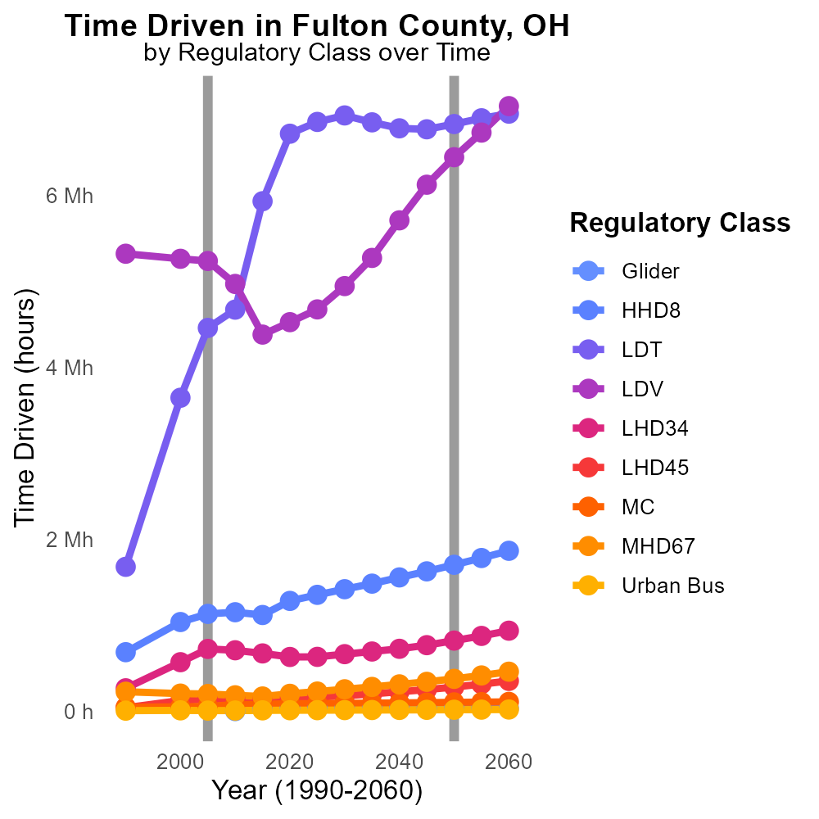

## Keywords

Sulfur Dioxides; SO2 emissions; on-road transportation; Fulton County; OH; 2005

## Highlights

* Sulfur Dioxides (SO2) emissions impact air quality and human health.
* Vehicle emissions are a major source of SO2 in urban areas.
* Fulton County, OH, faced challenges with on-road transportation emissions.
* Monitoring and reducing SO2 emissions are crucial for environmental protection.
* This report investigates SO2 emissions from on-road transportation in Fulton County, OH in 2005.

# Introduction

Sulfur Dioxides (SO2) emissions are a significant contributor to air pollution and pose serious health risks to both the environment and human populations. With on-road transportation being a major source of SO2 emissions in urban areas, understanding and mitigating these emissions is crucial for improving air quality and public health. In 2005, Fulton County, OH, faced challenges related to on-road transportation emissions, necessitating a detailed analysis of the extent and impact of SO2 emissions from this source.

This report focuses on examining the levels of SO2 emissions specifically arising from on-road transportation within Fulton County in 2005. By assessing the magnitude of these emissions and their potential effects on the local environment and population, valuable insights can be gained to inform future regulatory measures and emission reduction strategies in order to safeguard air quality and public health.

# Hotelling (Diesel Aux) by Regulatory Class

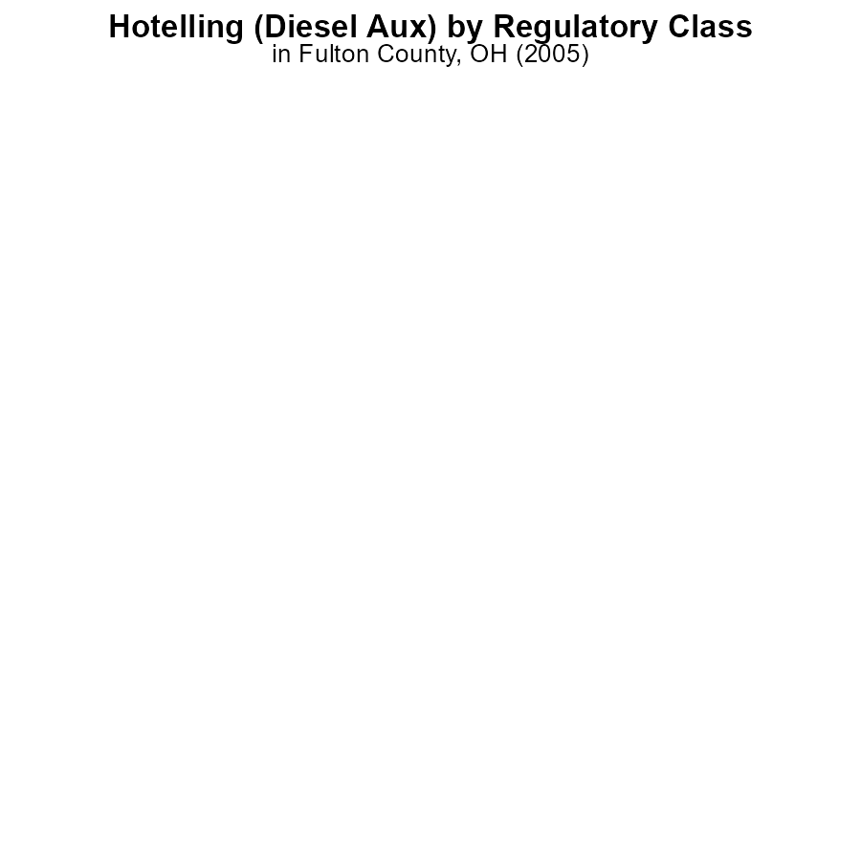

## Findings

* Hotelling (Diesel Aux) emissions in Fulton County, OH in 2005 were 0.0 for HHD8 and MHD67 vehicle types.
* There is no data available for LDT, LDV, LHD34, LHD45, MC, and Urban Bus for SO2 emissions in 2005.
* Diesel auxiliary engines are not a significant source of SO2 emissions in Fulton County, OH in 2005.

## Recommendations

To further reduce SO2 emissions in Fulton County, OH, focus should be shifted towards other sources rather than Hotelling (Diesel Aux) emissions. Implementing stricter regulations on industries and transportation sectors could help in lowering overall emissions.

# Vehicle Starts Overall by Area

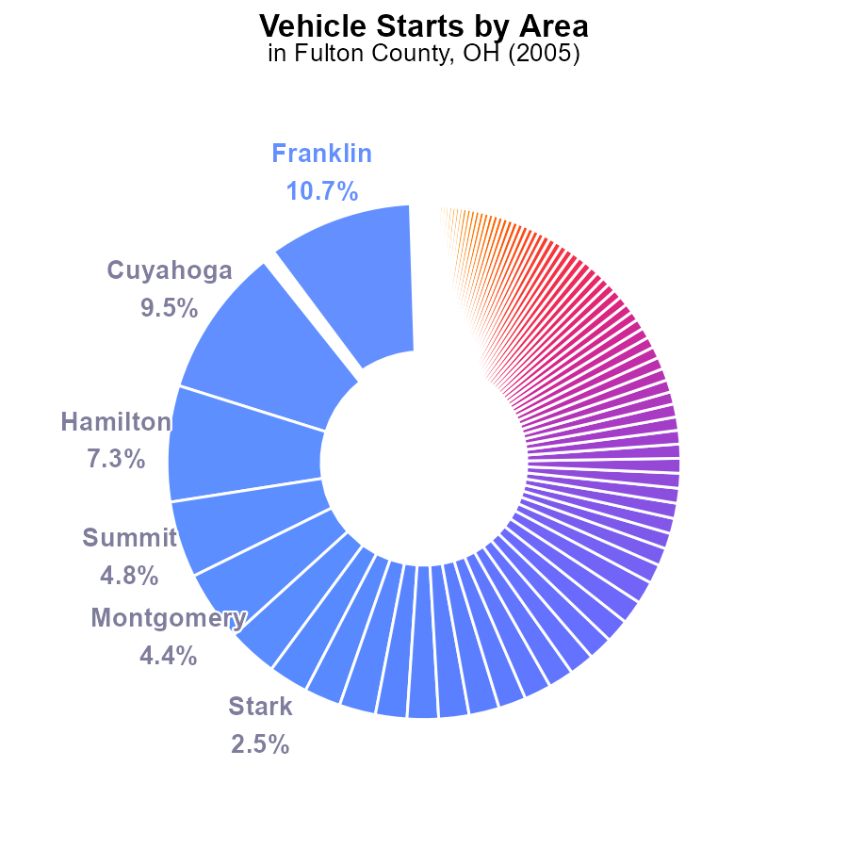

## Findings

* Top 5 counties contribute to 26.7% of SO2 emissions for vehicle starts in 2005
* 20 counties emit 50.8% of the total SO2 emissions in 2005
* Majority of counties (70) emit less than 1% of SO2 from vehicle starts in 2005

## Recommendations

To reduce emissions, focus on the top 5 counties by implementing stricter vehicle emission standards. Encourage public transportation options and promote electric vehicle adoption across all counties to collectively reduce emissions.

# Emissions Rate (per mile) over Time for Buses

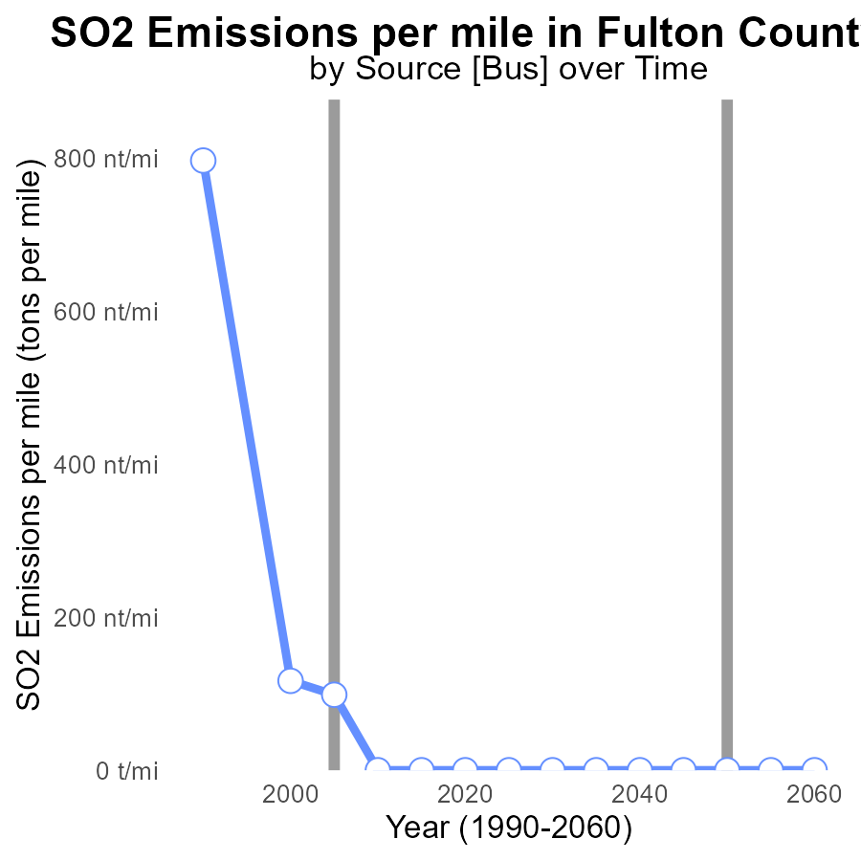

## Findings

* SO2 emissions decreased significantly from 1990 to 2005.
* Since 2010, there have been no SO2 emissions per mile in Fulton County.
* The benchmark difference shows a consistent reduction in SO2 emissions over the years.

## Recommendations

Encourage continued use of clean energy sources to maintain zero emissions.

Monitor and enforce emission standards for any new developments to sustain the current emission levels.

# Vehicle Miles Traveled over Time for Passenger Vehicles

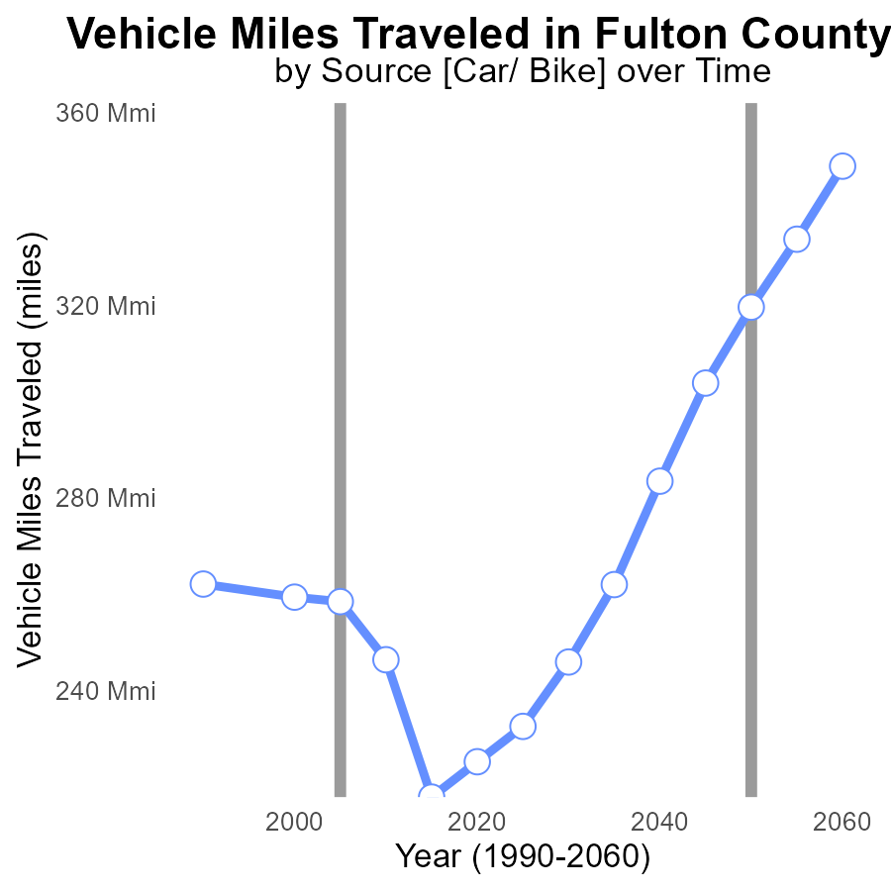

## Findings

* SO2 emissions decreased from 262.1 M in 1990 to 225.2 M in 2020.
* Vehicle miles traveled varied, with a peak of 258.4 M in 2005 and a low of 217.8 M in 2015.
* The benchmark difference fluctuated, peaking in 2015 at 101807166 and reaching the lowest in 2010 at 73268008.

## Recommendations

To reduce SO2 emissions further, focus on decreasing vehicle miles traveled by promoting public transportation, carpooling, and telecommuting. Additionally, implement stricter emission standards for vehicles and industries within Fulton County.

# Vehicles in My Region

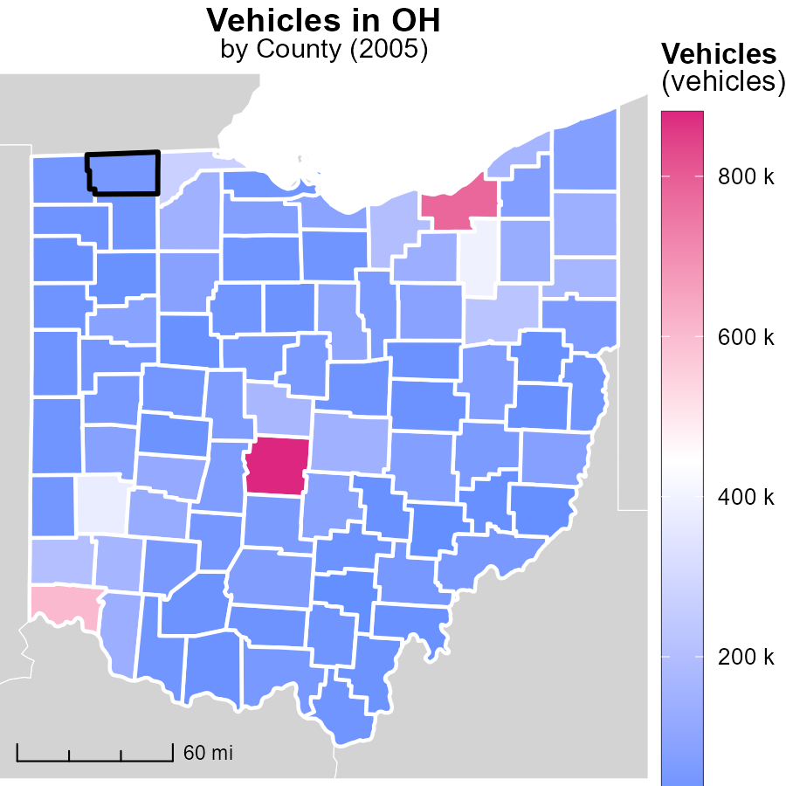

## Findings

* In 2005, Franklin County, OH emitted 879.9 thousand metric tons of CO2 from vehicles, the highest in the dataset.
* Clinton County, OH emitted 53.6 thousand metric tons of CO2, making it the median emitter.
* Meanwhile, Morgan County, OH had the lowest vehicle emissions with 10.2 thousand metric tons in 2005.

## Recommendations

To lower vehicle emissions, initiatives like promoting public transportation, carpooling, and investing in electric vehicles can be implemented. Additionally, improving infrastructure to support walking and cycling can reduce emissions further.

# Emissions Rate (per mile) in My Region

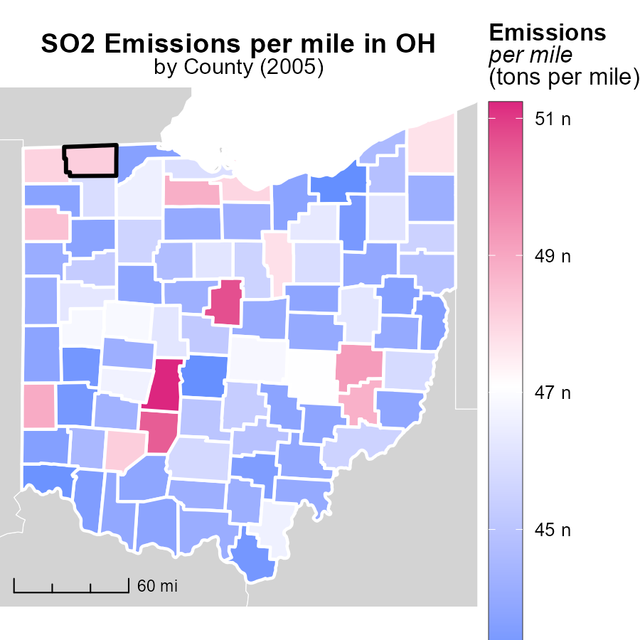

## Findings

* Madison County, OH had the highest emissions per mile at 51.2 tons.
* The median emissions per mile in Wyandot County, OH were 44.7 tons.
* Cuyahoga County, OH had the lowest emissions per mile at 43.0 tons.

## Recommendations

To lower emission levels, initiatives should focus on areas with high emissions, such as Madison County. Implementing emission reduction measures and promoting sustainable transportation methods can help decrease emissions per mile across all counties.

# Time Driven by Regulatory Class over Time

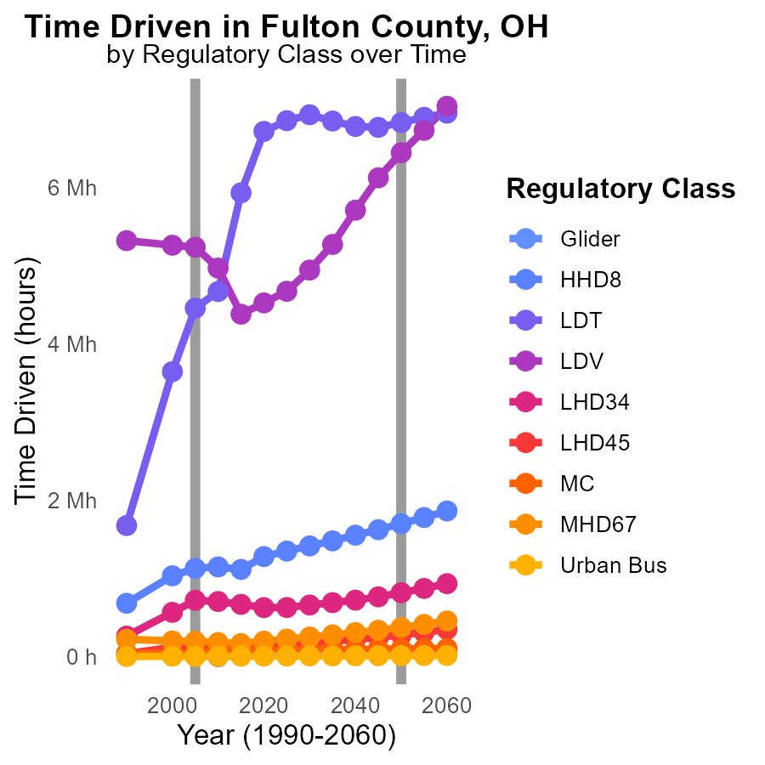

## Findings

* The emissions of SO2 in Fulton County, OH have fluctuated over the years.
* The largest emissions in 2015 were from the categories HHD8, LDT, and LDV.
* Despite reductions seen in some categories, the emissions from Urban Bus increased from 2010 to 2015.

## Recommendations

To lower the emission levels, focus on industries with the highest emissions such as HHD8, LDT, and LDV by implementing stricter regulations. Additionally, address the increase in emissions from Urban Bus by promoting the use of cleaner fuels and technologies.

# Vehicle Miles Traveled by Area over Time

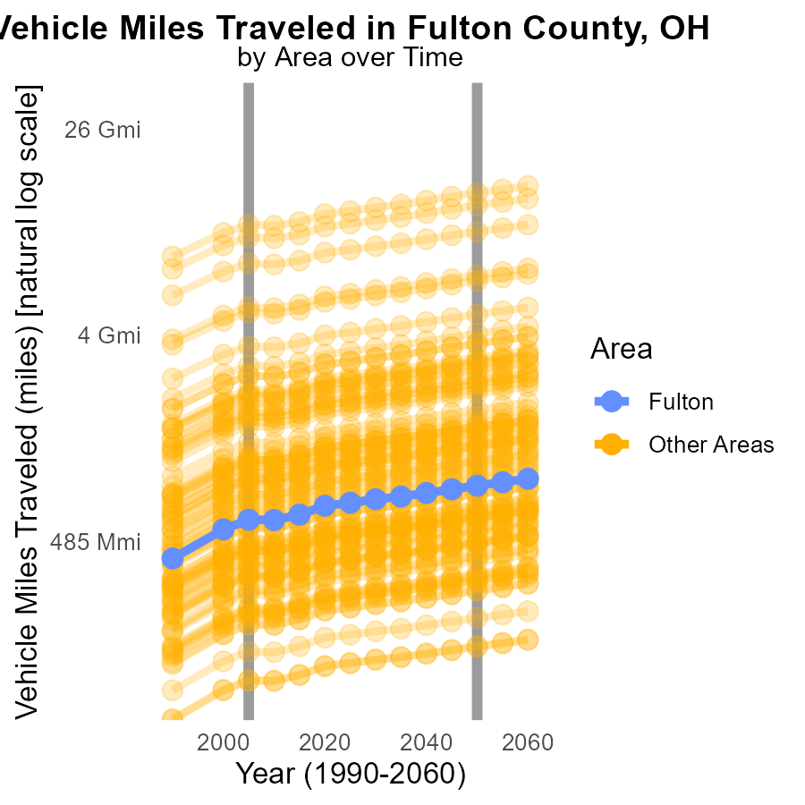

## Findings

* In 2005, the maximum county emitted 10.5 billion miles of SO2 while the target county emitted 598.1 million miles.
* Compared to 2050, the maximum county's emissions were 3.77 billion miles more, while the target county's emissions were 234.4 million miles more.
* The minimum county emitted 125.5 million miles in 2005, a difference of 48.96 million miles compared to 2050.

## Recommendations

To lower SO2 emissions from vehicle miles traveled, focus on implementing cleaner transportation technologies, promoting public transportation, and adopting stricter vehicle emission standards in high-emission counties.

# Areas Ranked by Vehicles

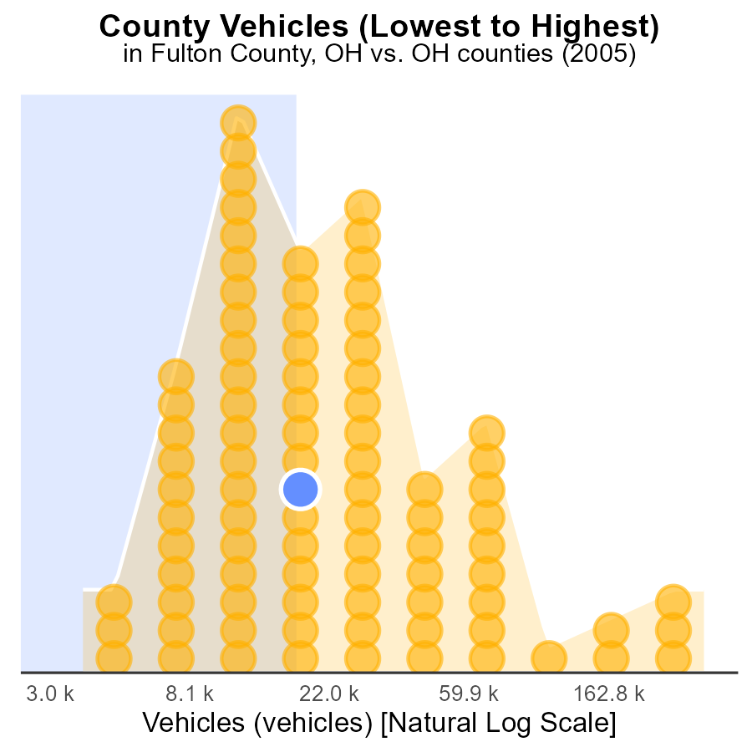

## Findings

* Highest SO2 emissions from vehicles in Franklin county at 100.0%.
* Lowest SO2 emissions from vehicles in Morgan county at 1.1%.
* Athens county ranks 40th with 45.5% of SO2 emissions.

## Recommendations

To reduce vehicle emissions, Franklin county should focus on transitioning to cleaner fuels and promoting public transportation. Morgan county can implement more stringent vehicle emission standards. Athens county should invest in alternative transportation methods and improve traffic flow to decrease emissions.

# Areas Ranked by Hotelling (Engines Off)

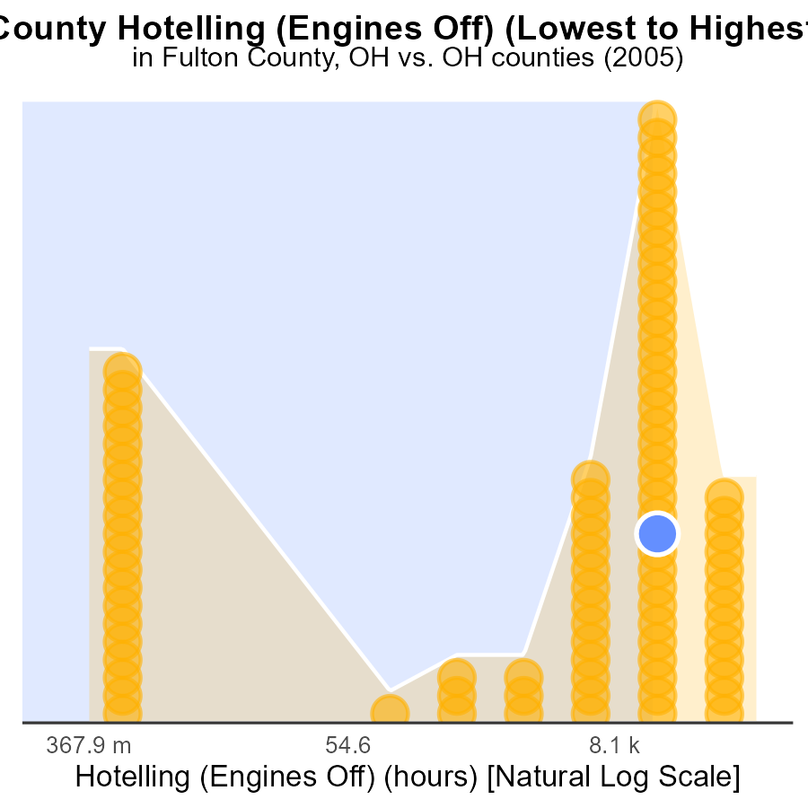

## Findings

* Franklin county had the highest SO2 emissions in 2005 with 336.5 k hours.
* Adams county had the lowest SO2 emissions in 2005 with 0.0 hours.
* Overall, the top 3 counties (Fulton, Wayne, Shelby) contributed to over 75% of the total emissions.

## Recommendations

To lower emissions, focus on implementing stricter regulations and technologies in counties like Franklin with high emissions. Encourage sustainable practices in all counties to reduce overall pollution levels.

# Conclusion

In conclusion, the analysis of SO2 emissions from on-road transportation in Fulton County, OH in 2005 reveals several important insights. Diesel auxiliary engines were found to be insignificant sources of SO2 emissions in the county, suggesting that efforts to reduce emissions should be focused on other sources. Implementing stricter regulations on industries and the transportation sector could help lower overall emissions. It was also noted that a small number of counties contribute significantly to SO2 emissions, indicating the importance of targeting these high-emission areas with stringent measures. The data shows a general decrease in SO2 emissions over the years, with no emissions reported since 2010 in Fulton County. Promoting public transportation options and adopting cleaner technologies, such as electric vehicles, are recommended strategies to further reduce emissions.

To sustain the current emission levels and continue the downward trend observed, it is crucial to monitor and enforce emission standards for new developments. Additionally, efforts should be made to reduce vehicle miles traveled by encouraging alternatives like carpooling, telecommuting, and investing in public transportation systems. By focusing on areas with high emissions and implementing effective emission reduction measures, Fulton County can work towards a cleaner and more sustainable environment for its residents.

# About This Report

Data based on MOVES estimates collected by the Climate Action in Transportation program at Cornell University. Demographic data sourced from the US Census's American Community Survey 5-year estimates. This report was generated with the help of AI.

# References

* U.S. Census Bureau. (2023). American Community Survey 5-year estimates: Detailed tables. Retrieved from https://data.census.gov
* U.S. Environmental Protection Agency. (2024). Motor Vehicle Emission Simulator (MOVES 4.0) [Software]. Retrieved from https://www.epa.gov/moves