 

**Carbon Emissions in Tompkins County, 2020**  
Made with CAT VISUALIZER by Gao Labs @ Cornell University.

New Research Shed Light on the Impact of Vehicle Emissions on CO2e and Light Trucks, Car/ Bikes, Combo Trucks, Heavy Trucks, Buses. Estimates from the Climate Action in Transportation (CAT) Dashboard from Cornell University are empowering communities with vital data for a healthier and more sustainable environment.

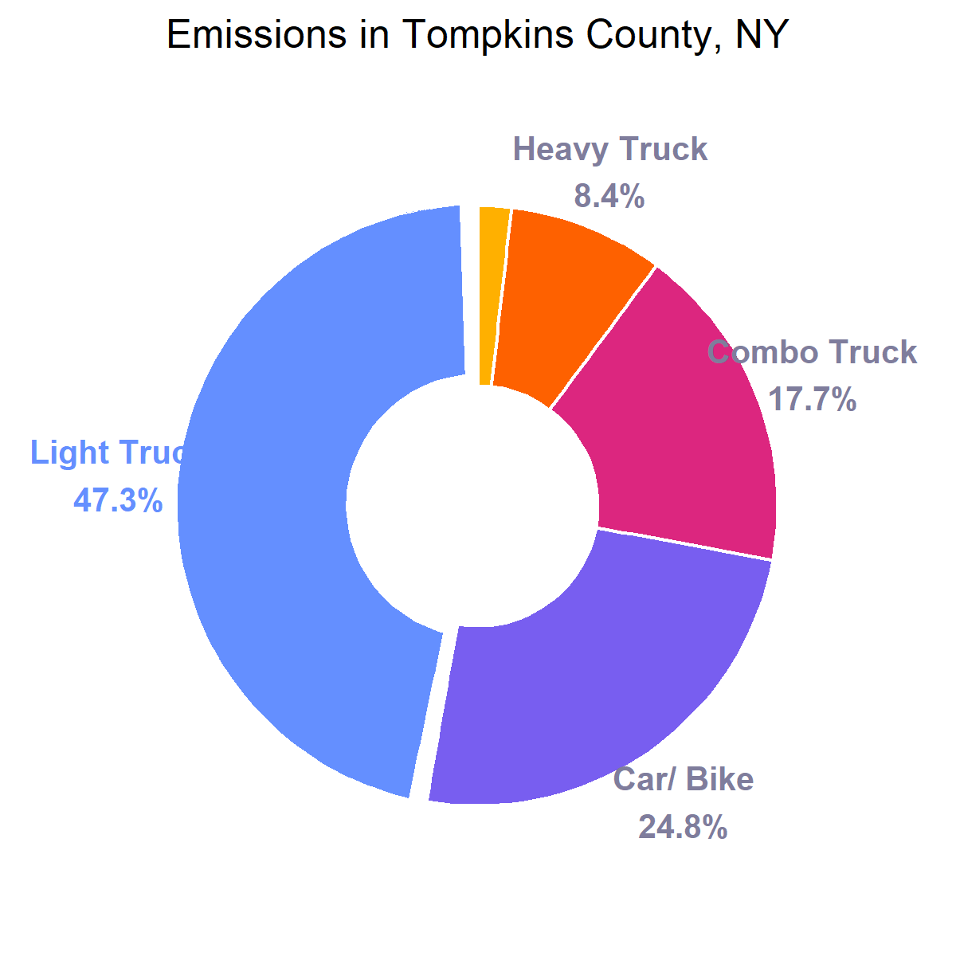

1. **Light Trucks Take the Lead:** Light Trucks are the primary culprits, accounting for a staggering 47.3% of total emissions. This indicates that they are either more abundant in number, have higher emission rates, or both.
2. **Car/ Bikes, Still a Concern:** Surprisingly, combined emissions from car/ bikes come in second at 24.8%. This demonstrates the collective impact of these types of vehicles in the region.
3. **Combo Trucks, Heavy Trucks, and Buses:** Combo trucks contribute 17.7% of the CO2e emissions, followed by heavy trucks at 8.4%. Buses represent a mere 1.8%.

In conclusion, while each types of vehicles contributes to the overall carbon emissions of Tompkins County, efforts to reduce emissions might be most effective if they initially focus on light trucks and car/ bikes. It provides a clearer picture of where interventions could be targeted for a low-emissions future.

Contact Information:  
Department Name, Organization Name  
Street Address, City, State  
Email: name@thing.com