Quick Start Guide to Accessing MariaDB Data

This readme contains a few helpful hints on how to access data in your new MariaDB installation.

Table of Contents

1. Introduction 1

2. HeidiSQL 1

2.1. Connecting to MariaDB 2

2.2. Viewing Tables 2

2.3. Running Simple Summary Statistics with SQL Commands 2

2.4. Exporting Data to Flat Files 3

3. MySQL Workbench 4

4. Where are my Data? How to Manually Migrate Data from MySQL to MariaDB 6

5. Data Folder Maintenance 7

# Introduction

Experienced MOVES users will note that MOVES has switched from using MySQL to MariaDB. This is because versions of MySQL 8.0 and later removed features that MOVES needs to run. MariaDB is a drop-in replacement for MySQL, meaning that language syntax, file formats, and APIs are identical between the two, so it is relatively straightforward to go from one to the other. Moreover, MariaDB intends to maintain the features needed for MOVES, so this change in the MOVES prerequisites is stable and is intended to be permanent. MariaDB installation is included as a feature of the MOVES installer.

Since MariaDB is a drop-in replacement for MySQL, you can use MySQL Workbench to access MariaDB databases if Workbench is the tool that you are used to using. Alternatively, MariaDB comes with its own database access tool called HeidiSQL.

# HeidiSQL

MariaDB comes installed with HeidiSQL, a free third-party tool to access its data. This tool allows you to view individual tables, filter records, and aggregate results using SQL commands. You can also use HeidiSQL to export data to flat files, which can then be used with other analysis tools (e.g., Excel, R, Python, Matlab, etc.).

There may be a shortcut on your desktop to HeidiSQL after running the MOVES installer. If not, you can find it by searching for HeidiSQL in the Windows start menu.

## Connecting to MariaDB

When opening HeidiSQL, the first screen you see is the Session Manager. This screen is used to enter connection details such as the port number and SQL username and password. The MOVES installer automatically creates and configures a connection to MariaDB for you using the MOVES username and password (these are both “moves”). Simply select the MOVES Connection option on the left and click Open.

## Viewing Tables

Databases are listed in the left side of the application. To see the tables in any database, click the > icon next to the database name. To view the data in a table, click on the table’s name. Heidi’s main view will change to information about the table (column names, their type, etc.). Clicking the Data tab above the main view will display the table.

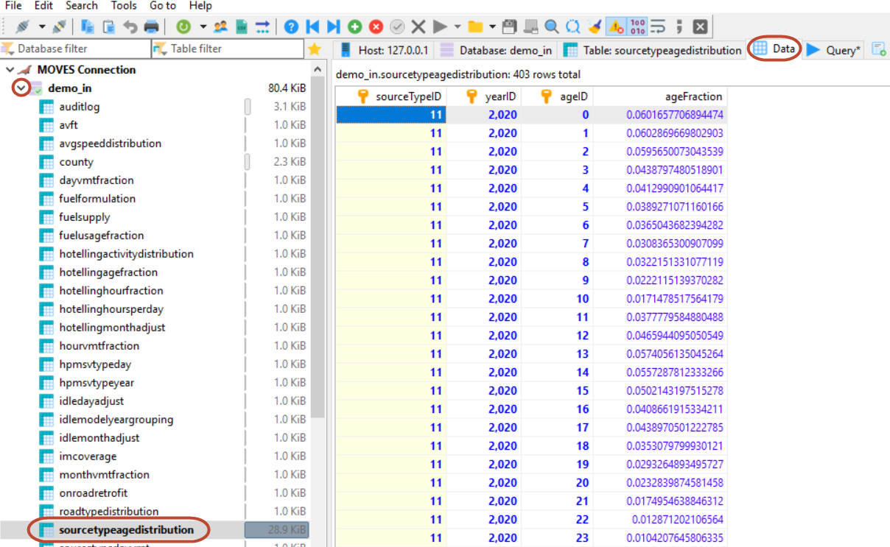

3. Click Data tab

2. Click on a table

1. Expand Database

## Running Simple Summary Statistics with SQL Commands

Custom SQL queries can be run by selecting the Query tab (next to the Data tab). See Module 4 of the [MOVES training materials](https://www.epa.gov/moves/moves-training-sessions#training) for sample SQL commands and for more information about simple data analysis in SQL. After writing the SQL query, execute it by clicking the blue “play” button or by pressing F9.

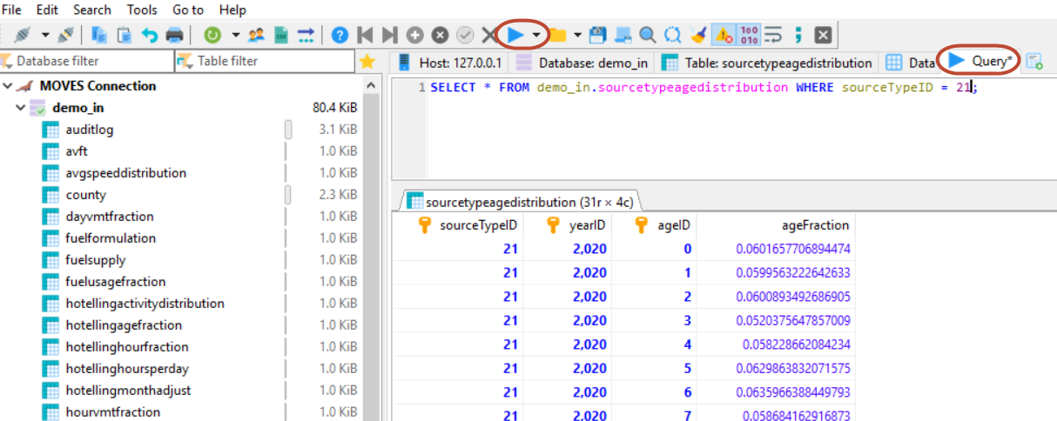

3. Execute query

2. Write query

1. Click Query tab

## Exporting Data to Flat Files

If you want to export data from a table that you are viewing via the Data tab or the results of a custom query that you have already run via the Query tab, select Export Grid Rows from the Tools dropdown menu. Select the File radio button under Output Target and then select a file name. Make sure Row Selection is set to Complete, and then click OK.

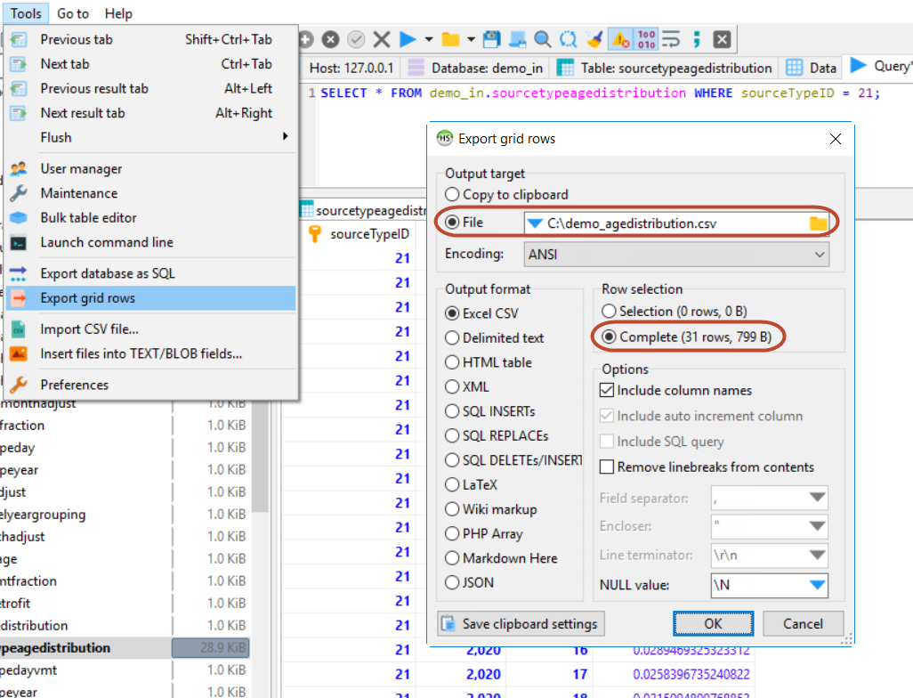

**Note:** If you are running the export tool from the Data tab, it might limit your export to 1000 rows by default. To increase this limit, select Preferences from the Tools dropdown menu. On the Grid Formatting tab, enter a higher value for the Rows Per Page setting, and then click OK.

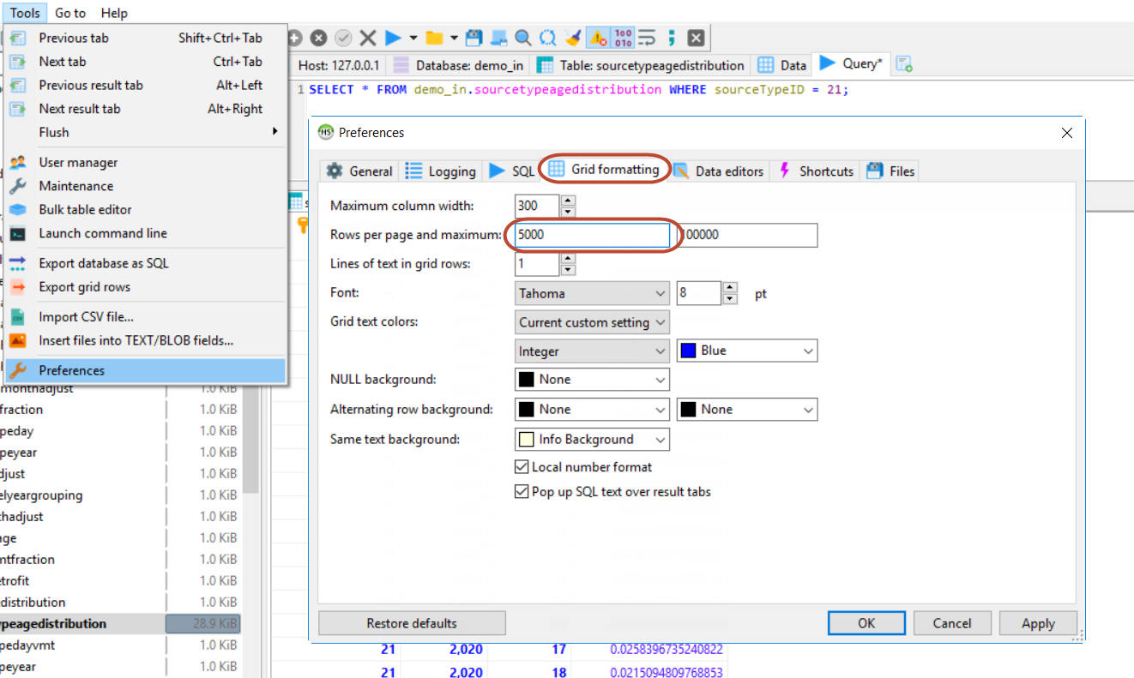

# MySQL Workbench

If you have used previous version of MOVES, you may be experienced with using MySQL Workbench and may not want to use a different tool. Fortunately, Workbench works with MariaDB and configuring it is easy. When opening MySQL Workbench, the first screen you see is Welcome to MySQL Workbench with a list of MySQL connections. Click the plus (“+”) icon to add a new connection.

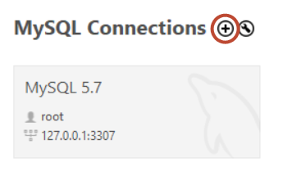

1. Enter a connection name to distinguish this new connection to MariaDB from any other connections (for example, you may already have a connection to MySQL 5.7).
2. Enter the port number selected when installing MOVES. If you do not know this information, you can look it up by opening the MOVES installation directory in Windows Explorer (by default, this is in C:\Users\Public\EPA\MOVES\MOVES3). Look for a MySQL.txt file in this location. If it doesn’t exist, your port number is 3306. If it does exist, it will contain the port number.
3. Enter “moves” (without quotes) as the username and then click Store in Vault.
4. Enter “moves” (without quotes) as the password, then OK.
5. Click Test Connection.
   1. If the connection is successful, you will receive a warning message explaining that some features of MySQL Workbench may not work with MariaDB. However, all basic features are compatible, so click Continue Anyway, and then OK.
   2. If something was entered incorrectly, you will receive an error message stating that MySQL Workbench failed to connect. Click OK, and then check the port number, username, and password to make sure you entered everything correctly.

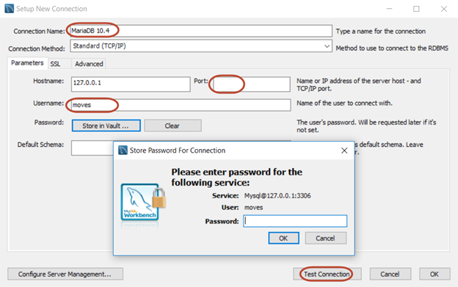

5. Click *Test Connection*

3. Enter **moves** and click *Store in Vault*

2. Enter Port Number

1. Enter Connection Name

4. Enter **moves** and click OK

This is the warning message that you will see whenever MySQL Workbench connects to MariaDB:

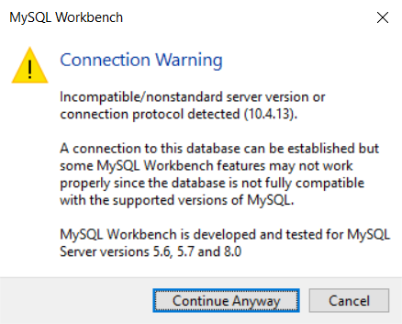

After clicking OK to save the connection to MariaDB, you will see your new connection in the list. To open the connection to MariaDB, simply click on the new connection option. You can now use MySQL Workbench as normal. Note: whenever opening this connection, you will see the warning message illustrated above. Click Continue Anyway to continue.

# Where are my Data? How to Manually Migrate Data from MySQL to MariaDB

If you are using the MOVES GUI or are in HeidiSQL or MySQL Workbench and cannot find a specific database, first check to make sure you are looking in the right place. MOVES3 can only access data in MariaDB.

The MOVES installer by default will offer to manually migrate all your data from MySQL to MariaDB, as well as to configure older versions of MOVES to use MariaDB. If you did not choose this option, the instructions in this section describe how to manually copy your old data from your old MySQL installation to MariaDB.

1. Restart your computer.
   * If any of the database files are in use, you may receive error messages in the subsequent steps. Restarting your computer will minimize the likelihood of this happening.
2. Locate your MySQL data folder.
   * You may have a shortcut on your desktop to “MySQL 5.6 Data” or “MySQL 5.7 Data”. If so, double-click on the shortcut and note the directory that opens.
   * If you do not have a shortcut, open a connection to MySQL in either MySQL Workbench or HeidiSQL (as described in the above sections), and run the following SQL command:

show variables like '%datadir%';

1. Locate your MariaDB data folder and determine your MariaDB port number.
   * You may have a shortcut on your desktop to “MariaDB 10.4 Data”. If so, double-click on the shortcut and note the directory that opens.
   * If you do not have a shortcut, open a connection to MariaDB in either MySQL Workbench or HeidiSQL, and run the following SQL command:

show variables like '%datadir%';

* + Running the following SQL command will report the port number:

show variables like 'port';

1. Move or copy the desired database folders from the MySQL data folder to the MariaDB folder.
   * **DO NOT** copy folders with the following names: **mysql**, **performance_schema**, **test**, or **sys**. Moving these folders may corrupt your MariaDB installation!
   * Move the folders instead of copying to prevent future confusion regarding which service you are using.
   * Only copy if you need to keep duplicate records for archival purposes.
2. Locate your MariaDB installation folder.
   * This is not necessarily in the same folder as your data folder. By default, MariaDB is installed to C:\Program Files\MariaDB\MariaDB 10.4

1. Open a command prompt.
   * You can do this by clicking the Windows Search icon in your taskbar and typing “cmd”.
2. Navigate to the MariaDB installation’s bin subfolder.
   * The command to change directories is “cd path\to\folder”. If MariaDB is installed in the default location, you would type:

cd c:\Program Files\MariaDB\MariaDB 10.4\bin

1. Run mysql_upgrade.
   * This will ensure all the MySQL databases are correctly set up to work with MariaDB.
   * The specific command that you would type is:

mysql_upgrade --force --user=root --password --port=xxxx

* + Replace “xxxx” with the actual port number. When you run this command, it will prompt you for the root password. If you do not know the MariaDB root password, see the MOVES Installation Troubleshooting guide (located in the installation subfolder wherever MOVES was installed) for help.

1. If you are not using MySQL for any other purpose, uninstall it to prevent future confusion.
   * Search for the program “MySQL Installer” on your computer. Launch this program and follow the on-screen instructions to remove MySQL Server. Since you have moved your data to a safe place (step 4), you may opt to delete the MySQL data directory during this process.

# Data Folder Maintenance

It is good practice to regularly maintain your database server’s data folder. If you have old data that you do not regularly need to access, you may be able to improve database performance by deleting or archiving your old databases. The recommended approach for archiving old databases is:

1. Restart your computer (if any of the database files are in use, you may receive error messages in the subsequent steps. Restarting your computer will minimize the likelihood of this happening.).
2. Navigate to your MariaDB data folder in Windows Explorer (see step 3 in the “Where are my Data” section above).
3. Select all the database folders that you wish to archive (do not select any server folders, such as **mysql**, **performance_schema**, **test**, or **sys**), right-click, and select Send to > Compressed (zipped) folder.
4. Rename the resulting zip file and move it to an appropriate archival location.
5. Delete the original folders that you just archived.
6. If you ever need to access these data again, simply extract the compressed folders to your MariaDB data folder.