EWAH-SM-03 | MESH FLOW SHORT SET  PERFORATED SUMMER SET — ABOVE-THE-KNEE VERSION | E W A H  SCULPT · FLOW · FREEDOM

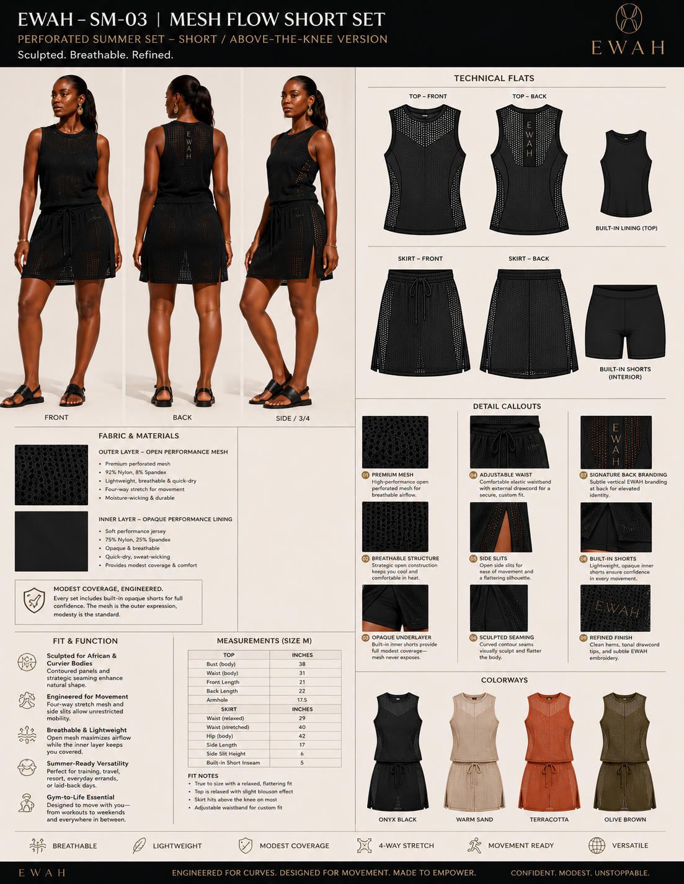
Design reference board — separate perforated top and lined skirt/skort.

1. Style Overview
Field | Specification
Style code | EWAH-SM-03
Style name | Mesh Flow Short Set
Category | Two-piece perforated top and skirt/skort
Development status | Tech Pack Draft v0.1
Fit intent | Relaxed top with shaped side panels; adjustable-waist skirt above knee with modest opaque inner short.
Primary use | Travel, resort, walking, light training and gym-to-life.
Ownership | Original EWAH design. Patterns, grading and technical files to remain EWAH property subject to contract.
Critical note | All measurements are preliminary development specifications and must be validated by a qualified pattern maker through physical fit samples.

2. Design Architecture & Technical Callouts
Ref | Feature | Requirement | Non-negotiable
01 | Relaxed perforated top | Sleeveless, softly shaped, hip-length; opaque fitted lining option. | Relaxed—not boxy or shapeless.
02 | Top side sculpting | Solid or denser-knit contour panels at waist. | Preserve EWAH seam language.
03 | Skirt outer layer | Open performance mesh, above-knee, slight A-line/column hybrid. | Must not cling or balloon.
04 | Adjustable waist | Elastic waistband with external drawcord. | No bulky gathered waist.
05 | Side slits | Open side panels/slits for mobility. | Opaque inner short remains covered.
06 | Inner short | Attached or modular opaque short, 5 in inseam. | No front seam; squat-safe.
07 | Back identity | Vertical back branding on solid spine/panel. | Simplified mark sized for mesh.

3. Bill of Materials (BOM)
# | Component | Material / specification | Color | Supplier / code | Approval
1 | Outer mesh | 92% nylon / 8% spandex open performance mesh, 150–180 GSM | Onyx | TBD | Swatch
2 | Top lining | 75% nylon / 25% spandex jersey, 180–220 GSM | Onyx | TBD | Swatch
3 | Inner short | 75% nylon / 25% spandex interlock, 230–260 GSM | Onyx | TBD | Swatch
4 | Waist elastic | Soft plush-back elastic, 35–45 mm | Black | TBD | Proto
5 | Drawcord | Matte round or flat elastic cord + soft tips | Black | TBD | Proto
6 | Logo | Stretch transfer or embroidery trial | Tonal/gold | TBD | Strike-off

4. Construction & Stitching
Ref | Area | Construction requirement | Stitch / finish | Tolerance
C1 | Top seams | Mesh and sculpting panels aligned symmetrically. | Overlock / flatlock trial | 1/8 in
C2 | Top neck/armhole | Soft binding, no scratch or gaping. | Self binding / coverstitch | 1/8 in
C3 | Skirt waistband | Distribute ease evenly; drawcord exits reinforced. | Overlock + coverstitch | 1/4 in
C4 | Skirt slits | Reinforced slit apex; clean narrow finish. | Coverstitch / binding | 1/8 in
C5 | Inner short | Secure attachment with low bulk. | Overlock + coverstitch | 1/4 in
C6 | Mesh hem | No waviness or stretched edge. | Narrow coverstitch / bonded | 1/8 in

5. Points of Measure — Base Size M
POM | Measurement point | Spec (in) | Tol. ± | How measured
T01 | Top bust circumference | 39.0 | 0.5 | 1 in below armhole ×2
T02 | Top waist circumference | 36.0 | 0.5 | At narrowest shaping point ×2
T03 | Top front length | 22.0 | 0.4 | HPS to hem
T04 | Top armhole circumference | 18.0 | 0.3 | Along seam
S01 | Skirt waist relaxed | 29.0 | 0.5 | Waist edge ×2
S02 | Skirt waist stretched | 40.0 | 0.75 | Comfortable max stretch ×2
S03 | Skirt full hip | 43.0 | 0.5 | At fullest point ×2
S04 | Skirt side length | 17.0 | 0.4 | Top waist to hem
S05 | Side slit height | 6.0 | 0.25 | Hem to apex
S06 | Inner-short inseam | 5.0 | 0.25 | Crotch to leg opening

6. Preliminary Grade Rules
Measurement | XS→S | S→M | M→L | L→XL | XL→2XL | 2XL→3XL | Notes
Top bust | 1.5 | 1.5 | 1.5 | 2.0 | 2.0 | 2.0 | Maintain relaxed ease
Top waist | 1.5 | 1.5 | 1.5 | 2.0 | 2.0 | 2.0 | Do not lose sculpting
Skirt hip | 1.75 | 1.75 | 2.0 | 2.0 | 2.25 | 2.25 | Validate on fuller glutes
Skirt waist relaxed | 1.0 | 1.0 | 1.25 | 1.25 | 1.5 | 1.5 | Elastic and drawcord adjustability
Skirt length | 0.25 | 0.25 | 0.25 | 0.25 | 0.25 | 0.25 | Keep above-knee intent
Inner-short inseam | 0 | 0 | 0 | 0 | 0 | 0 | Fixed 5 in
Grade rules are provisional. Final grading must preserve the waist-to-hip relationship, rear coverage, slit position, perforation map and underlayer security on every size.

7. Branding, Labels & Packaging
Element | Placement | Size / method | Color | Notes
Top front emblem | Left chest | 12–15 mm | Tonal/gold | Subtle
Top vertical lockup | Upper center back | 70–90 mm | Tonal/gold | On solid spine if needed
Skirt wordmark | Upper left hip | 35–50 mm wide | Tonal/gold | Avoid placement over high-stretch zone
Internal print | Top inside back / skirt inside waistband | Brand + size + fiber | Tonal | Heat transfer
Hangtag | Waist or side seam | Product story + barcode | Black/ivory/gold | Removable

8. Performance & Quality-Control Tests
Test | Method / movement | Pass criteria | Stage
Coverage | Standing, seated, forward bend | Opaque inner layers fully cover bust/seat | Proto
Slit mobility | Walk, lunge, stairs | No restriction; slit remains controlled | Proto
Waist security | 15 min movement circuit | Skirt does not slide or twist | Wear test
Mesh snag | Rub against smooth equipment simulation | No immediate snagging or laddering | Material
Recovery | 20 stretch cycles | No permanent distortion >3% | Lab
Wash | 5 home-laundry cycles | No hem wave, logo damage or mesh deformation | PP

9. Sample Review & Revision Log
Round | Date | Sample type | Issue / observation | Required correction | Status
Proto 1 |  | Development sample |  |  | Open
Proto 2 |  | Revised fit sample |  |  | Pending
Size set |  | XS–3XL |  |  | Pending
PP sample |  | Pre-production |  |  | Pending

10. Approval Gates
☐ Design architecture approved
☐ Fabric and color approved
☐ Base-size fit approved
☐ Movement and modesty tests passed
☐ Size-set approved
☐ Pre-production sample approved

