EWAH-ST-02 | AIR SCULPT SHORT DRESS  MODEST SUMMER TRAINING DRESS — SHORT PERFORATED VERSION | E W A H  SCULPT · FLOW · FREEDOM

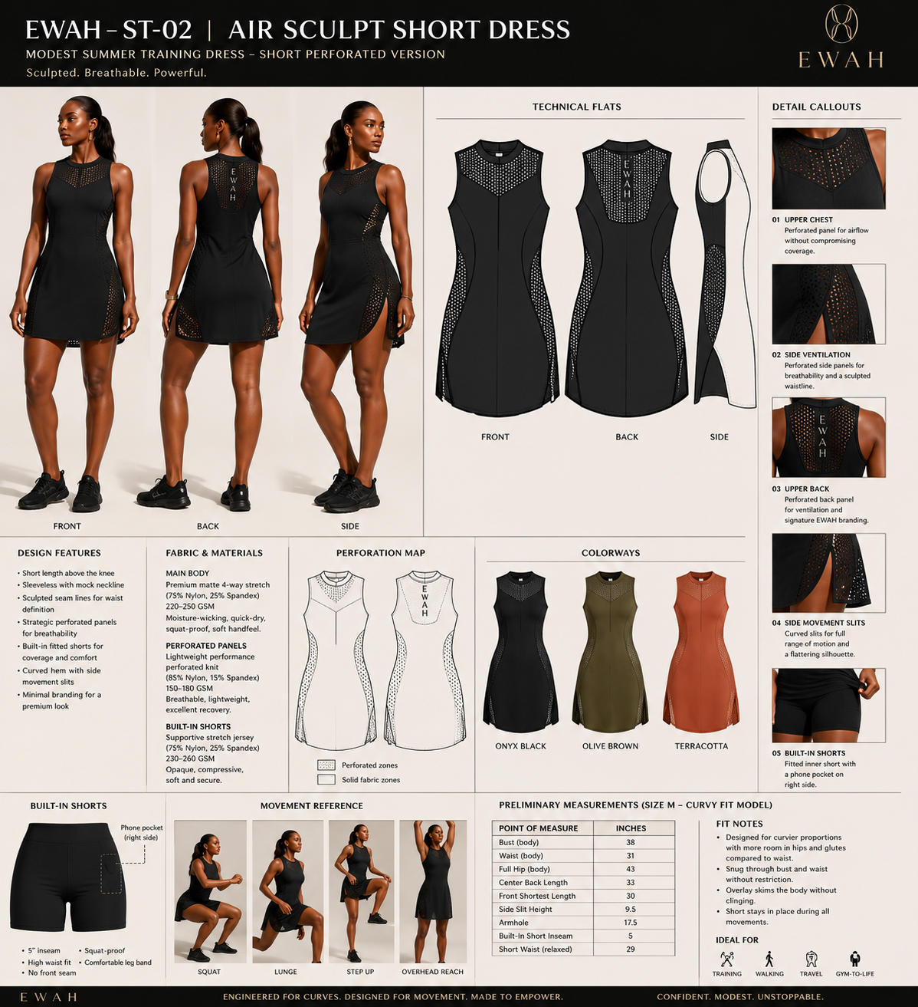
Design reference board — aesthetic intent, not final production drawing.

1. Style Overview
Field | Specification
Style code | EWAH-ST-02
Style name | Air Sculpt Short Dress
Category | Performance dress with attached inner short
Development status | Tech Pack Draft v0.1
Fit intent | Sculpted through bust and waist; additional room through hips/glutes; above-knee modest outer length.
Primary use | Strength training, walking, travel and gym-to-life.
Ownership | Original EWAH design. Patterns, grading and technical files to remain EWAH property subject to contract.
Critical note | All measurements are preliminary development specifications and must be validated by a qualified pattern maker through physical fit samples.

2. Design Architecture & Technical Callouts
Ref | Feature | Requirement | Non-negotiable
01 | Upper chest panel | Strategic perforated panel over opaque/supportive inner layer. | Airflow without visible cleavage or bra exposure.
02 | Sculpted bodice seams | Curved front/back seams frame waist and support fuller bust. | No generic A-line block.
03 | Side ventilation | Perforated side inserts follow contour line. | Must not reveal underwear or create side bulging.
04 | Side movement slits | Two curved slits integrated into outer dress. | Short remains covered while standing; opens only in movement.
05 | Built-in short | Attached at internal waist; 5 in inseam; right phone pocket. | No front seam; opaque; must not ride excessively.
06 | Back identity | Perforated upper-back panel with vertical EWAH lockup. | Use simplified one-color mark for production.

3. Bill of Materials (BOM)
# | Component | Material / specification | Color | Supplier / code | Approval
1 | Main body | 75% nylon / 25% spandex matte 4-way stretch, 220–250 GSM | Onyx | TBD | Lab dip
2 | Perforated panels | Performance perforated knit, 85% nylon / 15% spandex, 150–180 GSM | Onyx | TBD | Swatch
3 | Inner short | Opaque nylon/spandex interlock, 230–260 GSM | Onyx | TBD | Swatch
4 | Pocket bag | Self or lightweight power mesh | Onyx | TBD | Proto
5 | Logo transfer | Matte silicone or high-stretch heat transfer | Tonal / antique gold | TBD | Strike-off
6 | Care label | Soft satin or printed tear-away | Black | TBD | Artwork

4. Construction & Stitching
Ref | Area | Construction requirement | Stitch / finish | Tolerance
C1 | Contour seams | Join without puckering; seam line must remain smooth under stretch. | 4-thread overlock + coverstitch/topstitch as approved | 1/8 in
C2 | Mesh joins | Stabilize mesh-to-solid transitions; no rippling. | Narrow overlock or bonded seam trial | 1/8 in
C3 | Neck/armhole | Clean, soft binding; no gaping or cutting. | Self binding / bonded finish | 1/8 in
C4 | Side slits | Reinforce slit apex; clean inside finish. | Narrow coverstitch or bonded | 1/8 in
C5 | Inner short | Attach cleanly at waist; avoid bulk; phone pocket secure. | Overlock + coverstitch | 1/4 in
C6 | Hem | Curved hem must lie flat with no tunneling. | Twin needle / bonded hem | 1/8 in

5. Points of Measure — Base Size M
POM | Measurement point | Spec (in) | Tol. ± | How measured
P01 | Bust circumference, 1 in below armhole | 38.0 | 0.5 | Garment laid flat ×2
P02 | Waist circumference at narrowest seam | 31.0 | 0.5 | Garment relaxed ×2
P03 | Full hip circumference | 43.0 | 0.5 | At fullest outer-dress point ×2
P04 | Center back length | 33.0 | 0.4 | HPS/CB neck to hem
P05 | Front shortest length | 30.0 | 0.4 | HPS to shortest front hem
P06 | Armhole circumference | 17.5 | 0.3 | Along seam line
P07 | Side slit height | 9.5 | 0.25 | Hem to slit apex
P08 | Inner-short inseam | 5.0 | 0.25 | Crotch seam to leg opening
P09 | Inner-short waist relaxed | 29.0 | 0.5 | Waist edge ×2
P10 | Phone pocket usable opening | 5.5 | 0.25 | Finished opening

6. Preliminary Grade Rules
Measurement | XS→S | S→M | M→L | L→XL | XL→2XL | 2XL→3XL | Notes
Bust circumference | 1.5 | 1.5 | 1.5 | 2.0 | 2.0 | 2.0 | Total circumference increment
Waist circumference | 1.25 | 1.25 | 1.5 | 1.5 | 2.0 | 2.0 | Protect waist-to-hip ratio
Full hip circumference | 1.75 | 1.75 | 2.0 | 2.0 | 2.25 | 2.25 | Validate on fuller glutes
Body length | 0.25 | 0.25 | 0.25 | 0.25 | 0.25 | 0.25 | Do not shorten larger sizes
Armhole circumference | 0.25 | 0.25 | 0.25 | 0.3 | 0.3 | 0.3 | Check bra coverage
Short inseam | 0 | 0 | 0 | 0 | 0 | 0 | Fixed 5 in unless wear test requires
Grade rules are provisional. Final grading must preserve the waist-to-hip relationship, rear coverage, slit position, perforation map and underlayer security on every size.

7. Branding, Labels & Packaging
Element | Placement | Size / method | Color | Notes
Front emblem | Lower left hem or left chest | 12–16 mm high transfer | Tonal | Quiet branding
Vertical lockup | Upper center back within solid spine | 70–90 mm high | Tonal/gold | Must remain legible on mesh
Internal heat transfer | Inside upper back | Brand, size, country, fiber | Tonal | No scratchy neck label
Care label | Inside left side seam | Legally required content | Black/white | Confirm market requirements
Packaging | Recycled polybag + hangtag | Style/color/size barcode | Ivory/black/gold | No unverified sustainability claims

8. Performance & Quality-Control Tests
Test | Method / movement | Pass criteria | Stage
Squat opacity | 5 deep squats under bright light | No transparency at outer dress or inner short | Proto
Slit exposure | Lunge, step-up, seated position | Under-short provides full coverage; slit does not migrate | Proto
Neck security | Overhead reach and forward bend | No gaping or unintended exposure | Proto
Short ride-up | 15 min walking + squat circuit | No severe rolling or chafing | Wear test
Recovery | 20 stretch cycles | No permanent distortion >3% | Lab
Wash | 5 home-laundry cycles | No seam failure, logo cracking or mesh distortion | PP

9. Sample Review & Revision Log
Round | Date | Sample type | Issue / observation | Required correction | Status
Proto 1 |  | Development sample |  |  | Open
Proto 2 |  | Revised fit sample |  |  | Pending
Size set |  | XS–3XL |  |  | Pending
PP sample |  | Pre-production |  |  | Pending

10. Approval Gates
☐ Design architecture approved
☐ Fabric and color approved
☐ Base-size fit approved
☐ Movement and modesty tests passed
☐ Size-set approved
☐ Pre-production sample approved

