EWAH-WF-01 | WARRIOR FLOW DRESS-SKORT  SCULPTED PERFORMANCE DRESS — ASYMMETRIC FLOW VERSION | E W A H  SCULPT · FLOW · FREEDOM

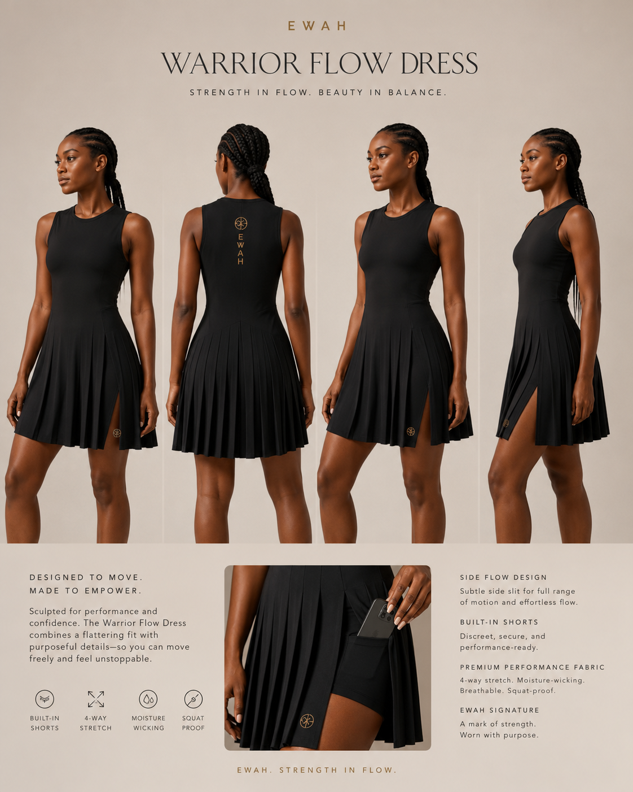
Primary design direction — use together with approved length and seam references.

1. Style Overview
Field | Specification
Style code | EWAH-WF-01
Style name | Warrior Flow Dress-Skort
Category | Premium asymmetric performance dress with inner short
Development status | Tech Pack Draft v0.1
Fit intent | Secure wrap-inspired bodice, defined waist, mixed smooth and controlled-flow panels, room through hips/glutes.
Primary use | Strength training, studio, walking, travel and gym-to-life.
Ownership | Original EWAH design. Patterns, grading and technical files to remain EWAH property subject to contract.
Critical note | All measurements are preliminary development specifications and must be validated by a qualified pattern maker through physical fit samples.

2. Design Architecture & Technical Callouts
Ref | Feature | Requirement | Non-negotiable
01 | Neckline | Secure wrap-inspired V or crossover illusion with internal stabilization. | No deep cleavage, gaping or literal costume closure.
02 | Bodice seams | Architectural curved seams frame bust, waist and back. | Strong EWAH sculptural identity.
03 | Waist structure | Clean shaped waist without bulky ties. | Must remain flat during movement.
04 | Asymmetric outer panels | Smooth main panel plus selective controlled pleat/flow panel. | Not fully pleated; no excessive volume.
05 | Movement openings | Dual side/asymmetric openings reveal inner short only in motion. | Standing coverage must remain modest.
06 | Inner short | Attached 5 in inseam short with optional phone pocket. | Opaque, no front seam, secure.
07 | Back seams/brand | Sculpted back with optional vertical lockup. | No generic racerback aesthetic.

3. Bill of Materials (BOM)
# | Component | Material / specification | Color | Supplier / code | Approval
1 | Main body | 75–80% nylon / 20–25% spandex matte jersey, 230–260 GSM | Onyx | TBD | Swatch
2 | Flow panel | Stretch woven or lighter jersey, 160–200 GSM | Onyx | TBD | Drape test
3 | Optional pleat insert | Heat-set stretch-compatible micro-pleat | Onyx | TBD | Wash test
4 | Inner short | Opaque nylon/spandex interlock, 230–270 GSM | Onyx | TBD | Swatch
5 | Stabilizer | Light clear elastic / knit stay tape | Clear/black | TBD | Proto
6 | Logo | High-stretch transfer / embroidery trial | Tonal/gold | TBD | Strike-off

4. Construction & Stitching
Ref | Area | Construction requirement | Stitch / finish | Tolerance
C1 | Crossover neckline | Stabilize edge; clean overlap; no rolling. | Binding + clear elastic / bonded trial | 1/8 in
C2 | Bodice seams | Curves must be smooth and symmetrical. | Overlock + cover/flatlock | 1/8 in
C3 | Waist join | Low-bulk join between bodice, outer skirt and short. | Overlock + understitch as needed | 1/4 in
C4 | Flow/pleat panel | Pleats controlled and anchored; drape must not twist. | Specialty stitch / topstitch | 1/8 in
C5 | Slit apex | Bar tack or reinforcement patch discreetly. | Reinforced coverstitch | 1/8 in
C6 | Hem | Smooth, premium, no tunneling. | Bonded / twin needle | 1/8 in

5. Points of Measure — Base Size M
POM | Measurement point | Spec (in) | Tol. ± | How measured
P01 | Bust circumference | 38.0 | 0.5 | 1 in below armhole ×2
P02 | Waist circumference | 31.0 | 0.5 | At waist seam ×2
P03 | Full hip allowance outer layer | 44.0 | 0.6 | At fullest point ×2
P04 | Center back length — above knee | 36.5 | 0.4 | CB neck to hem
P05 | Center back length — knee option | 39.5 | 0.4 | CB neck to hem
P06 | Front neckline depth | 4.25 | 0.2 | HPS to finished crossover
P07 | Armhole circumference | 17.75 | 0.3 | Along seam
P08 | Side opening height | 10.0 | 0.3 | Hem to apex
P09 | Inner-short inseam | 5.0 | 0.25 | Crotch to leg opening
P10 | Pocket opening | 5.5 | 0.25 | Usable finished opening

6. Preliminary Grade Rules
Measurement | XS→S | S→M | M→L | L→XL | XL→2XL | 2XL→3XL | Notes
Bust circumference | 1.5 | 1.5 | 1.5 | 2.0 | 2.0 | 2.0 | Confirm fuller-bust option later
Waist circumference | 1.25 | 1.25 | 1.5 | 1.5 | 2.0 | 2.0 | Protect shaping
Outer hip allowance | 1.75 | 1.75 | 2.0 | 2.0 | 2.25 | 2.25 | Allow drape over glutes
Body length | 0.25 | 0.25 | 0.25 | 0.25 | 0.25 | 0.25 | Two approved length variants
Opening height | 0.1 | 0.1 | 0.1 | 0.1 | 0.1 | 0.1 | Do not overexpose larger sizes
Short inseam | 0 | 0 | 0 | 0 | 0 | 0 | Fixed 5 in
Grade rules are provisional. Final grading must preserve the waist-to-hip relationship, rear coverage, slit position, perforation map and underlayer security on every size.

7. Branding, Labels & Packaging
Element | Placement | Size / method | Color | Notes
Front emblem | Lower left panel / chest | 12–16 mm | Tonal/gold | Quiet
Vertical lockup | Upper center back | 70–90 mm | Tonal/gold | Optional signature level
Internal print | Inside upper back | Brand, size, fiber, origin | Tonal | Heat transfer
Care label | Inside side seam | Regulatory content | Black/white | Soft/removable
Hangtag | Side seam | Story + fit profile + barcode | Black/ivory/gold | Premium uncoated stock

8. Performance & Quality-Control Tests
Test | Method / movement | Pass criteria | Stage
Neckline security | Bend, overhead press, bench setup | No gaping or exposure | Proto
Panel control | Walk, spin, fan test | Flow panel returns cleanly and does not twist | Proto
Slit coverage | Lunge, squat, stairs | Inner short covers fully; outer opening controlled | Proto
Machine safety | Simulated proximity to equipment | No loose panel likely to catch during intended use | Risk review
Pleat retention | 5 wash cycles if pleat used | Pleat remains defined and even | PP
Seam recovery | 20 stretch cycles | No popped stitches or distortion >3% | Lab

9. Sample Review & Revision Log
Round | Date | Sample type | Issue / observation | Required correction | Status
Proto 1 |  | Development sample |  |  | Open
Proto 2 |  | Revised fit sample |  |  | Pending
Size set |  | XS–3XL |  |  | Pending
PP sample |  | Pre-production |  |  | Pending

10. Approval Gates
☐ Design architecture approved
☐ Fabric and color approved
☐ Base-size fit approved
☐ Movement and modesty tests passed
☐ Size-set approved
☐ Pre-production sample approved

