E W A H
SCULPT • FLOW • FREEDOM
EWAH-WF-02 | WARRIOR FLOW SHORT SUMMER DRESS
ABOVE-THE-KNEE SCULPTED PERFORMANCE DRESS WITH BUILT-IN SHORTS
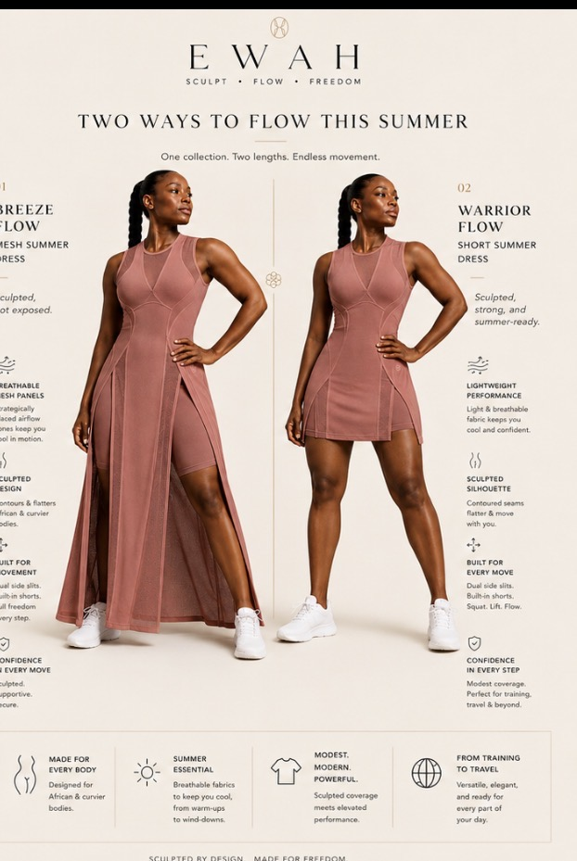
Approved reference direction: coordinated short Warrior Flow version shown on the right. Preserve the same seam architecture and airflow language as the long Breeze Flow style.

1. Style Overview
FIELD | SPECIFICATION
Status | Development tech pack draft — not production final
Category | Short luxury performance dress / training-to-travel
Silhouette | Above-the-knee sculpted dress with dual front-side openings and built-in shorts
Primary use | General gym, walking, travel, light lifting, gym-to-life
Fit intent | Defined waist, secure bust, fuller hip/glute accommodation, modest movement openings
Base size | Curvy M fit model — target body 38 in bust / 31 in waist / 43 in full hip

2. Design Architecture & Technical Callouts
FIELD | SPECIFICATION
Neckline | Refined high round neck with mesh insert; secure and supportive.
Bodice | Strong sculpted seam architecture derived from Breeze Flow family.
Skirt | Above-the-knee outer dress with center solid panel and curved side openings.
Underlayer | Opaque fitted short, 5 in inseam, no front seam, right-side phone pocket.
Back | Contoured center-back shaping with upper airflow panel and optional vertical EWAH lockup.
Hem | Curved front and back hem; rear coverage at least 1.0–1.5 in longer than front on curvy fit model.
Non-negotiable | Must not become a generic tennis dress; retain EWAH sculptural lines and controlled modesty.

3. Bill of Materials (BOM)
COMPONENT | SPECIFICATION | QTY
Main shell | Matte 4-way stretch nylon/spandex, 220–250 GSM | 1
Ventilation mesh | Fine perforated nylon/spandex, 150–190 GSM | 1
Built-in short | Opaque nylon/spandex interlock, 230–270 GSM | 1
Elastic | Soft 35–40 mm waistband elastic, high recovery | 1
Branding | Tonal or antique-gold heat transfer / silicone | 1
Thread | High-tenacity polyester stretch-compatible thread | As req.

4. Construction & Stitching
FIELD | SPECIFICATION
Primary seams | 4-thread overlock or equivalent stretch seam; clean internal finish.
Topstitching | Coverstitch or narrow twin-needle where visible; maintain consistent 3 mm visual line.
Mesh joins | Stabilize without rigid tape; avoid puckering and abrasion against skin.
Slits/openings | Reinforce stress points; clean narrow binding or turned finish.
Hem | Bonded or coverstitched according to approved sample; no waviness.
Underlayer attachment | Attach at waist seam; avoid bulky seam stack; accessible phone pocket.
Brand placement | Front emblem 18–22 mm; vertical back lockup only after exact placement approval.

5. Points of Measure — Base Size M
POINT OF MEASURE | INCHES | TOLERANCE
Bust circumference | 38 | ±0.5
Waist circumference | 31 | ±0.5
Full hip allowance — outer | 44 | ±0.75
Center-back length | 34.5 | ±0.5
Front shortest length | 32.5 | ±0.5
Side opening height | 10 | ±0.25
Armhole circumference | 17.5 | ±0.25
Shoulder width | 14.5 | ±0.25
Built-in short inseam | 5 | ±0.25
Short waist relaxed | 29 | ±0.5
All measurements are preliminary starting specifications. Final POMs must be set from approved physical pattern and fit sample.

6. Preliminary Grade Rules
FIELD | SPECIFICATION
Bust | +1.5 in total per size
Waist | +1.25 in total per size
Full hip / outer ease | +1.75 in total per size
Length | +0.25 in per size; petite/tall variants evaluated separately
Armhole | +0.25 in circumference per size
Built-in short inseam | Hold 5 in unless fit testing requires change
Critical rule | Preserve waist-to-hip relationship, slit placement, mesh zoning and rear coverage through grading.

7. Branding, Labels & Packaging
FIELD | SPECIFICATION
Primary branding | Small emblem at left hip or lower front; tonal black or antique gold.
Back branding | Optional vertical EWAH lockup centered on solid upper-back panel; never printed across open mesh.
Internal label | Heat-transfer brand/size label; soft removable care label at side seam.
Hangtag | Style code, color, size, fabric composition, coverage level, care QR code.
Packaging | Fold with tissue barrier; avoid crushing mesh; individual recycled polybag or premium paper sleeve.

8. Performance & Quality-Control Tests
- Deep squat, lunge and deadlift setup
- Step-up and overhead reach
- Treadmill walking and seated-machine use
- Neckline security across movement
- Short does not roll or ride excessively
- Opacity under stretch and sweat
- Rear hem remains covered over fuller glutes
- Side openings do not expose beyond approved coverage

9. Sample Review & Revision Log
ROUND | DATE | SAMPLE TYPE | ISSUE / OBSERVATION | ACTION | STATUS
1 |  | Proto 1 |  |  | Open
2 |  | Fit sample |  |  | Open
3 |  | Size set |  |  | Open
4 |  | Pre-production |  |  | Open

10. Approval Gates
☐ Design architecture approved
☐ Fabric and color approved
☐ Base-size fit approved
☐ Movement and modesty tests passed
☐ Size-set approved
☐ Pre-production sample approved

