EWAH
CAPSULE 01
FULL PRODUCT DEVELOPMENT PACK
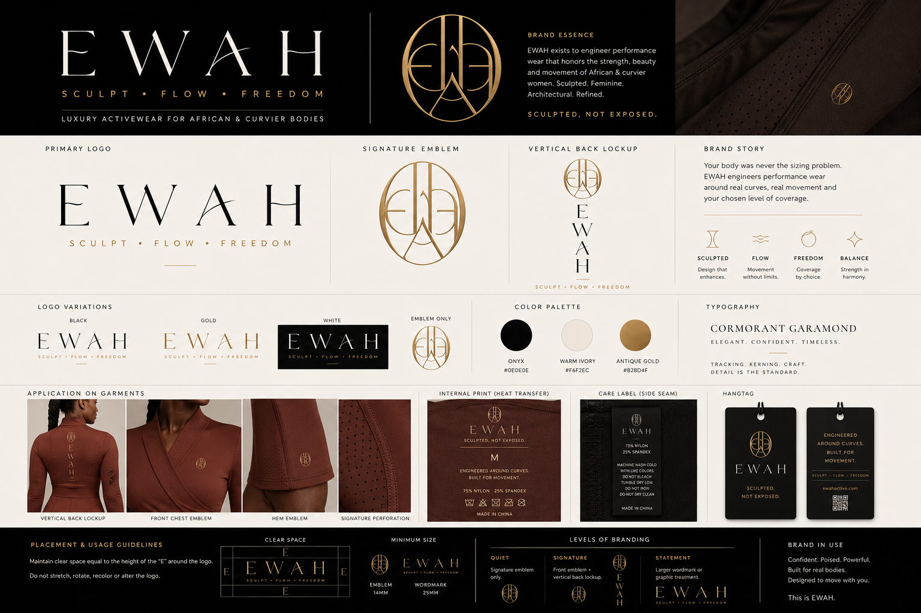
Luxury performance wear engineered around curves.
Prepared as an initial custom-development and manufacturer screening document. Measurements are starting specifications only and require physical fit validation, pattern refinement and grading by a qualified technical team.

Capsule 01 Development Strategy
EIGHT ORIGINAL PRODUCTS — ONE COHERENT DESIGN SYSTEM

Collection Thesis
EWAH Capsule 01 combines sculpted curve engineering, controlled volume, selective pleating, movement-safe coverage and luxury finishing. It is not a white-label activewear assortment. Every style must be developed from original patterns and validated on curvier fit bodies.

Products Included
01 | Warrior Flow Dress-Skort — sculpted asymmetric hero dress
02 | Air Sculpt Short Dress — short perforated summer training dress
03 | Breeze / Warrior Flow Dress Family — one sculpted upper block, two lengths
04 | Mesh Flow Short Set — perforated top and above-knee skirt with opaque built-in short
05 | Center Pleat Training Dress — selective pleat performance dress
06 | Sculpt Flow Set — tailored short-sleeve top and loose technical trouser
07 | Ease T-Shirt Dress — oversized boyfriend tee with concealed shorts
08 | Air Sculpt Mesh System — perforated luxury layering system

Shared EWAH Design Codes
- Strong curved or architectural seam lines that visibly sculpt the garment.
- Curve-first pattern blocks: fuller bust, hip, thigh and glute allowance with controlled waist fit.
- Coverage that remains stable during bending, squatting, lifting and walking.
- Pleats used selectively as movement architecture, never as decoration everywhere.
- Matte technical fabrics, refined texture and restrained branding.
- Small front emblem; vertical back lockup used only on selected signature products.
- No generic tenniswear, scrunch-bum construction, flimsy mesh or catalogue-derived silhouettes.

Recommended Prototype Sequence
Round 1 | Warrior Flow Dress-Skort + Air Sculpt Short Dress
Round 2 | Breeze / Warrior Flow Dress Family + Mesh Flow Short Set
Round 3 | Center Pleat Training Dress + Sculpt Flow Set
Round 4 | Ease T-Shirt Dress + Air Sculpt Mesh System

Warrior Flow Dress-Skort
EWAH-WF-01 | HERO PERFORMANCE DRESS
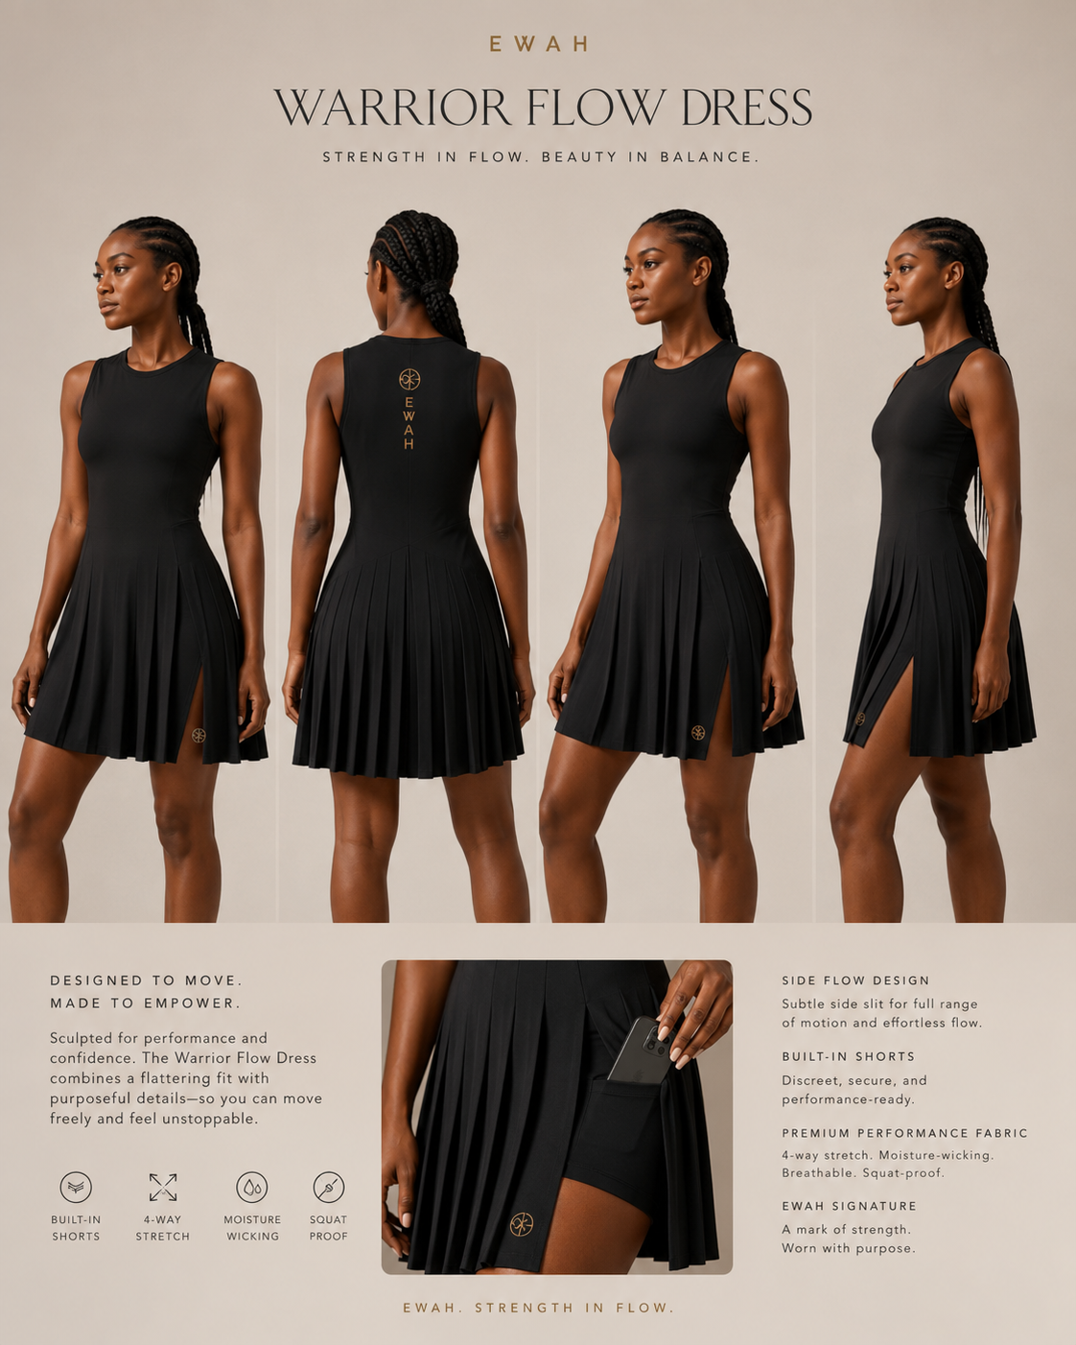
Concept reference only - final pattern and construction must follow approved specifications.
Role in capsule | Primary launch statement and factory capability test
Primary use | Strength training, walking, travel and gym-to-life
Prototype priority | Prototype Round 1
Target retail tier | Premium / luxury performance

1. Product Intent
A sleeveless, curve-conscious performance dress with a sculpted bodice, asymmetric smooth overlay, selective pleated movement panel and opaque built-in shorts. It must look architectural and flattering while remaining secure through real movement.

2. Locked Design Architecture
- Secure wrap-inspired neckline without literal martial-arts closures.
- Curved bodice seams that frame bust and waist.
- Asymmetric lower overlay combining smooth and controlled pleated sections.
- Dual movement openings positioned to protect coverage.
- Five-inch built-in short with hidden phone pocket.
- Above-knee first prototype; knee-length derivative after fit approval.

3. Curve-Fit Requirements
- Full-bust accommodation without armhole gaping.
- Defined waist with fuller hip and glute capacity.
- Back balance adjusted so the hem does not lift excessively over the seat.
- Short rise and gusset built for fuller glutes and thighs.
- Pleated panel must fall cleanly rather than add hip bulk.

4. Materials and Construction
Main body | Matte 4-way stretch nylon/spandex, 220-260 GSM.
Inner short | Opaque supportive interlock, 230-270 GSM.
Pleated panel | Heat-set micro-pleat technical woven or stretch overlay, 150-190 GSM.
Stitching | Flatlock or low-profile stretch seams; clean bonded or turned hems.

5. Branding and Finish
- Quiet emblem at lower front hem or upper chest.
- Optional vertical EWAH lockup centered at upper back.
- Heat-transfer internal label; removable soft care label.

Warrior Flow Dress-Skort — Development Specifications
EWAH-WF-01

6. Preliminary Prototype Specifications
Base fit body | Bust 38 in; waist 31 in; hip 43 in; height 5 ft 5-7 in.
Outer length | 34-35 in shortest front; 36-37 in center back.
Short inseam | 5 in.
Neck drop | Approximately 4-4.5 in, adjusted after movement test.
Slit opening | 9-11 in from hem; final exposure checked dynamically.

7. Movement and Wear Tests
- Deep squat, lunge, deadlift setup and overhead reach.
- Stair climb, fast walk and seated machine work.
- Check neckline security, short roll, slit exposure and overlay twisting.
- Wash test for pleat retention and seam recovery.

8. Non-Negotiables
- Must not resemble a generic tennis dress.
- Strong seam sculpture must remain visible in tonal fabric.
- Pleats and smooth areas must coexist; neither should dominate.
- No fabric substitutions without written approval.

9. Factory Questions Specific to This Style
- Can the factory heat-set pleats in technical fabric and guarantee wash retention?
- Can the short and outer dress be attached without a bulky waist seam?
- Can the same upper block support two hem lengths?

10. Sample Review Decision Gate
Advance only if the first sample reads as luxury performance wear while passing movement and coverage tests. If it looks decorative, costume-like or tennis-inspired, revise before grading.

Air Sculpt Short Dress
EWAH-ST-02 | MODEST SUMMER TRAINING DRESS — SHORT PERFORATED VERSION
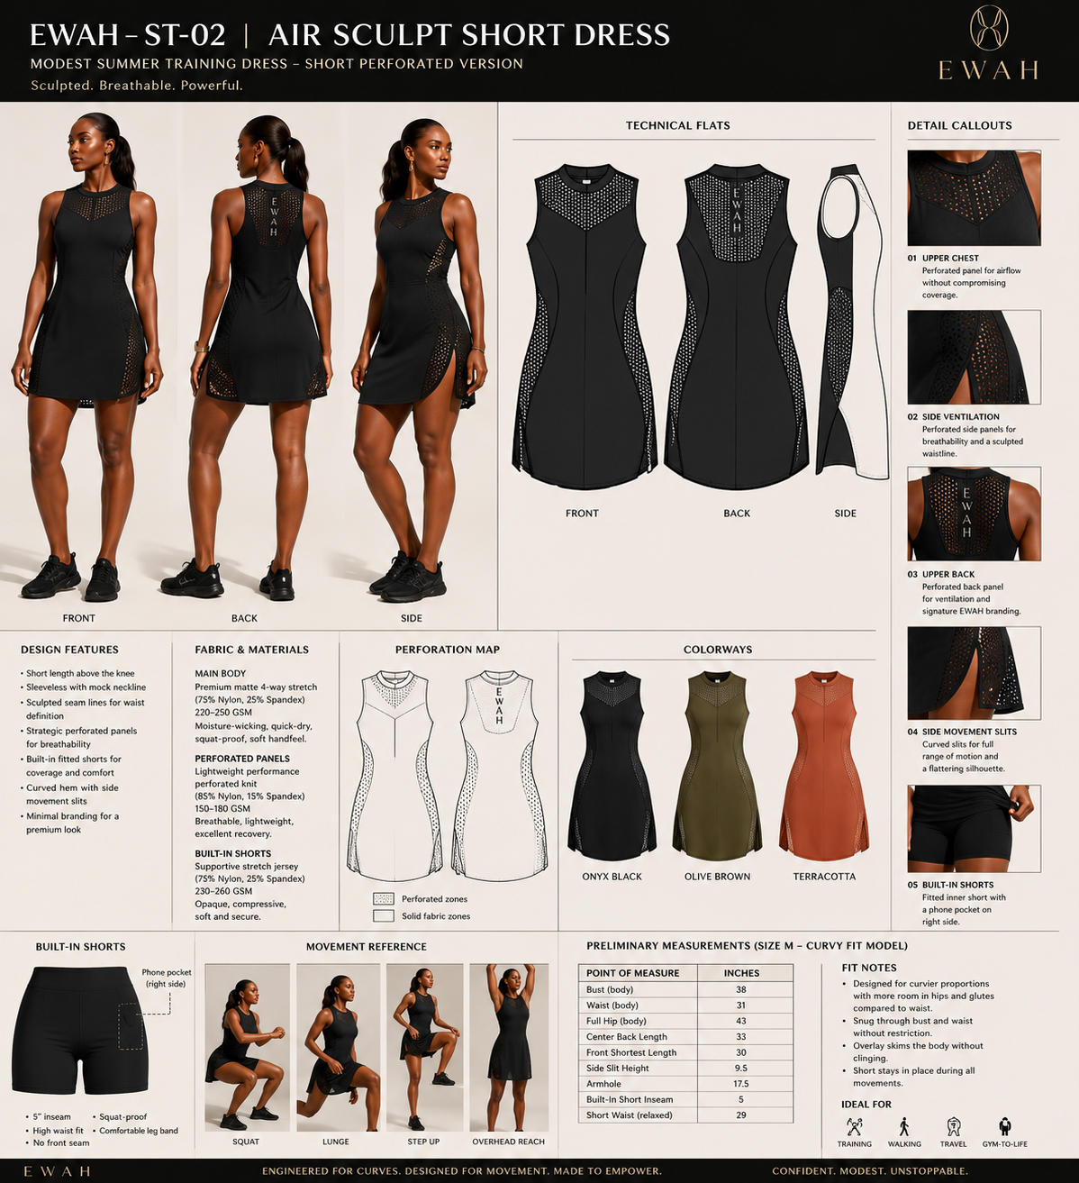
Concept reference only - final pattern and construction must follow approved specifications.
Role in capsule | Short breathable summer hero and curve-fit proof
Primary use | General gym, walking, travel and gym-to-life
Prototype priority | Prototype Round 1
Target retail tier | Premium core

1. Product Intent
A short, sleeveless summer training dress with a sculpted curvy fit, strategic perforated ventilation zones and opaque built-in shorts. It sits above the knee, keeps the neckline secure and uses curved side slits for movement without compromising modest coverage.

2. Locked Design Architecture
- Refined mock or high round neckline with perforated upper-chest airflow panel.
- Strong curved front and back sculpting seams framing bust, waist and hip.
- Curved side movement slits with perforated inserts and controlled exposure.
- Above-knee A-line release with a slightly longer back hem for seat coverage.
- Opaque five-inch built-in short with right-side phone pocket; no front seam.

3. Curve-Fit Requirements
- Bust and armhole shaped for fuller busts without tightness, gaping or bra exposure.
- Waist visually sculpts through seam placement rather than aggressive compression.
- Extra back length and sweep for fuller glutes while retaining a short-dress silhouette.
- Perforated side zones must remain flat and must not pull open over fuller hips.

4. Materials and Construction
Main body | Premium matte 4-way stretch nylon/spandex, 220-250 GSM.
Perforated panels | Lightweight performance mesh or engineered perforation, 150-180 GSM.
Built-in short | Opaque supportive stretch jersey, 230-260 GSM, five-inch inseam.
Finish | Low-profile stretch seams; clean bonded or turned neckline, armholes and slit edges.

5. Branding and Finish
- Small tonal emblem at lower hem or upper chest.
- Vertical EWAH lockup centered within the perforated upper-back panel.
- Onyx, olive brown and terracotta launch colorways; antique-gold branding kept subtle.

Air Sculpt Short Dress — Development Specifications
EWAH-ST-02

6. Preliminary Prototype Specifications
Base fit body | Bust 38 in; waist 31 in; hip 43 in.
Center back length | Approximately 33 in; graded by height block.
Front shortest length | Approximately 30-31 in; above knee on base fit model.
Side slit height | Approximately 9-10 in, validated dynamically.
Built-in short | 5 in inseam; no front seam; right-side phone pocket.

7. Movement and Wear Tests
- Squat, lunge, step-up, treadmill walk and overhead reach.
- Check perforated panel recovery, neckline security and short ride-up.
- Check slit spread, back hem lift, opacity under strong light and fabric cling after sweating.

8. Non-Negotiables
- Keep curved side slits and perforated zones; both are functional identity.
- Retain strong EWAH seam sculpture through the torso and side body.
- Solid zones and built-in short must remain fully opaque across bust, stomach and seat.
- Do not convert it into a generic tennis dress or plain tank dress.

9. Factory Questions Specific to This Style
- Can the factory laser-perforate or source premium performance mesh with consistent recovery?
- Can perforated and solid panels be shade-matched across bulk production?
- Can graded hem and slit positions preserve coverage on petite, standard and tall-curvy blocks?

10. Sample Review Decision Gate
Advance only if it reads as a premium, short modest training dress—not tenniswear—and passes squat, lunge, overhead-reach, opacity and built-in-short tests on multiple curvy bodies.

Center Pleat Training Dress
EWAH-CP-03 | SELECTIVE-PLEAT PERFORMANCE DRESS
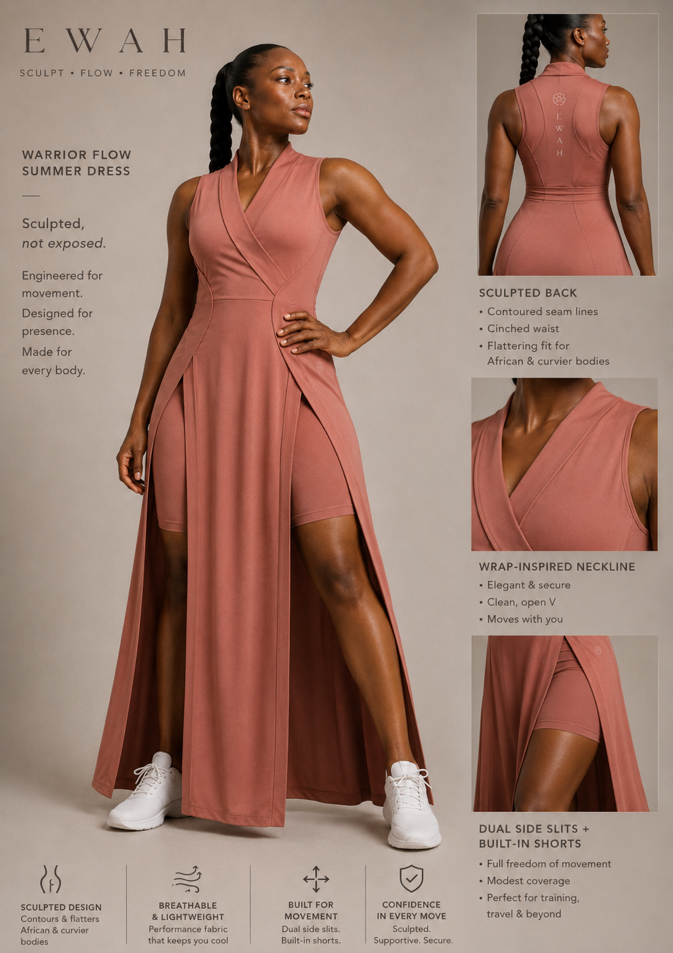
Concept reference only - final pattern and construction must follow approved specifications.
Role in capsule | Signature feminine movement piece
Primary use | Studio, walking, light strength training and gym-to-life
Prototype priority | Prototype Round 2
Target retail tier | Premium signature

1. Product Intent
A fitted sculpted bodice flowing into a skirt that mixes smooth panels with one controlled pleat structure. The rear should carry additional seam sculpture to shape the waist and seat without tracing the body excessively.

2. Locked Design Architecture
- Sculpted front bodice with clean neckline and short or sleeveless option.
- One central, side-front or offset pleat group; remaining skirt panels smooth.
- Side opening or slit retained for movement.
- Back princess seams or chevron seam map to shape the rear.
- Built-in shorts with optional removable construction study.

3. Curve-Fit Requirements
- Bodice shaped for bust projection, not merely width.
- Pleat release positioned below fullest stomach/hip point to avoid volume.
- Back seams must provide shape without a tight seat fit.
- Short leg opening must not cut into fuller thighs.

4. Materials and Construction
Bodice | Matte 4-way stretch jersey, 210-250 GSM.
Smooth skirt | Light technical double knit or stretch woven, 170-220 GSM.
Pleated area | Permanent micro-pleat technical fabric with recovery.
Inner short | Opaque stretch interlock, 220-250 GSM.

5. Branding and Finish
- Emblem at center upper back or lower side seam.
- Tonal branding preferred; antique gold only for non-training limited edition.

Center Pleat Training Dress — Development Specifications
EWAH-CP-03

6. Preliminary Prototype Specifications
Length options | Above knee and knee length.
Short inseam | 4.5-5 in.
Pleat start | At or below high hip; never at natural waist.
Back shaping | Two to four curved seam lines converging toward waist.
Sweep | Enough for squat without excessive flare.

7. Movement and Wear Tests
- Squat, floor stretch, seated pose and rotational movement.
- Pleat recovery after compression in a gym bag.
- Check rear seam comfort and opacity while bending.

8. Non-Negotiables
- Mix pleated and non-pleated areas.
- Do not turn the whole skirt into a tennis pleat.
- Back must be designed, not left plain.
- Maintain flattering waist-to-hip transition.

9. Factory Questions Specific to This Style
- Can pleated and smooth fabrics be matched in colorfastness and shade?
- Can seam intersections be stabilized without stiffness?
- Can the under-short be made removable without bulk?

10. Sample Review Decision Gate
Advance only if the pleat reads as engineered movement and the smooth panels retain EWAH sculptural control.

Sculpt Flow Set
EWAH-SF-04 | TAILORED TOP AND LOOSE TECHNICAL TROUSER
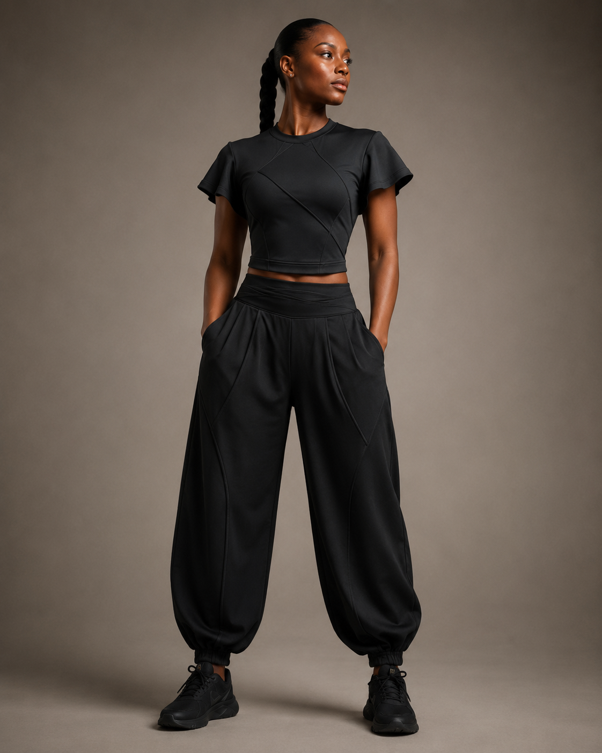
Concept reference only - final pattern and construction must follow approved specifications.
Role in capsule | Versatile separates and non-dress anchor
Primary use | Strength training, travel, warm-up and daily wear
Prototype priority | Prototype Round 2
Target retail tier | Premium core separates

1. Product Intent
A two-piece set pairing a tailored short-sleeve top that ends around the high hip with a loose, baggy technical trouser. The top should flatter the figure without covering the bottom; one version is fitted and one has controlled flow.

2. Locked Design Architecture
- Top A: close-fit sculpted short sleeve with curved seam map.
- Top B: relaxed short sleeve with controlled volume and shaped hem.
- Trouser: high waist, roomy hip and thigh, tapered or adjustable ankle.
- Optional wrap/pleat detail at waist inspired by movement garments without literal costume cues.
- Deep functional pockets that do not distort the hip.

3. Curve-Fit Requirements
- Waistband must fit smaller waists without gaping over fuller hips.
- Trouser rise and crotch extension built for fuller seat.
- Top hem positioned to balance proportions and show trouser waist.
- Sleeve circumference designed for fuller upper arms.

4. Materials and Construction
Top | Matte stretch jersey or compact ponte, 190-240 GSM.
Trouser | Lightweight stretch woven, 150-190 GSM, breathable and abrasion resistant.
Waistband | Soft internal elastic plus shaped outer waistband.
Hardware | Minimal matte cord locks or concealed snaps only if needed.

5. Branding and Finish
- Small emblem at top chest or sleeve.
- Subtle vertical lockup along trouser side seam only as optional statement version.

Sculpt Flow Set — Development Specifications
EWAH-SF-04

6. Preliminary Prototype Specifications
Trouser rise | High rise; final front/back rise set from fit body.
Leg shape | Wide through thigh, tapering below knee or adjustable hem.
Top length | Approximately 22-25 in depending size/height.
Pocket | Phone-secure side pockets plus optional hidden zip pocket.
Waist | Shaped waistband with internal adjustability.

7. Movement and Wear Tests
- Deep squat, leg press setup, walking and stair climb.
- Pocket load test and waistband gap test.
- Check trouser fabric noise, snagging and heat retention.

8. Non-Negotiables
- Baggy must look intentional, not oversized menswear.
- Top must remain tailored and distinctly EWAH.
- No literal kung-fu collar, frog closures or costume details.
- Trouser cannot pool dangerously around equipment.

9. Factory Questions Specific to This Style
- Can the factory create a curved waistband with internal adjustability?
- Which stretch woven gives drape without shine?
- Can the ankle be convertible between open and cinched?

10. Sample Review Decision Gate
Advance only if the set balances power, softness and movement while fitting a pronounced waist-to-hip difference.

Ease T-Shirt Dress
EWAH-ET-05 | OVERSIZED TRAINING TEE DRESS
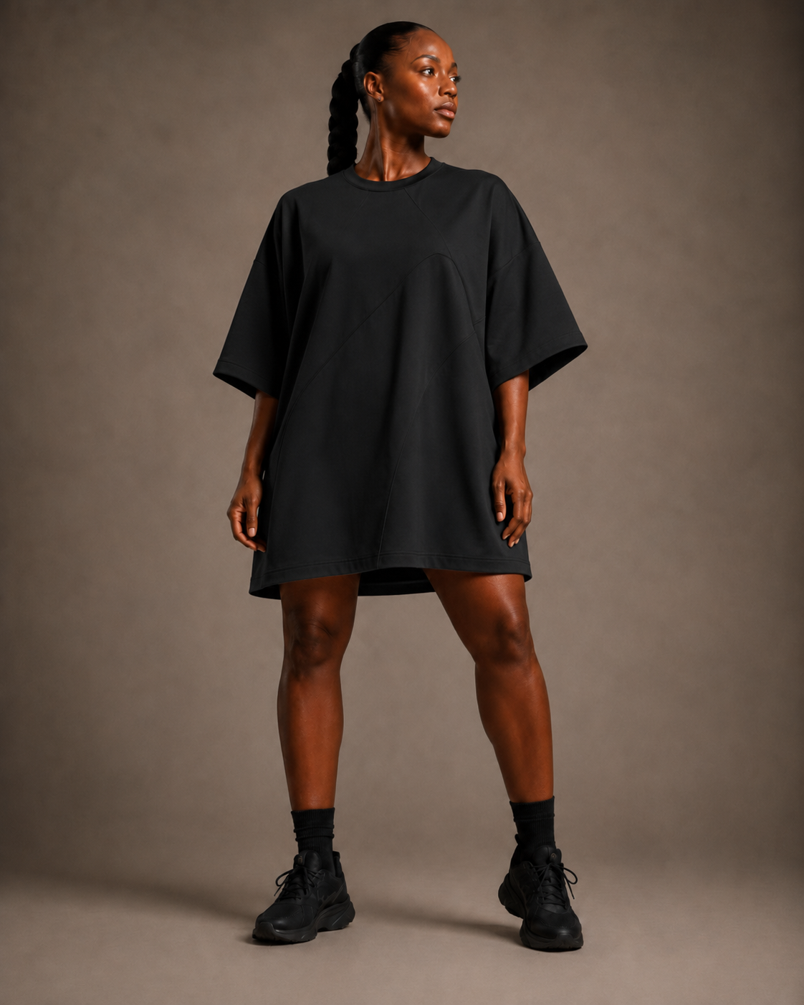
Concept reference only - final pattern and construction must follow approved specifications.
Role in capsule | Accessible entry product and lifestyle bestseller
Primary use | Warm-up, casual training, walking and off-duty wear
Prototype priority | Prototype Round 3
Target retail tier | Accessible premium

1. Product Intent
A genuinely baggy boyfriend T-shirt dress that fully covers the concealed shorts. It should look effortless but be patterned deliberately for curvier bodies so it does not pull across bust or hips and does not become shapeless.

2. Locked Design Architecture
- Dropped shoulder and wide short sleeve.
- Length fully conceals the internal or separate short when standing.
- Optional rear inverted pleat or curved side panels for movement.
- Slightly longer back hem.
- Large vertical EWAH back lockup as signature version.

3. Curve-Fit Requirements
- Full-bust and full-hip ease built separately; not simply a scaled-up unisex tee.
- Neckline stays close enough for bending.
- Sleeve opening generous without exposing bra.
- Hem sweep allows stride while retaining dress appearance.

4. Materials and Construction
Main body | Premium cotton-modal-spandex jersey or technical cotton handfeel, 180-230 GSM.
Performance version | Moisture-wicking nylon/modal blend, matte and breathable.
Short | Separate or internal lightweight opaque stretch short.
Neck rib | High-recovery rib matching body color.

5. Branding and Finish
- Signature vertical back emblem + EWAH wordmark.
- Quiet front emblem near chest or hem.
- Tonal option for elevated minimal version.

Ease T-Shirt Dress — Development Specifications
EWAH-ET-05

6. Preliminary Prototype Specifications
Length | Mid-thigh, calibrated so shorts remain hidden in neutral stance.
Back drop | 1-2 in longer than front.
Ease | Generous bust/hip ease with controlled shoulder width.
Sleeve | Elbow-adjacent or mid-upper-arm wide sleeve.
Short inseam | 4-5 in.

7. Movement and Wear Tests
- Bend, squat and overhead reach to check short exposure.
- Wash and twist test for neckline recovery.
- Back logo durability and handfeel test.

8. Non-Negotiables
- Must read as a short dress, not a long ordinary T-shirt.
- Shorts concealed when standing and walking normally.
- Baggy silhouette must still flatter curvier bodies.
- Back branding must remain crisp and luxurious.

9. Factory Questions Specific to This Style
- Can the factory use a soft high-density transfer that will not crack?
- Can front and back lengths be graded by height blocks?
- Can a rear pleat be added without making the garment look maternity-like?

10. Sample Review Decision Gate
Advance only if it delivers relaxed luxury and looks intentional from front, side and back.

Air Sculpt Mesh System
EWAH-AM-06 | PERFORATED LUXURY LAYERING SYSTEM
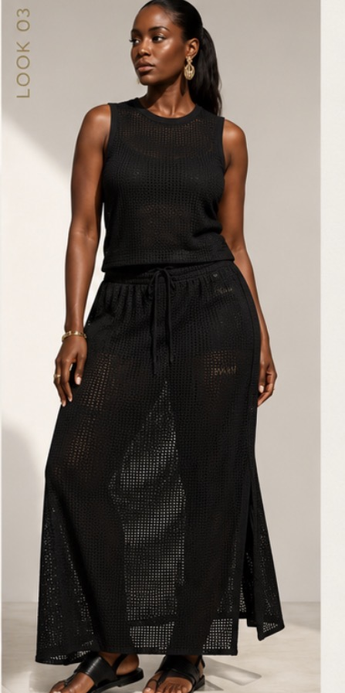
Concept reference only - final pattern and construction must follow approved specifications.
Role in capsule | Premium editorial statement and summer extension
Primary use | Travel, resort, walking, studio layering and controlled gym environments
Prototype priority | Prototype Round 3
Target retail tier | Luxury limited line

1. Product Intent
A perforated or open-knit outer layer paired with a smooth opaque sculpted base. Variations include a baggy vest, long dress, knee-length dress and skirt set. The system should feel luxurious and breathable, never like inexpensive sports mesh.

2. Locked Design Architecture
- Outer layer uses engineered perforation or refined knit texture.
- Opaque base may be bodysuit, fitted short set or slim inner dress.
- Outer silhouette carries EWAH curved seam or panel architecture.
- Long and knee-length dress variations share a core upper block where possible.
- Baggy vest has controlled armholes, shaped hem and optional side slits.

3. Curve-Fit Requirements
- Outer layer skims curves without catching on fullest points.
- Inner base provides secure bust, stomach and seat coverage.
- Perforation density changes strategically by body zone.
- Long styles include movement openings and safe hem management.

4. Materials and Construction
Outer | Premium warp knit mesh, engineered perforated jersey or custom open knit, 120-190 GSM.
Inner | Smooth opaque matte jersey, 200-240 GSM.
Binding | Soft stretch binding or bonded finish; no scratchy mesh edges.
Optional skirt lining | Fitted short or mini-slip, removable only if construction remains clean.

5. Branding and Finish
- Emblem integrated into knit/perforation pattern where feasible.
- Otherwise small tonal rubberized emblem.
- Avoid large surface print on textured fabric.

Air Sculpt Mesh System — Development Specifications
EWAH-AM-06

6. Preliminary Prototype Specifications
Vest length | High hip to upper thigh depending variant.
Dress lengths | Above knee, knee and maxi statement version.
Inner base | Mid-thigh short or fitted mini dress.
Perforation zones | More open at back/side body; denser across bust and seat.
Slits | Required on knee and maxi outer layers.

7. Movement and Wear Tests
- Snag test against benches, zippers and hook surfaces.
- Stretch recovery and edge-curl test.
- Layer heat and sweat test.
- Check transparency under strong light and photography flash.

8. Non-Negotiables
- Must include an intentional opaque underlayer.
- Texture must look premium, not netting or sports bib mesh.
- Long version must be marketed honestly for controlled movement, not all machinery.
- EWAH sculpture must remain visible through panel placement.

9. Factory Questions Specific to This Style
- Can the supplier develop custom perforation placement or only stock mesh?
- What minimums apply to custom knit development?
- Can outer and inner fabrics be shade-matched consistently?

10. Sample Review Decision Gate
Advance only if the system feels like luxury movement dressing and passes snag, transparency and comfort tests.

Breeze / Warrior Flow Dress Family
  - EWAH-ST-03 | TWO-LENGTH SCULPTED MESH SUMMER DRESS
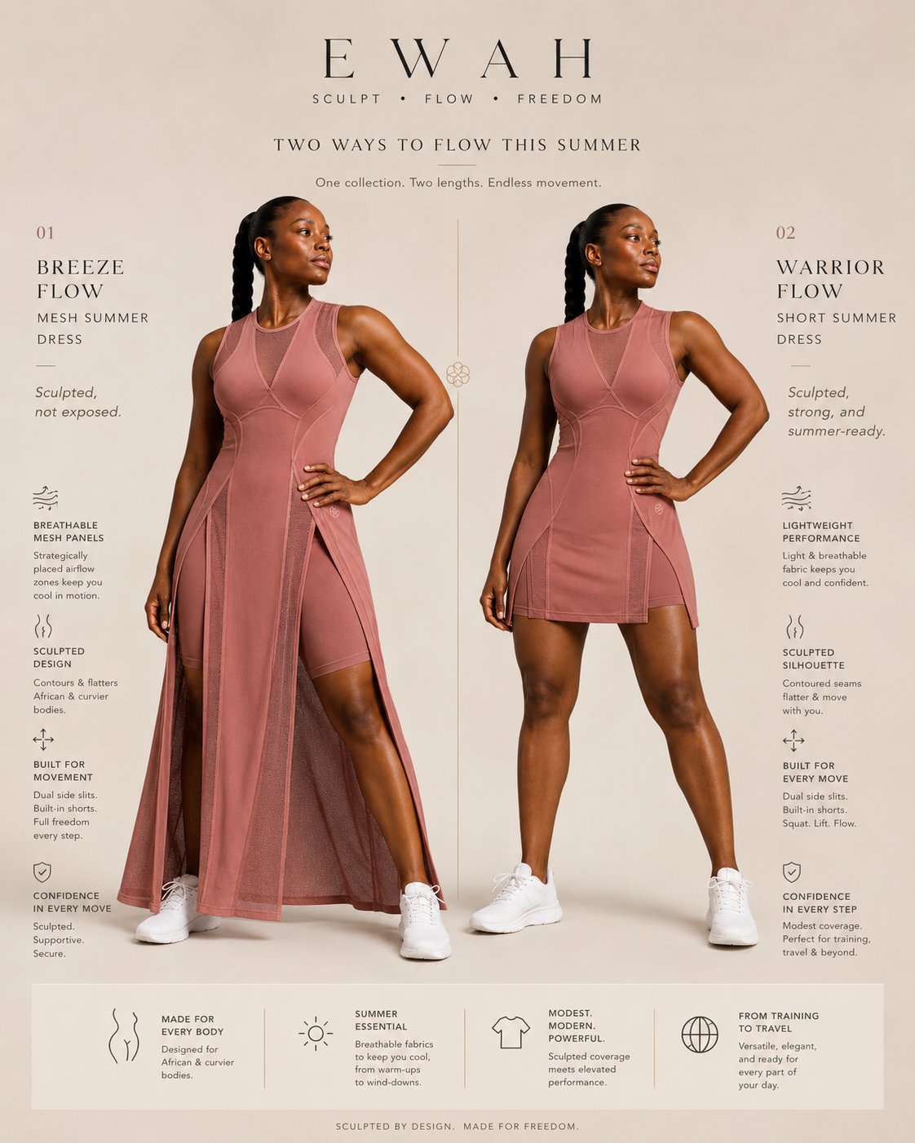
ST-03 visual reference: one sculpted upper block expressed as a maxi flow layer and a short summer dress.

1. Product Intent
A coordinated summer dress family using one sculpted sleeveless upper block, refined mesh neckline, curved seam architecture and opaque built-in shorts. The long Breeze Flow version creates luxury movement dressing; the short Warrior Flow version delivers above-knee performance coverage.

2. Locked Design Architecture
- Refined high round neckline with a breathable mesh inset.
- Curved bust, waist and hip seams carried consistently across both lengths.
- Maxi version: dual full-height side openings, controlled mesh flow panels and opaque short.
- Short version: above-knee front panels, two movement slits and slightly longer back.
- Five-inch opaque built-in short; right-side phone pocket.
- Upper back uses sculpted seams and optional vertical EWAH lockup.

3. Curve-Fit Requirements
- Bust projection and armhole shaping must prevent gaping.
- Waist definition is created through panels, not hard compression.
- Both lengths require additional back balance for fuller glutes.
- Long panels must fall away from the legs and avoid catching on the seat.
- Slit exposure must be tested dynamically on fuller thighs and hips.

4. Materials and Construction
Main body | Matte 4-way stretch jersey, 210-240 GSM.
Mesh panels | Premium performance mesh or refined perforated knit, 140-180 GSM.
Built-in short | Opaque supportive jersey, 230-260 GSM.
Long flow panels | Lightweight stretch mesh with stable edges and low snag risk.

5. Preliminary Prototype Specifications
Base fit body | Bust 38 in; waist 31 in; hip 43 in.
Short front length | Approximately 31-33 in; above knee.
Short back length | Approximately 33-35 in.
Maxi outer length | Approximately 52-56 in, height-block dependent.
Built-in short inseam | 5 in.
Slits | Two symmetrical movement slits; final heights validated dynamically.

6. Movement and Wear Tests
- Squat, lunge, step-up, overhead reach and treadmill walk.
- Long version: snag, stepping-on-hem and machine-proximity safety tests.
- Check neckline stability, mesh recovery, short ride-up and slit exposure.
- Wash test for mesh edge curl, seam recovery and shade matching.

7. Non-Negotiables
- Both lengths must visibly share one EWAH design family.
- Mesh must look refined and premium, never like sports bib netting.
- The short style must remain modest and movement-ready.
- The maxi version must be marketed for controlled movement, travel and layering—not all gym machinery.

8. Sample Review Decision Gate
Advance only if both lengths retain the same sculpted identity, pass dynamic coverage tests and justify separate retail propositions rather than appearing as simple hem-length changes.

Mesh Flow Short Set
  - EWAH-SM-03 | PERFORATED TOP + ABOVE-KNEE SKIRT WITH BUILT-IN SHORT
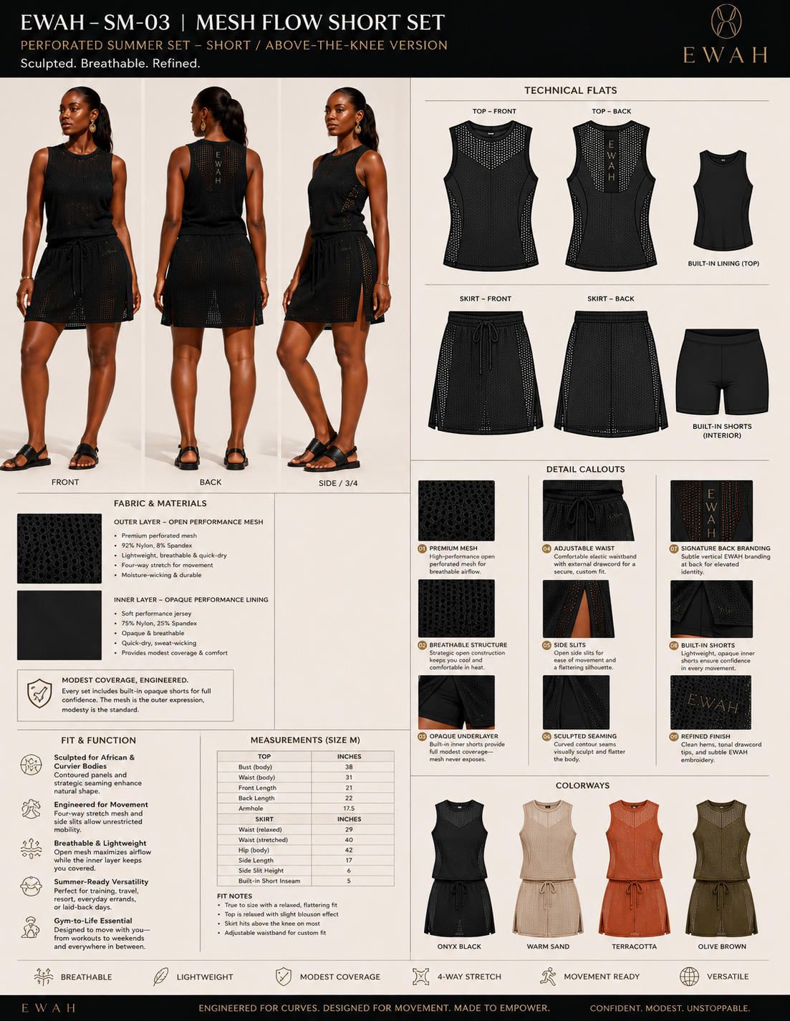
SM-03 visual reference: perforated top and adjustable above-knee skirt with opaque internal layers.

1. Product Intent
A lightweight two-piece summer system pairing a relaxed perforated sleeveless top with an above-knee perforated skirt. Each piece contains or coordinates with an opaque performance layer so the set feels airy and luxurious without sacrificing coverage.

2. Locked Design Architecture
- Relaxed sleeveless top with sculpted side seams and controlled armhole depth.
- Optional attached opaque lining top or coordinated fitted base tank.
- Above-knee skirt with adjustable elastic waistband and external drawcord.
- Curved side slits for movement; skirt remains longer at back.
- Opaque five-inch built-in short attached internally.
- Subtle back vertical branding and tonal front EWAH mark.

3. Curve-Fit Requirements
- Top provides bust and hip ease without becoming boxy.
- Skirt waistband accommodates pronounced waist-to-hip difference without gaping.
- Back skirt length and sweep account for fuller glutes.
- Built-in short rise, gusset and leg opening are engineered for fuller thighs.
- Mesh panels must not distort or become excessively transparent across fullest points.

4. Materials and Construction
Outer mesh | Premium perforated performance mesh, approximately 150-190 GSM.
Opaque lining | Matte nylon/spandex jersey, 210-240 GSM.
Built-in short | Supportive opaque jersey, 230-260 GSM.
Waistband | Soft elastic with adjustable drawcord; clean internal finishing.
Seams | Low-profile stretch construction; bound or bonded mesh edges.

5. Preliminary Prototype Specifications
Base fit body | Bust 38 in; waist 31 in; hip 43 in.
Top back length | Approximately 22 in.
Skirt side length | Approximately 17-19 in; above knee.
Side slit height | Approximately 5-6 in.
Built-in short inseam | 5 in.
Waist | Adjustable; relaxed target approximately 29 in on base sample.

6. Movement and Wear Tests
- Squat, lunge, stair climb, seated posture and fast walking.
- Waistband roll, drawcord security and pocket load test.
- Check mesh snagging, transparency and edge curl.
- Verify top remains down and skirt remains stable during overhead reach.

7. Non-Negotiables
- Mesh is the outer expression; modest coverage is engineered underneath.
- Set must look sculpted and elevated, not like a swimsuit cover-up.
- Skirt must remain above knee while fully covering the built-in short in neutral stance.
- No scratchy bindings, loose drawcord hardware or cheap glossy mesh.

8. Factory Questions Specific to This Style
- Can the factory source matching mesh and opaque jersey in identical colorways?
- Can the top lining be detachable or integrated without visible bulk?
- Can the skirt waistband remain smooth across a fuller stomach?
- What anti-snag and mesh-recovery tests can be documented?

9. Sample Review Decision Gate
Advance only if the set maintains premium texture, secure modest coverage, easy movement and a flattering above-knee proportion on at least three curvy fit architectures.
Manufacturer Screening and Development Controls
APPLICABLE TO ALL EIGHT PRODUCTS

Required Partner Capability
- Fully custom cut-and-sew development from EWAH specifications and approved patterns.
- In-house or disclosed pattern making, fit sampling, grading and fabric sourcing.
- Experience with stretch garments, built-in shorts, pleating, mesh/perforation and luxury finishing.
- Ability to fit on curvier bodies rather than relying only on straight-size forms.
- Written pattern ownership, confidentiality, subcontracting and material-substitution terms.

Development Deliverables Required From Factory
Before sample | Fabric swatches, trim options, construction review and quotation.
Sample round 1 | Pattern draft, first prototype and measurement report.
Revision | Written change log and updated pattern/spec.
Pre-production | Approved size set, graded nest, color approvals and sealed sample.
Bulk | Inline inspection, final random inspection and packing report.

EWAH Fit Validation Bodies
- Fit Body A: fuller hip/glute with smaller waist.
- Fit Body B: fuller stomach with substantial hip and thigh.
- Fit Body C: fuller bust and upper arm, with shorter torso.
- At least one petite-curvy and one tall-curvy wear test before final grading.

Critical Legal and Commercial Terms
- EWAH owns or receives unrestricted exclusive use of final patterns, grading rules and technical files after payment.
- No design, pattern, image or rejected sample may be reused, displayed or sold.
- No fabric, trim, construction or subcontractor changes without written approval.
- Bulk production begins only against an approved sealed sample and signed specification sheet.
- Defect tolerances, late-delivery remedies and remake/credit terms must be documented.

What This Pack Is — and Is Not
This pack is a structured product-development and manufacturer-screening brief. It is deliberately more complete than mood imagery, but it is not a substitute for final production patterns, graded nests, laboratory test reports or fit-approved technical specifications. Those outputs must be created and validated during sampling with qualified apparel professionals.

Immediate Execution Roadmap
MOVE FROM CONCEPT TO APPROVED PROTOTYPES
Step 1 | Select three factories or development studios for capability interviews.
Step 2 | Issue WF-01 and ST-02 briefs first; request fabric, perforation and sample quotations.
Step 3 | Appoint an independent technical designer or pattern reviewer where possible.
Step 4 | Run first fit session on at least two curvy bodies and record every movement failure.
Step 5 | Revise and seal WF-01/ST-02, then begin ST-03 and SM-03.
Step 6 | Develop CP-03 and SF-04 after the core dress/mesh fit language is proven.
Step 7 | Develop ET-05 and AM-06 only after the core fit and fabric system is stable.

Founder Decision Gates
- Does the garment visibly carry EWAH line sculpture without looking over-designed?
- Does it flatter multiple curvy body architectures rather than only one model?
- Can the wearer move without managing, pulling or re-covering the garment?
- Does the fabric and finish justify premium pricing?
- Would the product still be recognizable as EWAH without a visible logo?

