首先，平衡二叉树指，左右树高度差不超过1，且左右树都是平衡二叉树，高度指的是最大高度，如下图，也是平衡二叉树：

[1,1,1,11,1,1,null,1]，

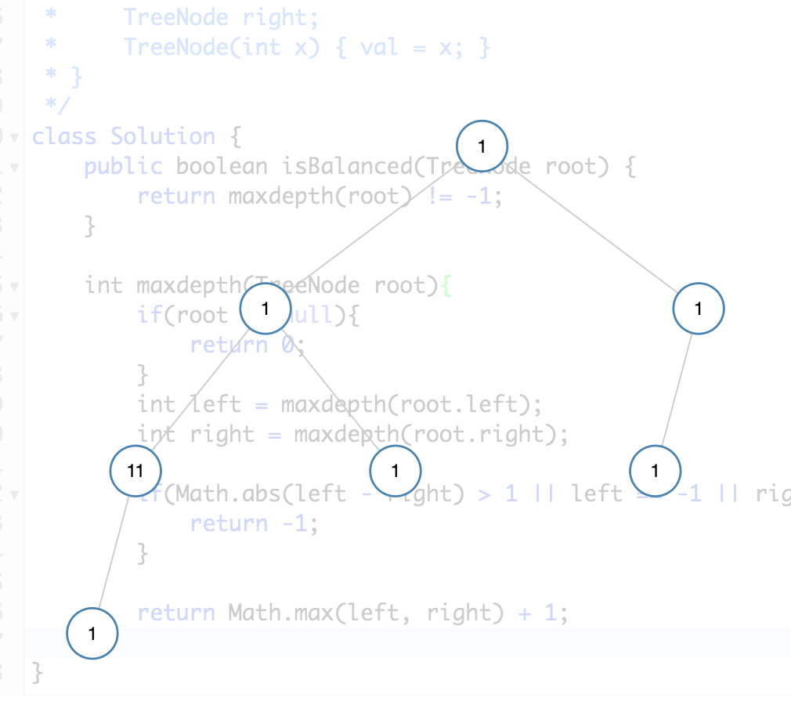

/\*\*

\* Definition for a binary tree node.

\* public class TreeNode {

\* int val;

\* TreeNode left;

\* TreeNode right;

\* TreeNode(int x) { val = x; }

\* }

\*/

class Solution {

public boolean isBalanced(TreeNode root) {

return maxdepth(root) != -1;

}

int maxdepth(TreeNode root){

if(root == null){

return 0;

}

int left = maxdepth(root.left);

int right = maxdepth(root.right);

if(Math.abs(left - right) > 1 || left == -1 || right == -1){

return -1;

}

return Math.max(left, right) + 1;

}

}